Table 1: The comparison of PMB3 with other reported colourimetric probes
Probe | Sensing Analyte | LOD  [M] | Binding constant[M⁻¹] | Mode of detection | Ref
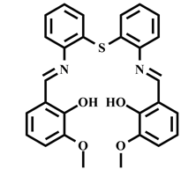 | Cu²⁺ | 0.66×10⁻⁶ | 1.90×10⁴ | Colourimetric | [31]
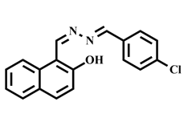 | Cu²⁺ | 5.80×10⁻⁶ | 1.20×10⁴ | Colourimetric | [32]
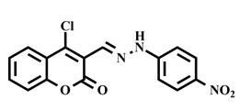 | Cu²⁺ | 8.0×10⁻⁶ | 4.49×10² | Colourimetric | [33]
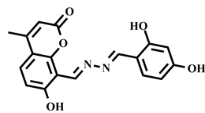 | Cu²⁺ | 28.0×10⁻⁶ | 1.87×10⁴ | Colourimetric | [34]
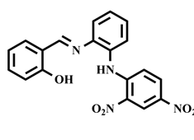 | Cu²⁺ | 8.77×10⁻⁶ | 2.70×10³ | Colourimetric | [35]
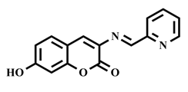 | Ni²⁺ | 0.5×10⁻⁶ | 2.343×10⁴ | Colourimetric | [25]
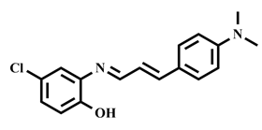 | Ni²⁺ | 1.0×10⁻⁷ | 1.29×10⁵ | Colourimetric | [36]
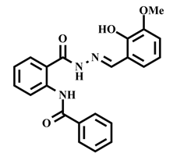 | Ni²⁺ | 1.71×10⁻⁶ | 1.10×10⁴ | Colourimetric | [37]
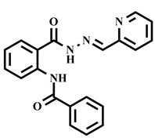 | Ni²⁺ | 1.8×10⁻⁶ | 1.45×10³ | Colourimetric | [38]
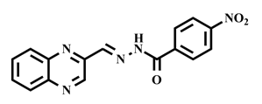 | Ni²⁺ | 1.47×10⁻⁶ | 2.5×10⁵ | Colourimetric | [39]
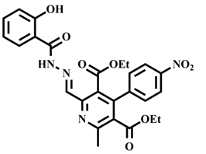 | Ni²⁺ | 0.14×10⁻⁶ | 3.07×10³ | Colourimetric | [40]
PMB3 | Cu²⁺  Ni²⁺ | 45.63×10⁻⁷  26.85×10⁻⁷ | 3.47×10⁴  8.02×10⁴ | Colourimetric | This Work

