Supplementary information

Weight evaluation
The numerical implementation of the integral transform approximation requires the adoption of computationally-efficient schemes for the evaluation of the line position and damping weights introduced in Eq. 15 in the main text.
The damping weight $a_{Γ,i}$is computed according to the algebraic formula in Eq. 8 in the main text. As the damping changes for each line only as a result of different rotational quanta, the associated weight is tabulated for all rotational quanta present in the line list. For each line the weight is then obtained from the table by indexing it with the rotational quantum number of that line.
The position weight $a_{ω,i}$ depends on the exact line position, so it must be computed for each line. Since its formula involves complex exponential terms, its value is also complex. To facilitate computation, it is convenient to split up the weight in real and imaginary parts and evaluate the complex exponentials as sines and cosines making use of Euler’s identity. The expression to be numerically evaluated is then:
$$a_{ω,i}=\frac{1}{2\sin\left|θ_{Δω}\right|}\left[\left(\sin\left|θ_{Δω}\right|+\sin{φ_{i}}\right)+j\left(\cos\left|θ_{Δω}\right|-\cos{φ_{i}}\right)\right],$$ | Eq. A1
with $φ_{i}=\left(2λ_{ω,i}-1\right)\left|θ_{Δω}\right|$, $λ_{ω,i}=\frac{ω_{i}-ω[k_{i}]}{Δω}$, and $\left|θ_{Δω}\right|=τΔω/2$ as defined in the main text. Compared to other equivalent expressions, this expression minimizes the per-line evaluations of sine/cosine functions. While faster than complex exponentials, sine and cosine functions are still fairly expensive to compute, especially considering they are evaluated for each line. A polynomial approximation can be used when $θ_{Δω}≪1$. The real and imaginary parts are separately parametrized by the polynomial expressions:
$$a_{ω,i}=a_{ω,R}\left(λ_{ω,i}\right)+ja_{ω,I}(λ_{ω,i}),$$ | Eq. A2a
$$a_{ω,R}(λ)=λ+A_{0}λ\left(λ-1\right)\left(2λ-1\right)\left[1+A_{1}\left(λ-λ_{+}\right)\left(λ-λ_{-}\right)\right],$$ | Eq. A2b
$$a_{ω,I}(λ)=B_{0}λ\left(λ-1\right)\left[1+B_{1}{\left(2λ-1\right)}^{2}\right].$$ | Eq. A2c1
The real part $a_{ω,R}$ is linear with $λ$, in addition to a third and a fifth order correction term. The value for $A_{0}$ is determined by matching the value of $a_{ω,R}$($λ)$ to Re$[a_{ω,i}]$ at the polynomial peaks, for $λ_{±}=\frac{1}{2}±\frac{1}{2\sqrt{3}}$. The value of $A_{1}$ is found by matching the slope at $λ=\frac{1}{2}$. This results in:
$$A_{0}=3\left[1-\sqrt{3}\frac{\sin\left(\left|θ_{Δω}\right|/\sqrt{3}\right)}{\sin\left|θ_{Δω}\right|}\right], A_{1}=\frac{6}{A_{0}}\left[\frac{\left|θ_{Δω}\right|}{\tan\left|θ_{Δω}\right|}-1\right]-6.$$ | Eq. A3
The imaginary part $a_{ω,I}$($λ)$ is zero at $λ=0, 1$ and has a peak at $λ=\frac{1}{2}$. $B_{0}$ and $B_{1}$ are obtained by setting the value at $λ=\frac{1}{2}$ and slope at $λ=0$equal to the respective values of $Im[a_{ω}^{i}]$, resulting in:
$$B_{0}=2\tan{(\left|θ_{Δω}\right|/2)}, B_{1}=4\left(\left|jθ_{Δω}\right|/B_{0}-1\right).$$ | Eq. A4
It is worth noting that, while the expressions for the A and B constants are rather involved, they are only evaluated once for each iteration, i.e. $θ_{Δω}$ is not a line property.

Ultrafast probe delay scan
The evolution of the molecular coherence following the impulsive excitation by a fs pulse can be measured in the time domain by employing a pump-probe scheme. The resulting probe delay scan is performed by integrating the CRS signal over $ω$ and scanning the probe delay time $τ$:
$$I_{PDS}\left(τ\right)=\int{{\left|{\hat{P}}_{CRS}\left(ω\right)\right|}^{2}dω}=\int{{\left|P_{CRS}\left(t^{'}\right)\right|}^{2}dt^{'}}.$$ | Eq. A5
Using Eq. 2 from the main text we find that:
$$I_{PDS}\left(τ\right)=\int{{\left|χ^{\left(3\right)}\left(t^{'}\right)\right|}^{2}{\left|E_{pr}\left(t^{'}-τ\right)\right|}^{2}dt^{'}},$$ | Eq. A6
which is a cross-correlation that can be expressed as a convolution in time:
$$I_{PDS}\left(τ\right)={\left|χ^{\left(3\right)}\left(τ\right)\right|}^{2}*{\left|E_{pr}\left(-τ\right)\right|}^{2}.$$ | Eq. A7
An ultrafast approximation for $χ^{(3)}\left(τ\right)$ is then found by using the definition of ${χ_{i}}^{(3)}\left(τ\right)$ and the integral transform approach to express $χ^{(3)}\left(τ\right)$:
$$χ^{(3)}\left(τ\right)=\iint{\hat{W}\left(ω,Γ\right) exp\left[\left(jω-Γ\right)τ\right] dω dΓ}.$$ | Eq. A8
Here the factor $exp\left(jωτ\right)$, combined with the integral over $ω$, is recognized as an inverse Fourier transform (from $ω$ to $τ$) to arrive at the expression for evaluating the time-domain signal:
$$χ^{(3)}\left(τ\right)=\int{F_{τ←ω}^{-1}\left\{\hat{W}\left(ω,Γ\right)\right\} exp\left(-Γτ\right) dΓ}$$ | Eq. A9
We note that the reasoning above requires the integral to be taken over the entire frequency domain. This domain can be effectively limited by excluding from the calculation of the line strength distribution function $\hat{W}\left(ω,Γ\right)$ those lines that lie outside a certain frequency range. We further note that the weights in Eq 8 in the main text are not quite as good in reducing the approximation error in $χ^{(3)}\left(τ\right)$, because they only target a single value of $τ$. However, this shortcoming can be offset by using a higher resolution for the $Γ$ grid, as briefly outlined in the main text and discussed in more detail in the section “Approximation error – Time domain approximation”.

Approximation error

Frequency-domain approximation
In the following we provide an analytical derivation of the approximation error introduced in Eq. 9 in the main text, with the choice of weights in Eq. 8 (ibid.). We furthermore prove that this error has an upper bound, which depends on the envelope of the probe field and the nondimensional grid parameters introduced in Eq. 8.
The approximated polarization, upon discretizing $x=ω$ or $Γ$, can be expressed as the sum of the exact polarization and an error term:
${\hat{P}}_{x,i}^{apx}\left(ω\right)={\hat{P}}_{i}\left(ω\right)+{\hat{P}}_{x,i}^{err}\left(ω\right)$. | Eq. A10
Ultimately, however, we are looking for the error in the signal intensity:
$${\hat{I}}_{x,i}^{err}\left(ω\right)={\left|{\hat{P}}_{x,i}^{apx}\left(ω\right)\right|}^{2}-{\hat{I}}_{i}\left(ω\right)≈2Re\left[\overline{{\hat{P}}_{i}\left(ω\right)} {\hat{P}}_{i,x}^{err}\left(ω\right)\right],$$ | Eq. A11
where the term ${\left|{\hat{P}}_{i}^{err}\left(z\right)\right|}^{2}$ was omitted in the RHS, due to its negligible contribution. The polarization error term due to the position and damping weights (respectively $x=$ $ω$ and $x=Γ$) ${\hat{P}}_{x,i}^{err}\left(z\right)$ can be found by developing the Taylor series of ${\hat{P}}_{x,i}^{err}\left(ω\right)$ around $ω=ω_{i}$:
$${\hat{P}}_{x,i}^{err}\left(ω;λ_{x,i},θ_{Δx},τ\right)≈λ_{x,i}\left(1-λ_{x,i}\right)\frac{θ_{Δx}^{2}}{2}\left[-\frac{1}{τ^{2}}\frac{d^{2}\hat{P}\left(ω\right)}{{dω}^{2}}+\frac{j}{τ}\frac{d\hat{P}\left(ω\right)}{dω}\right]+$$  $$λ_{x,i}\left(1-λ_{x,i}\right)\left(\frac{1}{2}-λ_{x,i}\right)\frac{θ_{∆x}^{3}}{6}\left[-\frac{2j}{τ^{3}}\frac{d^{3}\hat{P}\left(ω\right)}{{dω}^{3}}-\frac{3}{τ^{2}}\frac{d^{2}\hat{P}\left(ω\right)}{{dω}^{2}}+\frac{j}{τ}\frac{d\hat{P}\left(ω\right)}{dω}\right].$$ | Eq. A12
The error expression can be made dimensionless by dividing by the peak intensity at $ω=ω_{i}$. Further introducing the dimensionless frequency, $z=\left(ω-ω_{i}-jΓ_{i}\right){∆t}_{pr}$ and the dimensionless probe field ${\hat{E}}_{pr}\left(z\right)$:
$${\hat{E}}_{pr}\left(ω\right)={∆t}_{pr}{\hat{E}}_{pr}\left(z\right); \frac{d^{n}{\hat{E}}_{pr}\left(ω\right)}{{dω}^{n}}={∆t}_{pr}^{n+1}\frac{d^{n}{\hat{E}}_{pr}\left(z\right)}{{dz}^{n}},$$ | Eq. A13
the error can be expressed purely as derivatives with respect to the dimensionless probe function, i.e.:
$$\frac{{\hat{P}}_{x,i}^{err}\left(ω;λ_{x,i},θ_{Δx},θ_{∆t}\right)}{{\hat{P}}_{i}\left(ω=ω_{i}\right)}≈$$  $$\frac{1}{{\hat{E}}_{pr}\left(jIm\left(z\right)\right)}\left\{2λ_{x,i}\left(1-λ_{x,i}\right)θ_{Δx}^{2}\left[-θ_{Δt}^{2}\frac{d^{2}{\hat{E}}_{pr}}{{dz}^{2}}+jθ_{∆t}\frac{d{\hat{E}}_{pr}}{dz}\right]+\right.$$  $$\frac{4}{3}\left.λ_{x,i}\left(1-λ_{x,i}\right)\left(\frac{1}{2}-λ_{x,i}\right)θ_{∆x}^{3}\left[-2jθ_{Δt}^{3}\frac{d^{3}{\hat{E}}_{pr}}{{dz}^{3}}-3θ_{Δt}^{2}\frac{d^{2}{\hat{E}}_{pr}}{{dz}^{2}}+jθ_{∆t}\frac{d{\hat{E}}_{pr}}{dz}\right]\right\},$$ | Eq. A14
where we have defined the dimensionless probe pulse-width as $θ_{∆t}={∆t}_{pr}/τ$. The magnitude of the error is dominated by the smallest orders in $θ$, i.e. the square term in $θ_{∆x}$ and the linear term in $θ_{∆t}$:
$$\left|\frac{{\hat{P}}_{x,i}^{err}\left(ω;λ_{i,x},θ_{Δx},θ_{∆t}\right)}{{\hat{P}}_{i}\left(ω=ω_{i}\right)}\right|≈2λ_{x,i}\left(1-λ_{x,i}\right){\left|θ_{∆x}\right|}^{2}θ_{∆t}\left|\frac{d{\hat{E}}_{pr}(z)}{dz}\right|/\left|{\hat{E}}_{pr}\left(jIm\left(z\right)\right)\right|.$$ | Eq. A15
Finally, the error is largest in between two gridpoints where $λ_{i,x}=\frac{1}{2}$, so that the error is upper-bounded:
$$\left|\frac{{\hat{P}}_{x,i}^{err}\left(ω;θ_{Δx},θ_{∆t}\right)}{{\hat{P}}_{i}\left(ω=ω_{i}\right)}\right|≲\frac{1}{2}{\left|θ_{∆x}\right|}^{2}θ_{∆t}\left|\frac{d{\hat{E}}_{pr}(z)}{dz}\right|/\left|{\hat{E}}_{pr}\left(jIm\left(z\right)\right)\right|.$$ | Eq. A16
Because the entire RHS is now dimensionless and does not depend on any parameter of a particular line i, it needs to be evaluated only once to infer the error for any line in the database.
When it comes to its numerical implementation, the remarkable accuracy provided by the choice of weights in Eq. 8 in the main text allows for the resolution of the damping axis to be chosen very large, even up to $ΔΓ=Γ_{max}-Γ_{min}$, resulting in only $N_{Γ}=2$ gridpoints. Taking this one step further, one could use $Γ_{avg}=\frac{1}{2}(Γ_{max}+Γ_{min})$ for the damping coefficient in the exponential term of Eq. 8 in the main text, and replace Eq. 7 (ibid.) by:
$${\hat{X}}^{\left(3\right)}\left(ω\right)≡\exp\left(jωτ\right)\sum_{i}{W_{i}δ\left(ω-ω_{i}\right)\exp\left(-Γ_{i}τ\right)},$$ | Eq. A17
such that no integral/sum over $Γ$ is required at all. This is effectively equivalent to choosing $N_{Γ}=1$. In the tested spectrum, this choice only slightly increases the error to <0.5%. Finally, setting $Γ_{avg}=0$ results in a comparatively coarse approximation (error <5%), but is significant because it is equivalent to setting $Γ_{i}=0$ in Eq. 4 in the main text. This shows that, in approximation, the effect of the coherence decay is only that of reducing the intensity of the line, whereas the lineshape is mostly given by the shifted frequency profile of the probe pulse. In contrast to $ΔΓ$, the frequency resolution $Δω$ cannot be chosen arbitrarily large because, for one, at too large $Δω$ the DFT no longer accurately approximates the continuous FT.

Time-domain approximation
The integral approximation of the CRS signal in the time domain introduces a larger approximation error than the frequency-domain formulation given in Eq. 7 in the main text. There are two main reasons for this: (i) in the discretization of Eq. 10a in the main text, the choice of weights given in Eq. 8 (ibid.) eliminates the error only at a single value of the probe delay, $τ=τ_{0}$; and (ii) the integral transform relies on the approximated lineshapes being smooth, with higher derivatives vanishing at the gridpoints. In the time domain however, the prototype lineshapes oscillate rapidly, introducing finite discontinuities on the nodes of the time-grid.
As in the case of the error in the frequency domain, we are interested in the error in the signal intensity. The intensity is expressed as the convolution in Eq. 10a in the main text, which owing to the distributive property can be used to express the error as:
$$I_{PDS}^{err}\left(τ\right)={\left|E_{pr}\left(-τ\right)\right|}^{2}*{\left|χ_{err}^{(3)}\left(τ\right)\right|}^{2},$$ | Eq. A18
here $χ_{err}^{(3)}\left(τ\right)$ is the error between the approximated and exact $χ^{(3)}$:
$$χ_{apx}^{(3)}\left(τ\right)=χ^{(3)}\left(τ\right)+χ_{err}^{(3)}\left(τ\right)$$ | Eq. A19
In contrast to the frequency domain, the approximations introduced by the discretization of $ω$ and Γ impact the error differently. As mentioned before and illustrated in Fig. A1, the time-domain error due to the approximation of $ω_{i}$ is dominated by interference of neighboring oscillations. This interference results in an envelope function that affects the intensity of the oscillation$.$ With the choice of weights as in Eq. 8 in the main text, the discrete approximation of the non-linear optical susceptibility ${\hat{X}}^{\left(3\right)}\left(τ\right)$ has the following time-domain envelope:
$$A\left(τ\right)=\left| \exp\left[πj\frac{τ-τ_{0}/2}{2τ_{max}}\right]\left|1-a_{ω,i}\right|+\exp\left[-πj\frac{τ-τ_{0}/2}{2τ_{max}}\right]\left|a_{ω,i}\right|\right|.$$ | Eq. A20
This envelope is approximately a parabola that takes value 1 for $τ=0$ and $τ=τ_{0}$, with $τ_{0}$ the time at which the weights are evaluated, and has a maximum $A_{max}$ at $τ=τ_{0}/2$, that is a function of $λ_{ω,i}$. For $τ>τ_{0}$, the envelope rapidly decreases, reaching a minimum value at $τ=τ_{max}=π/Δω$, corresponding to the maximum error in the approximation of ${\hat{X}}^{\left(3\right)}$.
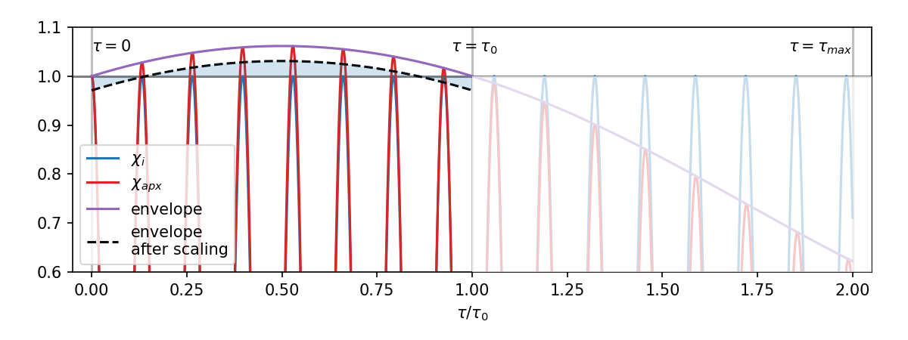
Fig. A1 | Error introduced by the time-domain ultrafast approximation. The interference of neighboring lineshapes on the time-grid results in an envelope (purple line) in the approximated ${\hat{X}}^{\left(3\right)}$ (red line) relative to the exact $χ^{\left(3\right)}$ (blue line). The error can be minimized by evaluating the weights at the last grid-point in the evaluated range (τ₀) and scaling the lines to center the error around unity (black dashed line).
The error in ${\hat{X}}^{\left(3\right)}\left(τ\right)$, evaluated over a range $τ=0… τ_{last}$, can thus be reduced by choosing a grid spacing $Δω$ such that $τ_{max}$ is much larger than the last point in the range of interest $τ_{last}$. This is equivalent to the requirement $\left|θ_{Δω}\right|≪1$ for all $τ$ in the range of interest. The error is further minimized by evaluating the weights at $τ_{0}=τ_{last}$ and scaling the line intensity by the factor:
$$C_{corr,i}=\frac{1}{2}+\frac{1}{2A_{max,i}}≈1-\frac{1}{4}λ_{ω,i}\left(1-λ_{ω,i}\right){\left|θ_{Δω,0}\right|}^{2},$$ | Eq. A21
The envelope is thus centered around unity in this range, as depicted by the black dashed line in Fig. A1. This envelope correction is employed for each line individually and is also implemented in the application code.

On-the-fly fitting of experimental data
As discussed in the main text, the substantial reduction in computational time required to simulate the time-resolved CRS signal allows for the on-the-fly evaluation of experimental data, making it faster than the data acquisition itself. In the main text we discuss the implications for the prospect commercialization of time-resolved CRS instruments, where the processing of the experimental data could be automated, providing live quantitative information on dynamic measurement environments.
To prove this claim, we developed two software widgets that demonstrate the on-the-fly simulation and fitting of the CRS signal, both in the frequency- and time-domain. The main functionalities and the operation of the widgets are detailed in the following paragraphs.

Installation procedure
The example applications can be installed by executing the steps below. This procedure can be used for both Windows or Linux operating systems.
- Unzip package
Unzip “ultrafast-crs.zip” into a new folder (e.g. “ultrafast-crs”).
- Install Python
In case Python is not installed on your system, download the installer at https://www.python.org/ and follow the instructions to install Python. Make sure to check “Add Python 3.x to PATH” during installation. Reboot your system after installation. The applications were tested on Python 3.12 for Windows 10 and Python 3.8 on Ubuntu 20.04 (WSL2), but they will likely work with older versions of Python 3.x / Windows / Linux as well. MacOS is currently not supported.
- Install dependencies
Open a command prompt and navigate to the unzipped folder “ultrafast-crs”. You can do this quickly by navigating to the folder in Windows and typing “cmd” in the address bar and pressing enter. A console window should pop up with the current directory set to the “ultrafast-crs” folder. Now type:
pip install -r requirements.txt
in the console and press enter. This will install the Matplotlib, Numpy, and Scipy packages as well as their dependencies.
- Download database files
The database datafiles are stored on a separate repository (https://github.com/dcmvdbekerom/ultrafast-crs_data).
To download the data, run the following python script:
python get_data.py
The database files will be downloaded in the “data/CH4_v2/” folder. If anything went wrong, you can manually download the files from https://github.com/dcmvdbekerom/ultrafast-crs_data/data/CH4_v2/.
- Run widget application
With the console window still open, first navigate to the demos folder by typing:
cd demos
Now the application can be run by typing:
python demo_t-domain.py
for the time domain widget, or:
python demo_w-domain.py
for the frequency domain widgets.

Frequency-domain widget
The widget for the on-the-fly fitting of frequency-domain CRS spectra can be launched by running the Python script widgets_w.py. The script generates a graphical user interface (GUI) as shown in Fig. A2. The interactive plot consists of a synthetic CH₄ ν₂ CRS spectrum (circle markers) and the best-fit spectrum computed by the ufa-cpp algorithm (solid line).
The widget provides the following features:
- The target spectrum.
Labelled as “data” in the legend, this synthetic spectrum is computed for a random temperature (T) in the range 296-1500 K and for a probe delay (τ) selected by the user in the range 20-100 ps, and simulates experimental data acquired in a typical fs/ps CRS experiment. The spectral resolution of this target spectrum is reduced to 2.0 cm⁻¹, with respect to synthetic spectra shown in Fig. 3 in the main text. The synthetic data is normalized to unity. Noise can be added to the data by increasing the Noise slider to a non-zero value.
- The best-fit spectrum.
Labelled as “fit” in the legend, this spectrum is calculated on-the-fly employing the ufa-cpp algorithm and including the full set of 10.9 M spectral lines of the MeCaSDa database¹. It is worth reminding that, employing the ref-py algorithm, based on the state-of-the-art spectral code of Ref.², a single evaluation of this spectrum requires many hours.
- Probe delay slider.
This slider allows the user to select the probe delay of the data spectrum in the range 20-100 ps, the new value is shown on the right-hand side of the slider. When slid, a new data spectrum can be simulated for the new value of τ and for a new random value of T. When the slider is released, the “fit” spectrum is also recomputed for the new value of τ and the current value of T and scale.
- Noise slider.
This slider allows the user to set the amount of noise that is added to the synthetic data. The set value determines the standard deviation of the Gaussian distribution from which the noise is sampled. It is expressed as a percentage of the maximum (normalized to 1).
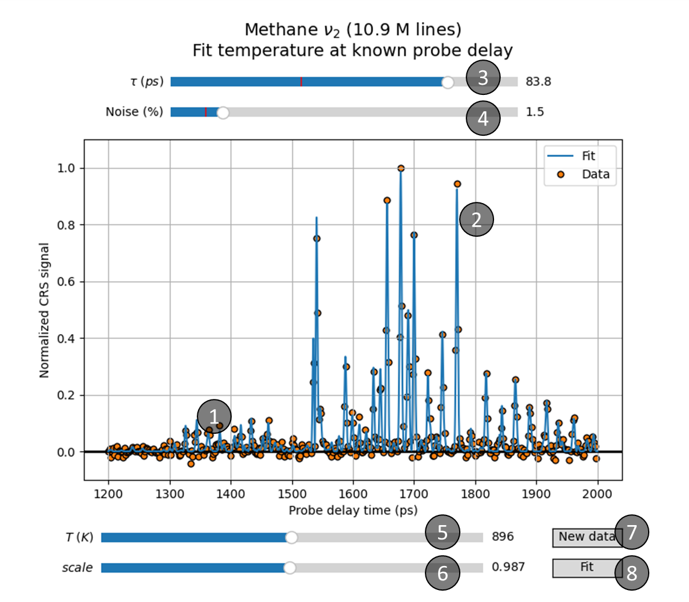
Fig. A2 | Frequency-domain widget. The (synthetic) target spectrum, simulating the experimental data acquired in a fs/ps CRS experiment is represented by orange circle markers. The widget fits these data on-the-fly to obtain the best fitting temperature, and the best-fitting spectrum is shown as a solid blue line. Noise can be introduced in the simulated experimental data by adjusting the Noise slider. The user can recompute the “fit” spectrum by activating the temperature (T) and probe delay (τ) sliders and rescale it by using the Scale slider. A new synthetic dataset can be generated by clicking the New data button and fitted on-the-fly by clicking the Fit button.
- Temperature slider.
This slider allows the user to change the temperature of the data spectrum in the range 296-1500 K, the new value is shown on the right-hand side of the slider. When slid, the fit spectrum is instantaneously recomputed for the new value of T and the current value of τ. The data spectrum is unaffected by changing the temperature slider, as the temperature of the spectrum is the unknown to be estimated, and its value is thus randomly selected by the widget.
- Scale slider.
Allows the user to rescale the fit plot. The value (1 by default) is shown on the right-hand side of the slider. This scale is applied after the spectrum is normalized to 1, which is required because the data, which is also normalized to 1, may have its maximum at a different spectral location due to its much coarser sampling.
- New data.
Clicking this button generates a new data spectrum at the current probe delay, and for a new randomly-selected temperature. It also recalculates the scale value that is required to perfectly reproduce the data. Both target values are indicated as red bars in the respective sliders for T and scale.
- Fit.
When this button is clicked the data is fitted with a best-fit spectrum to obtain the current temperature. The best-fit spectrum is automatically updated.

Time-domain widget
This widget allows for on-the-fly evaluation of the time-domain measurement of the CRS signal, performed by scanning the probe delay, and can be launched by running the Python script widgets_t.py. The script generates the GUI shown in Fig. A3. The interactive plot consists of a synthetic CRS signal (circle markers) and the best-fit time-trace computed by the ufa-cpp algorithm (solid line).

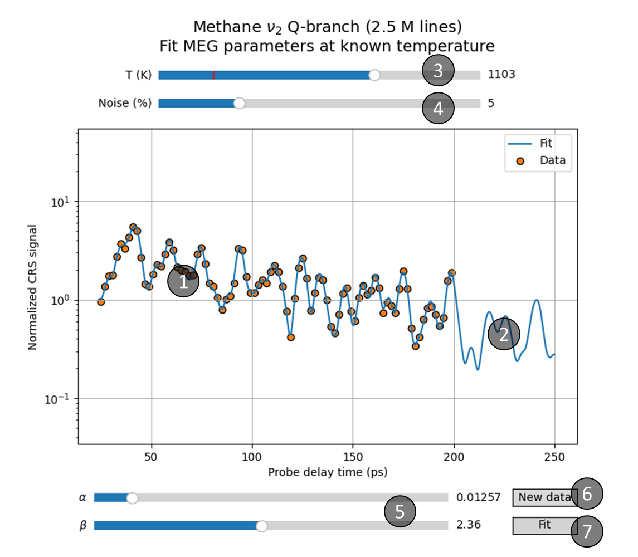
Fig. A3 | Time-domain widget. The (synthetic) target spectrum, simulating the experimental data acquired in a fs/ps CRS experiment is represented by orange circle markers. The widget fits these data on-the-fly to estimate the best fitting temperature, and the best-fitting spectrum is shown as a solid blue line. Noise can be introduced in the simulated experimental data by adjusting the Noise slider. The user can recompute the “fit” spectrum by activating the temperature and probe delay sliders and rescale it by using the scale slider. A new synthetic dataset can be generated by clicking the New data button and fitted on-the-fly by clicking the Fit button.
The widget provides the following features:
- The target trace.
Labelled as “data” in the legend, this temporal trace corresponds to the value of a synthetic integrated Q-branch spectrum (amounting to 2.5 M lines) computed over 87 values of τ in the range 20-200 ps. The probe delay scan is here simulated for the input temperature value (in the range 296-1500 K), and for randomly-selected values of the MEG parameters α and β. Noise can be added to the data by increasing the Noise slider to a non-zero value.
- The best-fit trace.
Labelled as “fit” in the legend, this temporal trace is calculated on-the-fly employing the ufa-cpp-t algorithm, and provides the fitted values of α and β.
- Temperature slider.
This slider allows the user to change the temperature of the data trace in the range 296-1500 K, the new value is shown on the right-hand side of the slider. When sliding, the fit trace is recomputed live for the new value of T and the current values of α and β. When the slider is released, a new data trace is computed at current values for T, α and β.
- Noise slider.
This slider allows the user to set the amount of noise that is added to the synthetic data. The set value determines the standard deviation of the Gaussian distribution from which the noise is sampled. It is expressed as a percentage of the local value of the data, reflecting the fact that during a probe delay scan the dynamic range of the digitizer (camera) can be readjusted at each probe delay.
- MEG parameter sliders
These two sliders allow the user to change two main parameters of the MEG scaling law that models the collisional dephasing of the Raman coherence. α can be varied in the range 0.002-0.1, β in the range 0-5, and the new value is shown on the right-hand side of the respective slider. The remaining MEG parameters are fixed at a = 2, δ = 1, and n = 0.
- New data.
This button allows the user to generate a new data trace at the current temperatures, and for new randomly-selected values of the MEG parameters α and β. The selected values for α and β are indicated by the red lines on their respective sliders.
- Fit.
This button allows the user to automatically fit the data trace to evaluate the corresponding MEG parameters. When clicked, the best-fitting trace is also updated.

Pseudo-code of ultrafast algorithm
The pseudo-code of the ultrafast algorithm described in this paper is detailed below:

def generate_axes(w_min, dw, N_w):
w_arr = [w_min + k*dw for k in range(N_w)]
dt = 2*pi/(N_w*dw)
t_arr = [(k*dt if k<(N_w+1)/2 else (k-N_w)*dt) for k in range(N_w)]
return w_arr, t_arr

def calc_Gamma(p, T, params):
< calculate Gamma_i according to Eq 17a..c >
return [Gamma_i for i in range(J_min, J_max)]

def calc_matrix(T, tau, Gamma_arr, w_min, dw, N_w, G_min, dG, N_G):
< calculate W_kl according to Eq 6b & Eq 8 >
return W_kl

def calc_transform(tau, w_min, N_w, G_min, dG, N_G, W_kl):
< calculate chi_t according to Eq 7 (integral only) >
return [chi_t[k] for k in range(N_w)]

def calc_chi(T, tau, w_min, N_w, t_arr, Gamma_arr, domain):
t_offset = (0.0 if domain > 0 else tau)
chi_arr = [0 for k in range(N_w)]
for wi, Gi, Wi in database:
chi_arr += [exp((1j*wi – Gi)*(t_arr[k] + t_offset)) for k in range(N_w)]
return chi_arr

def chi2Iw(chi_arr, E_probe, N_w, tau, dw, t_arr):
E_CRS = [(0.0 if t_arr[k] < -tau else chi_arr[k] * E_probe[k] for k in range(N_w)]
E_CRS_FT = fft(E_CRS)
I_CRS = [sqr(abs(E_CRS_FT[k])) for k in range(N_w)]
return I_CRS

def chi2It(chi_arr, E_probe, N_w, tau, dw, t_arr):
chi2_arr = [(0.0 if t_arr[k] < 0.0 else sqr(abs(chi_vec[k]))) for k in range(N_w)]
Epr2_arr = [sqr(E_probe[k]) for k in range (N_w)]
chi2_FT_arr = rfft(chi2_arr)
Epr2_FT_arr = rfft(Epr2_arr)
I_PDS_FT = [chi2_FT_arr[k] * Epr2_FT_arr[k] * N_t * dw for k in range(N_w)]
I_PDS = irfft(I_PDS_FT)
Return I_PDS

def calc_spectrum():
w_arr, t_arr = generate_axes(w_min, dw, N_w)
Gamma_arr, G_min, G_max = calc_Gamma(p, T, params)

If algo==0: # ultrafast
dG = (G_max * (1.0 + eps) – G_min) / (N_G – 1)
W_kl = calc_matrix(T, tau, Gamma_arr, w_min, dw, N_w, G_min, dG, N_G)
chi_arr = calc_transform(tau, w_min, N_w, G_min, dG, N_G, W_kl, domain)
else: # reference
chi_arr = calc_chi(T, tau, w_min, N_w, t_arr, Gamma_arr, domain)
if domain == 0: # return w-domain spectrum
x_arr = w_arr
I_arr = chi2Iw(chi_arr, E_probe, N_w, tau, dw, t_arr)
elif domain==1: # return t-domain spectrum
x_arr = t_arr
I_arr = chi2It(chi_arr, E_probe, N_w, tau, dw, t_arr)
else: # return chi without processing
x_arr = t_arr
I_arr[:N_t//2] = chi_arr.real
I_arr[N_t//2:] = chi_arr.imag

return I_arr

References
- Awa Ba, Y. et al. MeCaSDa and ECaSDa: Methane and ethene calculated spectroscopic databases for the virtual atomic and molecular data centre. J. Quant. Spectrosc. Radiat. Transf. 130, 62–68 (2013).
- Mazza, F. et al. The ro-vibrational ν₂ mode spectrum of methane investigated by ultrabroadband coherent Raman spectroscopy. J. Chem. Phys. 158, 094201 (2023).

