Supporting Information for
Cross-disciplinary Reactor-to-Repository Framework for Evaluating Spent Nuclear Fuel from Advanced Reactors
Haruko M. Wainwright^{1,2}, Chloe Christiaen³, Milos Atz⁴, John Sebastian Tchakerian¹, Jiankai Yu¹, Gavin Keith Ridley¹, Koroush Shirvan¹
¹Department of Civil and Environmental Engineering, Massachusetts Institute of Technology
²Department of Nuclear Science and Engineering, Massachusetts Institute of Technology
³École Polytechnique
⁴Ultra Safe Nuclear Corporation
* Haruko M. Wainwright
Email: hmwainw@mit.edu

This PDF file includes:

Supporting text
Figures S1 to S5
Tables S1 to S4
SI References

Text S1. Reactor Designs
Light Water Reactors (Reference PWR and Micro-PWR):
UO₂-fueled SMRs/MMRs are based on reliable and available technologies as well as established supply chains. They are therefore expected to be deployed sooner than the other concepts (NuScale, 2020)
For the reference large LWR reactor and micro-PWR (MPWR), a single pin-cell was modelled and used to obtain SNF characteristics. The PWR pincell was directly adapted from the PWR pincell model available on the OpenMC tutorial. The parameters used are summarized in Table S1. The simulation was performed the height of a single fuel pitch, 1.26 cm, with periodic axial boundaries conditions to represent an infinitely tall core. The layout of the pin-cell is presented in Figure S1.
High Temperature Gas Cooled Reactor with TRISO and FCM fuel:
This study considers a generic HTGR design as a SMR/MMR based on the HALEU TRISO fuel, helium coolant, and graphite moderator. TRISO fuel particles are composed of a central kernel of uranium oxycarbide (UCO), which is surrounded by layers of porous carbon, pyrolytic carbon (PyC) and silicon carbide (SiC; Van den Akker and Ahn, 2013). In this study, we assume that the particles are embedded into a graphite matrix, and scattered randomly in fuel channels. Prismatic graphite blocks are then composed of fuel and coolant channels. The higher temperatures (700°C to 1000°C) lead to higher thermal-to-electricity efficiency. HTGR is known to have enhanced safety due to the low density of fissile material in the TRISO fuels, as well as the high temperature durability and heat-transfer properties of graphite (Atz, 2019).
The HTGR microreactor design was developed based on a scaling of the General Atomics’ 350 MWth prismatic Modular HTGR (MHTGR) (General Atomics, 2012). A 3D homogeneous model of this core obtained from Kristina (2023) was scaled down and adapted to a microreactor design. In this design, the fuel pellets, which contains randomly dispersed TRISO particles embedded in a graphite matrix were homogenized while preserving the material volume, with the aim to reduce the computational time for time-dependent depletion calculation. We selected the homogeneous configuration with one region for TRISO fuel and layers and 2 graphite matrix regions, which was used in Kristina (2023).
In the microreactor design, several simplifications were made compared to the original model. The design of the core consists of an array of hexagonal fuel elements in a cylindrical arrangement, surrounded by a 40cm thick ring of reflector material (graphite) and the reactor vessel. The active core consists in a 3 rows annulus of prismatic fuel graphite blocks, contained within a 140 cm-diameter disk. The prismatic fuel block is made of a regular triangular array of 2 fuel holes, containing TRISO particles embedded in a graphite matrix, per one coolant hole filled with helium. The main specifications of the HTGR core are presented in Table S2. The simulations were performed on a 2D model. Reflective boundary axial conditions were set to represent an infinitely tall core.
Another HTGR design, using Fully Ceramic Microencapsulated (FCM) fuel, is considered in the study. The FCM fuel contains TRISO particles encased into a silicon carbide matrix (Duchnowski, 2022). This fuel has an advantage over the UCO-based TRISO because it may enhance safety during operating and accident conditions, with an increasing retention of fission products within the SiC matrix (USNC, 2021). In our study, we also assume that the fuel kernel material is replaced by uranium nitride (UN). Indeed, the SiC matrix results in a hardened neutron flux spectrum and requires a higher density fuel kernels such as UN (Lu, 2017).
The model described above was modified to be relevant with the HTGR using FCM fuel (called FCM-HTGR in our study). The active core diameter was increased to 220cm. The packing fraction, which corresponds to the mass of the TRISO particles divided by the mass of the fuel compact (mass of the matrix and mass of the particles), is increased to 0.60. The differences between the designs are summarized in Table S2. The core designs of the HTGR and FCM-HTGR models are presented respectively in Figure S2 and S3.
Heat Pipe Reactor
Our HPR design is similar to that of HTGR with the HALEU TRISO fuel, with a power output ranging from 200 kW to 5 MW. The heat pipes are filled with liquid sodium to transport heat from the core to the heat exchanger. Heat pipes optimizes energy transfers and substitute the reactors coolant pumps and other auxiliary systems (Testoni, 2021).
The HPR model was based on the HTGR reactor model described above, with a similar 70 cm radius active core (Figure S4). Several adaptations were made to obtain a model for HPR: (a) heat pipes were modelled by surrounding the coolant channels with a 0.4 mm thick FeCrAl pipe (73wt% Fe, 20wt% Cr, 5wt% Al, 2wt% Mo), (b) the helium coolant was replaced by a sodium coolant with 50% void density, and (c) U235 enrichment was increased to 19.75% to compensate for the heat pipes absorption. A burnup of 80 MWd/kgHM and an efficiency of 33% were considered for this microreactor.
Sodium Fast Reactor
Sodium cooled fast reactors (SFR) use liquid sodium as coolant, allowing higher operating temperature and increased thermal efficiency. Historically, SFRs have been considered in a closed fuel cycle with uranium and actinides recovery, as well as with partitioning and transmutation. However, we assume a once-through fuel cycle in this study for the comparison purposes. Their fuel is typically metallic Zr-alloy with stainless steel cladding and metallic fuel (Atz, 2019).
The SFR microreactor model was developed based on a scaling down of the 250 MWth Advanced Burner Test Reactor (Kim, 2020). The size, the components and the composition of the core are similar to the core design of the Toshiba-4S microreactor (Ueda et al., 2005).
The design of the core consists in an array of hexagonal elements in a prismatic arrangement (Figure S5). The 2 central prismatic rings are composed of fuel elements and are surrounded by 2 rings of hexagonal reflector elements and one ring of shield element. The outer most layer is the reactor pressure vessel. The fuel elements are composed of fuel pin cell disposed in a prismatic array and surrounded with sodium coolant. The fuel is a zirconium metal fuel U20Pu10Zr with a high enrichment in plutonium to increase the discharge burnup and to extend the reactor lifetime. The fuel is surrounded by a HT-9 cladding. Several simplifications were made compared to ABTR design: the active core is composed of one batch of fuel material and the control systems were removed from the core. In our 2D model, reflective axial boundary conditions were applied to be consistent with an infinitely tall core. The parameters of the SFR model are summarized in Table S3.

SI References
D.O.E. (2012). Repository Reference Disposal Concepts and Thermal Load Management Analysis. FCRD-UFD-2012-000219 Rev.2.
Duchnowski, E. M., Kile, R. F., Bott, K., Snead, L. L., Trelewicz, J. R., & Brown, N. R. (2022). Pre-conceptual high temperature gas-cooled microreactor design utilizing two-phase composite moderators. Part I: Microreactor design and reactor performance. Progress in Nuclear Energy, 149, 104257.
General Atomics. (2012). Prismatic Coupled Neutronics/thermal fluids benchmark of the MHTGR-350 MW core design.
Kim, T. (2020). Benchmark Specification of Advanced Burner Test Reactor. ANL/NSE-20/65.
Kristina. (2023). Neutronic Analysis of Horizontal -Compact High Temperature Gas-cooled Reactor. Massachussets Institute of Technology: Master of Science Thesis.
Lu, C., Hiscox, B. D., Terrani, K. A., & Brown, N. R. (2018). Fully ceramic microencapsulated fuel in prismatic high temperature gas-cooled reactors: analysis of reactor performance and safety characteristics. Annals of Nuclear Energy, 114, 277-287.
NuScale Power, L. (2020). NuScale Standard Plat Design Certification Application, Tier-2, Chapter 4- Reactor.
Romano, P. K., & Forget, B. (2013). The OpenMC monte carlo particle transport code. Annals of Nuclear Energy, 51, 274-281.
Romano, P. K., Horelik, N. E., Herman, B. R., Nelson, A. G., Forget, B., & Smith, K. (2015). OpenMC: A state-of-the-art Monte Carlo code for research and development. Annals of Nuclear Energy, 82, 90-97.
Shirvan, K., Buongiorno, J., MacDonald, R., Dunkin, B., Cetiner, S., Saito, E., ... & Forsberg, C. (2023). UO2-fueled microreactors: Near-term solutions to emerging markets. Nuclear Engineering and Design, 412, 112470.
Testoni, R., Bersano, A., & Segantin, S. (2021). Review of nuclear microreactors: Status, potentialities and challenges. Progress in Nuclear Energy, 138, 103822.
USNC, U. S. (2021). MMR, Ultra Safe Nuclear Corporation. Retrieved from Ultra Safe Nuclear Corporation: https://www.usnc.com
Ueda, N., Kinoshita, I., Minato, A., Kasai, S., Yokoyama, T., & Maruyama, S. (2005). Sodium cooled small fast long-life reactor “4S”. Progress in Nuclear Energy, 47(1-4), 222-230.
Westinghouse. (2011). AP1000 Design Control Document Rev.19- Tier 2 - Chapter 4-Reactor.

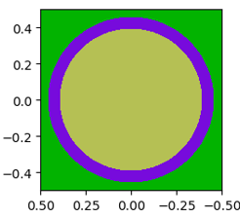
Fig. S1. PWR Pincell Model on OpenMC. The light green region is the UO2 fuel, the purple region is the zircaloy cladding, and the green outer region is the borated water.

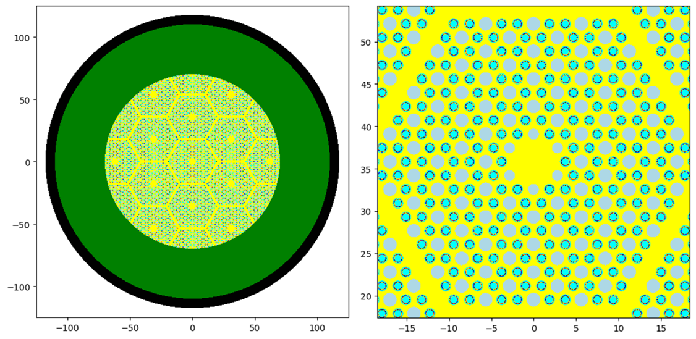
Fig. S2. 2D view of OpenMC Model for HTGR microreactor. On the left, a view of the full core model is presented. On the right, a zoom is made on a prismatic fuel block. Dark: Vessel, Green: Graphite reflector, Yellow: Graphite, Light blue: coolant hole, Cyan: Graphite matrix, Purple: Homogeneous TRISO
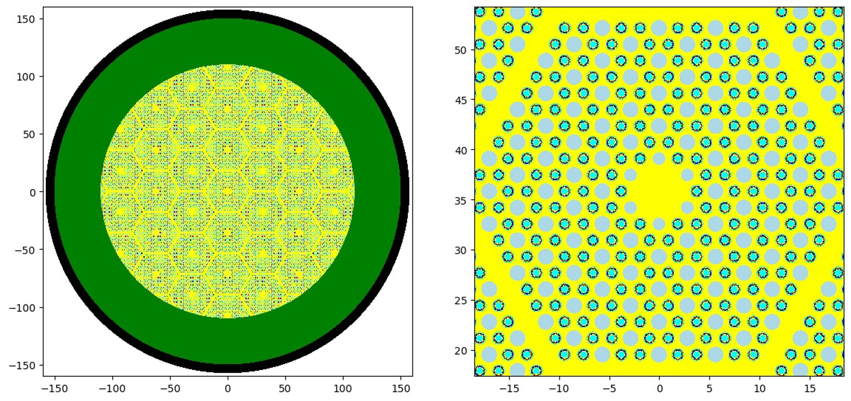
Fig. S3. 2D view of OpenMC Model for the FCM-HTGR. On the left, a view of the full core model is presented. On the right, a zoom is made on a prismatic fuel block. Dark: Vessel, Green: Graphite reflector, Yellow: Graphite, Light blue: coolant hole, Cyan: SiC matrix, Purple: Homogeneous TRISO.

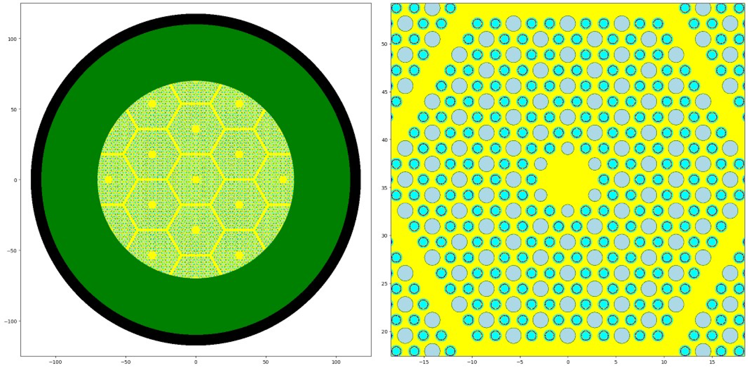
Fig. S4. 2D view of OpenMC Model for Heat-Pipe microreactor. On the left, a view of the full core model is presented. On the right, a zoom is made on a prismatic fuel block. Dark: Vessel, Green: Graphite reflector, Yellow: Graphite, Light blue: Coolant hole with sodium, Cyan: Graphite matrix, Purple: Homogeneous TRISO, Brown: Coolant Pipe.

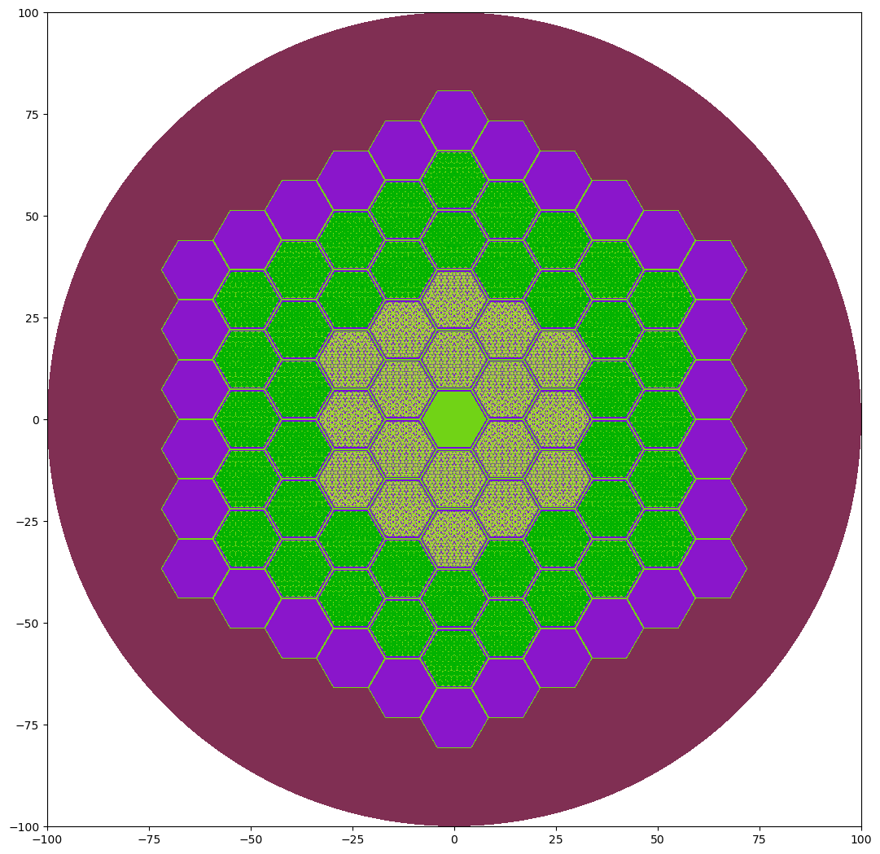
Fig. S5. SFR core model designed on OpenMC. From the inner most to the outer most ring, the components are: Empty cell filled with coolant, fuel assembly, reflector, shield, vessel.

Table S1: Reference PWR and PWR microreactor input parameters and geometry on OpenMC.
Parameters | Reference PWR (Westinghouse, 2011) | Small PWR  (Shilvan et al., 2023) | Unit
U-235 Enrichment | 4.5 | 4.5 | %
UO2 Fuel density | 10.5 | 10.5 | g/cm3
Linear power | 190 | 130 | W/cm
Fuel outer radius | 0.40947 | 0.40947 | cm
Cladding outer radius | 0.45720 | 0.45720 | cm
Cladding material | Zircaloy | Zircaloy
Coolant material | Borated water | Borated water
Burnup | 50 | 15 | MWd/kgHM
Efficiency | 33 | 33 | %

Table S2: HTGR and FCM-HTGR reference configuration and parameters.
Parameter | HTGR (Shilvan et al., 2023) | FCM-HTGR | Unit
Burnup | 80 | 80 | MWd/kgHM
Efficiency | 40 | 33 | %
Power density | 5 | 1.25 | kW/L
Linear power | 77.0 | 47.5 | kW/cm
Number of fuel blocks | 18 | 26
Number of fuel holes per fuel blocks | 216 | 216
Coolant holes per fuel blocks | 108 | 108
Active core diameter | 140 | 220 | Cm
Fissile material | UC_{0.5}O_{1.5} | UN
U235 initial enrichment | 15.5 | 19.75 | wt%
TRISO coating layers materials | Kernel/Buffer/  iPyC/SiC/oPyC | Kernel/Buffer/ iPyC/SiC/oPyC
Homogeneous TRISO coating layers radius | 212.5/312.5/347.5/382.5/422.5 | 364.3/535.7/ 595.7/ 655.7/ 724.3 | µm
TRISO coating layer densities | 10.5/1.0/1.9/3.2/1.9 | 14.3/1.0/1.9/3.2/1.9 | g/cm3
TRISO packing fraction | 0.35 | 0.6
Fuel compact radius/with gap | 0.6225/0.635 | 0.6225/0.635 | cm
Fuel compact matrix (density) | Graphite (1.7) | SiC (3.2) | g/cm3
Primary coolant | Helium | Helium
Coolant hole radius | 0.795 | 0.795 | cm
Holes pitch | 1.8796 | 1.8796 | cm
Fuel block edge length | 20.6756 | 20.6756 | cm
Reflector thickness | 40.0 | 40.0 | cm
Fuel temperature | 900 | 900 | K
Coolant temperature | 600 | 600 | K
Operating pressure | 6.39 | 3.00 | MPa
Table S3: Main specifications of SFR core model
Parameter | SFR microreactor | Unit
Burnup | 120 | MWd/kgHM
Efficiency | 40 | %
Power density | 68.8 | kW/l
Linear power | 250 | kW/cm
Coolant | Sodium
Number of fuel assembly | 18
Assembly edge lengh | 14.6850 | cm
Number of pin-cell per assembly | 217
Fuel pin pitch | 0.9080 | cm
Fuel pin diameter | 0.8000 | Cm
Fissile material (density) | U20Pu10Zr (15.8) | g/cm3
Cladding material (density) | HT-9 (6.55) | g/cm3
Cladding thickness | 0.0520 | cm
Reflector material (density) | HT-9 (6.55) | g/cm3
Shield material (density) | HT-9 and B4C (4.14) | g/cm3
Fuel temperature | 855 | K
Coolant temperature | 700 | K
Operating pressure | 6.39 | MPa

Table S4: Spent fuel package dimensions and loading (DOE, 2012)
Reactor | Number of fuel elements (assemblies/ fuel blocks per canister | Dimensions (m)  (Diameter x  Length)  Thickness = 0.125m | Heavy metal mass (kg/assembly) | Total Heavy Metal (kg/canister)
PWR | 1  2  3  4  12  21 | 0.41 x 5.0  0.82 x 5.0  0.82 x 5.0  0.82 x 5.0  1.29 x 5.0  1.60 x 5.0 | 460 | 460  920  1380  1840  5520  9660
HTGR | 6  18  42  78  114 | 0.6725 x 4.8875  1.0548 x 4.8875  1.3141 x 4.8875  1.9818 x 4.8875  1.9818 x 4.8875 | 8.6 | 51.6  154.8  361.2  670.8  980.4
FCM-HTGR | 6  18  42  78  114 | 0.6725 x 4.8875  1.0548 x 4.8875  1.3141 x 4.8875  1.9818 x 4.8875  1.9818 x 4.8875 | 21.2 | 127.2  381.6  890.4  1654  2417
SFR | 1  3  7  19 | 0.46 x 5.0  0.66 x 5.0  0.77 x 5.0  1.11 x 5.0 | 97.7 | 97.7  293.1  683.9  1856.3

