Supplementary Information for

A facile approach for generating ordered oxygen vacancies in metal oxides

Authors: Kexin Chen^{1†*}, Xuanyi Yuan^{2†}, Zhaobo Tian^{3†}, Mingchu Zou^{3†}, Yifei Yuan⁴, Zhanglin Chen³, Qinghua Zhang⁵, YuYang Zhang⁵, Xin Jin⁵, Tianpin Wu⁶，Reza Shahbazian-Yassar⁴, Guanghua Liu^{3*}.
Affiliations:
¹State Key Laboratory for Advanced Metals and Materials, University of Science and Technology Beijing, Beijing, 100083, China.
²Beijing Key Laboratory of Opto-electronic Functional Materials & Micro-nano Devices, Department of Physics, Renmin University of China, Beijing, 100872, China.
³State Key Laboratory of New Ceramics and Fine Processing, Department of Materials Science and Engineering, Tsinghua University, Beijing, 100084, China.
⁴Department of Mechanical and Industrial Engineering, University of Illinois at Chicago, Chicago, IL 60607, USA.
⁵Beijing National Laboratory for Condensed Matter Physics, Institute of Physics, Chinese Academy of Sciences, Beijing, China.
⁶College of Chemical and Biological Engineering, Zhejiang University, Hangzhou, 310058, China.
*Corresponding author. E-mail: kxchen@ustb.edu.cn；liuguanghua@mail.tsinghua.edu.cn
†These authors contributed equally to this work.

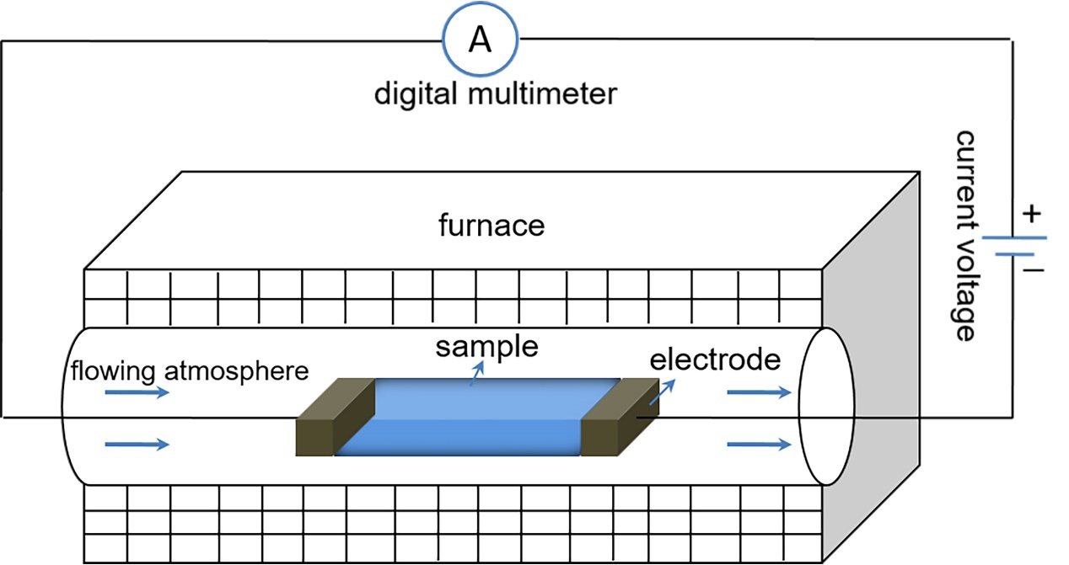

Supplementary Fig. 1.
Schematic representation of the experimental setup. The sample is heated in a tube furnace under a selected atmosphere, such as reducing or inert gas. Before putting in the furnace, the sample was first connected to two platinum, tungsten or graphite electrodes. A direct current power supply was used to apply the field, and a digital multimeter was connected in series with the electric circuit to measure the current passing through the sample.

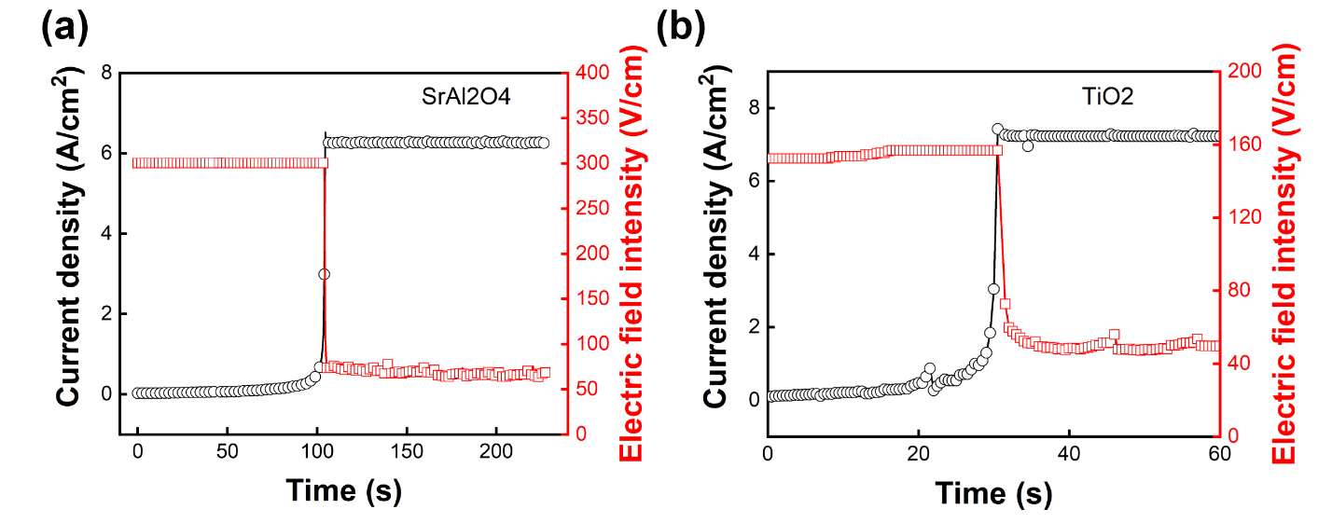

Supplementary Fig. 2.
Plots of current density and electric field intensity as a function of time for ET-treatment of (a) SrAl₂O₄ and (b) TiO₂ samples. The furnace temperature for SrAl₂O₄ was 1060℃, while that of TiO₂ was 700℃.
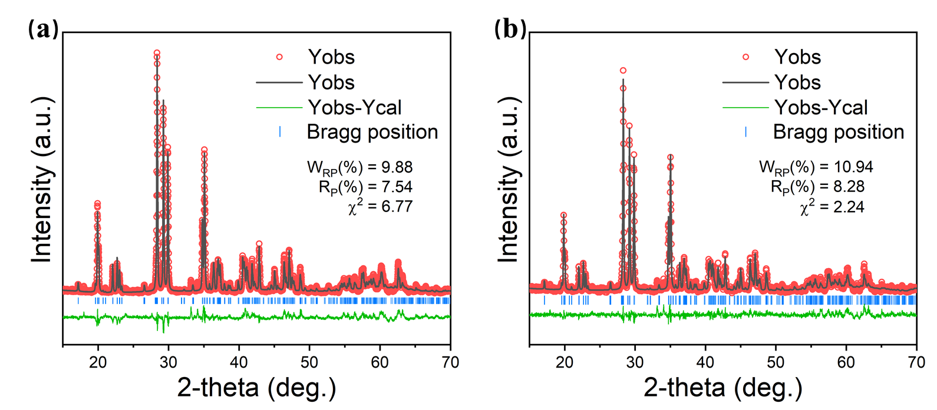
Supplementary Fig. 3.
Rietveld refinement of X-ray diffraction data collected for the sample (a) the reference sample and (b) ET-treated sample. All the peaks in the patterns can be indexed as SrAl₂O₄, matching well with PDF card no.34-0379. The samples belong to the monoclinic phase and the space group P1211. The reliability parameters are shown in the blank space. The calculated unit cell parameters are shown in Table S1. Careful comparison of the refined XRD data indicated that the lattice parameters of those sample did not change after ET treatment.

Supplementary Table 1. The refined unit cell parameters for different samples.
Sample | a(Å) | b(Å) | c(Å) | β(º) | V(Å³)
reference samples | 8.44095(1) | 8.81922(8) | 5.15689(1) | 93.39(3) | 383.22(0)
ET-treated | 8.43953(1) | 8.81722(1) | 5.15581(7) | 93.40(0) | 382.98(6)

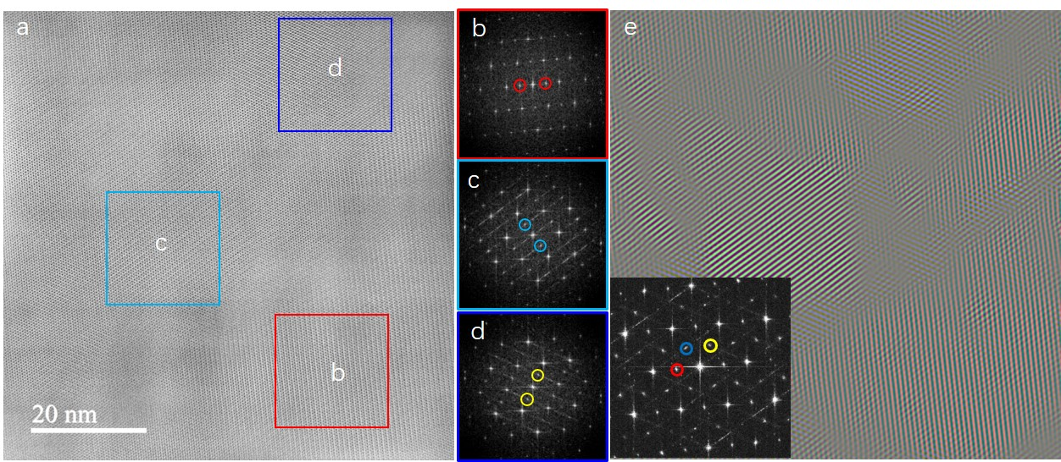
Supplementary Fig. 4.
The low-magnification angular bright-field image of ET-treated SrAl₂O₄ along the [100] projection. (b-d) are the corresponding FFT pattern from the regions as indicated in (a). Red, blue and yellow circles labelled the superstructure spots in each region. (e) is the composite graph by using the superstructure spots, where lattice fringes with different colors indicate regions with different superstructure orientations.

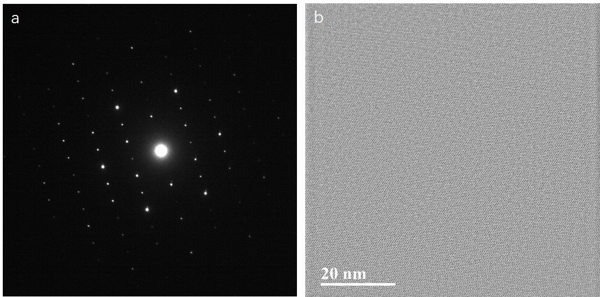
Supplementary Fig. 5.
The selected-area electron diffraction (a) and the low-magnification angular bright-field image (b) of reference SrAl₂O₄ along the [100] projection.

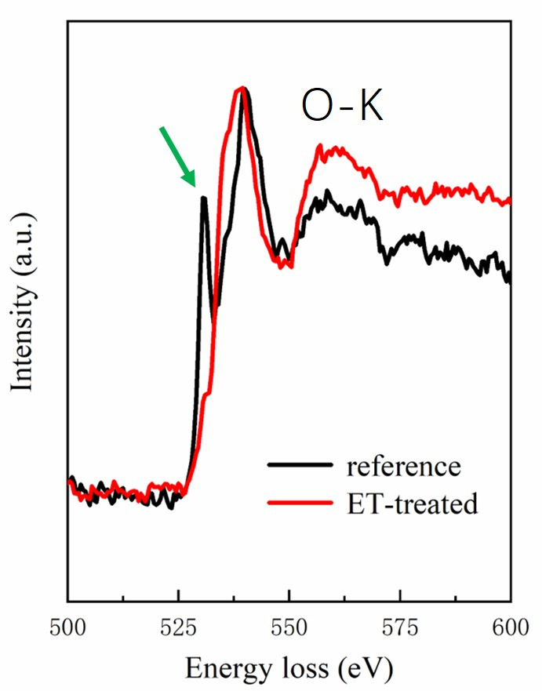
Supplementary Fig. 6.
Comparison of the EELS analyses of reference SrAl₂O₄ sample and ET-treated SrAl₂O₄ sample. The green arrow indicates the pre-peak of the oxygen K edge.

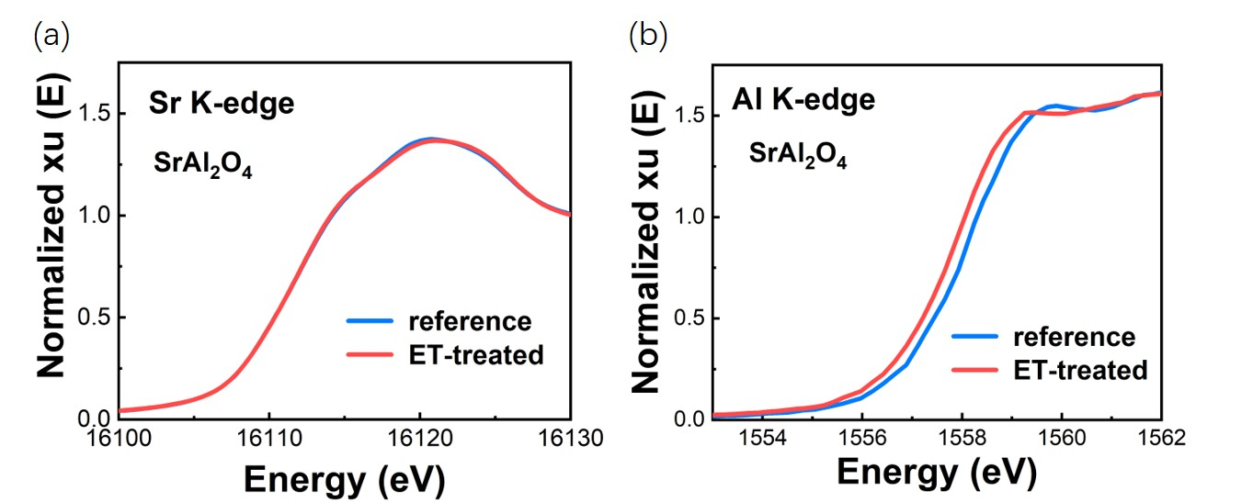
Supplementary Fig. 7.
Synchrotron XAS analyzing the Sr K-edge (a) and Al K-edge (b) in SrAl₂O₄.

Supplementary Fig. 8.
TGA analysis of ET-treated and reference SrAl₂O₄ sample in air and argon atmosphere respectively (Flow of 100 ml/min and a heating rate of 10 ℃/min). The concentration of oxygen vacancies was calculated from the difference in weight decreases between the two TGA curves.
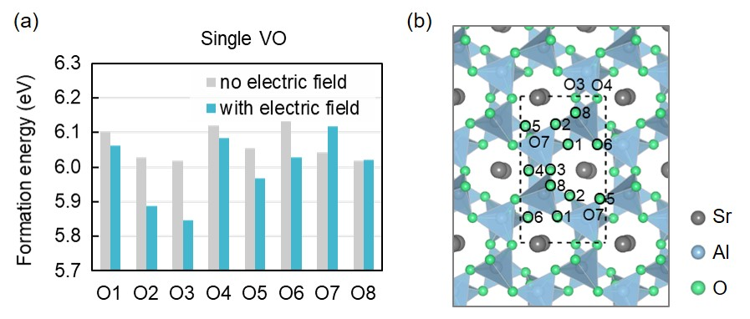
Supplementary Fig. 9.
Electric field effect on the formation of a single O vacancy (VO). (a) Formation energies of single VO at different O sites in bulk SrAl₂O₄ with and without electric field. (b) Atomic configurations of bulk SrAl₂O₄. The locations of different O sites are labeled.

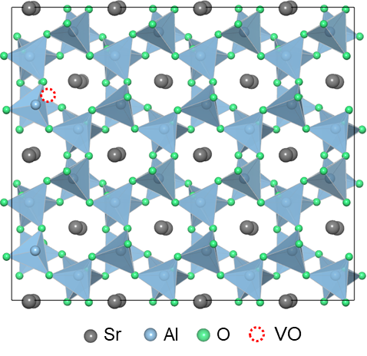
Supplementary Fig. 10.
Schematic of the atomic configurations of bulk SrAl₂O₄ with double O vacancies. The two O vacancies are located in one O column.

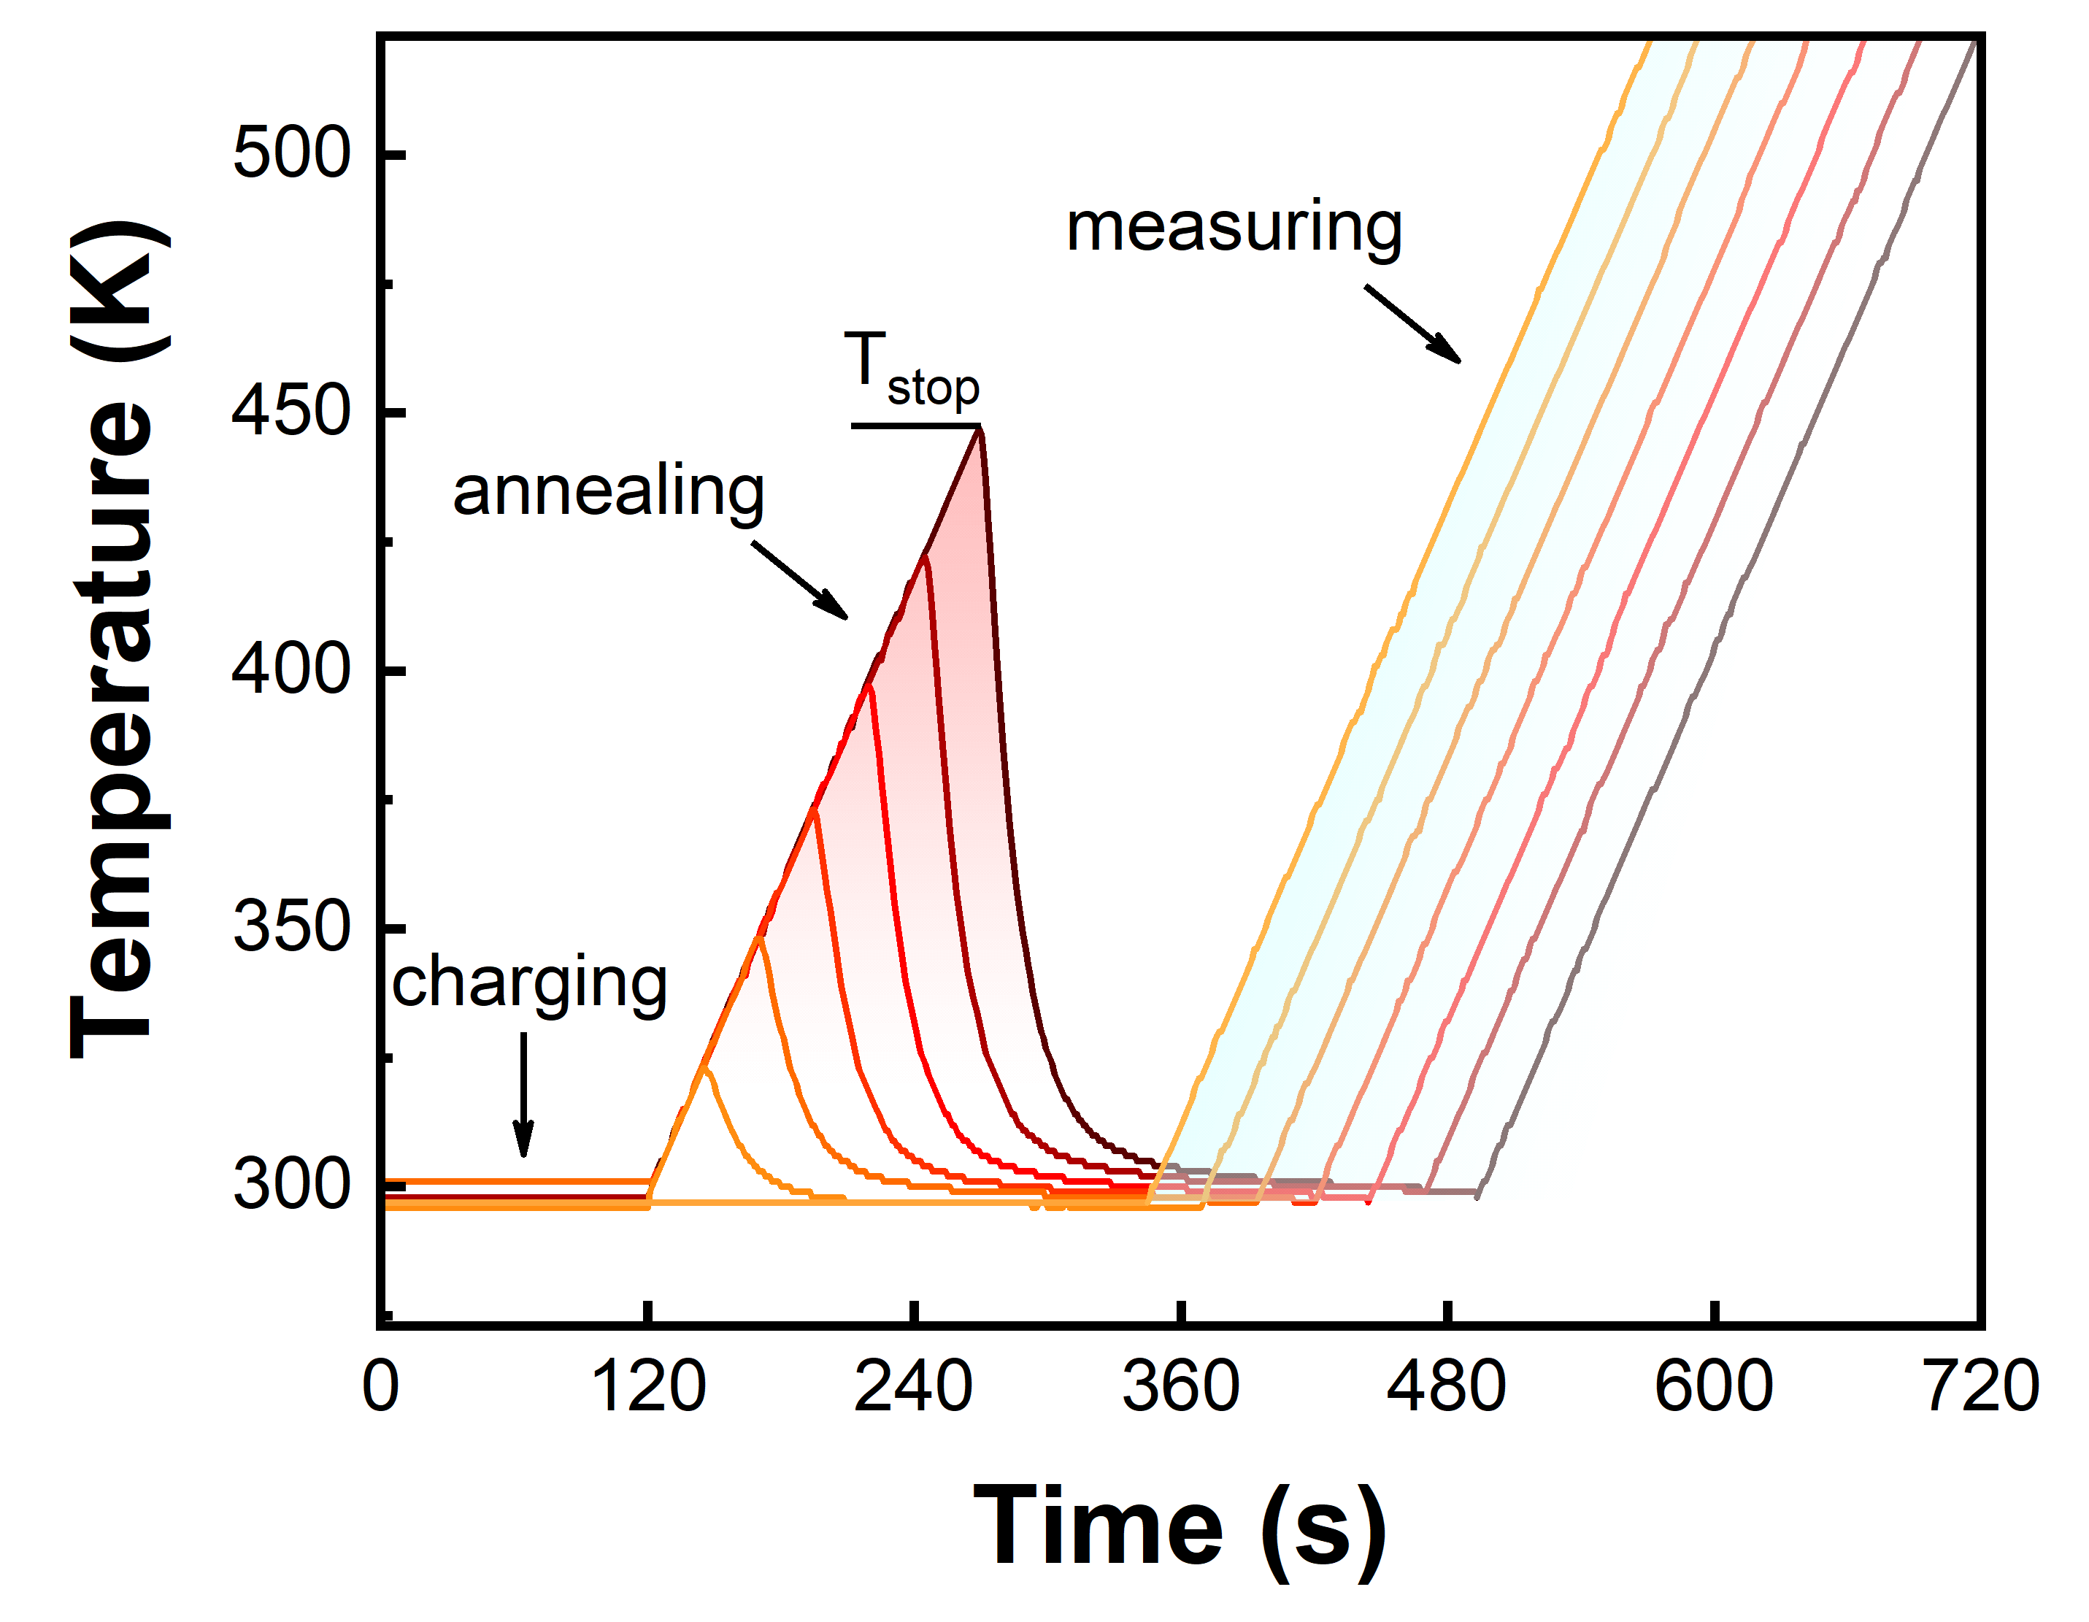
Supplementary Fig. 11.
Temperature procedure for the TL measurements according to McKeever’s Tm-Tstop method, in which the Tstop represents the set preheating temperature.

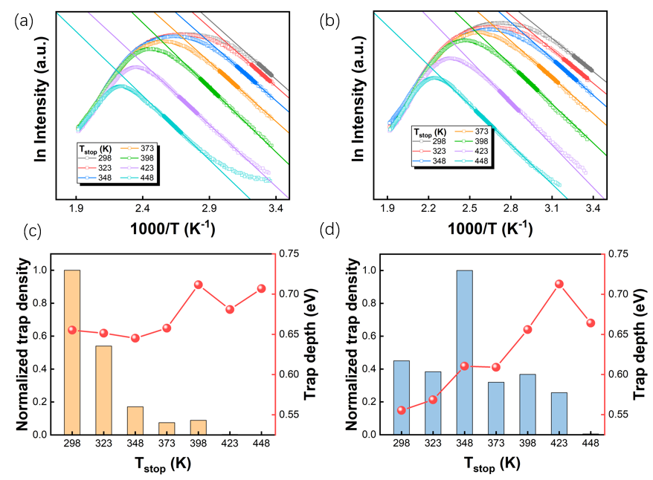
Supplementary Fig. 12.
Initial rise analysis (IRA) of TL spectra of (a) reference and (b) ET-treated samples. TL data in the range from 5% up to 15% of the maximum intensity in the initial part were used for linear fitting. The estimated trap depth and trap density distribution of (c) reference and (d) ET-treated samples at various Tstop.

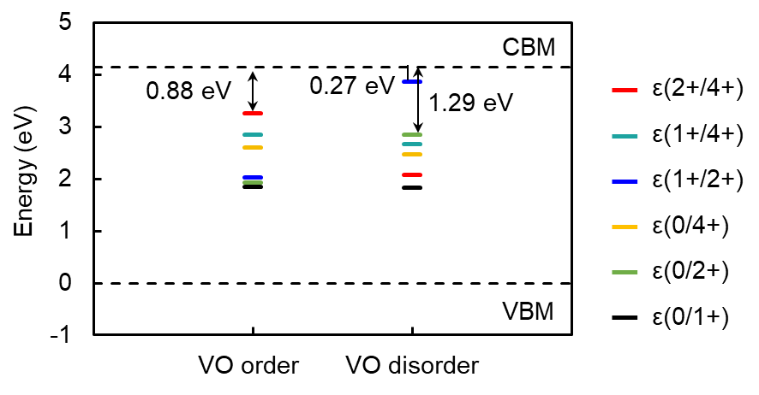
Supplementary Fig. 13.
Transition level in bulk SrAl₂O₄ with ordered and disordered VO. Compared to the ordered-VO structure, the transition levels distribution of the disordered-VO structure is deeper. To observe long afterglow at room temperature, the traps should have an appropriate depth somewhere between the two extremes trap depths (shallow traps, with a depth lower than around 0.4 eV; very deep traps, around 2 eV).

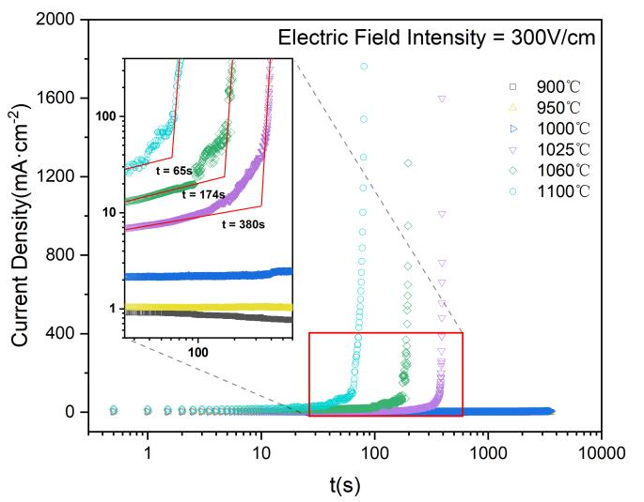
Supplementary Fig. 14.
The current-time curve of the sample treated by coupling the electric field with the thermal activation at different temperatures under a field of 300 V/cm.

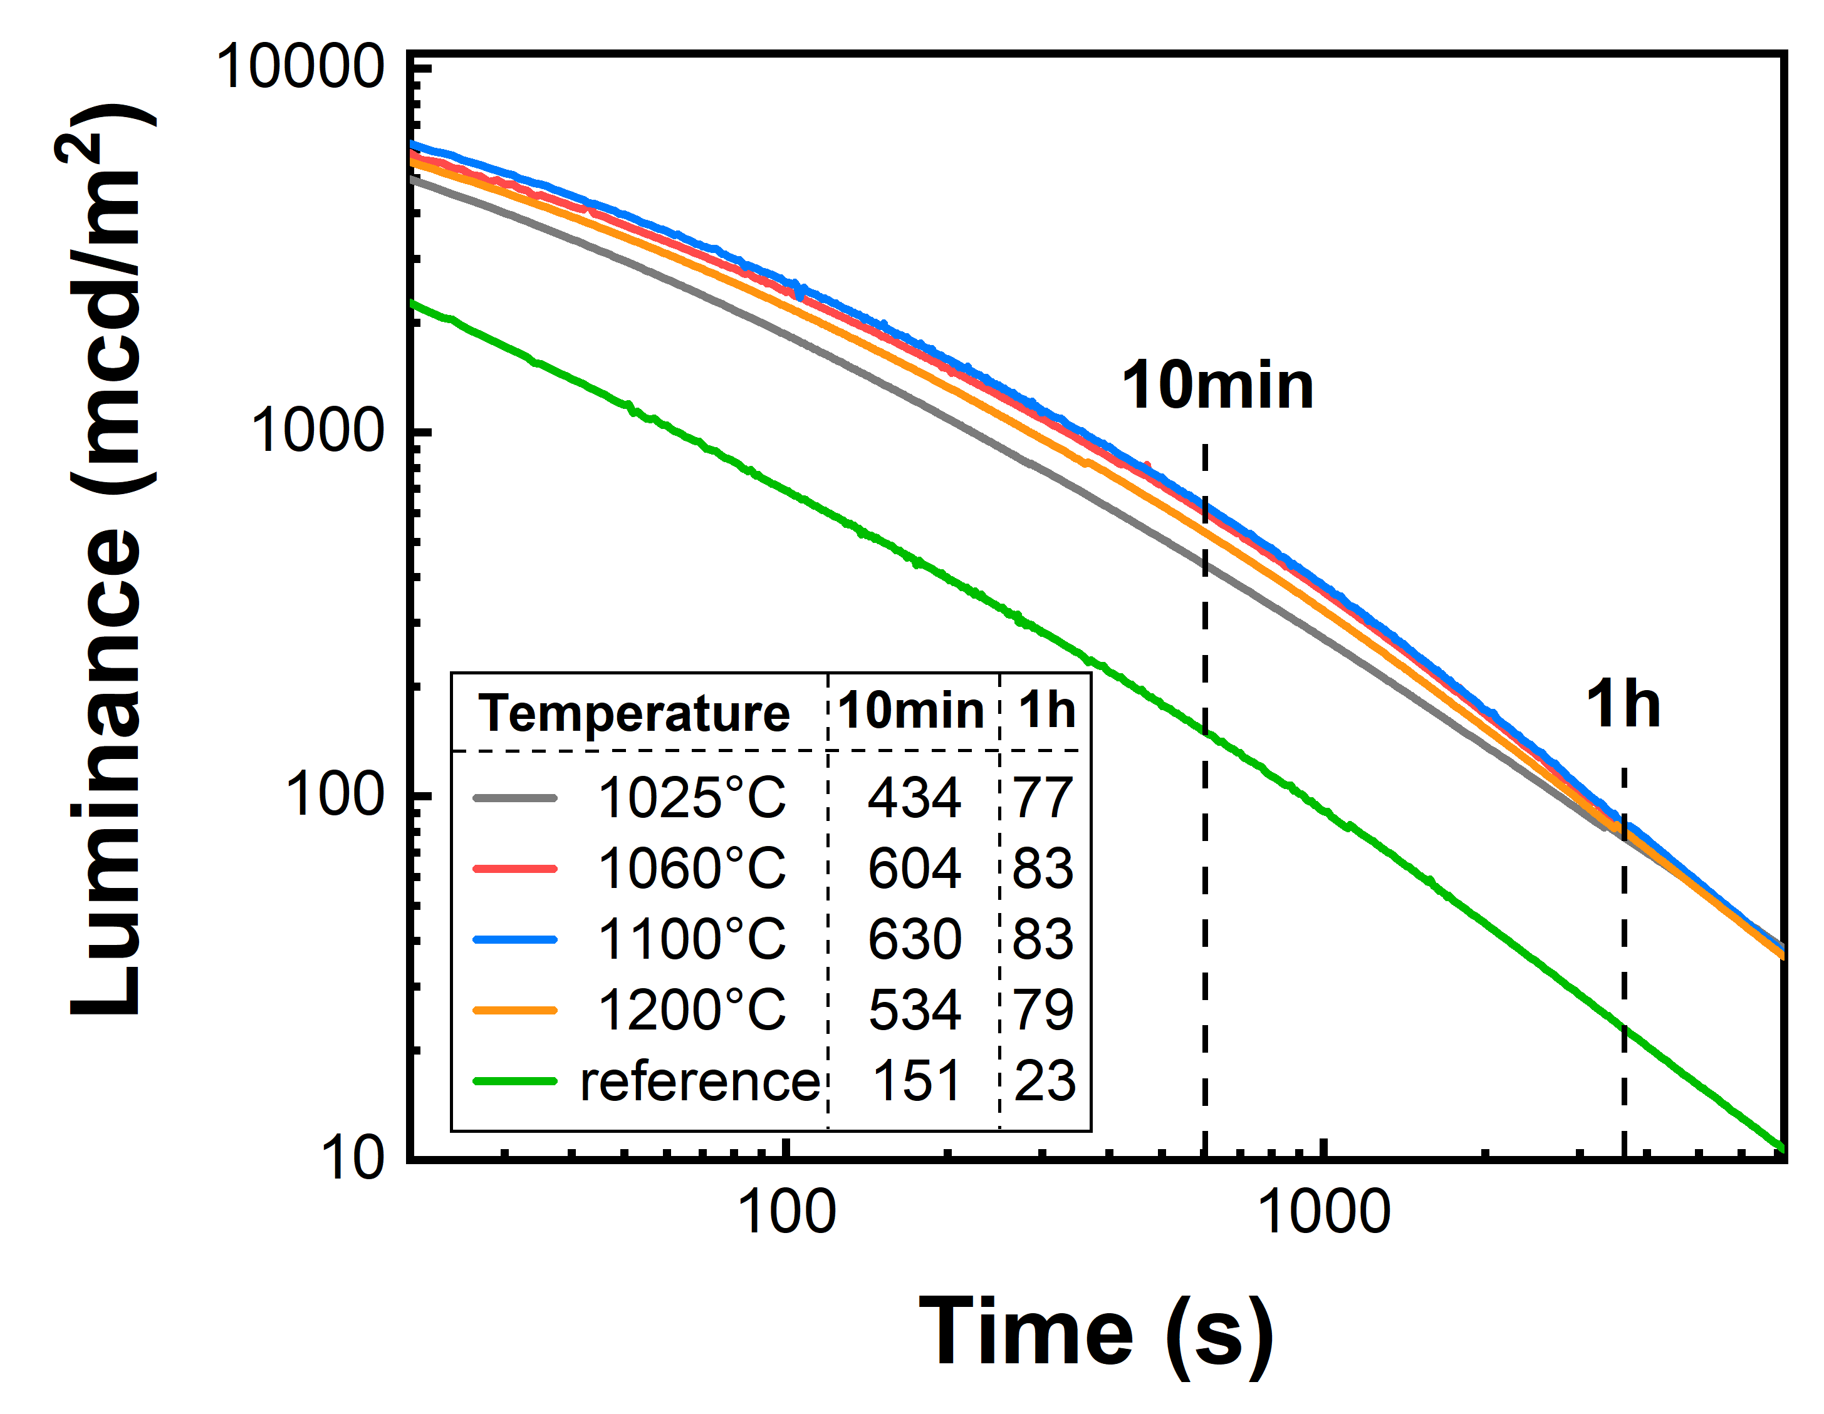
Supplementary Fig. 15.
Afterglow performance of the sample treated by coupling the electric field with the thermal activation at different temperatures under a field of 300 V/cm.

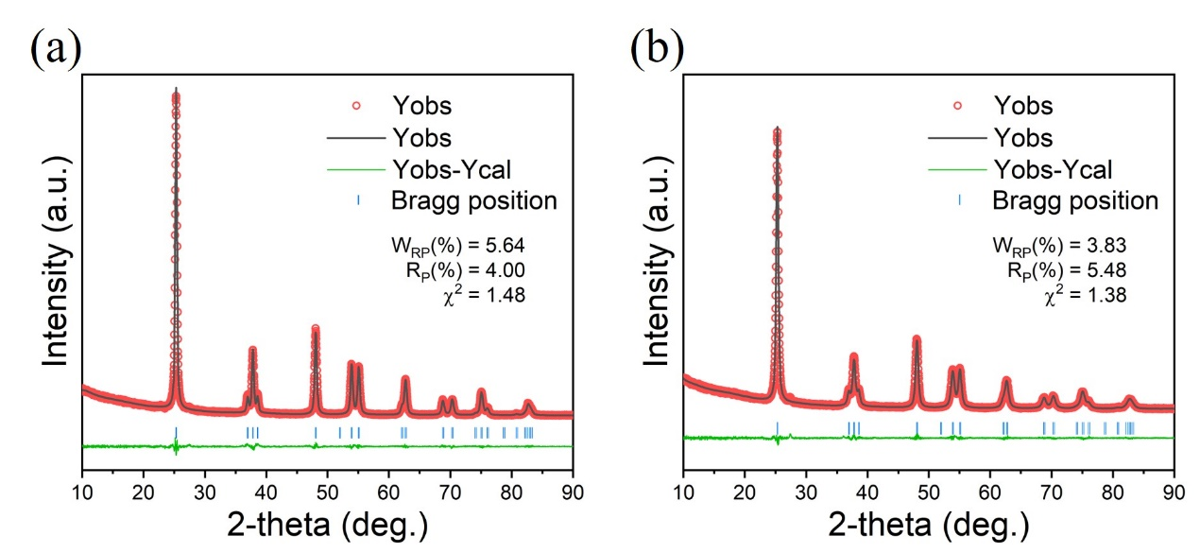
Supplementary Fig. 16.
Rietveld refinement of X-ray diffraction data collected for the sample (a) reference and (b) ET-treated sample. All the peaks in the patterns can be indexed as TiO₂, matching well with PDF card no.21-1272. The samples belong to the Tetragonal phase and the space group I41/amd (141). The reliability parameters are shown in the blank space. Careful comparison of the refined XRD data indicated that the lattice parameters of those sample did not change after ET treatment.

Supplementary Table 2. The refined unit cell parameters for TiO₂ samples.
Sample | a(Å) | b(Å) | c(Å) | V(Å³)
Annealed | 3.78550(5) | 3.78550(5) | 9.51229(4) | 136.31(2)
ET-treated | 3.78594(4) | 3.78594(4) | 9.51588(0) | 136.39(5)

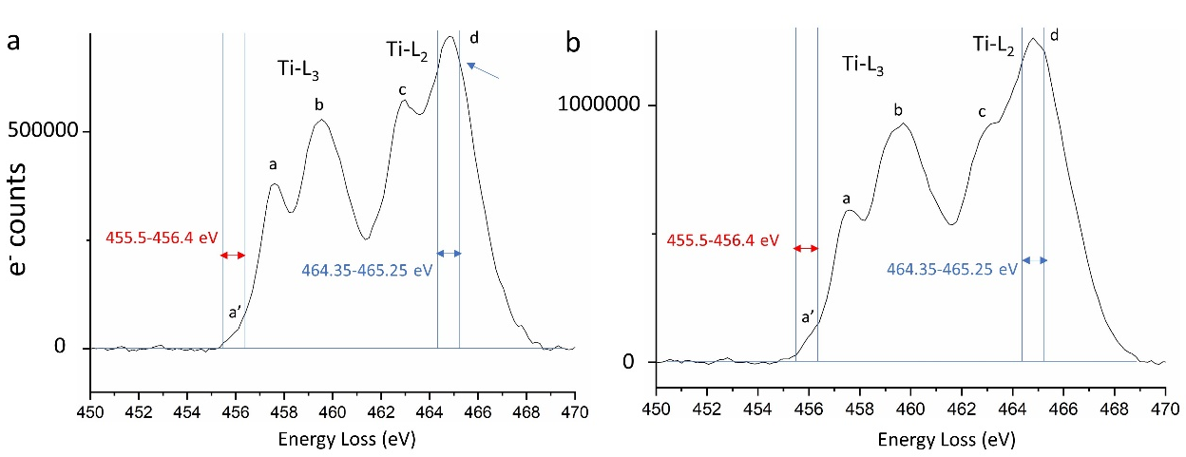
Supplementary Fig. 17.
The enlarged EELS of Ti-L edge for (a) annealed TiO₂ sample and (b) ET-treated TiO₂ sample.

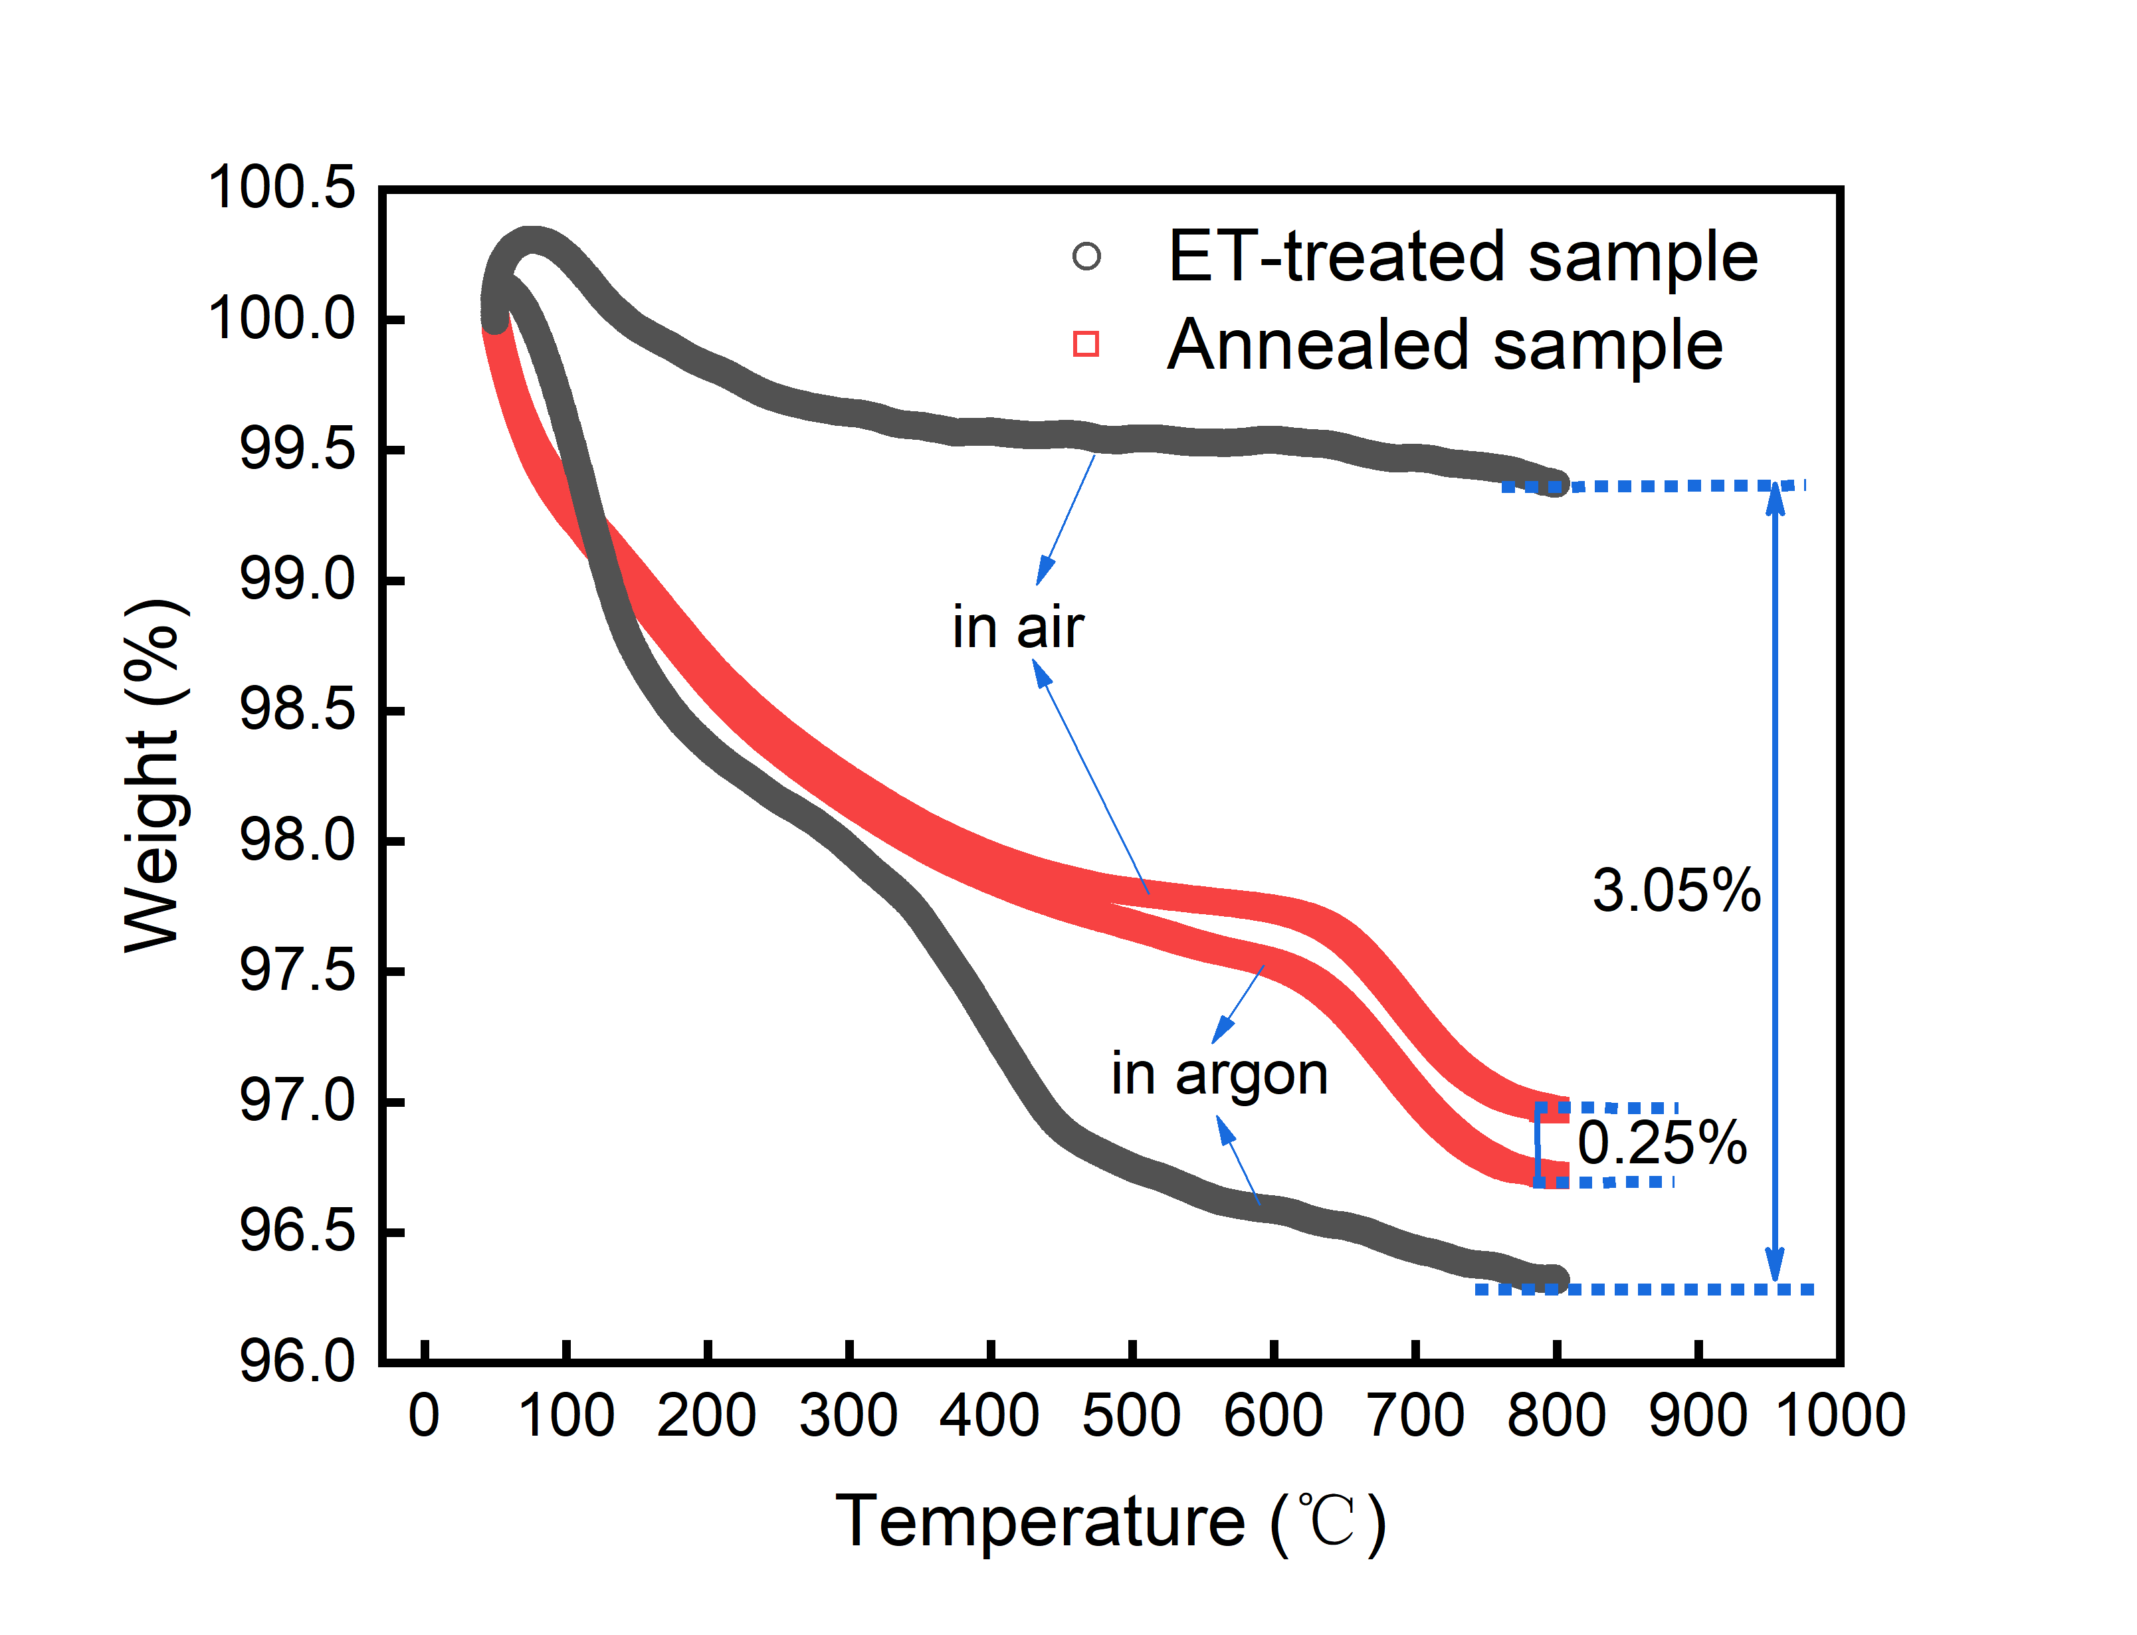

Supplementary Fig. 18.
TGA analysis of ET-treated and annealed TiO₂ sample in air and argon atmosphere (Flow of 100 ml/min and a heating rate of 10 ℃/min). The concentration of oxygen vacancies was calculated from the difference in weight decreases between the two TGA curves.

Supplementary Fig. 19.
(A) The absorption spectra of TiO₂ samples under different treatments (Inset images are the corresponding Photographs). (B) Electron paramagnetic resonance (EPR) spectroscopy performed at room temperature and without light irradiation for TiO₂ samples. (C) The high-resolution XPS spectra of Ti2p. (D) Synchrotron X-ray absorption spectroscopy (XAS) analyzing the O K-edge in TiO₂.

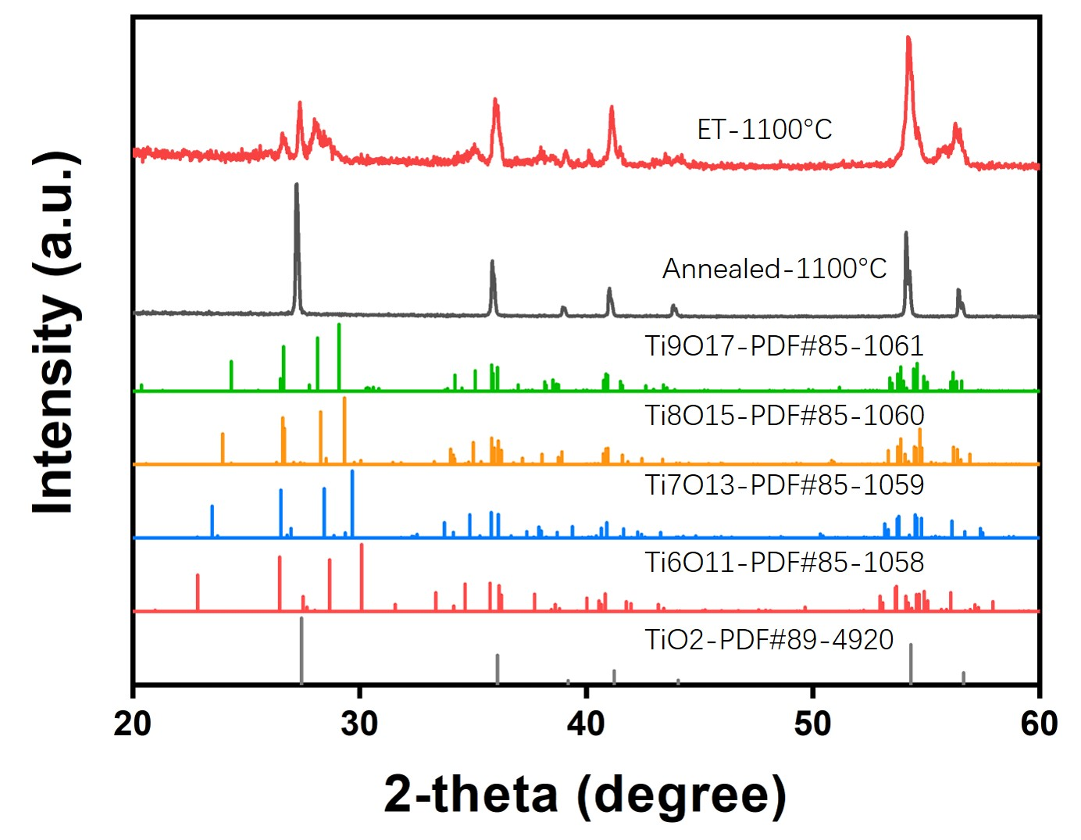
Supplementary Fig. 20.
Comparison of the X-ray diffraction of the ET-treated TiO₂ and annealed TiO₂ sample. A series of possible Magne´li phases were given at the bottom of the figure.

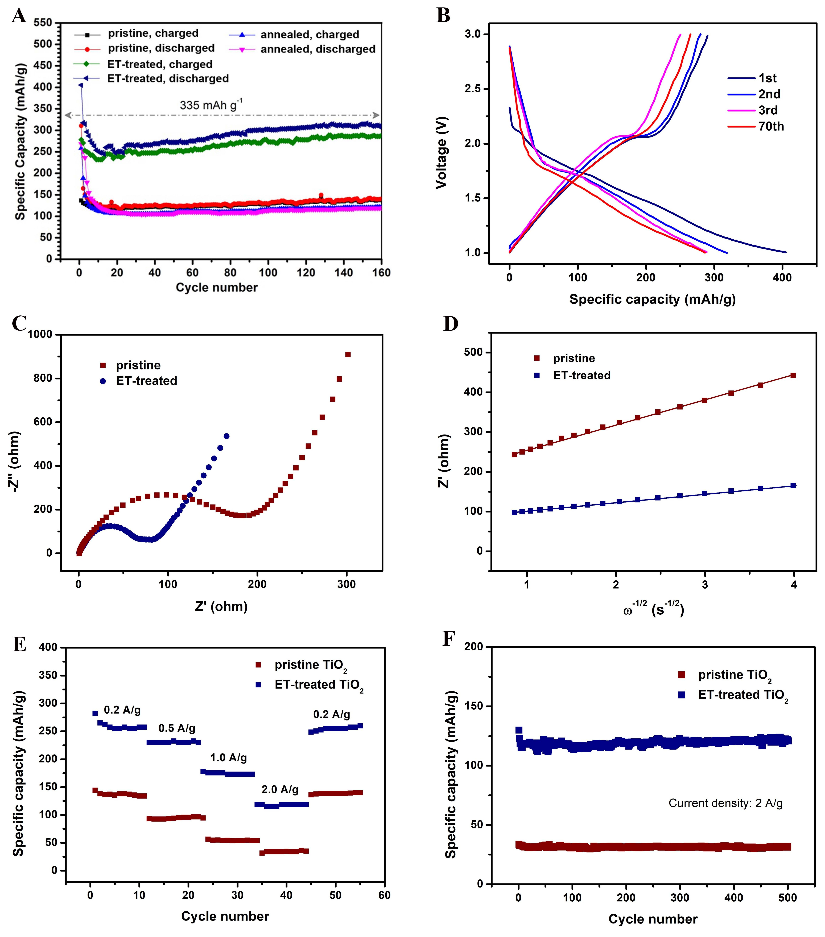
Supplementary Fig. 21.
Electrochemical performances of ET-treated TiO₂ electrode. (A) Variation in the discharge capacity versus cycle number for TiO₂ samples. (B) Stable charge/discharge voltage profiles of ET-treated TiO₂ electrode at 0.2 A/g between voltage limited of 1 to 3 V. (C) Nyquist plots of impedance data of ET-treated TiO₂ and pristine commercial TiO₂ electrodes in the frequency range from 100 kHz to 10 mHz. (D) The real part of the impedance versus of ET-treated TiO₂ and pristine commercial TiO₂ electrodes. (E) Specific discharge capacities at rates of 0.2, 0.5, 1.0, 2.0 A/g and then down to 0.2 A/g. (F) Discharge capacities of both samples for 500 cycles at high current density as 2 A/g.
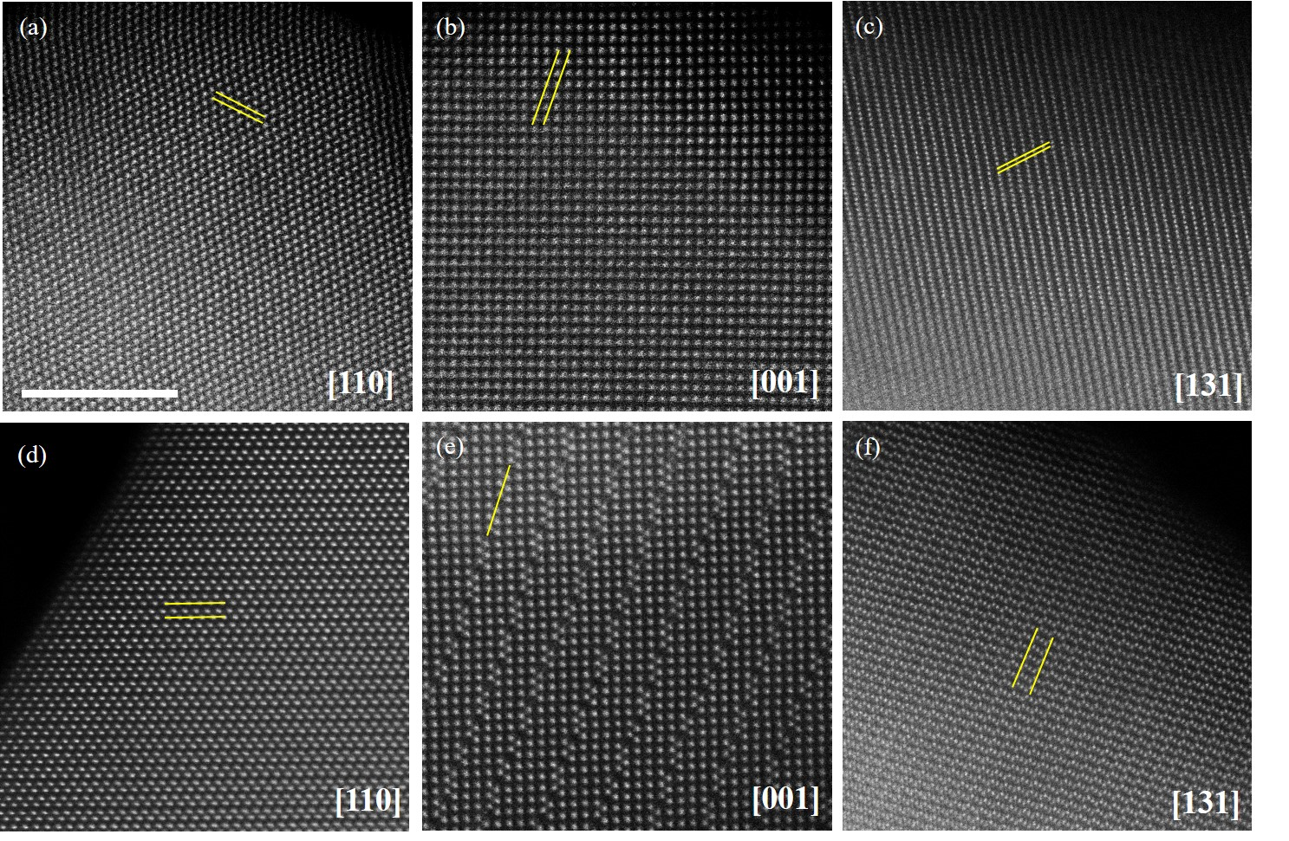
Supplementary Fig. 22.
The atomic-resolution image of annealed sample (a-c) and ET-treated oxides (d-f) for ZrO₂, WO₃ and VO₂, respectively. The modulation periodicities are outlined by double yellow lines. The scale bar is 5nm.

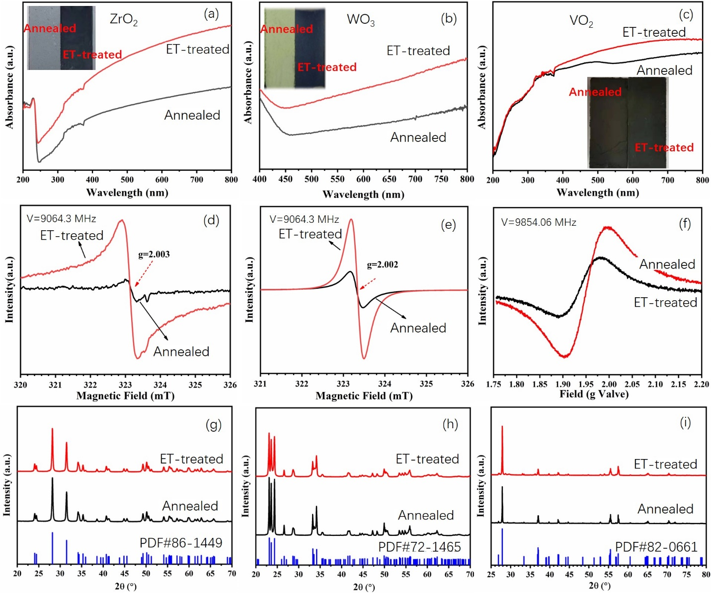
Supplementary Fig. 23.
The absorption spectra (a/b/c), Electron paramagnetic resonance (EPR) spectroscopy (d/e/f) and X-Ray diffraction (XRD) patterns (g/h/i) of ZrO₂/ WO₃ /VO₂ samples, respectively under different treatments. The light absorption ability of the ET-treated sample can be greatly enhanced, which is attributed to the creation of defects by our method. Inset images are the corresponding Photographs. The EPR measurements demonstrates that the content of oxygen vacancies increased in ET-treated sample compared with the annealed samples, while the XRD patterns show that the crystal structures of the ET-treated sample has not been changed.

