Supplementary Figure

Forelimb motor learning and memory consolidation drives distinct oligodendrocyte plasticity to fine-tune task-related neuronal activity

Shuming Wang¹, Nuo Xu^{1,5}, Wenwen Wang^{1,5}, Yongxiang He¹, Yuqian Yang¹, Liuning Zhang¹, Yanping Zou¹, Yuehua He¹, Liang Gao^{3,4}, Huiliang Li^{2,4}, Lin Xiao^{1,4}*

¹ Key Laboratory of Brain, Cognition and Education Sciences of Ministry of Education; Institute for Brain Research and Rehabilitation, Guangdong Key Laboratory of Mental Health and Cognitive Science, and Center for Studies of Psychological Application, South China Normal University, Guangzhou 510631, China.
² Wolfson Institute for Biomedical Research, University College London, Gower Street, London WC1E 6BT, UK.
³ Guangdong Provincial Key Laboratory of Brain Connectome and Behavior, CAS Key Laboratory of Brain Connectome and Manipulation, The Brain Cognition and Brain Disease Institute (BCBDI), Shenzhen Institutes of Advanced Technology, Chinese Academy of Sciences, Shenzhen-Hong Kong Institute of Brain Science-Shenzhen Fundamental Research Institutions, Shenzhen 518055, China.

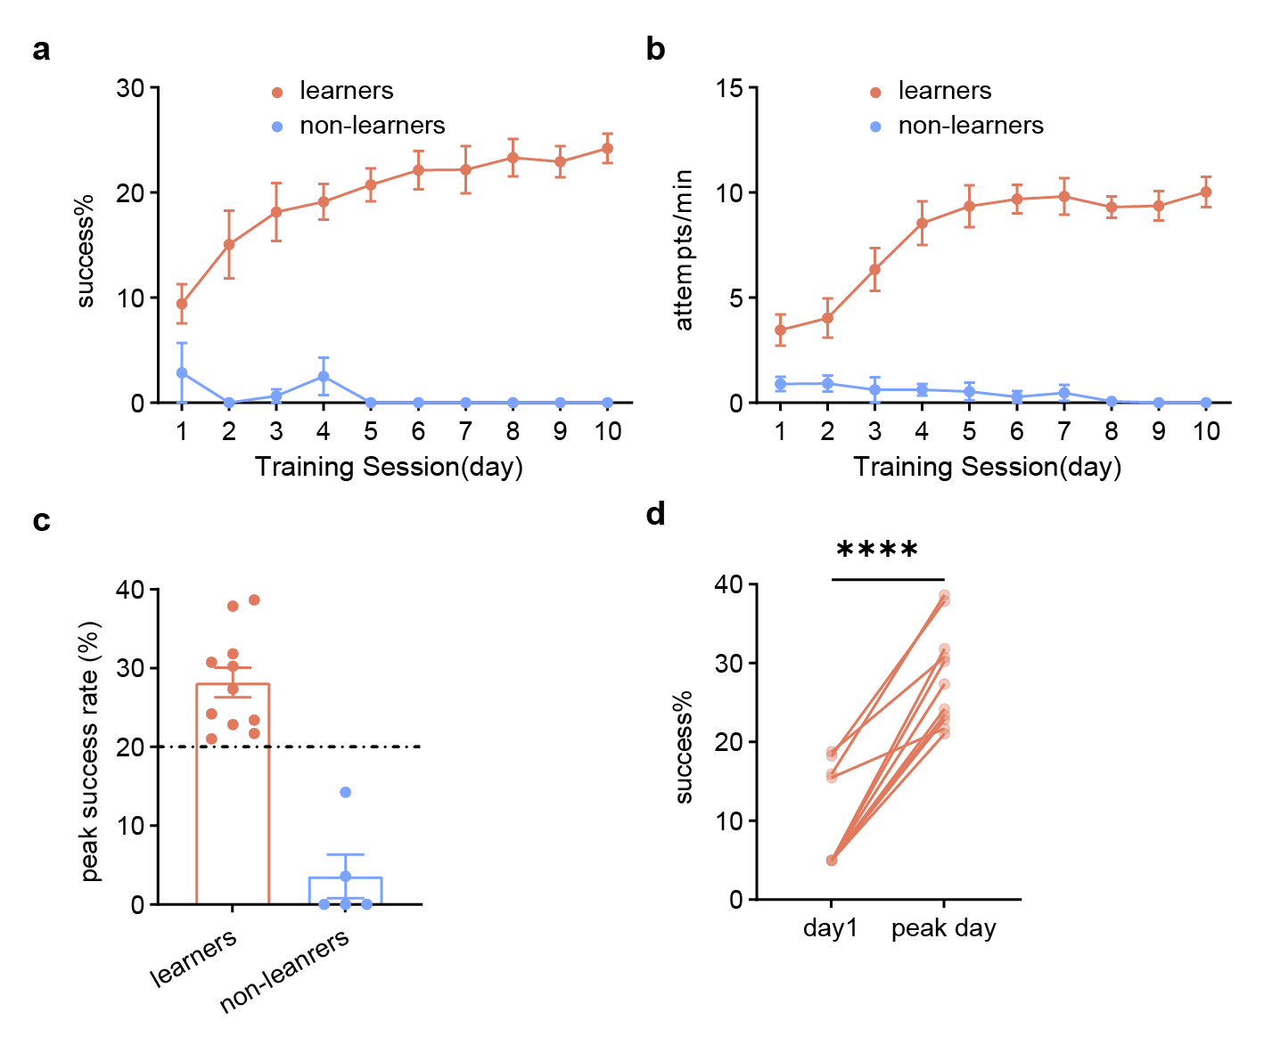
Supplementary Figure 1. Single pellet reaching task. a Learners improve success rate over practice, non-learners maintain low success rate. b Learners gradually increase their attempts during first several days when success reach comes with food reward, then reach a plateau. In contrast, non-learners fail to get food pellets and lose motivation to reach. c All learners achieve peak success rate over 20%, but non-learners fail to reach the line.d Learners perform significantly better after training course. Day1, 9.4%, peak day, 28.1%, p <0.0001, paired t test.
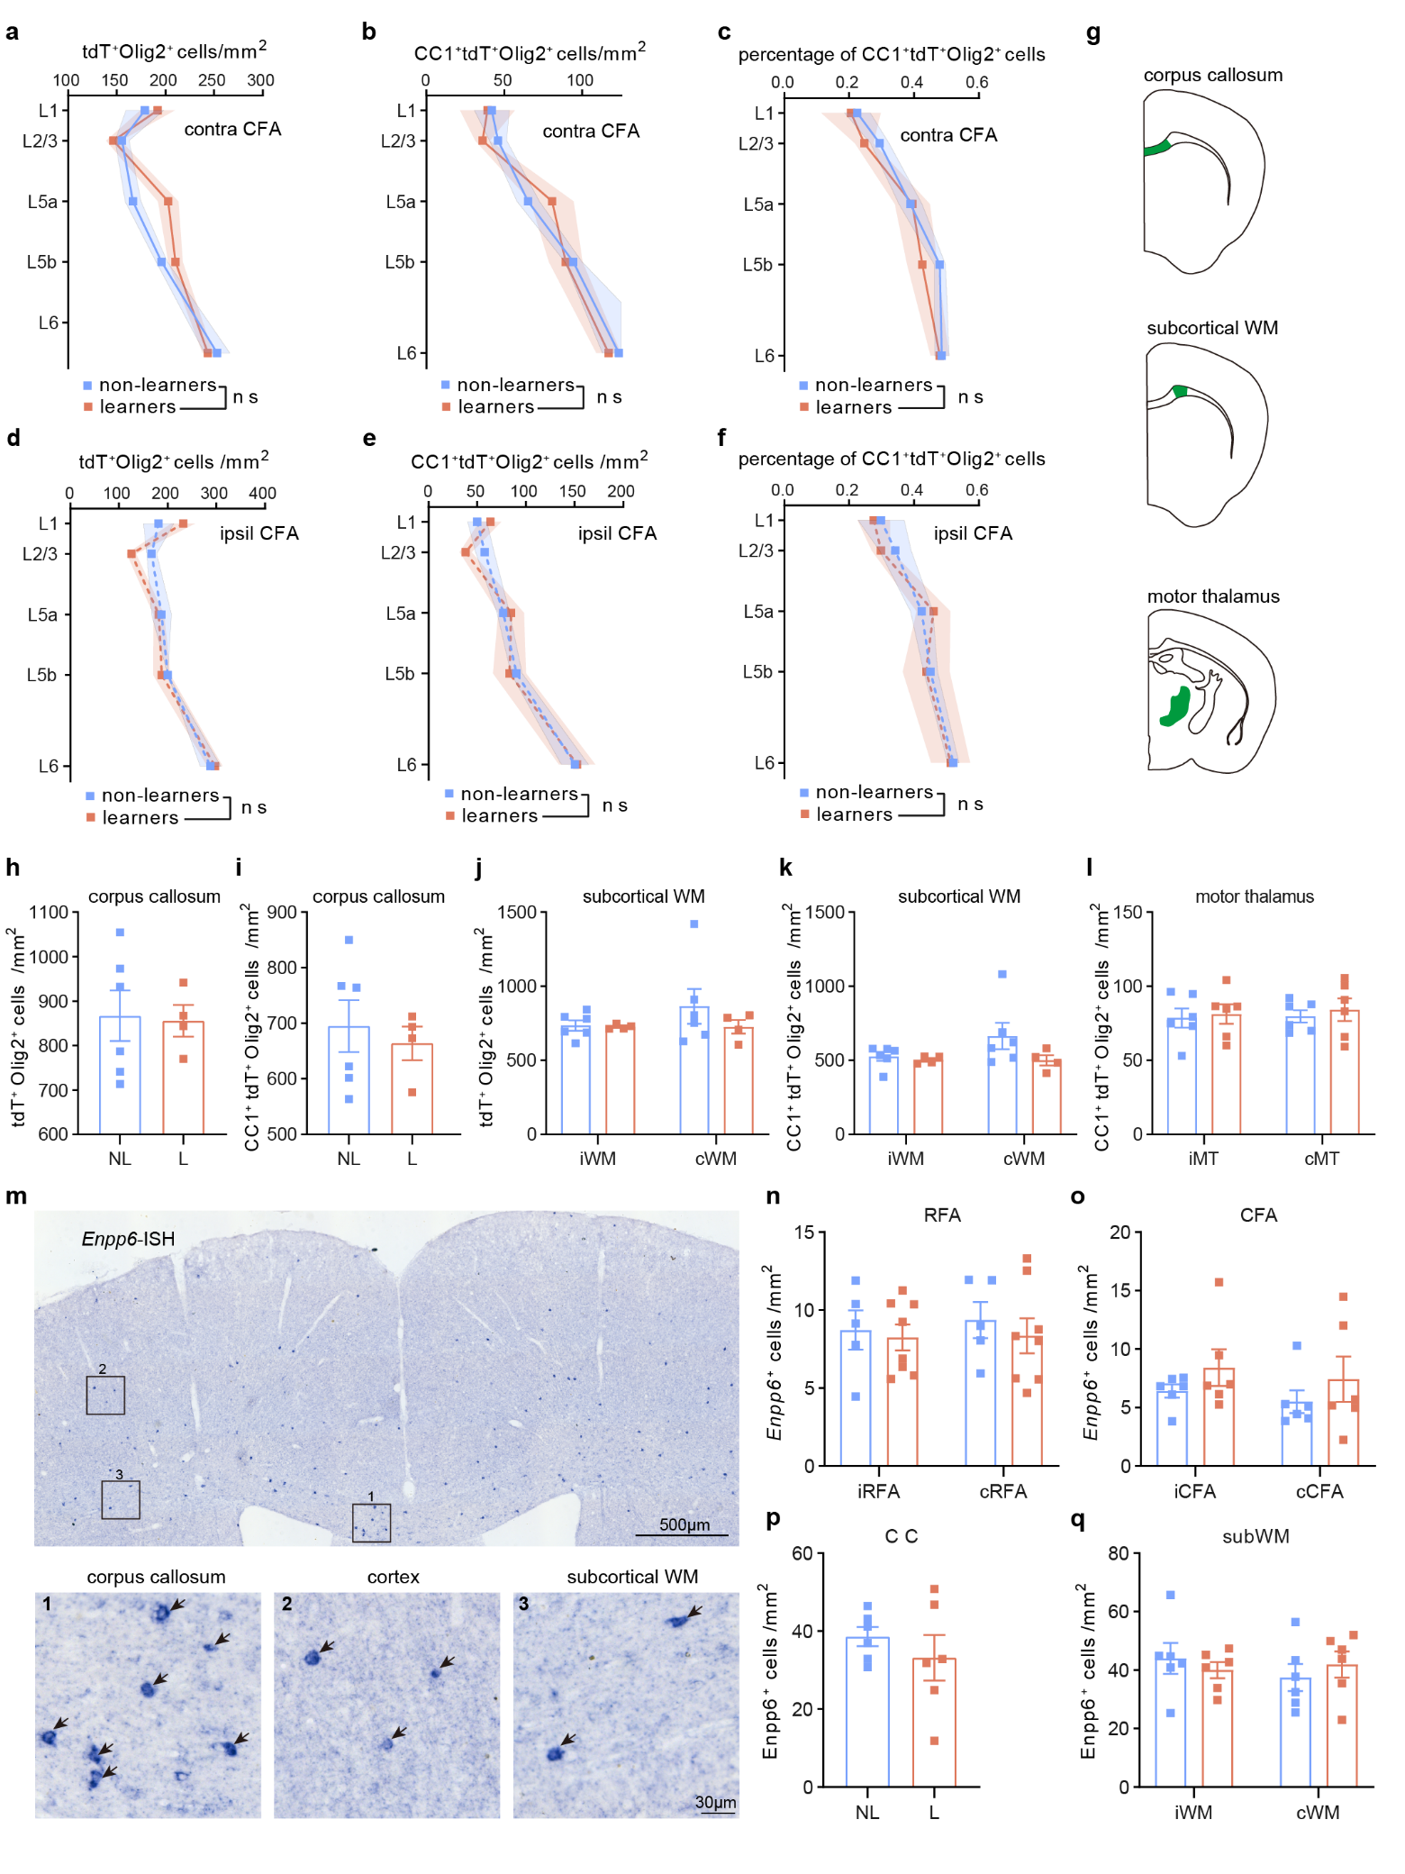
Supplementary Figure 2. Motor learning-induced OL changes in other motor-related regions. a-c Cell number density of tdT⁺Olig2⁺ (a), CC1⁺tdT⁺Olig2⁺ (b) and percentage of CC1⁺tdT⁺Olig2⁺ cells (c) in cCFA of learners (orange) and non-learners (blue), non-learners: 6 mice; learners: 4 mice. Two-way ANOVA: (a) non-learners vs learners (training factor), F (1, 40) = 1.403, P=0.2431; (b) training factor, F (1, 40) = 0.07773, P=0.7818; (c) training factor, F (1, 40) = 0.8776, P=0.3545. d-f Cell number density of tdT⁺Olig2⁺ (d), CC1⁺tdT⁺Olig2⁺ (e) and percentage of CC1⁺tdT⁺Olig2⁺ cells (f) in iCFA of learners and non-learners, non-learners: 6 mice; learners: 4 mice. Two-way ANOVA: (d) training factor, F (1, 40) = 0.001020, P=0.9747; (e) training factor, F (1, 40) = 0.004401, P=0.9747; (f) training factor, F (1, 40) = 0.1065, P=0.7459. G Schematic drawing of regions of interest, including corpus callosum, subcortical white matter (subcortical WM) and motor thalamus (MT). h-i Quantification of tdT⁺Olig2⁺ cell density (h) and CC1⁺tdT+Olig2+ cell density (i) in corpus callosum between learners (L) and non-learners (NL) mice. no significance, t test. j-k Quantification of tdT⁺Olig2⁺ cell density (j) and CC1⁺tdT+Olig2+ cell density (i) in subcortical WM (ipsil- and contra-WM). no significance, t test. l Quantification of CC1⁺tdT⁺Olig2⁺ cell density in MT. no significance, t test. m Representative image of Enpp6 by in situ hybridization of motor cortex including white matter. Up: an overview of upper brain slice. Lower left: enlarged view of corpus callosum in black suqare1, lower middle: enlarged view of cortex in suqare2 and lower right: enlarged view of subcortical WM in suqare3. Arrows denote Enpp6+ cells. n-o Enpp6⁺ cell density in cRFA (n), CFA (o), corpus callosum (p), subcortical WM (q) between learners and non-learners mice. no significance, t test.

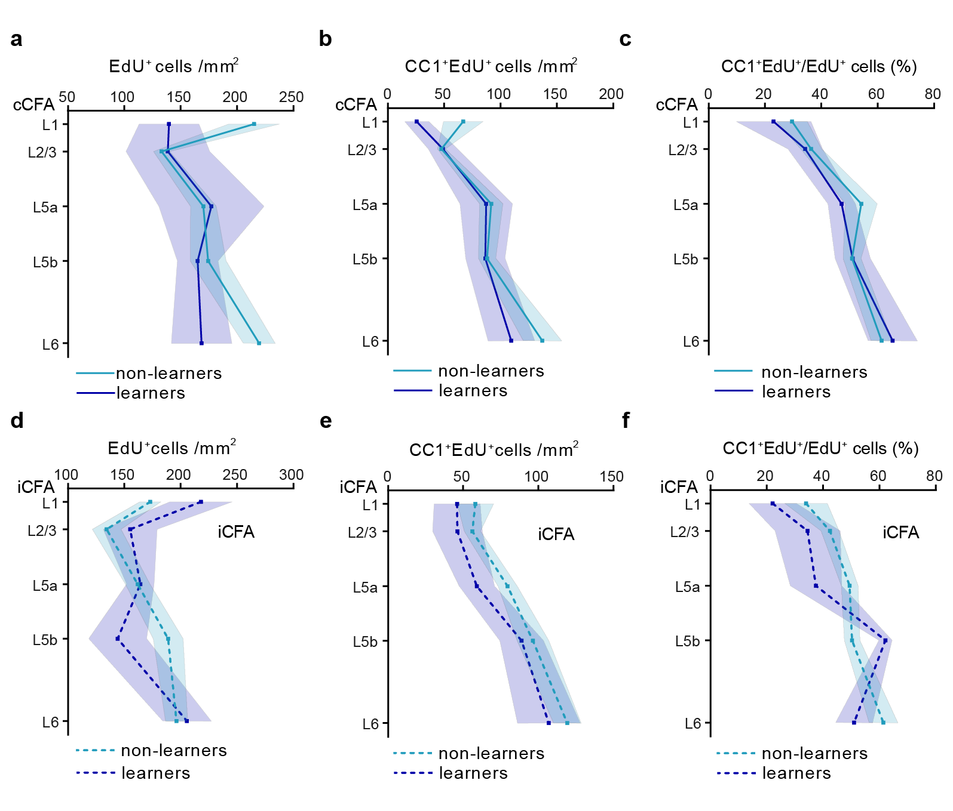
Supplementary Figure 3. Motor learning-induced OL changes in other motor-related regions by EdU labeling. a-c Cell number density of EdU⁺ (a), CC1⁺EdU⁺ (b) and percentage of CC1⁺EdU⁺ cells (c) in cCFA of learners (blue) and non-learners (light blue), non-learners: 6 mice; learners: 4 mice. Two-way ANOVA: (A) non-learners vs learners (training factor), F (1, 40) = 2.949, P=0.0937; (b) training factor, F (1, 40) = 2.430, P=0.1269; (c) training factor, F (1, 40) = 0.3635, P=0.5500. d-f Cell number density of EdU ⁺ (d), CC1⁺ EdU ⁺ (e) and percentage of CC1⁺ EdU ⁺ cells (f) in iCFA of learners and non-learners, non-learners: 6 mice; learners: 4 mice. Two-way ANOVA: (d) training factor, F (1, 40) = 0.4011, P=0.5301; (e) training factor, F (1, 40) = 2.689, P=0.1089; (f) training factor, F (1, 40) = 2.392, P=0.1298.

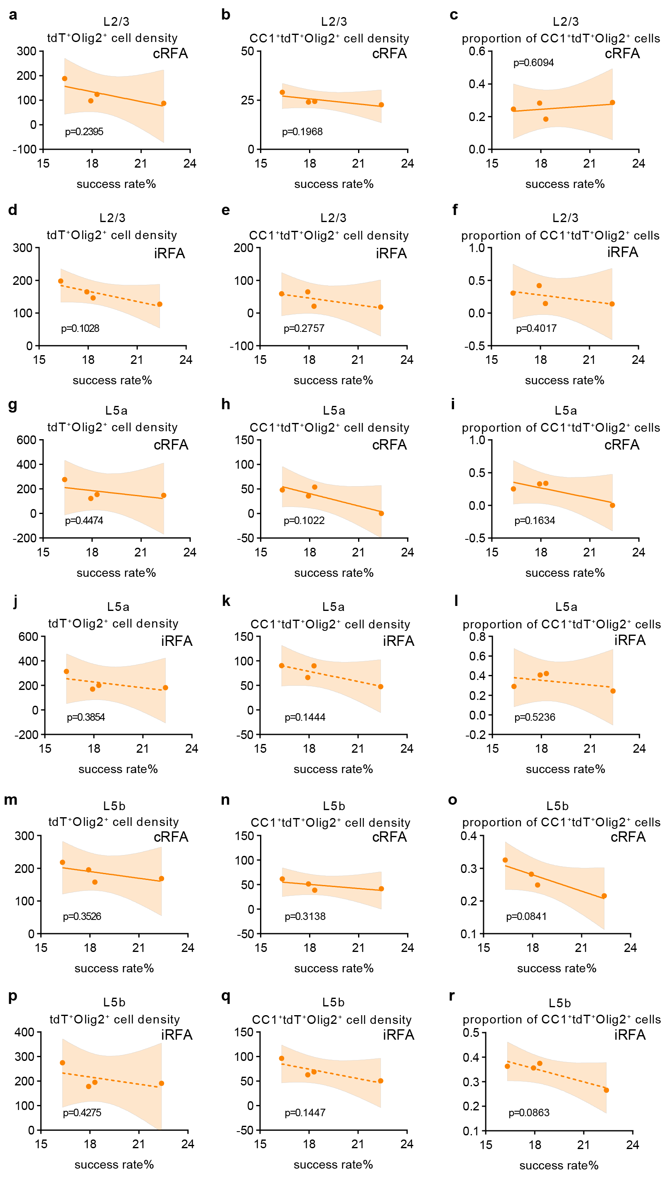
Supplementary Figure 4. Motor performance correlation with training-induced OL plasticity in individual mice. a-c Correlation between reaching performance (success rate) and tdT⁺Olig2⁺ (a), CC1⁺tdT⁺Olig2⁺ cell density (b) and percentage of CC1⁺tdT⁺Olig2⁺ cells (c) for individual mice (n=4) in L2/3 of cRFA. d-f Correlation between reaching performance (success rate) and tdT⁺Olig2⁺ (d), CC1⁺tdT⁺Olig2⁺ cell density (e) and percentage of CC1⁺tdT⁺Olig2⁺ cells (f) for individual mice (n=4) in L2/3 of cRFA. g-i Correlation between reaching performance (success rate) and tdT⁺Olig2⁺ (g), CC1⁺tdT⁺Olig2⁺ cell density (h) and percentage of CC1⁺tdT⁺Olig2⁺ cells (i) for individual mice (n=4) in L5a of cRFA. j-l Correlation between reaching performance (success rate) and tdT⁺Olig2⁺ (j), CC1⁺tdT⁺Olig2⁺ cell density (m) and percentage of CC1⁺tdT⁺Olig2⁺ cells (l) for individual mice (n=4) in L5a of iRFA. m-o Correlation between reaching performance (success rate) and tdT⁺Olig2⁺ (m), CC1⁺tdT⁺Olig2⁺ cell density (n) and percentage of CC1⁺tdT⁺Olig2⁺ cells (o) for individual mice (n=4) in L5b of cRFA. p-q Correlation between reaching performance (success rate) and tdT⁺Olig2⁺ (p), CC1⁺tdT⁺Olig2⁺ cell density (q) and percentage of CC1⁺tdT⁺Olig2⁺ cells (r) for individual mice (n=4) in L5b of iRFA. Pearson correlation. * p<0.5, no significance p>0.5.

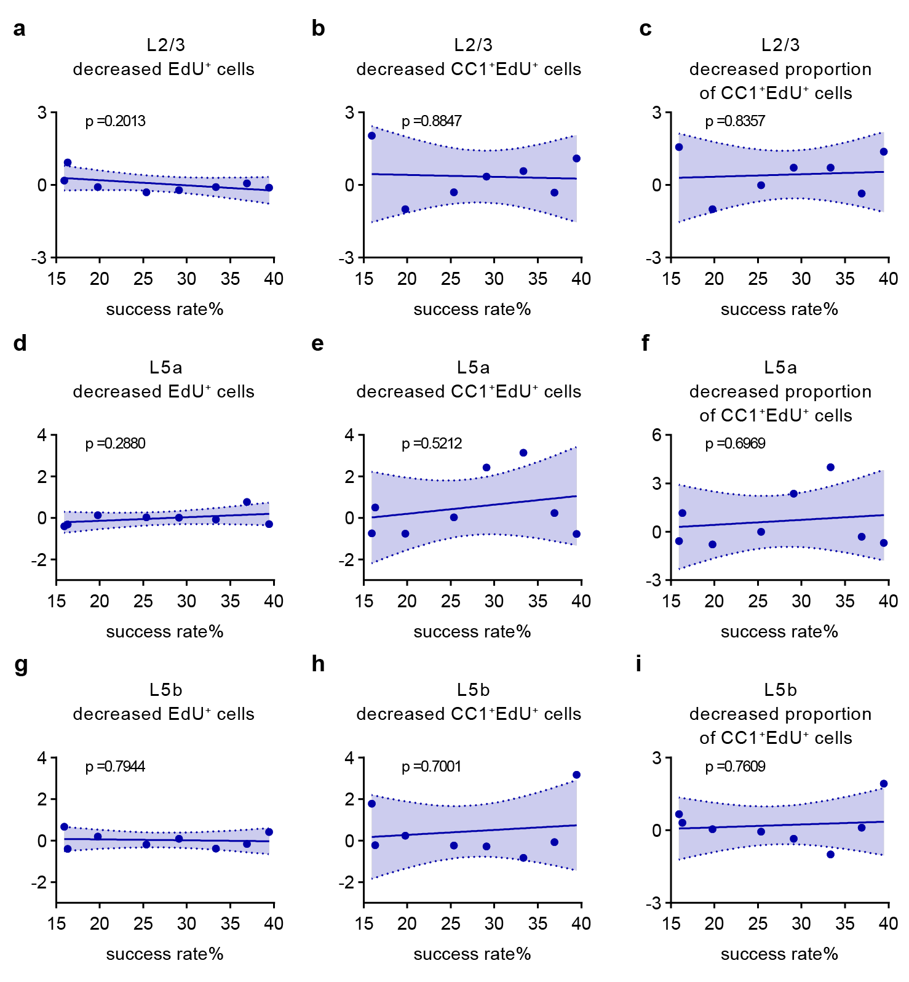

Supplementary Figure 5. Motor performance correlation with training-induced OL dynamics by EdU tracking. a-c Correlation between reaching performance (success rate) and decreased fraction of EdU⁺ (a), CC1⁺ EdU⁺ cell density (b) and percentage of EdU ⁺ cells (c) for individual mice (n=8) in L2/3 of RFA. d-f Correlation between reaching performance (success rate) and decreased fraction of EdU⁺ (D), CC1⁺ EdU⁺ cell density (e) and percentage of EdU ⁺ cells (f) for individual mice (n=8) in L5a of RFA. g-i Correlation between reaching performance (success rate) and decreased fraction of EdU⁺ (g), CC1⁺ EdU⁺ cell density (h) and percentage of EdU ⁺ cells (i) for individual mice (n=8) in L5b of RFA. Pearson correlation, no significance p>0.5.

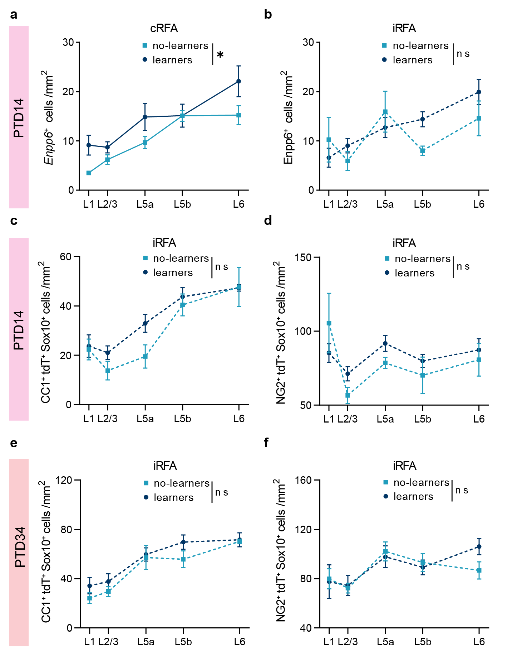
Supplementary Figure 6. Prolonged oligodendrocyte dynamics in rostral forelimb area after learning. a-b Quantification of Enpp6⁺ cells number in cRFA (a) and iRFA (b) of learners and non-learners mice at ptd14. Two-way ANOVA: in cRFA, non-learners vs learners, F (1, 55) = 5.900, P=0.0184. c-d Cell density of CC1⁺tdT⁺Sox10⁺ (c) and NG2⁺tdT⁺Sox10⁺ (d) in iRFA of learners and non-learners mice at ptd14. Two-way ANOVA: training factor, P=0.0700 (CC1⁺tdT⁺Sox10⁺ cell density), P=0.3643 (NG2⁺tdT⁺Sox10⁺ cell density). e-f Cell density of CC1⁺tdT⁺Sox10⁺ (e) and NG2⁺tdT⁺Sox10⁺ (f) in iRFA of learners and non-learners mice at ptd34. Two-way ANOVA: training factor, P=0.0795 (e), P=0.7064 (f).

