Supplementary Information

Wafer-scale monolayer organic single-crystalline films and arrays toward high-performance organic electronics

Ximeng Yao^{1,4}, Chunli Ma^{1,4}, Lingjie Sun²*, Xianshuo Wu¹, Xianfeng Shen¹, Zhaofeng Wang¹, Shuyuan Yang¹, Pichao Gao¹, Dong Zeng¹, Wei Deng³, Jiansheng Jie³, Fangxu Yang¹, Rongjin Li^{1*} and Wenping Hu¹

¹Key Laboratory of Organic Integrated Circuit, Ministry of Education & Tianjin Key Laboratory of Molecular Optoelectronic Sciences, Department of Chemistry, School of Science, Tianjin University, Tianjin 300072, China.
²Institute of Molecular Aggregation Science of Tianjin University, Tianjin 300072, China.
³Institute of Functional Nano & Soft Materials (FUNSOM), Jiangsu Key Laboratory for Carbon-Based Functional Materials & Devices Soochow University, Suzhou 215123, China.
⁴These authors contributed equally: Ximeng Yao, Chunli Ma.
*Correspondence to: lirj@tju.edu.cn; sunlingjie@tju.edu.cn

This PDF file includes:

Figs. S1 to S19
Table S1

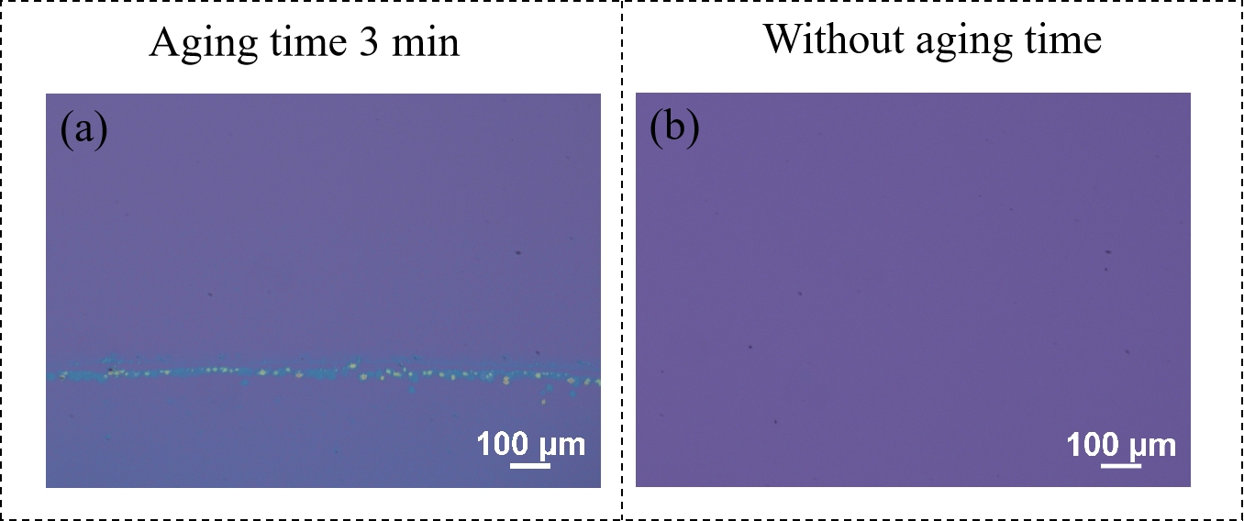
Supplementary Figure 1 | Investigation into seed crystal adhesion with and without aging time. a Optical microscope (OM) images of PTS-modified Si/SiO₂ substrates vertically immersed in top-phase solution after aging for 3 min, followed by rapid pulling. b OM image of a PTS-modified Si/SiO₂ substrate vertically immersed in top-phase solution followed by rapid pulling in the absence of aging time.

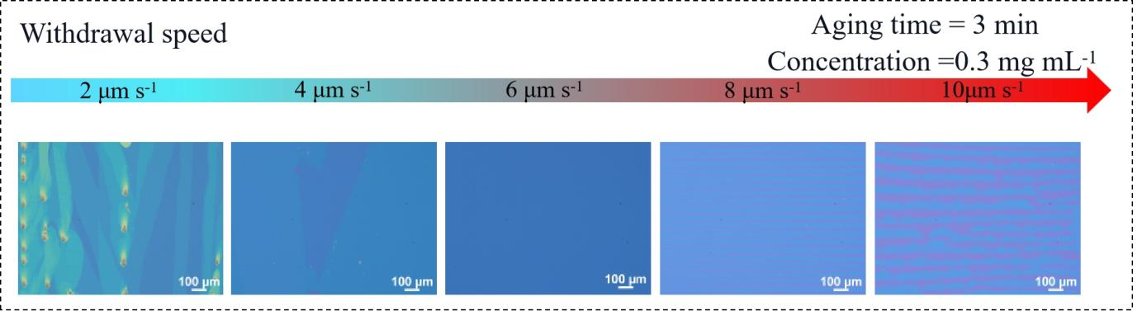
Supplementary Figure 2 | OM images of 2DMCs by SDC at different withdrawal speed.

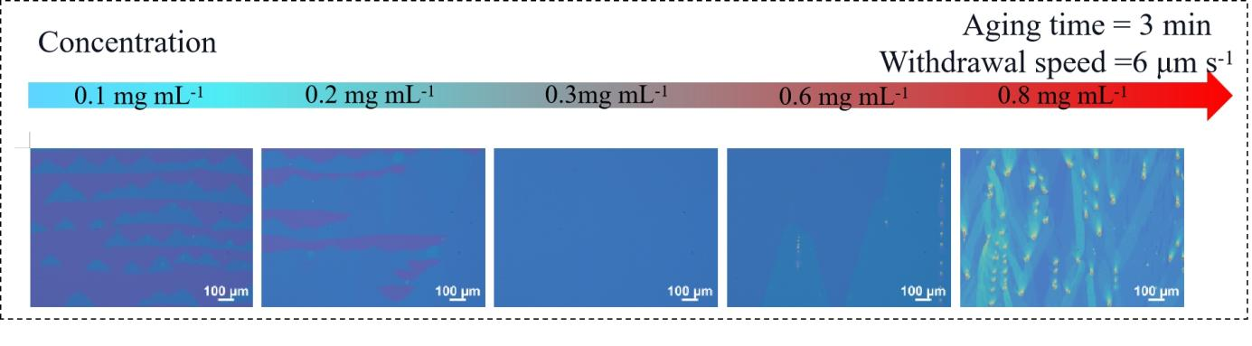
Supplementary Figure 3 | OM images of 2DMCs by SDC at different concentrations.

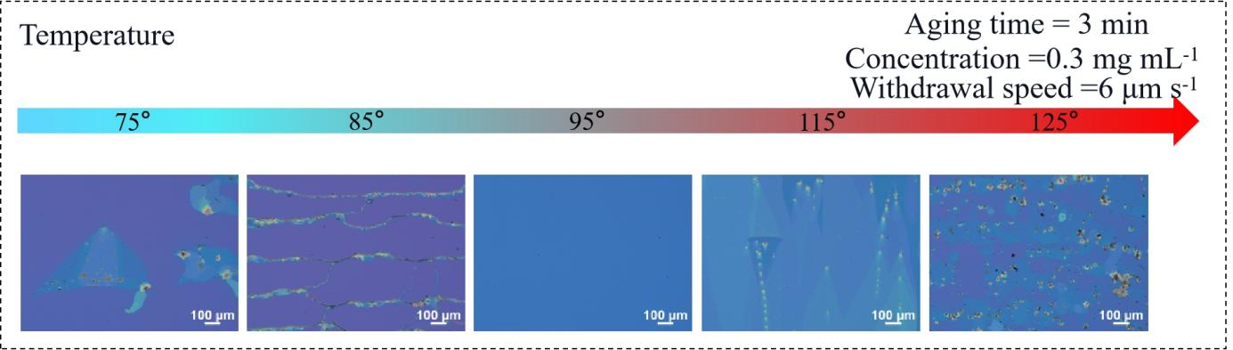
Supplementary Figure 4 | OM images of 2DMCs by SDC at different temperature.
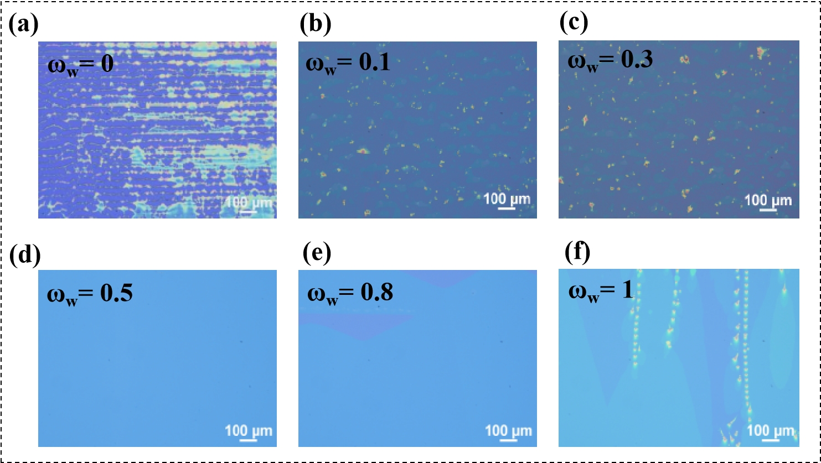
Supplementary Figure 5 | Investigation into the Influence of different molar fractions of glycerol and water mixtures on the growth of 2DMCs by SDC.
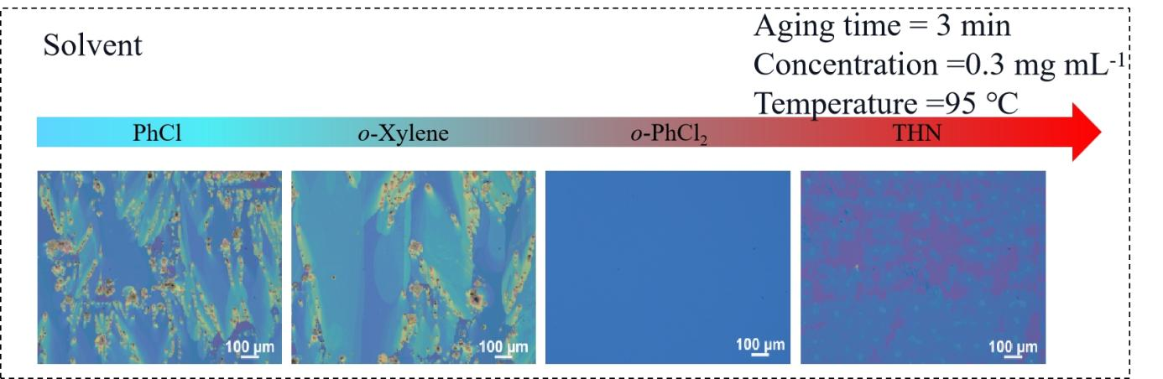
Supplementary Figure 6 |OM images of 2DMCs by SDC at different solvent. The properties of the solvent are listed in the table S1 below. As the SDC growth of C10-DNTT 2DMCs occurs at elevated temperatures, selecting a solvent with a suitable boiling point is essential.
Supplementary Table 1 | Physical properties of different solvents used.
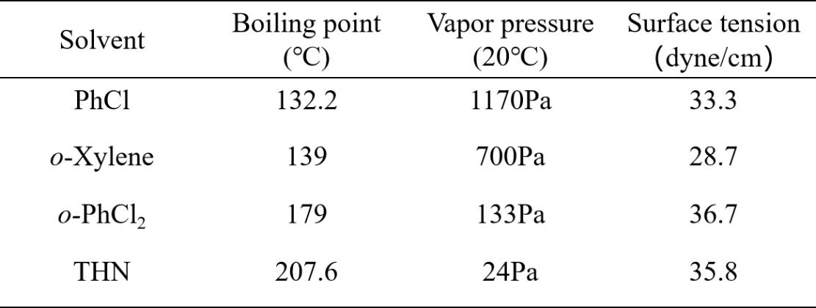

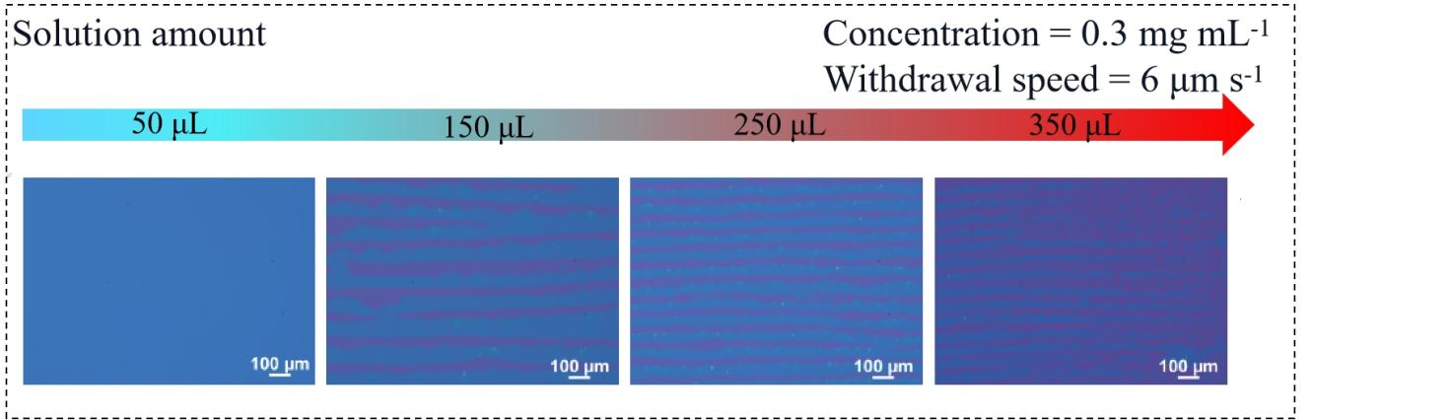
Supplementary Figure 7 | Investigation into the influence of upper solution volume of OSCs on the growth of 2DMCs by SDC.
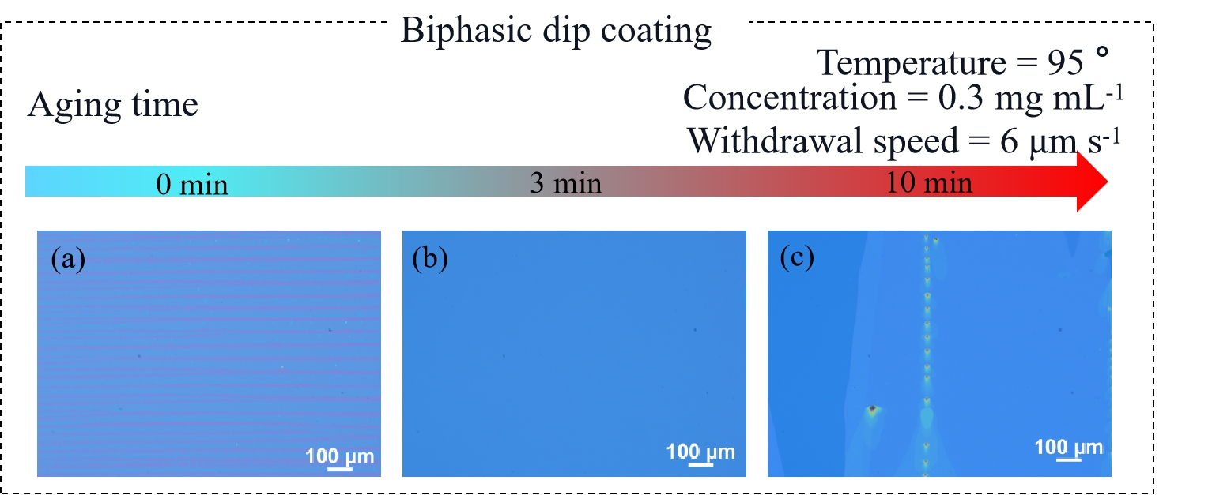
Supplementary Figure 8 | OM images of 2DMCs by SDC with different aging times. a 0 min, b 3 min, and c 10 min
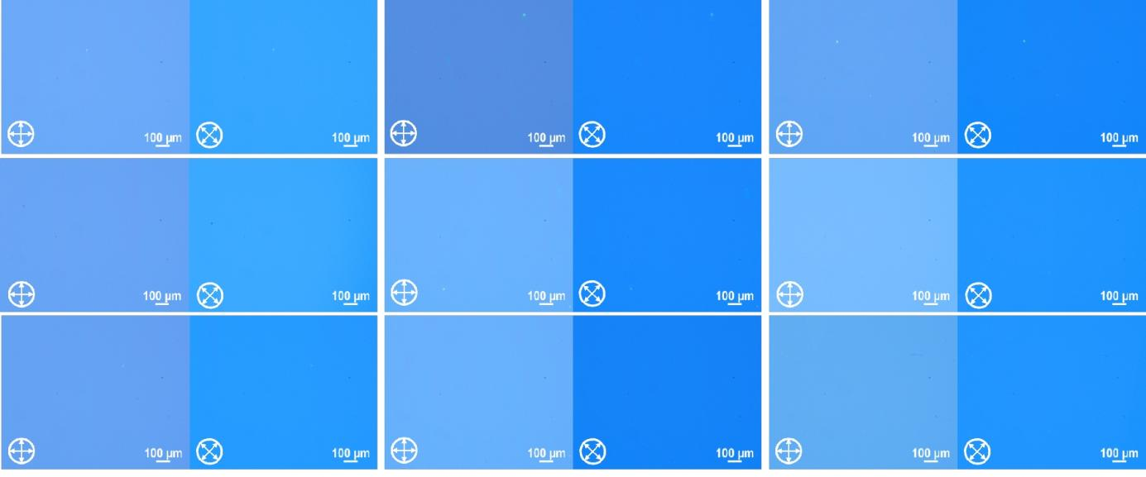
Supplementary Figure 9 | Random POM images of a wafer-scale monolayer C10-DNTT 2DMC acquired at a 3 × 3 matrix of positions.
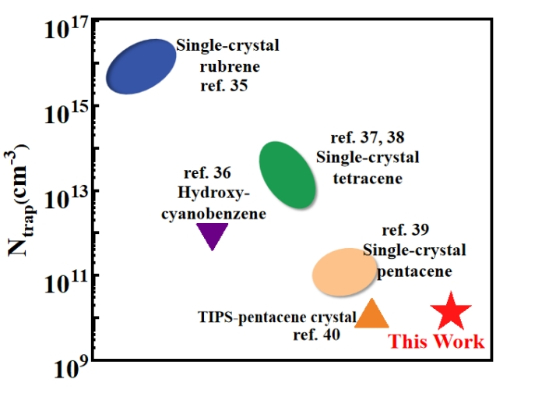
Supplementary Figure 10 | Comparison of trap densities between C10-DNTT 2DMCs and other OSC single crystals. The data in Supplementary Fig. 10 are from refs^{35–40}.

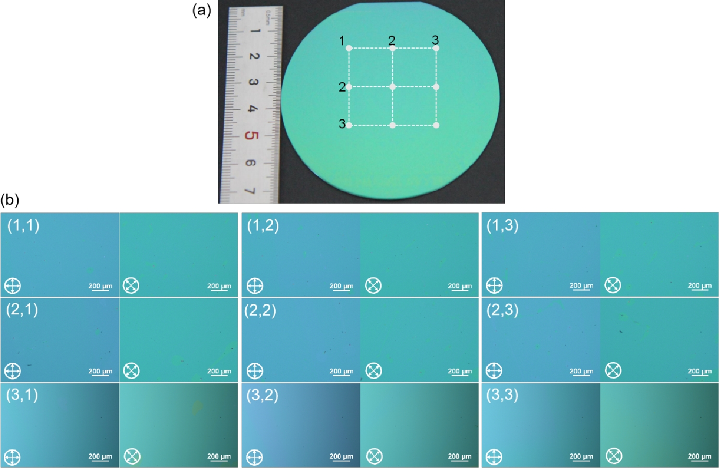
Supplementary Figure 11 | a Photograph of a wafer-scale, monolayer C6-DPA 2DMC film on a PTS-modified Si/SiO₂ substrate. b POM images of a 3 x 3 matrix region across a wafer-scale, monolayer C6-DPA 2DMCs.
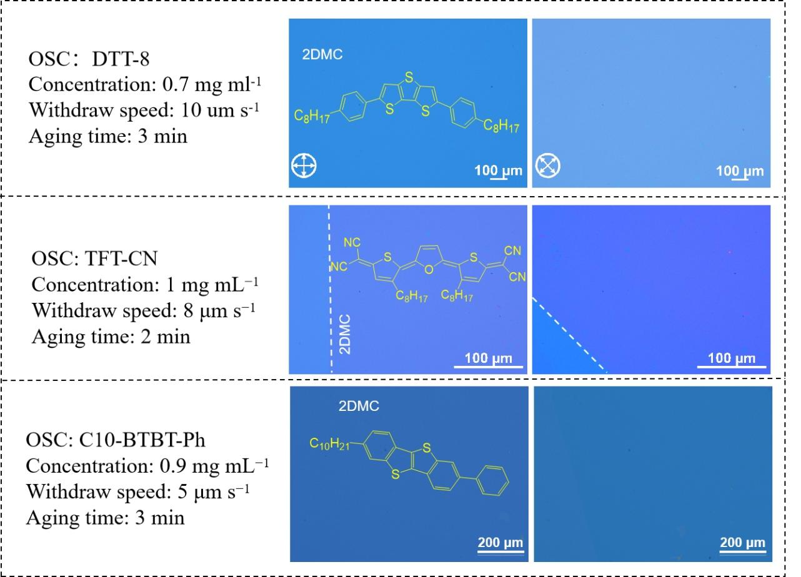
Supplementary Figure 12 | POM images of DTT-8, TFT-CN and Ph-BTBT-C10 2DMCs on PTS-modified Si/SiO₂ substrate by SDC.

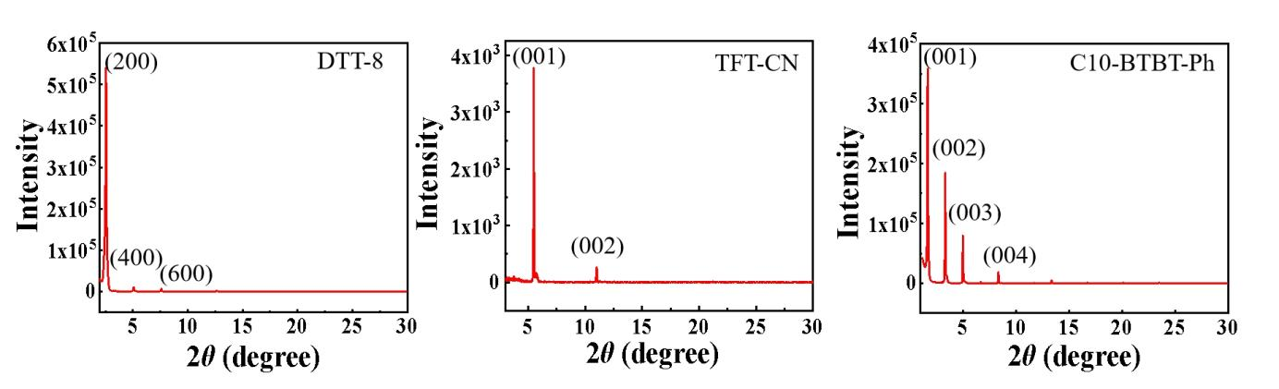
Supplementary Figure 13 | Out-of-plane XRD pattern of the DTT-8, TFT-CN and Ph-BTBT-C10 2DMCs.
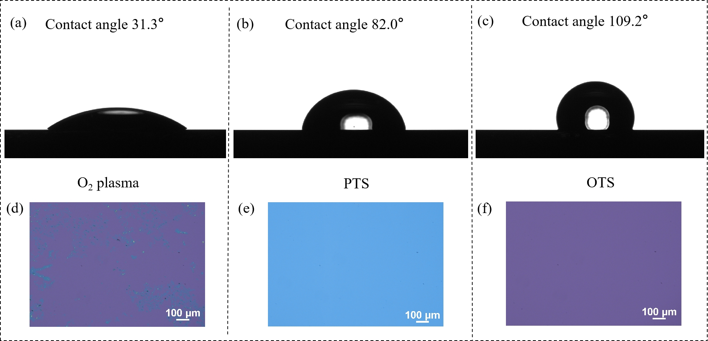
Supplementary Figure 14 | Contact angle of substrates with different surface energies, and corresponding OM images of crystals prepared using the SDC method. a Contact angle of O₂ plasma-modified Si/SiO₂ substrate; b PTS-modified Si/SiO₂ substrate; c OTS-modified Si/SiO₂ substrate.d-f OM images of crystals prepared by the SDC method on the corresponding substrates.

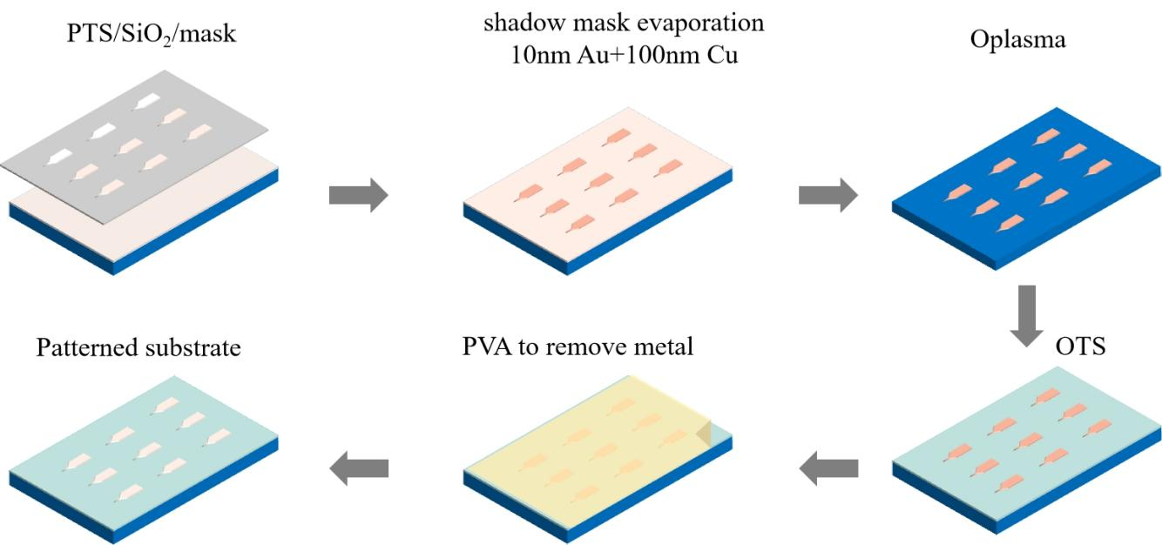
Supplementary Figure 15 | Schematic illustration of the procedures to fabricate the wetting/dewetting patterns on the substrate.
Patterning of hydrophilic/hydrophobic regions enables spatial confinement of crystal growth on a substrate. This is achieved by using self-assembled monolayers (SAMs) of PTS/OTS as hydrophilic/hydrophobic materials (Supplementary Fig. 14 ). Initially, a desired pattern is deposited onto a hydrophilic substrate using shadow masks; here, we deposited metal thin films (10nm Au+100nm Cu) with triangular tip patterns to protect the underlying hydrophilic layer. Subsequently, the substrate surface is bombarded with oxygen plasma and then modified with an OTS hydrophobic layer. Afterward, a spin-coating PVA layer is used to lift off the metal pattern film. As a result, the desired PTS hydrophilic pattern is embedded within the hydrophobic OTS substrate (Supplementary Fig. 15).

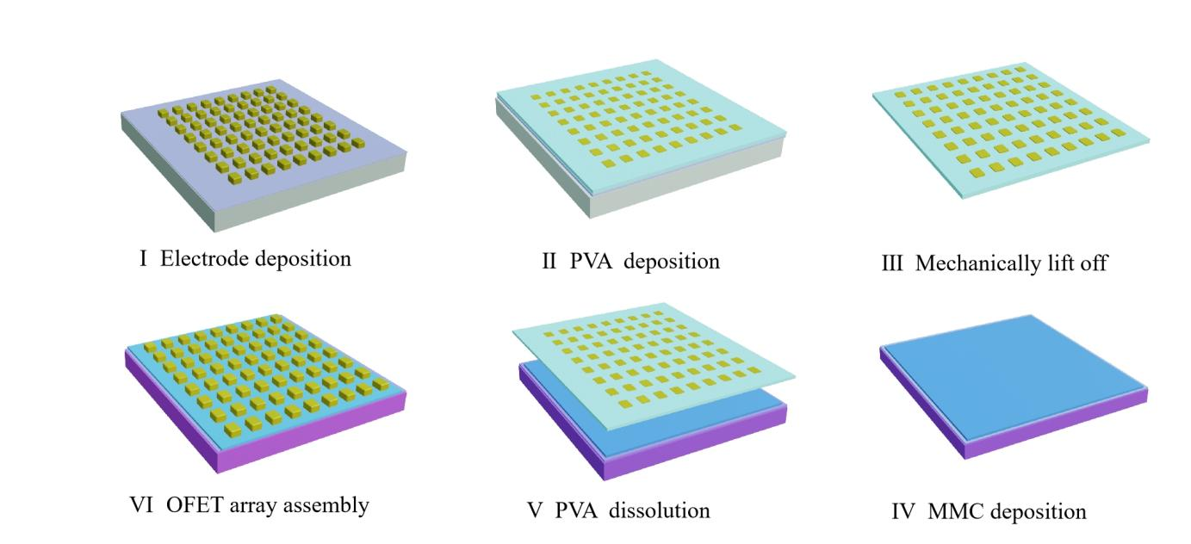
Supplementary Figure 16 | The schematic step-by-step fabrication processes for the monolayer C10-DNTT 2DMC-based OFET array. The shape, spacing, and number of the electrode pairs are illustrative for better visibility.

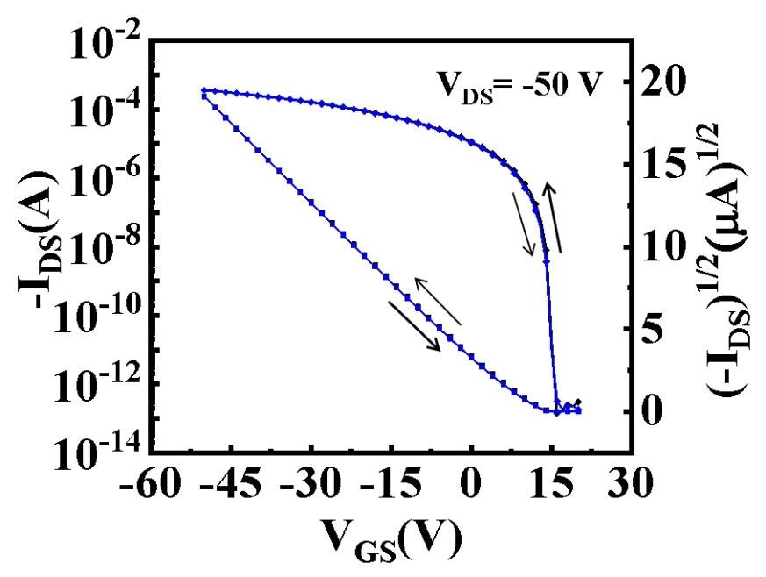
Supplementary Figure 17 | Typical hysteresis curve of OFETs based on the C10-DNTT 2DMCs.

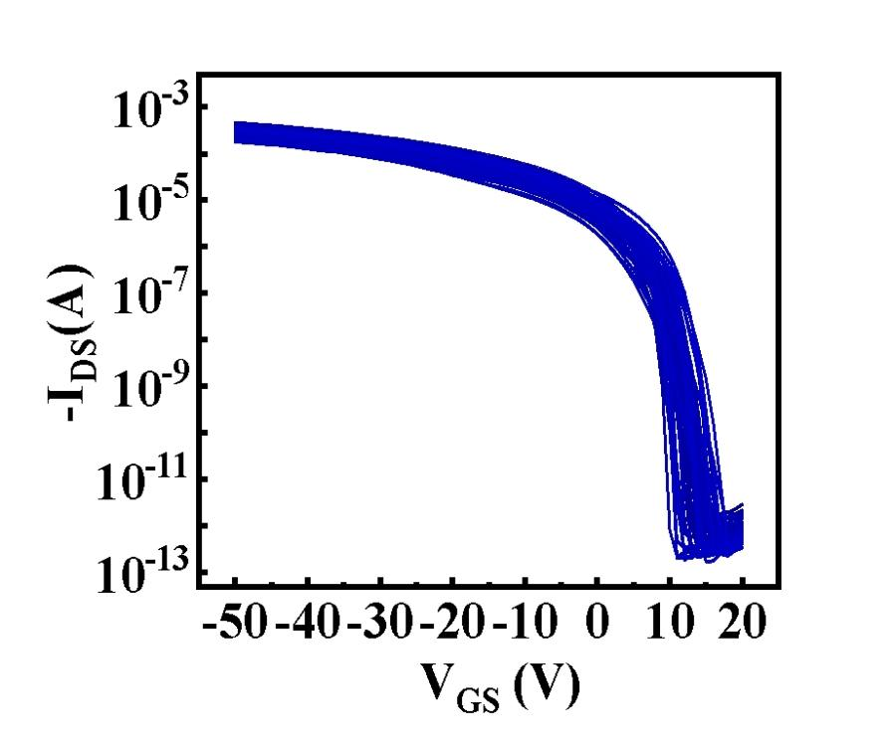
Supplementary Figure 18 | Transfer characteristics of 8×8 OFETs in the array. Channel length = 45 μm, and channel width = 80 μm.

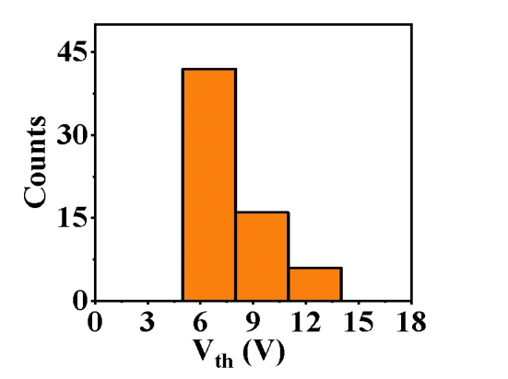
Supplementary Figure 19 | Statistical data for the threshold voltage of the device array.

