Appendix
Contents
Introduction 1
Data: Service time distributions estimation tool 2
Data: Service time distributions 3
Model: Class Structure 7
Model: Graphical overview 8
Full Factorial experimental design 9

Introduction
This appendix contains more detail about the model, in particular the elicitation of the process time distributions from clinic staff. It is not possible to provide complete information to allow the model to be reproduced, but the model and associated code can be made available upon request. Unfortunately you will need AnyLogic Professional version 8.3.3 to run the model.

Data: Service time distributions estimation tool
A programme was developed in Microsoft Excel using VBA to elicit estimates from clinic staff as data was not readily available. A screenshot from the programme is provided in Figure 1.
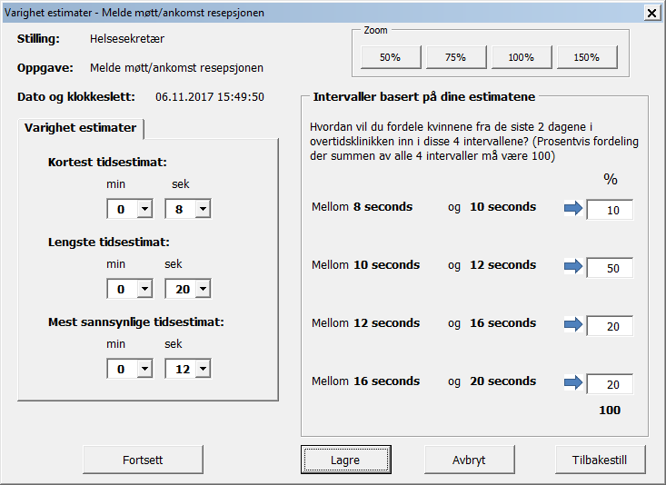
Figure 1 - Screenshot from process time estimation program (only available in Norwegian)

Using the program process time distributions were derived for the processes depicted in Figure 2 of the paper and in the Model: Graphical overview section. The estimates used are shown in the Data: Service time distributions section.
The service time distributions depicted in Figures 2, 4, 8 and 9 were provided through the data elicitation program. The decimal delimiter in the associated tables is a “,”. The service distributions depicted in Figure 3, 5, 6 and 7 were provided by TBS and KF authors of this paper. The x axis in the graphs are in minutes apart from Figure 4 which is the frequency.

Data: Service time distributions
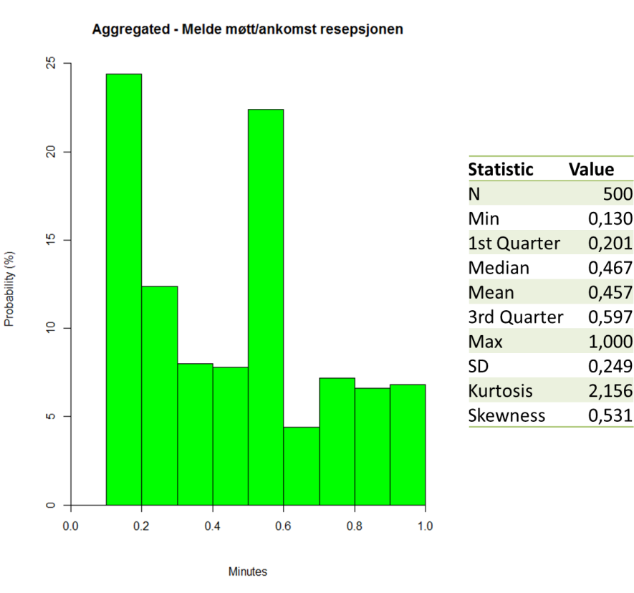
Figure 2: Check in service time distribution, provided by reception staff

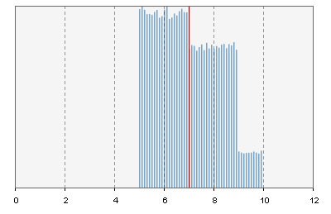
Figure 3: CTG connection service time distribution, provided by TBS and KF

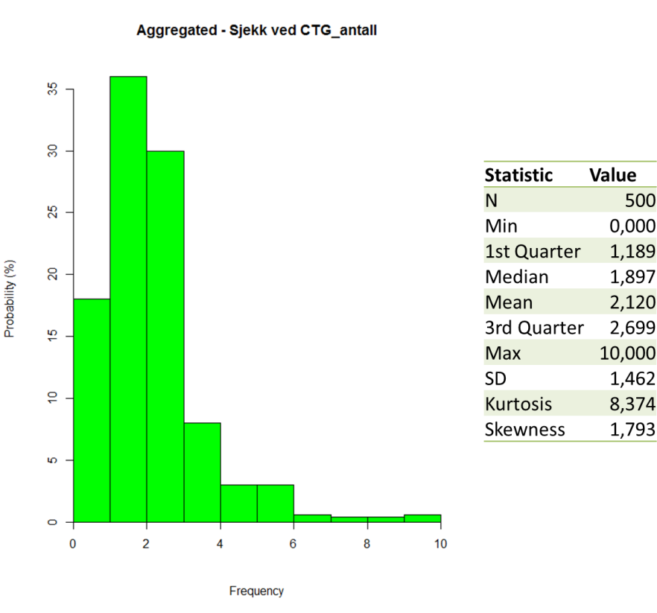
Figure 4: Number of CTG checks, provided by midwives
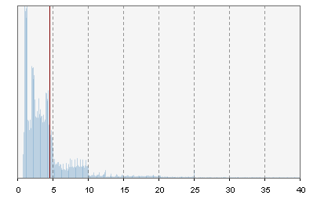
Figure 5: CTG scan duration, provided by TBS and KF
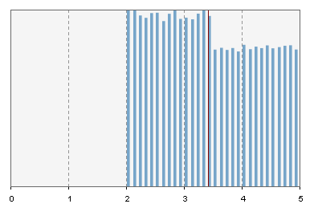
Figure 6: Disconnection from CTG service time distribution, provided by TBS and KF
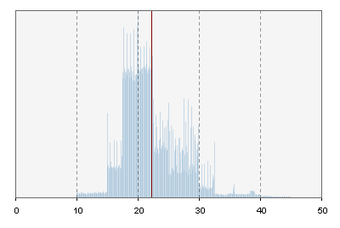
Figure 7: Doctor Consultation service time distribution, provided by doctors

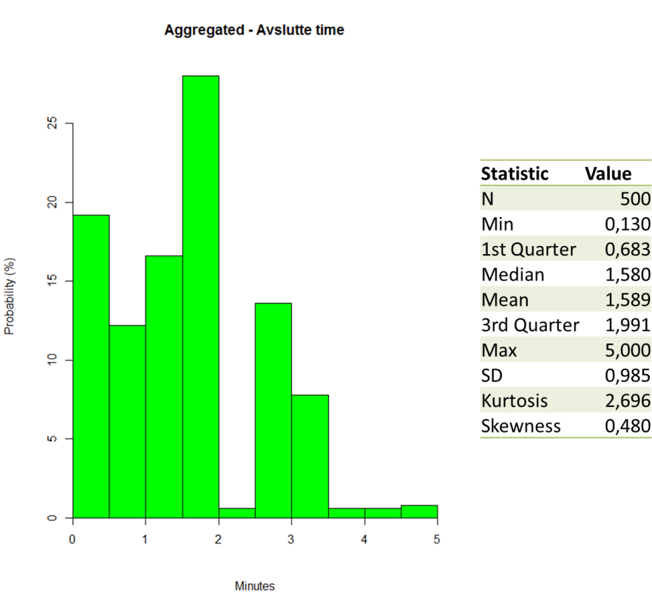
Figure 8: Check out service time distribution, provided by reception staff
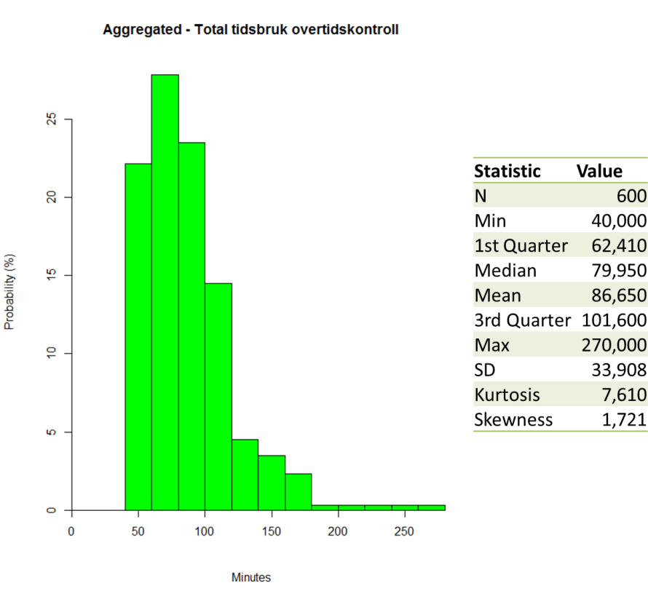
Figure 9: Estimated length of stay (LoS) distribution, provided by midwives

Model: Class Structure
The DES clinic model of the Main agent depicted in the UML diagram below is shown in the Model: Graphical overview section.
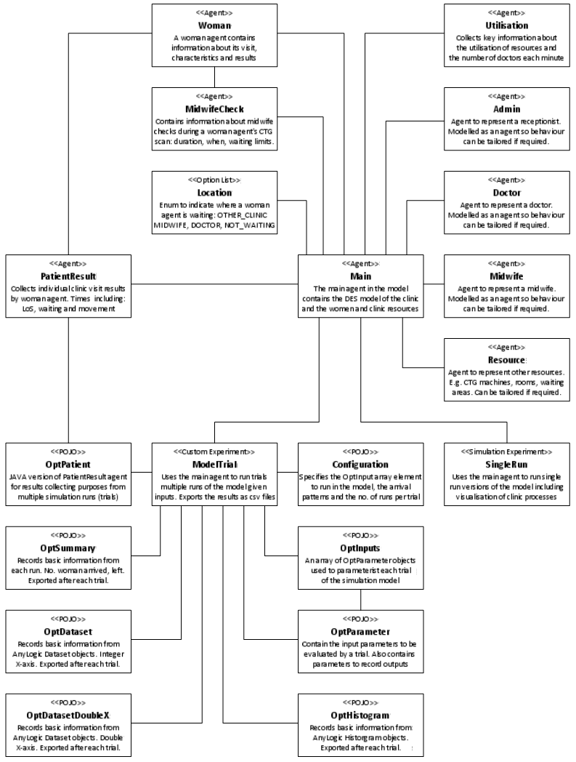
Figure 10: UML type diagram of the post term clinic outpatient model

Model: Graphical overview
A simplified overview of the DES clinic model is provided below. This diagram omits midwife checks, and does not explain the internal coding of the women agents. This is a more detailed version of Figure 2 included in the paper.
Figure 11: Simplified flow chart of DES clinic model

Full Factorial experimental design
All the configurations in Table 3 were evaluated in an earlier version of the model. The configurations that are included in the paper and analysed in greater detail are highlighted in green in Table 3, they were renamed in the paper.
Table 1 - Configuration inputs
Var. | Description | Values
x1 | The women arrival pattern: | 0 = 100% at 08:00  1 = 50% at 08:00 and 50% at 08:30
x2 | The first y patients can see the doctor first.  y = number of doctors, | 0 = no  1 = yes
x3 | Number of midwives available: | 2,3,4
x4 | Number of doctors available: | 2,3,4
x5 | Number of CTGs available: | 3,4,5

Table 2 - Configuration inputs in the model
Var. | Model variable(s) | Type
x1 | All_at8 | Boolean: true = 0; false = 1
x2 | doctorBeforeMidwife | Boolean: true = 1; false = 0
x3 | midwives | Int
x4 | doc_FØD  doc_FØD2  doc_ØHJ  doc_Extra | Int 0 or 1
x5 | equip_Room026  equip_Roome039 | Int

Table 3 - Configuration highlighted in green included in the BJOG paper
No. | x1 | x2 | x3 | x4 | x5 |  | No. | x1 | x2 | x3 | x4 | x5
1 | 0 | 0 | 2 | 2 | 3 |  | 55 | 0 | 1 | 3 | 3 | 4
2 | 1 | 0 | 2 | 2 | 3 |  | 56 | 1 | 1 | 3 | 3 | 4
3 | 0 | 1 | 2 | 2 | 3 |  | 57 | 0 | 0 | 4 | 3 | 4
4 | 1 | 1 | 2 | 2 | 3 |  | 58 | 1 | 0 | 4 | 3 | 4
5 | 0 | 0 | 3 | 2 | 3 |  | 59 | 0 | 1 | 4 | 3 | 4
6 | 1 | 0 | 3 | 2 | 3 |  | 60 | 1 | 1 | 4 | 3 | 4
7 | 0 | 1 | 3 | 2 | 3 |  | 61 | 0 | 0 | 2 | 4 | 4
8 | 1 | 1 | 3 | 2 | 3 |  | 62 | 1 | 0 | 2 | 4 | 4
9 | 0 | 0 | 4 | 2 | 3 |  | 63 | 0 | 1 | 2 | 4 | 4
10 | 1 | 0 | 4 | 2 | 3 |  | 64 | 1 | 1 | 2 | 4 | 4
11 | 0 | 1 | 4 | 2 | 3 |  | 65 | 0 | 0 | 3 | 4 | 4
12 | 1 | 1 | 4 | 2 | 3 |  | 66 | 1 | 0 | 3 | 4 | 4
13 | 0 | 0 | 2 | 3 | 3 |  | 67 | 0 | 1 | 3 | 4 | 4
14 | 1 | 0 | 2 | 3 | 3 |  | 68 | 1 | 1 | 3 | 4 | 4
15 | 0 | 1 | 2 | 3 | 3 |  | 69 | 0 | 0 | 4 | 4 | 4
16 | 1 | 1 | 2 | 3 | 3 |  | 70 | 1 | 0 | 4 | 4 | 4
17 | 0 | 0 | 3 | 3 | 3 |  | 71 | 0 | 1 | 4 | 4 | 4
18 | 1 | 0 | 3 | 3 | 3 |  | 72 | 1 | 1 | 4 | 4 | 4
19 | 0 | 1 | 3 | 3 | 3 |  | 73 | 0 | 0 | 2 | 2 | 5
20 | 1 | 1 | 3 | 3 | 3 |  | 74 | 1 | 0 | 2 | 2 | 5
21 | 0 | 0 | 4 | 3 | 3 |  | 75 | 0 | 1 | 2 | 2 | 5
22 | 1 | 0 | 4 | 3 | 3 |  | 76 | 1 | 1 | 2 | 2 | 5
23 | 0 | 1 | 4 | 3 | 3 |  | 77 | 0 | 0 | 3 | 2 | 5
24 | 1 | 1 | 4 | 3 | 3 |  | 78 | 1 | 0 | 3 | 2 | 5
25 | 0 | 0 | 2 | 4 | 3 |  | 79 | 0 | 1 | 3 | 2 | 5
26 | 1 | 0 | 2 | 4 | 3 |  | 80 | 1 | 1 | 3 | 2 | 5
27 | 0 | 1 | 2 | 4 | 3 |  | 81 | 0 | 0 | 4 | 2 | 5
28 | 1 | 1 | 2 | 4 | 3 |  | 82 | 1 | 0 | 4 | 2 | 5
29 | 0 | 0 | 3 | 4 | 3 |  | 83 | 0 | 1 | 4 | 2 | 5
30 | 1 | 0 | 3 | 4 | 3 |  | 84 | 1 | 1 | 4 | 2 | 5
31 | 0 | 1 | 3 | 4 | 3 |  | 85 | 0 | 0 | 2 | 3 | 5
32 | 1 | 1 | 3 | 4 | 3 |  | 86 | 1 | 0 | 2 | 3 | 5
33 | 0 | 0 | 4 | 4 | 3 |  | 87 | 0 | 1 | 2 | 3 | 5
34 | 1 | 0 | 4 | 4 | 3 |  | 88 | 1 | 1 | 2 | 3 | 5
35 | 0 | 1 | 4 | 4 | 3 |  | 89 | 0 | 0 | 3 | 3 | 5
36 | 1 | 1 | 4 | 4 | 3 |  | 90 | 1 | 0 | 3 | 3 | 5
37 | 0 | 0 | 2 | 2 | 4 |  | 91 | 0 | 1 | 3 | 3 | 5
38 | 1 | 0 | 2 | 2 | 4 |  | 92 | 1 | 1 | 3 | 3 | 5
39 | 0 | 1 | 2 | 2 | 4 |  | 93 | 0 | 0 | 4 | 3 | 5
40 | 1 | 1 | 2 | 2 | 4 |  | 94 | 1 | 0 | 4 | 3 | 5
41 | 0 | 0 | 3 | 2 | 4 |  | 95 | 0 | 1 | 4 | 3 | 5
42 | 1 | 0 | 3 | 2 | 4 |  | 96 | 1 | 1 | 4 | 3 | 5
43 | 0 | 1 | 3 | 2 | 4 |  | 97 | 0 | 0 | 2 | 4 | 5
44 | 1 | 1 | 3 | 2 | 4 |  | 98 | 1 | 0 | 2 | 4 | 5
45 | 0 | 0 | 4 | 2 | 4 |  | 99 | 0 | 1 | 2 | 4 | 5
46 | 1 | 0 | 4 | 2 | 4 |  | 100 | 1 | 1 | 2 | 4 | 5
47 | 0 | 1 | 4 | 2 | 4 |  | 101 | 0 | 0 | 3 | 4 | 5
48 | 1 | 1 | 4 | 2 | 4 |  | 102 | 1 | 0 | 3 | 4 | 5
49 | 0 | 0 | 2 | 3 | 4 |  | 103 | 0 | 1 | 3 | 4 | 5
50 | 1 | 0 | 2 | 3 | 4 |  | 104 | 1 | 1 | 3 | 4 | 5
51 | 0 | 1 | 2 | 3 | 4 |  | 105 | 0 | 0 | 4 | 4 | 5
52 | 1 | 1 | 2 | 3 | 4 |  | 106 | 1 | 0 | 4 | 4 | 5
53 | 0 | 0 | 3 | 3 | 4 |  | 107 | 0 | 1 | 4 | 4 | 5
54 | 1 | 0 | 3 | 3 | 4 |  | 108 | 1 | 1 | 4 | 4 | 5

