Supporting information
Blood-triggered Efficient Self-sealing and Tissue Adhesive Nanofiber Hemostatic Fabric
Yan Fang,^{a‡} Linyu Wang,^{a‡} Peng Ni,ª Zhibo Xu,ª Ziying Wang,ª Yunxiang Weng,ª Qinhui Chen,^{a∗} and Haiqing Liu^{a∗}
ª College of Chemistry and Materials Science, Fujian Normal University, Fujian 350007, China
∗Correspondence to: Qinhui Chen (E-mail: chenqh@fjnu.edu.cn )
Haiqing Liu (E-mail: haiqingliu@fjnu.edu.cn)
‡ Yan Fang and Linyu Wang contributed equally to this paper

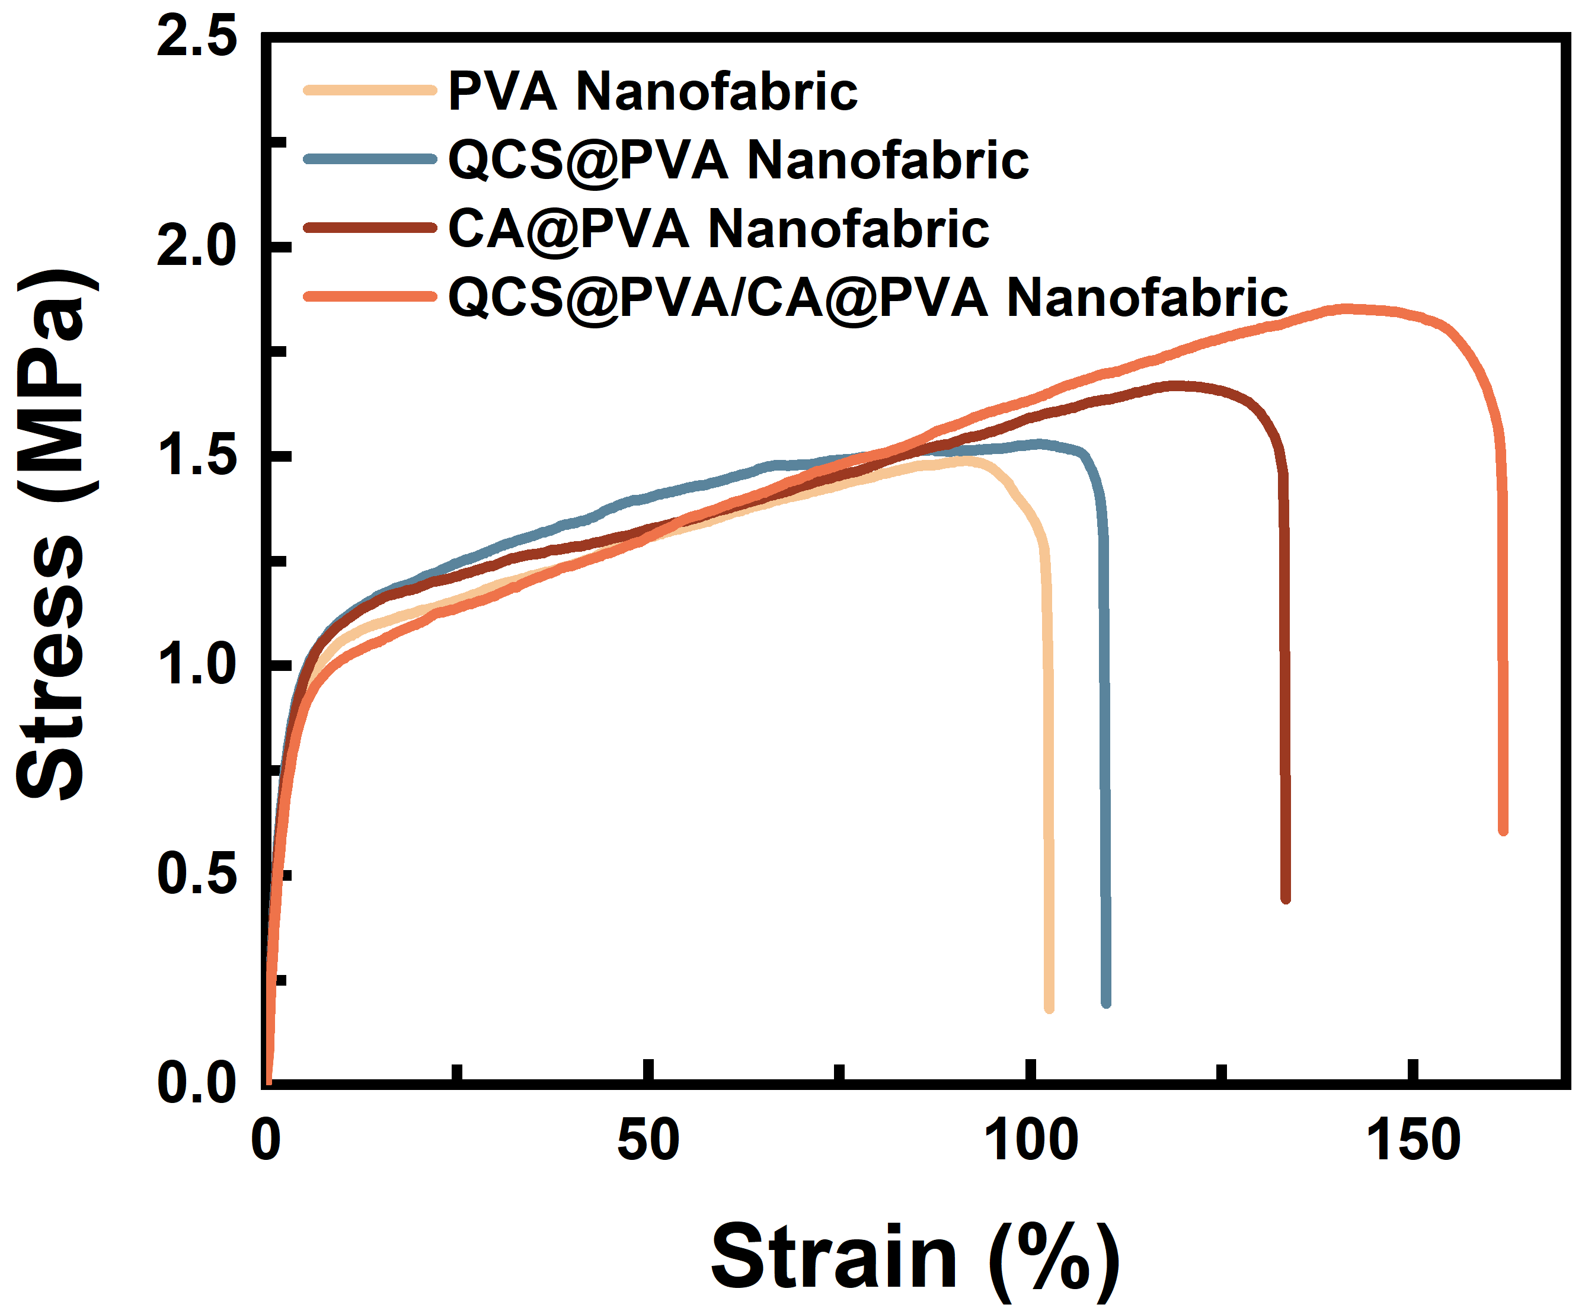
Figure S1 The mechanical properties of PVA nanofabric, QCS@PVA nanofabric, CA@PVA nanofabric, and QCS@PVA/CA@PVA nanofabric.

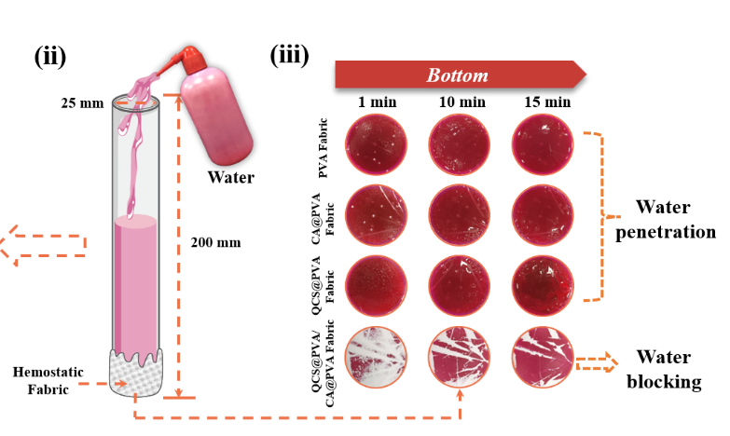
Figure S2 Water penetration behavior on the bottom surface of PVA nanofabric, CA@PVA nanofabric, QCS@PVA nanofabric, and QCS@PVA/CA@PVA nanofabric.

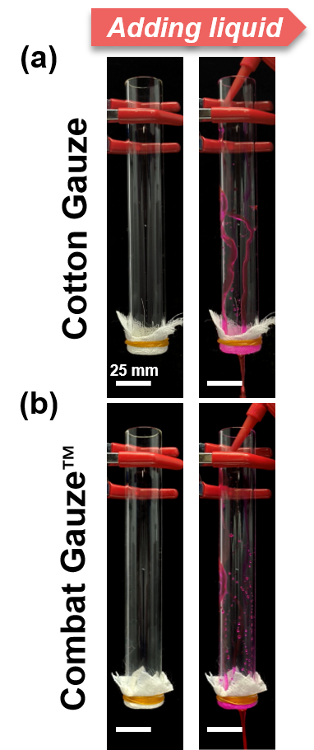
Figure S3 Water rapidly penetrated through cotton Gauze and Combat GauzeTM.
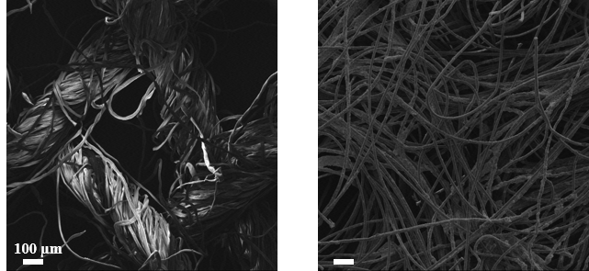
Figure S4. SEM images of Cotton Gauze (left) and Combat GauzeTM (right).

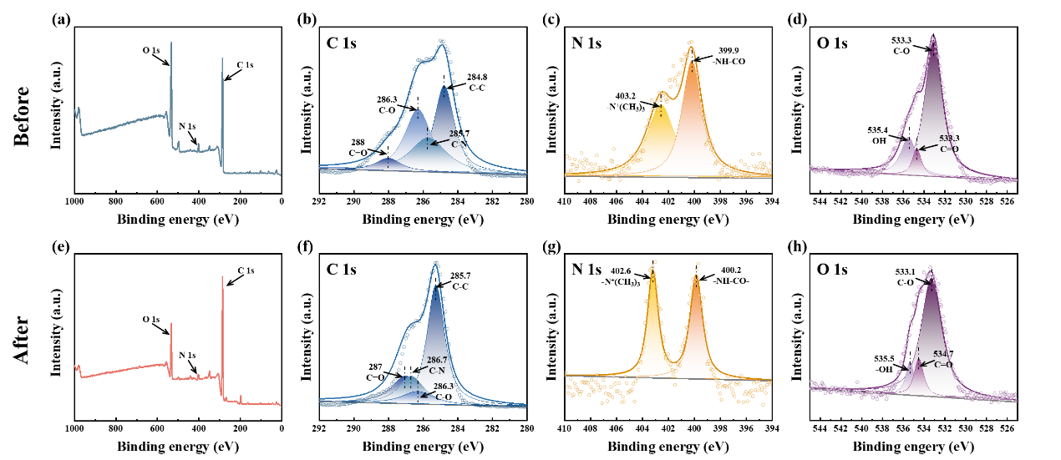
Figure S5. XPS spectra of QCS@PVA/CA@PVA nanofabric before and after wetted by water.
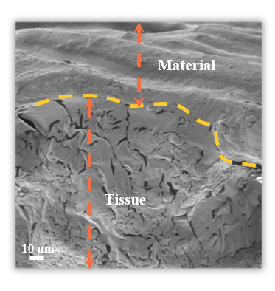
Figure S6. SEM images of the interface between porcine skin and QCS@PVA/CA@PVA nanofabric.

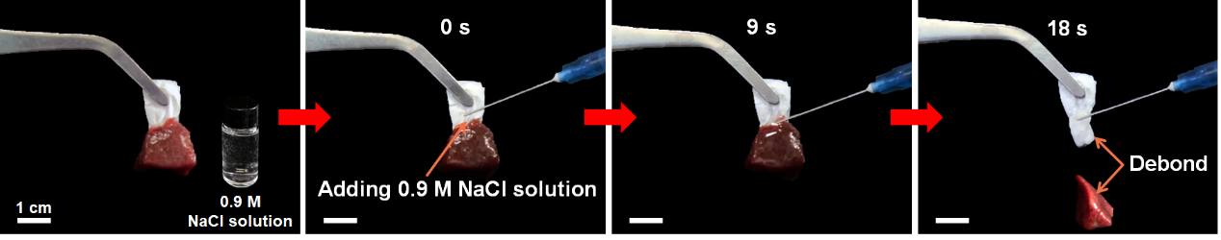
Figure S7. Debonding of the QCS@PVA/CA@PVA nanofabric by the addition of 0.9% NaCl solution.
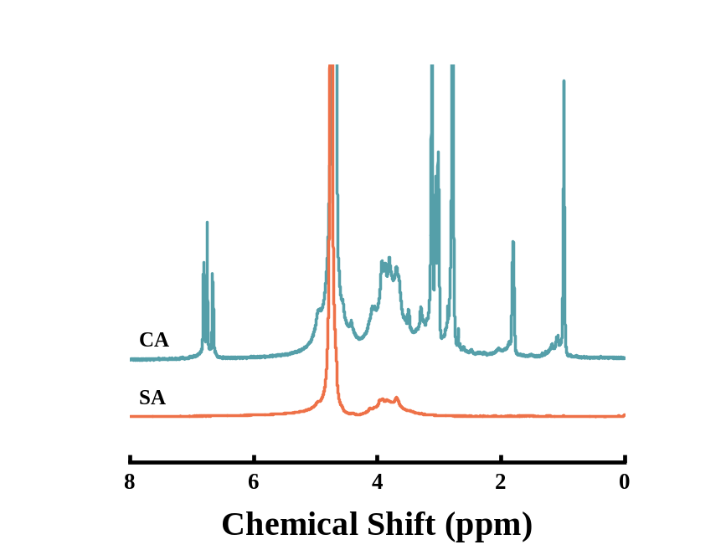
Figure S8. ¹H NMR spectrum of SA and CA.
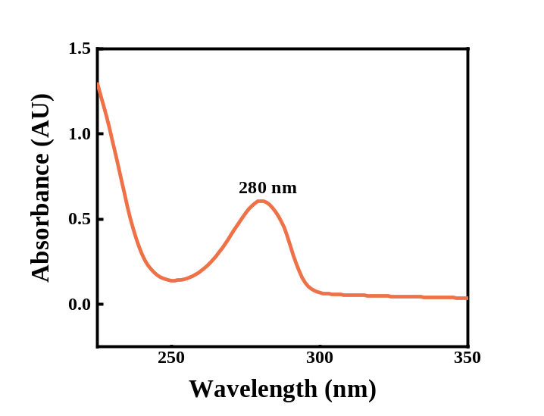
Figure S9. UV-vis profile of CA.

