SUPPLEMENTARY FIGURES

Figure S1

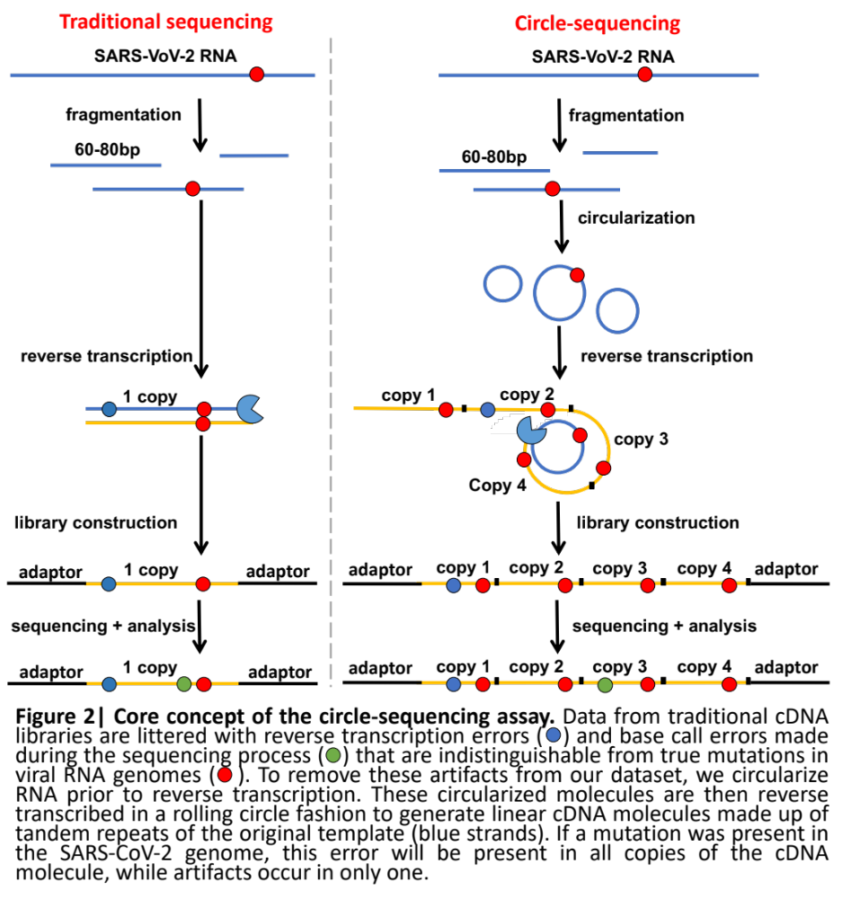

Figure S1| Core concept of the circle-sequencing assay. Data from traditional cDNA libraries are littered with reverse transcription errors ( ) and base call errors made during the sequencing process ( ) that are indistinguishable from true mutations in viral RNA genomes ( ). To remove these artifacts from our dataset, we circularize R NA prior to reverse transcription. These circularized molecules are then reverse transcribed in a rolling circle fashion to generate linear cDNA molecules made up of tandem repeats of the original template (blue strands). If a mutation was present in the SARS-CoV-2 genome, this error will be present in all copies of the cDNA molecule, while artifacts occur in only one.

Figure S2
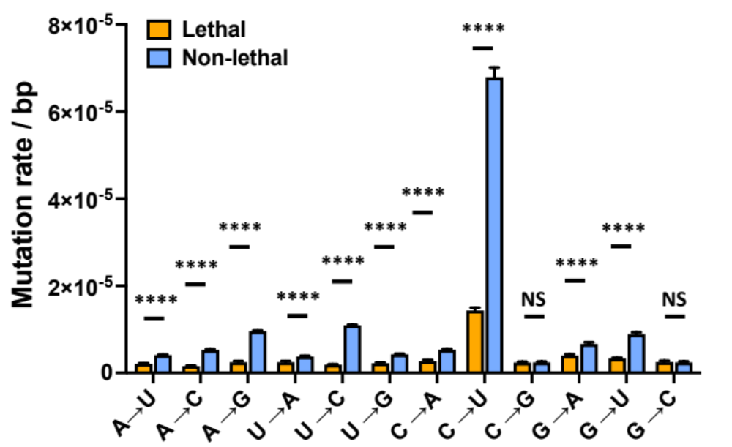

Figure S2| Mutation frequency of mutations that are predicted to be lethal or highly detrimental compared to mutations in the rest of the genome. Consistent with the idea that the mutations we selected as lethal or highly detrimental for benchmarking purposes, we found that most mutations had a significantly lower mutation frequency compared to mutations that elsewhere in the genome. Error bars represent standard error of the mean.

Figure S3
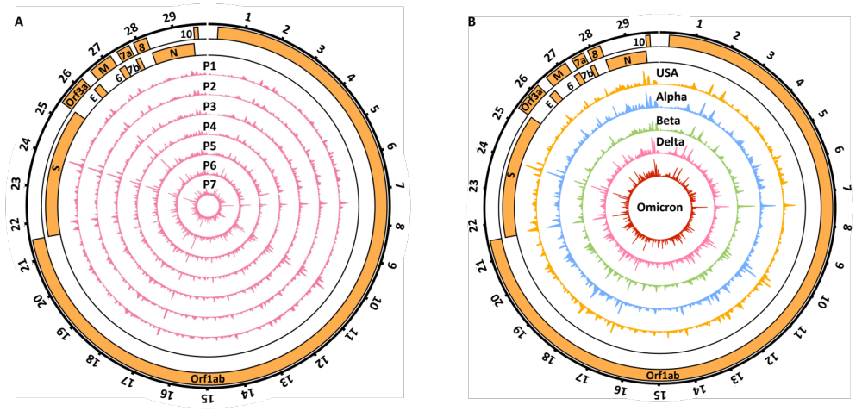

Figure S3| Coverage of SARS-CoV-2 strains. The sequencing coverage of the SARS-CoV-2 virus depends directly on the pattern of RNAseIII cleavage, which depends on the presence or absence of secondary structures. This pattern remains the same across all passages (A, Delta strain) and is nearly identical between strains (B), indicating strong conservation of the secondary structures of the SARS-CoV-2 genome. Genes are depicted on the two outer rings, coverage peaks (arbitrary units) are depicted in the inner rings, and the location of genes and coverage along the genome is depicted in 1kb intervals. P1 to P7 indicate passage number.

Figure S4
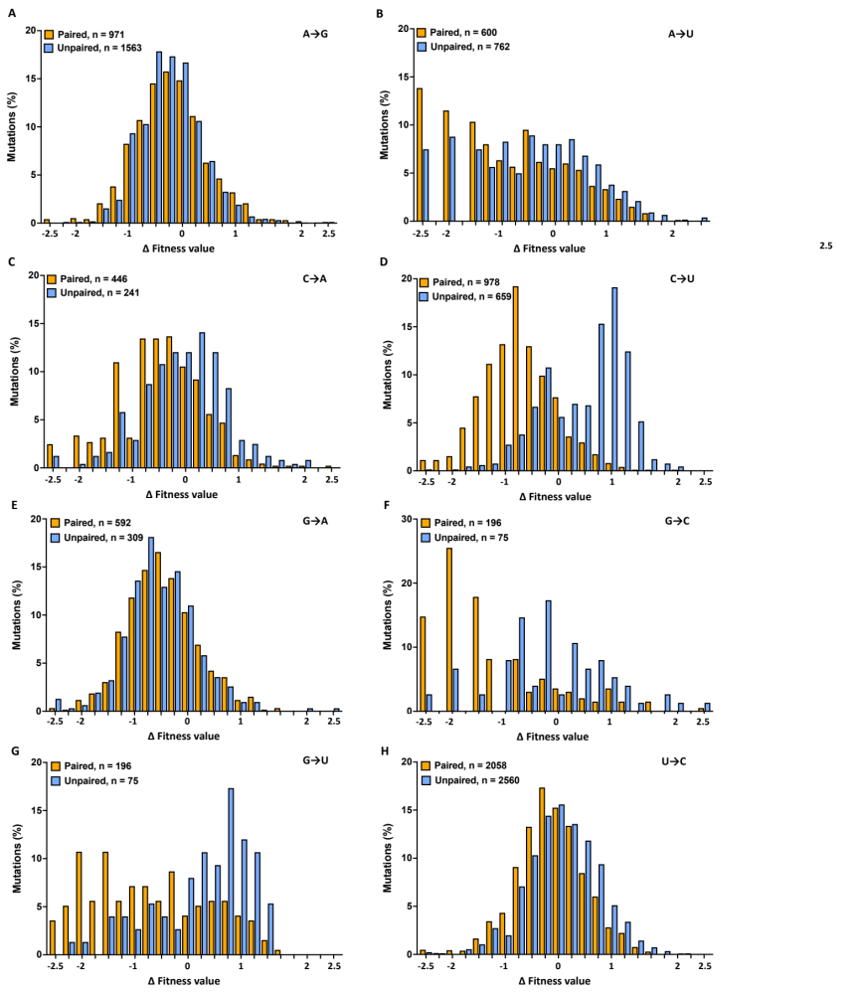

Figure S4| Distribution of fitness values from Bloom and Neher (2023), split for paired and unpaired bases. Only A→G and G→A mutations did not show a significant difference in fitness values under paired or unpaired circumstances.
Figure S5
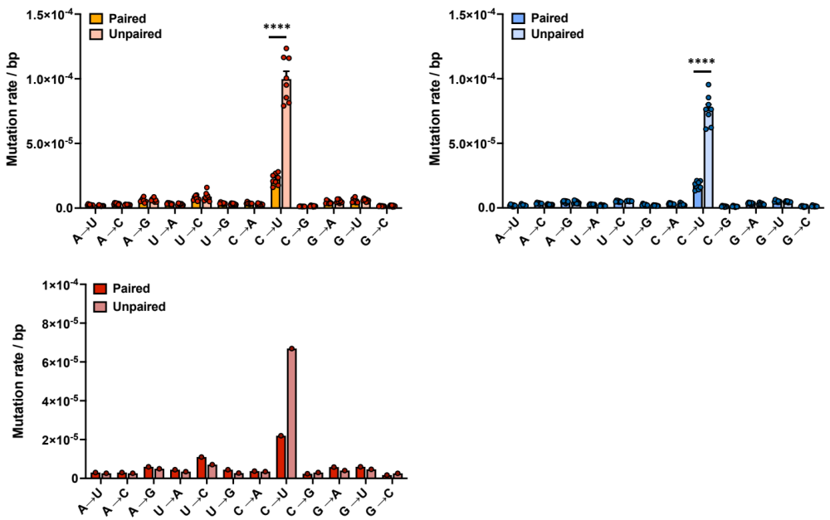

Figure S5| Mutation spectra of paired and unpaired bases of 3 SARS-CoV-2 strains. The rate of C →U mutations, but not other mutations, is increased in unpaired versus paired bases tin he USA, Alpha, and Omicron strains of SARS-CoV-2. **** = P<0.0001, paired t-test.

