Supporting Information for

Neutrophil chemotaxis score and chemotaxis-related genes have the potential for clinical application to prognosticate the survival of patients with tumours

Yunxi Yang, Jun Yang, Linbin Li, Yiming Shao, Lu Liu, Bingwei Sun*

* Corresponding author: Bingwei Sun

Email: sunbinwe@hotmail.com

This PDF file includes:

Supporting Materials and Methods
Figures S1 to S10
SI References

SI Materials and Methods

Materials
Ethics declarations
This study was approved by the Medical Ethics Committee of Suzhou Hospital Affiliated to Nanjing Medical University (approval number: KL901390). PB samples were obtained from healthy voluntary blood donors and individuals with tumours through the median cubital vein. All participants were informed about the study and provided written consent for the use of their blood samples for research purposes prior to inclusion.
Participant selection
Between May 2022 and November 2022, 164 adult patients with primary tumours were recruited from the Oncology Department of Suzhou Hospital Affiliated to Nanjing Medical University. The residual blood samples collected upon admission prior to any treatment were used for the analysis of chemotactic function in neutrophils. Exclusion criteria included severe infections, major trauma, immune-related diseases, neutropenia (neutrophil count <2 × 10⁹ cells/L), pregnancy, or hematologic malignancies. During the same period, 73 adult volunteers with standard health examination results were recruited from the Suzhou Health Examination Centre for the assessment of the chemotactic function of neutrophils in PB.
Clinical data collection
This study collected and analysed data from 425,252 healthy individuals with unremarkable health examination results at Suzhou Health Examination Centre between 2017 and 2022, and 16,016 inpatient cases from the Oncology Department of Suzhou Hospital Affiliated to Nanjing Medical University, during the same period. The analysis focused on WBC and neutrophil counts from routine blood tests (Table 1). Furthermore, data on gender, age, diagnosis, WBC count, neutrophil count, and lymphocyte count were collected from all participants (Table 2).
Neutrophil purification
PB samples from both patients with tumours and healthy volunteers were subjected to neutrophil isolation and purification using the EasySepTM Direct Human Neutrophil Isolation Kit (STEMCELL Technologies, Canada) following manufacturer’s instructions. The obtained cells were cultured in Roswell Park Memorial Institute (RPMI) 1640 medium (Gibco, Canada) supplemented with 10% foetal bovine serum (FBS) (Corning, New Zealand) at a cell density of 1 × 10⁹ cells/mL.
Assessment of chemotactic function of neutrophils
The chemotactic function of neutrophils was examined using an under-agarose chemotaxis assay. Firstly, culture dishes containing agarose gel were prepared according to the formulation used in previous studies⁴¹. Next, three small holes were made in the agarose using a puncher. The excess agarose and any exudate water were removed from the holes. Subsequently, 10 µL of cells were added to the side holes, whilst 10 µL of 0.1 µM fMLF (Sigma Aldrich, USA) was added to the central hole. The culture dish was placed in a CO₂ incubator at 37°C for 2 h. The original images of neutrophil chemotaxis were observed and captured using an Olympus IX73 microscope in a phase-contrast mode, with a 4× objective lens and a 10× eyepiece. The images were uploaded to the Construction of the Cell Chemotaxis Analysis Platform (CCAP) for further analysis, as described in the previously published study¹ (Fig.1b). The specific values of the following chemotaxis indicators were obtained: chemotaxis distance (CD), maximum speed of chemotaxis (Vmax), chemotactic cell ratio (CCR), chemotaxis index (CI), and chemotactic function score (CFS). Among these indicators, a CFS score of 15 is indicative of normal neutrophil chemotactic function, while scores of 11–14, 7–10, 4–6, and ≤3 showed mild, moderate, severe, and extremely severe abnormalities, respectively.
Neutrophil- and chemotaxis-related biomarkers
The gene sets related to neutrophils and their chemotaxis were retrieved as biomarkers to replicate the process of neutrophil chemotaxis from PB to tissues. The model was primarily established using two parts consisting of 155 genes, including the neutrophil-related gene sets summarized in the study of Şenbabaoğlu et al.², and the gene sets related to chemotaxis summarized in Gene Set Enrichment Analysis (GSEA) (https://www.gsea-msigdb.org/gsea/index.jsp).
Materials and data sets
In this study, pan-cancer expression profile data were initially retrieved from The Cancer Genome Atlas (TCGA) through the University of California Santa Cruz (UCSC) Xena browser, comprising 8,980 cases across 32 tumour types, excluding acute myeloid leukaemia (https://xenabrowser.net/datapages/). Clinical information of patients in TCGA was downloaded from the cBioPortal database. The TCGA data were randomly categorized into training and testing sets in a 7:3 ratio, respectively, for the development and validation of the ChemoScore model based on neutrophil-chemotaxis scores. To further validate the ChemoScore model in external data, gene expression and matched survival data were collected from eight independent datasets, including Chinese Glioma Genome Atlas (CGGA, n = 1,314) (http://www.cgga.org.cn/), Molecular Taxonomy of Breast Cancer International Consortium (METABRIC, n = 1,980) (https://ega-archive.org/dacs/EGAC00001000484), and other datasets from Gene Expression Omnibus (GEO) (https://www.ncbi.nlm.nih.gov/geo/). These datasets were related to colorectal cancer (CRC) (GSE87211 [n = 196], GSE33113 [n = 90]), rectal cancer (GSE40492 [n = 219]), colon cancer (GSE39582 [n = 585]), lung cancer (GSE3141 [n = 111], GSE8894 [n = 138]), and BRCA (GSE2990 [n = 122], GSE19615 [n = 115]).
Construction of a pan-cancer prognostic model related to neutrophil chemotaxis
The aforementioned 155 genes were subjected to LASSO algorithm for gene selection, resulting in genes significantly associated with prognosis. LASSO regression was conducted using the R package “glmnet” with the parameter set as “family = cox”³. This method simplifies the model and avoids overfitting during the training process. Optimal regularization parameters were selected for LASSO regression based on a standard error rule, resulting in the most economical model with non-zero coefficients for the selected genes. Subsequently, multivariable Cox regression analysis was conducted to examine the correlation between the expression levels of each gene and DSS, obtaining the corresponding regression coefficients (β) for these genes. Cox regression was implemented using the function “coxph” from the R package “survival.” ChemoScore was calculated as the weighted sum of the normalized expression values of the neutrophil chemotaxis-related genes and their regression coefficients (β), reflecting the risk of DSS for each patient. Finally, the median ChemoScore served as a threshold for categorizing tumour samples into high-risk group (HRG) and low-risk group (LRG).
Immune microenvironment, inflammation, and other cancer signature scores
The recognized signature gene sets for immune microenvironment, provided by Bindea et al.⁴, and signature gene sets for cell cycle and epithelial-mesenchymal transition (EMT), provided by Zhang et al.⁵, other gene sets summarized in GSEA, were utilised to calculate the single-sample gene set enrichment analysis (ssGSEA) scores. This analysis was performed using the R software package “GSVA”⁴⁷.
Validation using tissue microarray analysis
Clinical validation was performed using three types of tumour tissue microarrays, including 72 samples of lung adenocarcinoma (LUAD), 60 samples of colon adenocarcinoma (COAD), and 86 samples of stomach adenocarcinoma (STAD). All microarrays were obtained from Shanghai Outdo Biotech Co., LTD. (Shanghai, China). Clinical information of all patients is provided in the Supplementary Table 5. IF staining of tissues was performed using CD66b antibody (ab197678, Abcam, UK) and 4',6-diamidino-2-phenylindole (DAPI) mounting medium (p0131-25, Beyotime, China) following the manufacturer's recommended protocol. CD66b, specific to neutrophil membranes, was used to evaluate neutrophil infiltration in tumour tissues by calculating the ratio of CD66b-positive (CD66b⁺) cells to the total number of cells (DAPI-stained cells).
Statistical analysis
The training and testing datasets were subjected to zero-mean normalization, resulting in data transformation with a mean value set to “0” and the standard deviation to “1”. Kaplan–Meier (KM) analysis was utilised to estimate the difference in survival rates between patients in the LRG and the HRG, and survival curves were plotted accordingly. The log-rank test was employed to compare the survival curves between these two groups. To evaluate the correlation between ChemoScore and patient survival rate, the hazard ratio (HR) and the corresponding 95% confidence interval (CI) were obtained through Cox proportional hazards regression. Furthermore, the predictive performance of ChemoScore for 3-, 5-, and 10-year survival rates was determined by calculating the area under the receiver operating characteristic (ROC) curve (AUC). The Kruskal–Wallis test was employed to examine categorical clinical features of ChemoScore across multiple groups. Conversely, the Wilcoxon test was employed to compare the ChemoScore between the two groups. The association of numerical clinical features or immune features with ChemoScore was assessed using the Spearman correlation test, with the results reported as correlation coefficients and p-values. A multivariable Cox regression analysis was initially conducted to construct and substantiate a prognostic nomogram illustrating the relationship between predictor variables and outcomes. Multiple predictive indicators, including clinical factors, were then integrated to provide personalised survival predictions for each patient. The clinical benefit of incorporating clinical features into the ChemoScore model was assessed using decision curve analysis (DCA). Unless otherwise specified, all reported p-values were two-sided, and a significance level of 0.05 was applied for all analyses. Statistical analysis and graphical representations were performed using the R/Bioconductor programming environment (R version 4.2).
In the analysis of clinical data from blood routine and PB neutrophil chemotaxis tests, differences between the two groups were compared using Student's t-test and Mann–Whitney U test. IF images of tissue microarrays were examined using the APTIME software developed by 3D Medicines. The proportions of three tumour-infiltrating CD66b⁺ cells were compared using one-way analysis of variance (ANOVA) with median-based grouping. KM analysis was used to evaluate the probability of survival outcomes for high CD66b expression (CD66b_{high}) and low CD66b expression (CD66b_{low}), with significance between groups determined using the log-rank test. Multivariable Cox regression was used to analyse the significance of neutrophil infiltration in predicting patient mortality. All statistical analyses and figures were generated using GraphPad Prism software (version 9.4).

SI Figures S1 to S10

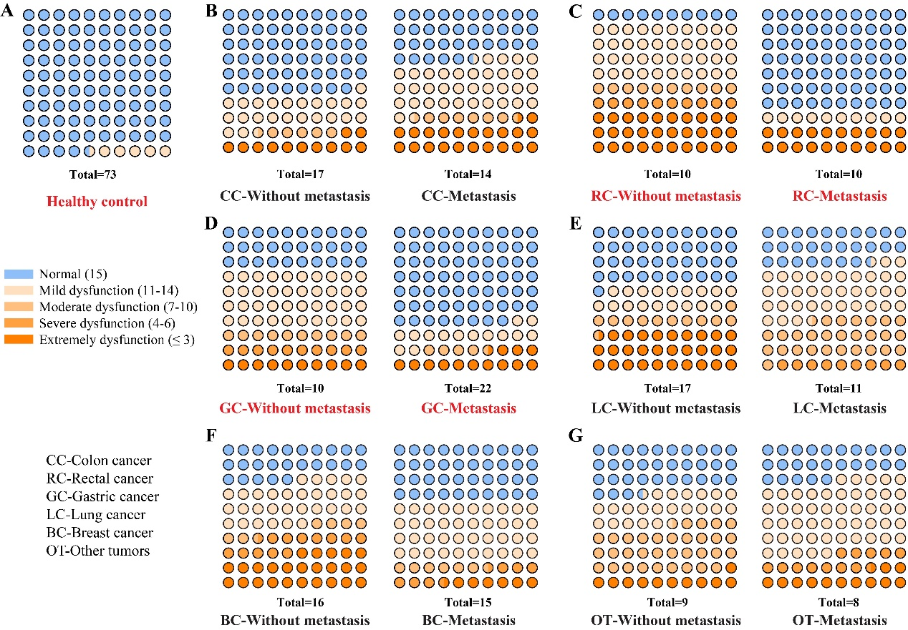
Figure S1. Distribution of CFS percentage in various tumour types.

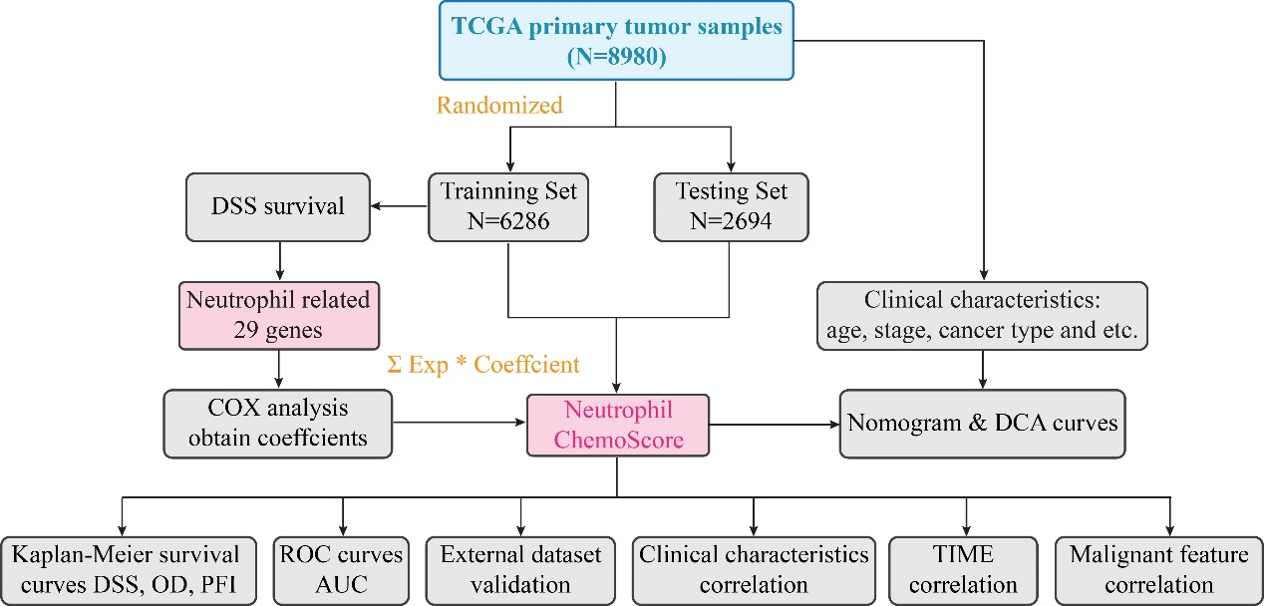
Figure S2. Flowchart depicting the construction and validation process of the ChemoScore model.
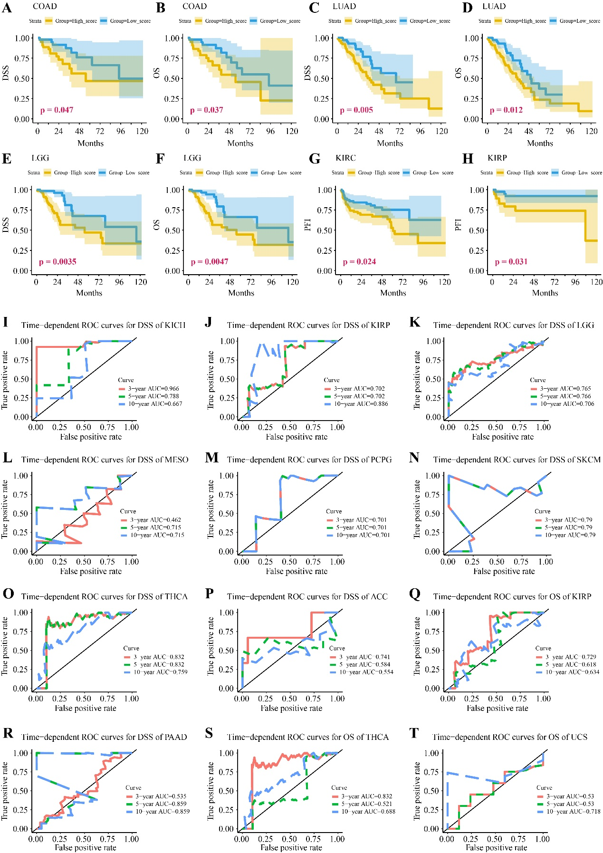
Figure S3. Strong predictive capabilities of ChemoScore exhibited in various tumours in TGGA test set. (A-H) KM survival curves for COAD, LUAD, LGG, KIRC, and KIRP classified based on ChemoScore. (I-T) Time-dependent ROC curves for ACC, LGG, KICH, KIRP, MESO, PAAD, PCPG, SKCM, THCA, and UCS classified based on ChemoScore.
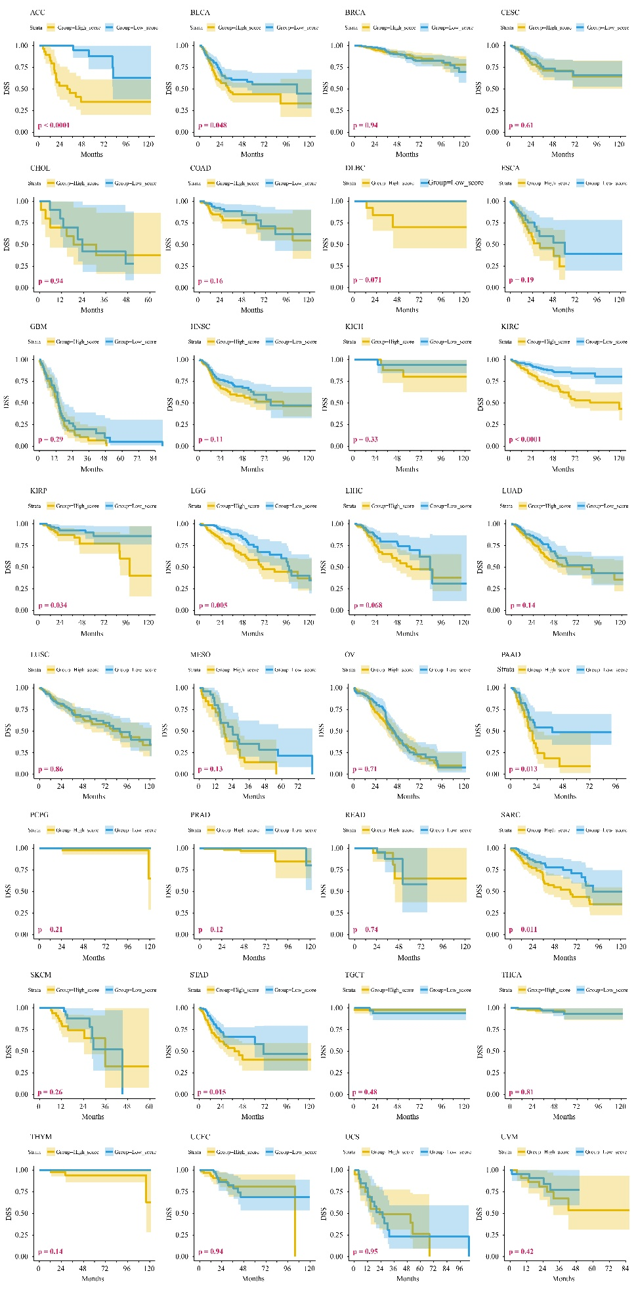
Figure S4. KM survival curves for DSS in patients with 32 tumour types in the TCGA training set.
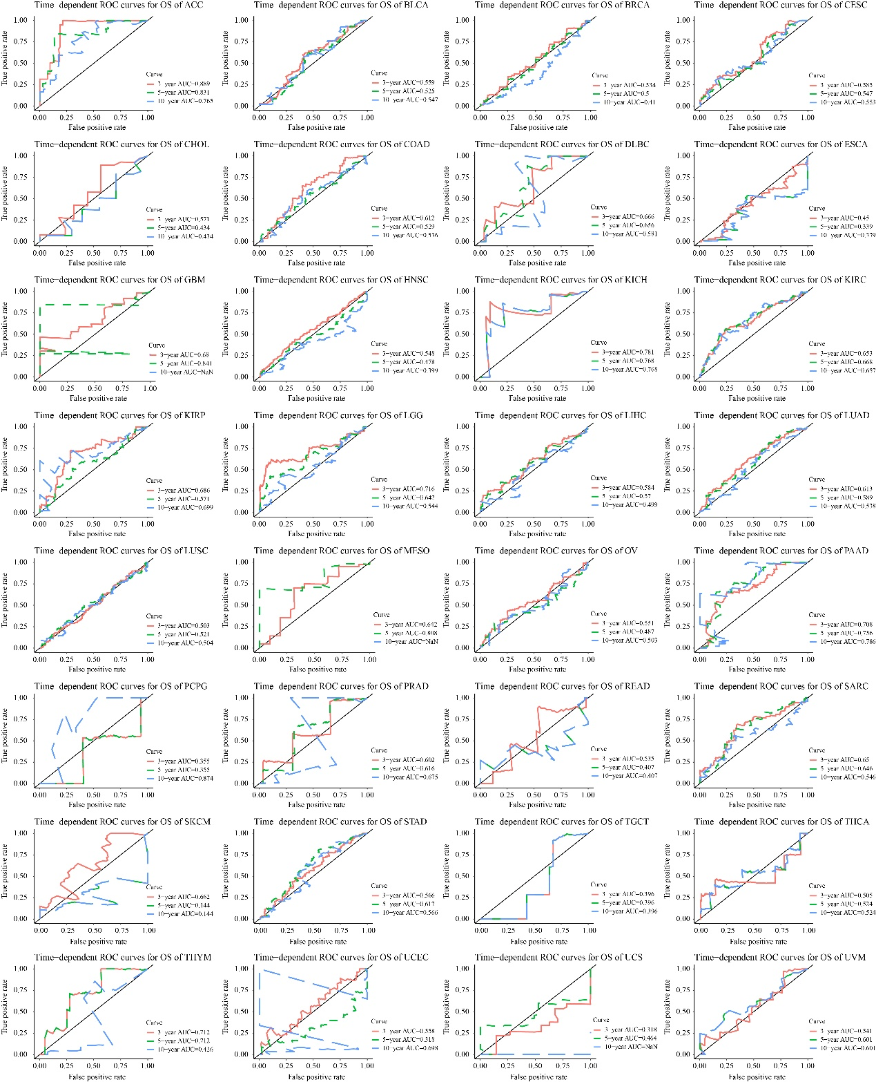
Figure S5. Time-dependent ROC curves for DSS in patients with 32 tumour types in the TCGA training set.

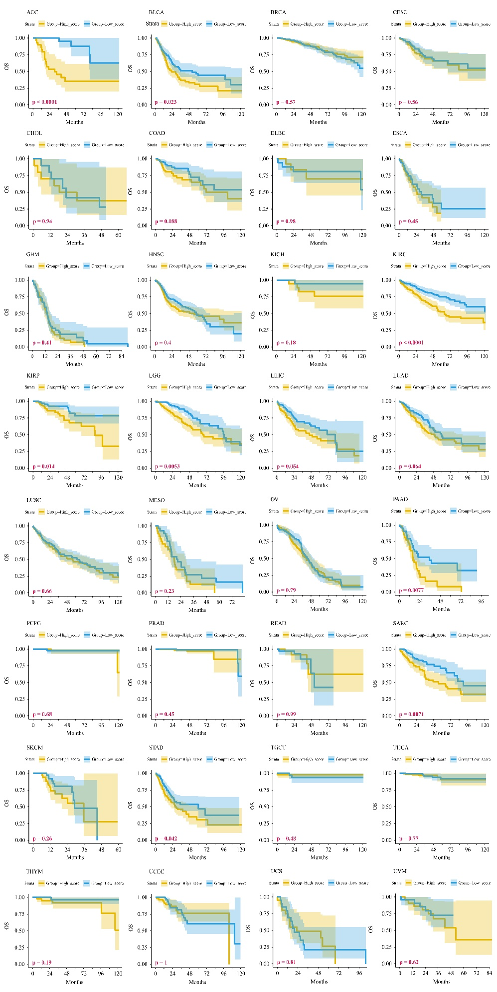
Figure S6. KM survival curves for OS in patients with 32 tumour types in the TCGA training set.
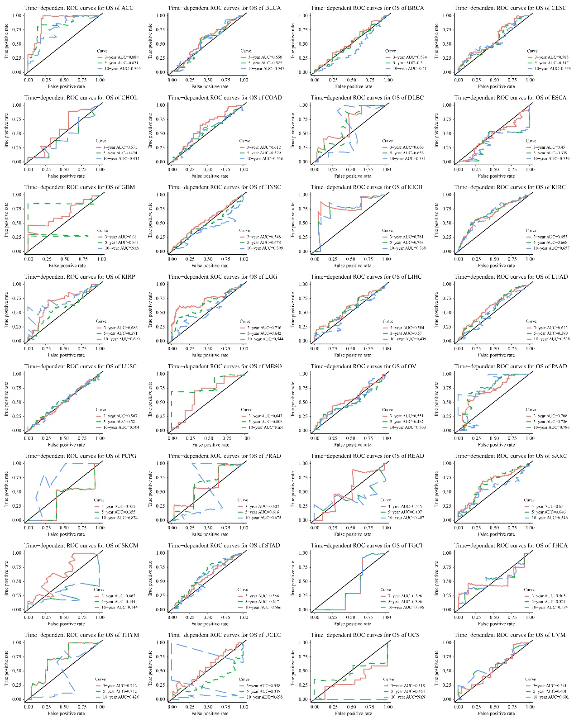
Figure S7. Time-dependent ROC curves for OS in patients with 32 tumour types in the TCGA training set.

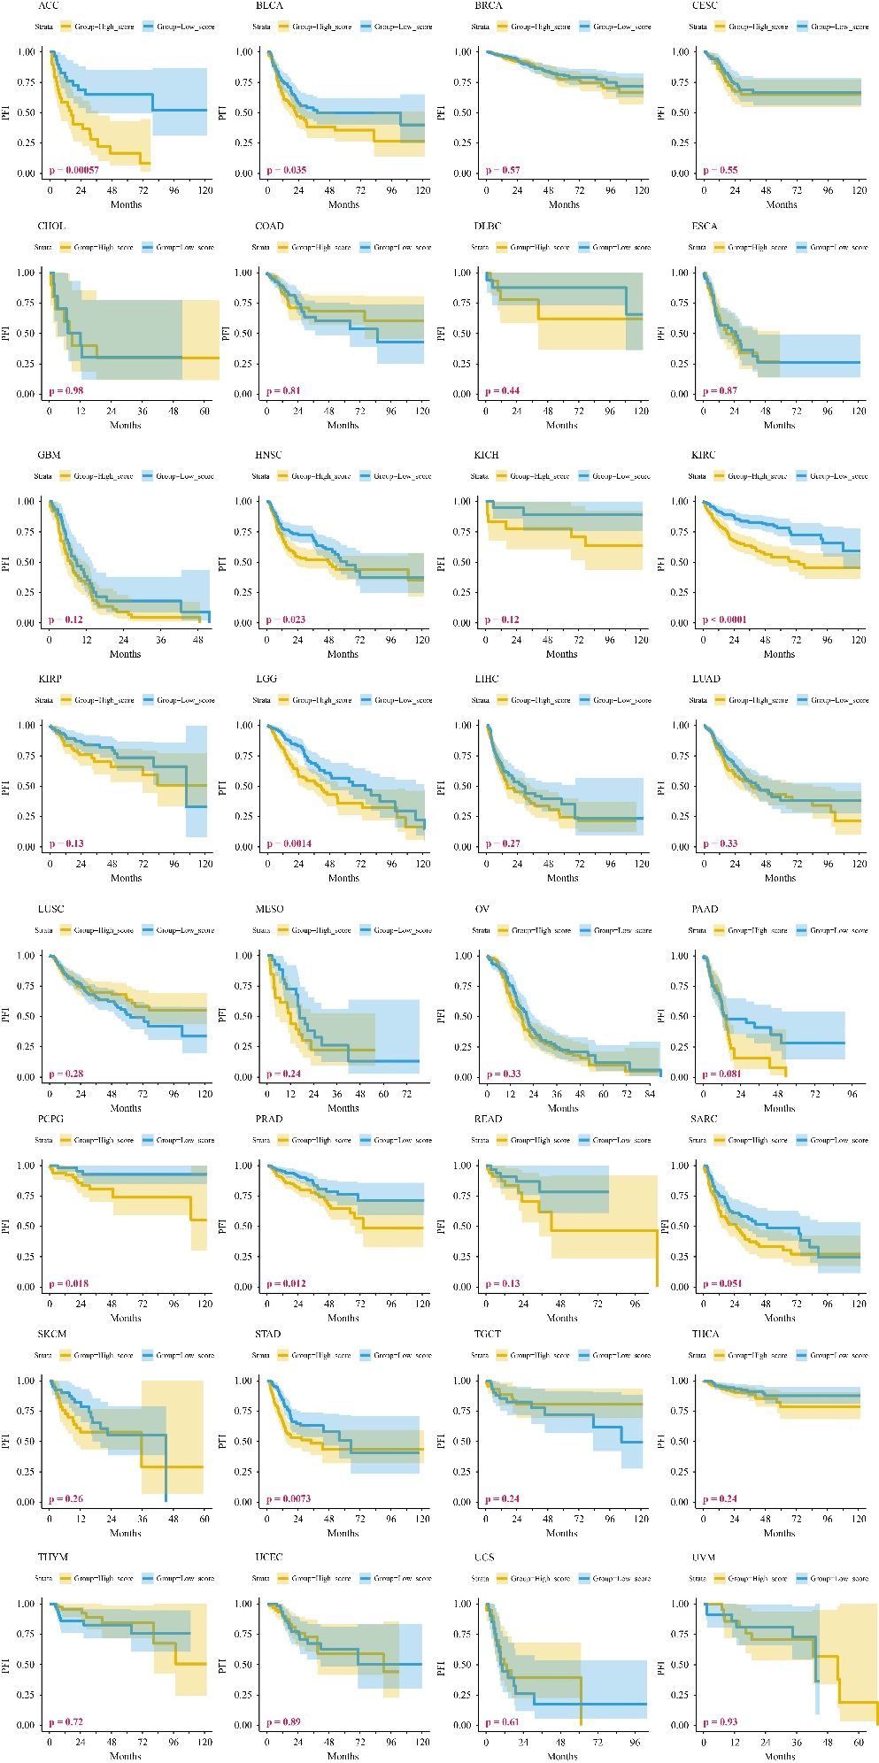
Figure S8. KM survival curves for PFI in patients with 32 tumour types in the TCGA training set.
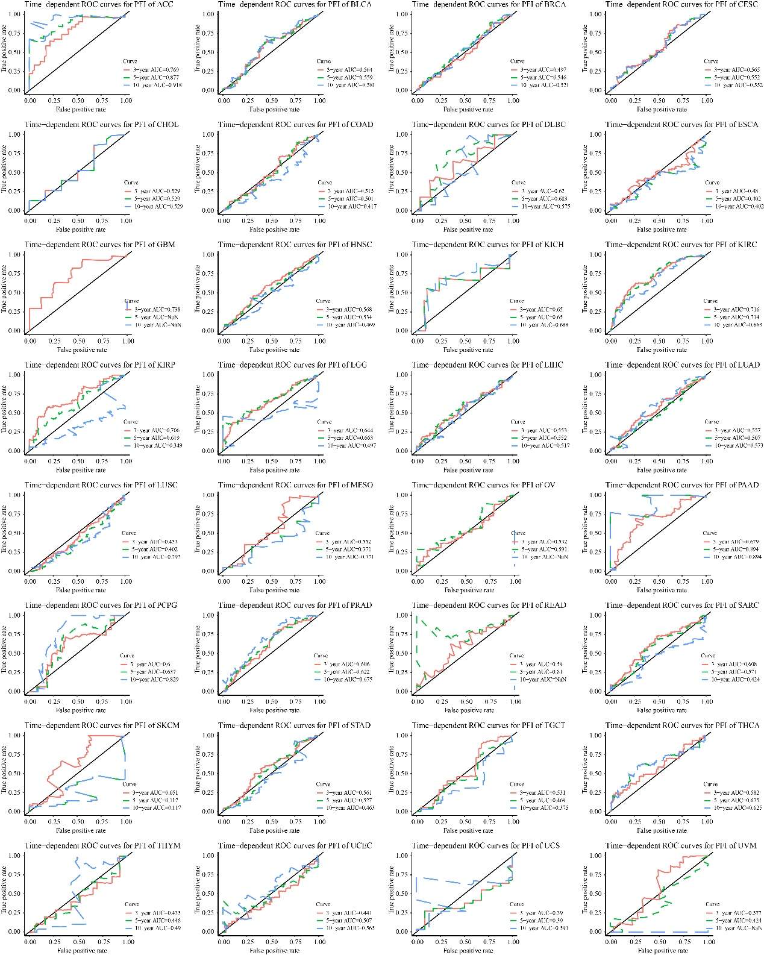
Figure S9. Time-dependent ROC curves for PFI in patients with 32 tumour types in the TCGA training set.

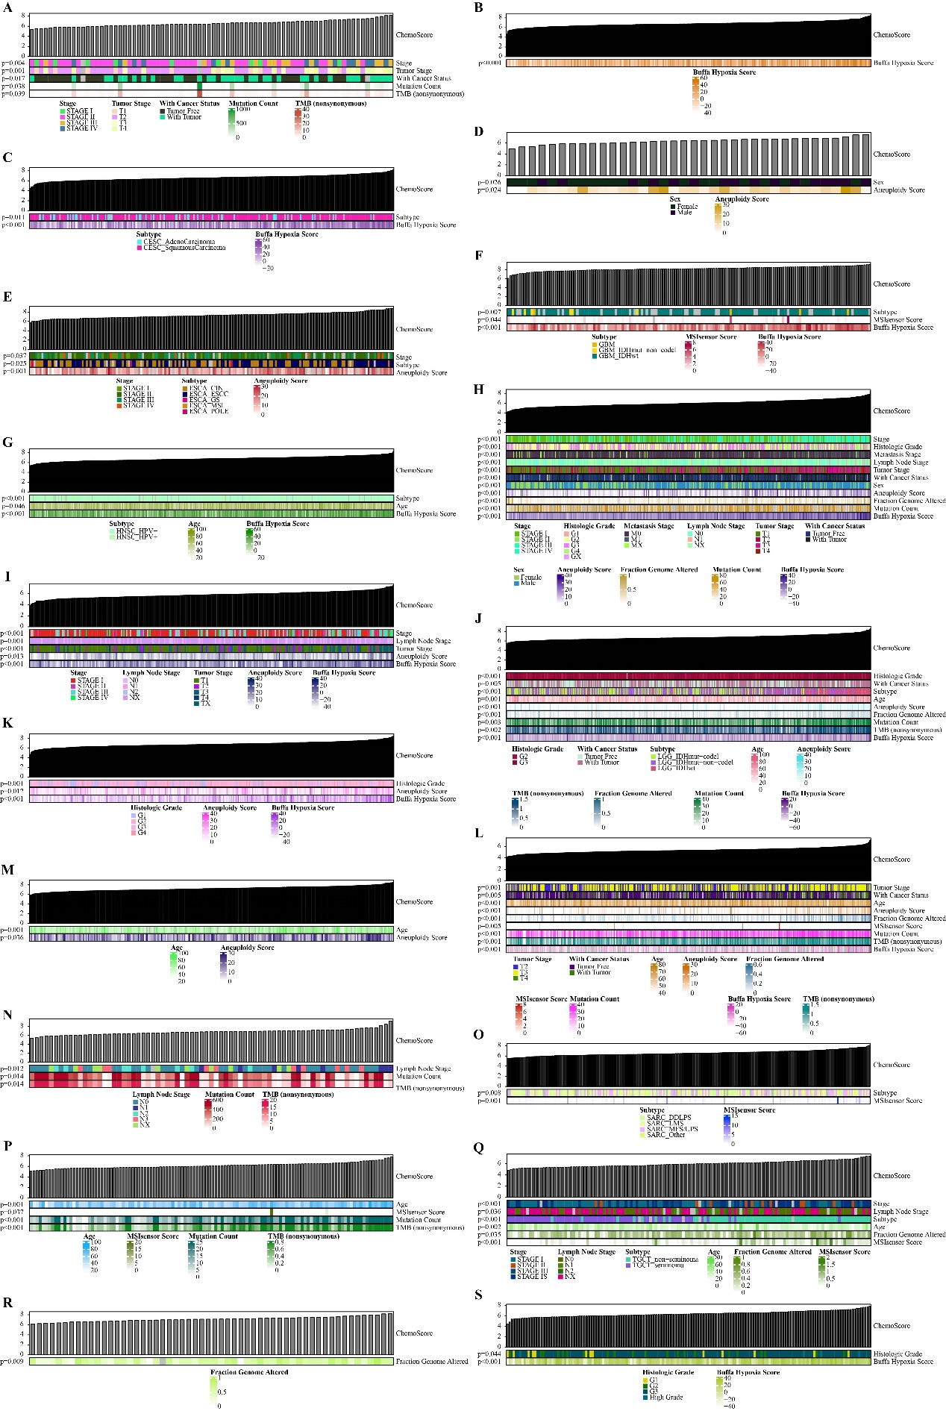 Figure S10. Correlation between ChemoScore and clinical baseline characteristics of patients with tumours.
SI References

- Yang Y, et al. (2021) A novel computer vision-based assessment of neutrophil chemotaxis in patients with severe infection. Clin Transl Immunology 10(8):e1333.
- Şenbabaoğlu Y, et al. (2016) Tumor immune microenvironment characterization in clear cell renal cell carcinoma identifies prognostic and immunotherapeutically relevant messenger RNA signatures. Genome bio 17(1):231.
- Tay JK, Narasimhan B, & Hastie T (2023) Elastic Net Regularization Paths for All Generalized Linear Models. J Stat Softw 106.
- Bindea G, et al. (2013) Spatiotemporal dynamics of intratumoral immune cells reveal the immune landscape in human cancer. Immunity 39(4):782-795.
- Zhang Y, et al. (2022) A signature for pan-cancer prognosis based on neutrophil extracellular traps. J Immunother Cancer 10(6): e004210.

