Supplement File:

Table S1 Threshold values for antifungal susceptibility test interpretation utilized in our study
Antifungal | Disk concentration | Inhibitory zone diameter (mm)
Antifungal | Disk concentration | R | SDD | S
Fluconazoleª | 25 µg | ≤ 14 | 15–18 | ≥ 19
Itraconazole^{c} | 10 µg | ≤ 9 | 10–14 | ≥ 15
Clotrimazole^{c} | 50 µg | ≤ 11 | 12–19 | ≥ 20
Ketoconazole^{b} | 50 µg | < 10 | 10–20 | > 20
Miconazole^{b} | 50 µg | < 10 | 10–20 | > 20
Nystatin^{c} | 100 U | ≤ 10 | 11–14 | ≥ 15
ª CLSI¹⁵; ^{b} Dota et al.²⁷; ^{c} Khan et al.²⁶. R, Resistant; SDD, Susceptible dose dependent; S, Susceptible.

Table S2 Comparison of obstetric risk factors and previous drug use in patients with acute and recurrent vaginal candidiasis and control group
 | AVC  n (%) | RVC  n (%) | Control  n (%) | P
Age (mean ± SD) | 33,8±8,7 | 35,9±9,9 | 37,5±11,4 | .087
Smoking history | 1 (2.4%) | 6 (8.2%) | 18 (10.9%) | .065
Pregnancy | 19 (37.3%) | 12 (29.3%) | 63 (32.5%) | .705
Previous number of pregnancies [median (min–max)] | 2 (0–5) | 2 (0–5) | 2 (2–10) | .874
Previous number of delivery  Nulliparous  Primiparous  Multiparous | 6 (17.6%)  13 (38.2%)  15 (44.2%) | 4 (18.2%)  7 (31.8%)  11 (50.0%) | 43 (35.0%)  23 (18.7%)  57 (46.3%) | .179
Previous mode of delivery  VD  CD  VBAC | 13 (38.2%)  14 (41.2%)  1 (2.9%) | 8 (36.4%)  10 (45.5%)  - | 37 (30.3%)  43 (35.2%)  - | .182
Oral antifungal use | - | - | 4 (2.3%) | .772
Topical antifungal use | 7 (15.6%) | 3 (8.6%) | 24 (14.0%) | .628
Topical steroid use | 4 (8.9%) | 2 (5.7%) | 11 (6.4%) | .802
Diabetes mellitus | 1 (2.2%) | 3 (8.6%) | 17 (9.9%) | .245
Hypothyroidism | 2 (4.4%) | 4 (11.8%) | 10 (5.9%) | .409
Hiperthyroidism | 1 (2.2%) | 1 (2.9%) | 3 (1.8%) | .807
Atopic dermatitis | 5 (11.1%) | 3 (8.6%) | 16 (9.4%) | .946
Personal history of allergies | 3 (6.5%) | 4 (11.4%) | 24 (14.0%) | .382
Asthma | 3 (6.5%) | 4 (11.4%) | 19 (11.1%) | .774
Allergic conjunctivitis | 4 (8.9%) | 5 (14.3%) | 24 (14.0%) | .646
Allergic rhinitis | 4 (8.9%) | 5 (14.3%) | 23 (13.5%) | .686
Family history of allergies | 15 (33.3%) | 14 (40.0%) | 15 (8.8%) | .000
ACV, Acute vaginal candidiasis; RCV, Recurrent vaginal candidiasis; VD, Vaginal delivery; CD, Cesarean delivery; VBAC, Vaginal birth after cesarean.
ªThe statistical analysis results presented in the table were conducted among the participants who responded to the survey questions regarding the respective parameter.

Table S3 Comparison of RT-PCR HRMA results obtained in this study with findings reported in the literature
 |  | Melting temperature (T_{m}) (°C)
Candida species | This study |  | Somogyvári et al.⁴⁷ | Nemcova  et al.²⁵ | Bezdicek  et al.^{48§}
C. albicans ATCC 10231 | 84.3 |  | 84.5 | 82.9 | 84.6
C. glabrata ATCC 90030 | 83.1 |  | 83.2 | 81.7 | 83.4
C. krusei ATCC 6258 | 88.9 |  | 88.6 | 86.6 | 88.4
C. tropicalis CBS 13933 | 81.9 |  | 81.8 | 80.7 | 82.3
C. parapsilosis ATCC 90018 | 82.7 |  | 82.6 | 81.5 | 83.1
C. kefyr¶ | 84.2 |  | – | 82.6 | –
C. lusitaniae¶ | 85.0 |  | 85.4 | 83.6 | –
C. inconspicua¶ | 86.8 |  | 86.4 | 84.6 | –
¶Clinical isolates
§In this table, the lowest temperature values reported in the study by Bezdicek et al.⁴⁸ were utilized.

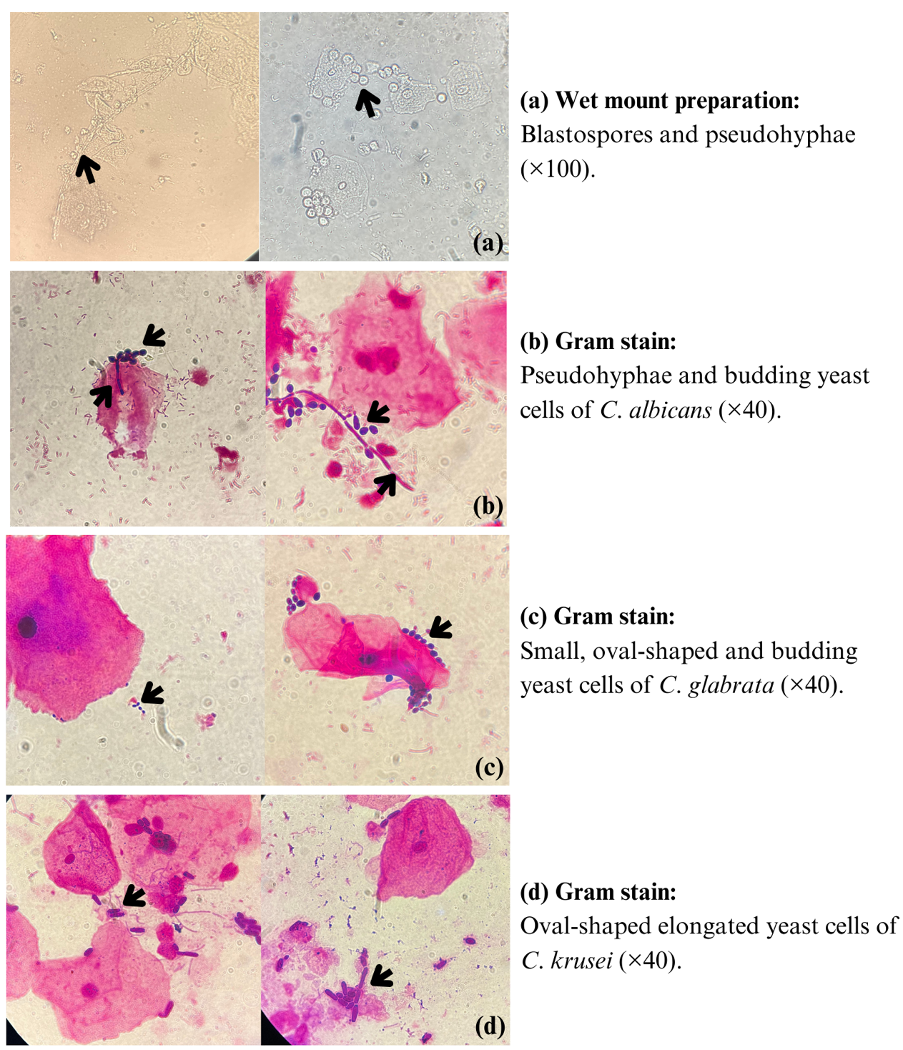
Fig S1 Microscopic examination of vaginal smear

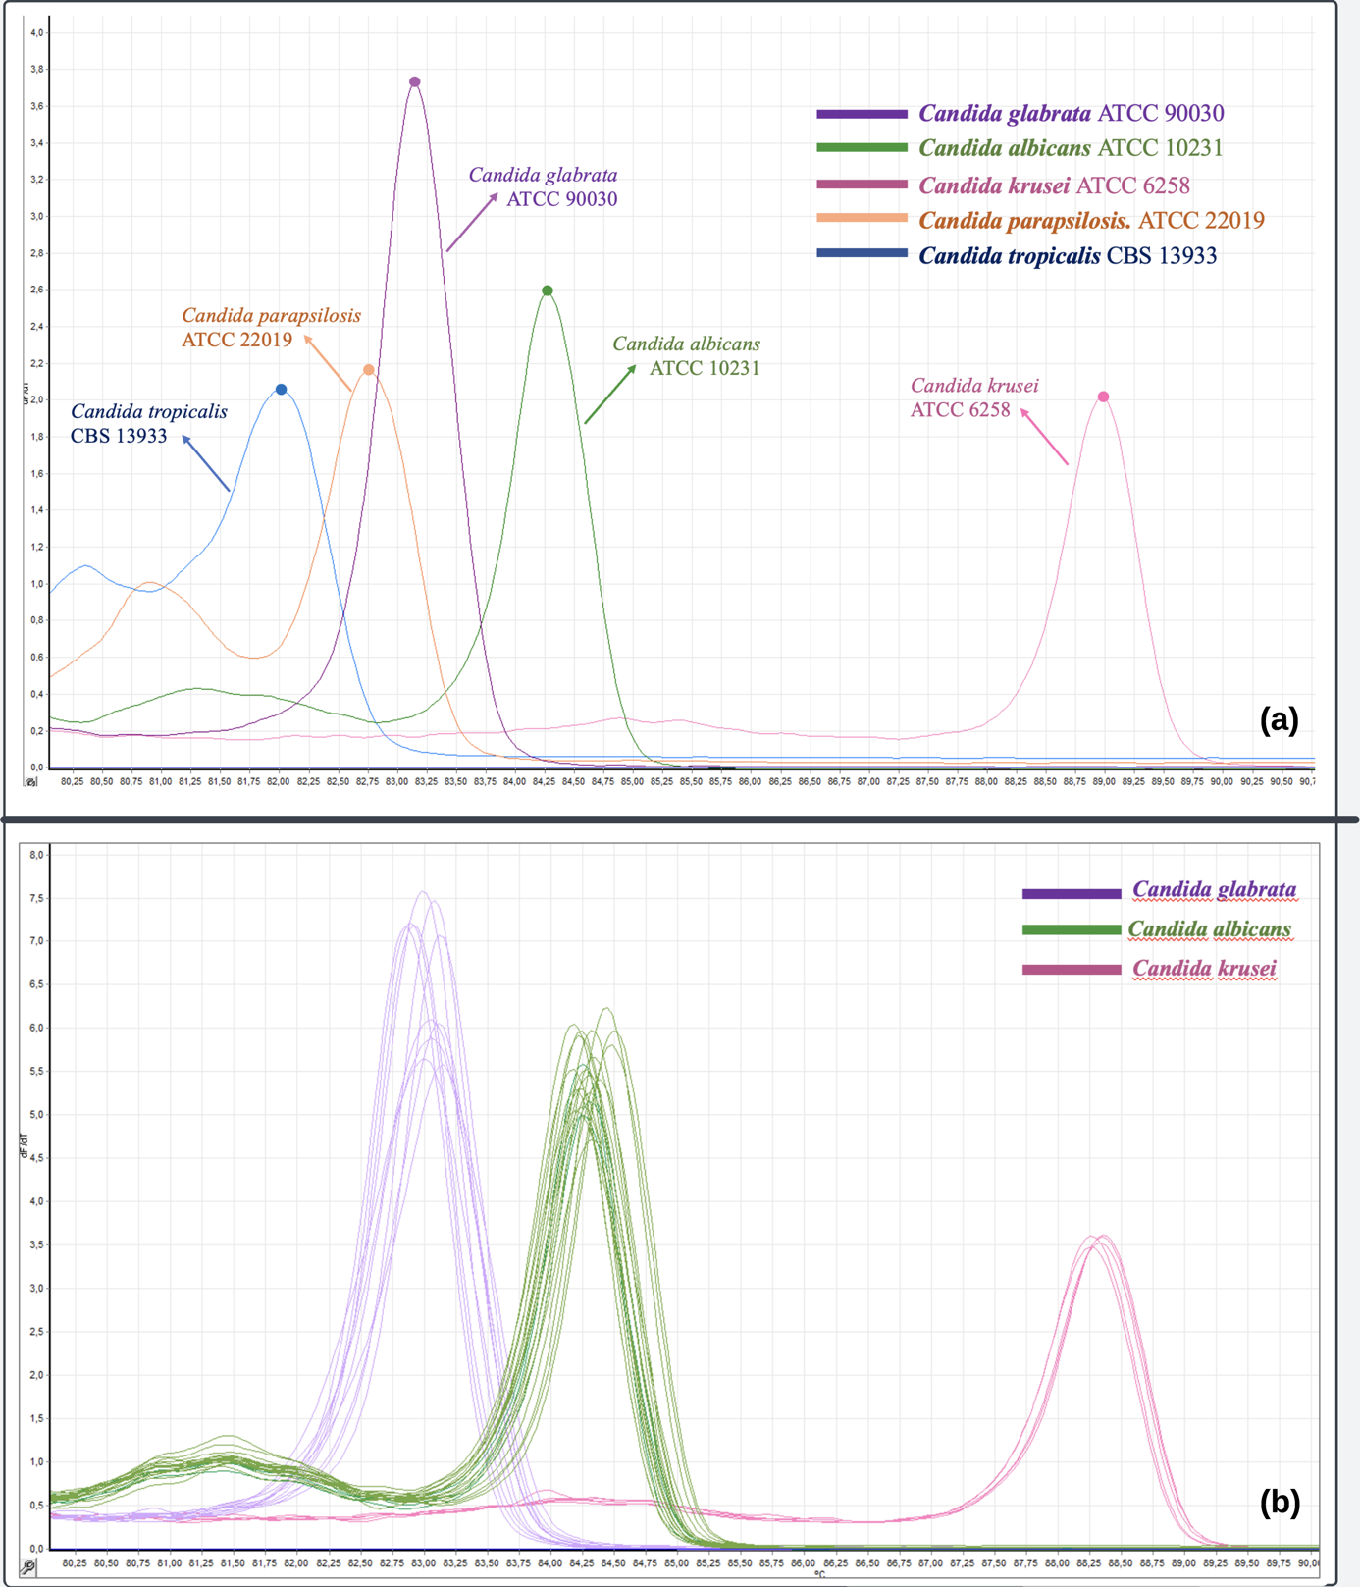
Fig S2 Melting peaks of Candida isolates: (a) reference isolates, and (b) clinical isolates

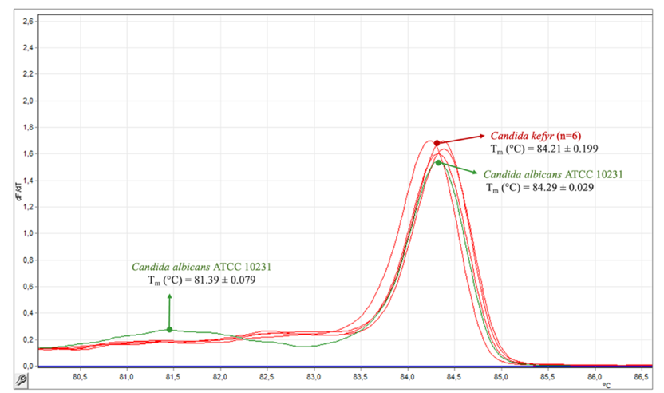
Fig S3 Melting profiles of reference C. albicans and clinical C. kefyr isolates

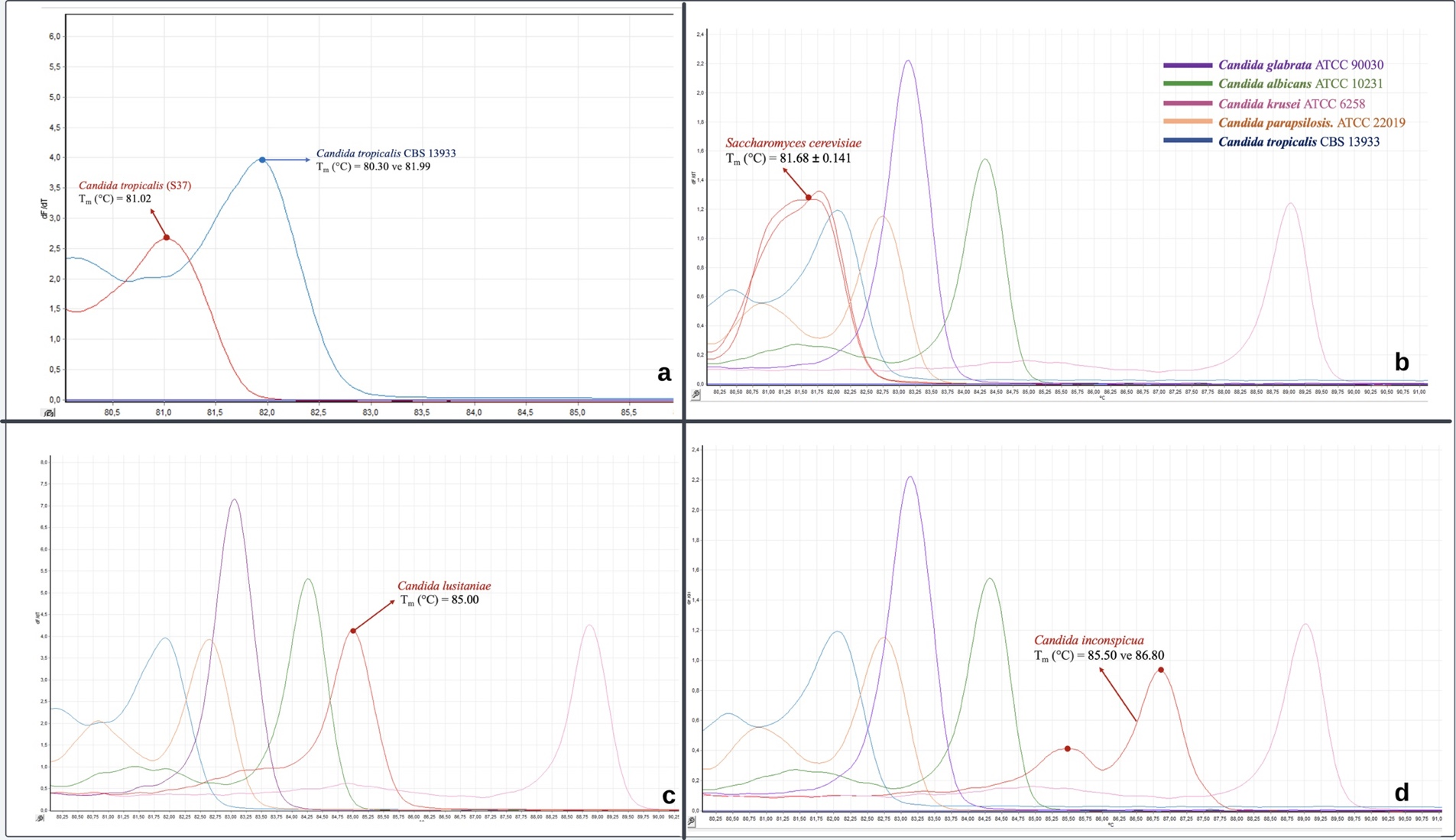
Fig S4 Melting profiles of reference and clinical isolates: (a) C. tropicalis, (b) S. cerevisiae, (c) C. lusitaniae, and (d) C. inconspicua

