Supplementary Figures

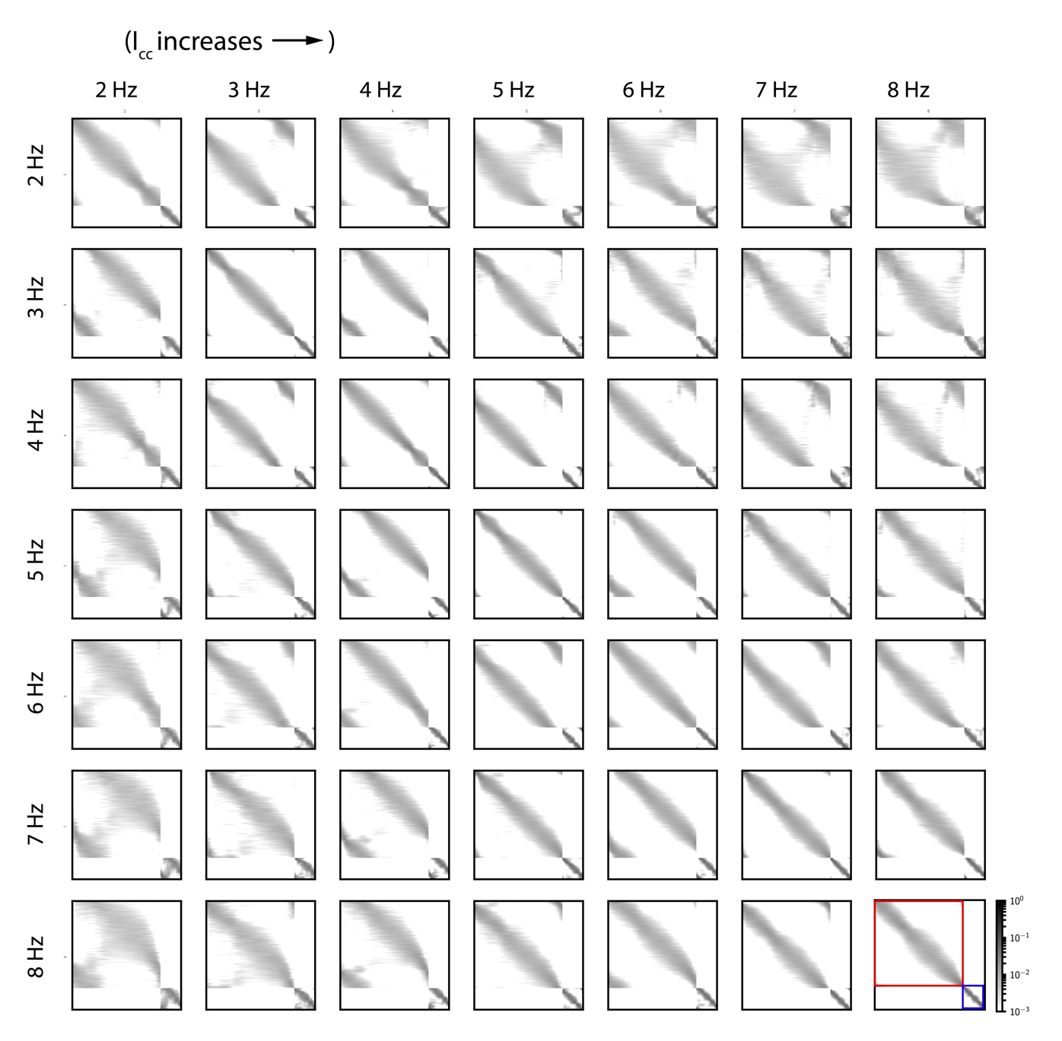

Fig S1. Ordering of unit sequences is highly preserved for nearby frequencies.
Comparing the sequence of units after they have been sorted according to their time of peak firing rate for one stimulus frequency versus another reveals that while neurons do change their position in the firing sequence, they generally move to a firing position that is relatively close to their previous position. For each trial of a given stimulus frequency, neurons are sorted according to the time of their peak firing during one ITI of the continuation phase. Grey intensity at position (i,j) of panel (n,m) indicates the probability that a unit that fired at position i according to the sorting of frequency n will fire at position j according to sorting of frequency m. Excitatory and inhibitory units are sorted separately: for each panel, the upper block corresponds to the excitatory units while the lower block corresponds to the inhibitory units (as illustrated by the red and blue squares of panel (7,7), respectively). The panels on the diagonal indicate how much variability there is in sequences for the same stimulus and thus indicates how much the firing order changes due to noise. The ordering of the inhibitory units seems much more preserved as indicated by the narrower grey cloud along the diagonal for the inhibitory block vs. the excitatory block. There is a small amount of shifting of units between the end and the beginning of each sequence (indicated by the cloud of grey in off-diagonal corners of the excitatory block) but this is to be expected since noise can drive units to fire earlier or later than the ‘tap’ thus affecting their position in the ITI. Comparing the 2 Hz row and 3 Hz column (this corresponds to increasing $I_{cc}$), the grey cloud along the diagonal has shifted downward which suggests that units that fired later in the sequence under 2 Hz now appear earlier in the sequence for 3 Hz. Meanwhile, the probability that a unit that appeared in the middle of the sequence for the 2 Hz sequence would now appear at the beginning or end of the sequence for the 3 Hz sequence is close to zero – this is indicated by the presence of white off of the diagonal in each panel. The opposite pattern occurs when $I_{cc}$ decreases; units that fired earlier in the sequence for 3 Hz now fire later in the sequence for 2 Hz (3 Hz row, 2 Hz column). Probabilities are computed over 10,000 trials of each frequency.

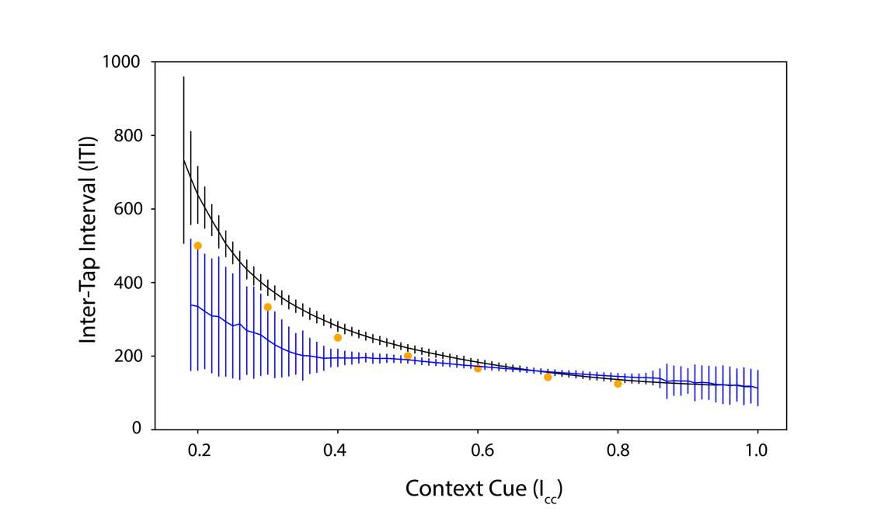
Fig S2. Oscillations persist in RNN after silencing inter-tap excitatory group.
Simulation of RNN ITIs for varying levels of context cue before (grey) and after (blue) silencing all of the Int-E units. Vertical lines indicate mean $±$ std. dev. of the ITIs of the model output during 50,000 ms of simulated continuation phase for each context input. Yellow circles indicate trained points. Silencing the Tap-E population has the effect of speeding up and increasing the variability of the oscillations for low frequencies.

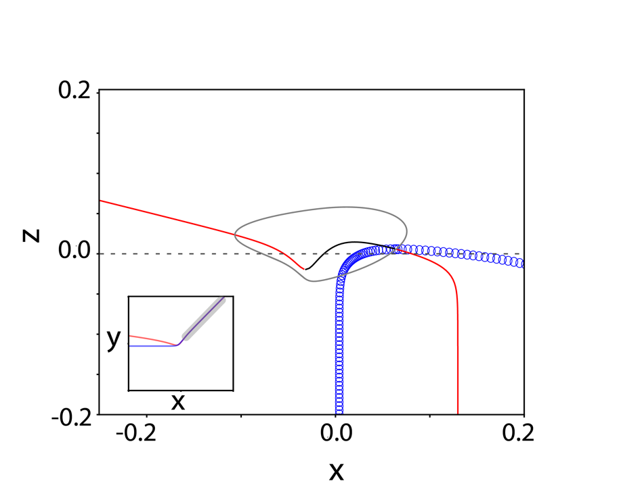
Fig. S3: Bifurcation diagram with z as a control parameter of x-y subsystem of 3-variable reduced model at $I_{cc}=0.5$.
For fixed levels of $z$, the $x-y$ subsystem shows stable steady states (red lines), unstable steady states (black line) and unstable oscillations (blue open circles). The left-hand stable branch corresponds to a strong attractor. The right-hand stable branch is also an attractor but is surrounded by an unstable orbit so trajectories cannot get to the attracting state unless they start near it. Limit cycle (stable) trajectory for the 3-variable model (black closed curve) is superimposed, showing that the left-branch is tracked closely during the INT-phase. The inset shows a snapshot of the $x-y$ phase plane with grey indicating the very small region that is surrounded by the unstable orbit when $z=0$ (dashed line).

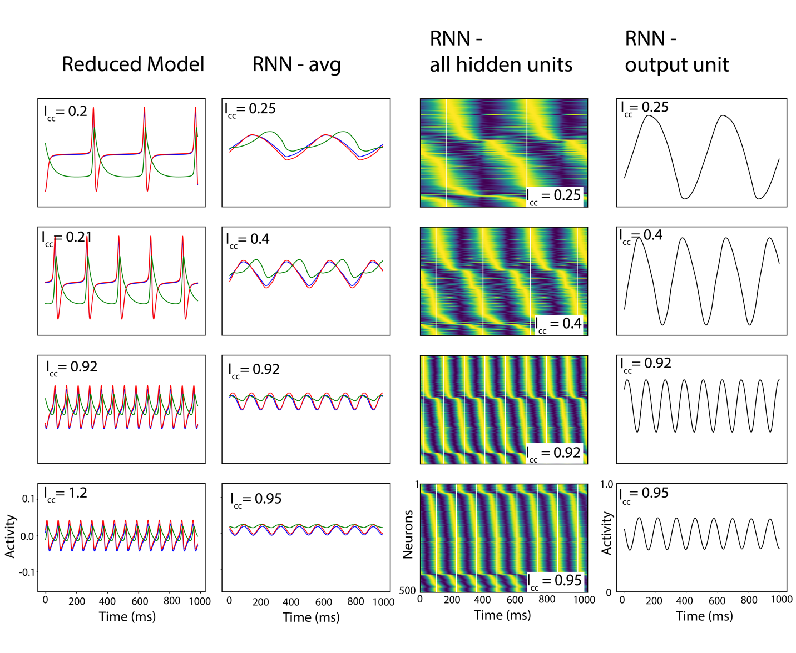
Fig S4. Oscillation time courses for RNN and reduced model.
First column shows the reduced model time courses for different levels of context cue (indicated in panel). Red, blue and green traces show the activity for Tap-E ($x$), Tap-I ($y$) and Int-I ($z$) variables, respectively. Note that the as the context cue decreases (moving up the column), the period of activity where the $x$ and $y$ variables are near zero increases – this is an indication of the homoclinic bifurcation. The second column shows the firing activity time courses for RNN units averaged by group. Red, blue, and green correspond to the average firing activity of hidden units in the Tap-E, Tap-I and Int-I subpopulations. Note that the amplitude of the oscillations decreases as context cue increases (moving down the column) – this is indicative of approaching the Hopf Bifurcation at a high level of context cue. Third column shows the normalized activities for all hidden units in the RNN with yellow colors indicating the maximum activity for that unit and dark blue indicating the lowest activity for that unit. Excitatory and inhibitory units are sorted separately: excitatory units are shown in the first 400 rows and inhibitory units are shown in the bottom 100 rows for each panel. White vertical lines indicate model “tap” times. Note that individual units (rows in subpanels) show an elongated period of low firing (dark blue) as context cue is decreased (moving up the figure column) – this is suggestive of the homoclinic bifurcation in the RNN. Fourth column shows the activity of the RNN output unit. All depicted trajectories are simulated without noise. The reduced model trajectories (first column) have notable different qualities from the RNN sub-population averaged time courses (second column): the reduced model trajectories are substantially more negative, show a more pronounced period of near constant activity and have a more pronounced spike-event.

Movie 1:
Link:https://drive.google.com/file/d/1OixLeOv_5paX1SQV1gSy6ejStnE0ie3Y/view?usp=drive_link
Phase plane projections for $x-y$ (left panel), $x-z$ (middle panel) and time course of activity for 3-variable reduced model. Nullclines are shown in red, blue and green for$x,y$and $z$variables, respectively. Black trace in right and middle panels shows example trajectory projected onto the corresponding plane. Right panel shows time course of $x$ (red), $y$ (blue) and $z$ (green) variables during one oscillation cycle. In the left panel, the oscillation hugs the E-I balance manifold (overlapping $x,y$ nullclines in $x,y≥0$ region) until $z$ becomes sufficiently large so that the fixed point on the bottom left of the appears and acts like a strong attractor. As $z$ is reduced, this point disappears and the trajectory heads back to the $x,y≥0$ region.

Movie 2:
Link: https://drive.google.com/file/d/1beTfj5n4WVTYN3xm-hAf6HCSA04aH4L3/view?usp=sharing
(Left) Projection of RNN activity for $I_{cc}=-0.2,$ where the RNN converges to a stable fixed point, into the plane spanned by the first two principal components. Example trajectory is shown in red. Tone of red indicates activity of average Int-I population activity with white indicating low firing and dark red indicating high firing. Vector fields at each time point are indicated in white and speed is indicated by the color. Color map is the same as in Fig. 5. Once the system reaches the steady state, three fixed points can be seen (dark blue regions) but only the left-most is stable (which is where the trajectory ends). (Right) Time course of averaged Tap-E (red), Tap-I (blue), and Int-I (green) units during the trajectory shown on the left. Shading indicates $±$ standard error of the mean. For this initial condition we see an early rapid amplification of Tap-E, Tap-I in the absence of Int-I firing (a characteristic response of an excitable system), that then recruits strong inhibition from Int-I. The slow decay (from t=50 to 250 ms) resembles passage near a slowly evolving saddle point. Units were sorted into Tap-E, Tap-I and Int-I groups based on their firing phase during a 5Hz stim.

Movie 3:
Link: https://drive.google.com/file/d/1Wa4vSAF67qzRR6k5eAF1fnOWbwFiwNVk/view?usp=sharing
(Left) Projection of RNN activity for an example time course at $I_{cc}=0.5$, when the RNN shows a single cycle of the oscillation, into the plane spanned by the first two principal components. Example trajectory in red. Tone of red indicates activity of average Int-I population activity with white indicating low firing and dark red indicating high firing. Vector fields at each time point are indicated in white and speed is indicated by the color. Color map is the same as in Fig. 5. The oscillation begins heading in the direction of the upper, right fixed point then turns around to head toward the bottom-left fixed point which acts as a strong attractor (when the $z$ activity is very high as indicated by the dark red shading of the trajectory). Finally, the trajectory turns around and heads back toward its starting point along the slow manifold (dark blue). (Right) Timecourse of averaged Tap-E (red), Tap-I (blue), and Int-I (green) neurons during the trajectory shown on the left demonstrate the synchronous activity of the Tap-E and Tap-I groups. Shading indicates $±$ standard error of the mean.

