Table 3: ROC Curve analyses for the presence of an EAH for Irisin values. AUC: 0.621
 | Group B (EAH)
 | 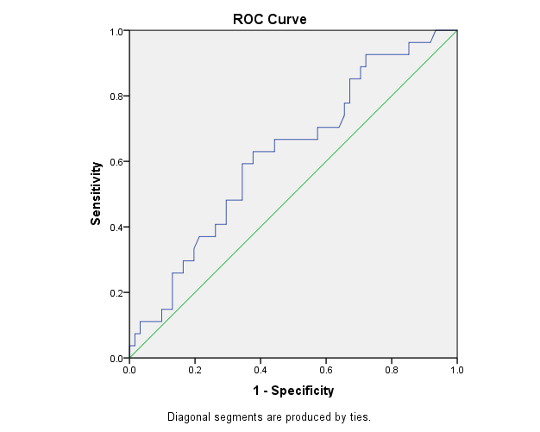
 | Sensitivity | 1-Specificity
156.33 (pg/ml) | .852 | .672
239.00 (pg/ml) | .704 | .574
290.00 (pg/ml) | .667 | .443
424.67 (pg/ml) | .481 | .295

