Online Resource 2
Online Resource 2 includes: maps showing variation of cumulative detection probability of the Togean babirusa for 15 and 21 days of surveys, sampling effort estimation to detect general state of the Togean babirusa’s occupancy decline, and comparison of sampling efforts when two vs. one camera traps are used per station.

Developing a monitoring protocol for a threatened species in a developing country: lessons learned from monitoring the Togean Islands babirusa

Agus Sudibyo Jati^{ab}, Bayu Wisnu Broto^{c}, Gabriela Franzoi Driª, Ikeu Sri Rejeki^{d}, Alessio Mortelliti^{ae}*

ªDepartment of Wildlife, Fisheries, and Conservation Biology, University of Maine, Orono, Maine, USA
^{b}IUCN SSC Wild Pig Specialist Group
^{c}Institute for the Implementation of Standards for Environment and Forestry Instrument Makassar, Ministry of Environment and Forestry, Makassar, Sulawesi Selatan, Indonesia
^{d}Directorate of Biodiversity Conservation, Ministry of Environment and Forestry, Gedung Manggala Wanabhakti Blok 1 Lt. 8, Jakarta, Indonesia
^{e}Department of Life Sciences, University of Trieste, Edificio M, Via Licio Giorgieri 10, Trieste, Italy
*Corresponding author: alessio.mortelliti@units.it

Fig. S1 Probability of detecting the Togean Islands babirusa at least once (cumulative detection probability; p*) for 15 days (panel A; mean=0.982) and 21 days (panel B; mean=0.995). The p* of 15 and 21 days were relatively similar, indicating that surveys longer than 15 days are redundant. Calculation of p* followed Mackenzie & Royle (2005) with initial detection probability from Jati et al. (2024)

Fig. S2 Required sampling efforts to detect a decline in occupancy of the Togean Islands babirusa’s (i.e., the spatial variation of occupancy probabilities was disregarded). Under this scenario, the camera stations should be distributed throughout the entire study area, regardless of the initial occupancy probabilities. Two camera traps are required per station. These sampling efforts were estimated through power analysis using the following parameters: power = 0.8, alpha = 0.1, number of survey days = 15, initial occupancy = 0.755 (predicted using the null occupancy model, that is the model with constant occupancy across the range), initial detectability = 0.298 (average detectability, predicted using detection model with island, proportion of pioneer vegetation within 4 km, and canopy openness as covariates), and effect sizes ranges from 0.15 to 0.5 (i.e., percent occupancy decline to be detected)

Fig. S3 Comparison of required sampling efforts to detect the Togean babirusa occupancy decline in high occupancy (Ψ = 0.897 ± SD 0.044; panel a) and medium occupancy area (Ψ = 0.615 ± SD 0.111; panel b) using one vs. two camera traps per station. Only sampling efforts for high and medium occupancy areas are shown here. To estimate the required sampling efforts for surveys with only one camera per station, first, we randomly selected one camera trap of each station from Jati et al. (2024) and created the babirusa detection history using the new dataset. We run occupancy modeling following the same procedure with Jati et al. (2024), then used the estimated occupancy and detection probability to create rasters of the required sampling effort to detect occupancy decline of the Togean Islands babirusa following the procedure described in the main text. We masked the rasters with the monitoring area boundaries (Fig. 1 of the main text) in ArcGIS Pro and averaged the pixel values to get the estimate of required sampling effort per area group per effect size
Fig. S1

Fig. S2

Fig. S3
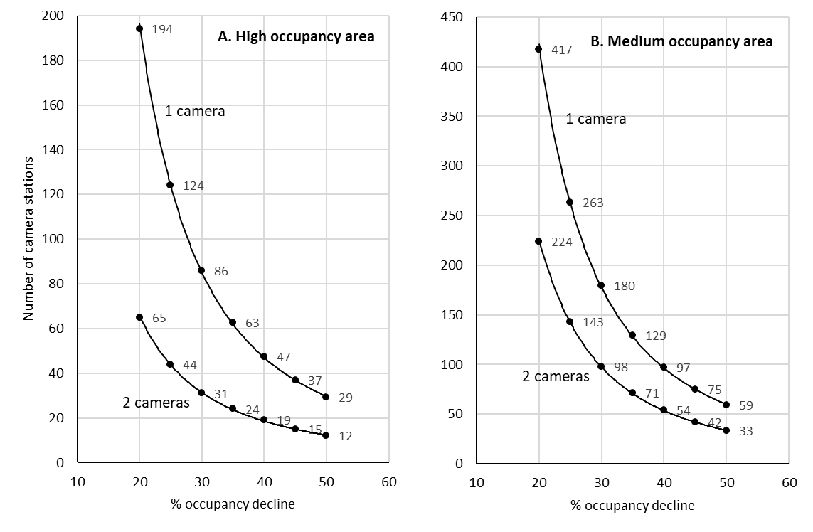

References
Jati AS, Broto BW, Dri GF, et al (2024) Conserving large mammals on small islands: A case study on one of the world’s most understudied pigs, the Togean islands babirusa. Biodivers Conserv. https://doi.org/10.1007/s10531-024-02800-5
Mackenzie DI, Royle JA (2005) Designing occupancy studies: General advice and allocating survey effort. Journal of Applied Ecology 42:1105–1114. https://doi.org/10.1111/j.1365-2664.2005.01098.x

