Appendices
  - Table 1. Contributors to ACCESS
Phase | Attendees (total)
Roundtable 1 | 3x NHS research staff, senior trial manager, trial coordinator and 8x PPI contributors (14)
Roundtable 2 | ACCESS team member, 3 clinicians, R&D director, statistician, trial manager and 5x PPI contributors (11)
Roundtable 3 | ACCESS team member, 3x NHS research staff, 2x senior trial managers and 5x PPI contributors (11)
Roundtable 4 | 3x NHS research staff, 1 trial manager, 1 researcher, 7x PPI contributors (12)
Roundtable 5 | ACCESS team member, 2x NHS research staff, 2x researchers, 6x PPI contributors (11)
Redesign 1 | Consultant, research nurse, trial manager, 2xPPI contributors (5)
Redesign 2 | GP, CTU director, 10x PPI contributors (12)
Redesign 3 | 3x clinicians, 8xPPI contributors (11)
Interviews | 4x clinicians, 3x CTU staff, 5x researchers, 1x NHS research staff and 2 community experts (PPI). (15)
Under-served groups represented by PPI (where provided by the contributor) = ethnic minority, experience of socioeconomic disadvantage, comorbidities, disability, people with mental health conditions, carer (for someone with impaired capacity), older people.

  - Figure 1 – Jamboards from the roundtable meetings
Meeting date: 3rd March 2022
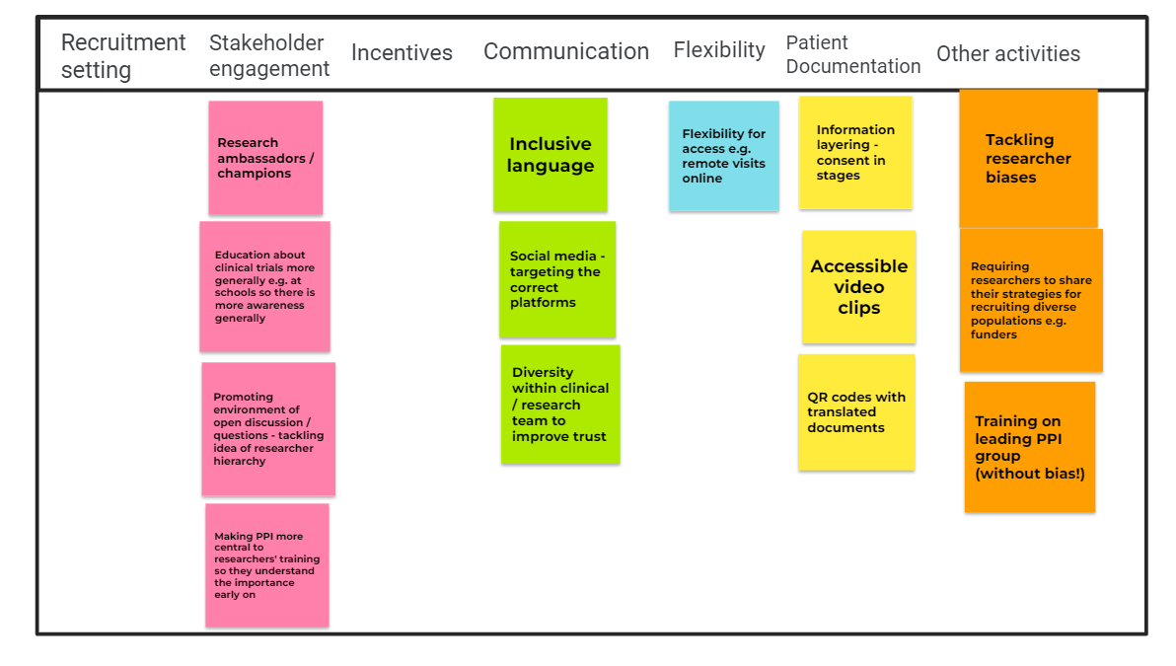

Meeting date: 7th March 2022
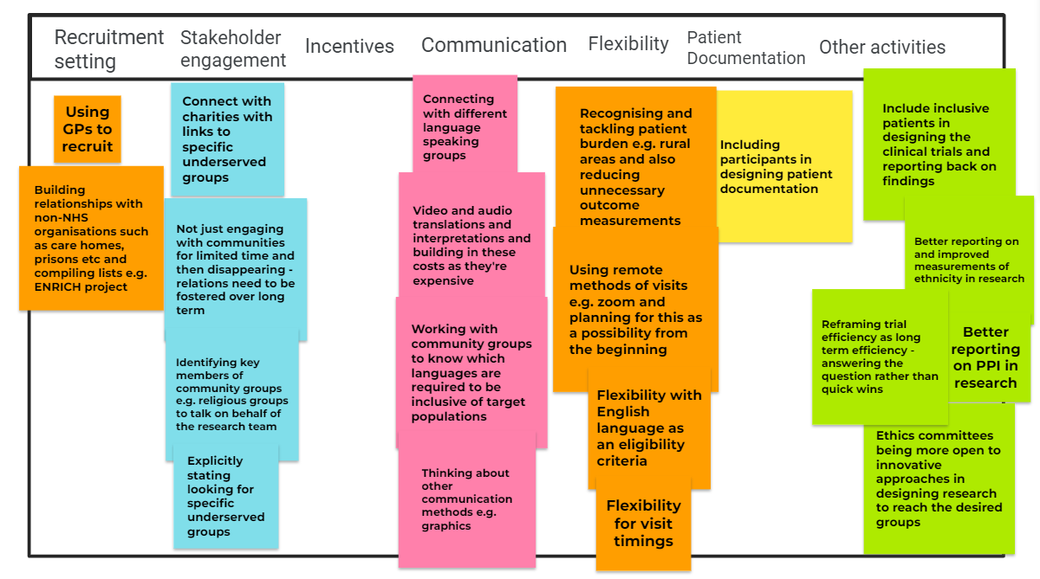

Meeting date: 18th March 2022
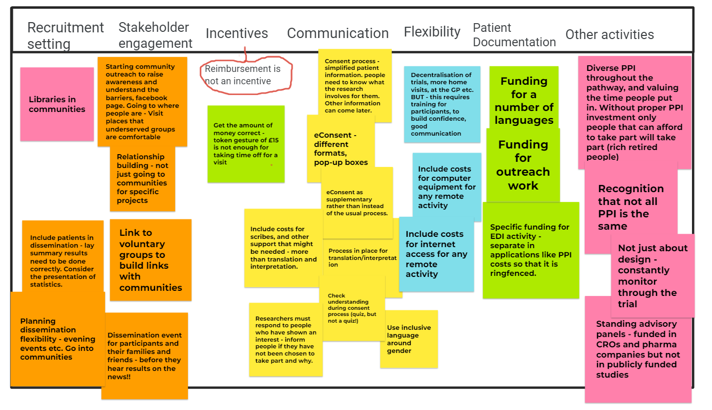

Meeting date: 25th March 2022
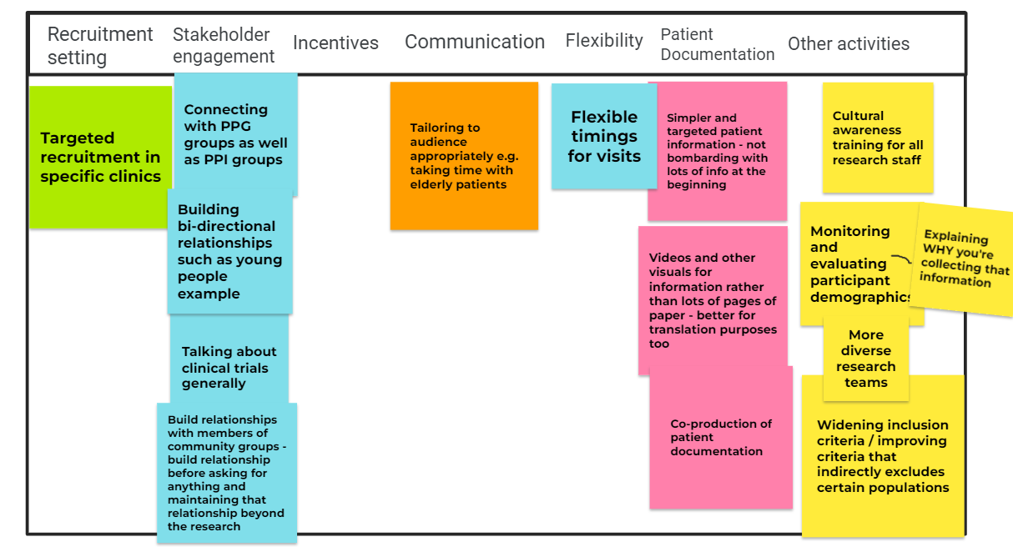
Meeting date: 28th March 2022
