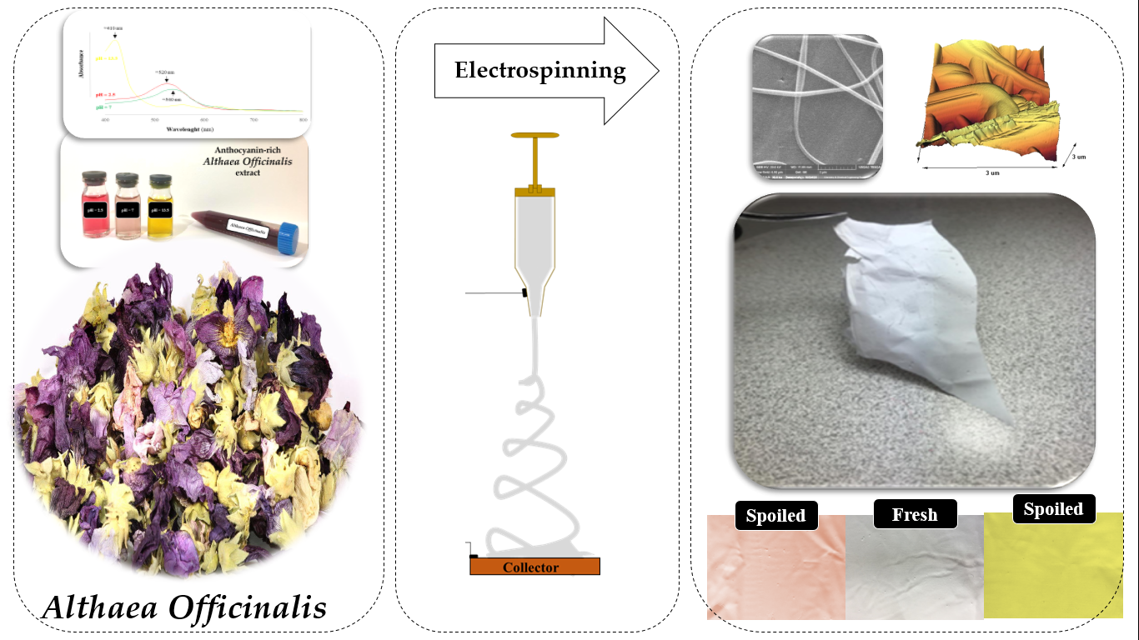
Schematic representation of the electrospinning technique utilized for obtaining AO_{EX}-loaded PVA nanofiber as real-time multi-functional innovative packaging of rainbow trout fillet

