Supplementary Information

Enhancing the anode performance of microbial fuel cells in the treatment of oil-based drill sludge by adjusting the stirring rate and supplementing oil-based drill cuttings

Qi Feng ª, Longjun Xu ^{a,} *, Chenglun Liu ^{a, b}, Yu Hao^{c}, Zhengxin Yang ª, Teng Zhang ª, Yanling Liu ª, Huaren Su ª
ª State Key Laboratory of Coal Mine Disaster Dynamics and Control, Chongqing University, Chongqing, 400044, China
^{b} College of Chemistry and Chemical Engineering, Chongqing University, Chongqing,
401331, China
^{c} School of Resources and Security, Chongqing Vocational Institute of Engineering, Chongqing, 402260, China
* Corresponding author.
E-mail address: xulj@cqu.edu.cn (L. Xu).

Section 1: The details for microbial community analysis
The microbial community characteristics in these samples were assayed through high-throughput sequencing and determined using V3~V4 region of the 16S rRNA gene. For high-throughput sequencing, the genes were amplified by PCR with TransStart Fastpfu DNA Polymerase. The sequencing was performed on Meijiyun platform and the analysis was carried out with the universal bacterial primers of 338F (5′-ACTCCTACGGGAGGCAGCAG-3′) and 806R (5′-GGACTACHVGGGT-WTCTAAT-3′). Clustering of sequence into operational taxonomic units (OTUs) was performed at 97 % sequence identity. From each OTU selected the representative sequences, and annotated with species information using Ribosomal Database Project classifiers with the Silva database (SSU123Genus level heatmap was prepared using Heatmap Illustrator (HEMI, version 1.0)).

Section 2: Data analysis
1. The current density (${\text{I}}_{\text{A}}$) and power density (${\text{P}}_{\text{A}}$) of the MFC were obtained with the following equation (1) and (2)
${\text{I}}_{\text{A}}\text{=}\frac{\text{U}}{{\text{R}}_{\text{ext}}\text{A}}$ (1)
${\text{P}}_{\text{A}}\text{=}{\text{I}}_{\text{A}}\text{*U}$ (2)
Where $U$ is the measured voltage (V), Rext is the external resistance value (Ω) and A is the surface area of anode (m²).
2. Exchange current density (i₀, A/cm²) was calculated by the Tafel curve expressed as the Butler-Volmer:
Log i= log i₀-βnFη/2.303 RT (3)
Where i is the current density at which an electric current passes (A/m²); i₀ is exchange current density (A/cm²); β is the symmetry factor; F is the Faraday constant (96485 C/mol); η is served as the cathodic overpotential (V); R is as the ideal gas constant (8.31 J /(mol K); and T is the absolute temperature (K).
3. Coulomb efficiency (CE) is the relative contribution index of MFC power generation to organic matter removal, and the calculation equation is as follows (4):
$\text{CE(\%)=}\frac{{\text{M}}_{\text{s}}\int_{\text{0}}^{\text{t}}{\frac{\text{U}}{\text{R}}\text{dt}}}{\text{F•b}{\text{•V}}_{\text{anode}}\text{•∆COD}}\text{×100\%}$ (4)
Where Ms is molar mass of substrate, g/mol ; F is Faraday constant, 96485 C/mol ; b is number of electrons to be transferred by oxidized 1mol organic matter; Vanode is total effective volume, L, $∆COD$ is variation of COD versus with time of 0~t, g/L.

Tab. S1 Main characteristics of anolyte and catholyte
Parameters | OBDS | Landfill leachate | aerobic sludge
COD(mg/L) | 21900 ± 210 | 2864 ± 2.32 | 3219 ± 23
NH₃-N(mg/L) | 395±17.8 | 418 ± 4.7 | 105.4 ± 9.6
${\text{NO}}_{\text{3}}^{\text{-}}$−N (mg/L) | 32 ± 0.17 | 170 ± 2.4 | 210.4 ±10.3
${\text{NO}}_{\text{2}}^{\text{-}}$−N (mg/L) | 2 ± 0.0014 | 5.65 ± 0.14 | 7.3 ± 0.23
pH | 7.2 ± 0.1 | 8.98 ± 0.1 | 6.3 ± 0.05
Conductivity (mS/cm²) | 36.3 ± 0.7 | 6.95 ± 0.4 | 17.3 ± 0.5

Tab. S2 Main characteristics of anolyte and catholyte
Element | Wt (%) | Atom (%)
C K | 21.59 | 38.79
O K | 34.79 | 46.94
Al K | 0.85 | 0.68
Si K | 2.31 | 1.78
S K | 7.80 | 5.25
Cl K | 1.21 | 0.73
Ca K | 2.31 | 1.25
Ba L | 29.13 | 4.58

Tab. S3 Fitting parameters value in Tafel Curve
MFC | βc (mV/dec) | βa  (mV/dec) | Onset Potential  (mV) | Exchange Voltage (mV) | Exchange Current (A/cm²)
Control group | 82.1 112.3 |  | 350 | 287 | 1.7×10⁻³
100 r/min | 103.6 54.1 |  | 380 | 310 | 2.1×10⁻³
2 g/L | 88.9 51.3 |  | 370 | 300 | 1.8×10⁻³
100 r/min +2g/L | 49.9 43.2 |  | 393 | 380 | 2.2×10⁻³

Tab. S4 Proportion of elements in biofilms under the conditions of control group biofilm and 100r/min +2 g/L.
Element | Samples
Element | Control group |  | 100 r/min +2 g/L
 | Wt (%) | Atom (%) | Wt (%) | Atom (%)
C K | 28.83 | 40.85 | 40.15 | 52.04
N K | 7.91 | 9.61 | 8.47 | 9.41
O K | 34.72 | 36.93 | 31.12 | 30.28
Na K | 2.30 | 1.71 | 1.38 | 0.93
Si K | 0.98 | 0.59 | 1.38 | 0.77
P K | 5.57 | 3.06 | 1.82 | 0.91
Cl K | 5.90 | 2.83 | 4.85 | 2.13
Ca K | 1.83 | 0.78 | 1.55 | 0.60
Fe K | 11.97 | 3.65 | 7.93 | 2.21
Al K | / | / | 0.49 | 0.28
S K | / | / | 0.87 | 0.42

Tab. S5 Proportion of elements in treated samples (control group and the group of 100 r/min + 2 g/L).
Element | Samples
Element | Control group |  | 100 r/min +2 g/L
 | Wt (%) | Atom (%) | Wt (%) | Atom (%)
C K | 25.28 | 42.77 | 26.05 | 37.69
O K | 34.04 | 43.23 | 41.56 | 45.14
Mg K | 0.63 | 0.53 | 0.79 | 0.57
Al K | 1.09 | 0.82 | 3.58 | 2.31
Si K | 3.66 | 2.65 | 17.09 | 10.57
S K | 6.22 | 3.94 | 0.76 | 0.41
Cl K | 1.61 | 0.92 | 1.21 | 0.59
Ca K | 2.98 | 1.51 | 2.78 | 1.20
Ba L | 24.49 | 3.62 | 3.41 | 0.43
K K | / | / | 1.64 | 0.73
Fe K | / | / | 1.13 | 0.35

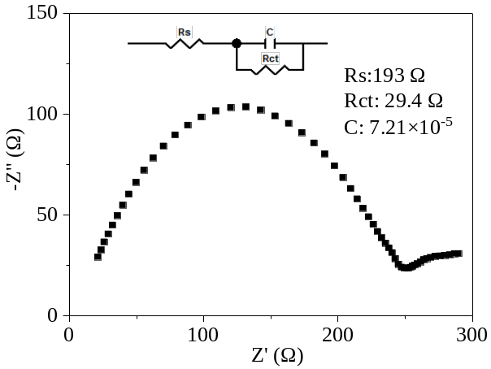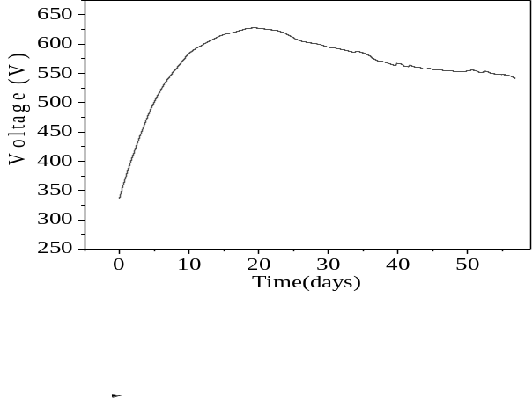

Fig. S2 (a) output voltage curves and (b) EIS under the optimized conditions.
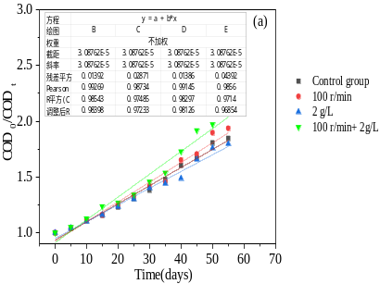
Fig. S3 (a) zero order kinetics fitting of COD removal in anolyte, where COD₀ is the initial COD; (b) first order kinetics fitting of COD removal in anolyte; (c) second order kinetics fitting of COD removal in anolyte.

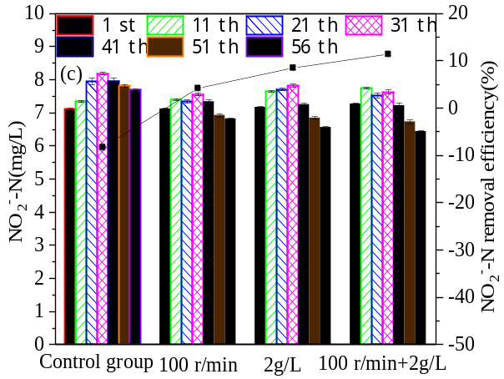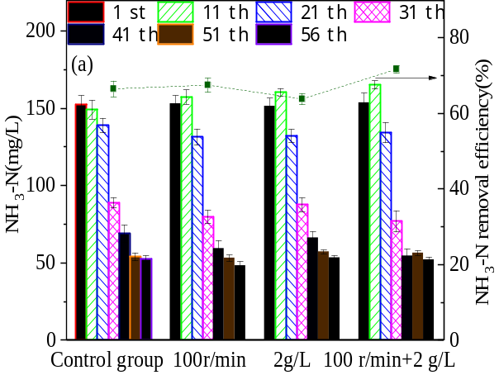
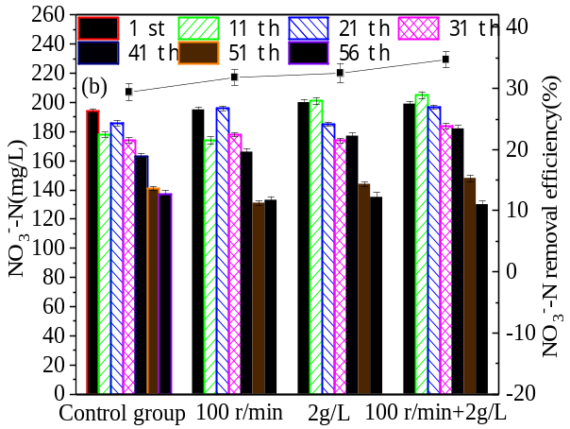
Fig. S4 Removal concentrations of NH₃-N (a), ${\text{NO}}_{\text{3}}^{\text{-}}$-N (b) and ${\text{NO}}_{2}^{-}$-N (c)among the cathode chambers, respectively.
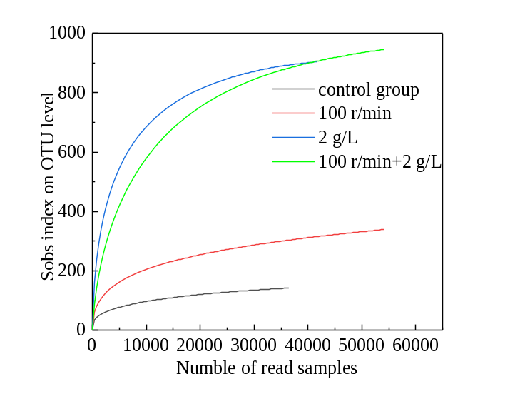
Fig. S5 Rarefaction curves for microbial communities.
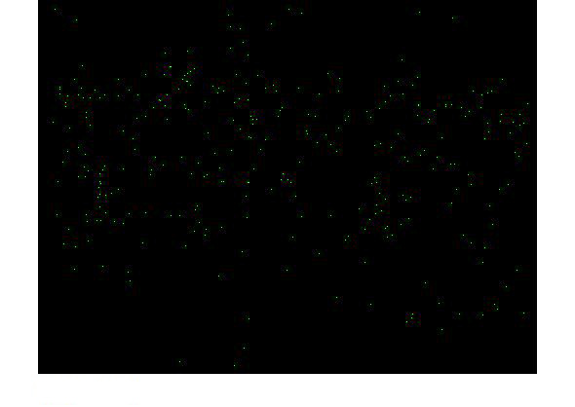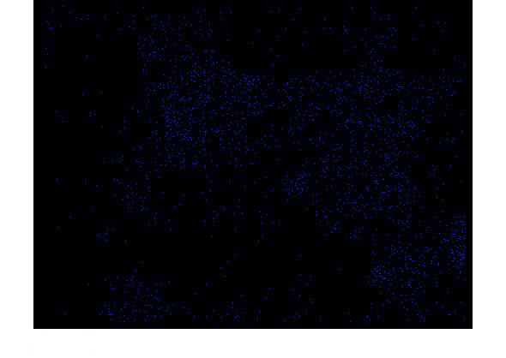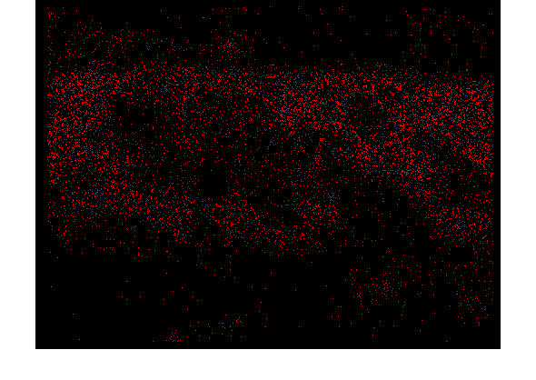
C
O
N
(a)
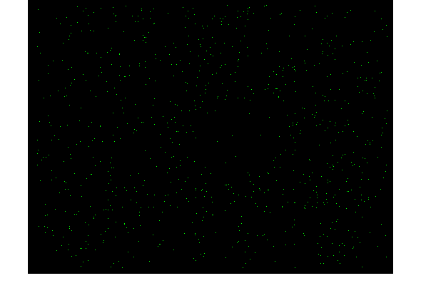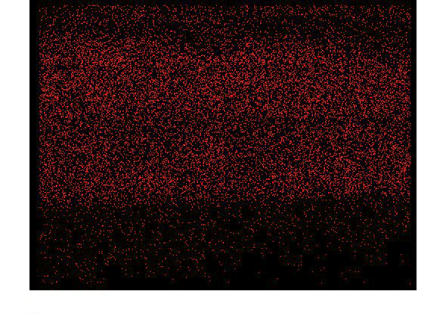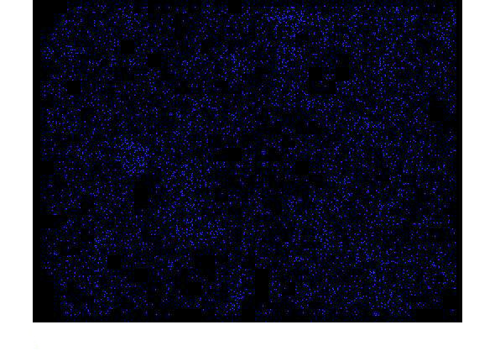
C
N
O
(b)

Fig. S6 Elemental mapping of biofilms: (a) control group, (b) 100 r/min + 2 g/L.
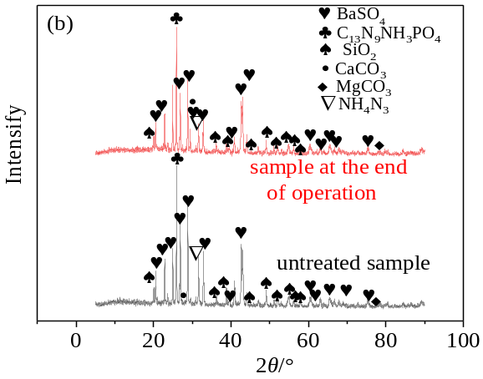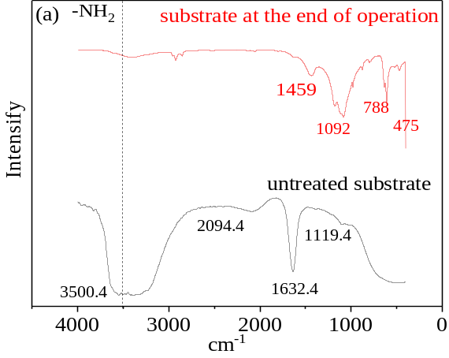

Fig. S7 Anode chamber substrate in the control group: (a) FT-IT and (b) XRD.

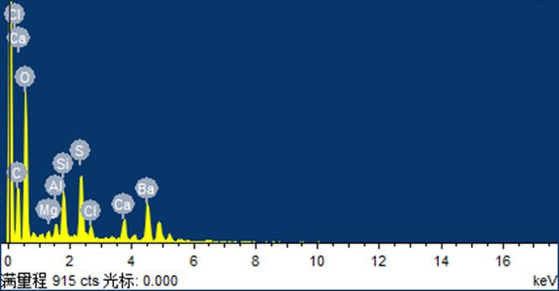
(a)

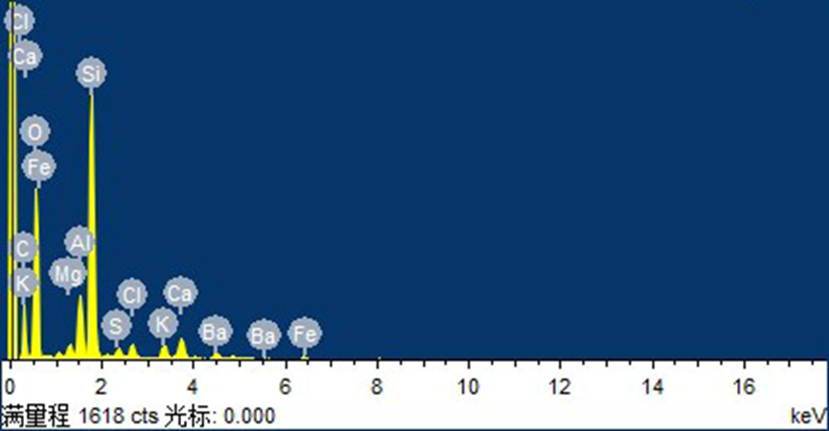
(b)
Fig. S8 EDS of the treated samples (a) control group; (b) 100 r/min + 2 g/L.

