Supplementary Information
for
Fundamentals of human interaction: type reciprocity
Siegwart Lindenberg
Jaap J. A. Denissen
Eric van Damme

Content:
Appendix 1:

Type reciprocity: Evidence and Robustness
- Brief description of the experiments.
- Table S1 of the percentage of act-reciprocal participants per game.
- Table S2 of the average percentage of type-reciprocal choices per game and incentive condition.
- Table S3 of the average percentage of type-reciprocal choices per game and collapsed incentive conditions.
- Very-high vs low reciprocating.
- Table S4a. Average percentage of negative type reciprocating choices per game for low. high, and very high groups of positive reciprocating subjects.
- Table S4b. Average percentage of positive type reciprocating choices per game for low. high, and very high groups of negative reciprocating subjects.
Descriptive norm effects
- Table S5, Examples from Experiments 3a and 3b.
Strong type reciprocity
- Description of strong reciprocity.
- Table S6. Correlations coefficients between positive and negative type reciprocity per game.
- Figure S1. Scatter plot for positive and negative type reciprocity.
Results for Robin’s mixed type (random sequence of 50% cooperative/50% competitive).
- Description of results for Robin’s mixed type
- Table S7. Percentage of act-reciprocal participants for Robin’s mixed type per game. collapsed across incentive conditions for each of the experiments.
- Table S8. Average percentage cooperative choices for Robin’s mixed type per game.
- Table S9. Distribution of cooperative choices for Robin’s mixed type.

References

Appendix 2

Sample Screenshots of the instructions

Appendix 1

- Brief description of the experiments

Experiments were designed such that all of them would test the prevalence of type reciprocity as well as its robustness against conditions that potentially disturb type reciprocity. We used three different games (Mutual Partner Control (MPC), Stag Hunt (SH) and Prisoners’ Dilemma) that were all played 10 times against a cooperative, a competitive, and a mixed partner called Robin. Each combination of a repeated game and a type of Robin is called a supergame; hence, each subject played 9 supergames.
Experiment 1. Baseline is the Mutual Partner Control (MPC) game. Potentially disturbing conditions (comparison with the baseline): structural enticement for act rather than type reciprocity (Stag Hunt, SH), and structural enticement of competitive type reciprocity (Prisoners’ Dilemma , PD). Relevant comparisons made: average percentage type-reciprocal choices for MPC versus SH, and for MPC versus PD, for all three kinds of partners.
Experiment 2. Potentially disturbing condition: extra enticement for gain maximization added to setup of Experiment 1, which potentially boosts cooperative type reciprocity and reduces competitive type reciprocity. We used the same 9 supergames as in Experiment 1, but now with sharing outcomes equally between the participant and Robin after each supergame has been played (making the cooperative choice in all supergames dominant in terms of gain maximization). The following relevant comparisons were made: average percentage type-reciprocal choices for MPC, SH, and PD all with sharing outcomes versus the respective average percentage type-reciprocal choices for MPC, SH, and PD all without sharing outcomes (data from Experiment 1).
Experiment 3. Potentially disturbing condition: effect of the information on behavior of peers (descriptive norm effects) added to setup of Experiment 1, which potentially adds normative pressure for participants to follow peer example rather than stick to type reciprocity. Relevant comparisons: average percentage type-reciprocal choices for MPC, SH, and PD all with peer effects versus the respective average percentage type-reciprocal choices for MPC, SH, and PD all without peer effects (data from Experiment 1).
Experiment 4. Potentially disturbing condition: effect of the information on behavior of peers (descriptive norm information) added to the setup of Experiment 2 (sharing outcomes). Information on cooperative peers potentially boosts cooperative type reciprocity and reduces competitive type reciprocity even more than the gain maximization effects of Experiment 2; conversely, information on competitive peers potentially reduces cooperative type reciprocity and boosts competitive type reciprocity compared to the effects of Experiment 2. Relevant comparisons were therefore: average percentage type-reciprocal choices for MPC, SH, and PD (all with peer descriptive norm information and sharing outcomes) versus the average percentage type-reciprocal choices for MPC, SH, and PD of Experiment 2 (all with sharing outcomes but no peer descriptive norm information).

Note: for all tables below, 117 “phony” participants (i.e. those who seemingly just pressed the same lever to get paid for participation) and 5 participants who indicated not having understood the instructions, were removed from the samples.

Table S1. Percentage of act-reciprocal participants per game, collapsed across incentive conditions for each of the experiments, excluding the 3 games with a mixed Robin . When calculating the percentage of type reciprocity for a particular supergame, act-reciprocal participants were removed before the calculation. Numbers in brackets represent confidence intervals (CIs), based on the standard error.

 |  |  | Experiments*
Robin type | game | Incentive condition | 1 | 2 | 3a | 3b | 4a | 4b
coop | MPC | collapsed | 34% [23, 45] | 30% [20, 40] | 31% [24, 37] | 35% [27, 42] | 27% [18, 36] | 27% [17, 36]
coop | SH | collapsed | 29% [19, 39] | 26% [16, 36] | 37% [30, 44] | 31% [24, 39] | 25% [16, 34] | 30% [20, 40]
coop | PD | collapsed | 34% [23, 45] | 33% [23, 44] | 32% [25, 38] | 28% [21, 35] | 21% [13, 30] | 23% [14, 32]
comp | MPC | collapsed | 20% [11, 29] | 27% [17, 37] | 23% [17, 29] | 18% [12, 24] | 17% [9, 25] | 13% [6, 21]
comp | SH | collapsed | 22% [13, 32] | 33% [23, 44] | 23% [17, 29] | 21% [15, 27] | 22% [14, 31] | 28% [18, 37]
comp | PD | collapsed | 17% [9, 26] | 16% [8, 24] | 19% [14, 25] | 15% [9, 20] | 20% [12, 29] | 16% [8, 24]
* Note. Experiments: 1 (comparing influence of game on type reciprocity); 2 (sharing at the end of supergame added to setup of Experiment 1); 3a (information on cooperative descriptive norm added to setup of experiment 1); 3b (information on competitive descriptive norm added to setup of experiment 1); 4a ) (sharing and information on cooperative descriptive norm added to setup of experiment 1); 4b (sharing and information on competitive descriptive norm added to setup of experiment 1). Confidence intervals (Cis, between brackets) differ between conditions due to differences in sample size. In a given supergame, a person is considered act reciprocal if he matches Robin’s switches between cooperative and competitive choices in more than 25% of the cases in that supergame (see the methods section of the main text).

Table S2. Average percentage of type-reciprocal choices (after removing act-reciprocal participants per supergame), separate for game, incentive condition, and experiment. (The games with a mixed Robin are again excluded).

 |  |  | Experiment*
Robin  type | Game | Incentive  condition | 1 | 2 | 3a | 3b | 4c | 4d
coop | MPC | incentive | 62% [50, 74] | 77% [66, 87] | 75% [66, 83] | 70% [61, 80] | 76% [65, 87] | 72% [58, 85]
coop | MPC | no incentive | 75% [63, 87] | 76% [64, 89] | 72% [65, 78] | 71% [63, 80] | 72% [60, 84] | 72% [61, 83]
coop | SH | incentive | 78% [65, 91] | 72% [59, 84] | 54% [44, 65] | 60% [59, 78] | 72% [62, 83] | 78% [66, 90]
coop | SH | no incentive | 71% [57, 85] | 71% [58, 84] | 60% [54, 71] | 64% [54, 73] | 72% [60, 84] | 73% [62, 84]
coop | PD | incentive | 42% [26, 57] | 23% [10, 37] | 25% [18, 32] | 33% [24, 42] | 45% [32, 59] | 58% [44, 71]
coop | PD | no incentive | 49% [36, 62] | 44 % [30, 59]  44% [30, 59] | 38% [30, 47] | 39% [29, 49] | 47% [34, 60] | 48% [36, 61]
comp | MPC | incentive | 71% [61, 81] | 44% [32, 55] | 57% [50, 64] | 64% [58, 70] | 48% [38, 58] | 41% [31, 52]
comp | MPC | no incentive | 68% [58, 78] | 51% [38, 64] | 70% [67, 78] | 66% [59, 72] | 59% [47, 70] | 55% [45, 65]
comp | SH | incentive | 71% [63, 79] | 54% [41, 67] | 71% [64, 78] | 69% [63, 76] | 54% [43, 66] | 70% [58, 81]
comp | SH | no incentive | 73% [65, 82] | 67% [53, 82] | 78% [73, 83] | 73% [67, 79] | 71% [63, 80] | 64% [56, 73]
comp | PD | incentive | 87% [80, 93] | 69% [58, 81] | 84% [81, 88] | 82% [77, 87] | 78% [71, 85] | 77% [69, 86]
comp | PD | no incentive | 85% [80, 91] | 70% [59, 80] | 85% [81, 90] | 81% [76, 86] | 80% [70, 90] | 72% [64, 80]
Note: For the description of the experiments, see Note for Table S1. Confidence intervals (CIs, between brackets) differ between conditions due to differences in sample size. All incentive CIs overlap with corresponding CIs for the no-incentive conditions.

Table S3. Results for type reciprocity of Table S2 collapsed with regard to incentive condition. (See Table S8 for the results when Robin is of the mixed type.)

 |  |  |  | Experiment*
Robintype | game | Incentive  condition |  | 1 | 2 | 3a | 3b | 4a | 4b
coop | MPC | collapsed |  | 69% [60, 77] | 76% [68, 85] | 73% [68, 78] | 71% [65, 77] | 74% [66, 82] | 72% [63, 80]
coop | SH | collapsed |  | 74% [65, 84] | 71% [62, 80] | 59% [52, 65] | 66% [59, 73] | 72% [64, 80] | 76% [68, 84]
coop | PD | collapsed |  | 46% [36, 56] | 34% [24, 44] | 32% [26, 37] | 36 % [29, 42] | 40% [37, 56] | 53% [44, 62]
comp | MPC | collapsed |  | 69% [62, 76] | 47% [39, 56] | 65% [60, 70] | 65% [60, 69] | 53% [46, 60] | 48% [41, 56]
comp | SH | collapsed |  | 72% [67, 78] | 60% [50, 70] | 75% [71, 79] | 71% [67, 76] | 62 % [55, 70] | 67% [60, 74]
comp | PD | collapsed |  | 86% [82, 90] | 70% [62, 77] | 85% [82, 88] | 82% [78, 85] | 79% [73, 85] | 74% [68, 80]
* Note. For the description of the experiments, see Note for Table S1. Confidence intervals (CIs) differ between conditions due to differences in sample size.

- Very-high vs low type-reciprocating
When subjects type-reciprocate in at least 9 out of 10 choices in a supergame, we call it “very-high type-reciprocation”. We define “low reciprocation” when subjects type-reciprocate at most 4 out of 10 choices in a supergame (thus, this includes also 0 type-reciprocating). Tables S4a and S4b show the frequencies (N) for the various groups. In most of the 36 supergames, the group of very-high type-reciprocating subjects (both positive and negative) is larger than the group of low type-reciprocating subjects (both positive and negative). This is an extra indication for the robustness of type-reciprocating. The exceptions are found in the PD games (resulting in less positive type-reciprocation) and in the two experiments (2 and 4a and 4b) that have extra tempting gain opportunities for cooperating (resulting in less negative type reciprocation). The prevalence of very-high compared to low reciprocation also shows that type-reciprocation is not explained by subjects’ matching the probability (80/20) of Robin’s choices.

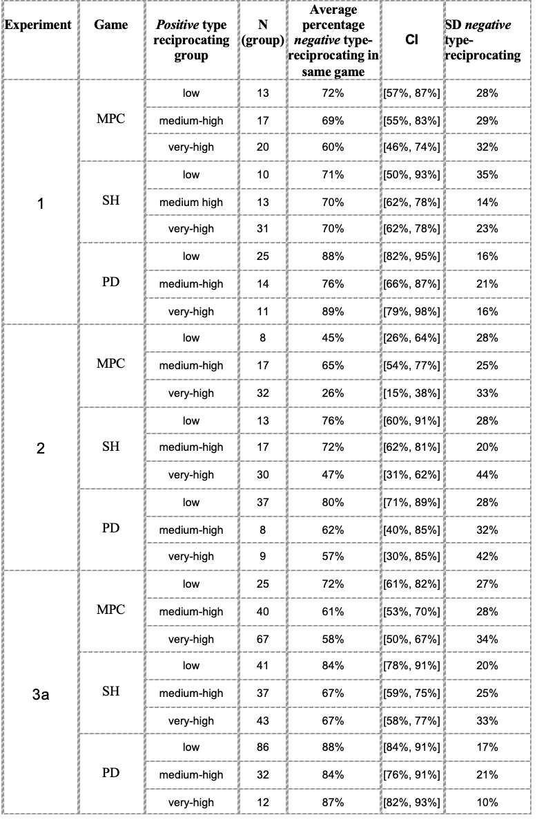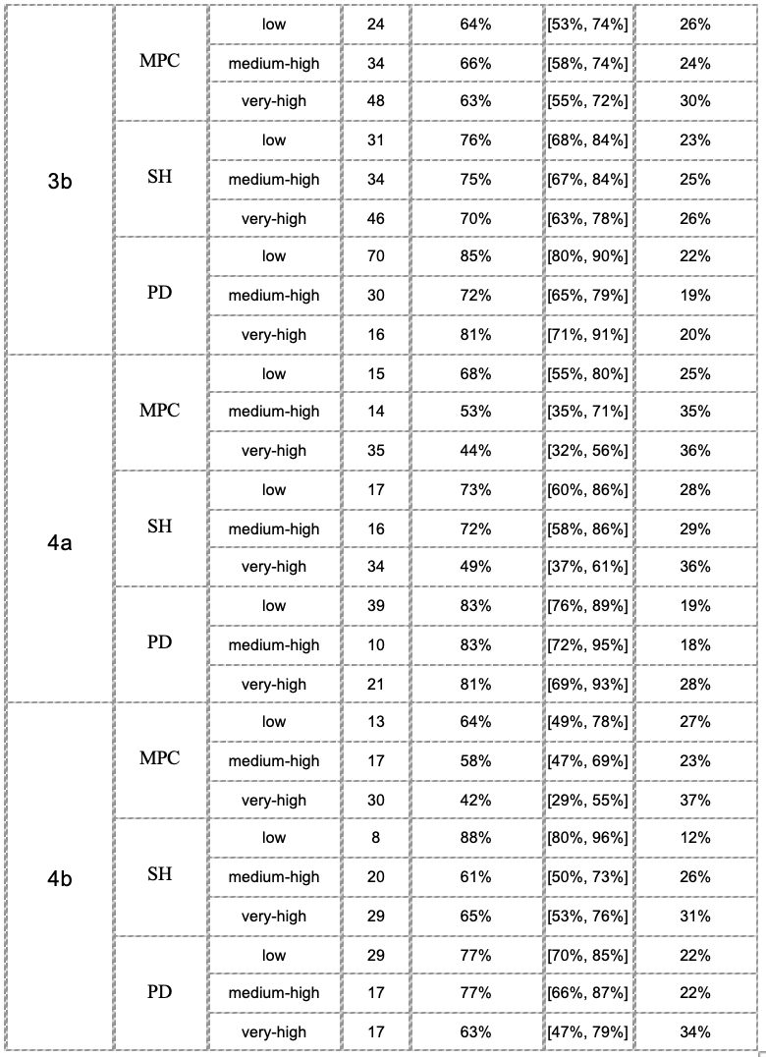
Table S4a. Average percentage of negative type-reciprocating choices per game for three groups of positive reciprocating subjects: low (0-4 out of 10); high (5-8 out of 10), and very high (9 or 10 out of 10), with Frequencies % [N, with act reciprocators removed] for each group, confidence intervals % [CI], and the standard deviation % [SD] of negative type-reciprocating in a condition
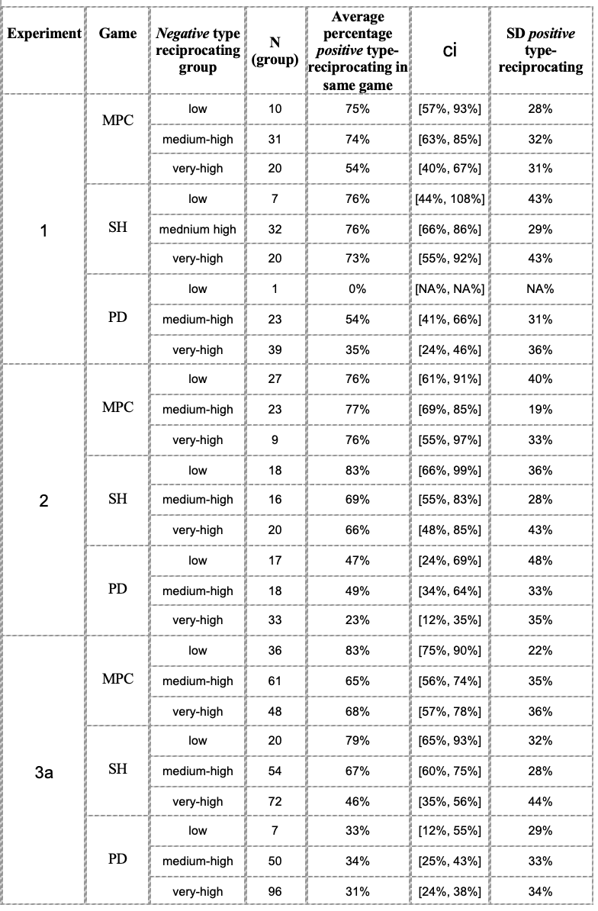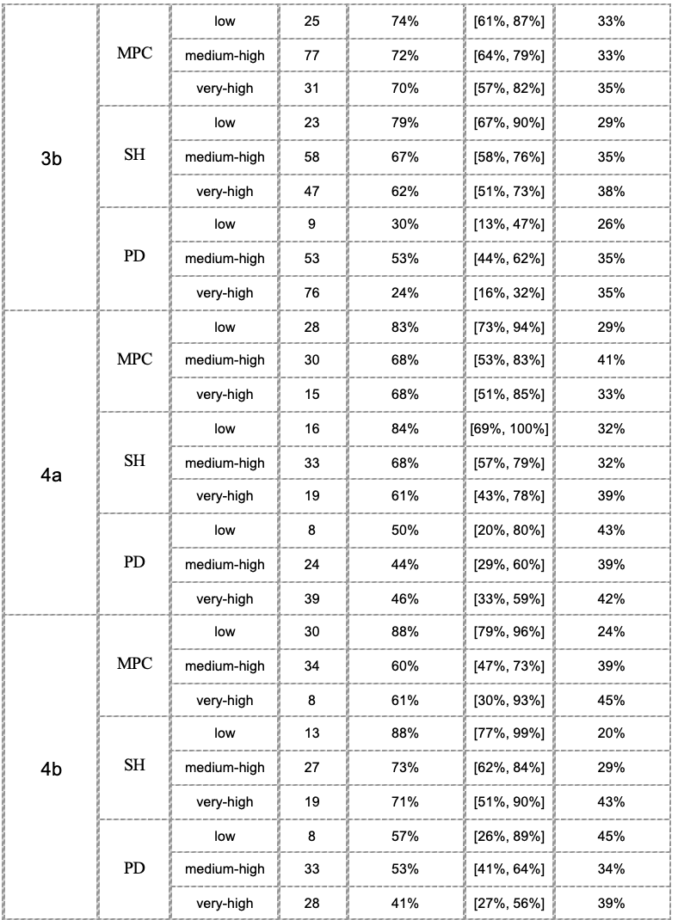
Table S4b. Average percentage of positive type-reciprocating choices per game for three groups of negative type-reciprocating subjects: low (0-4 out of 10); high (5-8 out of 10), and very high (9 or 10 out of 10), with Frequencies % [N, with act reciprocators removed] for each group, confidence intervals % [CI], and the standard deviation % [SD] of negative type reciprocating in a condition

Descriptive norm effects

The effects of information on descriptive norms are more or less absent in the average type reciprocity percentages. However, the distribution of type reciprocity is somewhat affected by the information on descriptive norms, but often in oppositive directions: some participants are positively influenced by the descriptive norm and some other participants show reactance to it by going against the norm, mostly canceling each other’s effects out. Table 5 shows some examples by presenting the percentages for type reciprocity in the low range (0%-20%) and in the high range (80%-100%). The shifts were sometimes very modest and sometimes larger (we did not calculate their statistical significance; we decided -somewhat arbitrarily - to ignore shifts below 2%). For the comparison between Experiments 2 and 4a/4b, we also observe heterogeneous effects: some conformity some reactance, some small, some larger effects. We don’t know what makes participants react one way or the other. There are studies that show reactance to descriptive norms (for example, Paryavi, Bohnet & van Geen, A. 2019; Kavvouris, Chrysochou & Thøgersen 2020). Kavvouris et al. 2020 found that descriptive norm information creates less reactance than injunctive norm information), but these studies also offer no explanation for differences in people’s reaction to information of descriptive norms.

Table S5. Examples from Experiments 3a and 3b of conformity (bold numbers) and reactance (italic numbers) to the descriptive norm, separate for the low range (0%-20%) and the high range (80%-100%) of type reciprocity.

 |  | Compare Exp 1 with Exp. 3a |  |  | Compare Exp 1 with Exp. 3b
Supergame | Range  % type rec. | % pos type rec. Exp 1 | % pos. type rec. Exp 3a |  | %pos.  type rec. Exp 1 | %pos.  type rec. Exp 3b
MPC | 0-20 | 12.0 | 11.4 |  | 12.0 | 12.3
MPC | 80-100 | 52.0 | 59.8 |  | 52.0 | 55.7
SH | 0-20 | 16.7 | 25.6 |  | 16.7 | 17.1
SH | 80-100 | 68.5 | 45.5 |  | 68.5 | 53.2
PD | 0-20 | 34.0 | 49.2 |  | 34.0 | 51.7
PD | 80-100 | 36.0 | 13.8 |  | 36.8 | 18.1

 |  | Compare Exp 1 with Exp. 3a |  |  | Compare Exp 1 with Exp. 3b
Supergame | Range  % type rec. | % neg. type rec. Exp 1 | % neg. type rec. Exp 3a |  | %neg.  type rec. Exp 1 | %neg.  type rec. Exp 3b
MPC | 0-20 | 9.8 | 11.7 |  | 9.8 | 10.5
MPC | 80-100 | 55.7 | 46.2 |  | 55.7 | 59.8
SH | 0-20 | 5.1 | 11.0 |  | 5.1 | 6.3
SH | 80-100 | 49.2 | 59.6 |  | 49.2 | 52.3
PD | 0-20 | 0.0 | 1.3 |  | 0.0 | 3.6
PD | 80-100 | 74.6 | 78.4 |  | 74.6 | 70.1

Strong reciprocity
- Description of strong reciprocity
There have been many publications about so-called “strong reciprocity”, meaning that act reciprocity is not just about reciprocating friendly acts but also unfriendly acts (Gintis 2000; Fehr, Fischbacher & Gächter 2002). Strong reciprocity has been heralded as a major contribution to human cooperation. As Fehr, Fischbacher & Gächter (2002, p.1) put it: “it can lead to almost universal cooperation in circumstances in which purely self-interested behavior would cause a complete breakdown of co- operation.” However, there are two meanings of “strong”. For one, “strong” could refer to people having both preferences (to return a kind act kindly and to return an unkind act unkindly). Let us call them “two-directional” reciprocators. The economist Matthew Rabin (Rabin (1993, p. 1281) claimed that “People like to help those who are helping them, and to hurt those who are hurting them” and “the same people who are altruistic to other altruistic people are also motivated to hurt those who hurt them.” Rabin does not provide proof of these statements, while Yamagishi et al. (2012) found positive and negative reciprocity to be almost uncorrelated. The second (weaker) meaning of “strong” is that in the population both preferences occur, but not necessarily in the same people. There can be “one-directional” type reciprocators. The language in the literature on strong act reciprocity is suggestive of the two-directional reciprocation (for example “A strongly reciprocal individual responds kindly toward actions that are perceived to be kind and hostility toward actions that are perceived to be hostile" (Fehr & Fischbacher 2005, p.153), whereas the empirical evidence is compatible with the one-directional reciprocation, because experiments are between-subjects design (see for example Fehr, Fischbacher & Gächter 2002, Isler et al.2021), and ethnographic evidence refers mostly to the existence of both kinds of preferences in the population, not within one and the same individual (see for example Fehr & Henrich 2003). The few experiments that explicitly used a within-subject design found little evidence for two-directional reciprocity (see for example Yamagishi et al 2012). This may be different for type reciprocity. Because each of our six experiments has a within-subject design, we could actually answer the question whether and to what degree type reciprocity is “strong” in the sense that individuals have both preferences.
Table S6 shows the correlations between the percentage of being positive type-reciprocal (with a cooperative Robin) and being negative type-reciprocal (with a competitive Robin) in the same game. Eleven of the 18 correlations are not significant, and two of the remaining 7 correlations are only marginally significant (p=0.08 and p=0.06, respectively). The unweighted average correlation over all experiments and conditions was weakly negative [r = -18; p<.001]. These results seem to fit with the finding by Yamagishi et al. (2012). However, a closer look at Tables S4a and S4b reveals a different story. Take for example the MPC supergame of Experiment 1 (Table S4a). Whereas in that supergame the small group of low positive type-reciprocating subjects showed quite high negative reciprocating (70% one-directional reciprocating), the larger groups of high and very-high type-reciprocating subjects also showed quite high negative reciprocating, with 71% and 60% respectively (two-directional reciprocating). The picture is similar for the corresponding group of negative type-reciprocating subjects (Table S4b). A look at the upper left corner of the scatterplot over all games and conditions (Figure S1) shows that there is a dominant pattern for the positive low type-reciprocators: they tend to be very high negative type reciprocators.
The same holds for the lower right corner: the dominant pattern is for low negative type reciprocators to be very high on positive reciprocation. These patterns point to one-directional type reciprocators. There is, however also clear evidence for two-directional reciprocators (upper right corner): a large portion (indeed he largest portion, see the distributions depicted at the top and right side of the figure) of positive (negative) very high type-reciprocators tends to be also very high negative (positive) type reciprocators. They are thus mainly two-directional type-reciprocators. At the very high ends of type-reciprocating we thus find both one-directional and two-directional type-reciprocators, whereas at the low ends, we find mostly one-directional reciprocators. The middle group (high type-reciprocators) seems to be less outspoken with regard to being one- or two-directional and more dependent on the condition. The dispersion of two-directional choices (see SD in Tables S4a and S4b) is rather sizable. An indication for the robustness of type reciprocity itself is the fact that the lower left corner of the plot is virtually empty. This means that there are very few participants who are not type-reciprocal in some way.
Table S6. Correlations coefficients between positive and negative type reciprocity per game, based on the number (N) of participants who were not act reciprocal in a game with both a positive and a negative Robin.

Exp. | Game | Corr. Coeff. | p | N
1 | MPC | -0.13 | 0.41 | 40
1 | SH | 0.03 | 0.85 | 44
1 | PD | -0.12 | 0.44 | 43
2 | MPC | -0.25 | 0.12 | 41
2 | SH | -0.27 | 0.08 | 45
2 | PD | -0.31 | 0.03 | 48
3a | MPC | -0.22 | 0.03 | 98
3a | SH | -0.32 | 0.00 | 97
3a | PD | -0.04 | 0.64 | 111
3b | MPC | -0.02 | 0.84 | 90
3b | SH | -0.13 | 0.23 | 92
3b | PD | -0.23 | 0.02 | 101
4a | MPC | -0.25 | 0.06 | 57
4a | SH | -0.28 | 0.04 | 52
4a | PD | -0.05 | 0.73 | 57
4b | MPC | -0.32 | 0.02 | 52
4b | SH | -0.22 | 0.16 | 44

Figure S1. Scatterplot for positive (x-axis) and negative (y-axis) type reciprocity over all games and experiments (excluding games with a mixed Robin). The size of the circles represents the number of participants that contribute to the data points. The bars at the top and to the right represent the column and row frequencies, respectively.

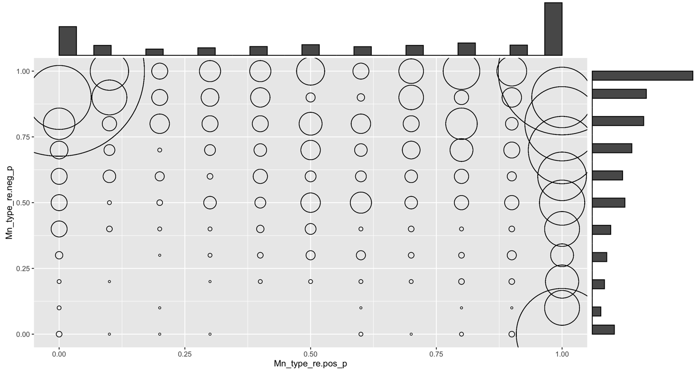

Results for the mixed (random sequence of 50% cooperative/50% competitive) Robin

- Description of results for Robin’s mixed type

Type reciprocity was operationalized throughout as type matching. This also holds for the mixed Robin (50/50) (see Table S8). In this case, a person is type-reciprocal in a supergame if he/she has approximately 50% cooperative choices, provided that this matching is not to be interpreted as act reciprocity. To satisfy the latter condition, we again removed participants whom we identify as act-reciprocal (see Table S7). A mixed Robin can distribute the 5 cooperative and 5 competitive choices in a supergame very differently (for example 5 times cooperative and 5 times competitive, or alternating, or any other pattern). In the experiments the distribution was randomized. Act reciprocity in this case means that the participant mirrors the changes in Robin’s choices (cooperative, competitive). Again, we took a conservative cut-off point: If a participant mirrored Robin’s changes in more than 25% of the cases, we classified him/her as act-reciprocal for that supergame and removed him or her from the sample in that particular supergame. We then calculated the percentage cooperative choices.
More formally: Take a supergame. Let $R_{t}ϵ\left\{1, 2\right\}$ denote the action chosen by Robin in round $t$ for $t=1, 2, …,10.$ Let $S_{t}$ be the action of the participant in round $t$ for $t=1, 2, …,10.$ We say that Robin switches in round $t$ if $R_{t}≠R_{t-1}$. We write $T_{a}$ for the number of switches of Robin before the final round; hence, $T_{a}=\#t$ with $R_{t}≠R_{t-1}$ and $t<10$The reason for excluding the final round is that the subject cannot respond to that switch. The range of switches Robin can make and the participant can mirror is $T_{a\left(min\right)}=1,$ $T_{a(max)}=8$. If $R_{t}≠R_{t-1}$ and $t<10$, we say that a subject mirrored Robin in $t+1$, when at that time he makes the same switch as Robin made a period earlier; formally, $S_{t+1}≠S_{t}$and $S_{t}=R_{t-1}.$(The first condition thus says that there is a change in round $t$+1, while the second condition guarantees that the participant’s switch indeed mirrored Robin’s switch.) The number of incidences of act reciprocity, $I_{a}$, is now defined as $I_{a}=\#t$ for which $R_{t}≠R_{t-1}$, $t<10$, $S_{t+1}≠S_{t}$, and $S_{t}=R_{t-1}.$ We say that a participant is act-reciprocal in any particular supergame if $\frac{I_{a}}{T_{a}}>0.25$. Note that in contrast to a cooperative or competitive Robin (see Methods in the main text), R_{o} does not play a role for the mixed Robin.
Table S7. Percentage of act-reciprocal participants for a mixed Robin per game, collapsed across incentive conditions for each of the experiments. Numbers in brackets represent confidence intervals (CIs), based on the standard error.

Robin type | Game | 1 | 2 | 3a | 3b | 4a | 4b
Mixed | MPC | 25% [15, 35] | 23% [14, 33] | 29% [22, 35] | 30% [23, 37] | 32% [22, 42] | 27% [17, 36]
Mixed | SH | 34% [23, 45] | 20% [11, 28] | 25% [19, 31] | 29% [22, 36] | 30% [2, 39] | 27% [17, 36]
Mixed | PD | 30% [20, 41] | 35% [24, 45] | 23% [17, 29] | 19% [13, 25] | 20% [12, 29] | 23% [14, 32]

Our expectation with regard to a mixed Robin was that participants will tend to see Robin more likely as competitive than as strictly mixed, because Robin is unreliable. We find corroboration for this conjecture in the data (see Table S8), even though the effects were not very strong. Table S8 gives the average percentage of cooperative choices against a mixed Robin. Only 3 of the 18 percentages are somewhat (but statistically significantly) above 50%. Furthermore, all 3 of these are in the sharing conditions (that reward cooperative choices). By contrast, 13 of the 18 percentages were below 50% and 9 of them significantly so. Of the 3 results of Experiment 2 (where sharing makes cooperative choice dominant in terms of gain maximization), even 2 were below 50%. Similarly, in Experiment 4 (with outcome sharing and descriptive cooperative (4a) and competitive (4b) norms), only 2 of the 4 results were significantly above 50% (for the MPC). Seemingly, the information on a descriptive norm itself did not have a direct effect, but it looks like it made some participants focus more on the gain opportunity by cooperating when that was the gain maximizing choice (because with sharing the outcome, the cooperative choice was also the gain maximizing choice). For the PD game in Experiments 4a and 4b, we see again (as with and 80/20 and 20/80 partner) that the impact of the conflictful relationship induced by the structure of the game trumped gain maximization, with results way below 50%.
Another corroboration of the expectation that an unreliable partner will be more likely seen and treated as competitive rather than being simply matched, can be found in Table S9. There we see that with few exceptions (which are again located in the “sharing” Experiments 2 and 4a and 4b, in which being cooperative is the most lucrative choice), the competitive deviations (0-3) from type reciprocity were more frequent than the cooperative deviations (7-10). Thus a Robin that is sometimes cooperative and sometimes competitive was more likely to be seen and treated as competitive.
Table S8. Average percentage cooperative choices (after removing act-reciprocal participants per supergame), for Robin’s mixed type (50% cooperative, 50% competitive, random sequence), per game, collapsed incentive condition, and experiment (with confidence intervals in parentheses).

 |  | Experiments*
Robin: type | Game | 1 | 2 | 3a | 3b | 4a | 4b
mixed | MPC | 44 % [40, 48] | 58 % [54, 62] | 48 % [46, 51] | 48 % [45, 51] | 57 % [53, 60] | 55 % [52, 59]
mixed | SH | 46 % [42, 50] | 45 % [41, 49] | 39 % [37, 42] | 43 % [40, 46] | 52 % [48, 55] | 52 % [48, 56]
mixed | PD | 29 % [26, 33] | 32 % [28, 35] | 24 % [22, 26] | 22 % [20, 25] | 33 % [30, 36] | 36 % [32, 40]
* Note. Note. Experiments: Confidence intervals (between brackets) differ between conditions due to
differences in sample size. Italic numbers indicate percentages that are significantly below .50

Table S9. Distribution of cooperative choices (after removing act-reciprocal participants per supergame), for Robin’s mixed type.

Experiment | Supergame | Cooperative  choices | N
1 | MPC | 0-1 | 15
1 | MPC | 2-3 | 10
1 | MPC | 4-6 | 31
1 | MPC | 7-8 | 11
1 | MPC | 9-10 | 9
1 | SH | 0-1 | 10
1 | SH | 2-3 | 18
1 | SH | 4-6 | 29
1 | SH | 7-8 | 14
1 | SH | 9-10 | 5
1 | PD | 0-1 | 19
1 | PD | 2-3 | 21
1 | PD | 4-6 | 30
1 | PD | 7-8 | 5
1 | PD | 9-10 | 1
2 | MPC | 0-1  2-3  4-6  7-8  9-10 | 9  12  27  17  16
2 | SH | 0-1  2-3  4-6  7-8  9-10 | 20  15  21  11  14
2 | PD | 0-1  2-3  4-6  7-8  9-10 | 25  17  28  6  5
3a | MPC | 0-1  2-3  4-6  7-8  9-10 | 32  32  76  21  29
3a | SH | 0-1  2-3  4-6  7-8  9-10 | 44  43  61  27  15
3a | SH | 0-1  2-3  4-6  7-8  9-10 | 77  42  62  5  4
3a | PD | 0-1  2-3  4-6  7-8  9-10 | 77  42  62  5  4
3b | MPC | 0-1  2-3  4-6  7-8  9-10 | 24  28  66  25  19
3b | SH | 0-1  2-3  4-6  7-8  9-10 | 25  35  66  22  14
3b | PD | 0-1  2-3  4-6  7-8  9-10 | 71  35  46  7  3
4a | MPC | 0-1 | 9
4a | MPC | 2-3 | 14
4a | MPC | 4-6 | 33
4a | MPC | 7-8 | 11
4a | MPC | 9-10 | 21
4a | SH | 0-1  2-3  4-6  7-8  9-10 | 19  8  27  17  17
4a | PD | 0-1 | 25
4a | PD | 2-3 | 24
4a | PD | 4-6 | 25
4a | PD | 7-8 | 8
4a | PD | 9-10 | 6
4b | MPC | 0-1 | 9
4b | MPC | 2-3 | 9
4b | MPC | 4-6 | 31
4b | MPC | 7-8 | 19
4b | MPC | 9-10 | 14
4b | SH | 0-1  2-3  4-6  7-8  9-10 | 9  15  30  16  12
4b | PD | 0-1  2-3  4-6  7-8  9-10 | 21  18  32  5  6

References
Bowles, S.; Gintis, H. 2004. The evolution of strong reciprocity: Cooperation in heterogeneous populations. Theoretical Population
Biology. 65 (1): 17–28
Fehr, E. & Fischbacher, U. 2005. The Economics of strong reciprocity. In Moral Sentiments and Material Interests, ed. By H. Gintis, S. Bowles & E.
Fehr. Pp 151-191.Cambridge, MA.: Cambridge, MA, MIT Press
Fehr, E, Fischbacher, U. & Gächter, S. 2002. Strong reciprocity, human cooperation, and the enforcement of social norms. Human Nature-an Interdisciplinary Biosocial Perspective 13(1):1-25.
Fehr, E., & Henrich, J. 2003. Is strong reciprocity a maladaptation? On the evolutionary foundations of human altruism. In P. Hammerstein (Ed.), Genetic and cultural evolution of cooperation (pp. 55–82). Cambridge, MA, MIT Press.
Gintis, H. 2000 . Strong Reciprocity and Human Sociality. Journal of Theoretical Biology, 206 (2): 169–179
Isler, O., Gächter, S., Maule, A.J. & Starmer, C. 2021. Contextualized strong reciprocity explains selfless cooperation despite selfish intuitions and
weak social heuristics. Scientific Reports 11:13868
Kavvouris, C., Chrysochou, P.. & John Thøgersen, J. 2020. “Be Careful What You Say”: The role of psychological reactance on the impact of pro-environmental normative appeals. Journal of Business Research, 113: 257-265.
Paryavi, M., Bohnet, I., van Geen, A. 2019. Descriptive norms and gender diversity: Reactance from men. Journal of Behavioral Public Administration, 2(1): 1-16
Rabin, M. 1993. Incorporating fairness into game theory and economics. American Economic Review, 83(5):1281–1302.
Yamagishi, T. et al.2012. Rejection of unfair offers in the ultimatum game is no evidence of strong reciprocity. |PNAS, 109 (11 December ), 20364-20368

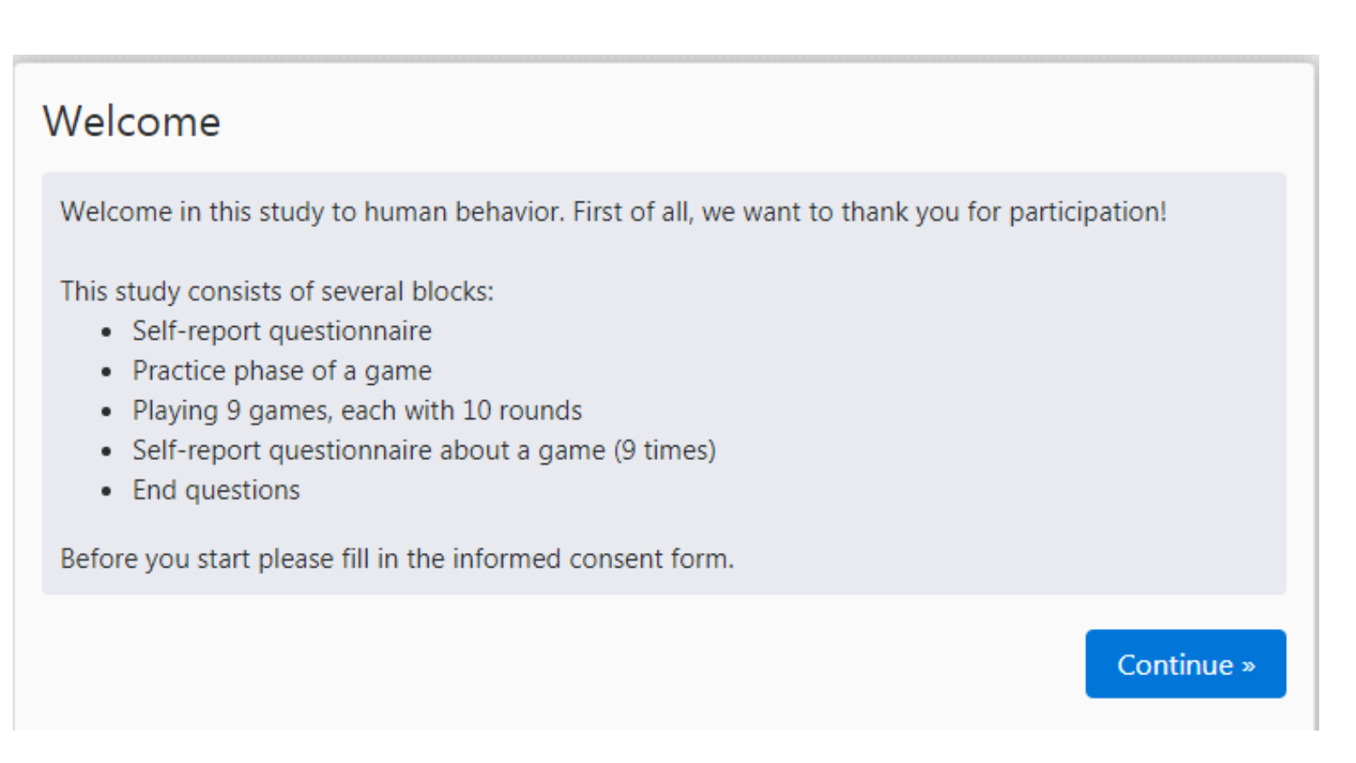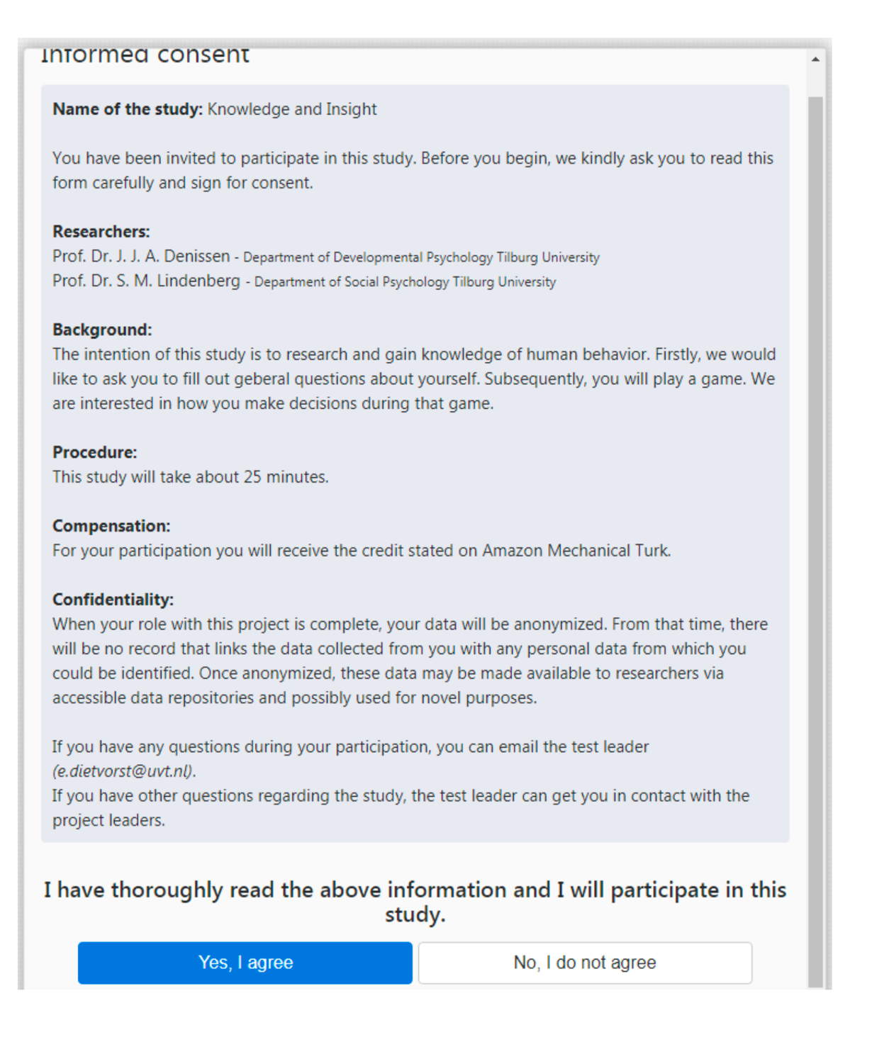
Appendix 2
Sample Screenshots of the instructions
