Table S1. Reading Characteristics of Participants in This Study
Characteristic | mean (SD) |  |  | F/H/χ2 | P value
Characteristic | Glaucoma Patient  (n = 163) | Older Healthy People  (n = 56) | Young Healthy People  (n = 220) | F/H/χ2 | P value
RA, logMAR
both eyes | 0.494(0.216) | 0.317(0.168) | 0.194(0.104) | 176.9 | < 0.001
right eye | 0.576(0.250) | 0.420(0.207) | 0.251(0.119) | 156.6 | < 0.001
left eye | 0.597(0.244) | 0.404(0.215) | 0.244(0.126) | 175.3 | < 0.001
MRS, wpm
both eyes | 111.3(42.22) | 135.7(38.97) | 183.4(45.46) | 168.7 | < 0.001
right eye | 110.1(47.68) | 134.0(36.60) | 166.8(45.42) | 103.7 | < 0.001
left eye | 108.9(52.16) | 130.8(42.57) | 169.1(47.03) | 113.9 | < 0.001
CPS, logMAR
both eyes | 0.601(0.262) | 0.427(0.208) | 0.322(0.200) | 120.7 | < 0.001
right eye | 0.685(0.321) | 0.557(0.293) | 0.358(0.167) | 122.5 | < 0.001
left eye | 0.708(0.306) | 0.636(0.834) | 0.357(0.209) | 134.2 | < 0.001
Abbreviations: SD, standard deviation; SE, spherical equivalent; RA, reading acuity; MAR, minimum angle of resolution; MRS, maximum reading speed; wpm, words per minute; CPS, critical print size; VFQ, visual functioning questionnaire

Table S2. VFQ-25 Sub-scales Scores of Participants in This Study
Characteristic | General Vision | Ocular Pain | Near Activities | Distance Activities | Social Function | Mental Health | Role Difficulties | Dependency | Driving | Color Vision | Peripheral Vision
G  (n = 163) | 58.20  (12.52) | 71.27  (20.59) | 72.14  (24.39) | 77.21  (21.05) | 89.06  (17.15) | 65.03  (27.53) | 74.44  (26.03) | 75.57  (28.23) | 81.14  (19.88) | 91.36  (18.68) | 84.68  (22.15)
OH  (n = 56) | 64.55  (12.24) | 78.59  (20.81) | 84.82  (16.62) | 89.36  (11.65) | 98.32  (5.801) | 79.82  (16.97) | 78.55  (29.87) | 84.45  (23.66) | 95.00  (10.35) | 98.86  (5.330) | 94.32  (10.72)
YH  (n = 220) | 67.71  (13.82) | 86.13  (14.17) | 93.54  (12.57) | 88.27  (13.85) | 95.60  (11.72) | 84.05  (15.82) | 90.64  (15.31) | 93.06  (15.41) | 92.50  (10.25) | 96.89  (11.34) | 91.99  (14.45)
F/H/χ2 | 32.66 | 42.24 | 78.84 | 23.55 | 20.45 | 62.880 | 35.48 | 43.57 | 24.22 | 12.45 | 11.01
P value | <0.001 | <0.001 | <0.001 | <0.001 | <0.001 | <0.001 | <0.001 | <0.001 | <0.001 | 0.002 | 0.004
Abbreviations: G, glaucoma patient; OH, older healthy people (age > 35); YH, young healthy people (age≤35); VFQ, visual functioning questionnaire.

Table S3. Reading Characteristics in Different Age, Gender and Myopia
 | Glaucoma patients/eyes, No. (%) |  | RA (logMAR) | MRS (wpm) | CPS (logMAR) | VFQ
Age | Young (<=35) | 15(13.51) | 0.303(0.166) | 129.8(29.35) | 0.398(0.202) | 79.78(17.20)
 | Middle-age (36~60) | 51(45.95) | 0.386(0.190) | 131.0(43.20) | 0.516(0.204) | 75.90(14.19)
 | Elderly (>60) | 45(40.54) | 0.605(0.147) | 98.45(35.04) | 0.756(0.228) | 67.67(17.15)
 | F/H/χ2 |  | 37.3 | 107.40 | 31.39 | 10.19
 | P value |  | < 0.001 | < 0.001 | < 0.001 | 0.006
Gender | Male | 72(44.17) | 0.492(0.212) | 113.6(37.20) | 0.566(0.213) | 71.73(16.62)
 | Female | 91(55.83) | 0.495(0.221) | 109.4(45.91) | 0.628(0.294) | 74.17(16.26)
 | Mann-Whitney U |  | 3076 | 2834 | 2603 | 1383
 | P value |  | 0.892 | 0.33 | 0.365 | 0.422
Myopia* | Emmetropia | 20(13.51) | 0.532(0.178) | 97.37(37.14) | 0.615(0.200) | 78.83(13.77)
 | Low | 60(40.54) | 0.592(0.230) | 105.6(44.69) | 0.690(0.275) | 73.41(16.92)
 | Moderate | 39(26.35) | 0.429(0.238) | 135.5(45.14) | 0.549(0.305) | 77.19(18.27)
 | High | 29(19.60) | 0.507(0.206) | 127.2(41.05) | 0.699(0.310) | 71.87(14.97)
 | F/H/χ2 |  | 14.77 | 15.53 | 9.493 | 7.496
 | P value |  | 0.002 | 0.001 | 0.023 | 0.058
*: Myopic group comparisons were made between the reading ability characteristics of the participants' one eye (left & right eye), while age and gender group comparisons were made between the reading ability characteristics of the participants' both eyes.
Abbreviations: RA, reading acuity; MAR, minimum angle of resolution; MRS, maximum reading speed; wpm, words per minute; CPS, critical print size; VFQ, visual functioning questionnaire.

Table S4. Reading Characteristics and VFQ Scores of Participants in Different A&K classification
 | No. (%) | mean (SD)
A&K classification | Glaucoma patients' eye | RA (logMAR) | MRS (wpm) | CPS (logMAR) | VFQ
I | 22(15.49) | 0.425 (0.189) | 145.2 (24.69) | 0.530 (0.218) | 78.64 (11.94)
II | 36(25.35) | 0.458 (0.179) | 133.7 (39.90) | 0.630 (0.303) | 74.56 (15.43)
III | 21(14.79) | 0.502 (0.219) | 131.3 (41.37) | 0.650 (0.308) | 72.84 (15.88)
IV | 28(19.72) | 0.591 (0.217) | 101.0 (44.41) | 0.662 (0.232) | 72.32 (16.14)
V | 35(24.65) | 0.790 (0.220) | 85.98 (61.56) | 0.923 (0.311) | 71.35 (17.14)
P value |  | < 0.001 | < 0.001 | < 0.001 | 0.106
Abbreviations: RA, reading acuity; MAR, minimum angle of resolution; MRS, maximum reading speed; wpm, words per minute; CPS, critical print size; VFQ, visual functioning questionnaire; A&K classification, Aulhorn & Karmeyer classification.

Table S5. Parameter estimates for multivariate linear regression model of RA, MRS, CPS and VFQ.
 | Multivariate Linear Regression |  | Stepwise Regression (P value=0.05)
Measure | β(95% CI) | p value | β(95% CI) | p value
RA, logMAR
Intercept | 0.0284(-0.0855 to 0.142) | 0.622 | 0.0284(-0.0855 to 0.142) | 0.622
Age,y | 0.00860(0.00682 to 0.0104) | <0.001 | 0.00860(0.00682 to 0.0104) | <0.001
SE,D | -0.0120(-0.0209 to -0.00302) | 0.009 | -0.0120(-0.0209 to -0.00302) | 0.009
MRS, wpm
Intercept | 186.39(161.50 to 211.27) | <0.001 | 183.61(163.68 to 203.54) | <0.001
Age,y | -1.302(-1.692 to -0.914) | <0.001 | -1.276(-1.636 to -0.916) | <0.001
SE,D | 0.365(-1.586 to 2.317) | 0.712
CPS, logMAR
Intercept | 0.129(-0.0348 to 0.294) | 0.121 | 0.129(-0.0348 to 0.294) | 0.121
Age,y | 0.00837(0.00580 to 0.0109) | <0.001 | 0.00837(0.00580 to 0.0109) | <0.001
SE,D | -0.0207(-0.0334 to -0.00803) | 0.002 | -0.0207(-0.0334 to -0.00803) | 0.002
VFQ
Intercept | 98.12(88.63 to 107.61) | <0.001 | 98.12(88.63 to 107.61) | <0.001
Age,y | -0.341(-0.490 to -0.191) | <0.001 | -0.341(-0.490 to -0.191) | <0.001
SE,D | 1.486(0.734 to 2.238) | <0.001 | 1.486(0.734 to 2.238) | <0.001
Abbreviations: SE, spherical equivalent; D, diopters; RA, reading acuity; MAR, minimum angle of resolution; MRS, maximum reading speed; wpm, words per minute; CPS, critical print size; VFQ, visual functioning questionnaire.

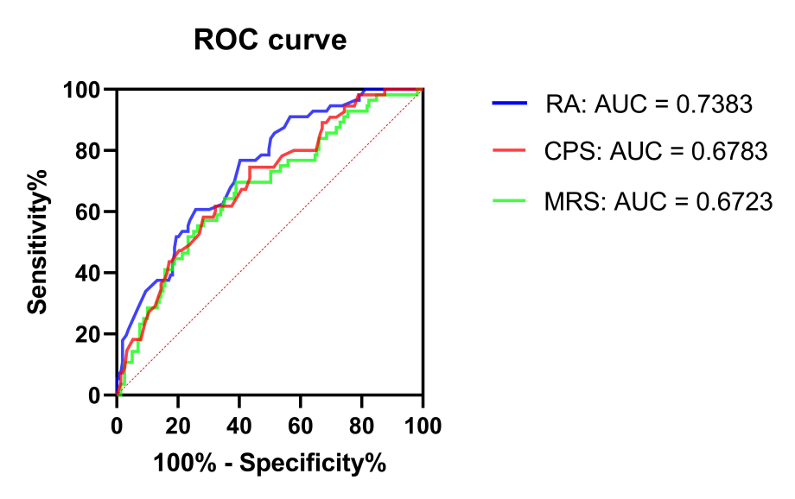
Figure S1. ROC curve of both eyes’ RA, MRS, and CPS.

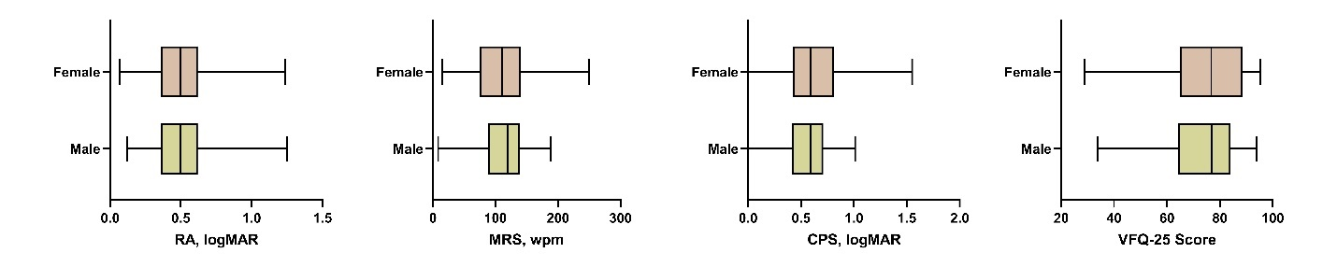
Figure S2. Reading characteristics in different gender. Gender group comparisons were made between the reading ability characteristics of the participants' both eyes. Abbreviations: RA (reading acuity), MRS (maximum reading speed), CPS (critical print size), MAR (minimum angle of resolution), wpm (words per minute). The absence of a pairwise comparison line between two bars indicates that the difference between the two groups is not statistically significant.

