Supplementary Information

Flexible Self-rectifying Synapse Array for Energy-efficient Edge Multiplication in Electrocardiogram Diagnosis

Younghyun Lee^{1,†}, Hakseung Rhee^{1,†}, Geunyoung Kim^{1,†}, Woon Hyung Cheong¹, Do Hoon Kim¹, Hanchan Song¹, Sooyeon Narie Kay¹, Jongwon Lee^{2,}*, and Kyung Min Kim^{1,}*

¹Department of Materials Science and Engineering, Korea Advanced Institute of Science and Technology (KAIST), 291 Daehak-ro, Yuseong-gu, Daejeon, 34141, Republic of Korea

²Department of Semiconductor Convergence, Chungnam National University (CNU), 99 Daehak-ro, Yuseong-gu, Daejeon, 34134, Republic of Korea

*Correspondence and requests for materials should be addressed to J. Lee and K. M. Kim.
(Email: J. Lee: jwlee80@cnu.ac.kr, K. M. Kim km.kim@kaist.ac.kr)

This Supplementary Information contains the following materials:

S1. Electrical characterization of f-MDPE (Supplementary Figures 1-3)

S2. Transformation for hardware-aware training (Supplementary Figures 4-6 and Supplementary Table 1)

S3. Array operation of f-MDPE for ECG diagnosis (Supplementary Figures 7, 8 and Supplementary Table 2)

S4. The simulation of a large-scale convolutional neural network (Supplementary Table 3, and Supplementary Figure 9)

S5. Energy consumption and latency comparisons between digital approaches and f-MDPE (Supplementary Figures 10-12 and Supplementary Tables 4, 5)

Supplementary Note. Definition of F1 score

Supplementary Video. CMOS-based microprocessor system implanted with a hardware-aware 1D CNN module for in-situ individual ECG diagnosis.

S1. Electrical characterization of f-MDPE
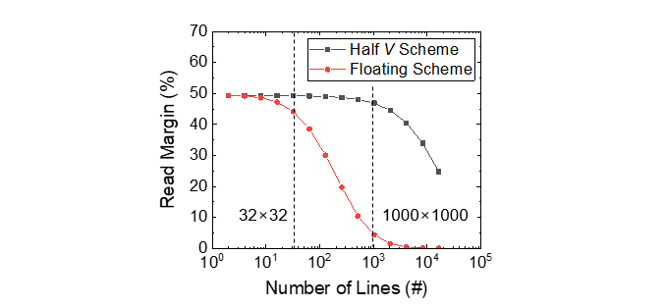

Supplementary Figure 1 Read margin as a function of the number of lines in a square crossbar array. Via a half-voltage scheme, an approximately 50% read margin can be achieved for a 1000×1000 array. The worst-case approximation, assuming that other devices were programmed at the LRS, was used to estimate the maximum array size. The sneak resistance could be assumed to be connected to the selected device in parallel
$$R_{sneak}=\frac{R_{LRS, 1}^{sneak}}{N-1}+\frac{R_{LRS,2}^{sneak}}{{(N-1)}^{2}}+\frac{R_{LRS,1}^{sneak}}{N-1}$$
where $R_{LRS,1}^{sneak}$ represents the resistance of the device that shares the same word line or bit line with the selected device, while $R_{LRS,2}^{sneak}$ does not. Furthermore, a one-bit pull-up read scheme commonly used for simplified equivalent circuits of an array is considered^{1,2}. The pull-up voltage (V_{pu}) is applied to the selected word line, with the pull-up resistance (R_{pu}) connected in series. We calculated V_{out} (the voltage across the selected cell), where V_{pu} is equal to twice the read voltage and R_{pu} is equal to the LRS resistance^{3,4}. Consequently, the read margin (RM) can be defined as
$$RM≡ \frac{∆V_{out }}{V_{pu}}=\frac{V_{out , HRS}}{V_{pu}}-\frac{V_{out ,LRS}}{V_{pu}}$$
where V_{out} is the voltage across the selected device.

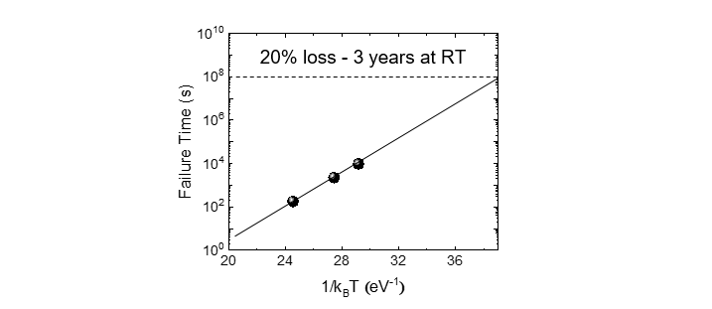

Supplementary Figure 2 Arrhenius plot of failure time verses various temperatures. The failure time was defined as the moment at which 20% of the original conductance was lost.

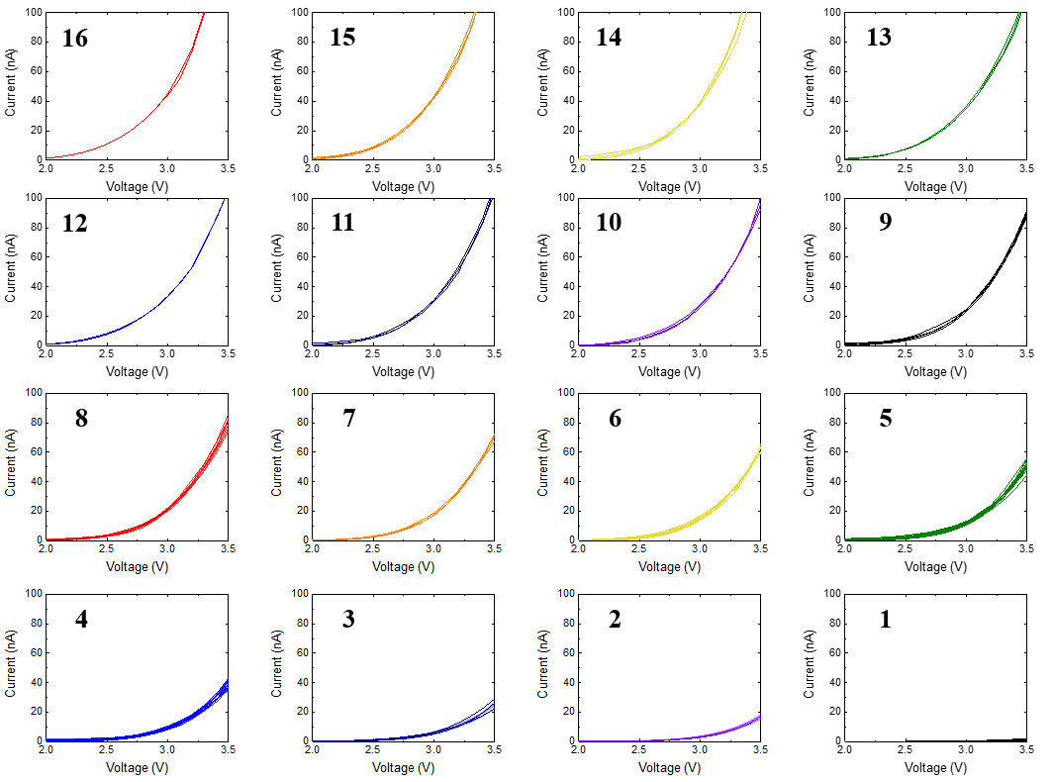

Supplementary Figure 3 Repeated I-V curves of 16 states in the read region (2 V ~ 3.5 V).

S2. Transformation for hardware-aware training
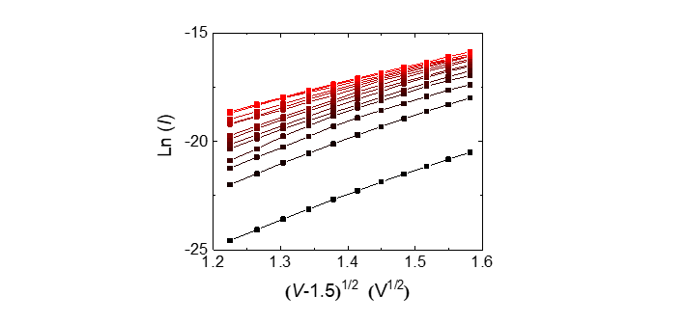
Supplementary Figure 4 Ln(I) vs. (V-1.5)^{1/2} plots for analog states to the Schottky emission equation.

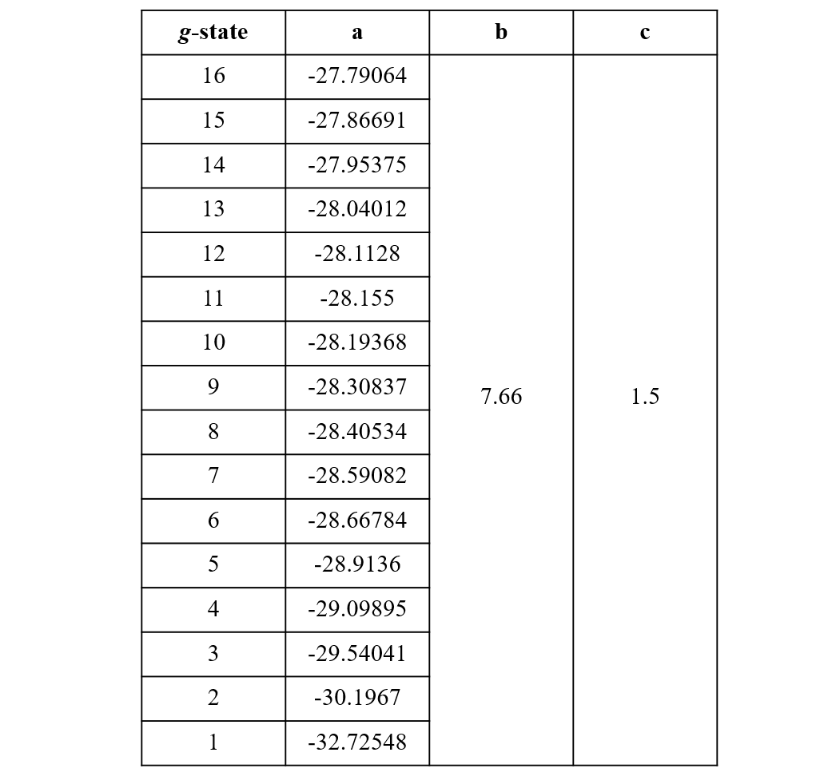

Supplementary Table 1 Hardware parameters extracted from the Schottky fitting for nonlinearity-aware training.

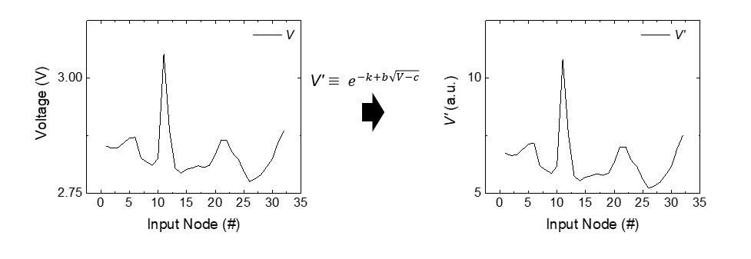

Supplementary Figure 5 Transformed input voltage ($\text{V'}$) of a common ECG pulse with k = 7.

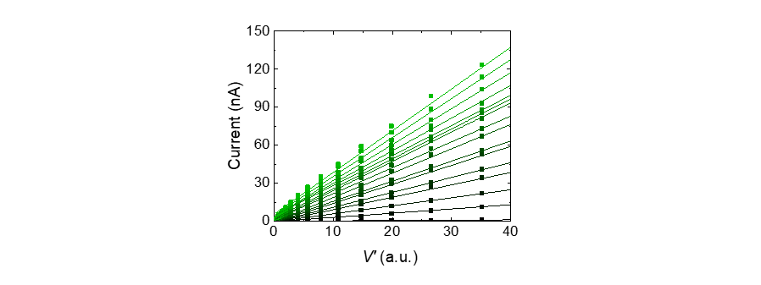

Supplementary Figure 6 Linear behaviors of current vs. transformed voltage (I-$\text{V'}$ plot) for all conductance states.

S3. Array operation of f-MDPE for ECG diagnosis

Step | Description
1 | Load ECG raw data record.
2 | Denoise loaded data using the Mallat algorithm.
3 | Load the location and class information for each peak in the annotation file.
4 | Extract single pulses by selecting segments from the (i−100)^{th} to the (i+200)^{th} data point for each peak located at position i.
5 | Resample each single pulse to a length 32 data by interpolation and normalize from 2.0 V to 3.5 V.

Supplementary Table 2 Preprocessing process for ECG diagnosis with f-MDPE.
The MIT-BIH dataset is frequently used to evaluate arrhythmia detectors⁵. This dataset offers sequential ECG signals, including peak locations and true labels. Initially, we denoised the raw data using the Mallat algorithm, a well-known method for denoising ECG signals⁶. For each peak located at position i, we extracted single pulse segments ranging from the (i−100)^{th} to the (i+200)^{th} position, creating individual pulse samples for analysis. Subsequently, each pulse was resampled to a length of 32 data points, and the amplitude was normalized from 2.0 V to 3.5 V, corresponding to the input voltage range of the f-MPDE.

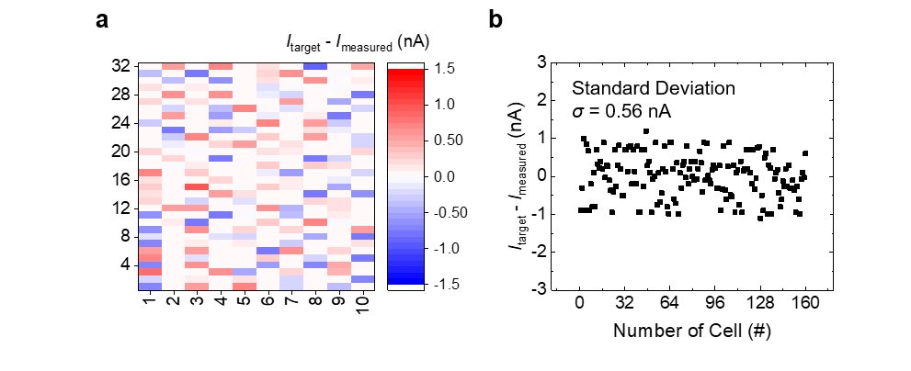

Supplementary Figure 7 (a) Disparity between the target and measured currents depicted in Figures 5c, d. (b) Difference in currents between the target and measured currents at each single point. Unprogrammed cells were excluded due to their low current levels.

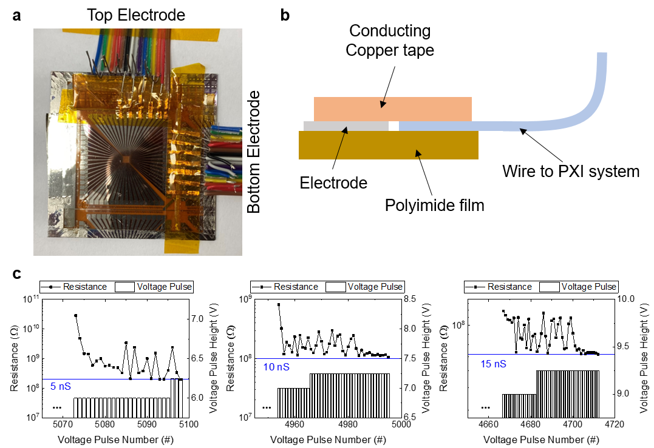

Supplementary Figure 8 Demonstration of an array operation with electrical connections between the array and the crossbar controller. (a) An optical image of the array after connection. (b) Schematic of the experimental setup for wiring. (c) Programming results of the device. Voltage pulses were applied until the target conductance states were reached (5 nS, 10 nS, and 15 nS). The voltage pulses were sequentially applied while increasing the height from 4 V to 12 V until they reached the target conductances.

S4. Simulation of a large-scale convolutional neural network

Array Size |  | 1k | 2k | 4k
Accuracy | F1 macro | 0.8797 | 0.9372 | 0.9343
 | F1 micro | 0.9768 | 0.9878 | 0.9884
Conv.1 | in | 1 | 1 | 1
 | out | 4 | 4 | 4
 | kernel size | 21 | 21 | 21
Pool.1 | kernel size | 9 | 9 | 9
Conv.2 | in | 4 | 4 | 4
 | out | 16 | 16 | 16
 | kernel size | 23 | 23 | 23
Pool.2 | kernel size | 6 | 6 | 6
Conv.3 | in | 16 | 16 | 16
 | out | 32 | 32 | 32
 | kernel size | 25 | 25 | 25
Pool.3 | kernel size | 6 | 4 | 3
Conv.4 | in |  | 32 | 32
 | out |  | 64 | 64
 | kernel size |  | 27 | 27
Pool.4 | kernel size |  | 4 | 3
FC1 | in | 32 | 128 | 320
 | out | 5 | 5 | 5
FC2 | in
 | out
Parameters (#) |  | 407 | 943 | 1901
Number of synapses (#) |  | 814 | 1886 | 3802

Supplementary Table 3 In the investigation of scaled-up 1D convolutional neural network (1D CNN) model architectures, diverse configurations incorporating array size have been explored. These architectures are designed to control the number of convolutional and pooling layers, as well as fully connected layers, ensuring compatibility with the array size. Notably, the required number of synapses is doubled to accommodate both positive and negative weight values. For example, a 2k-sized array can hold 1000 parameters, which is suitable for operating the proposed 2k model architectures.

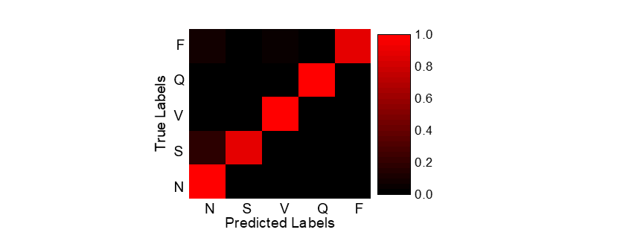

Supplementary Figure 9 Confusion matrix of the 2k model.

S5. Energy consumption and latency comparisons between digital approaches and f-MDPE

Layer | Input  Channel | Parameters | Multiplications | Average weight of parameters (nS) | Remarks
Input | 300
1 | 300 | 93 | 25,875 | 6.417 | Convolution and Max-pooling
2 | 300 | 98 | 28,752 | 6.116 | Convolution and Max-pooling
3 | 288 | 54 | 15,168 | 3.452 | Convolution and Max-pooling
4 | 192 | 58 | 10,880 | 1.867 | Convolution and Max-pooling
5 | 128 | 640 | 640 | 7.958 | Fully connected
Output | 5
SUM |  | 943 | 81,315 | 5.161

Supplementary Table 4 Detailed architecture of the 2k model with the number of multiplication operations and average weight of the parameters for calculating energy consumption.

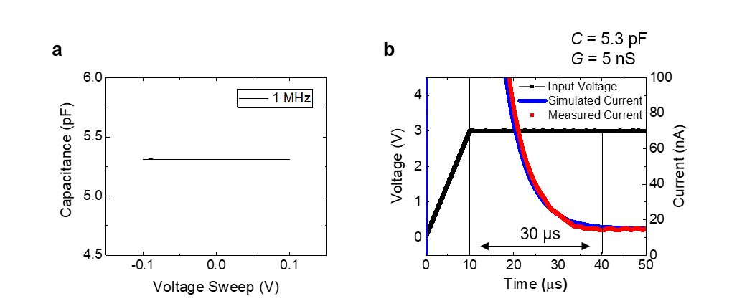

Supplementary Figure 10 Read latency of the CTM device. (a) Measured capacitance of the device (5.3 pF). (b) Measured and simulated currents under a read voltage pulse. A numerical simulation was conducted utilizing LTSpice, incorporating a parallel capacitor. The conductance was 5 nS.

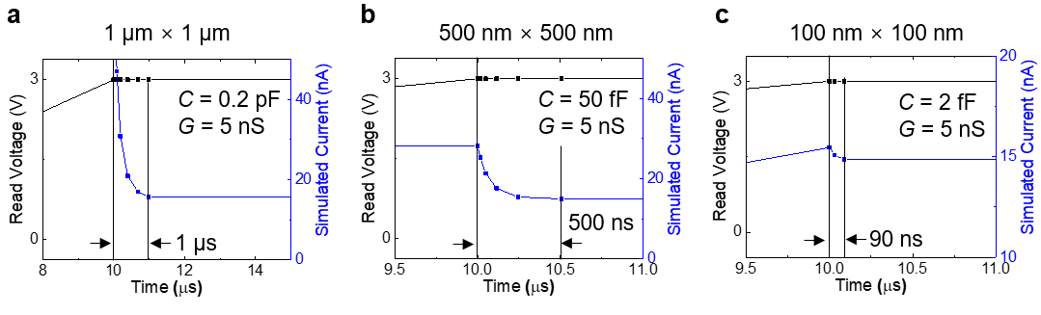

Supplementary Figure 11 The simulated read latency of the scaled-down MDPE was investigated for various device sizes; (a) 1 µm × 1 µm, (b) 500 nm × 500 nm, and (c) 100 nm × 100 nm. These simulations were also conducted utilizing LTSpice, incorporating parallel capacitors and considering the reduction in capacitance following the geometric scaling-down effect.

Energy Consumption per Inference | f-MDPE  (5 µm × 5 µm) |  | Scaled-down MDPE  (100 nm × 100 nm) |  | CPU | GPU
 | Energy (J) | Counts | Energy (J) | Counts
2k-sized array | 1.14 × 10⁻⁷ | 1 | 3.41 × 10⁻¹⁰ | 1
Input-ADC | 1.20 × 10⁻¹⁴ | 64 | 1.20 × 10⁻¹⁴ | 64
MUX | 5.71 × 10⁻¹⁵ | 64 | 5.71 × 10⁻¹⁵ | 32
Output-ADC | 1.20 × 10⁻¹⁴ | 32 | 1.20 × 10⁻¹⁴ | 32
Input register | 1.24 × 10⁻¹² | 1 | 1.24 × 10⁻¹² | 1
Output register | 1.24 × 10⁻¹² | 1 | 1.24 × 10⁻¹² | 1
MaxPool | 4.00 × 10⁻¹³ | 1 | 4.00 × 10⁻¹³ | 1
Total | 1.14 × 10⁻⁷ J |  | 3.45 × 10⁻¹⁰ J |  | 1.68 × 10⁻⁴ J | 4.1 × 10⁻⁵ J

Supplementary Table 5 Energy consumption of the 2k model. The detailed energy consumption of the 2k model was compared between digital approaches and MDPE. For MDPE, the average conductance state is 5.161 nS (as mentioned in Supplementary Table 4), and we assume that the average input read voltage is 3 V. Then, we calculated the energy consumption of the f-MPDE (5 µm × 5 µm) as E = V² × G × t × N_{CNN} = 1.14 × 10⁻⁷ J, where t is the read latency (t = 30 µs) and N_{CNN} is the number of necessary multiplications, as described in Supplementary Table 4 (N_{CNN} = 81,315 for the 2k model). While the read latency could be reduced under a scaled-down device for 300 ns, as described in Supplementary Figure 12, the energy consumption of 100 nm × 100 nm MDPE was estimated to be 3.41 × 10⁻¹⁰ J. The feature size of the scaled-down device was estimated by using a general E-beam lithography process, which is sufficient for fabricating a 100-nm array. The energy consumption of peripheral circuits was estimated based on 28-nm CMOS technology⁷⁻⁹. Thus, the total energy consumption for inference was 1.14 × 10⁻⁷ J and 3.45 × 10⁻¹⁰ J, respectively. Furthermore, for the digital approaches benchmarked by Su-in Yi et al.⁹ and Da Li et al.¹⁰, a CPU was benchmarked based on 22-nm CMOS technology using the Intel Xeon E5-2650 v2, and a GPU was based on 28-nm CMOS technology using the NVIDIA K20. The benchmark CPU and GPU consumed 2,069 pJ and 503 pJ, repectively, per multiplication. The total energy consumption for an inference was 1.68 × 10⁻⁴ J and 4.1 × 10⁻⁵ J, respectively.


Supplementary Figure 12 Latency comparisons between CTM and conventional processors while inferring a heartbeat signal. The time to be processed after the last signal input was calculated.

Supplementary Note Definition of F1 score

The F1 score serves as a crucial evaluation parameter for assessing the performance of classification algorithms, particularly for imbalanced datasets such as the MIT-BIH ECG dataset. In classifying normal signals, the confusion matrix comprises true positive (TP, correctly identified normal signal), true negative (TN, correctly identified abnormal signal), false positive (FP, incorrectly classified normal signal), and false negative (FN, incorrectly classified abnormal signal).
The accuracy, often called the F1-micro score, is a fundamental metric for evaluating the performance of classification models and is defined as the ratio of TP and TN to the summation of all the elements in the confusion matrix:
$$\text{Accuracy} \text{(F1-micro score)}= \frac{\text{TP}\text{+TN}}{\text{TP}+\text{TN}\text{ + }\text{FP}\text{ + }\text{FN}}$$
This metric measures the proportion of correctly classified instances among all instances in the dataset, providing an overall assessment of the model’s predictive capability. However, in the case of an imbalanced dataset, the accuracy can be significantly influenced by the imbalance in the dataset, leading to biased evaluations.
To address this issue, the F1 score is calculated as the harmonic mean of precision and recall, where precision represents the ratio of TP to the summation of TP and FP, and recall represents the ratio of TP to the sum of TP and FN:
$$\text{F1 score}= \frac{2}{1/{\text{precision}}+1/{\text{recall}}}$$
$$\text{Precision}= \frac{\text{TP}}{\text{TP}+\text{FP}}$$
$$\text{Recall}= \frac{\text{TP}}{\text{TP}+\text{FN}}$$
The F1 score provides a balanced evaluation considering both recall and precision. Additionally, the F1-macro score, an average of F1 scores for all indices, is the most important parameter for imbalanced datasets containing multiple classes. Achieving a high F1-macro score is often a primary objective because it indicates the model’s ability to effectively identify true signals while minimizing false positives and false negatives for all classes. Alternatively, when focusing on classifying only abnormal signals as abnormal, the F1 score for abnormal signals may be the primary goal.

References

1. Sung, S. H. et al. Simultaneous emulation of synaptic and intrinsic plasticity using a memristive synapse. Nature Communication 13, 2811 (2022).
2. Huang, C.-H. et al. Self-selecting resistive switching scheme using TiO2 nanorod arrays. Scientific Report 7, 2066 (2017).
3. Linn, E., Rosezin, R., Kügeler, C., & Waser, R. Complementary resistive switches for passive nanocrossbar memories. Nature Materials 9, 403 (2010).
4. Ni, R. et al. Controlled majority-inverter graph logic with highly nonlinear, self-rectifying memristor. IEEE Transaction on Electron Devices 68, 4897 (2021).
5. Apandi, Z. F. M., Ikeura, R., & Hayakawa, S. Arrhythmia detection using MIT-BIH dataset: A review. 2018 International Conference on Computational Approach in Smart Systems Design and Applications (ICASSDA), 1 (2018).
6. Gang, S., Liang, R., & Yuhan, G. Research on the method of ECG denoising based on improved wavelet packet. 2015 IEEE International Conference on Cyber Technology in Automation, Control, and Intelligent Systems (CYBER), 1425 (2015).
7. Cui, Y., Wu, C., Li, Z., & Shan, W. Energy-Efficient Design of Large Fan-in Dynamic One-hot Multiplexer in 28nm CMOS Technology. 2021 IEEE International Conference on Integrated Circuits, Technologies and Applications (ICTA), 197 (2021).
8. Park, J. S., An, T. J., Ahn, G. C., & Lee, S. H. A 12.1 fJ/conv.-step 12b 140 MS/s 28-nm CMOS pipelined SAR ADC based on energy-efficient switching and shared ring amplifier. IEEE Transactions on Circuits and Systems Ⅱ: Express Briefs 66, 1119 (2018).
9. Yi, S.-i., Kendall, J. D., Williams, R. S., & Kumar, S. Activity-difference training of deep neural networks using memristor crossbars. Nature Electronics 6, 45-51 (2023).
10. Li, D., Chen, X., Becchi, M., & Zong, Z. Evaluating the energy efficiency of deep convolutional neural networks on CPUs and GPUs. 2016 IEEE international conferences on big data and cloud computing (BDCloud), social computing and networking (SocialCom), sustainable computing and communications (SustainCom)(BDCloud-SocialCom-SustainCom), 477 (2016).

