VAL-L-4-OHIL  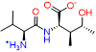 | 2R-3S-4S-4OHIL  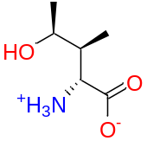 | 2R-3S-4R-4OHIL  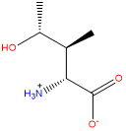 | 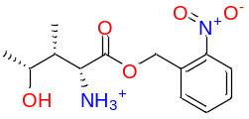  4-OHIL-5 | 4-OHIL-Amide-2  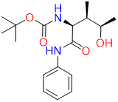
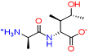  ALA-L-4-OHIL | 2R-3R-4R-4OHIL  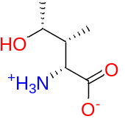 | 4-OHIL-1  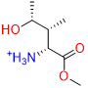 | 4-OHIL-6  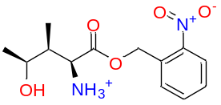 | 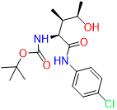  4-OHIL-Amide-3
THR-L-4-OHIL  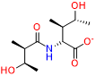 | 2S-3S-4S-4OHIL  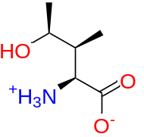 | 4-OHIL-2  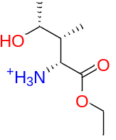 | 4-OHIL-7  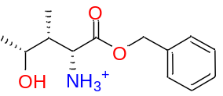 | 2S-3R-4R-4OHIL  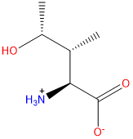
GLY-L-4-OHIL  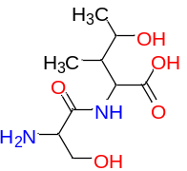 | 2R-3R-4S-4OHIL  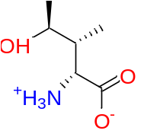 | 4-OHIL-3  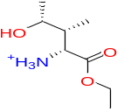 | 4-OHIL  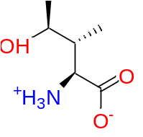
SER-L-4-OHIL-1  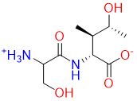 | 2S-3S-4R-4OHIL  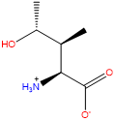 | 4-OHIL-4  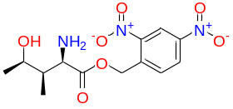 | 4-OHIL-Amide-1  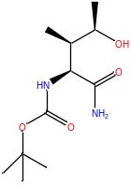
Table1: 2D structure representation of various 4-hydroxyisoleucine derivatives

Table 2: Docking score representation of various 4-hydroxyisoleucine derivatives against diabetes targets
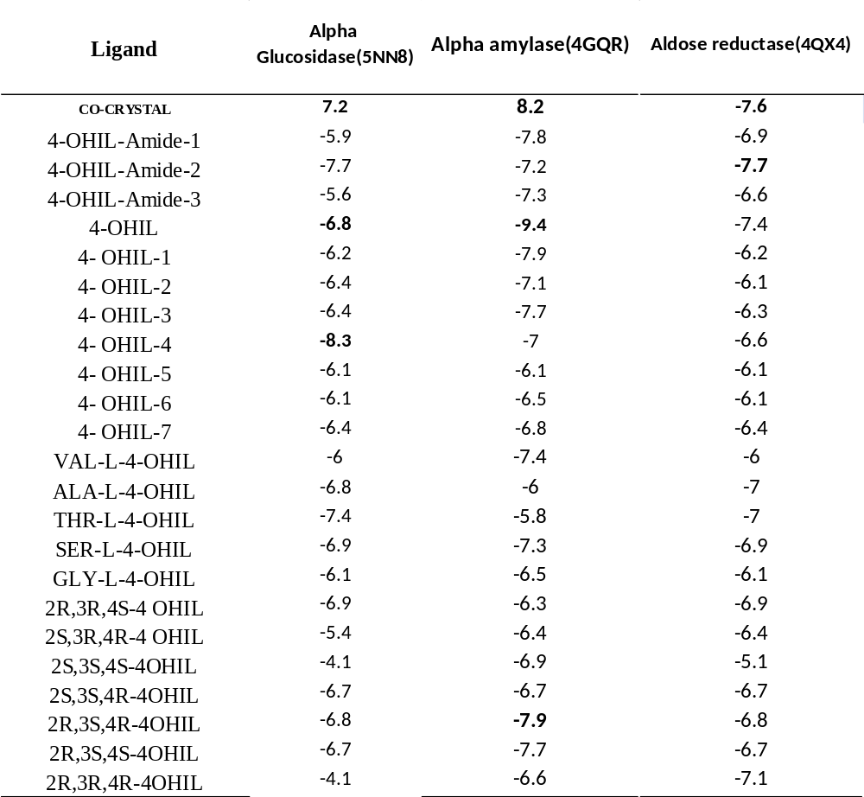

Table 3: Hydrophobic interactions of 4-hydroxyisoleucine derivatives against various diabetes targets
Sno | ligand | Hydrophobic interactions  (4qx4) | Hydrophobic interactions  (5nn8) | Hydrophobic  interactions  (4gqr)
1 | 4-OHIL-Amide-1 | TRP-20  VAL-47  TYR-48  TRP-79  TRP-111  PHE-122  TYR-209  TRP-219  CYS-298 | TRP-376  LEU-405  ILE-441  TRP-481  TRP-516  MET-519  PHE-649  LEU-650 | TRP-59  TYR-62  LEU-162  LEU-165  ALA-198
2 | 4-OHIL-Amide-2 | TRP-20  VAL-47  TYR-48  TRP-79  TRP-111  PHE-122  TYR-209  TRP-219  CYS-298  LEU-300 | TRP-376  ILE-441  TRP-481  MET-519  PHE-525  PHE-649  LEU-650 | TRP-58  TRP-59  TYR-62  LEU-162  LEU-165  ALA-198
3 | 4-OHIL-Amide-3 | TRP-20  VAL-47  TYR-48  TRP-79  TRP-111  PHE-122  TRP-219  CYS-298  LEU-300  LEU-301 | ALA-284  TRP-376  ILE-441  TRP-516  PHE-525  ALA-555  PHE-649 | TRP-58  TRP-59  TYR-62  TYR-151  LEU-162
4 | 4-OHIL | TRP-20  TYR-48  TRP-79  TRP-111  TRP-219  CYS-298 | TRP-376  LEU-405  ILE-441  TRP-481  TRP-516  MET-519  TRP-613  PHE-649 | TRP-58  TYR-62  LEU-165
5 | 4- OHIL-1 | TRP-20  VAL-47  TYR-48  TRP-79  TRP-111  TYR-209  CYS-298 | TRP-376  TRP-481  TRP-516  MET-519  PHE-649 | TRP-58  TYR-62  LEU-162  ALA-198
6 | 4- OHIL-2 | TRP-20  VAL-47  TYR-48  TRP-79  TRP-111  TYR-209  CYS-298 | TRP-516  MET-519  PHE-649 | TRP-58  TYR-62  LEU-162  LEU-165  ALA-198
7 | 4- OHIL-3 | TYR-209  ILE-260  CYS-298 | TRP-376  TRP-516  MET-519  PHE-649 | TRP-59  LEU-162  LEU-165  ALA-198  ILE-235
8 | 4- OHIL-4 | TRP-20  VAL-47  TYR-48  TRP-79  TRP-111  PHE-122  TYR-209  TRP-219  CYS-298  LEU-300 | TRP-376  TRP-516  MET-519  LEU-650  LEU-677 | TRP-58  TRP-59  TYR-62  LEU-162  ALA-198  ILE-235
9 | 4- OHIL-5 | TRP-20  VAL-47  TYR-48  TRP-79  TRP-111  PHE-122  TRP-219  CYS-298  LEU-300 | TRP-376  TRP-516  MET-519  PHE-649  LEU-650 | TRP-58  TRP-59  TYR-62  LEU-162  LEU-165  ALA-198  ILE-235
10 | 4- OHIL-6 | TRP-20  TYR-48  TRP-79  TRP-111  PHE-122  TYR-209  TRP-219  CYS-298  LEU-300 | TRP-376  TRP-516  MET-519  PHE-649  LEU-650  LEU-677  LEU-678 | TRP-58  TRP-59  TYR-62  LEU-162  ALA-198  ILE-235
11 | 4- OHIL-7 | TRP-20  TYR-48  TRP-111  PHE-122  TYR-209  TRP-219  CYS-298  LEU-300 | TRP-376  LEU-405  ILE-441  TRP-481  TRP-516  MET-519  PHE-649  LEU-650  LEU-677 | TRP-58  TRP-59  TYR-62  LEU-162  LEU-165  ALA-198
12 | VAL-L-4-OHIL | TRP-20  VAL-47  TYR-48  TRP-79  TRP-111  PHE-122  TYR-209  TRP-219  LEU-300 | TRP-376  LEU-405  ILE-441  TRP-481  TRP-516  MET-519  PHE-649 | TRP-58  TYR-62  LEU-162  LEU-165  ALA-198  ILE-235
13 | ALA-L-4-OHIL | TRP-20  VAL-47  TYR-48  TRP-79  TRP-111  PHE-122  TYR-209  TRP-219  CYS-298 | TRP-376  ILE-441  TRP-481  TRP-516  MET-519  PHE-649 | TRP-58  TYR-62  LEU-162
14 | THR-L-4-OHIL | TRP-20  TYR-48  TRP-79  TRP-111  PHE-122  TYR-209  TRP-219  CYS-298  LEU-300 | TRP-376  ILE-441  TRP-481  MET-519  PHE-649 | TRP-58  TRP- 59  TYR-62  LEU-162
15 | SER-L-4-OHIL | TRP-20  VAL-47  TYR-48  TRP-79  TRP-111  TYR-209  TRP-219  CYS-298 | TRP-481  TRP-516  MET-519  TRP-613  PHE-649 | TRP-58  TRP- 59  TYR-62  LEU-162
16 | GLY-L-4-OHIL | TRP-20  VAL-47  TYR-48  TRP-79  TRP-111  PHE-122  TYR-209  TRP-219  LEU-300 | ILE-283  ALA-284  TRP-376  ILE-441  TRP-481  MET-519 | TRP-58  TYR-62  LEU-162  ALA-198
17 | 2R,3R,4S-4 OHIL | TYR-48  TRP-79  TRP-111  TYR-209  CYS-298  LEU-300 | TRP-376  ILE-441  TRP-481  TRP-516  TRP-613  PHE-649 | TRP-58  TYR-62
18 | 2S,3R,4R-4 OHIL | TYR-48  TRP-79  TRP-111 | TRP-376  ILE-441  TRP-481  TRP-516  MET-519  PHE-649 | TRP-58  TYR-62  LEU-162
19 | 2S,3S,4S-4OHIL | TRP-20  TYR-48  TYR-209  ILE-260  CYS-298 | TRP-376  TRP-516  MET-519  TRP-613  PHE-649 | TRP-58  TYR-62  LEU-162  ALA-192
20 | 2S,3S,4R-4OHIL | TRP-20  TYR-48  TRP-111  TYR-209  TRP-219  CYS-298 | TRP-376  LEU-405  ILE-441  TRP-481  TRP-516  MET-519  PHE-649 | TRP-58  TYR-62  LEU-162  ALA-198
21 | 2R,3S,4R-4OHIL | TRP-20  TYR-48  TYR-209  ILE-260  CYS-298  LEU-300 | TRP-376  LEU-405  ILE-441  TRP-481  TRP-516  MET-519  TRP-613  PHE-649 | TYR-62  LEU-162
22 | 2R,3S,4S-4OHIL | TRP-20  VAL-47  TYR-48  TRP-79  TRP-111  CYS-298 | TRP-376  LEU-405  TRP-481  TRP-516  MET-519  TRP-613  PHE-649 | TYR-62  LEU-162
23 | 2R,3R,4R-4OHIL | TRP-20  TYR-48  TRP-79  TRP-111  TYR-209  CYS-298 | TRP-376  LEU-405  ILE-441  TRP-481  TRP-516  MET-519  TRP-613  PHE-649 | TRP-58  TYR-62  LEU-162  ALA-198

Table 4: AI Generative model scaffolds
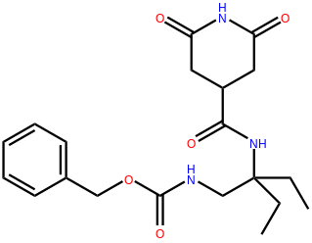 | 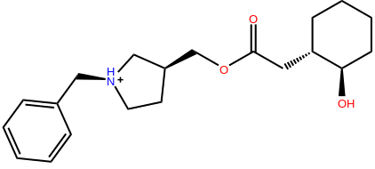 |  |  | 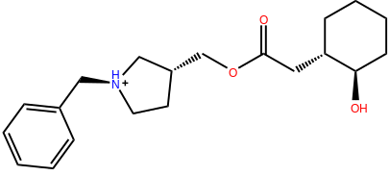
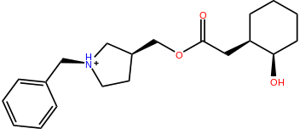 | 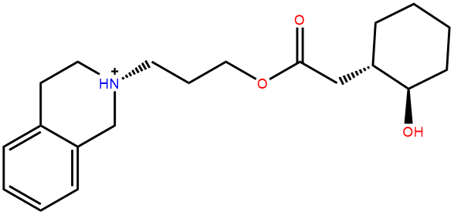 |  |  | 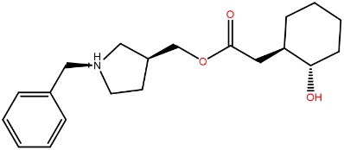
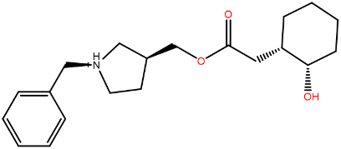 | 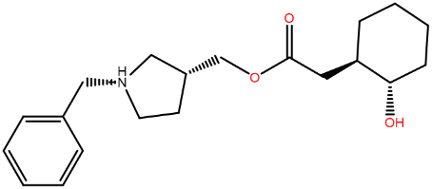 |  |  | 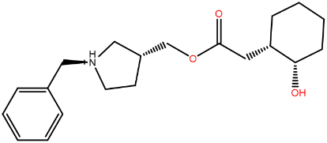
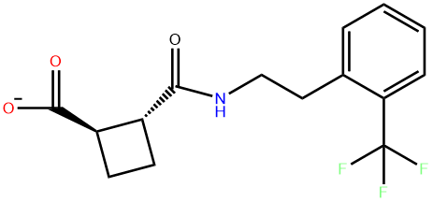 |  | 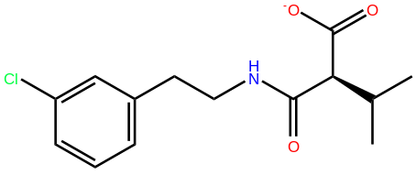 |  |  | 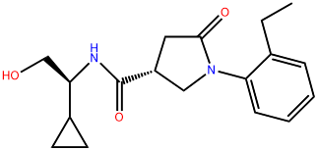
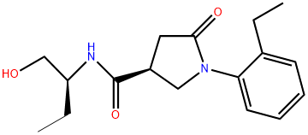 |  | 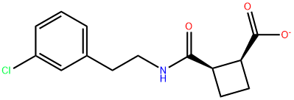 |  |  | 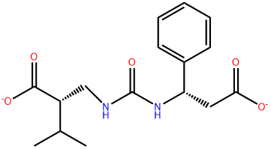
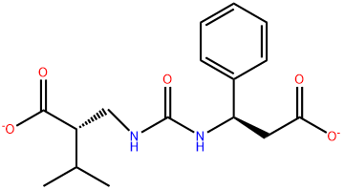 |  |  | 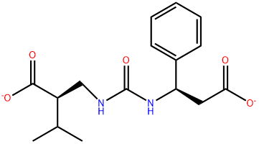 |  | 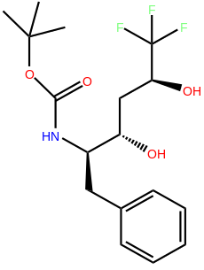
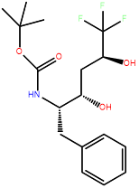 |  |  | 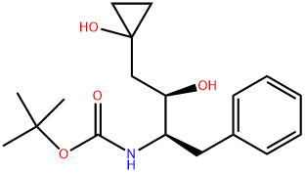 |  | 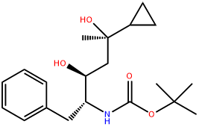
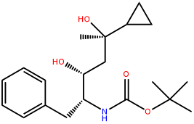 |  |  | 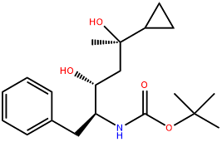 |  | 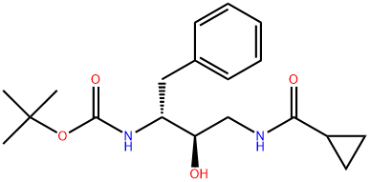
 |  |  | 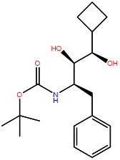 |  | 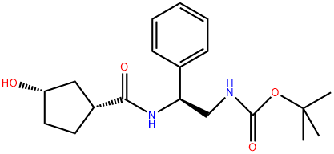
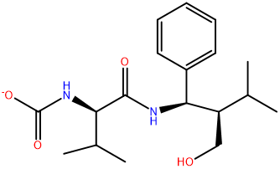 |  |  | 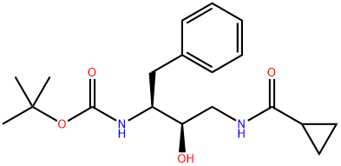 |  | 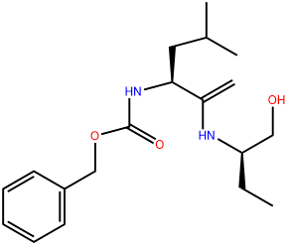
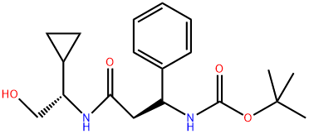 |  |  | 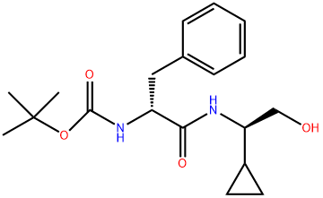 |  | 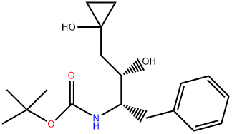
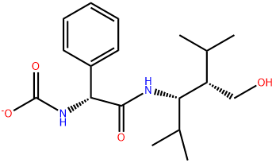 |  |  | 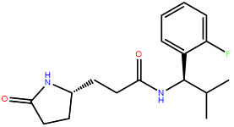 |  | 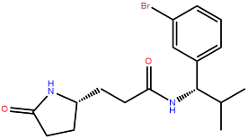
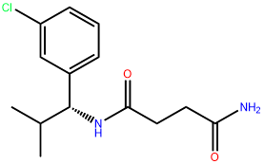 |  |  | 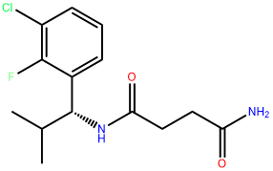 |  | 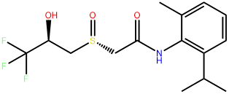
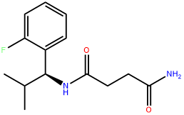 |  |  | 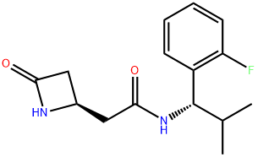

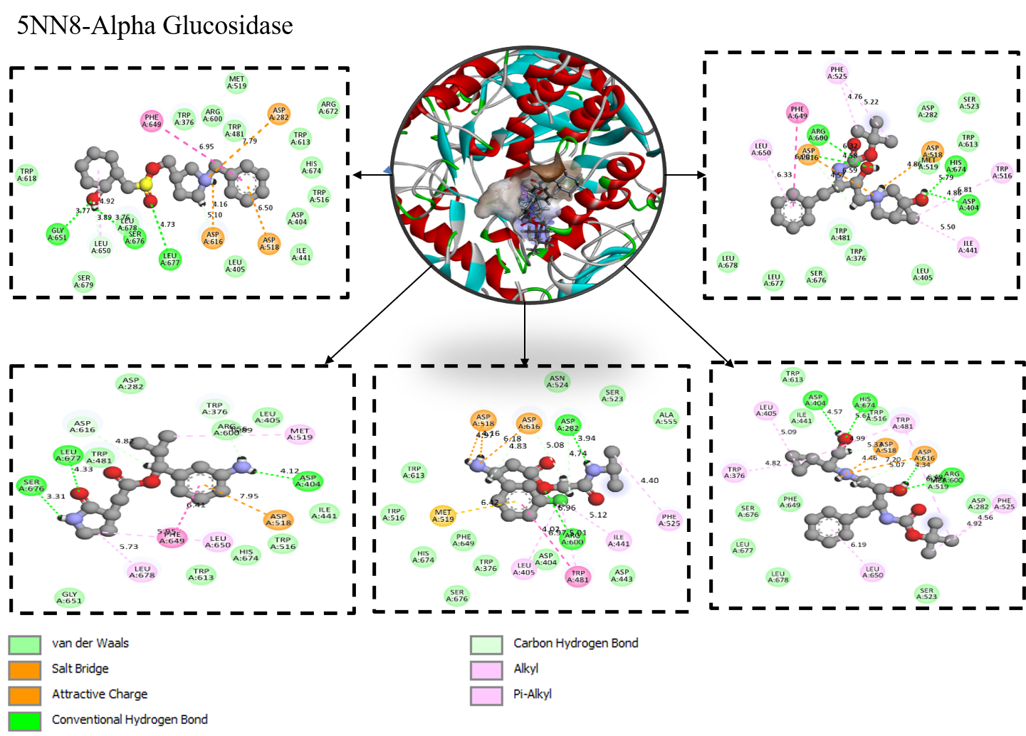
Figure 1: Docking result of Alpha Glucosidase (5NN8) Target Optimised structures using generative model (Ligdream)
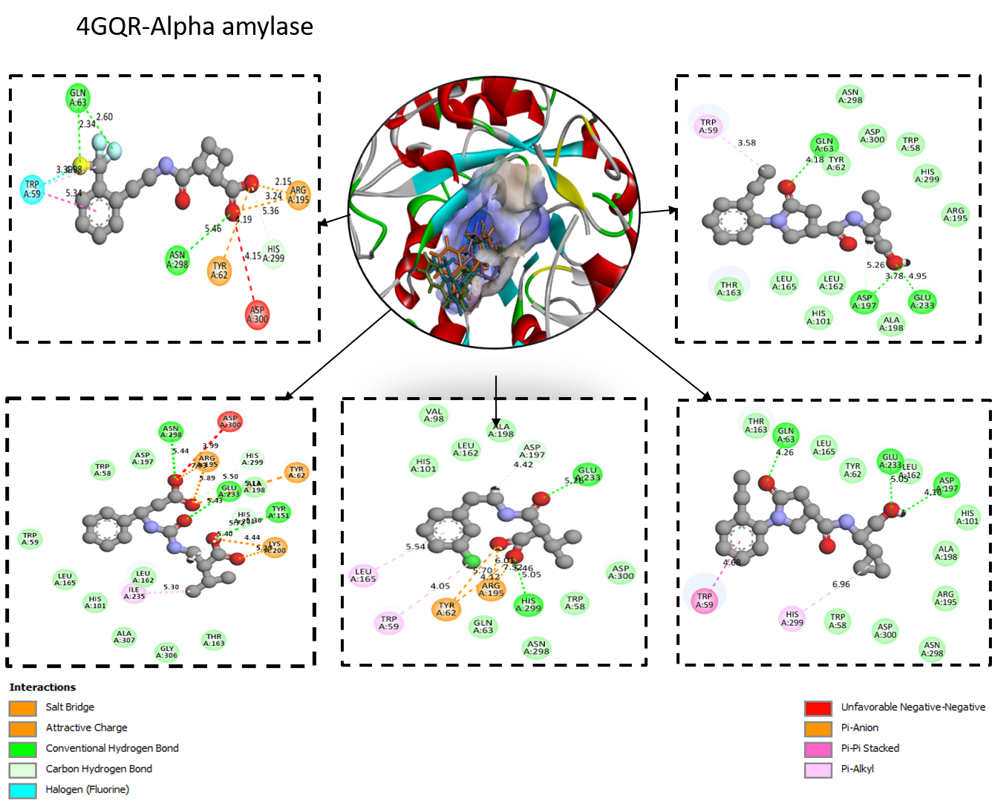
Figure 2: Docking result of Alpha Amylase (4GQR) Target Optimised structures using generative model (Ligdream)
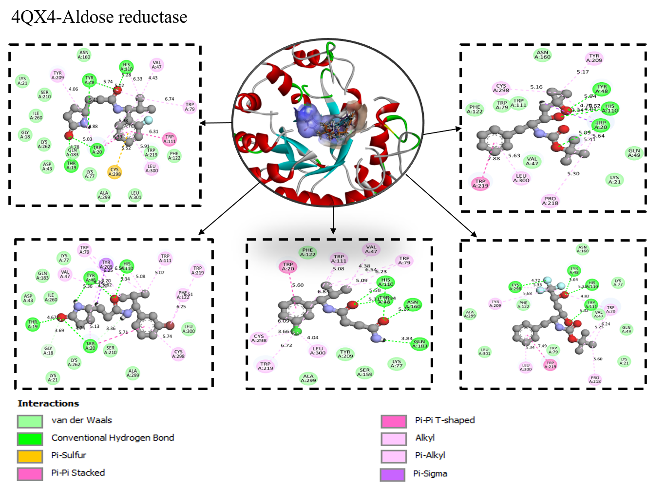
Figure 3: Docking result of Aldose reductase (4QX4) Target Optimised structures using generative model (Ligdream)

