APPENDIX

Table 1: ANOVA RESULT SUMMARY
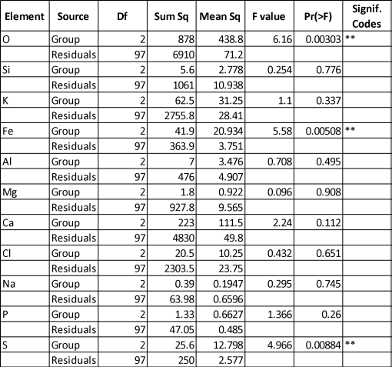

Table 2: Variance between group

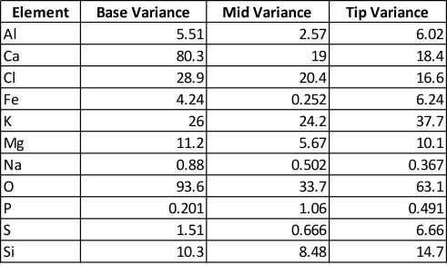

Table 2: Correlation Across The Group
 | O | Si | K | Fe | Al | Mg | Ca | Cl | Na | P |  | S
O | 1 | -0.309 | -0.317 | -0.525 | -0.197 | 0.15 | -0.6 | -0.219 | 0.197 | -0.109 |  | -0.007
Si | -0.309 | 1 | 0.363 | 0.551 | 0.794 | -0.522 | -0.114 | -0.304 | -0.326 | -0.195 |  | -0.433
K | -0.317 | 0.363 | 1 | 0.4 | 0.435 | -0.609 | 0.136 | -0.578 | -0.737 | -0.138 |  | -0.433
Fe | -0.525 | 0.551 | 0.4 | 1 | 0.63 | -0.376 | 0.089 | -0.284 | -0.29 | -0.167 |  | -0.195
Al | -0.197 | 0.794 | 0.435 | 0.63 | 1 | -0.567 | -0.165 | -0.437 | -0.373 | -0.332 |  | -0.507
Mg | 0.15 | -0.522 | -0.609 | -0.376 | -0.567 | 1 | -0.251 | 0.664 | 0.636 | 0.347 |  | 0.383
Ca | -0.6 | -0.114 | 0.136 | 0.089 | -0.165 | -0.251 | 1 | -0.116 | -0.358 | 0.068 |  | 0.094
Cl | -0.219 | -0.304 | -0.578 | -0.284 | -0.437 | 0.664 | -0.116 | 1 | 0.643 | 0.197 |  | 0.288
Na | 0.197 | -0.326 | -0.737 | -0.29 | -0.373 | 0.636 | -0.358 | 0.643 | 1 | -0.021 |  | 0.394
P | -0.109 | -0.195 | -0.138 | -0.167 | -0.332 | 0.347 | 0.068 | 0.197 | -0.021 | 1 |  | 0.154
S | -0.007 | -0.433 | -0.433 | -0.195 | -0.507 | 0.383 | 0.094 | 0.288 | 0.394 | 0.154 |  | 1

