Supplementary Information
Box 1 Inclusion and exclusion criteria
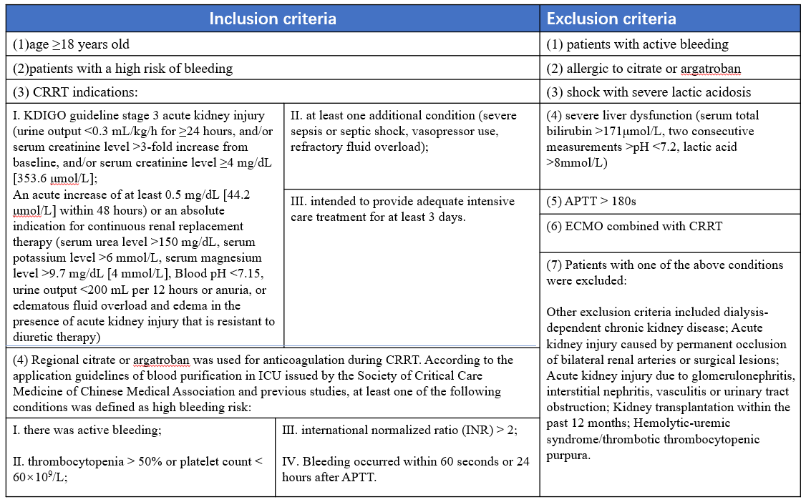

Table S1 Comparison of biochemical indexes between the two groups pre- and post-treatment
indicators |  | ARC group(n=103) | Argatroban group(n=104) | statistical value | p values
pH | Pre-treatment | 7.42(7.35, 7.48) | 7.39(7.32, 7.45) | -1.763 | 0.078
pH | Post-treatment | 7.41(7.36, 7.46) | 7.41(7.37, 7.46) | -0.497 | 0.619
HCO₃⁻ | Pre-treatment | 23.07±6.62 | 22.27±7.53 | 0.729 | 0.467
HCO₃⁻ | Post-treatment | 27.05(23.40, 33.80) | 23.50(20.15, 25.75) | -4.091 | 0.000
Ca | Pre-treatment | 2.15(1.97, 2.30) | 2.08(1.98, 2.21) | -1.632 | 0.103
Ca | Post-treatment | 2.51±0.32 | 2.11±0.20 | 12.530 | 0.000
Na | Pre-treatment | 139.55(136.30, 142.85) | 138.10(136.20, 140.90) | -1.704 | 0.088
Na | Post-treatment | 143.03±5.63 | 137.66±2.47 | 10.178 | 0.000
K | Pre-treatment | 4.11(3.78, 4.72) | 4.185(3.82, 4.59) | -0.072 | 0.943
K | Post-treatment | 4.01±0.52 | 4.17±0.50 | -2.673 | 0.008
Mg | Pre-treatment | 0.87(0.80, 0.98) | 0.93(0.86, 0.97) | -1.668 | 0.095
Mg | Post-treatment | 0.84±0.14 | 1.01±0.10 | -8.620 | 0.000
P | Pre-treatment | 1.07(0.67, 1.60) | 1.05(0.68, 1.55) | -0.137 | 0.891
P | Post-treatment | 0.80(0.55, 1.09) | 0.80(0.55, 1.13) | -0.574 | 0.566
WBC | Pre-treatment | 11.75(7.10, 15.70) | 10.19(7.96, 14.75) | -0.163 | 0.870
WBC | Post-treatment | 10.60(7.10, 14.40) | 9.87(7.59, 14.19) | -0.091 | 0.927
HGB | Pre-treatment | 87.50(73.00, 104.00) | 83.00(75.00, 95.00) | -1.664 | 0.096
HGB | Post-treatment | 83.00(74.00, 98.50) | 81.00(74.00, 92.00) | -1.365 | 0.172
PLT | Pre-treatment | 100.0(59.00, 186.00) | 114.0(65.00, 185.00) | -1.371 | 0.170
PLT | Post-treatment | 93.00(60.00, 150.00) | 104.00(58.00, 153.00) | -0.564 | 0.573
Scr | Pre-treatment | 161.90(84.70, 261.20) | 176.00(99.00, 257.00) | -1.313 | 0.189
Scr | Post-treatment | 118.00(61.95, 191.90) | 128.00(81.00, 207.00) | -0.909 | 0.363
BUN | Pre-treatment | 14.14(8.93, 21.50) | 13.97(8.36, 21.82) | -0.530 | 0.596
BUN | Post-treatment | 9.68(6.36, 15.27) | 8.73(6.26, 13.10) | -1.676 | 0.094
Abbreviations: WBC: white blood cell, HGB: haemoglobin, PLT: platelet, Scr: serum creatinine, BUN: blood urea nitrogen

