Progranulin associates with Rab2 and is involved in autophagosome-lysosome fusion in Gaucher Disease
Xiangli Zhao, Rossella Liberti, Jinlong Jian, Wenyu Fu, Aubryanna Hettinghouse, Ying Sun, Chuan-ju Liu

This Supplementary Information File Includes:
Figs. S1 to S4 (Pages 2-6)
Abbreviations (Page 7)

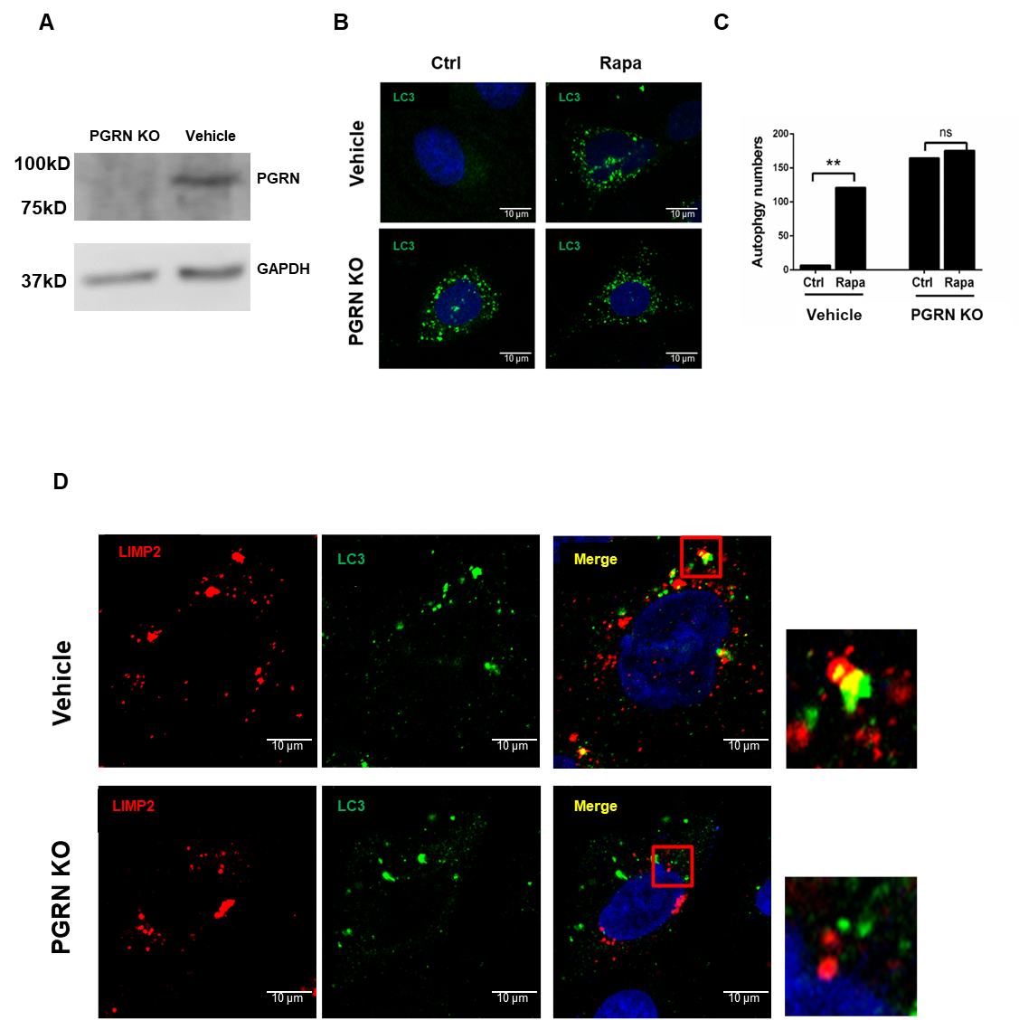

Supplementary Figure 1. PGRN deficiency impaired the autophagosome-lysosome fusion in C28I2 cells. (A) Knockout of PGRN in C28I2 cells. (B) LC3 expression level by immunofluorescence staining in control and PGRN KO C28I2 cells with rapamycin stimulation or DMSO treatment. (C) Qualitative analysis of A. (D) Co-localization of LIMP2 and LC3 proteins in PGRN KO C28I2 cells after rapamycin treatment using confocal microscopy. Red staining: LC3, green staining: LIMP2. C, data are mean ± SD; * p < 0.05 or ** p < 0.01.

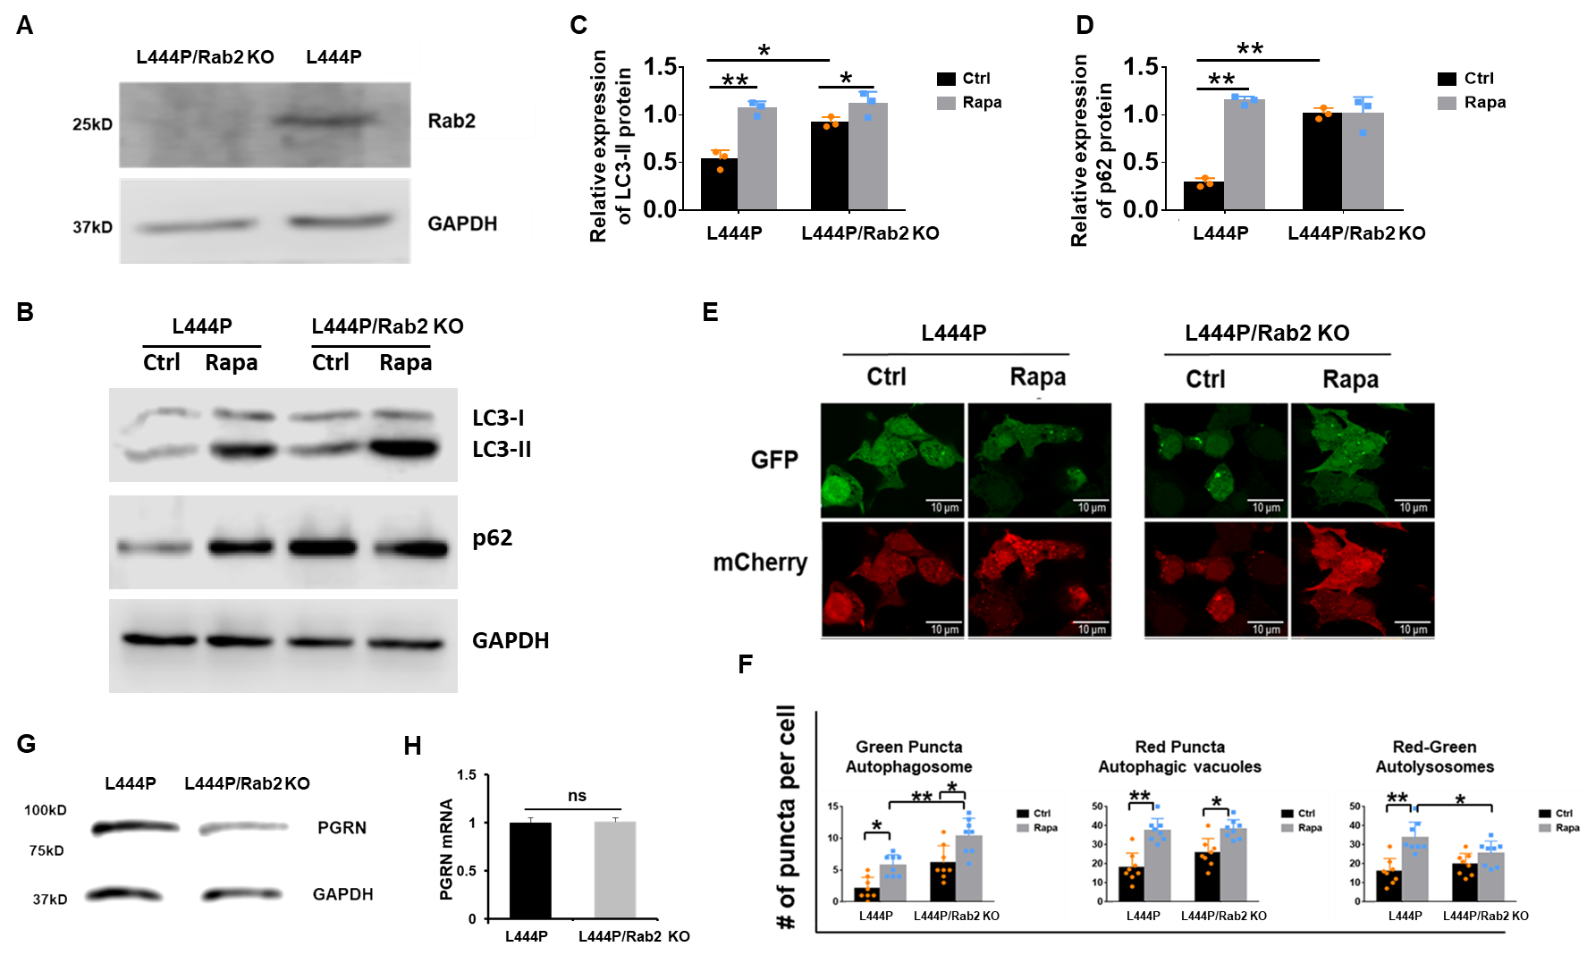

Supplementary Figure 2. Rab2 deficiency induces defective autophagic flux and lowers PGRN level in GD fibroblasts. (A) Rab2 was knocked out in L444P using CRISPR-Cas9. (B) Expression levels of autophagy markers LC3 and p62 in L444P or L444p/Rab2 KO with rapamycin (100nM) stimulation, DMSO treatment used as a control. (C) Quantiﬁcation of LC3-II expression level. (D) Quantiﬁcation of p62 expression level. (E) Confocal microscopy analysis of mCherry-GFP-LC3 expressed in L444P or L444p/Rab2 KO with or without rapamycin stimulation. MCherry⁺GFP⁻ (red) puncta indicate autolysosomes, mCherry⁺GFP⁺ (yellow) indicates autophagosome. (F) Quantification of (E). (G) Protein level of PGRN in Rab2 deficient L444P, assayed by Western blotting. (H) mRNA level of PGRN in L444P or L444p/Rab2 KO using real time RT-PCR. C, D, F and H, data are mean ± SD; * p < 0.05 or ** p < 0.01.

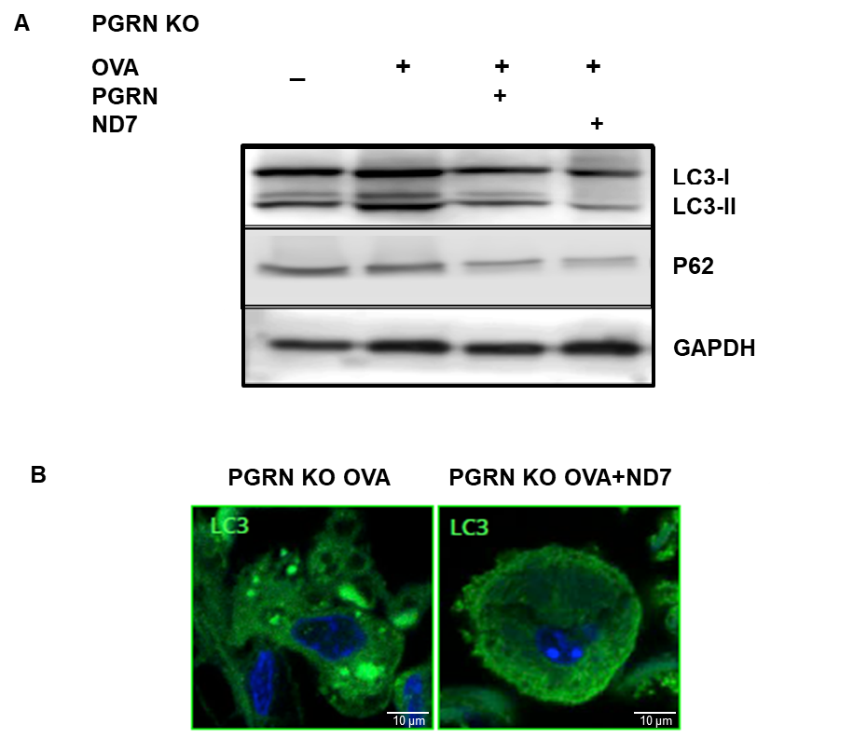
Supplementary Figure 3. ND7 administration decreases levels of autophagic markers in GD model. (A) Autophagic markers in PGRN KO OVA-challenged mice after PGRN or ND7 treatment. Anti-LC3 and anti-p62 western blot of lung tissues from PGRN KO mice lysed after PBS, OVA, PGRN, or ND7 treatments. (B) Immunofluorescence staining of LC3 in PGRN KO OVA-challenged mice after ND7 treatments. Immunofluorescence staining of LC3 in lung tissues from PGRN KO mice lysed after OVA or ND7 treatments. n ≥ 5 mice per group.

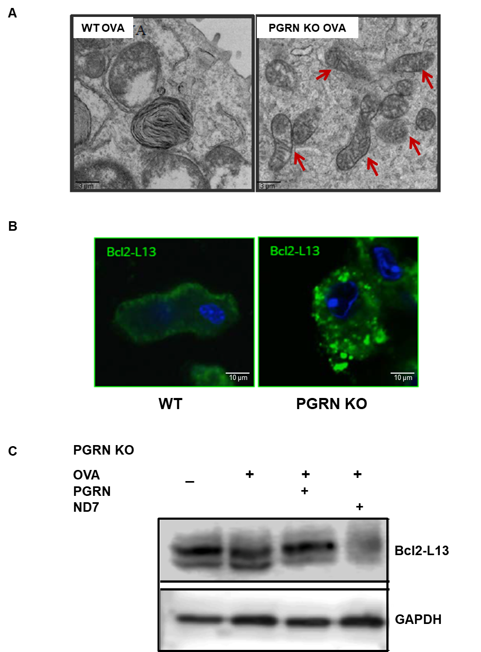

Supplementary Figure 4. PGRN deficiency reduced the clearance of damaged mitochondria in GD macrophages. WT and PGRN KO mice received I.P. injection of OVA at Day 1 and 15, followed by intranasal challenge of 1% OVA beginning at Day 29 and administrated thereafter three times a week for four weeks. (A) Microautophagy in WT or PGRN KO OVA- challenged mice. The red arrows indicate the damaged mitochondria. (B) Bcl2-L13 level in PGRN KO mice. Immunofluorescence staining of Bcl2-L13 in lung tissues from WT and PGRN KO mice lysed after OVA challenge. (C) Bcl2-L13 level in PGRN KO OVA-challenged mice after ND7 treatments. Anti- Bcl2-L13 western blot of lung tissues from PGRN KO mice lysed after PBS, OVA, PGRN, or ND7 treatments. n ≥ 5 mice per group.

Abbreviations
ATG5: autophagy related 5; ATG12: autophagy related 12; ATG16L1: autophagy related 16 like 1; Ctrl: control; EM: Electron microscopy; GCase: β-glucocerebrosidase; GD: Gaucher disease; GFP: green fluorescent protein; Grn: Granulin; HSP70: 70 kilodalton heat shock proteins; IP: immunoprecipitation; KO: knockout; LC3: microtubule-associated protein 1 light chain 3; LIMP2: Lysosomal integral membrane protein 2; LSD: lysosome storage disease; β-GlcCer: β-glucosylceramide; ND: N-terminal deletion; OVA: ovalbumin; PGRN: progranulin; Rab2: Ras-related protein Rab-2A; Rab7: Ras-related protein Rab-7a; RUBCNL/PACER: rubicon like autophagy enhancer; SQSTM1/p62: sequestosome 1; STX17: syntaxin 17; TNF: Tumor Necrosis Factor; VAMP8: Vesicle-associated membrane protein 8; WB: western blot; WT: wild type.

