Sequencing-based study of neural induction of human dental pulp stem cells

Shohei Takaoka, Fumihiko Uchida, Hiroshi Ishikawa, Junko Toyomura, Akihiro Ohyama, Hideaki Matsumura, Koji Hirata, Satoshi Fukuzawa, Naomi Ishibashi Kanno,
Aiki Marushima, Kenji Yamagata, Toru Yanagawa, Yuji Matsumaru, Eiichi Ishikawa, Hiroki Bukawa

Appendix

Appendix Material and Method
Immunofluorescence staining
Ni-DPSCs were cultured and subcultured for 2 and 3 DIV, respectively. Cells sustained for 15 DIV were subjected to microtubule-associated protein 2 (MAP2) staining. The cells were fixed with 4% paraformaldehyde for 10 min, permeabilized with 0.1% PBS-Triton X-100 for 5 min, treated with Blocking One Histo blocking buffer (Nacalai Tesque, Inc., Kyoto, Japan) for 10 minutes, and incubated overnight with primary antibodies at 4℃. The primary antibodies used are listed in Appendix Table 2. The secondary antibodies used were Alexa Fluor 488-conjugated goat anti-mouse IgG, Alexa Fluor 568-conjugated goat anti-rabbit IgG, and Alexa Fluor 647-conjugated goat anti-chicken IgY (Thermo Fisher Scientific). Nuclei were stained using 4′,6-diamidino-2-phenylindole (Vector Laboratories, Burlingame, CA, USA). The images were captured using a fluorescence microscope (BZ-X810; Keyence, Osaka, Japan).

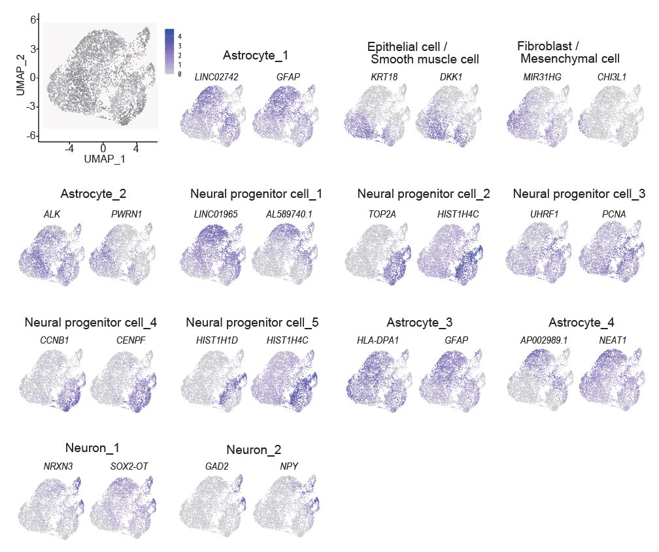

Appendix Figure 1. Superimposition of the expression levels of genes
UMAP plots coloured by expression levels of top 2 characteristic cluster marker genes.

Appendix Table 1. Top 10 genes in each individual cluster
Cluster 0 | Cluster 1 |  | Cluster 2 | Cluster 3 | Cluster 4 | Cluster 5 | Cluster 6 | Cluster 7 | Cluster 8 | Cluster 9 | Cluster 10 | Cluster 11 | Cluster 12
GFAP |  | KRT18 | CHI3L1 | ALK | LINC01965 | HIST1H4C | PCNA | CENPF | HIST1H4C | GFAP | AP002989.1 | NRXN3 | NPY
LINC02742 |  | DKK1 | MIR31HG | PWRN1 | AL578740.1 | TOP2A | UHRF1 | CCNB1 | HIST1H1D | HLA-DPA1 | NEAT1 | SON2-OT | GAD2
SEPRINE1 |  | S100A2 | CLMP | RUNX2 | FABP5 | HIST1H1B | MCM3 | PTTG1 | HIST1H1B | SPP1 | GALNT17 | DLX6-AS1 | HIST1H4C
RASAL2 |  | RBP1 | TENMA3 | NIBAN1 | PTPRZ1 | CENPF | DTL | TOP2A | HIST1H3D | HOPX | LINCO2742 | ERBB4 | HIST1H3B
HOPX |  | S100A6 | S100A2 | RCAN1 | S100B | MKI67 | NRG1 | UBE2C | HIST1H1A | FABP7 | NPAS3 | NKAIN2 | HIST1H3D
HMGCS1 |  | COL6A1 | TIAM1 | RNF220 | SOX5 | HIS1H1D | MIR924HG | ARL6IP1 | HIST1H1C | MT3 | PPP2R2B | NXPH1 | SOX2-OT
HLA-DPA1 |  | COL6A2 | LHFPL6 | KCNIP4 | SNTG1 | NPY | ATAD2 | KPNA2 | H2AFZ | HLA-DRA | KAZN | ROBO2 | HIST1H1C
LMCD1-AS1 |  | PRDX6 | NPAS2 | EML6 | LRRC3B | HIST1H3D | SLC35F3 | ASPM | HIST2H2AC | HLA-DPB1 | RASAL2 | PDE4D | NRXN3
GRIA1 |  | PLAAT4 | SLC20A1 | TSHZ2 | ST6GALNAC5 | DIAPH3 | MCM4 | UBE2S | RRM2 | CLU | BICD1 | NRXN1 | HIST1H1A
MSMO1 |  | S100A10 | CDH18 | ST8SIA5 | PANTR1 | HMGB2 | MCM5 | HMGB2 | HIST1H2AJ | CD74 | MIR99AHG | CASC15 | HIST1H1B

Appendix Table 2. Primary antibodies
Antibody | Company | Catalog No. | Dilution
GFAP | SIGMA | G3893 | 1:1000
Nestin | abcam | ab105389 | 1:200
SOX2 | MERCK | AB5603 | 1:100
Ki67 | abcam | ab15580 | 1:200
FABP7 | Santa Cruz | sc-374588 | 1:100
DCX | abcam | ab18723 | 1:500
MAP2 | abcam | ab5392 | 1:1000
αSMA | abcam | ab7817 | 1:100
Abbreviations: GFAP, grail fibrillary acidic protein; SOX2, sex-determining region Y-box 2; FABP7, fatty acid binding protein 7; DCX, doublecortin; MAP2, microtubule-associated protein 2; αSMA, α-smooth muscle actin;

