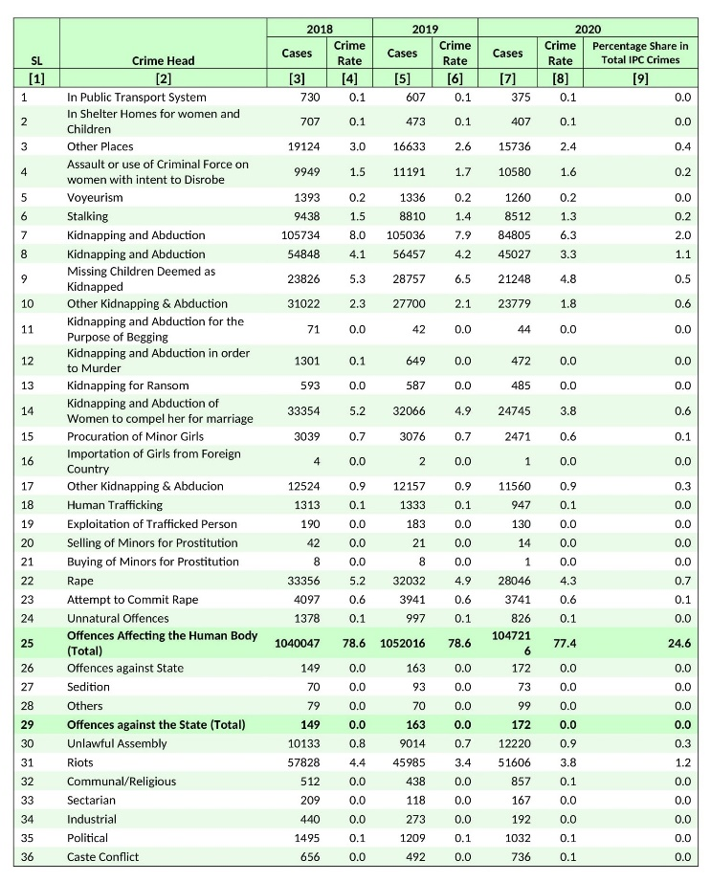

Table – 1. IPC Crimes Head wise - 2018-2020

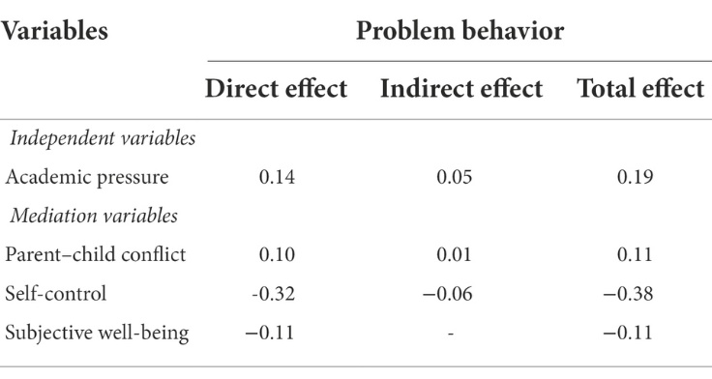
Table 2. The influence of academic pressure on adolescents’ problem behavior.

