Supporting Material

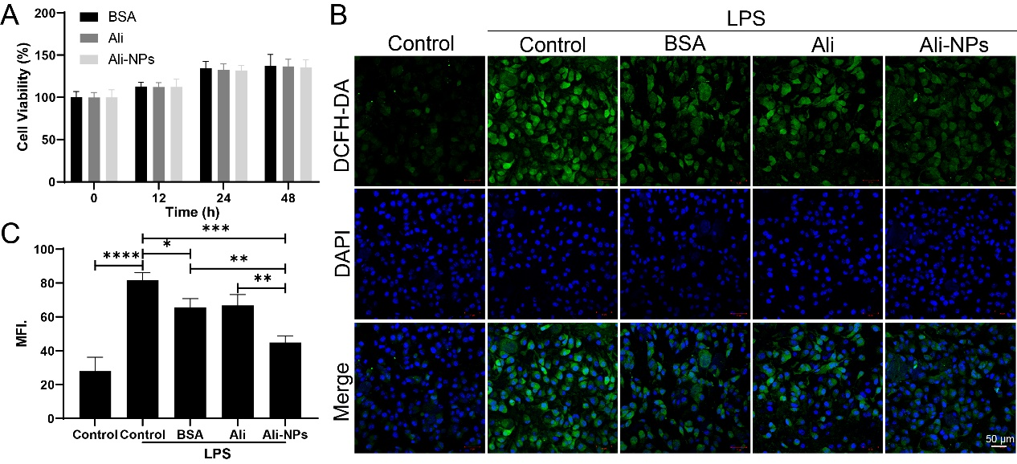
Figure S1 (A) The safety of BSA, Ali, and Ali-NPs on BV2 cells, cells were incubated with drugs in different concentration for 12, 24 or 48h. Results are presented as means ± SD, n = 5. Representative fluorescence images (B) and quantification (C) of ROS which detected using DCFH-DA in NSCs co-cultured with BSA, Ali, Ali-NPS. Scale bar: 50 µm. * P < 0.05, ** P < 0.01, *** P < 0.001, **** P < 0.0001.
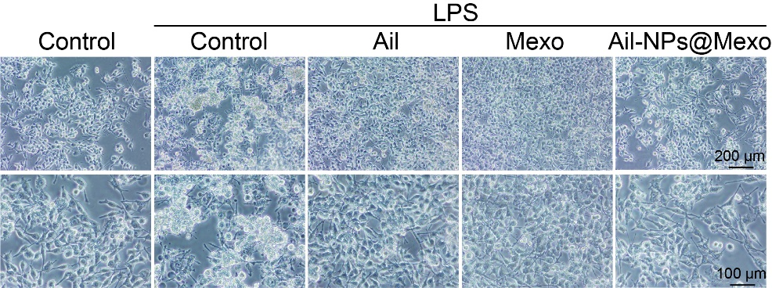
Figure S2. Ali, Mexo, Ali-NPs@Mexo treated LPS-induced cell damage separately.
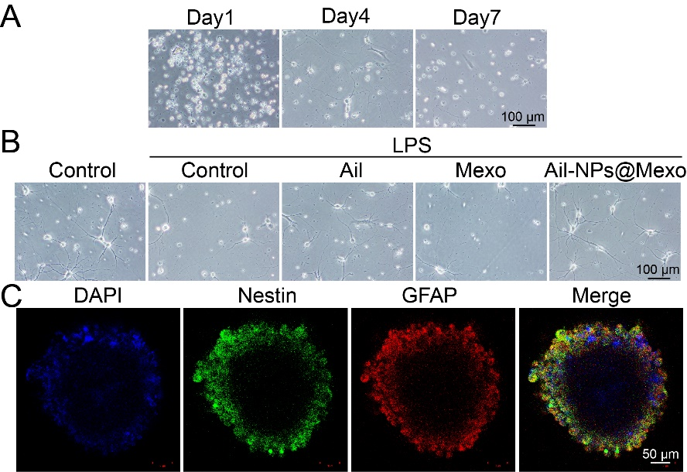
Figure S3 Primary neurons were successfully isolated.
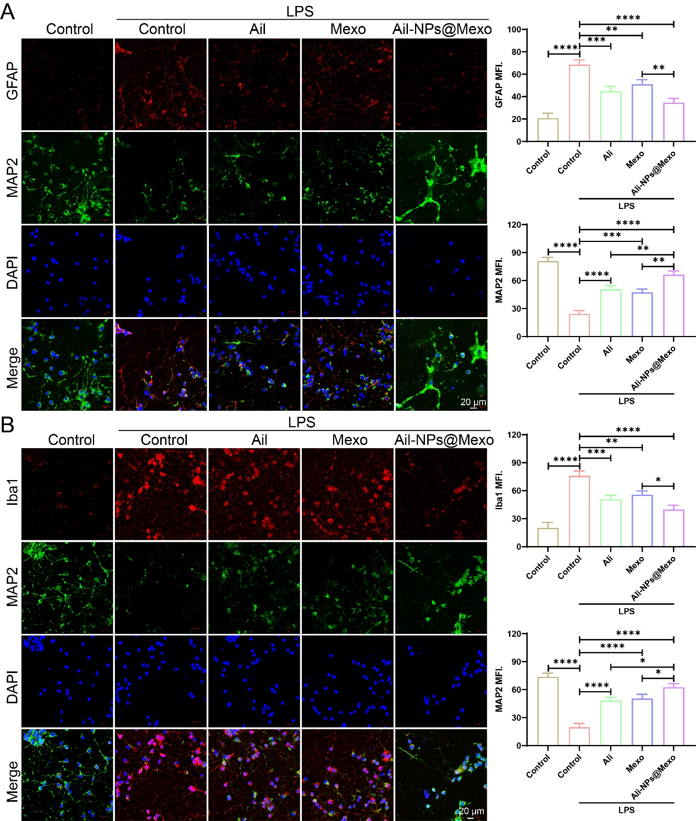
Figure S4 (A) Representative fluorescence images and quantification of GFAP and MAP2. (scale bar, 20 µm). (B) Representative fluorescence images and quantification of Iba1 and MAP2. (scale bar, 20 µm). * P < 0.05, ** P < 0.01, *** P < 0.001, **** P < 0.0001.
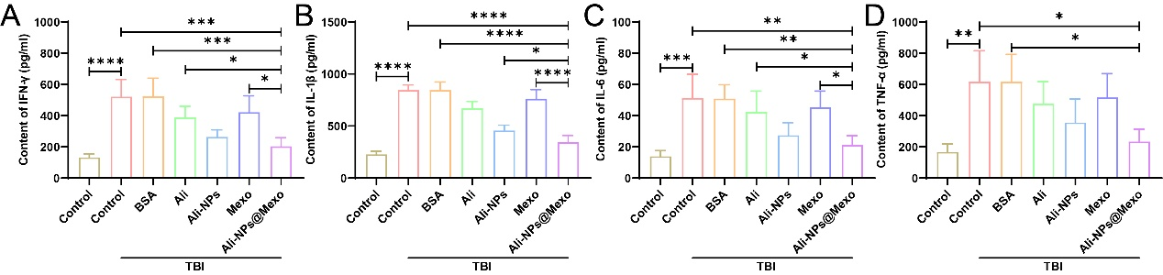
Figure S5 Serum levels of related inflammatory factors. Results are presented as means ± SD, n = 3. * P < 0.05, ** P < 0.01, *** P < 0.001, **** P < 0.0001.
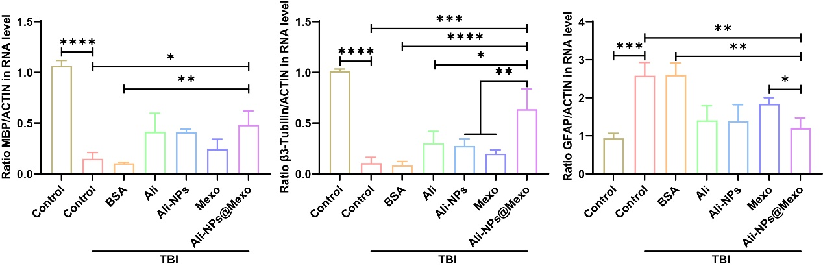
Figure S6 The expression of GFAP, β3-Tubilin, MBP analyzed by RT-qPCR. * P < 0.05, ** P < 0.01, *** P < 0.001, **** P < 0.0001.
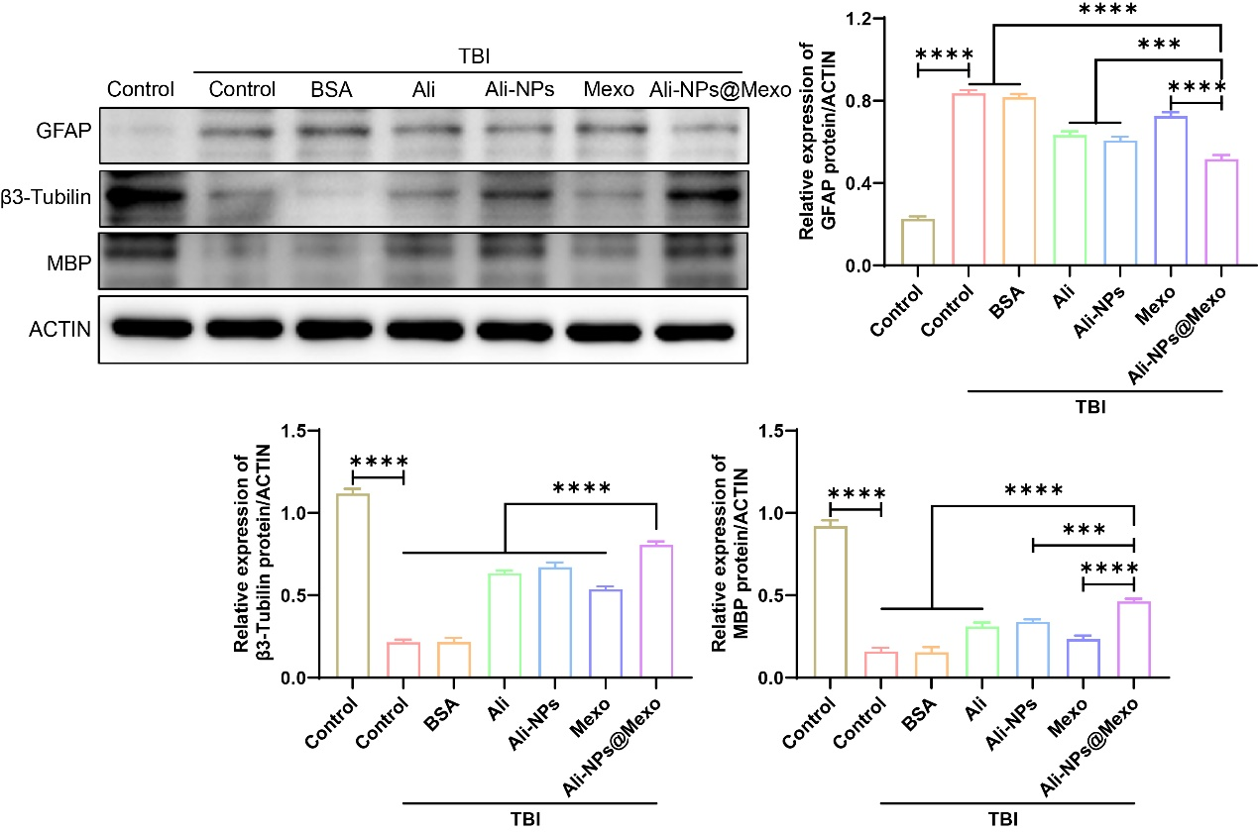
Figure S7 Western blots and quantification of GFAP, β3-Tubilin and MBP expression in primary neuronal cells. Western blot analysis was performed. *** P < 0.001, **** P < 0.0001.
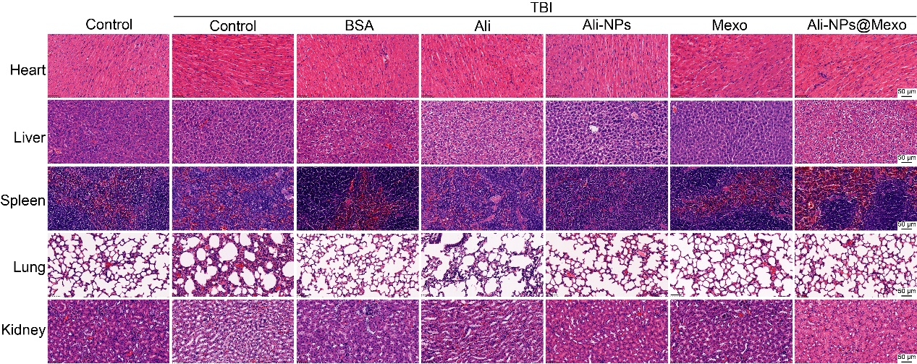
Figure S8 H&E staining analysis of the different tissues after therapy.

