Cerebrospinal Fluid Dynamics: Uncovering Alternative Blood Vessel Clearance Mechanisms
Qiuju Yuan^{1,2,3}, Senthil Kumaran Satyanarayanan², Suki Man-Yan Lee^{1,2,4}, Lingli Yan², Yaofeng Wang², Yan-Fang Xian³, Liumin He^{5,6}, Yingying Zhou³, Wutian Wu^{6,7}, You-Qiang Song⁸, Huanxing Su^{9*}, Zhi-Xiu Lin^{3*}, Dajiang Qin^{1,2,10*}

¹Key Laboratory of Biological Targeting Diagnosis, Therapy and Rehabilitation of Guangdong Higher Education Institutes, The Fifth Affiliated Hospital of Guangzhou Medical University, Guangzhou, China
²Centre for Regenerative Medicine and Health, Hong Kong Institute of Science & Innovation, Chinese Academy of Sciences, Hong Kong SAR, China
³School of Chinese Medicine, Faculty of Medicine, The Chinese University of Hong Kong, Hong Kong SAR, China
⁴School of Public Health, Li Ka Shing Faculty of Medicine, The University of Hong Kong, Hong Kong SAR, China
⁵Department of Spine Surgery, The Third Affiliated Hospital, Sun Yat-Sen University, Guangzhou, 510630 China
⁶Joint International Research Laboratory of CNS Regeneration Ministry of Education, Guangdong-Hong Kong-Macau Institute of CNS Regeneration, Jinan University, Guangzhou, 510623 China
⁷Jiansu Re-Stem Biotechnology Co., Ltd, Wuzhong District, Suzhou, China
⁸School of Biomedical Sciences, Li Ka Shing Faculty of Medicine, The University of Hong Kong, Hong Kong SAR, China
⁹State Key Laboratory of Quality Research in Chinese Medicine, Institute of Chinese Medical Sciences, University of Macau, Macao SAR, China
¹⁰Bioland Laboratory (Guangzhou Regeneration Medicine and Health Guang Dong Laboratory), Guangzhou 510663, China

Running title: Alternative Blood Vessel Clearance Mechanisms in CSF Dynamics

*Corresponding authors:

Huanxing Su, State Key Laboratory of Quality Research in Chinese Medicine, Institute of Chinese Medical Sciences, University of Macau, Macao, China
Email: huanxingsu@um.edu.mo

Zhi-Xiu Lin, School of Chinese Medicine, Faculty of Medicine, The Chinese University of Hong Kong, Shatin, New Territory, Hong Kong Special Administration Region, China.
Email: linzx@cuhk.edu.hk

Dajiang Qin, Key Laboratory of Biological Targeting Diagnosis, Therapy and Rehabilitation of Guangdong Higher Education Institutes, The Fifth Affiliated Hospital of Guangzhou Medical University, Guangzhou, China
Email: qin_dajiang@gzhmu.edu.cn

Supplementary Methods

Tracer drainage in the spinal cord and optic nerve
The spinal cord extending from the cervical to the lumbar region was exposed. The cervical cord and its spinal nerves were dissected and preserved in a fixative solution containing 4% paraformaldehyde (PFA) before being immersed in a 30% sucrose solution. Subsequently, the spinal cords with their associated spinal nerves were sectioned (10 µm thickness) using a cryostat. To isolate the optic nerve, the ventral part of the skull was removed to expose the optic nerves. The optic nerves were carefully dissected and promptly placed in the same fixative solution for subsequent sectioning, following the above mentioned procedure.

Tracer drainage in popliteal, inguinal, and sacral lymph nodes
The C57BL/6J mice were anesthetized, as mentioned before. Then, 5 µL of tracers (EB or Tr-d10) were injected into their left footpads. After 30 and 120 mins of the post-injection, mice were euthanized, as mentioned before, and dissected to locate the LNs of interest [popliteal (PLN), inguinal (ILN), and sacral lymph nodes (SLN)]. Similarly, the nodes were extracted and processed as previously mentioned.

Supplementary Figures
Suppl. 1

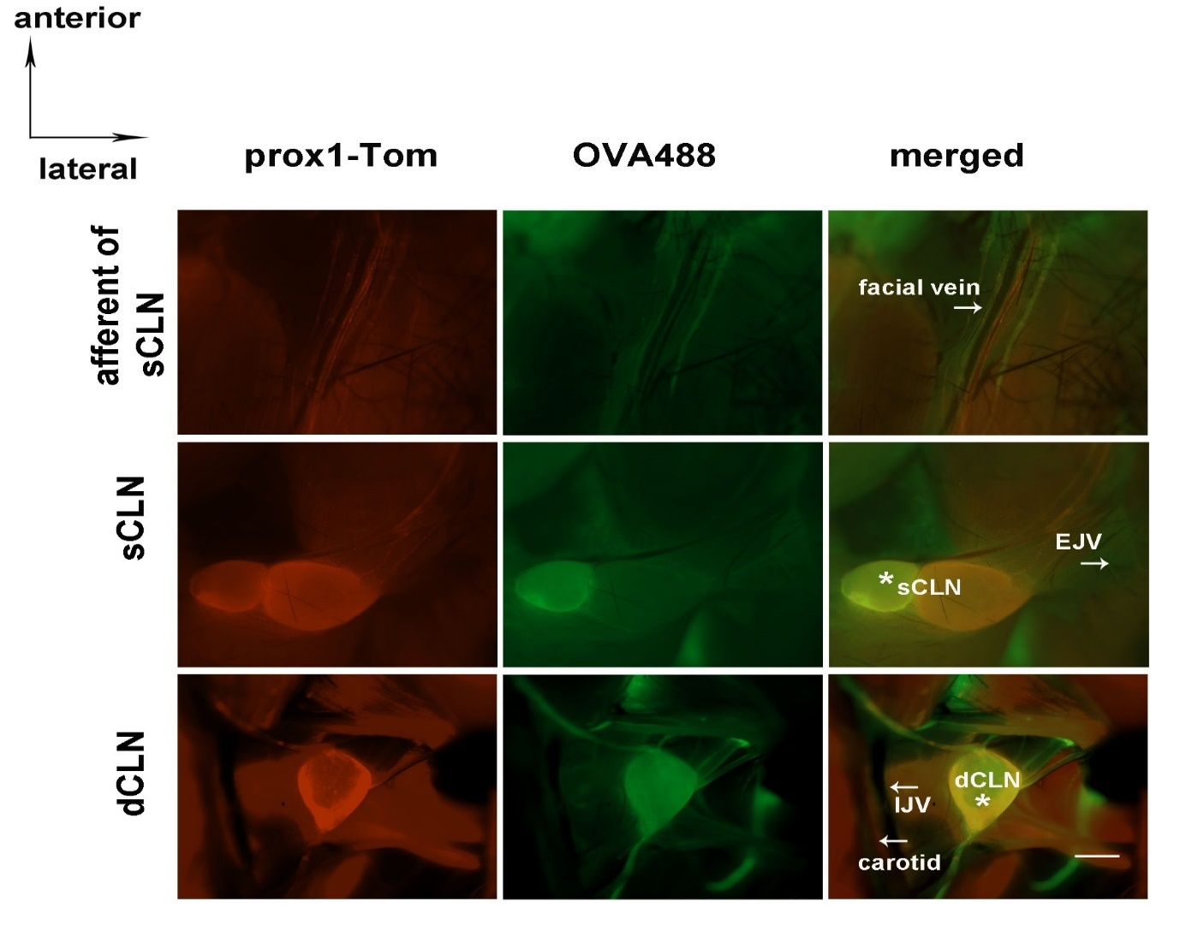
Suppl. 2 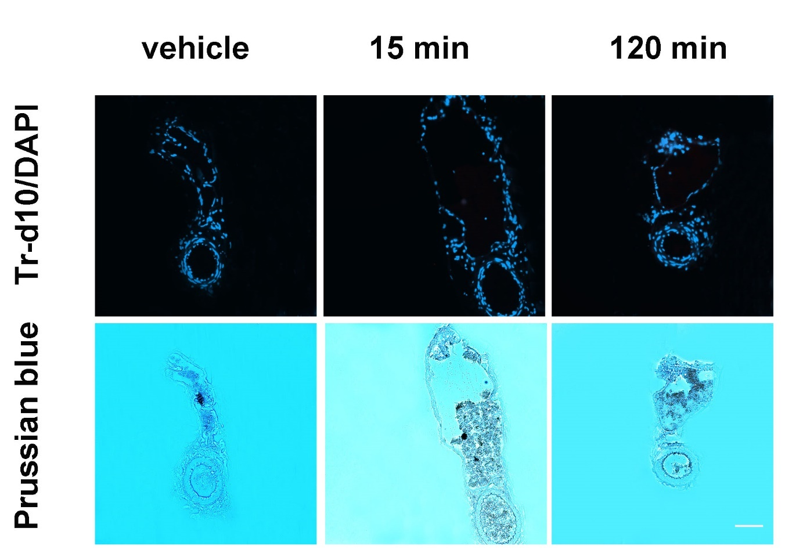

Suppl. 3
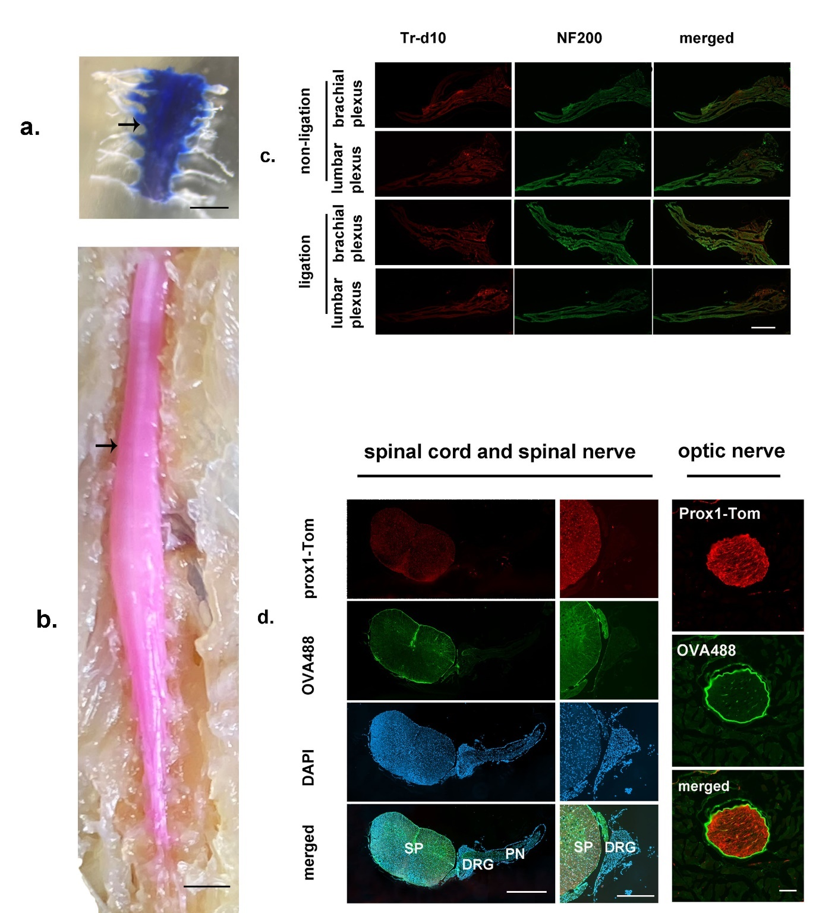

Suppl. 4
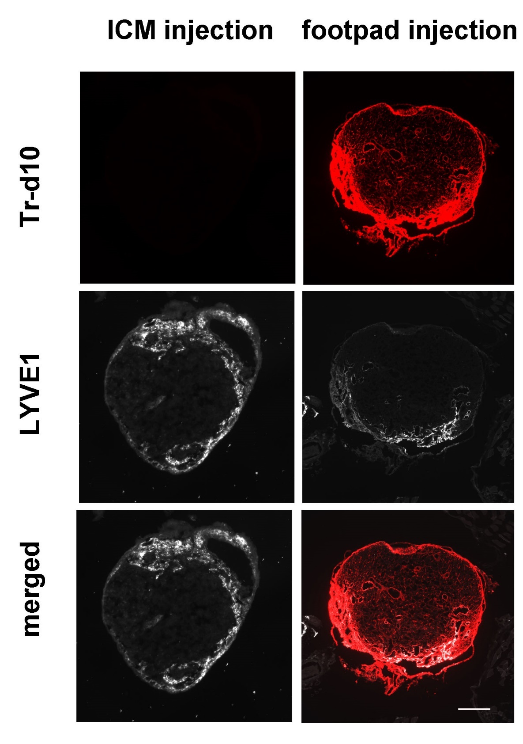

Suppl. 5

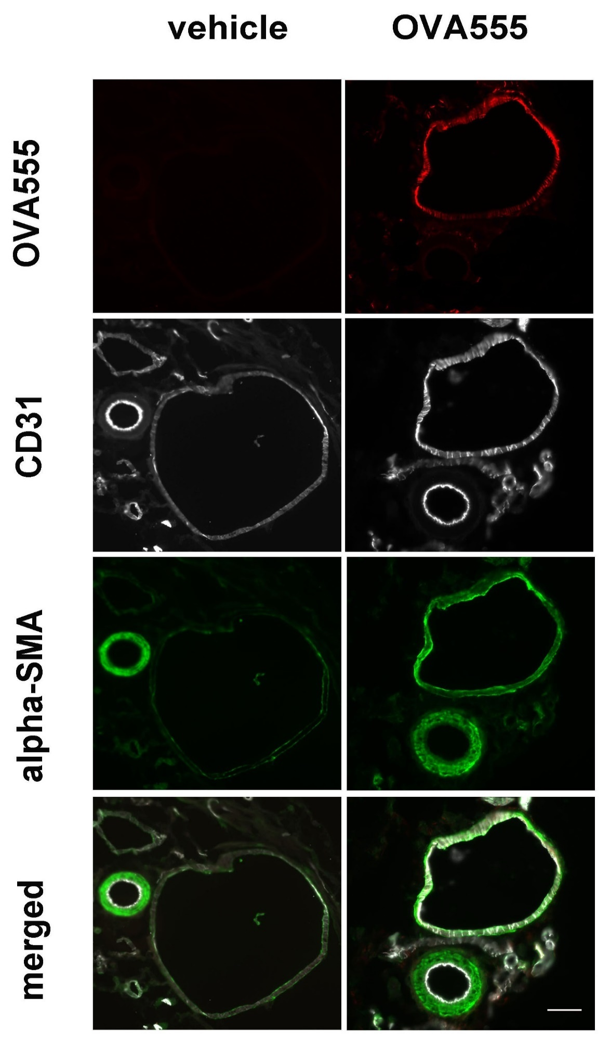
Suppl. 6
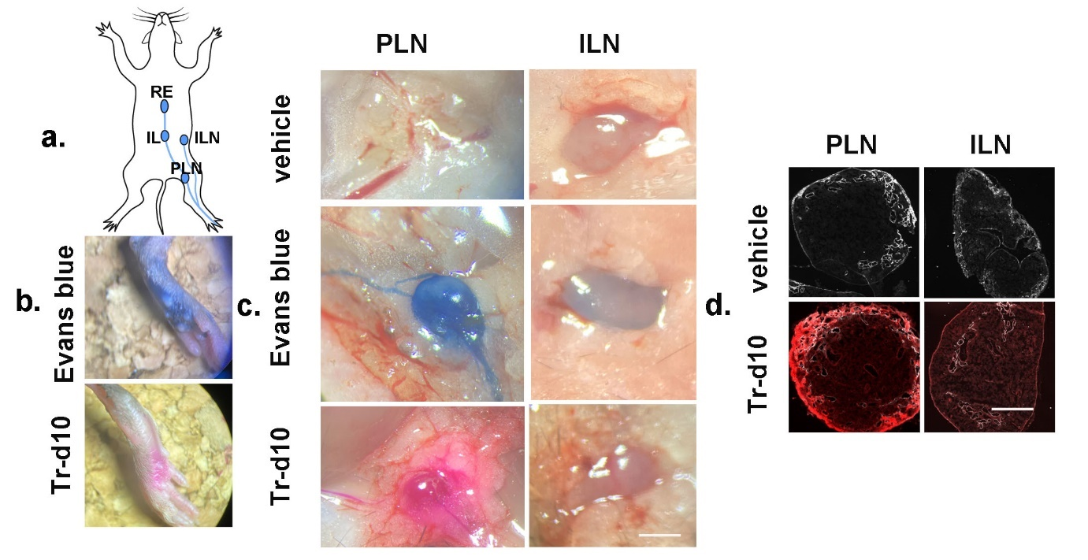

Suppl. 7
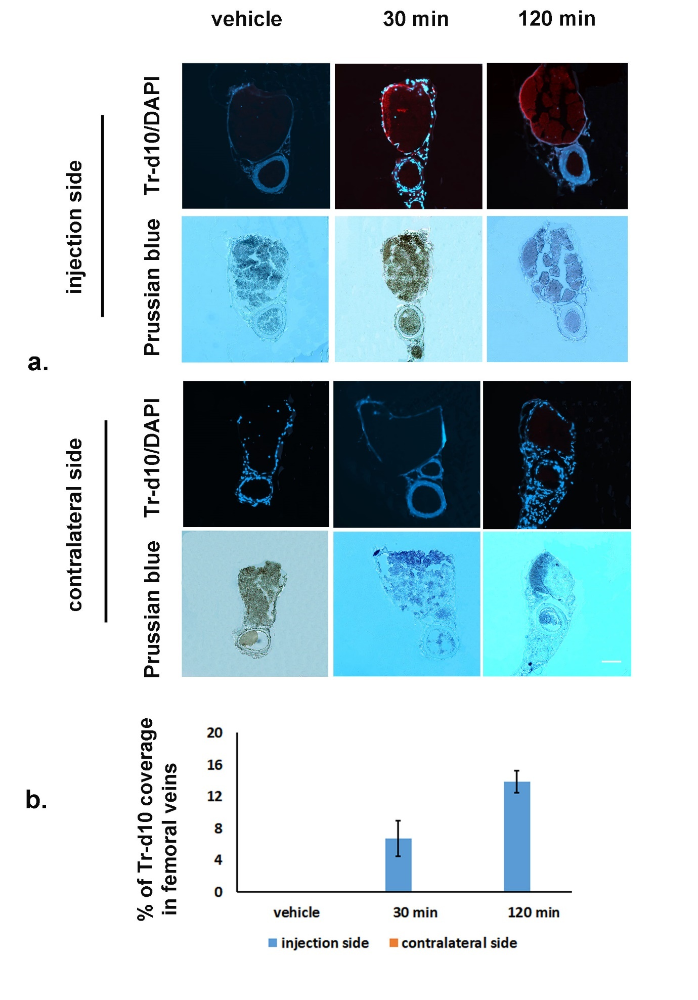

Suppl. 8
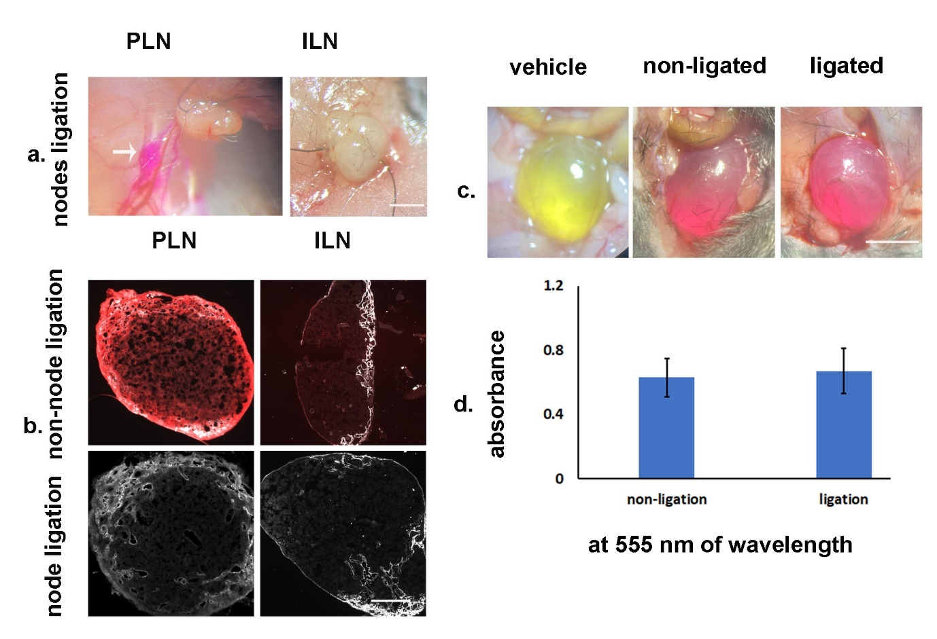

Supplementary Figure Legends
Suppl. 1: In Vivo Visualization of CSF Tracer in Prox1 tdTom Mice
Representative images showing sCLNs and dCLN with their afferent and efferent vessels after ICM injection of OVA488 in Prox1 tdTom mice. The tracer OVA488 is observed within the cervical lymphatic structures of the mice (stars). No tracer is observed in the facial veins and jugular veins. Scale bar represents 1 mm.

Suppl. 2: CSF Tracer Distribution in femoral arteries and veins.
Representative images showing femoral vein and artery after ICM injection of Tr-d10 or vehicle in the WT mice. CSF tracer Tr-d10 is not observed in the femoral vein and artery of the mice at different time points (15 and 120 min) as in the vehicle group. Cell nuclei are counterstained with DAPI. The corresponding Prussian blue staining of the same sections at the respective time points identifies iron within blood vessels, providing a morphological context to the fluorescence images. Scale bar represents 40 µm.

Suppl. 3: CSF Tracer Distribution in the Spinal Nerve Pathway.
(a) & (b) CSF tracer EB and Tr-d10 are only observed within the spinal subarachnoid space (arrows) but not in the spinal nerves following ICM injection of either EB or Tr0d10. (c) Representative immunofluorescence images depicting brachial and lumbar plexus in non-ligated and ligated models, with neurofilament 200 (NF200) highlighting nerve fibers following ICM injection of Trd10. No significant Tr-d10 is observed in the spinal nerves, regardless of ligation. (d) Distinct compartmentalization of OVA488 in the spinal cord and dorsal root ganglion (DRG) but not peripheral nerves (PN), as shown in prox1-Tom mice following ICM injection of OVA488. In contrast, as a positive control (1) the optic nerve is encircled by OVA488 with prox1-Tom delineating the optic nerve as optic nerve expresses prox1 (2). Cell nuclei are counterstained with DAPI. The scale bar in (a) and (b) represents 1 mm. Scale bar in (c) represents 40 µm. Scale bar in the first collum of (d) represents 500 µm. Scale bar in the second collum of (d) represents 200 µm. Scale bar in the third collum of (d) represents 20 µm.

Suppl. 4: The CSF Tracer Absence in Sacral Lymphatic Nodes (SLN) Post-ICM Injection
A comparison of the tracer Tr-d10 distribution in popliteal lymph nodes (PLN) following ICM and footpad injection of Tr-d10. The footpad injection of Tr-d10 results in the presence of the tracer in the PLN. In contrast, ICM injection of the tracer shows no detectable presence of Tr-d10 in the PLN, indicating that the CSF tracer may not be drained via the PLN. The presence of lymphatic vessel endothelial hyaluronan receptor 1 (LYVE-1) seen in the SLN and PLN highlights the structure of the lymphatic nodes. Scale bar represents 250 µm.

Suppl. 5: The Drainage of a CSF Tracer with a Larger Molecular Weight
Representative immunofluorescence images depicting the distribution of a CSF tracer with a higher molecular weight (OVA555, 45 kDa) in the facial vein from exsanguinated mice after ICM injection compared to the vehicle. Post-ICM injection of OVA555 results in the presence of the tracer in the facial vein but not the facial artery as evidenced by OVA555+/CD31+/αSMA + immunostaining. The scale bar represents 40 µm.

Suppl. 6: Lymphatic Drainage of the Tracer Tr-d10 Following Footpad Injection of Tr-d10 (a) Diagram illustrating the footpad injection site and the subsequent lymphatic drainage pathways in a mouse model, showing the direction of tracer movement toward the popliteal lymph node (PLN) and inguinal lymph node (ILN). (b) Macroscopic images depicting the visualization of Evans Blue dye (EB) and Tr-d10 after footpad injection. (c) Macroscopic images of PLN and ILN from mice receiving the vehicle, EB, and Tr-d10 injection showing the visible transport of the tracers within the PLN and ILN compared with that in the vehicle group. (d) Representative images depicting the distribution of the tracer Tr-d10 in the PLN and ILN after footpad injection of Tr-d10. The footpad injection of Tr-d10 results in the presence of the tracer in the PLN and ILN. The lymphatic vessel endothelial hyaluronan receptor 1 (LYVE-1) seen in the PLN and ILN highlights the structure of the lymphatic nodes. Scale bar represents 500 µm.

Suppl. 7: Drainage of the Tracer Tr-d10 via Blood Vessels Following Footpad Injection of Tr-d10
(a) Representative images of the femoral vein and artery in the injection and the contralateral sides following the footpad injection of Tr-d10. A triple staining involving Tr-d10/DAPI/Prussian blue is employed to identify the localization of the tracer Tr-d10. Cell nuclei are counterstained with DAPI, highlighting the femoral vein and artery structure. The presence of the tracer in the veins but not the artery of the injection side at both 30- and 120 minutes post-injection, as well as its absence on the contralateral side, indicates that the tracer in the veins is not indirectly introduced through the systemic circulation but instead directly absorbed via blood capillaries. (b) Quantification of Tr-d10 area fraction within the femoral vein over time (mean ± SEM), demonstrating a peak in tracer presence at 30 minutes and a decrease at 120 minutes. Scale bar represents 40 µm.

Suppl. 8: Impact of Popliteal (PLN) and Inguinal (ILN) Lymph Nodes Ligation on Tracer Drainage Following Footpad Injection of the Tr-d10.
(a) Macroscopic images of ligated PLN and ILN lymph nodes following footpad injection of Tr-d10. The tracer is visibly present in the afferent lymphatic vessels of the PLN, as shown by an enlargement with accumulated tracer Tr-d10 (an arrow), confirming the interruption of lymphatic flow. (b) Representative lymph nodes’ sections stained with LYVE1 immunostaining after Tr-d10 footpad injection. The non-ligated displayed the presence of Tr-d10 in PLN and ILN following the footpad injection, whereas ligated nodes showed no Tr-d10 signal, indicating that ligation prevented the entry of the tracer. The presence of LYVE-1 seen in the PLN and ILN highlights the structure of the lymphatic nodes. (c) A representative dissected lower abdomen showing urinary bladder at 2 h following Tr-d10 or vehicle footpad injection, with non-ligation and ligation of both PLN and ILN ligation. The presence of pink coloration indicates the tracer's passage into the urine. (d) Quantitative analysis of Tr-d10 in urine samples based on absorbance at a wavelength of 555 nm. The graph depicts similar absorbance levels for non-ligated and ligated groups, suggesting unaffected tracer elimination from the footpad into the urine following both PLN and ILN ligation. The scale bar in (a) represents 1 mm. Scale bar in (b) represents 400 µm. Scale bar in (c) represents 4 mm.

