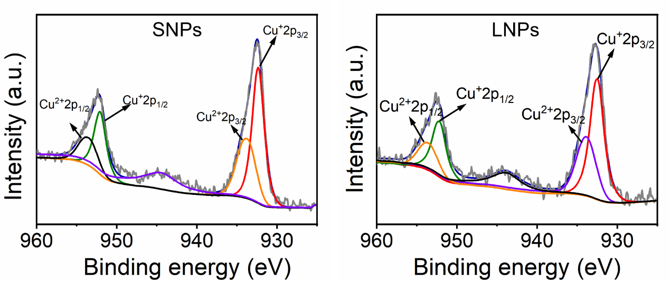

Figure S1. XPS spectra for SNPs and LNPs, respectively.

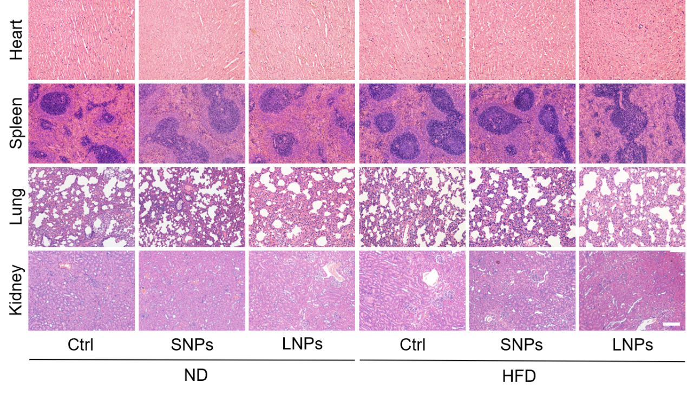

Figure S2. H&E staining of the hearts, livers, spleens, lungs, and kidneys of rats in the ND group and HFD group after administration of SNPs and LNPs. Scale bar = 100 μm.

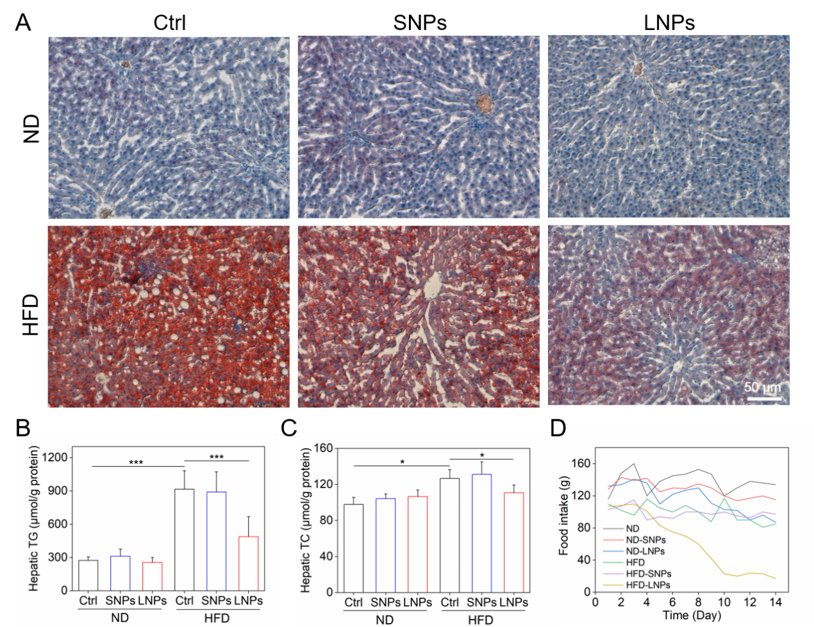

Figure S3. Lipid content detection in the liver in rats treated with SNPs or LNPs in ND and HFD rats. (A) Hepatic lipid droplet in the liver sections by Oil-red-O (ORO) staining. (B) Hepatic triglyceride (TG) and (C) total cholesterol (TC) levels. (D) Food intake curves for rats to consume during the 14-day consecutive injection of BSA@Cu_{2-x}S NPs. Data are expressed as the mean ± standard deviation (Mean ± SD). Statistical significance was assessed using one-way ANOVA and Tukey test, and a probability value of p<0.05 was considered statistically significant. *p<0.05, ***p<0.001.

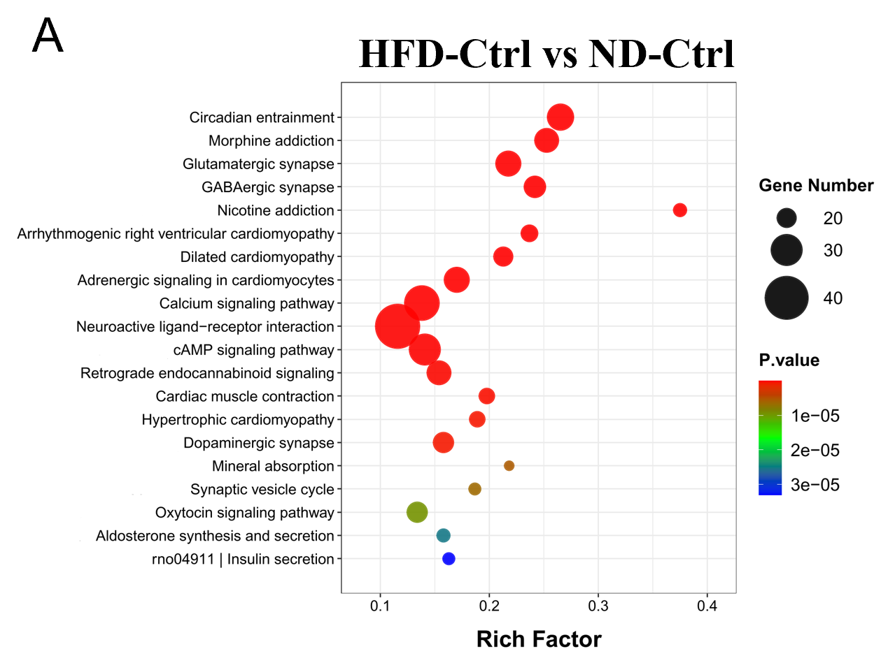

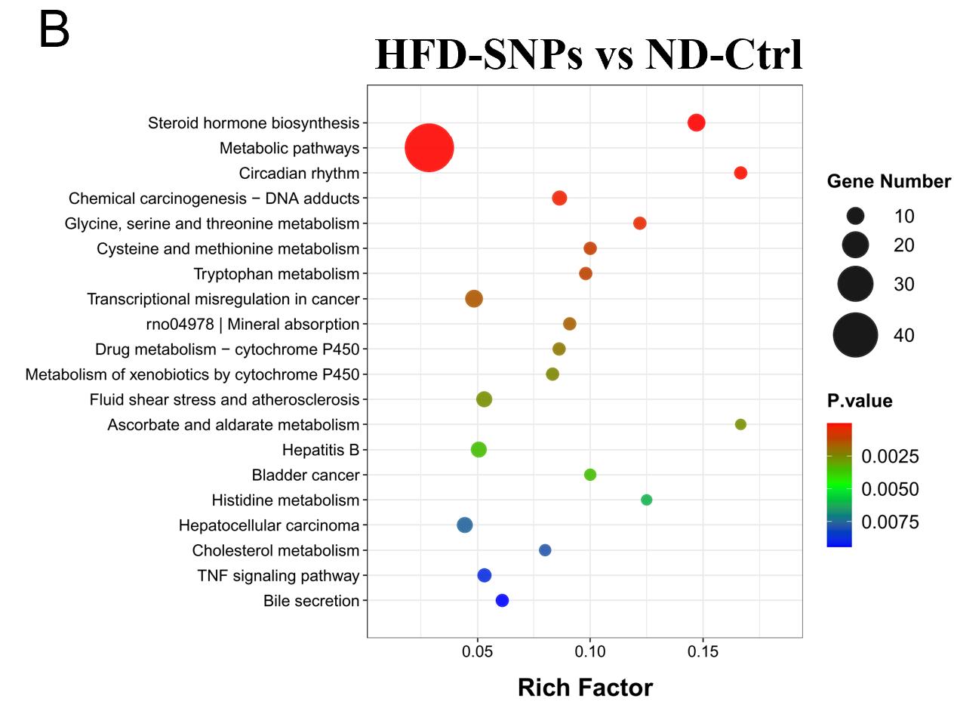

Figure S4. KEGG enrichment analysis between the HFD/HFD-SNPs group and ND-Ctrl group. The rich factor (X-axis) indicates the ratio of DEGs enriched in a pathway to the total genes in that pathway. The diameter of the dots represents the absolute number of DEGs, and the color indicates the p value.
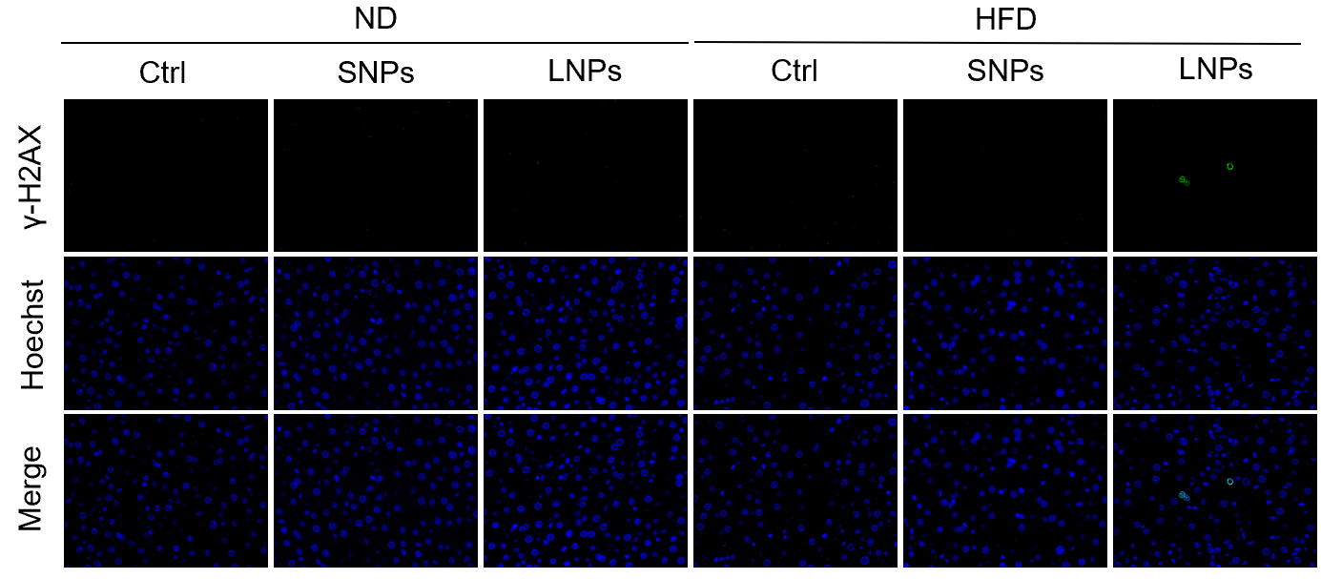
Figure S5. Immunofluorescence staining of γ-H2AX.
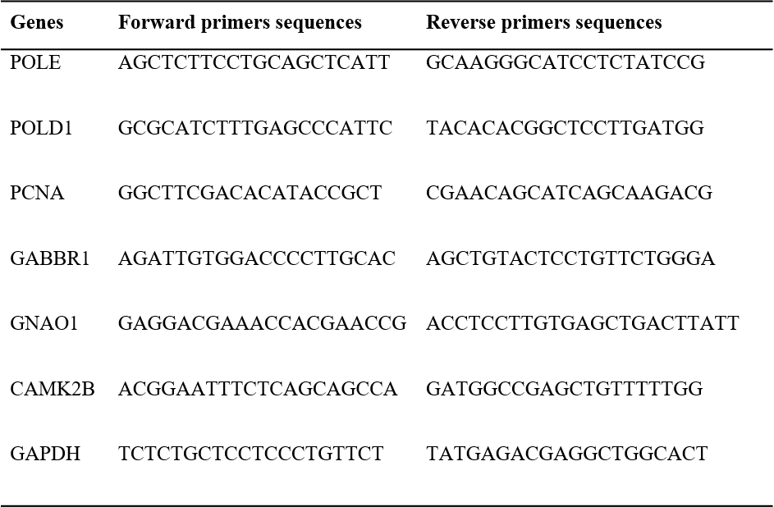

Table S1. List of the sequences of qPCR primers used in this work.

