Supplementary Material

Supplementary Figures and Tables
Table S1. Summary of PALSAR-2 and Sentinel-1 dataset in this study.
Sensor | Path | Number of data | Number of InSAR | Period for LOS time series
PALSAR-2 | 23 [Descending] | 23 | 190 | May 7, 2016 – September 18, 2017  November 13, 2017 – May 5, 2018
 | 130 [Ascending] | 10 | 21 | May 1, 2016 –September 17, 2017  October 19, 2017 – February 8, 2018
 | 131 [Ascending] | 16 | 78 | February 11, 2016 – October 10, 2017  November 21, 2017 –February 13, 2018
Sentinel-1 | 156 [Ascending] | 32 | 52 | January 3, 2017 – October 6, 2017  October 30, 2017 – February 27, 2018
 | 163 [Descending] | 29 | 45 | January 9, 2017 – September 18, 2017  October 12, 2017 – February 21, 2018

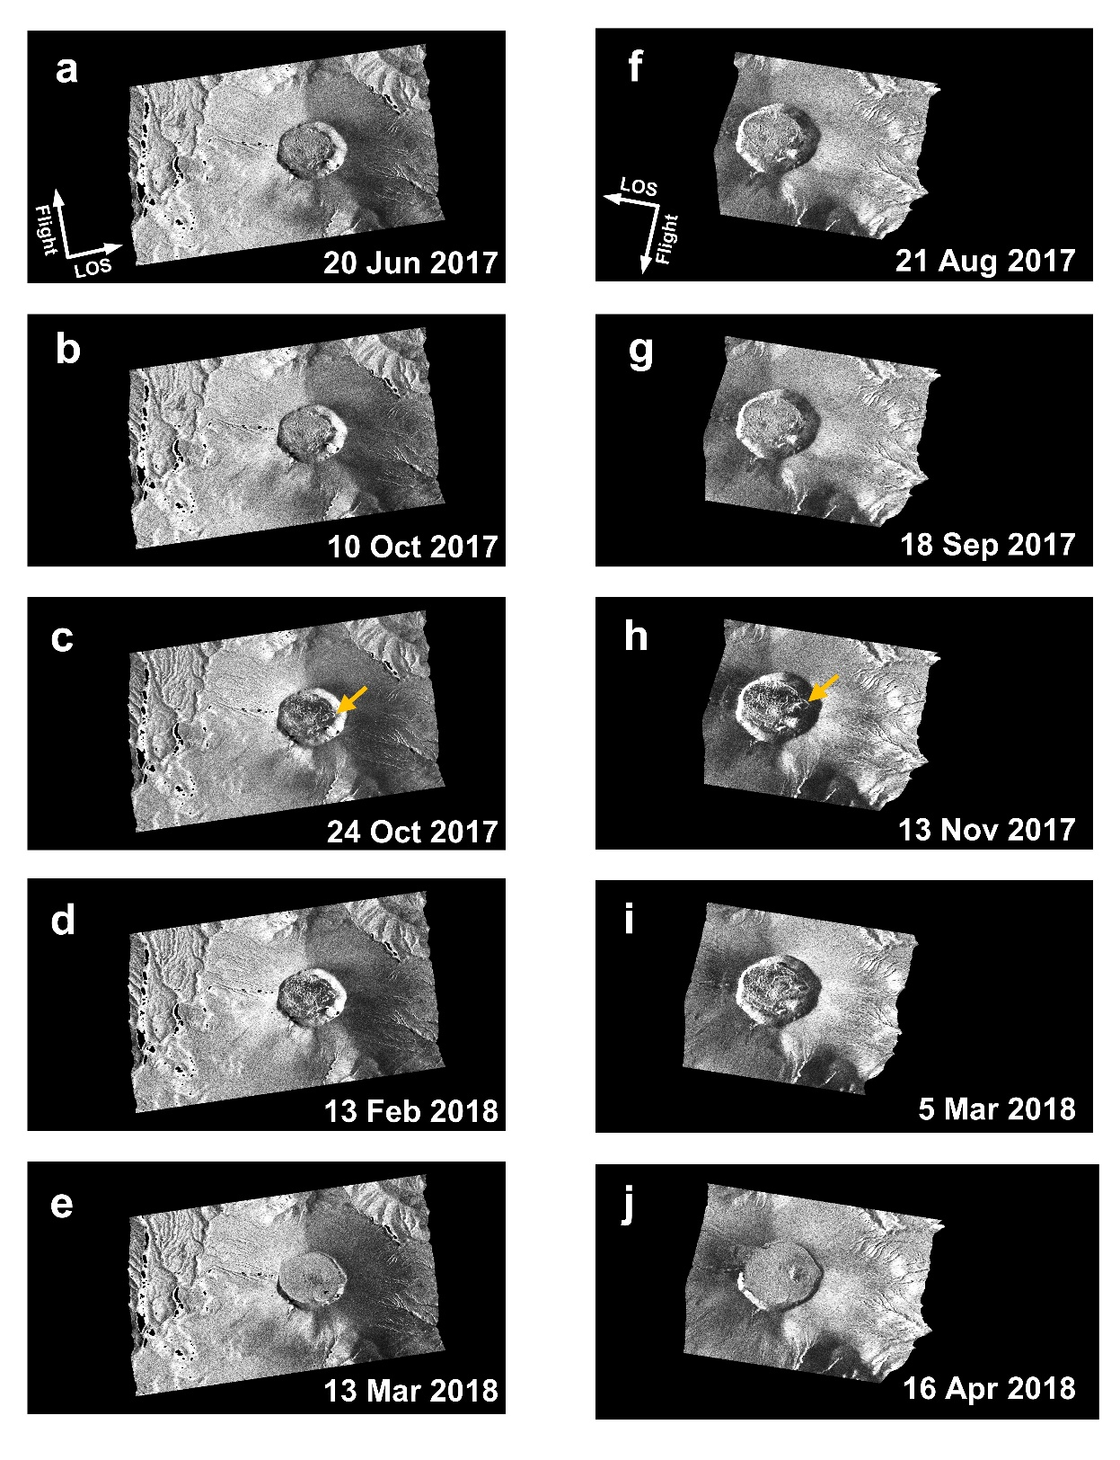
Supplementary Figure S1. Time-series of PALSAR-2 intensity image in 2017 and 2018. (a-e) PALSAR-2 Path 131 and (f-j) Path 23, respectively. Orange arrows in Panels c and h indicate the location of the vent of the eruption in 2017.

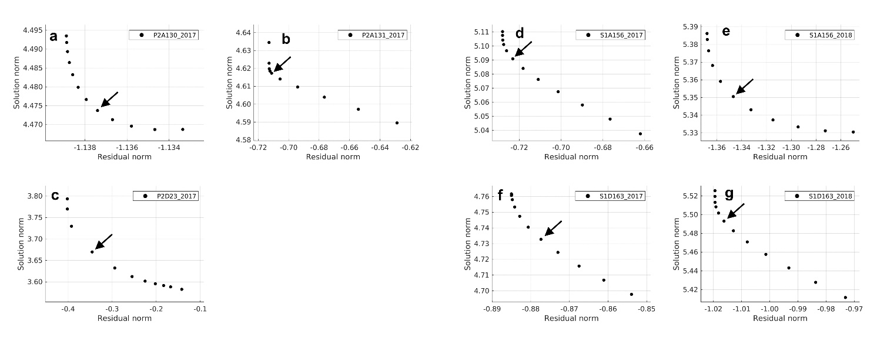
Supplementary Figure S2. L-curve plot for multi-temporal InSAR analysis. (a) PALSAR-2 Path 130, (b) Path 131 and (c) Path 23 for data prior to the 2017 eruption. (d, e) Sentinel-1 Path 156 and (f, g) Path 163. Plot for data prior to the 2017 eruption (d, f) and during the inter-eruptive period (e, g).

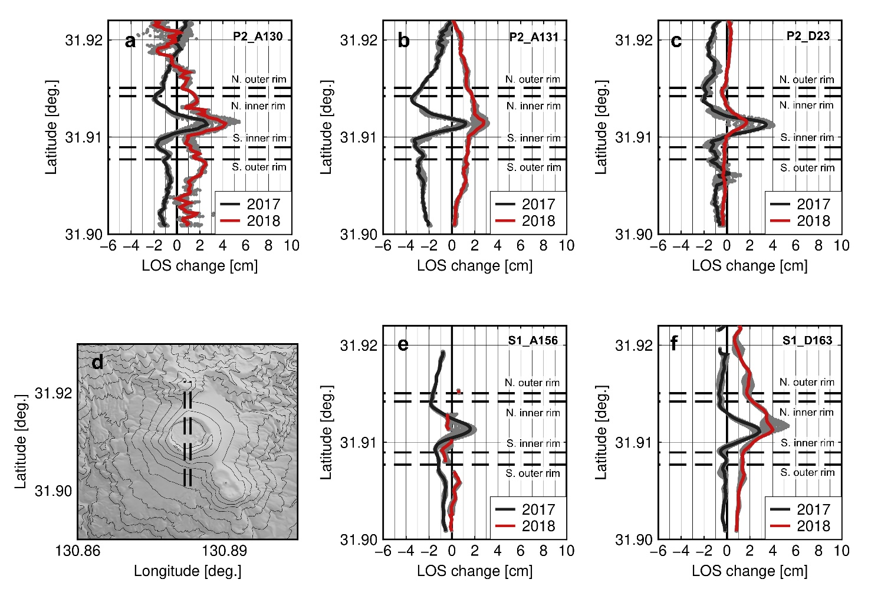
Supplementary Figure S3. North-south cross-section of cumulative LOS change before the 2017 eruption and the inter-eruptive period. (a) PALSAR-2 Path 130, (b) PALSAR-2 Path 131, (c) PALSAR-2 Path 23, (d) Topographic map with 50 m contour intervals, (e) Sentinel-1 Path 153, and (f) Sentinel-1 Path168. Positive values (downward) indicate distance changes moving away from the satellite. Horizontal dashed lines indicate the location of the inner and outer rims of the crater. Red and black lines indicate the median values of extracted deformation prior to the 2017 eruption and during the inter-eruptive period between the eruptions in 2017 and 2018 along the cross-sections within 100 m. All extracted data are plotted as gray dots.

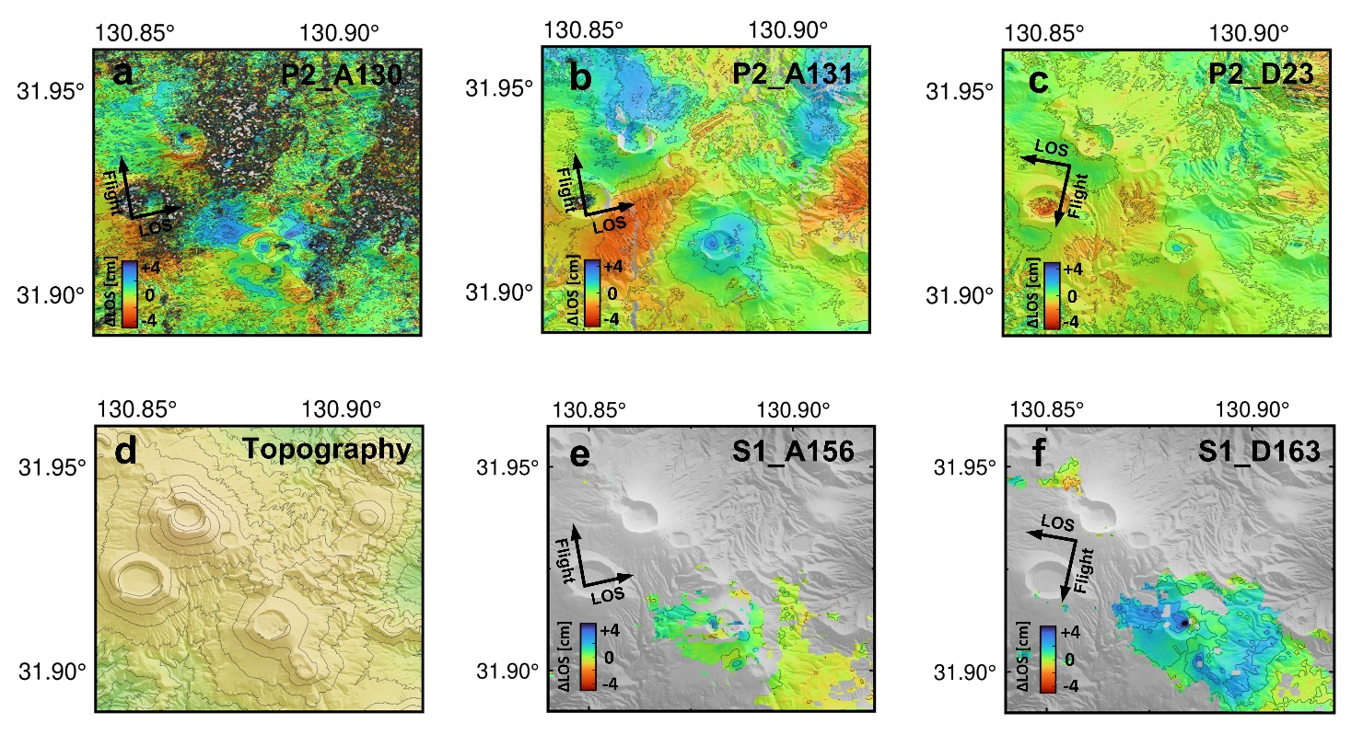
Supplementary Figure S4. Cumulative LOS change during the inter-eruptive period. The observation period was from the end of the 2017 eruption to the last data acquisition prior to the 2018 eruption. (a) PALSAR-2 Path 130 (October 19, 2017 – February 8, 2018), (b) PALSAR-2 Path 131 (November 21, 2017 – February 13, 2018), (c) PALSAR-2 Path 23 (November 13, 2017 – May 5, 2018), (d) Topographic map, (e) Sentinel-1 Path 156 (October 30, 2017 – February 27, 2018), and (f) Sentinel-1 Path 163 (October 12, 2017 – February 21, 2018). Positive values (blue) indicate distance changes moving away from the satellite.

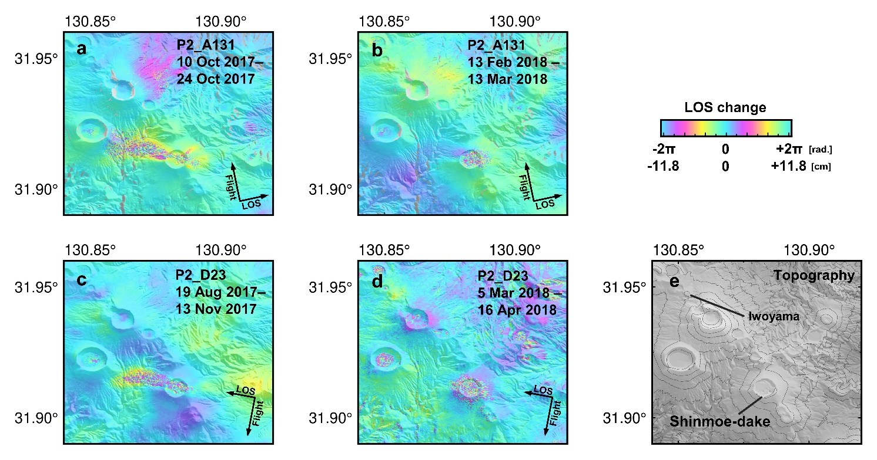
Supplementary Figure S5. Co-eruptive PALSAR-2 InSAR for the eruptions in 2017 and 2018. Wrapped PALSAR-2 InSAR spanning the 2017 eruption (Left) and the 2018 eruption (Center). (a, b) PALSAR-2 Path 131 and (c, d) Path 23. Positive values (blue) indicate distance changes moving away from the satellite. (e) Topographic relief map.

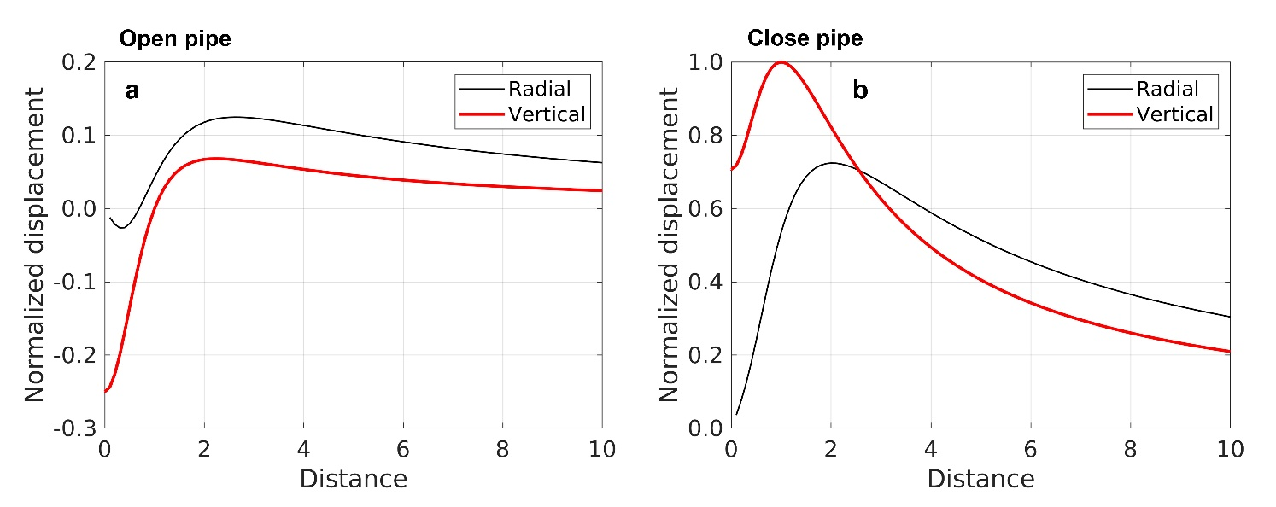
Supplementary Figure S6. Normalized surface displacement for a pipe-like pressure source. (a) Open pipe, and (b) close pipe. Assuming that a pipe radius is 1. The analytical solution is proposed by Bonaccorso and Davis (1999).

