Supplementary Files
Unveiling molecular markers and prediction of Stomach cancer from transcriptomic profile through a comprehensive study of feature mining and learning based algorithm
Supplementary Tables

Supplementary Table 1: Features identified from filtyer technique with scores.

Case 2 | MRMR | Genes Name | Feature score | Case 2 | MRMR | Genes Name | Feature score
Case 2 | MRMR | DPT | 0.258836 | Case 2 | MRMR | DPT | 0.258836
Case 2 | MRMR | MYZAP | 0.195129 | Case 2 | MRMR | MYZAP | 0.195129
Case 2 | MRMR | HPGD | 0.147762 | Case 2 | MRMR | HPGD | 0.147762
Case 2 | MRMR | HPCAL4 | 0.127316 | Case 2 | MRMR | HPCAL4 | 0.127316
Case 2 | MRMR | IGHA1 | 0.121688 | Case 2 | MRMR | JCHAIN | 0.112645
Case 2 | LS | Genes Name | L score | Case 2 | LS | Genes Name | L score
Case 2 | LS | SRSF4 | 0.078041 | Case 2 | LS | UBE2D2 | 0.088116
Case 2 | LS | BSDC1 | 0.084594 | Case 2 | LS | TRIP4 | 0.097363
Case 2 | LS | UBE2D2 | 0.088517 | Case 2 | LS | NCKAP1 | 0.105635
Case 2 | LS | ANKRD13C | 0.088735 | Case 2 | LS | DYRK1A | 0.105974
Case 2 | LS | SF1 | 0.09032 | Case 2 | LS | BRD4 | 0.106406
Case 2 | ReliefF | Genes Name | Feature score | Case 2 | ReliefF | Genes Name | Feature score
Case 2 | ReliefF | DPT | 0.277176 | Case 2 | ReliefF | DPT | 0.278997
Case 2 | ReliefF | GNG7 | 0.27205 | Case 2 | ReliefF | MYZAP | 0.27653
Case 2 | ReliefF | LYVE1 | 0.249629 | Case 2 | ReliefF | HPGD | 0.251753
Case 2 | ReliefF | ASPA | 0.243305 | Case 2 | ReliefF | HPCAL4 | 0.248375
Case 2 | ReliefF | PDZD4 | 0.223642 | Case 2 | ReliefF | IGHA1 | 0.233371
Case 2 | SelectKBest | Genes Name | Fvalue | Case 2 | SelectKBest | Genes Name | Fvalue
Case 2 | SelectKBest | DPT | 261.7536 | Case 2 | SelectKBest | DPT | 261.7536
Case 2 | SelectKBest | MYZAP | 184.2612 | Case 2 | SelectKBest | MYZAP | 184.2612
Case 2 | SelectKBest | LYVE1 | 168.8912 | Case 2 | SelectKBest | LYVE1 | 168.8912
Case 2 | SelectKBest | SCARA5 | 159.9946 | Case 2 | SelectKBest | SCARA5 | 159.9946
Case 2 | SelectKBest | GCNT4 | 159.4985 | Case 2 | SelectKBest | GCNT4 | 159.4985

Supplementary Table 2: Shortlisted top 22 genes from Case 1 and Case 2 dataset. There are a total 11 unique and 11 common genes identified.

Gene_Name | P.Value | adj.P.Val | B
DPT | 1.94E-41 | 5.5E-37 | 83.32306
MYZAP | 1.12E-32 | 7.37E-30 | 63.43193
LYVE1 | 1.15E-35 | 2.18E-32 | 70.20873
SCARA5 | 7.03E-38 | 3.33E-34 | 75.26222
GCNT4 | 3.47E-37 | 1.41E-33 | 73.66425
UBE2D2 | 1.47E-09 | 2.63E-09 | 11.20343
TRIP4 | 9.93E-12 | 2.38E-11 | 16.05655
NCKAP1 | 1.25E-11 | 2.94E-11 | 15.844
DYRK1A | 2.61E-12 | 6.81E-12 | 17.3619
BRD4 | 0.00000413 | 0.00000518 | 3.493814
HPGD | 1.7E-32 | 1.02E-29 | 63.02326
HPCAL4 | 1.31E-40 | 1.86E-36 | 81.47021
JCHAIN | 5.96E-35 | 8.75E-32 | 68.61572
GNG7 | 2.05E-39 | 1.94E-35 | 78.70462
ASPA | 1.62E-38 | 1.15E-34 | 76.66794
PDZD4 | 5.22E-24 | 1.72E-22 | 43.76944
SRSF4 | 1.48E-08 | 2.35E-08 | 8.968082
BSDC1 | 1.84E-10 | 3.71E-10 | 13.21915
ANKRD13C | 4.58E-10 | 8.74E-10 | 12.33153
SF1 | 6.82E-08 | 1.01E-07 | 7.480671
IGHA1 | 7.39E-33 | 5.38E-30 | 63.8586
MALL | 1.99E-26 | 1.31E-24 | 49.25167

Supplementary Table 3:GO Enrichment analysis
GO BP Term | PValue | Bonferroni | Genes
GO:0060267~positive regulation of respiratory burst | 0.007176 | 0.665343 | IGHA1, JCHAIN
GO:0003094~glomerular filtration | 0.019363 | 0.948805 | IGHA1, JCHAIN
GO:0048025~negative regulation of mRNA splicing, via spliceosome | 0.023394 | 0.972627 | DYRK1A, SRSF4
GO:0001895~retina homeostasis | 0.043314 | 0.998806 | IGHA1, JCHAIN
GO:0019731~antibacterial humoral response | 0.075339 | 0.999993 | IGHA1, JCHAIN
GO MF Term | PValue | Bonferroni | Genes
GO:0008353~RNA polymerase II carboxy-terminal domain kinase activity | 0.013626 | 0.666318 | DYRK1A, BRD4
GO:0003713~transcription coactivator activity | 0.031749 | 0.924309 | DYRK1A, TRIP4, BRD4
GO:0034987~immunoglobulin receptor binding | 0.098466 | 0.99975 | IGHA1, JCHAIN
GO CC Term | PValue | Bonferroni | Genes
GO:0071752 ~secretory dimeric IgA immunoglobulin complex | 0.002903 | 0.177005 | IGHA1, JCHAIN
GO:0071748 ~monomeric IgA immunoglobulin complex | 0.003869 | 0.228753 | IGHA1, JCHAIN
GO:0071751 ~secretory IgA immunoglobulin complex | 0.004834 | 0.277249 | IGHA1, JCHAIN
GO:0070062 ~extracellular exosome | 0.016417 | 0.670129 | NCKAP1, HPGD, GNG7, UBE2D2, IGHA1, LYVE1, JCHAIN

Supplementary Table 4: Details of selected top 22 genes with their protein structure ID
Protein gene Name | Protein gene ID
DPT | Computed Structure Models
MYZAP | 2KXS
LYVE1 | Computed Structure Models
SCARA5 | 7C00
GCNT4 | Computed Structure Models
UBE2D2 | 3JVZ
TRIP4 | 2.00E+50
NCKAP1 | Computed Structure Models
DYRK1A | 4AZE
BRD4 | 2OUO
HPGD | 2GDZ
HPCAL4 | Computed Structure Models
JCHAIN | Computed Structure Models
GNG7 | Computed Structure Models
ASPA | 4NFR
PDZD4 | Computed Structure Models
SRSF4 | Computed Structure Models
BSDC1 | Computed Structure Models
ANKRD13C | Computed Structure Models
SF1 | Computed Structure Models
IGHA1 | 1OWO
MALL | Computed Structure Models
BRK1 | 3P8C
CYFIP1 | Computed Structure Models
UBC | 4DDI
GNB4 | Computed Structure Models
GNB2 | Computed Structure Models
GNB1 | 4FKM

Supplementary Table 5:Details of used FDA-aaproved 8 drugs.
Drug CID | Drug Name | Used for treatment
CID10373441 | Trifluridine and Tipiracil Hydrochloride | Colorectal cancer,Stomach adenocarcinoma
CID148124 | Docetaxel | Breast cancer, Non-small cell lung cancer, Prostate cancer, Squamous cell carcinoma of the head and neck , Stomach adenocarcinoma
CID3385 | Fluorouracil | Breast cancer, Colorectal cancer, Gastric (stomach) cancer, Pancreatic cancer
CID5746 | Mitomycin | Urothelial cancer, Gastric (stomach) cancer, Pancreatic cancer, Renal cell carcinoma
CID60953 | Capecitabine | Breast cancer, Colorectal cancer, Gastric (stomach) cancer, Pancreatic cancer
CID6442177 | Everolimus | Pancreatic cancer, gastrointestinal cancer, and lung cancer, Breast cancer,Subependymal giant cell astrocytoma
CID6918011 | Lanreotide | Gastroenteropancreatic neuroendocrine tumors
CID443939 | Doxorubicin Hydrochloride | leukemia, Breast cancer, Gastric (stomach) cancer ,Neuroblastoma, Non-small cell lung cancer, Ovarian cancer, Small cell lung cancer, Thyroid cancer, bladder cancer,Wilms tumor .
CID6857410 | UDP-D-galactose | UDP-D-galactose is a natural product found in Homo sapiens. It is related with galactosaemia and Embryonal carcinoma.

Supplementary Table 6: CytoHub plugins calculated top 15 protein-protein network with their degree scores.
Rank | Name | Degree Score
1 | UBC | 12
2 | GNB1 | 5
3 | BRK1 | 4
3 | NCKAP1 | 4
3 | GNB2 | 4
3 | CYFIP1 | 4
3 | GNB4 | 4
8 | WASF1 | 3
8 | CBL | 3
8 | GNG7 | 3
8 | U2AF2 | 3
8 | UBE2D2 | 3
13 | SRSF4 | 2
13 | SF1 | 2
13 | RBX1 | 2

Supplementary Table 7: Classification results of miRNA expression testing dataset result.
Classifier
Feature selection techniques | Matrices | RF | KNN | XGB | GB | AdaBoost | GaussianNB
MRMR+Case 1 | Precision | 0.965 | 0.965 | 0.965 | 0.965 | 0.965 | 0.945
MRMR+Case 1 | Recall | 0.96 | 0.96 | 0.96 | 0.96 | 0.96 | 0.94
MRMR+Case 1 | F1-score | 0.96 | 0.96 | 0.96 | 0.96 | 0.96 | 0.94
MRMR+Case 1 | Accuracy | 0.96 | 0.96 | 0.96 | 0.96 | 0.96 | 0.94
MRMR+Case 2 | Precision | 0.965 | 0.965 | 0.965 | 0.965 | 0.98 | 0.945
MRMR+Case 2 | Recall | 0.96 | 0.96 | 0.96 | 0.96 | 0.98 | 0.94
MRMR+Case 2 | F1-score | 0.96 | 0.96 | 0.96 | 0.96 | 0.98 | 0.94
MRMR+Case 2 | Accuracy | 0.96 | 0.96 | 0.96 | 0.96 | 0.98 | 0.94
Boruta+Case 1 | Precision | 0.965 | 0.965 | 0.95 | 0.965 | 0.965 | 0.965
Boruta+Case 1 | Recall | 0.96 | 0.96 | 0.94 | 0.96 | 0.96 | 0.96
Boruta+Case 1 | F1-score | 0.96 | 0.96 | 0.945 | 0.96 | 0.96 | 0.96
Boruta+Case 1 | Accuracy | 0.96 | 0.96 | 0.94 | 0.96 | 0.96 | 0.96
Boruta+Case 2 | Precision | 0.965 | 0.965 | 0.95 | 0.965 | 0.965 | 0.965
Boruta+Case 2 | Recall | 0.96 | 0.96 | 0.94 | 0.96 | 0.96 | 0.96
Boruta+Case 2 | F1-score | 0.96 | 0.96 | 0.945 | 0.96 | 0.96 | 0.96
Boruta+Case 2 | Accuracy | 0.96 | 0.96 | 0.94 | 0.96 | 0.96 | 0.96
LASSO+Case1 | Precision | 0.965 | 0.965 | 0.965 | 0.965 | 0.92 | 0.98
LASSO+Case1 | Recall | 0.96 | 0.96 | 0.96 | 0.96 | 0.92 | 0.98
LASSO+Case1 | F1-score | 0.96 | 0.96 | 0.96 | 0.96 | 0.92 | 0.98
LASSO+Case1 | Accuracy | 0.96 | 0.96 | 0.96 | 0.96 | 0.92 | 0.98
LASSO+Case2 | Precision | 0.965 | 0.945 | 0.98 | 0.965 | 0.98 | 0.98
LASSO+Case2 | Recall | 0.96 | 0.94 | 0.98 | 0.96 | 0.98 | 0.98
LASSO+Case2 | F1-score | 0.96 | 0.94 | 0.98 | 0.96 | 0.98 | 0.98
LASSO+Case2 | Accuracy | 0.96 | 0.94 | 0.98 | 0.96 | 0.98 | 0.98

Supplementary Table 8: Classification results of DNA-methylation testing dataset result.
 | Classifier
Feature Selection techniques | Matrices | RF | KNN | XGB | GB | AdaBoost | GaussianNB
MRMR+Case1 | Precision | 0.985 | 0.985 | 0.985 | 0.96 | 0.96 | 0.985
MRMR+Case1 | Recall | 0.985 | 0.985 | 0.985 | 0.955 | 0.955 | 0.985
MRMR+Case1 | F1-score | 0.99 | 0.99 | 0.99 | 0.955 | 0.955 | 0.99
MRMR+Case1 | Accuracy | 0.99 | 0.99 | 0.99 | 0.96 | 0.96 | 0.99
MRMR+Case2 | Precision | 0.995 | 0.995 | 0.982 | 0.97 | 0.964 | 0.99
MRMR+Case2 | Recall | 0.985 | 1 | 0.985 | 0.955 | 0.955 | 1
MRMR+Case2 | F1-score | 0.985 | 1 | 0.985 | 0.955 | 0.955 | 1
 | Accuracy | 0.99 | 1 | 0.99 | 0.96 | 0.96 | 1
Boruta+Case1 | Precision | 0.985 | 0.985 | 0.97 | 0.97 | 0.985 | 0.985
Boruta+Case1 | Recall | 0.985 | 0.985 | 0.97 | 0.97 | 0.985 | 0.985
Boruta+Case1 | F1-score | 0.985 | 0.985 | 0.97 | 0.97 | 0.985 | 0.985
Boruta+Case1 | Accuracy | 0.99 | 0.99 | 0.97 | 0.97 | 0.99 | 0.99
Boruta+Case2 | Precision | 0.985 | 0.985 | 0.97 | 0.985 | 0.96 | 0.985
Boruta+Case2 | Recall | 0.985 | 0.985 | 0.97 | 0.985 | 0.955 | 0.985
Boruta+Case2 | F1-score | 0.985 | 0.985 | 0.97 | 0.985 | 0.955 | 0.985
Boruta+Case2 | Accuracy | 0.99 | 0.99 | 0.97 | 0.99 | 0.96 | 0.99
LASSO+Case1 | Precision | 0.986 | 0.96 | 0.97 | 0.96 | 0.96 | 0.885
LASSO+Case1 | Recall | 0.985 | 0.955 | 0.97 | 0.955 | 0.955 | 0.83
LASSO+Case1 | F1-score | 0.985 | 0.955 | 0.97 | 0.955 | 0.955 | 0.83
LASSO+Case1 | Accuracy | 0.985 | 0.96 | 0.97 | 0.96 | 0.96 | 0.84
LASSO+Case2 | Precision | 0.985 | 0.96 | 0.97 | 0.97 | 0.96 | 0.89
LASSO+Case2 | Recall | 0.985 | 0.955 | 0.97 | 0.975 | 0.955 | 0.845
LASSO+Case2 | F1-score | 0.985 | 0.955 | 0.97 | 0.97 | 0.955 | 0.845
LASSO+Case2 | Accuracy | 0.99 | 0.97 | 0.97 | 0.97 | 0.96 | 0.85

Supplementary Figures

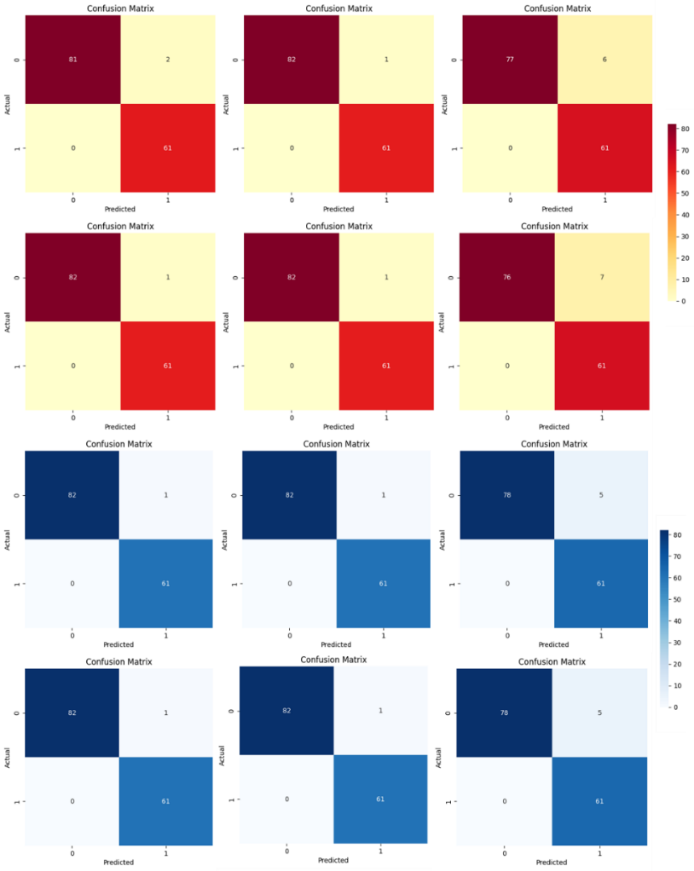
Supplementary Figure 1a: Confusion matrix results of MRMR with six classifiers viz; RF, KNN, XGB, GB, Ada Boost, and Gaussian NB.
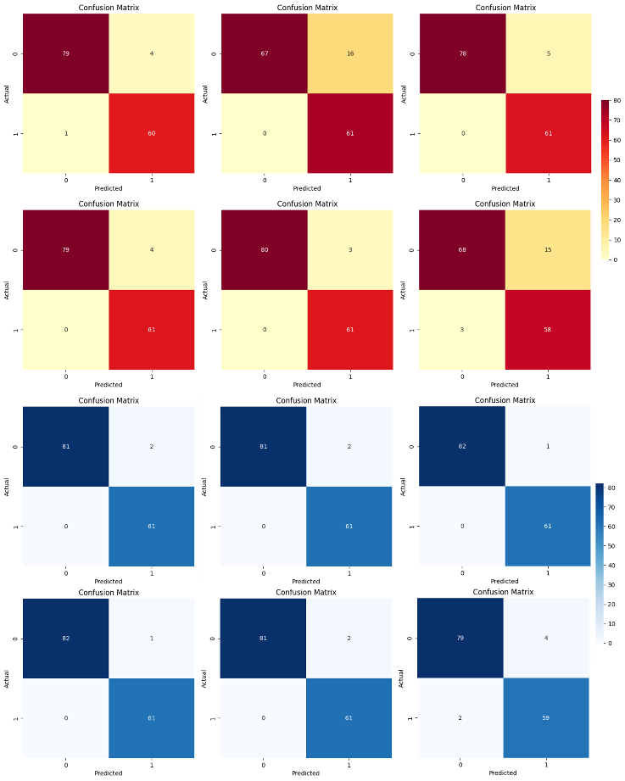

Supplementary Figure 1b: Confusion matrix results produced by LS with six classifiers. Each confusion matrix plot represents for each classifier RF, KNN, XGB, GB, Ada boost and Gaussian NB respectively.
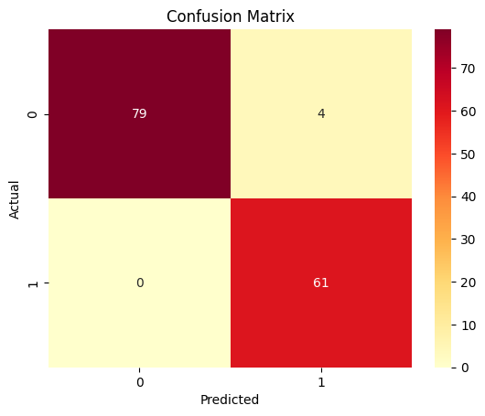
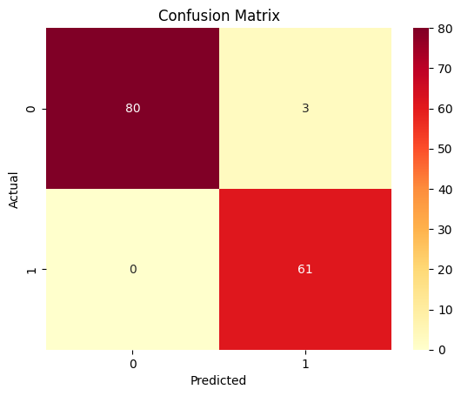
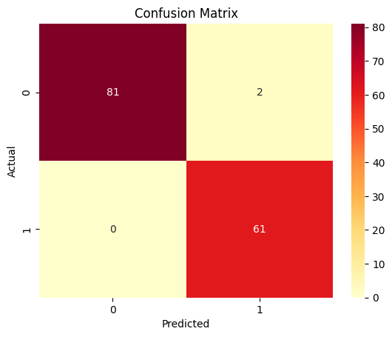
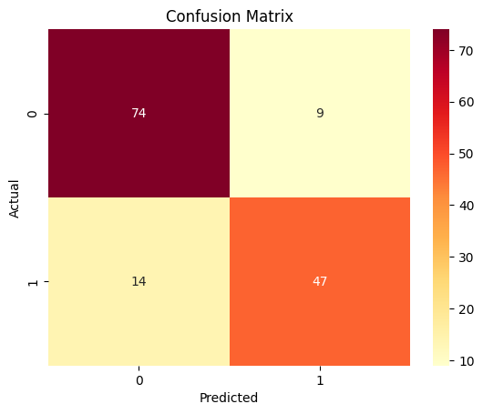
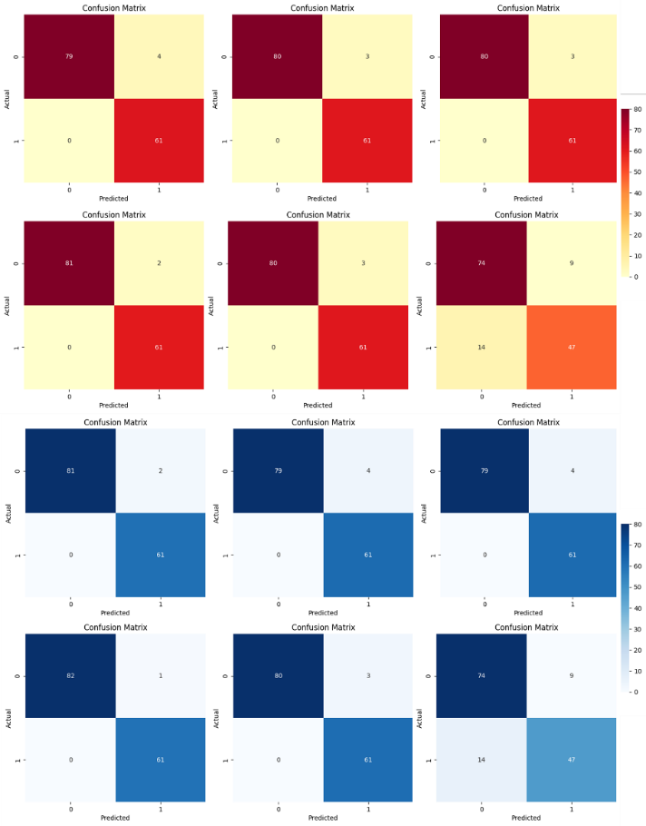
Supplementary Figure 1c: Confusion matrix results produced by ReliefF with six classifiers. Each confusion matrix plot represents for each classifier RF, KNN, XGB, GB, Ada boost, and Gaussian NB respectively.

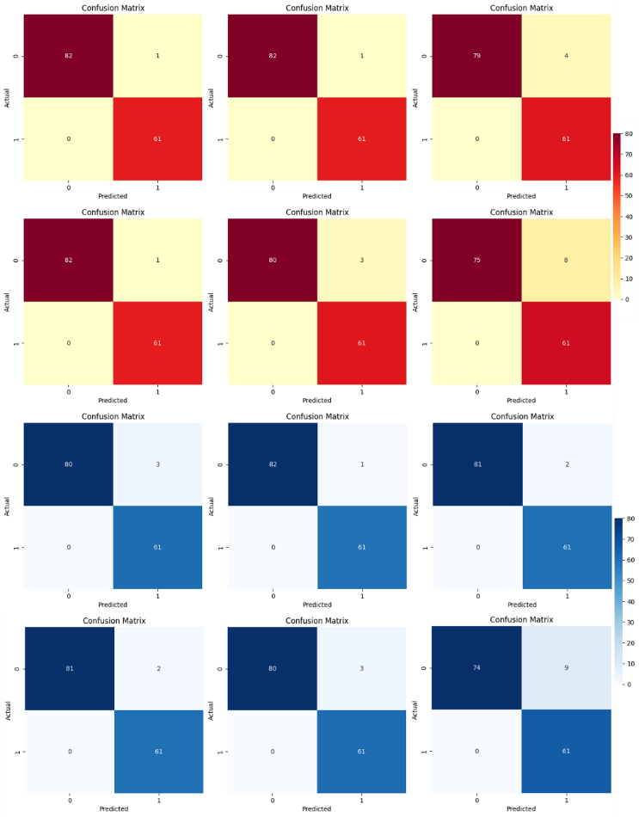
Supplementary Figure 1d: Confusion matrix results produced by SelectKBest with six classifiers. Each confusion matrix plot represents for each classifier RF, KNN, XGB, GB, Ada boost, and Gaussian NB respectively.

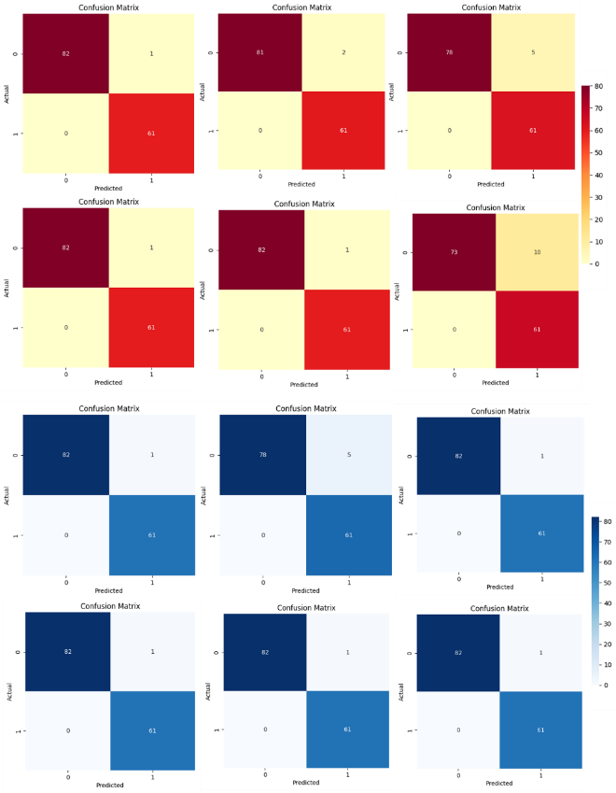
Supplementary Figure 1e: Confusion matrix results produced by SFS-SVC with six classifiers. Each confusion matrix plot represents for each classifier RF, KNN, XGB, GB, Ada boost and Gaussian NB respectively.

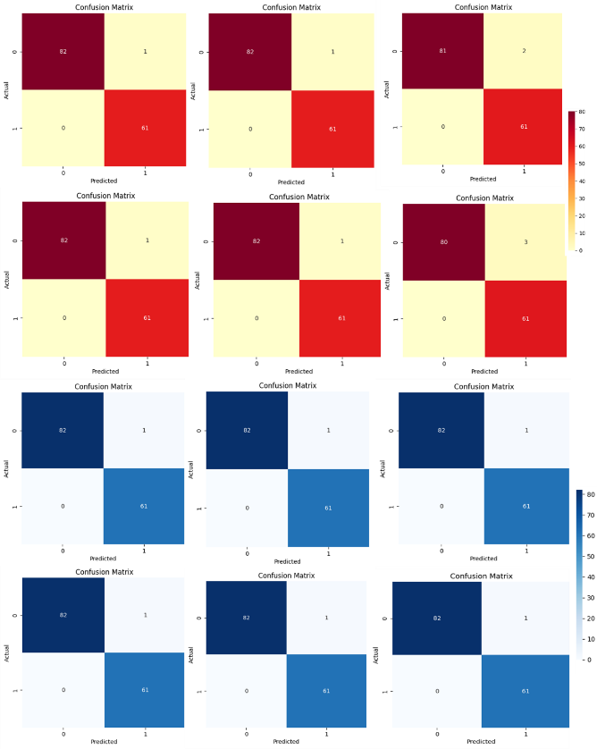
Supplementary Figure 1f: Confusion matrix results produced by LASSO with six classifiers. Each confusion matrix plot represents for each classifier RF, KNN, XGB, GB, Ada boost and, Gaussian NB respectively.

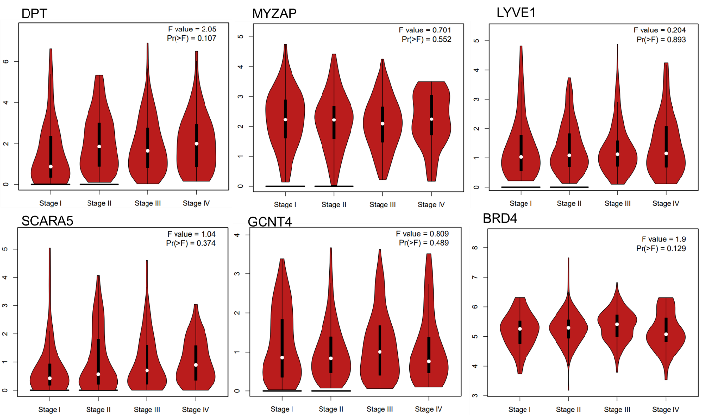
Supplementary Figure 2a: Pathological stage wise gene expression of genes DPT, MYZAP, LYVE1, SCARA5, GCNT4, BRD4.
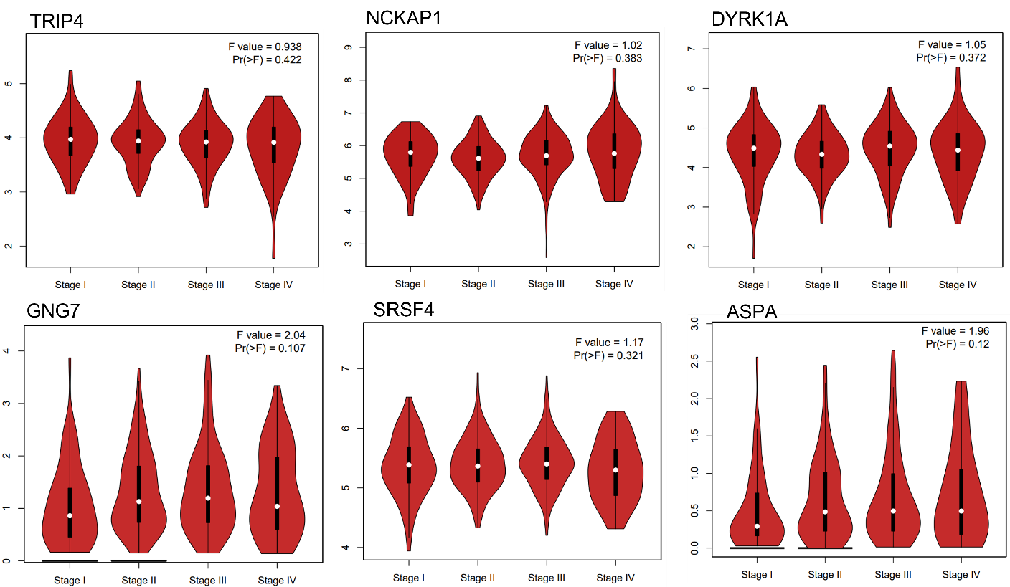
Supplementary Figure 2b: Pathological stage wise gene expression of genes TRIP4, NCKAP1, DYRK1A, GNG7, SRSF4, ASPA
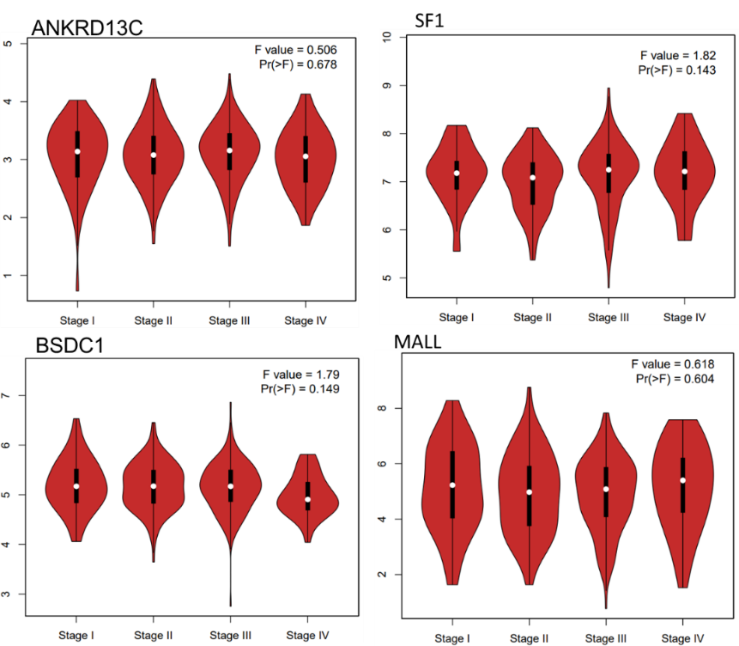
Supplementary Figure 2c: Pathological stage wise gene expression of genes ANKRD13C, SF1, BSDC1, MALL.

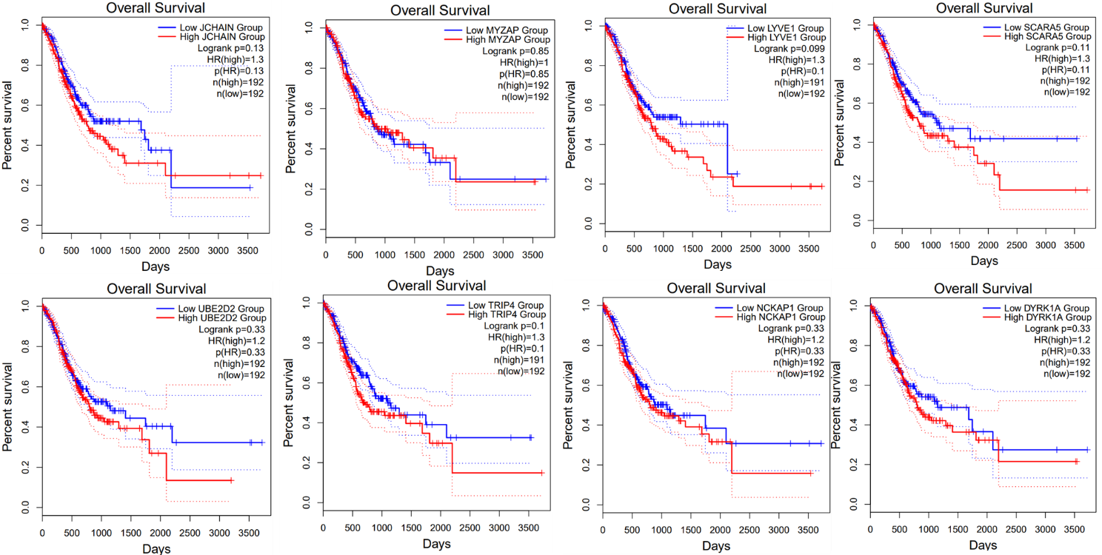
Supplementary Figure 3a: Survival analysis of shortlisted top 22 genes.1a: Kaplan Meier curve plot of HPCAL4, JCHAIN, GNG7, ASPA, PDZD4, SRSF4, BRD4, HPGD genes.
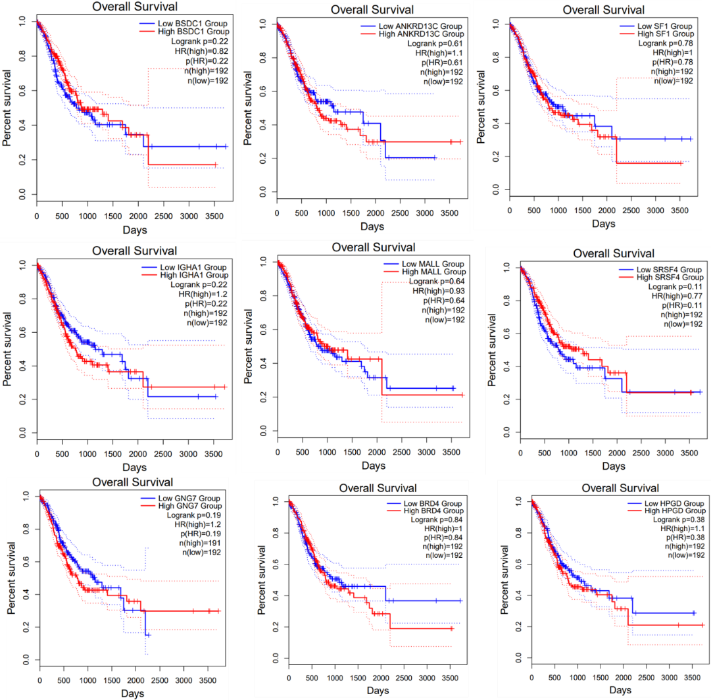
Supplementary Figure 3b: Survival analysis of shortlisted top 22 genes.1a: Kaplan Meier curve plot of BSDC1, ANKRD13C, SF1, IGHA1, MALL genes.
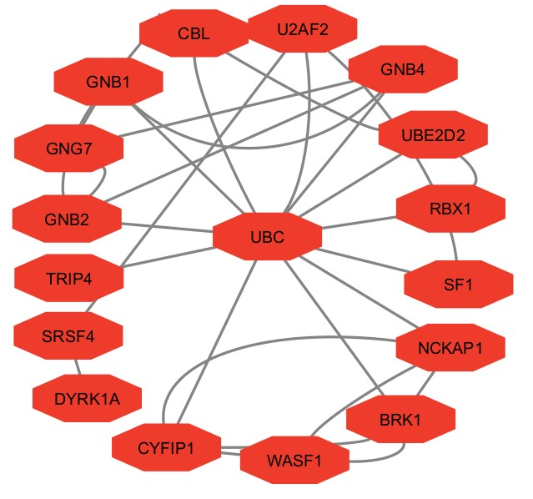
Supplementary Figure 4: String downloaded 29 protein-protein interaction network.
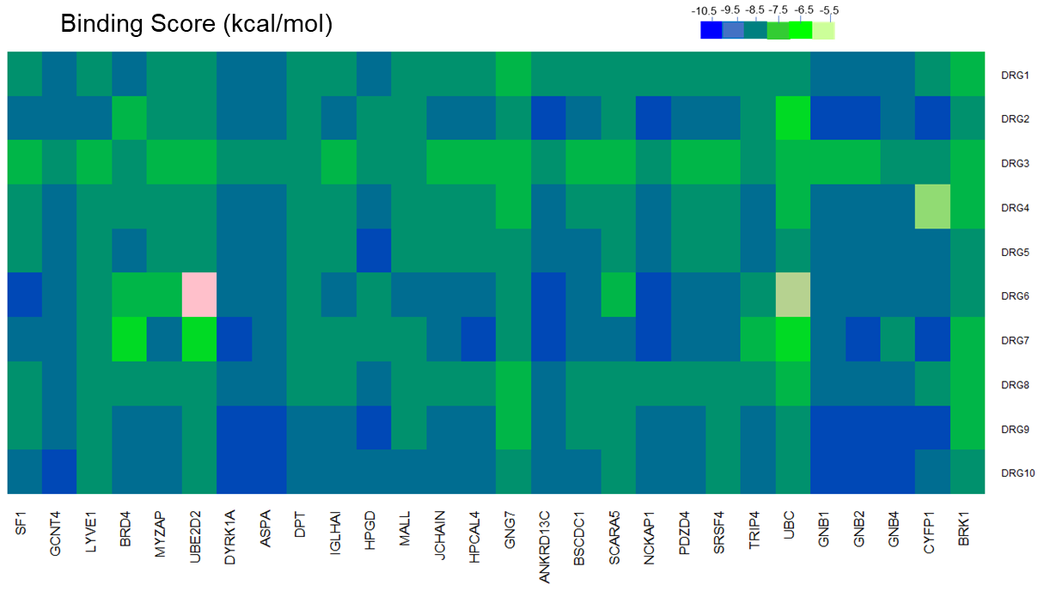
Supplementary Figure 5: A heatmap representation for binding affinity (K/Cal) of 10 drugs with 28 genes docked complex. Binding affinity scores have been represented accordingly with the color bar as the highest dark blue color, medium light blue color, and lowest in a light green color.

