Supplementary data

1: The primers used for q-PCR in this study
Name | Sequence |  | Product size(bp)
cysD -F  cysD -R | 5’- AAAGCAGATTGTGCGCTTCC-3’  5’- TTTCCATCGAGGCTTCGGAC-3’ |  | 167
gsdA -F  gsdA -R | 5’- AGGATTCCAAACCCCACGTC-3’  5’- GAGGTTCTCGCAGATGGAGG-3’ |  | 209
icd -F  icd –R | 5’- GATGTCTGGTTGCCCGAAGA-3’  5’- GTCGGTCTTCTCAGGCTCAC-3’ |  | 204
gshA –F  gshA –R | 5’- CAACCATTTCGCCGCCTATG-3’  5’- CTTGACGAAGACGAAGGGCT-3’ |  | 223
gshB-F  gshB-R | 5’- GAAAATCGCTTTCCTCGCCG-3’  5’- GATACCAGTCATCGGCCTCG-3’ |  | 197
gsr-F  gsr-R | 5’- ATTACCACGAGGAGTTCGCC-3’  5’- G AGGCTGACCTTGGCGTTATC-3’ |  | 157
16s RNA-F  16s RNA-R | 5’- GTAGTCCACGCCCTAAACG -3’  5’- AACCCAACATCTCACGACAC -3’ |  | 201
trxB -F  trxB -R | 5’- ACAAGCCCATCTATGACATCCC-3’  5’- TGTTCACCAGGGTCACTTCC-3’ |  | 129
selD -F  selD -R | 5’- CCGGTTCTCTGCTCTACCTG-3’  5’- GTTTGCACATCCAATCCCGC-3’ |  | 117
selA -F  selA -R | 5’- CGCAGATTCGACTACGGTCA-3’  5’- CACCAGGTCCGCATATCTCC-3’ |  | 128
metG-F  metG-R | 5’- TTGAACGCCAAGGTCGAAGA-3’  5’- GCGATGTTGACGTACTTGCC-3’ |  | 92
mdh -F  mdh -R | 5’- AATGAAACCGACCCGGACAA-3’  5’- TGCGCTCGATGTAGAAGCAT-3’ | 112
ligK -F  ligK -R | 5’- TATTGCACTATGCCGTGCTG-3’  5’- ATGCCCTTCTTCATCGCCAG-3’ | 121
pntA -F  pntA -R | 5’- CCAAACAGGCCGACATCATC-3’  5’- CTTGACCGTGTCTTCGCTGA-3’ | 83
iolA -F  iolA -R | 5’- GTTCCCCTGTACCTCAACGG-3’  5’- TCGACTTCTTCCTTGGTGGC-3’ | 122
ghrA -F  ghrA -R | 5’- TTTCTCTACAAGGCCGACCC-3’  5’- ACAGGATTTCCAGCTTGGGG-3’ | 181
gluC-F  gluC-R | 5’- GCCCATCCTGTATCACAACCG-3’  5’- GCATCACGCAGACGAAATCC-3’ | 113
mmsB-F  mmsB-R | 5’- CGCAACTGGACGCTGGAA-3’  5’- TGGTCGCCAACGCATTCT-3’ | 142
argC-F  argC-R | 5’- GGCAGACTATCCGCTGAACA-3’  5’- GTCCATAGGTGACGAAGGGC-3’ | 119
lpxB-F  lpxB-R | 5’- CAGCTCAAGAAGGCCGGTAT-3’  5’- TGGCGGTAGATGCTTTCCTC -3’ | 143

2 The growth curves and selenite reduction of Herbaspirillum camelliae strains WT00C, CT00C, NCT00C and NT00C (A) the strain WT00C; (B) the strain CT00C; (C) the strain NCT00C; (D) the strain N00C. (a) growth curve; (b) production of red elemental selenium via selenite reduction under different selenite concentrations in the given time.

(A)
(a)
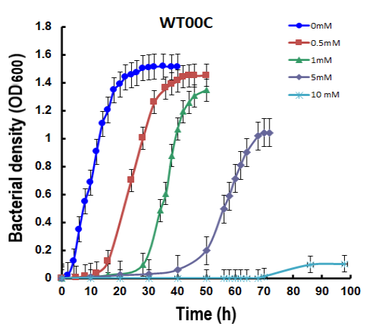

(b)
(32 h) (46 h) (50 h) (70 h) (98 h)
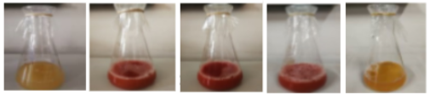
Selenite | 0 mM | 0.5 mM | 1 mM | 5 mM | 10 mM

(B)
(a)
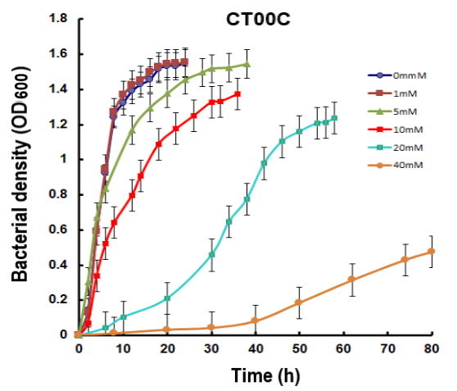

(b)
(24 h) (24 h) (28 h) (36 h) (57 h) (146 h)
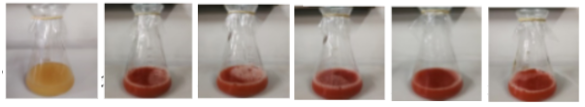
 | 0 mM | 1 mM | 5 mM | 10 mM | 20 mM | 40 mM

(C)
(a)

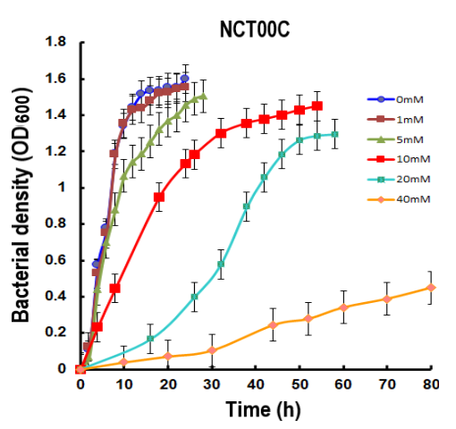

(b)
(24 h) (24 h) (28 h) (52 h) (57 h) (116 h)
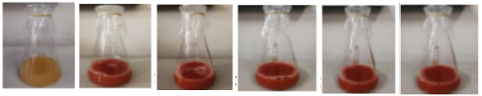
Selenite | 0 mM | 1 mM | 5 mM | 10 mM | 20 mM | 40 mM

(D)
(a)
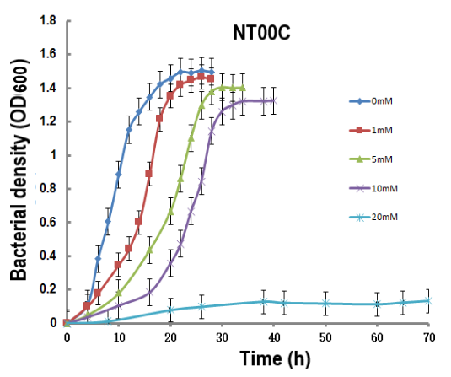

(b)
(24 h) (24 h) (32 h) (34 h) (60 h)
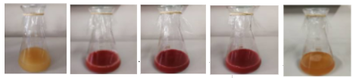
Selenite | 0 mM | 1 mM | 5 mM | 10 mM | 20 mM

