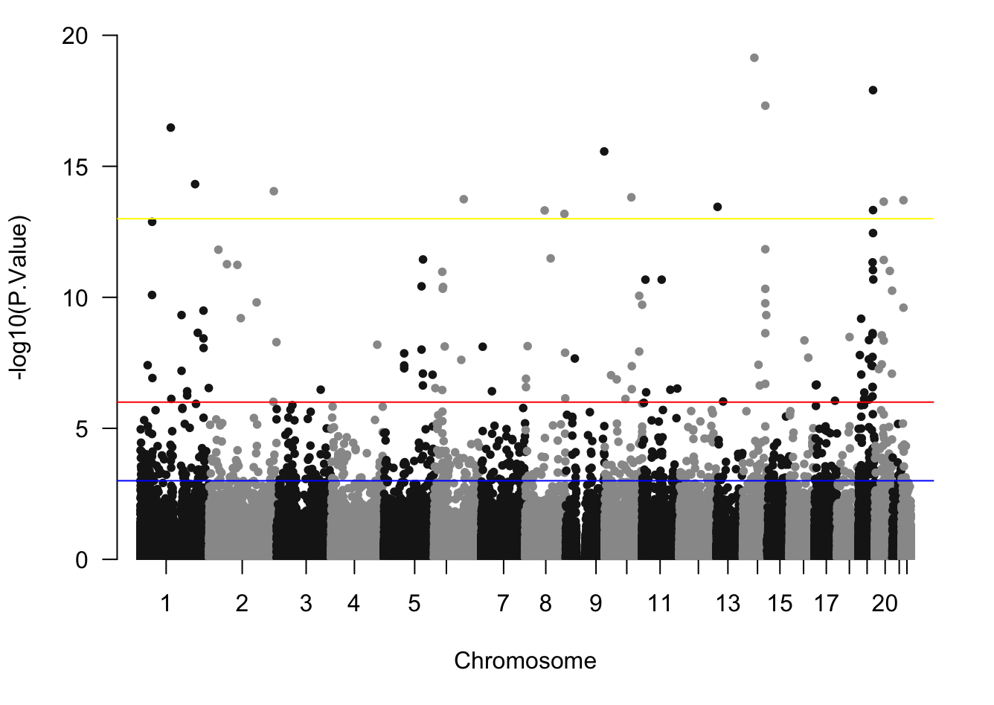Figure S1. Manhattan plot showing differentially methylated CpGs before treatment (above red threshold).

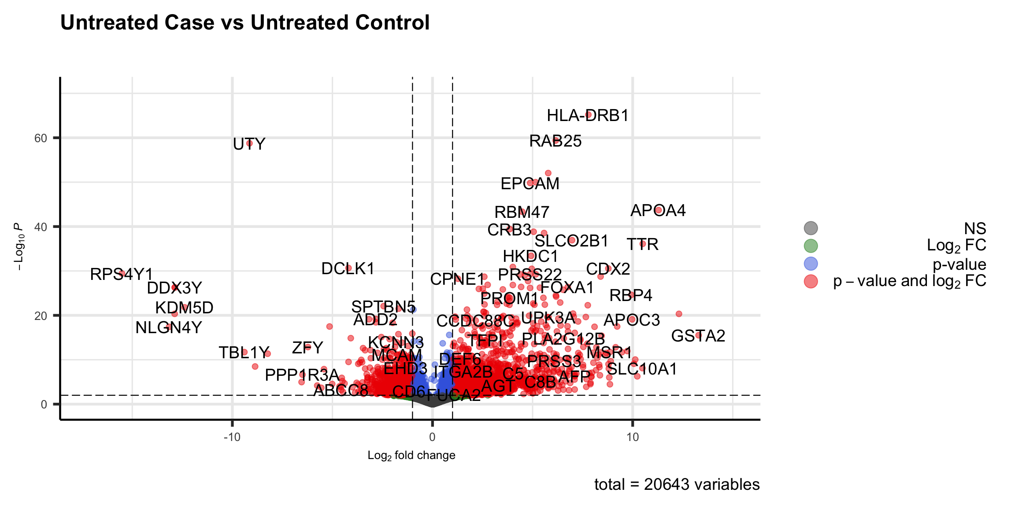
Figure S2. Volcano plot showing significant regions differentially expressed at baseline.

Figure S3-S15: Number of reads distributed among groups (Untreated: before clozapine exposure, Treated: after 2.8uM clozapine treatment for 24 hours, control: clozapine-tolerant, case: clozapine-myocarditis). In green: before treatment, In red: after treatment.

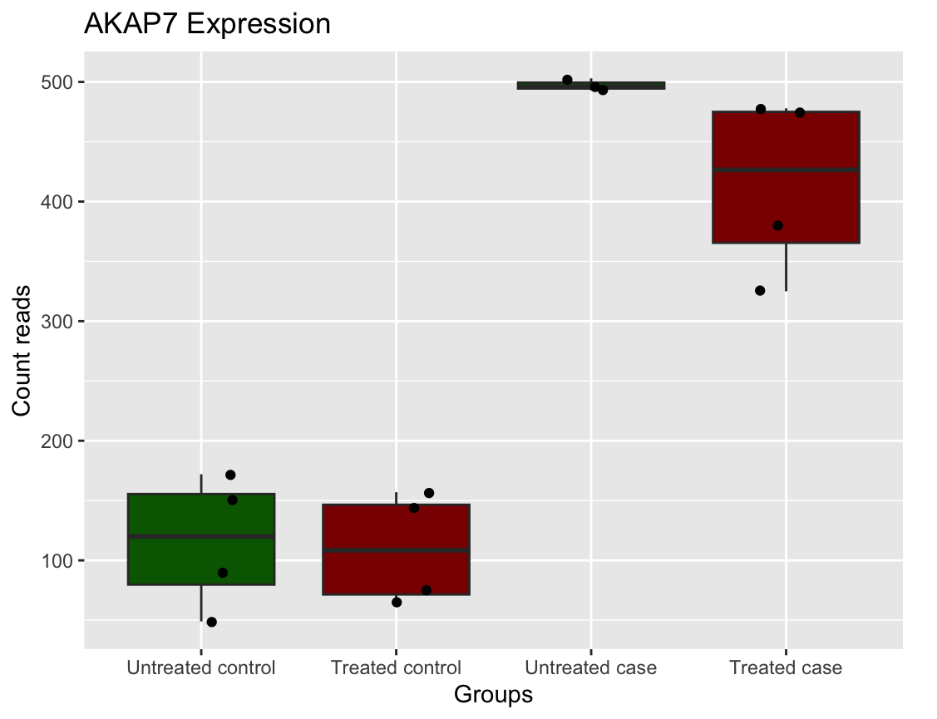
Figure S3. Boxplot of AKAP7 Expression Profile.

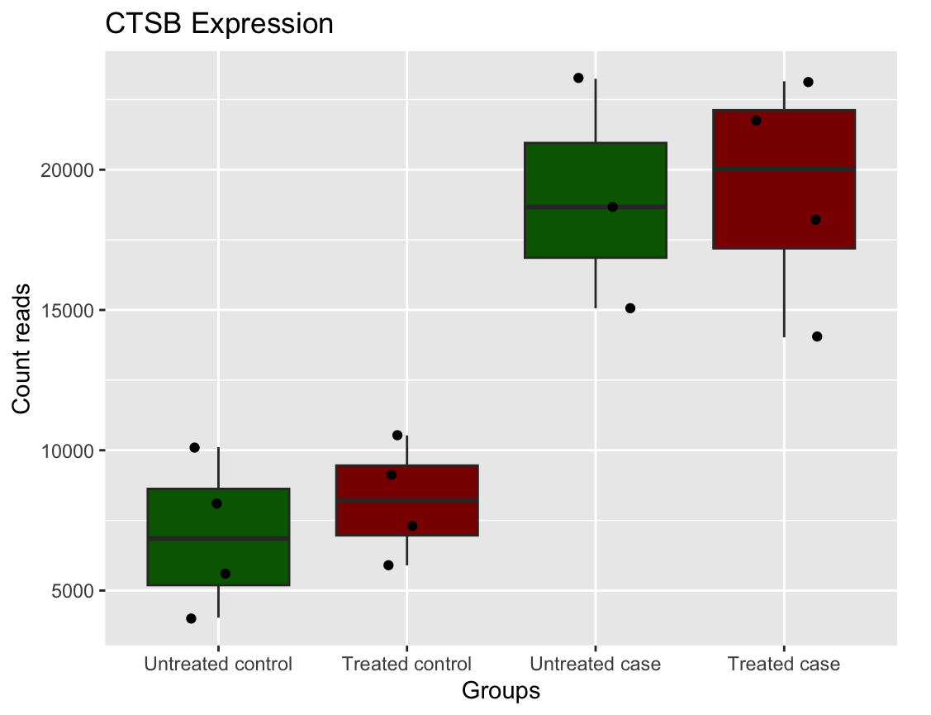
Figure S4. Boxplot of CTSB Expression Profile.
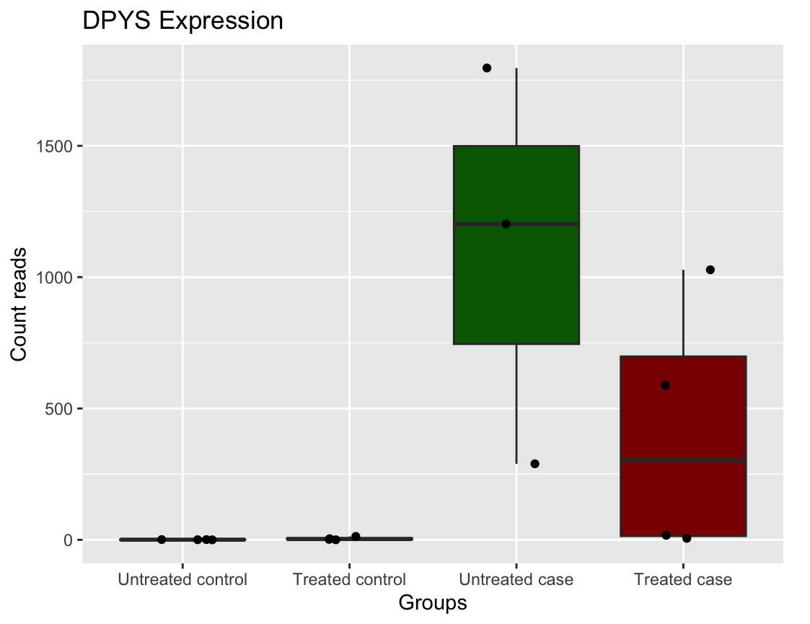
Figure S5. Boxplot of DPYS Expression Profile.

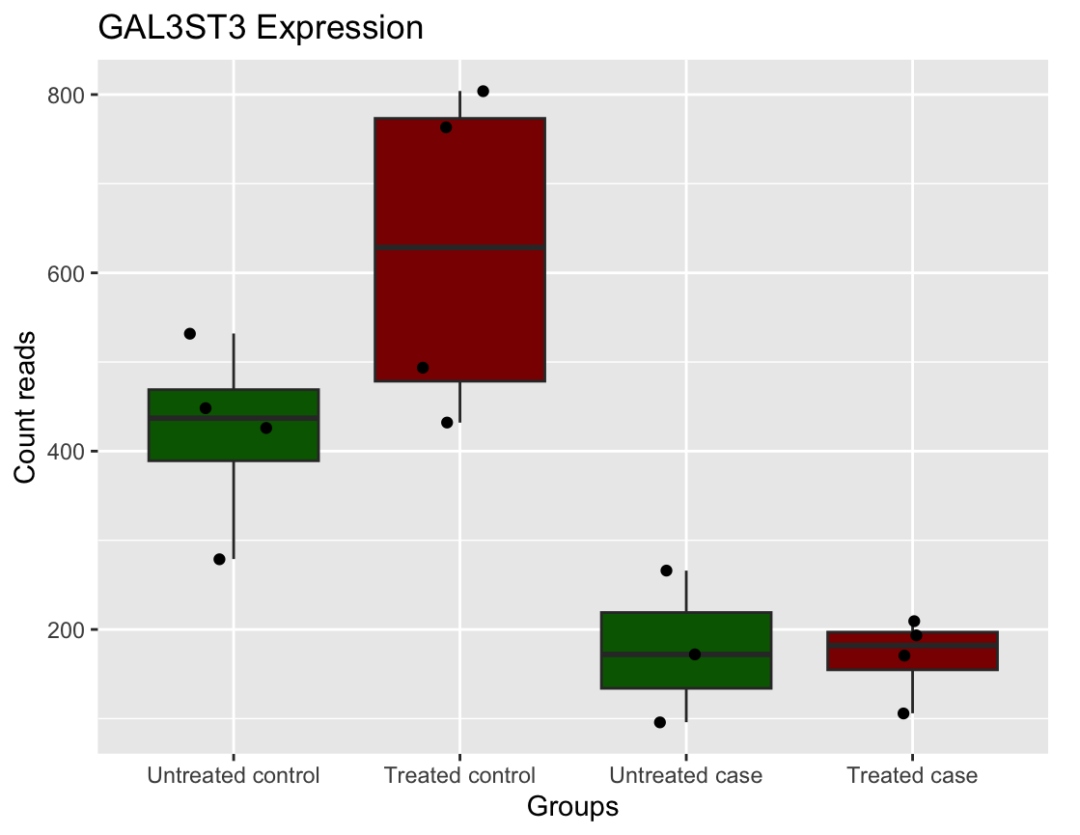
Figure S6. Boxplot of GAL3ST3 Expression Profile.

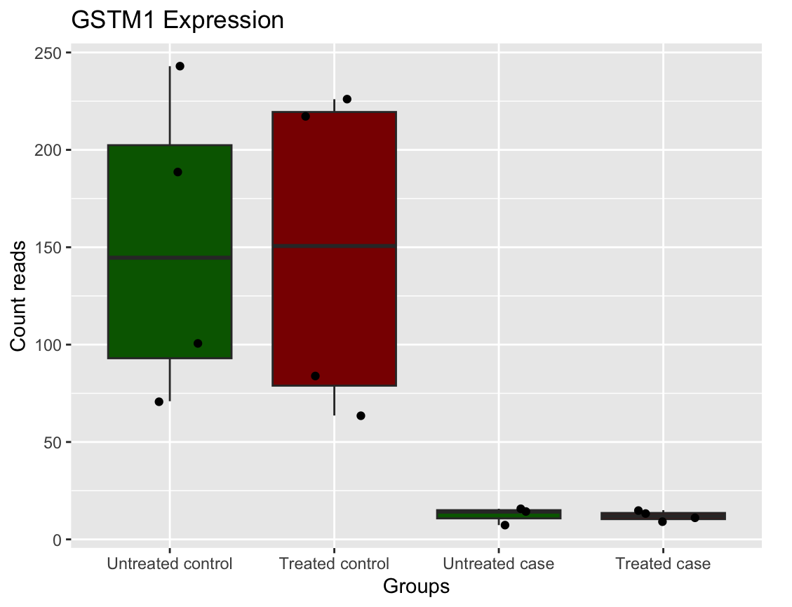
Figure S7. Boxplot of GSTM1 Expression Profile.

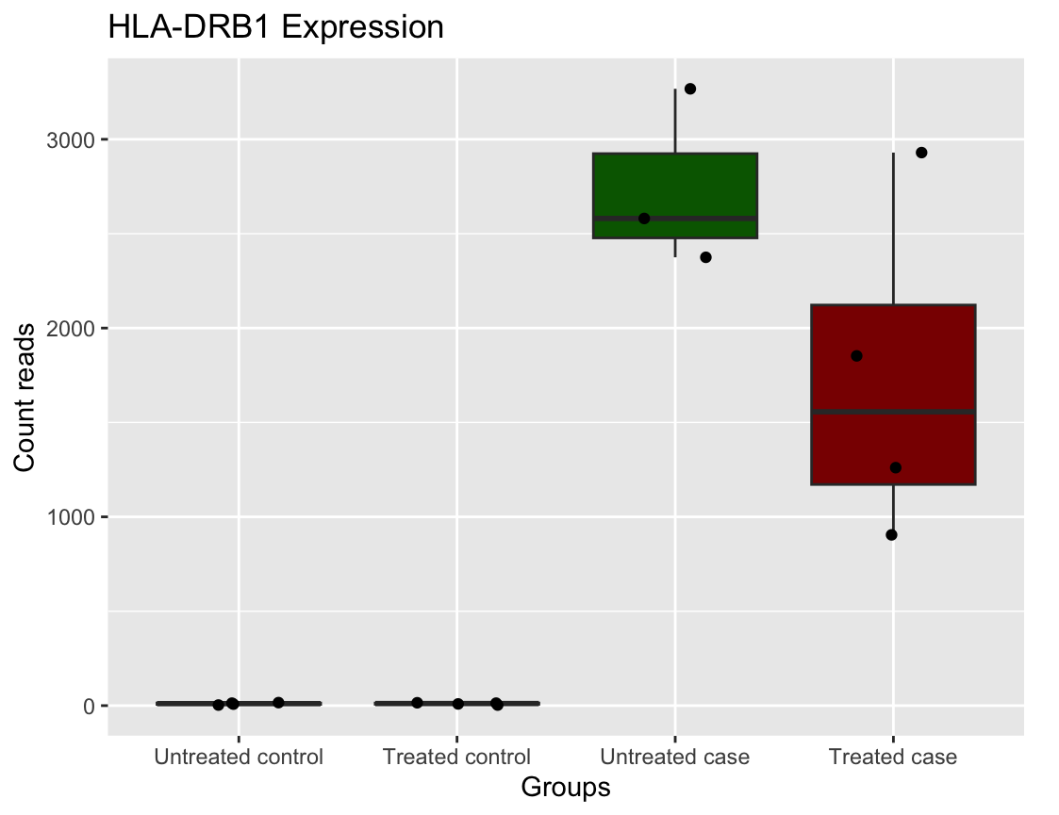
Figure S8. Boxplot of HLA-DRB1 Expression Profile.

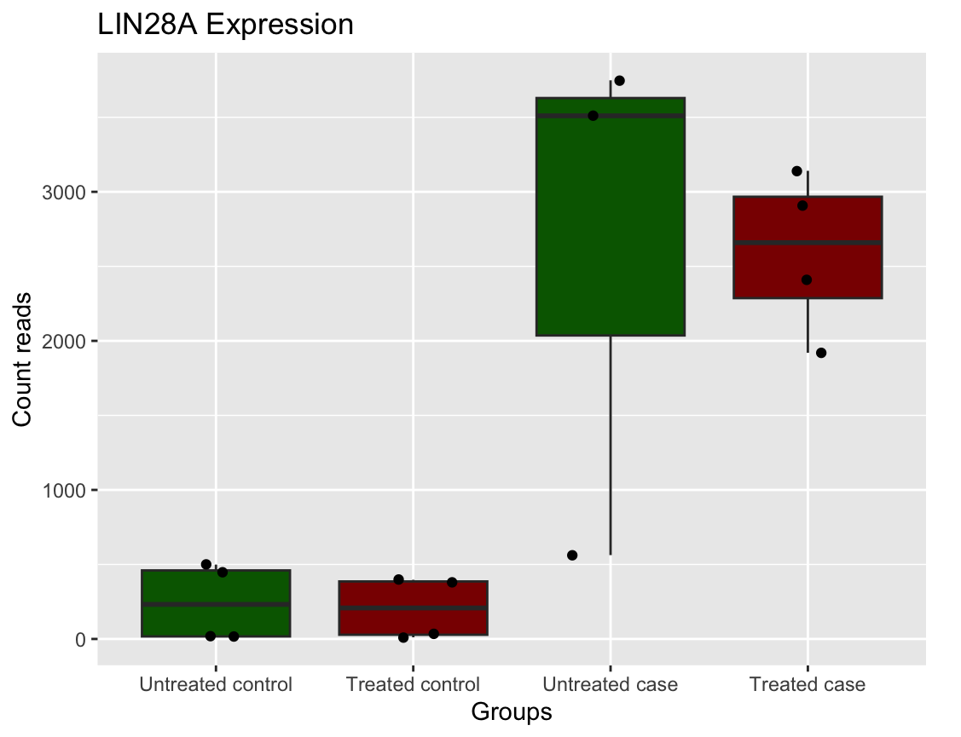
Figure S9. Boxplot of LIN28A Expression Profile.

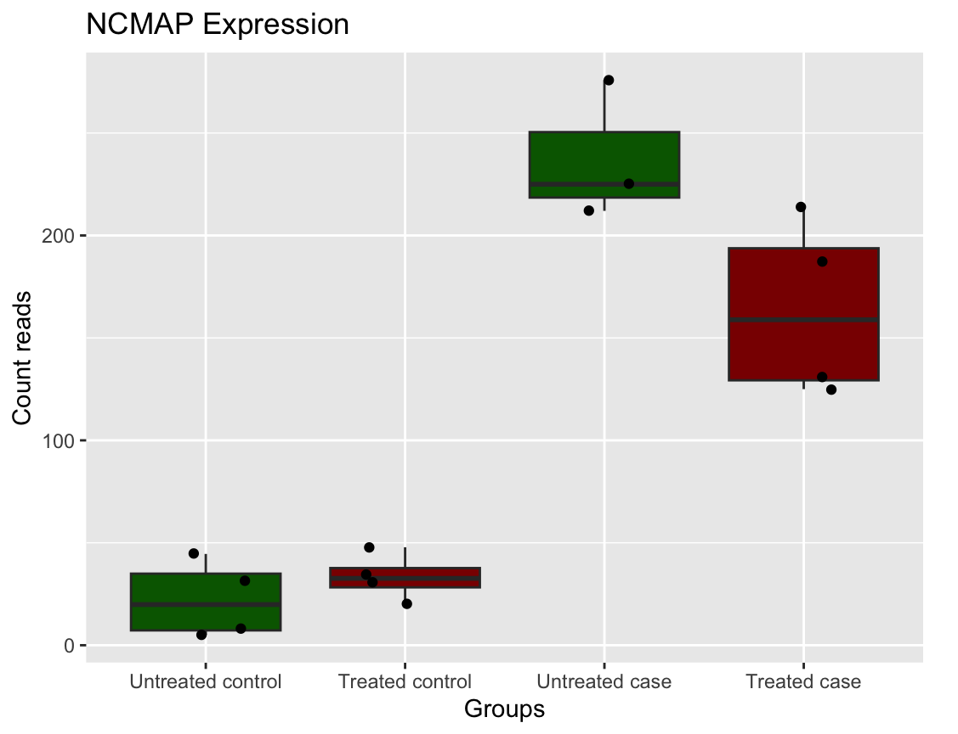
Figure S10. Boxplot of NCMAP Expression Profile.

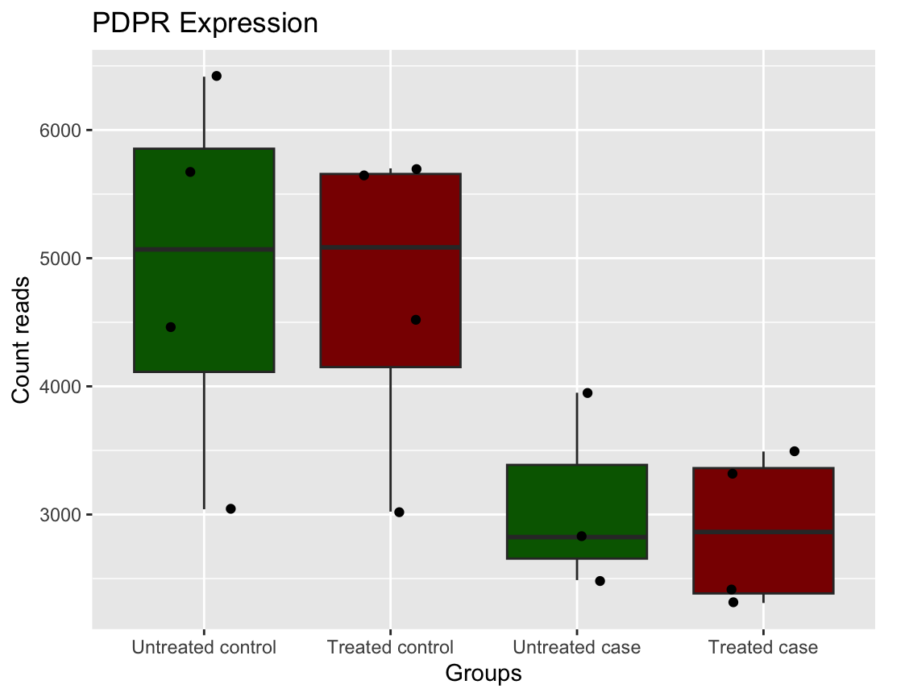
Figure S11. Boxplot of PDPR Expression Profile.

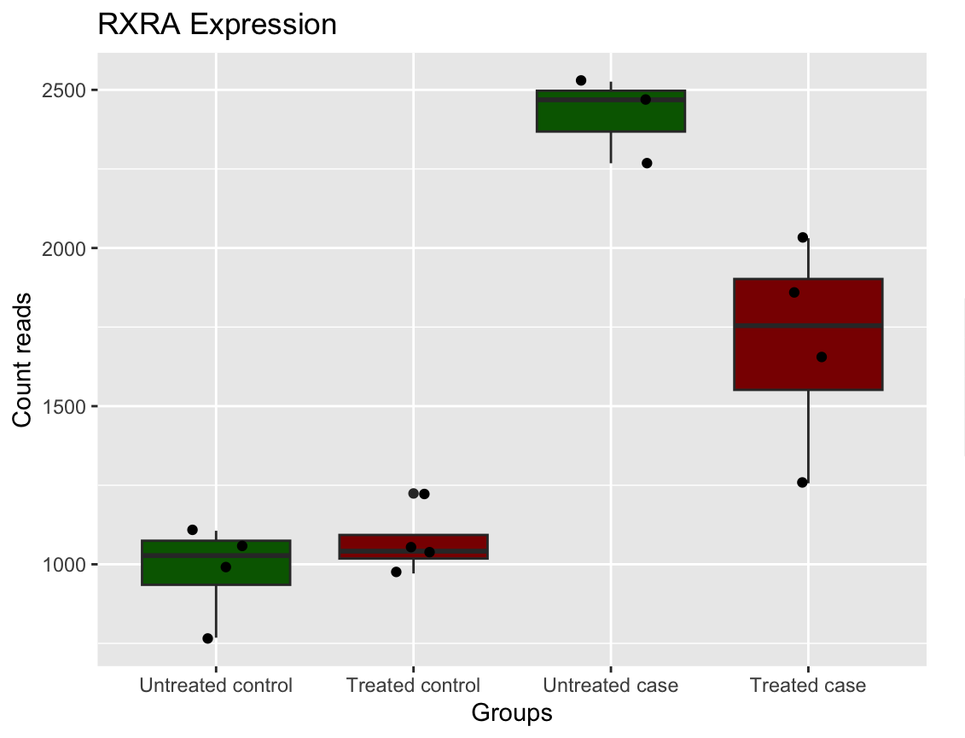
Figure S12. Boxplot of RXRA Expression Profile.

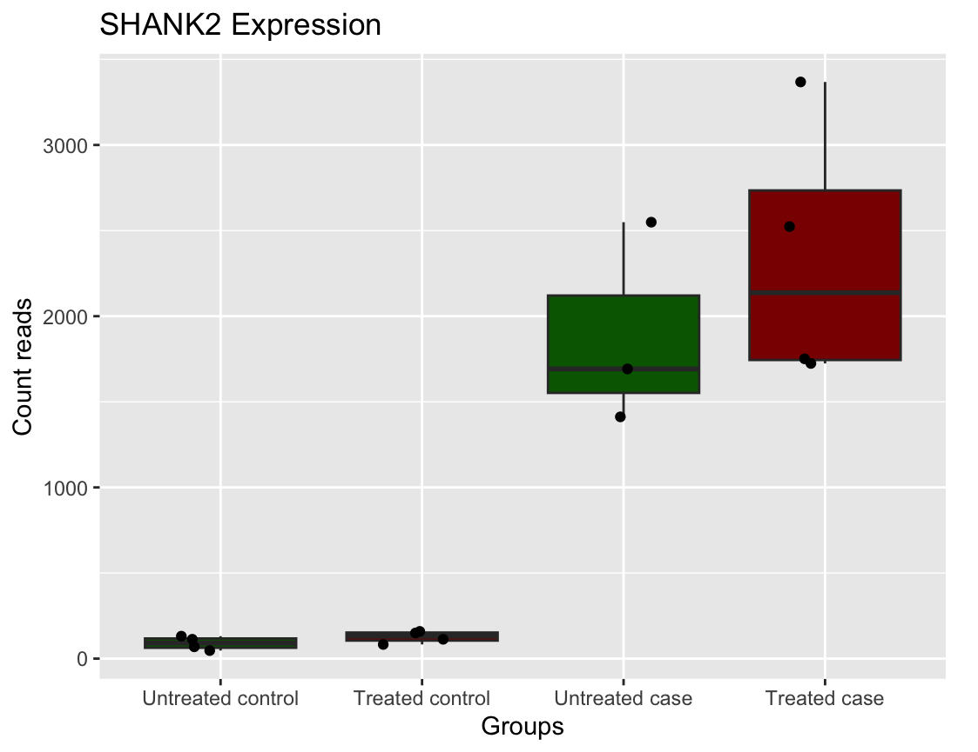
Figure S13. Boxplot of SHANK2 Expression Profile.

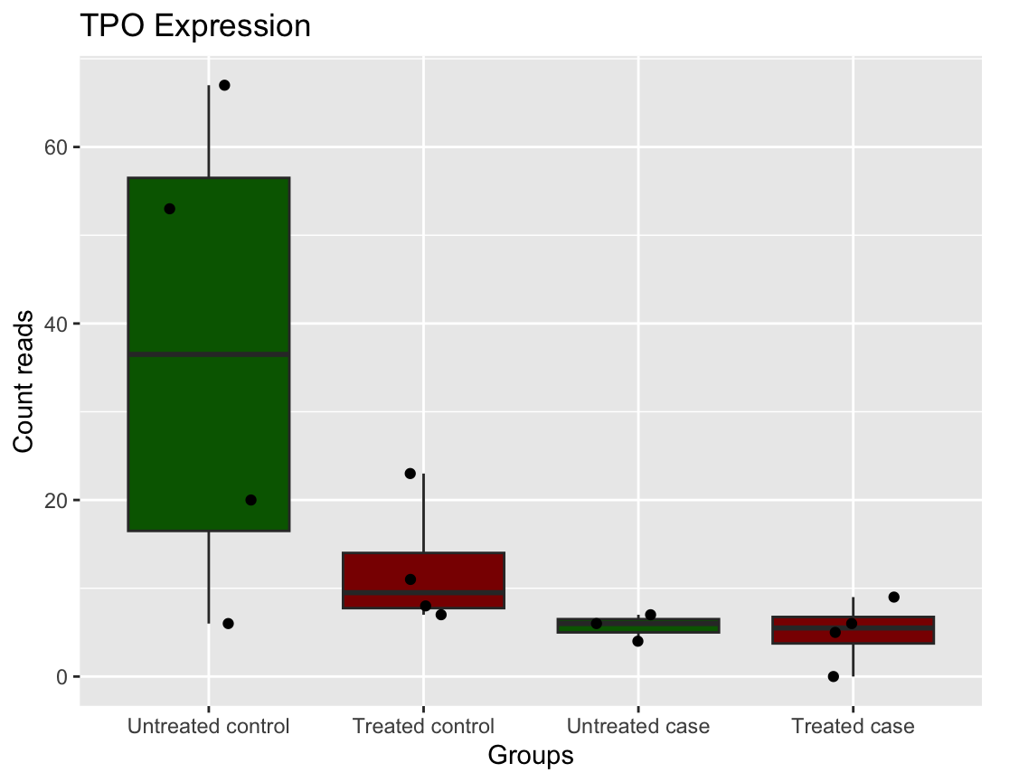
Figure S14. Boxplot of TPO Expression Profile.

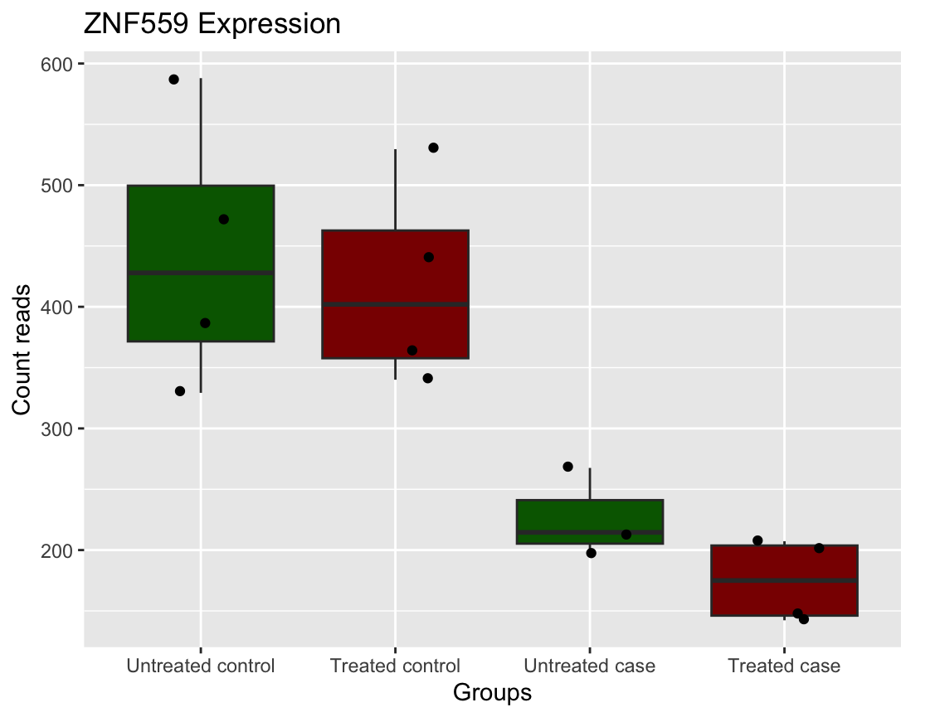
Figure S15. Boxplot of ZNF559 Expression Profile.

Supplementary Table S1. DNA methylation ß-values for each sample before and after clozapine exposure.
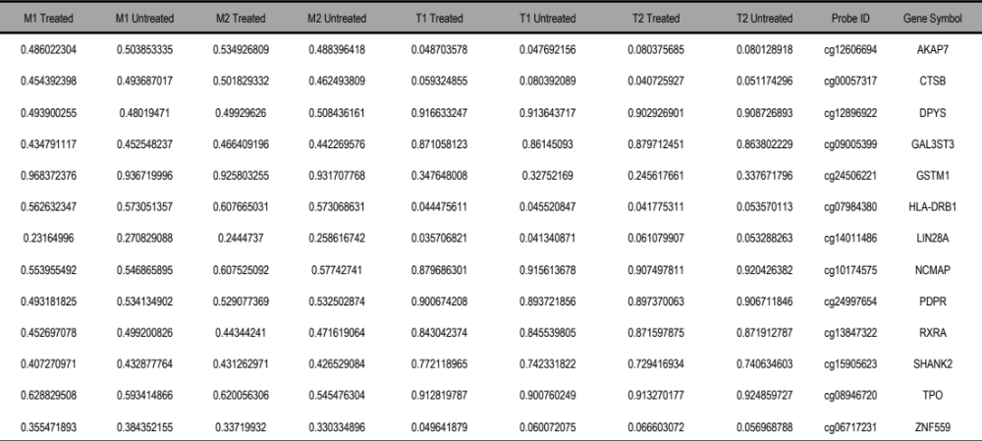
(M1,M2): myocarditis-cases, (T1, T2): tolerant-controls, Untreated: before clozapine treatment, Treated: after 24 hours of 2.8uM clozapine exposure, ß-values range from 0 to 1 and represent the percentage of methylation multiplied by 100.

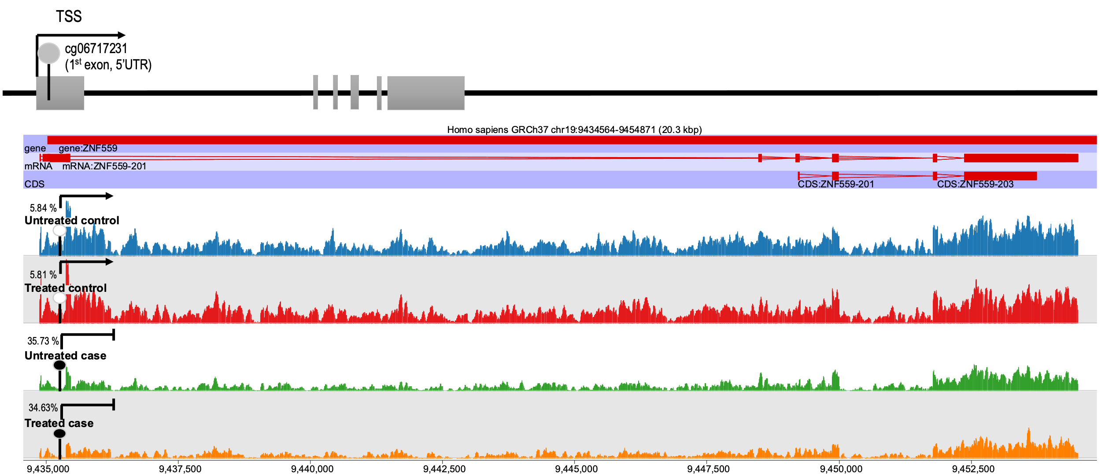
Figure S16. Chromosome view by SeqMonk data visualization of ZNF559 gene expression before and after clozapine treatment in cases and controls. The CpG site is located at 1st exon (5’UTR), a promoter-associated region and the low percentage of methylation was correlated with increased gene expression in the control group.

