Supplementary Figures
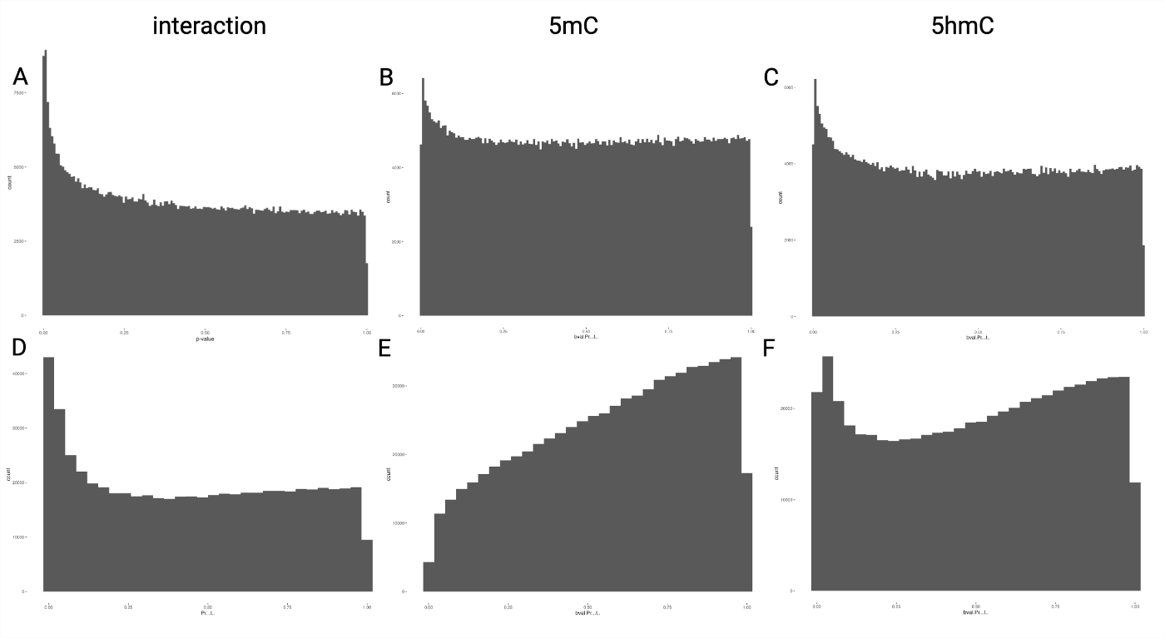
Supplementary Figure 1: P-value histograms for hypothesis testing in interaction and separate analyses. P-value histograms can be used as a quality control measure in association studies with a large number of hypothesis tests. Using a normal distribution model, the interaction hypothesis test histogram (A) is appropriate, with a peak of low p-values as would be expected from a well-calibrated hypothesis test. Histograms from separate modeling for 5mC (B) and 5hmC (C) alone show an overabundance of high p-values. Beta regression modeling did not perform well in interaction (D) or separate 5mC (E) or 5hmC (F) modeling.

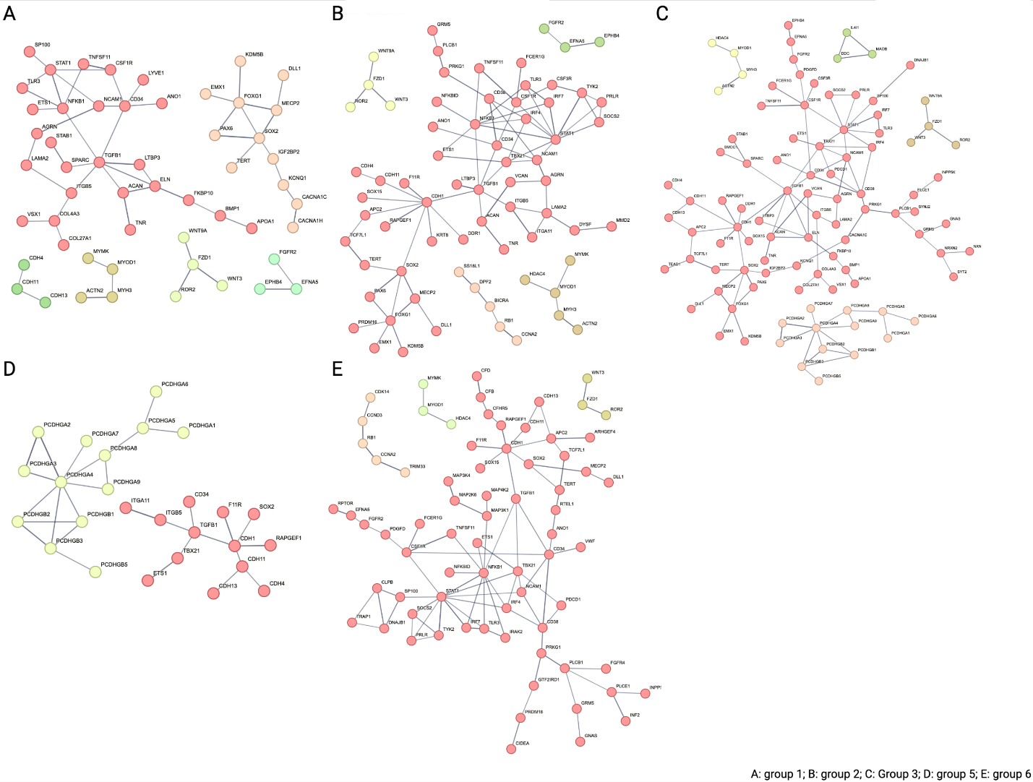
Supplementary Figure 2: String protein interaction network for each GO Term Group. Protein interaction networks of genes within each GO Term Group (confidence < 0.7; >2 genes per network). The following groups that correspond to GO terms in Table 2 are displayed: (A) group 1, (Β) group 2, (C) group 3, (D) group 5, (E) group 6. Groups 0 and 4 are not shown because they had no connected networks with >2 genes.

