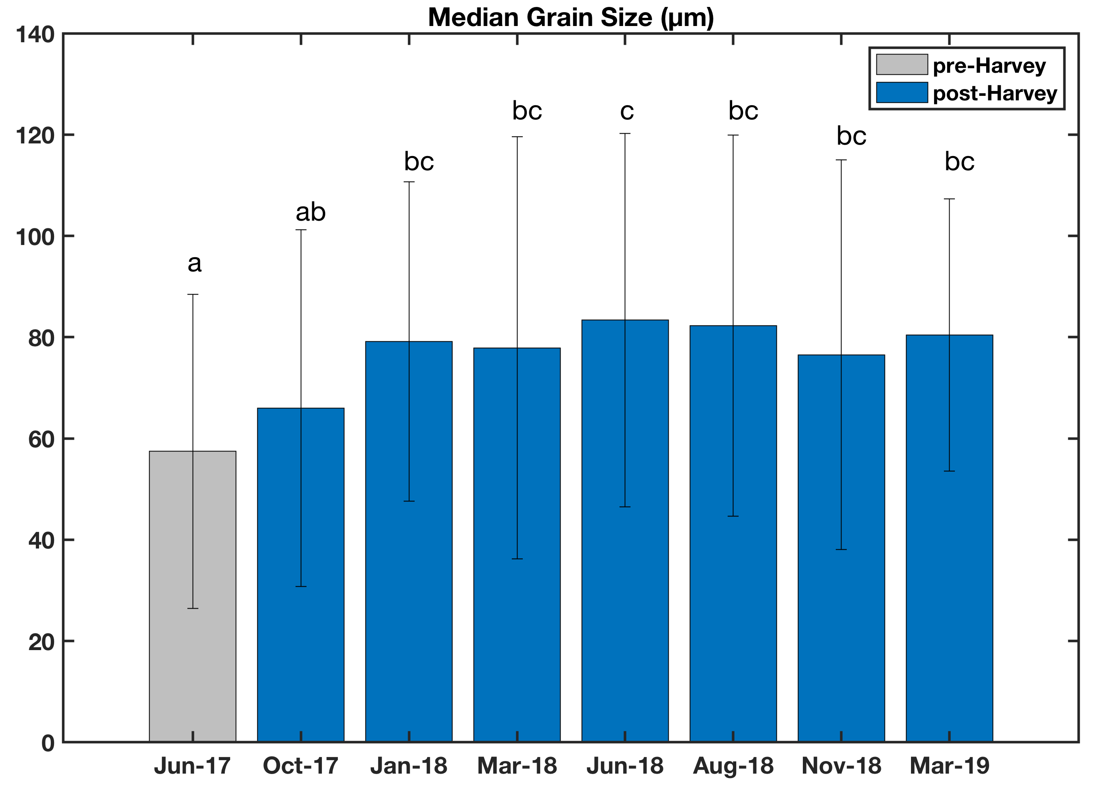

Figure S1. Average ± standard deviation median grain size (µm) for the 19 sites in the Mission-Aransas Estuary surface sediment from June 2017 to March 2019. Different lowercase letters are used to denote statistical differences (p<0.05) among different sampling events.

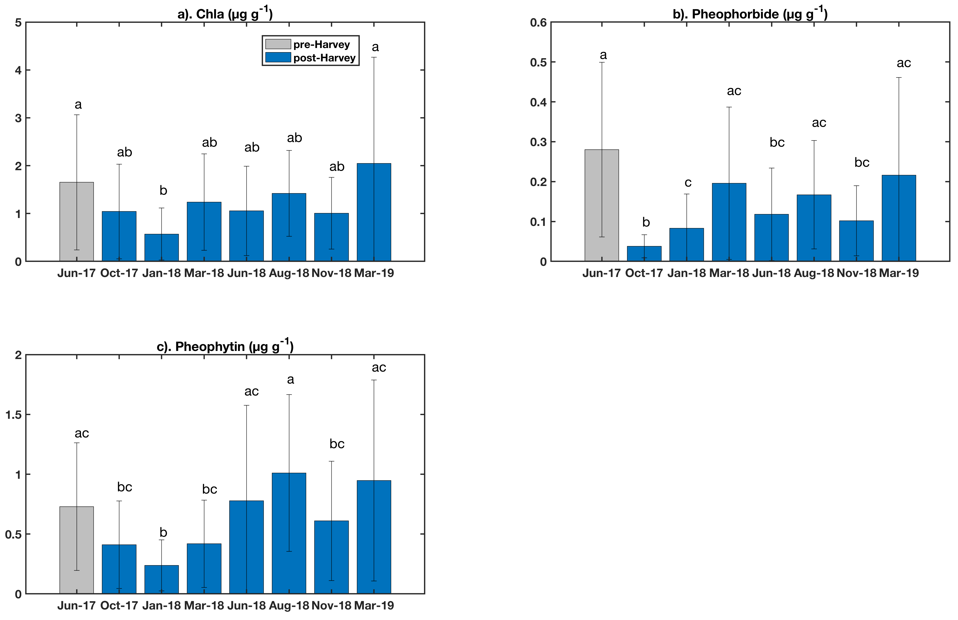

Figure S2. Average ± standard deviation concentrations of (a) Chla (µg g⁻¹), (b) Pheophorbide (µg g⁻¹), and (c) Pheophytin (µg g⁻¹) for the 19 sites in the Mission-Aransas Estuary surface sediment from June 2017 to March 2019. Different lowercase letters are used to denote statistical differences (p<0.05) among different sampling events.

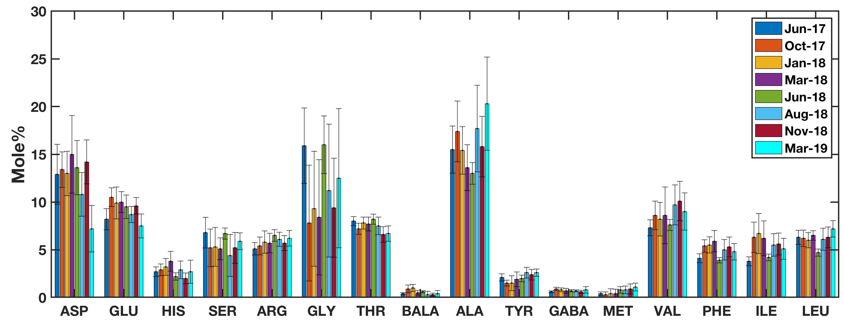

Figure S3. The average ± standard deviation mole% of each amino acid (16 types) for the 19 sites in the Mission-Aransas Estuary surface sediment from June 2017 to March 2019.

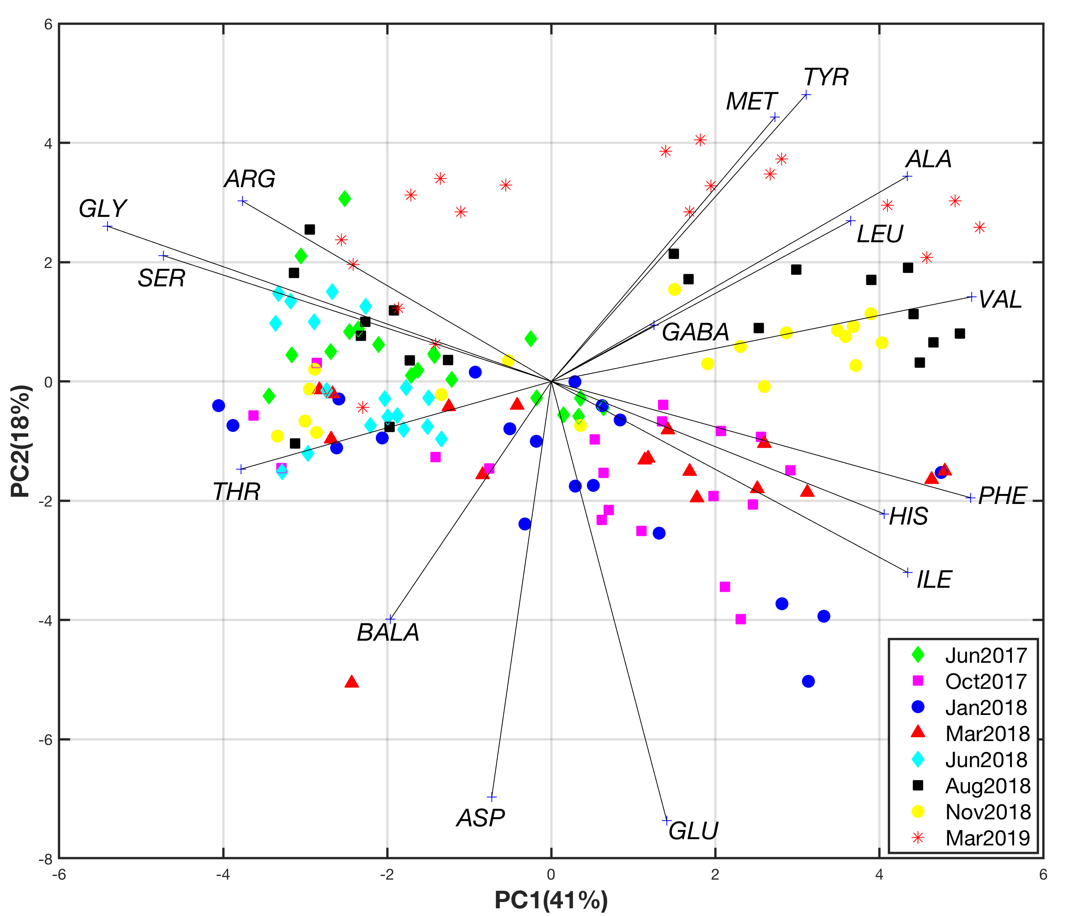

Figure S4. PCA was performed on the mole% of the 16 amino acids for the 19 sites in the Mission-Aransas Estuary surface sediment from June 2017 to March 2019.

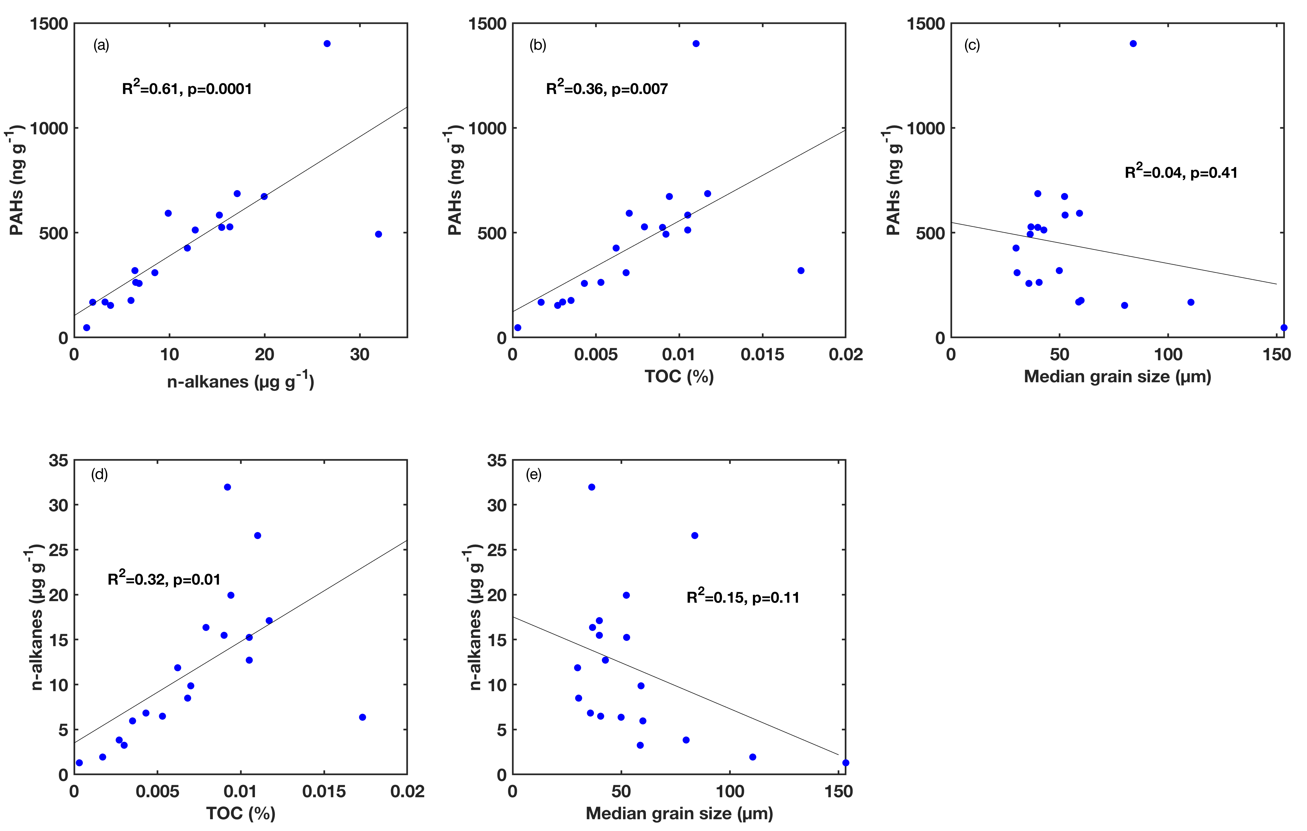

Figure S5. The PAHs (ng g⁻¹) and n-alkanes (µg g⁻¹) concentrations at each of the 19 sampling sites in the Mission-Aransas Estuary surface sediment in June 2017 (i.e., pre-Harvey), and their correlations with TOC (%) and Median grain size (µm).

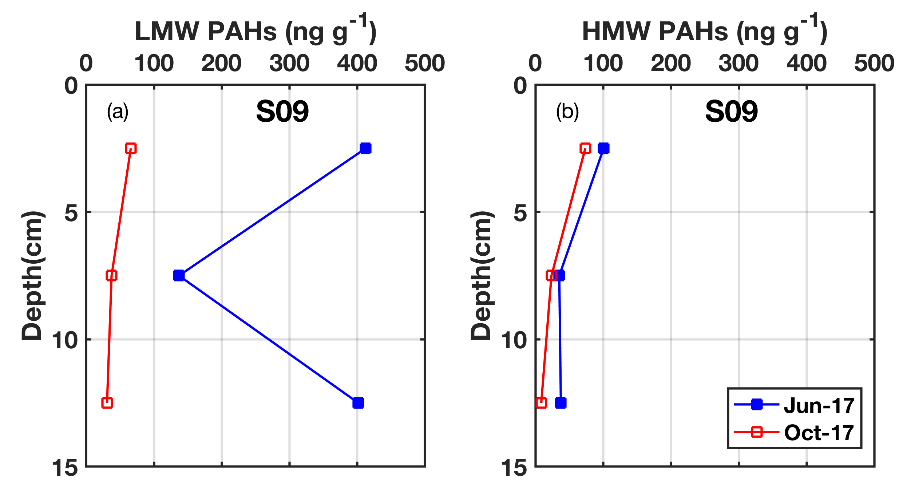
Figure S6. The (a) LMW PAHs (ng g⁻¹) and (b) HMW PAHs (ng g⁻¹) concentrations at site S09 at three different sediment layers in the Mission-Aransas Estuary in June 2017 (i.e., pre-Harvey), and October 2017 (post-Harvey).

