Supplemental Information

Deviations from REMIND default assumptions

We make the following deviations from standard scenario settings in this analysis:
- We use a model version based on REMINDv3.2.0 that additionally includes a separate carbon market for novel CDR. The code is available on Github at https://github.com/amerfort/remind/tree/SepMark_REMIND3.2.0
- We exclude novel CDR from the tax on GHG emissions and add a complementary subsidy.
- Instead of a peak budget target, we prescribe explicit residual emissions and removal targets for 2050.
- The tax on net negative emissions is turned off to avoid additional modifications of the effective carbon price.
- Enhanced weathering is an available CDR option.
- Maximum annual primary energy biomass is limited to 100 EJ/yr for sustainability reasons.

Technoeconomic data on CDR technologies
In REMINDv3.2.0¹ there are 4 BECCS conversion routes that capture CO₂ released during combustion or the refinery processes that convert lignocellulosic biomass feedstock into secondary energy carriers: bioliquids, biogas, electricity and H₂. Which specific technology is economically most useful in a given scenario is not only dependent on the contribution to CDR but also on how valuable the secondary energy carrier is to the abatement side. In the model we represent a low-temperature Direct Air Capture technology following the specifications provided by Climeworks². For DAC, learning is endogenous, with investment costs declining with increased cumulative capacity.
Table 1: REMIND’s representation of bio-based CO₂ capture technologies. Only when the captured CO₂ is geologically stored (and not used for synthetic fuels) will it be counted as CDR. REMIND tracks biomass flows in terms of energy content rather than tons of dry matter and capture efficiencies in the model are given as GtC/ZJ with respect to primary energy content. The carbon capture rates are calculated here for comparison using the assumptions of 18GJ/tDM on energy content per tonne dry matter and 0.49 tC/tDM on carbon content per tonne dry matter of biomass feedstock. *Capture rates of all technologies featuring carbon capture are additionally reduced by 1% to account for losses during CO₂ transportation, this table shows original capture rates before reduction.
Bioenergy with carbon capture technology | Investment costs [US$2015/kW] | Fixed O&M costs as a fraction of investm. costs | Variable O&M costs [US$2015/kWa] | Energy conversion efficiency | Lifetime [years] | CO₂ capture  GtC/ZJ*  (rate)
Electricity:  Biomass integrated gasification combined cycle power plant | 3150 | 0.04 | 50.5 | 0.28 | 40 | 20  (73%)
Hydrogen | 2040 | 0.08 | 10.6 | 0.55 | 35 | 22.5  (83%)
Bioliquids:  Biodiesel production with Fischer-Tropsch | 3600 | 0.06 | 10.6 | 0.41 | 35 | 12  (44%)
Biogas | 1230 | 0.06 | 12.8 | 0.55 | 40 | 9.5  (35%)

DAC technoeconomic assumptions
Investment costs [US$2015/tC] | 18000  (floor cost after learning: 4800)
Fixed O&M costs as a fraction of investm. costs | 0.025
Energy demand (electr. for ventilation) [TWa/GtC] | 5.28
Energy demand (heat for material recovery) [TWa/GtC] | 21.12
Lifetime [years] | 20

CCS (geological storage of CO2)
Investment costs [US$2015/tC] | 220
Fixed O&M costs as a fraction of investm. costs | 0.06
Electricity demand [TWa/GtC] | 0.005
Lifetime [years] | 40
Total global storage potential GtCO2 | 3959
Maximum annual injection rate GtCO2/yr (0.5% of total storage potential) | 19.9

The description of the additional tax on CCS is taken from Strefler et al. 2021³: “To reflect the risk of leakage and the associated possible costs, costs of improved safety criteria related to monitoring, reporting, and verification, and difficulties due to public acceptance, which are all likely to increase with deployment, the best estimate of costs for geological carbon storage is increased linearly such that costs are about 100% or 30 $ tCO₂−1 higher at maximum deployment.”
For still immature technologies, among others are all BECCS technologies, DAC, and CCS, there are mark-up costs for the near-term periods: investment costs are multiplied with 1.5 in 2025 and 1.2 in 2030.

Technoeconomic data on EW
The following description is taken from Strefler et al 2018⁴ “EW is based on the acceleration of the natural weathering of silicate rocks, which is an integral part of the carbon cycle. In REMIND, we assume those rocks to be basalt, which is rich in phosphorus and potassium and contains very low concentrations of trace elements. 1 t of basalt binds 0.3 tCO2 in the weathering process. The basalt has to be mined, ground to small grain sizes, and spread on agricultural fields. We assume a maximum of 15 kg ground stone per square meter at any given point in time. Only the amount of basalt that weathers in a given year can then be replenished. The regional potential for carbon removal depends on the agricultural land and the climate zone as this process is faster in warm and humid regions and amounts to a maximum of 4.9 Gt CO2/yr removed⁵ (see Table S4). However, the potential of EW is still highly uncertain. Weathering rates are so far only calculated and would have to be measured in field experiments. Also, the amount of stone that can be spread on fields is a rather conservative assumption and could be higher initially. In the long run, i.e. if applied over decades, it is unclear to what extent EW could be sustained without significantly changing the soil structure. Applying EW not only on croplands as assumed here but also on woods would increase the potential, but also the costs as spreading would become more difficult. Both uncertainties could change the total amount of EW, but would not have much impact on regional distributions as warm and humid regions would remain favourable. Economic costs are at about 200$/tCO2 removed, including investment costs (<10%), O&M costs (40%), electricity costs (<10%) for grinding and transport and distribution costs (~40% depending on distance).”

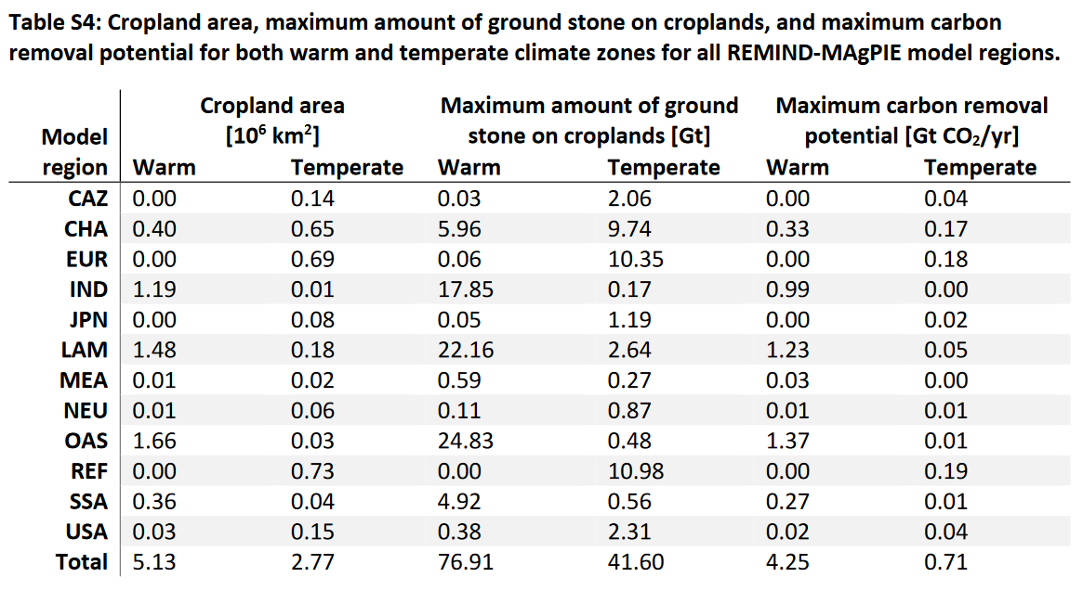

Sensitivity scenarios with unconstrained biomass availability

If the biomass limit of 100 EJ/yr is lifted, we observe almost identical biomass use of around 106 EJ/yr for scenarios with CDR targets from 2-8 GtCDR/yr. Significant increases only occur for the scenarios with highest CDR targets with 10 and 12 GtCDR/yr with 113 and 127 EJ/yr respectively.
However, like the scenarios shown in the main analysis, different net-zero formulations lead to varying cumulative emissions until 2050. When contrasting the scenarios with separate targets with counterfactuals reaching the same cumulative emissions but with only a uniform carbon price, scenarios with equally tight CO2 budgets (pink scenarios) require more biomass while scenarios with comparably loose budgets require significantly less biomass (blue scenarios). Hence the
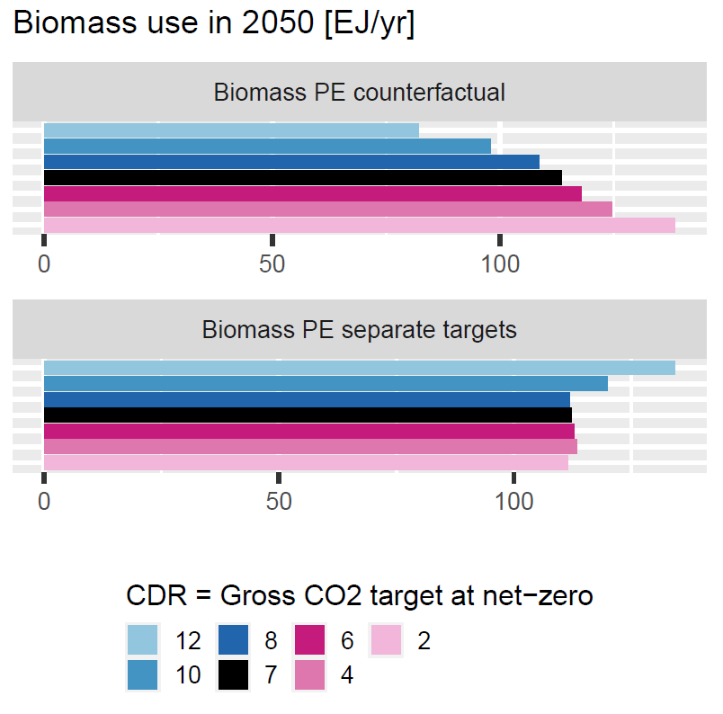
To illustrate the inherent uncertainty of future carbon prices, we show the quantities of residual emissions (brown) and permanent CDR (green) at different carbon prices in 2050 from 165 IAM scenarios submitted to the IPCC 6th assessment report (panel b). Scenarios where filtered to only include all C1 and C2 scenarios, with carbon prices ranging from 50-1,000 $/tCO₂ in 2050.
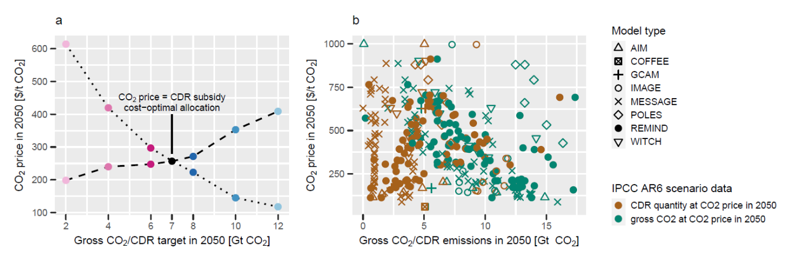

1. Baumstark, L. et al. REMIND2.1: Transformation and innovation dynamics of the energy-economic system within climate and sustainability limits. Geosci. Model Dev. Discuss. 2021, 1–50 (2021).
2. Beuttler, C., Charles, L. & Wurzbacher, J. The Role of Direct Air Capture in Mitigation of Anthropogenic Greenhouse Gas Emissions. Front. Clim. 1, 10 (2019).
3. Strefler, J. et al. Carbon dioxide removal technologies are not born equal. Environ. Res. Lett. 16, 074021 (2021).
4. Strefler, J. et al. Between Scylla and Charybdis: Delayed mitigation narrows the passage between large-scale CDR and high costs. Environ. Res. Lett. 13, 044015 (2018).
5. Strefler, J., Amann, T., Bauer, N., Kriegler, E. & Hartmann, J. Potential and costs of carbon dioxide removal by enhanced weathering of rocks. Environ. Res. Lett. 13, 034010 (2018).

