Multiplexed molecular imaging identifies pancreatic cancer candidates for epigenetic modulators
Krzysztof Szymoński ^{1,2*}, Natalia Janiszewska ^{3,4}, Kamila Sofińska ³, Katarzyna Skirlińska-Nosek ^{3,4}, Dawid Lupa ³, Michał Czaja ^{3,4}, Marta Urbańska ^{3,4}, Katarzyna Jurkowska ³, Kamila Konik ⁵, Marta Olszewska ⁶, Dariusz Adamek ^{1,2}, Kamil Awsiuk ³, Ewelina Lipiec ³, and Marek Szymoński ³

¹ Jagiellonian University, Medical College, Department of Pathomorphology, Cracow, Poland
² Diagnostyka Consilio Sp. z o.o., Cracow, Poland
³ Jagiellonian University, Faculty of Physics, Astronomy and Applied Computer Science, M. Smoluchowski Institute of Physics, Cracow, Poland
⁴ Jagiellonian University, Doctoral School of Exact and Natural Sciences, Cracow, Poland
⁵ University Hospital in Cracow, Department of Pathomorphology, Cracow, Poland
⁶ Jagiellonian University, Medical College, Department of Paediatrics, Cracow, Poland

*Corresponding author: Krzysztof Szymoński,
Mailing address: Department of Pathomorphology, Jagiellonian University Medical College, Grzegorzecka 16, 31-531 Cracow, Poland
E-mail address: krzysztof.szymonski@uj.edu.pl
Phone number: +48 12 421 15 64

Supplementary Materials

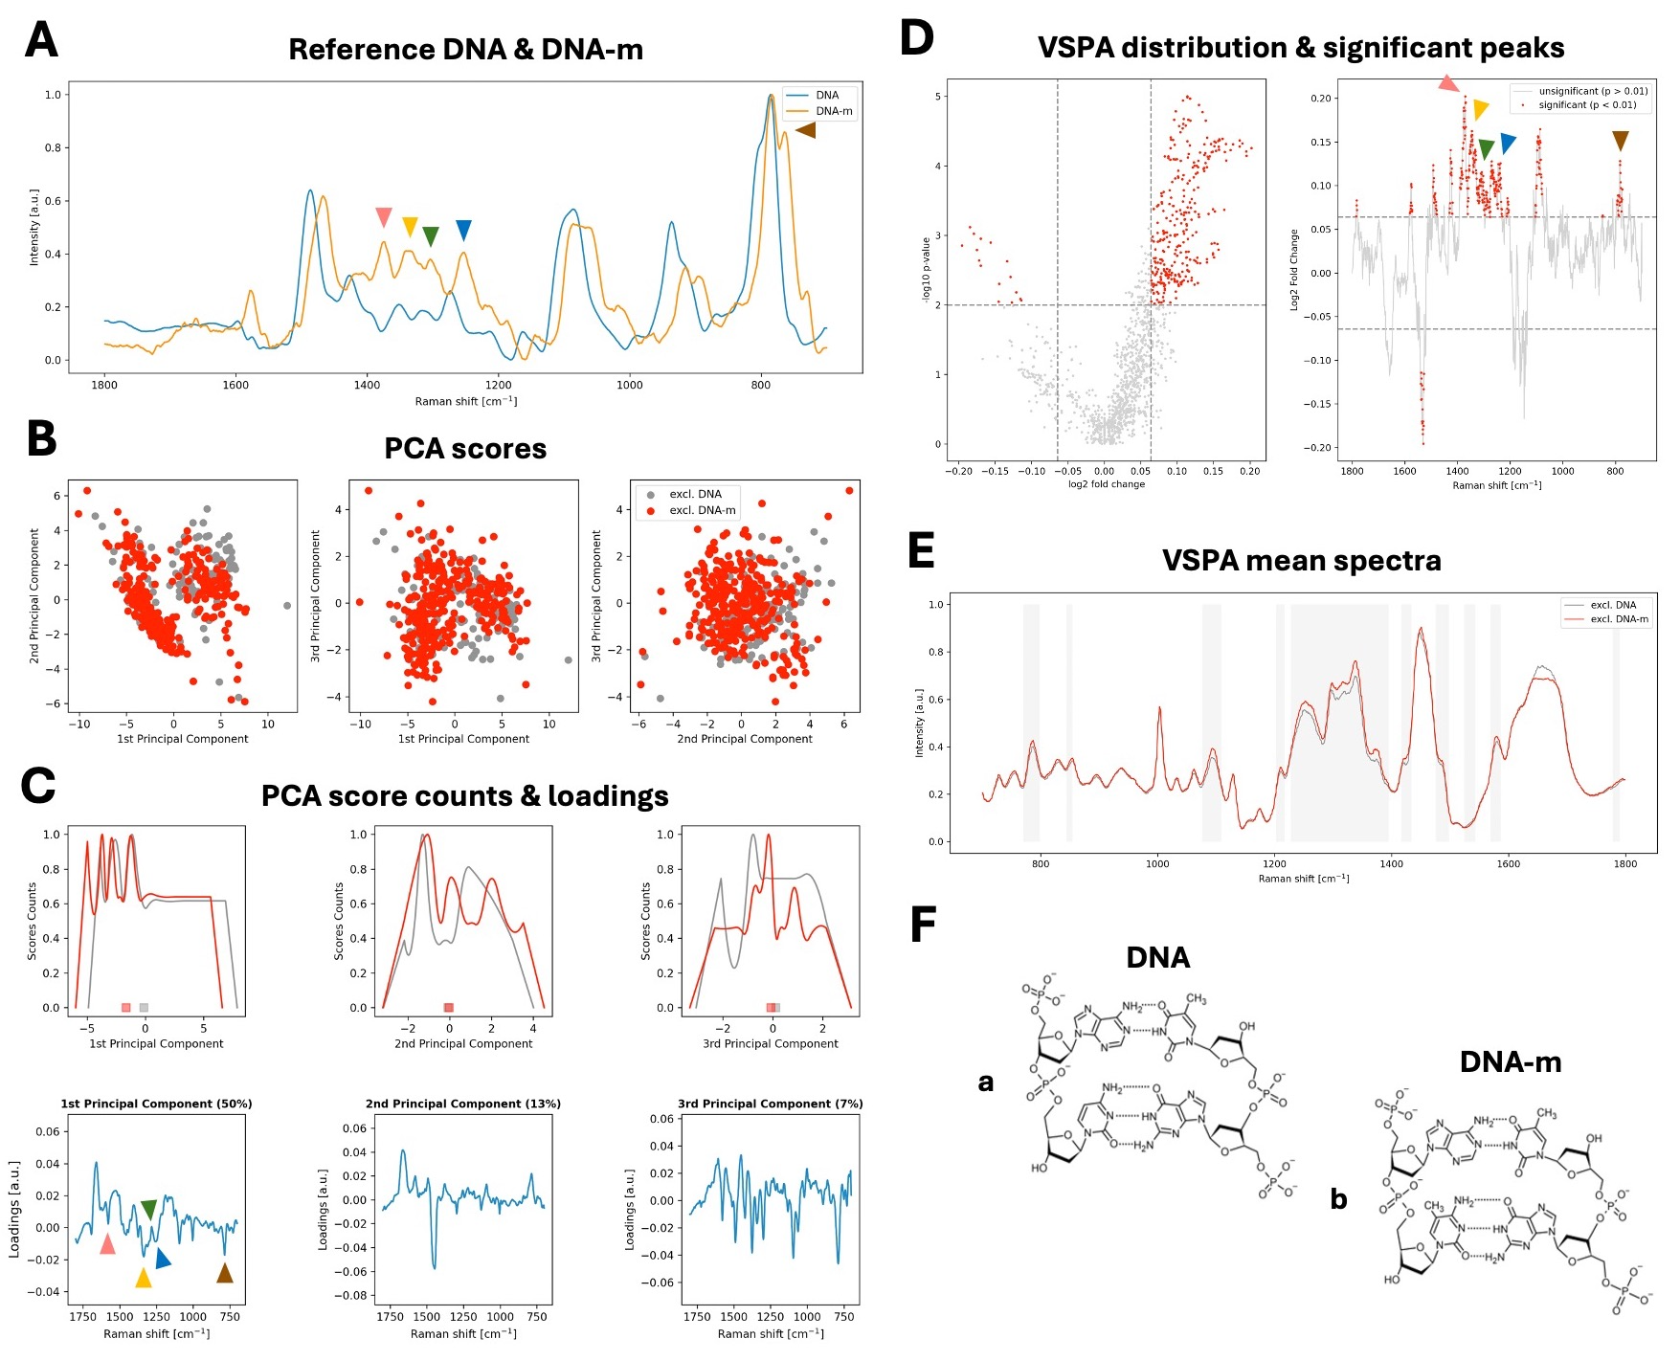

Supplementary Figure S1. The identification of differentiating DNA methylation spectral features in exclusive spectra. Our approach to confirming DNA-m specificity in spectra extracted with Pearson R correlation-based technique involved three steps: (A) the manual recognition of characteristic features in reference spectra of DNA and DNA-m, (B-C) PCA of DNA and DNA-m exclusive spectra obtained from PC tissues - here presented with (B) 2D scores plots and (C) score counts plots. The color squares at the bottom of (C, top plots) represent scores median distribution, highlighting the separation between groups, specifically only along 1st principal component. The loadings plots (C, bottom plots) identify spectral features of that separation. Next, (D-E) VSPA allowed for the identification of significant spectral peaks (p<0.01, Mann–Whitney U test) that manifested with the minimal fold-change (defined as 500 highest fold-change values). Here presented with (D) VSPA significant peaks plot and (E) VSPA mean spectra plot with certain ranges marked. The same spectral features found in (A) were identified in (C, loadings plot) and in (D, significant peaks plot) – marked by color arrowheads. These are presented in Supplementary Table S1 with the assignment to functional groups vibrations. To illustrate in (F) we show the molecular structure of (F, a) DNA and (F, b) DNA-m. (DNA-m, DNA methylation; PCA, principal components analysis; VSPA, volcano plot-based spectral peaks analysis)

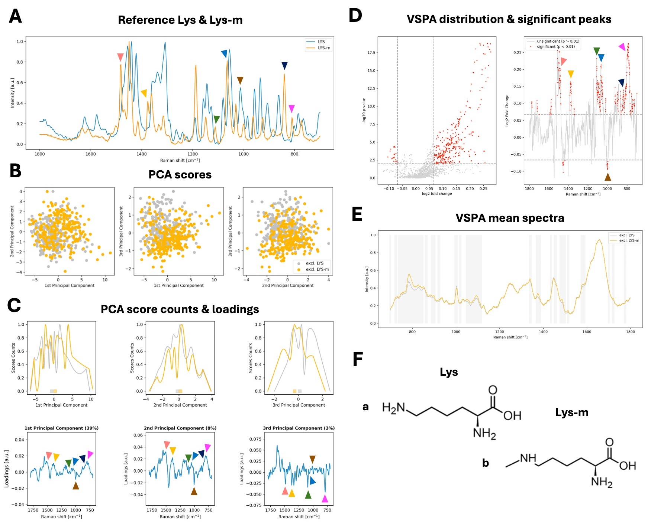

Supplementary Figure S2. The identification of differentiating Lys-m spectral features in exclusive spectra. Our approach to confirming Lys-m specificity in spectra extracted with Pearson R correlation-based technique involved three steps: (A) the manual recognition of characteristic features in reference spectra of Lys and Lys-m, (B-C) PCA of Lys and Lys-m exclusive spectra obtained from PC tissues - here presented with (B) 2D scores plots and (C) score counts plots. The color squares at the bottom of (C, top plots) represent scores median distribution, highlighting the separation between groups. The loadings plots (C, bottom plots) identify spectral features of that separation. Next, (D-E) VSPA allowed for the identification of significant spectral peaks (p<0.01, Mann–Whitney U test) that manifested with the minimal fold-change (defined as 500 highest fold-change values). Here presented with (D) VSPA significant peaks plot and (E) VSPA mean spectra plot with certain ranges marked. The same spectral features found in (A) were identified in (C, loadings plot) and in (D, significant peaks plot) – marked by color arrowheads. These are presented in Supplementary Table S2 with the assignment to functional groups vibrations. To illustrate in (F) we show the molecular structure of (F, a) Lys and (F, b) Lys-m. (Lys-m, lysine methylation; PCA, principal components analysis; VSPA, volcano plot-based spectral peaks analysis)

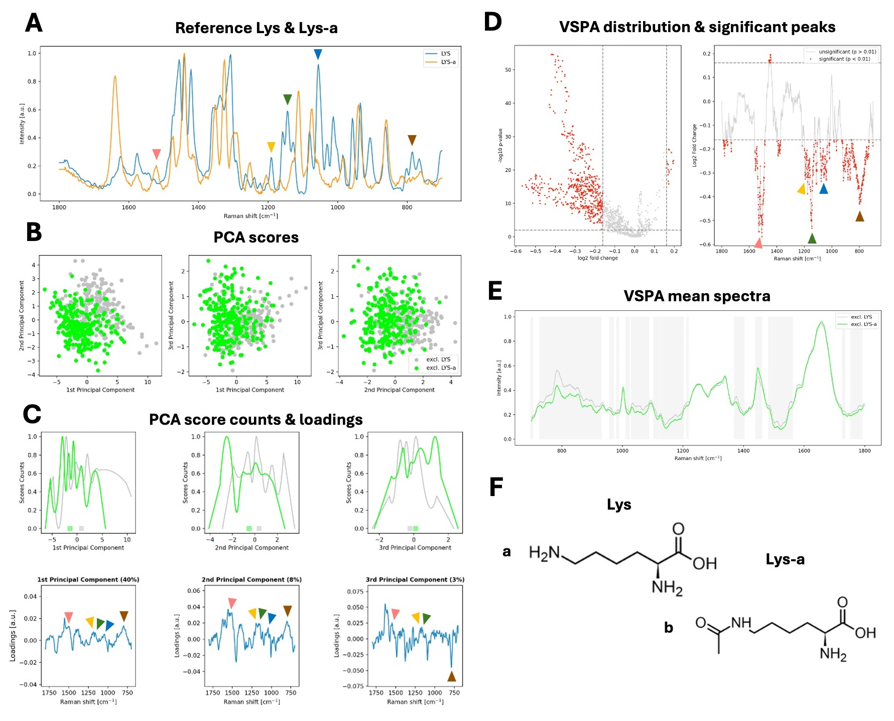

Supplementary Figure S3. The identification of differentiating Lys-a spectral features in exclusive spectra. Our approach to confirming Lys-a specificity in spectra extracted with Pearson R correlation-based technique involved three steps: (A) the manual recognition of characteristic features in reference spectra of Lys and Lys-a, (B-C) PCA of Lys and Lys-a exclusive spectra obtained from PC tissues - here presented with (B) 2D scores plots and (C) score counts plots. The color squares at the bottom of (C, top plots) represent scores median distribution, highlighting the separation between groups. The loadings plots (C, bottom plots) identify spectral features of that separation. Next, (D-E) VSPA allowed for the identification of significant spectral peaks (p<0.01, Mann–Whitney U test) that manifested with the minimal fold-change (defined as 500 highest fold-change values). Here presented with (D) VSPA significant peaks plot and (E) VSPA mean spectra plot with certain ranges marked. The same spectral features found in (A) were identified in (C, loadings plot) and in (D, significant peaks plot) – marked by color arrowheads. These are presented in Supplementary Table S3 with the assignment to functional groups vibrations. To illustrate in (F) we show the molecular structure of (F, a) Lys and (F, b) Lys-a. (Lys-a, lysine acetylation; PCA, principal components analysis; VSPA, volcano plot-based spectral peaks analysis)

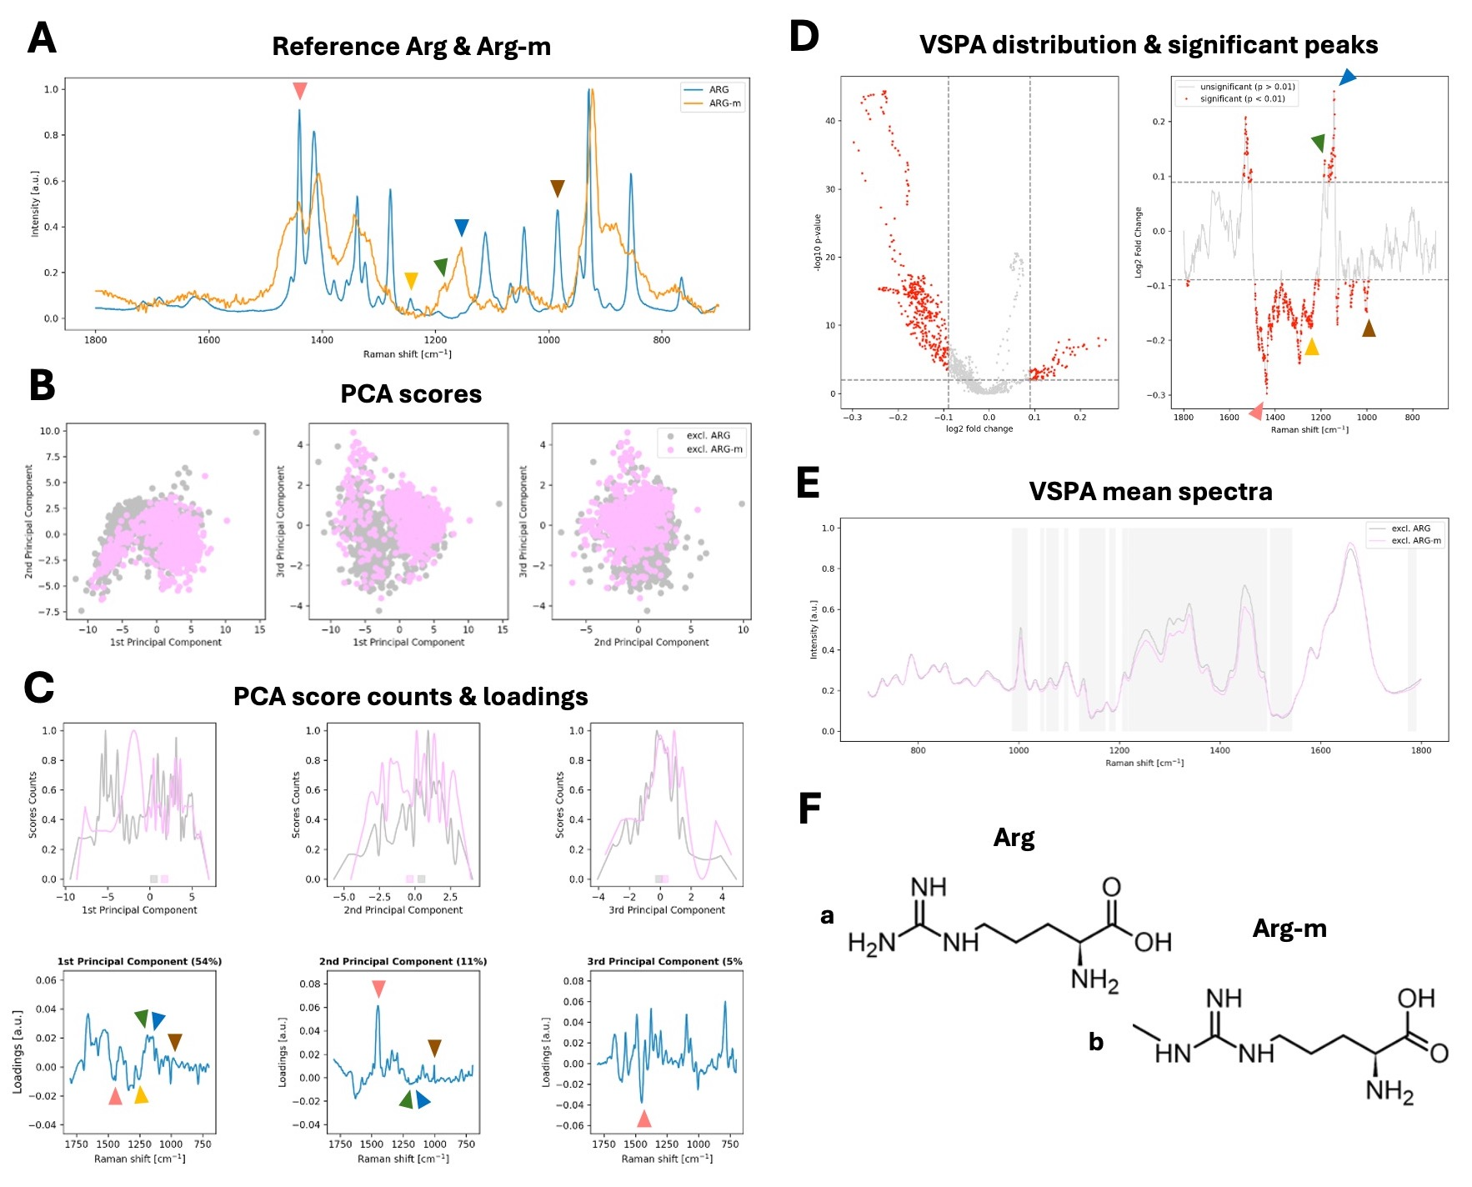

Supplementary Figure S4. The identification of differentiating Arg-m spectral features in exclusive spectra. Our approach to confirming Arg-m specificity in spectra extracted with Pearson R correlation-based technique involved three steps: (A) the manual recognition of characteristic features in reference spectra of Arg and Arg-m, (B-C) PCA of Arg and Arg-m exclusive spectra obtained from PC tissues - here presented with (B) 2D scores plots and (C) score counts plots. The color squares at the bottom of (C, top plots) represent scores median distribution, highlighting the separation between groups. The loadings plots (C, bottom plots) identify spectral features of that separation. Next, (D-E) VSPA allowed for the identification of significant spectral peaks (p<0.01, Mann–Whitney U test) that manifested with the minimal fold-change (defined as 500 highest fold-change values). Here presented with (D) VSPA significant peaks plot and (E) VSPA mean spectra plot with certain ranges marked. The same spectral features found in (A) were identified in (C, loadings plot) and in (D, significant peaks plot) – marked by color arrowheads. These are presented in Supplementary Table S4 with the assignment to functional groups vibrations. To illustrate in (F) we show the molecular structure of (F, a) Arg and (F, b) Arg-m. (Arg-m, arginine methylation; PCA, principal components analysis; VSPA, volcano plot-based spectral peaks analysis)

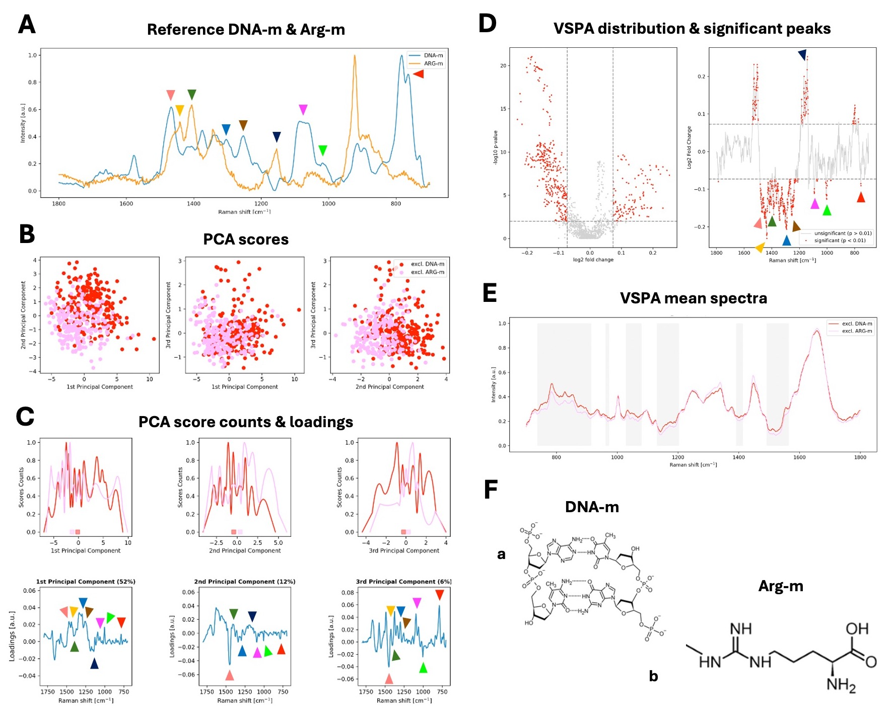
Supplementary Figure S5. The identification of spectral features differentiating DNA-m and Arg-m in exclusive spectra. Our approach to confirming DNA-m and Arg-m specificity in spectra extracted with Pearson R correlation-based technique involved three steps: (A) the manual recognition of characteristic features in reference spectra of DNA-m and Arg-m, (B-C) PCA of DNA-m and Arg-m exclusive spectra obtained from PC tissues - here presented with (B) 2D scores plots and (C) score counts plots. The color squares at the bottom of (C, top plots) represent scores median distribution, highlighting the separation between groups. The loadings plots (C, bottom plots) identify spectral features of that separation. Next, (D-E) VSPA allowed for the identification of significant spectral peaks (p<0.01, Mann–Whitney U test) that manifested with the minimal fold-change (defined as 500 highest fold-change values). Here presented with (D) VSPA significant peaks plot and (E) VSPA mean spectra plot with certain ranges marked. The same spectral features found in (A) were identified in (C, loadings plot) and in (D, significant peaks plot) – marked by color arrowheads. These are presented in Supplementary Table S5 with the assignment to functional groups vibrations. To illustrate in (F) we show the molecular structure of (F, a) DNA-m and (F, b) Arg-m. (DNA-m, DNA methylation; Arg-m, arginine methylation; PCA, principal components analysis; VSPA, volcano plot-based spectral peaks analysis)

Supplementary Table S1. Assignment of Raman bands identified as specific for DNA and DNA methylation with the analytical approach presented in Supplementary Figure S1.
Raman shift [cm⁻¹] | Functional groups vibrations* | Reference
1375 (m) | A, T, G | ¹
1340 (m) | A | ²
1304 (m) | A, T, G, C | ³
1252 (m) | G, C | ³
765 (m) | DNA bkb | ⁴
* A, adenine; T, thymine; C, cytosine; G, guanine; bkb, phosphate backbone

Supplementary Table S2. Assignment of Raman bands identified as specific for lysine and lysine methylation with the analytical approach presented in Supplementary Figure S2.
Raman shift [cm⁻¹] | Functional groups vibrations* | Reference
1485(m) | δ NH₃⁺ | ⁵
1375(m) | δ CH₂ | ⁵
1110(m) | τ NH₂ | ⁵
1064(m) | v CN, v CC | ⁵
1012 | v CN, v CC | ⁵
840(m) | δ COO⁻ | ⁵
808(m) | δ COO⁻ | ⁵
* ν, stretching; δ, bending; τ, twisting; ρ, rocking; ω, wagging

Supplementary Table S3. Assignment of Raman bands identified as specific for lysine and lysine acetylation with the analytical approach presented in Supplementary Figure S3.
Raman shift [cm⁻¹] | Functional groups vibrations* | Reference
1521(a) | ν NH₃⁺ | ⁶
1190 | τ NH₂ | ⁶
1145 | τ NH₂ | ⁶
1055 | v CN, v CC | ⁶
785 | δ COO⁻ | ⁶
* ν, stretching; δ, bending; τ, twisting; ρ, rocking; ω, wagging

Supplementary Table S4. Assignment of Raman bands identified as specific for arginine and arginine methylation with the analytical approach presented in Supplementary Figure S4.
Raman shift [cm⁻¹] | Functional groups vibrations* | Reference
1440 | δ CH₂ | ¹
1243 | δ CH₂ | ¹
1183(m) | ρ NH₃⁺ | ¹
1154(m) | δ_{asym} C-N₂-H₂ | ⁷
984 | ρ CH₂ | ¹
* ν, stretching; δ, bending; δ_{asym}, asymmetric bending; τ, twisting; ρ, rocking; ω, wagging

Supplementary Table S5. Assignment of Raman bands identified as specific for Arginine and Arginine methylation with the analytical approach presented in Supplementary Figure S5.
Raman shift [cm⁻¹] | Functional groups vibrations* | Reference
1467 | δ CH₂, CH₃ | ¹
1441 | δ CH₂ | ⁶
1406 | ν COO⁻ | ⁶
1304 | A, T, C, G | ³
1252 | G, C | ³
1154 | δ_{asym} C-N₂-H₂ | ⁷
1086 | ν PO₂⁻ | ⁸
1076 | ν CN | ⁶
1018 | ρ CH₃ | ⁹
764 | ν OPO | ¹⁰
* ν, stretching; δ, bending; δ_{asym}, asymmetric bending; τ, twisting; ρ, rocking; ω, wagging; A, adenine; T, thymine; C, cytosine; G, guanin

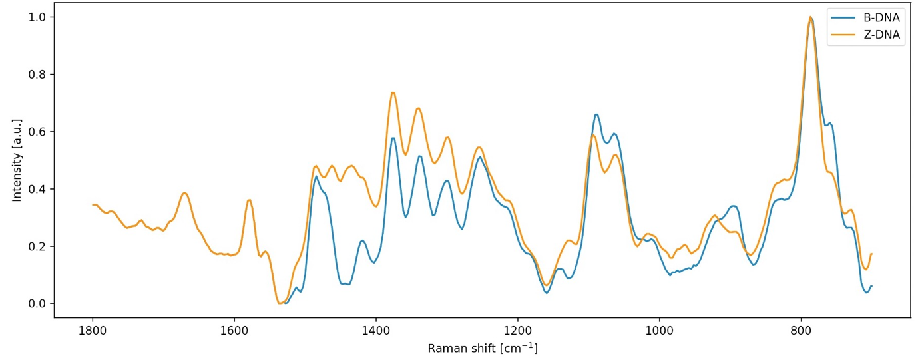
Supplementary Figure S6. Reference spectra of DNA in right-handed B-DNA and left-handed Z-DNA conformations. These spectra were used as a reference for correlation-based assessment of DNA conformations in PC tissues.

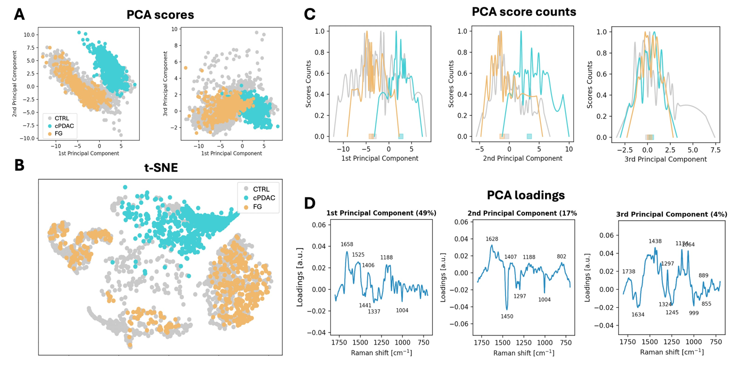
Supplementary Figure S7. The results of PCA and t-SNE analysis performed on chromatin spectra acquired from CTRL, cPDAC, and FG tissue samples. PCA scores plots (A), t-SNE results (B), and PCA score counts (C) visualize the clustering of similar spectra and the separation between spectra of various PC subtypes. The PCA loadings (D) highlight Raman bands from amides, and methyl and methylene motions driving the separation, including: i) the positive correlation of the PC-1 loading with the Amide I at 1658 cm⁻¹, indicating the relatively high content of α-helical proteins (cPDAC and partially CTRL); ii) methyl and methylene deformational motions at 1441cm⁻¹ and 1337cm⁻¹ and methyl deformation of cytosine at 1406 cm⁻¹ ¹¹, which confirms differences in DNA methylation level in the investigated tissues; iii) the asymmetric bending (O–P–O) of RNA and C3’ endo-sugar phosphate from DNA at 1188 cm⁻¹, related to DNA conformational transition; iv) the positive correlation of the PC-2 loading with the Amide I at 1628 cm⁻¹, indicating the relatively high content of β-sheet secondary structure in proteins of CPDAC in comparison with FG and CTRL.
The abovementioned bands are responsible for the clustering of spectra presented in Figure 6 of the manuscript, however, for the sake of clarity and transparency, here, the interpretation of chemometric analysis was performed for this limited dataset. (PCA, principal components analysis; PC-1 and 2, principal components 1 and 2t-SNE, t-distributed stochastic neighbor embedding; CTRL, benign control pancreatic duct samples; cPDAC, conventional ductal adenocarcinoma; FG, foamy-glands ductal adenocarcinoma)

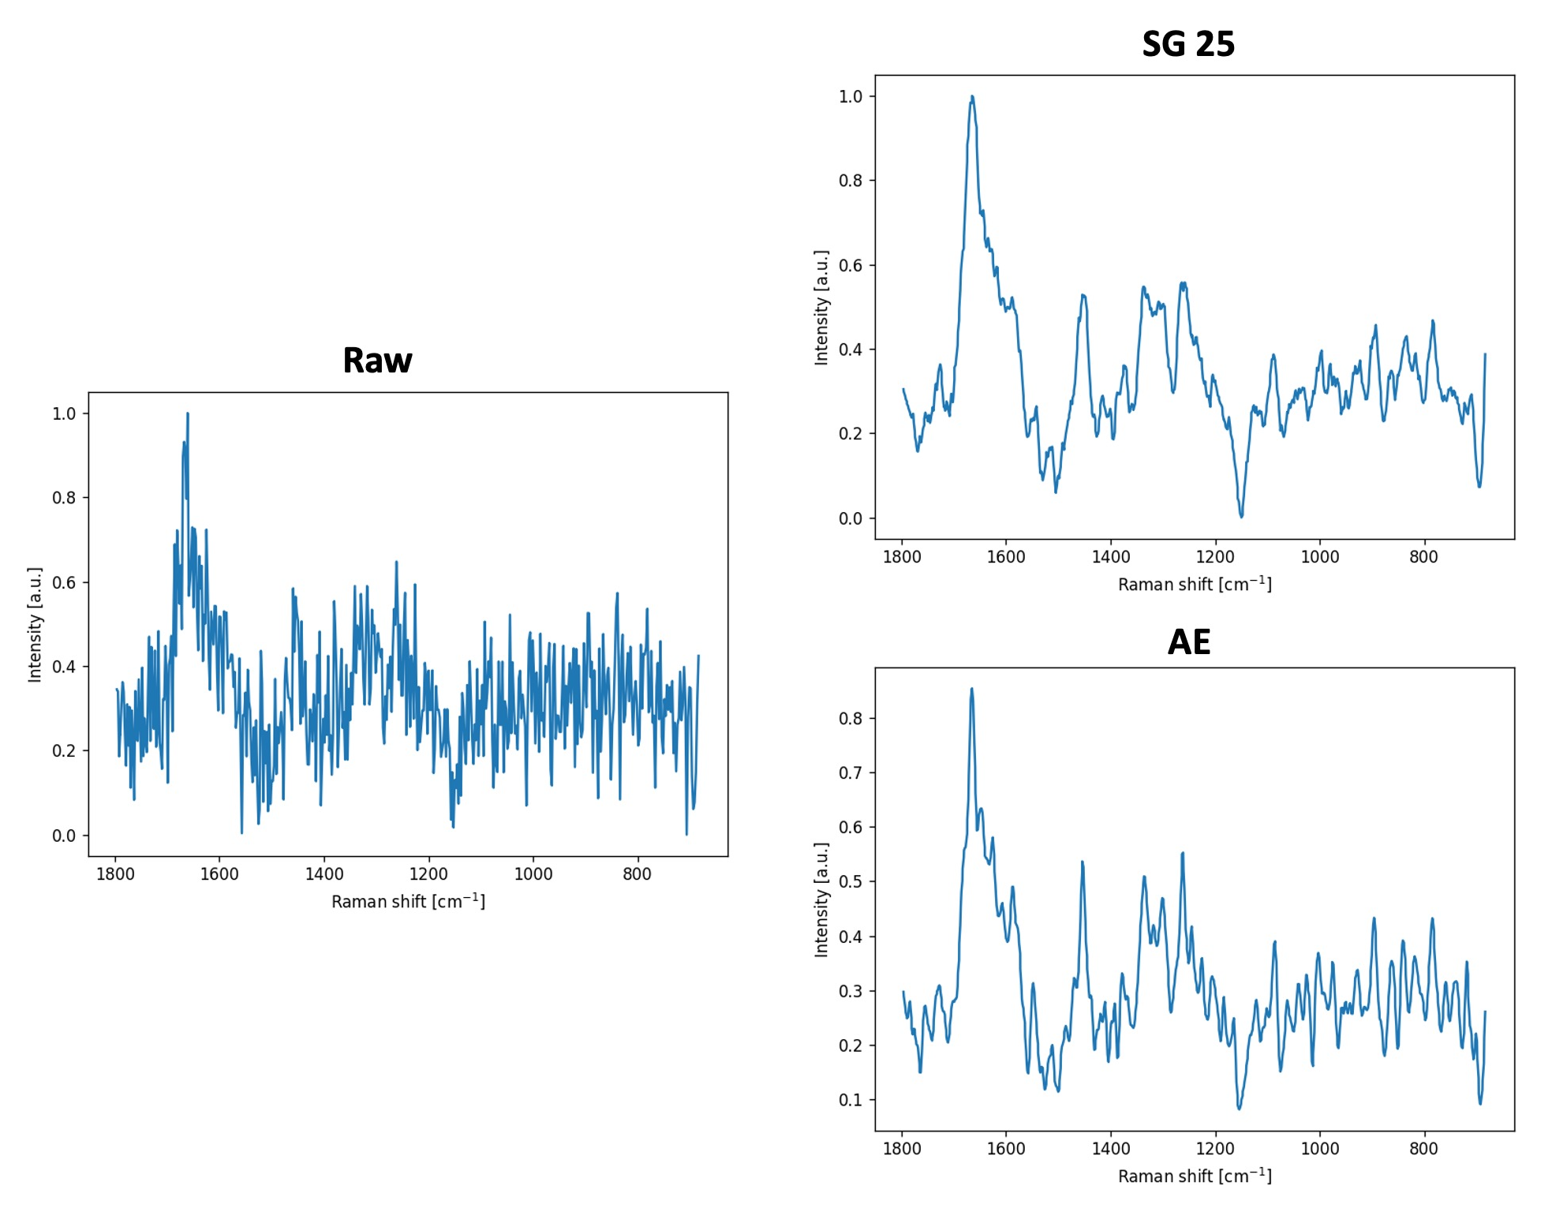
Supplementary Figure S8. Comparison of standard and machine learning-based approach to spectra pre-processing. Autoencoder is a machine learning technique that is based on two artificial neural networks, specifically convolutional neural networks. First, the encoder, extracts the most important features of a dataset, by limiting its dimensionality. Then, the process is reversed, by the decoder, which restores the initial data from the encoder-extracted features list. The process is automatic, flexible, and efficient for large datasets. Here as an example, a comparison of the Savitzky-Golay standard approach (SG 25) and the result of autoencoder (AE) processing is shown. The AE seems to better highlight meaningful features compared to SG 25.

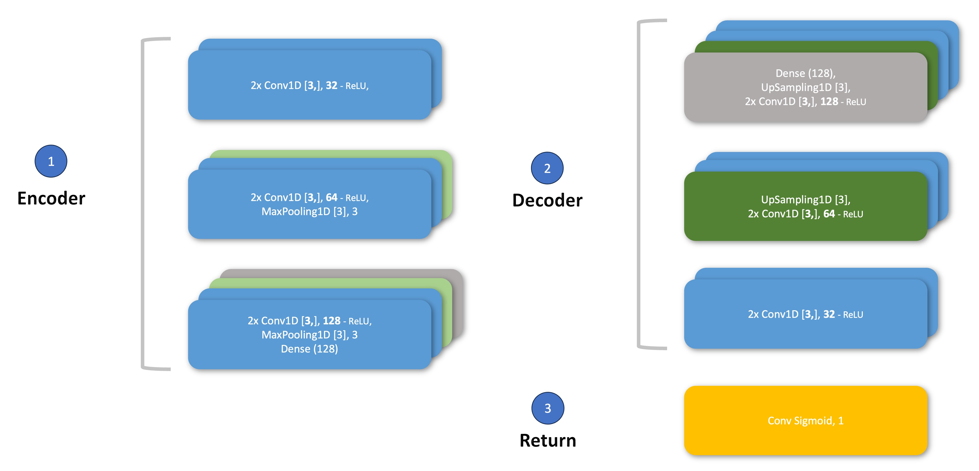

Supplementary Figure S9. The autoencoder architecture used in the study. We exploited a custom-designed autoencoder architecture. Specifically, the encoder (1) comprised a block of 2 convolutional layers with 32 filters (kernel size [3,], ReLu activation), followed by another block of 2 convolutional layers with 64 filters (same setting) and a max pooling layer (pool size 3, stride 3), and final block of of 2 convolutional layers with 128 filters (same setting), a max pooling layer (same setting), and a dense layer with 128 neurons. The decoder (2) reversed the encoder and finalized with a sigmoid return (3) layer.

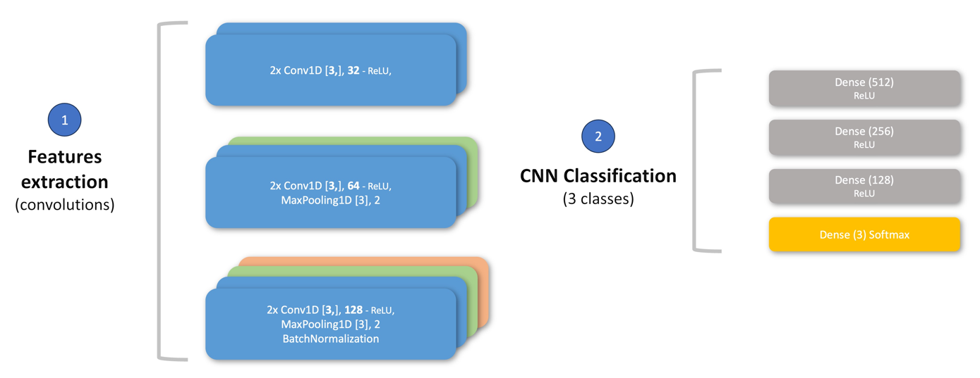
Supplementary Figure S10. The architecture of convolutional neural network used for spectra classification. A custom-designed CNN architecture was used for spectra classification into 3 classes, specifically the nuclei, cytoplasm, and tumor stroma. First features extraction (1) was utilized by 3 sets of convolutional layers: 2x with 32 filters, then 2x 64 filters and a max pooling layer, and 2x 128 filters, max pooling, and a batch normalization layer. All convolutional layers comprised of kernel size [3,] and were ReLu-activated. After features extraction for the process was finalized with a fully connected set of classification layers (2), specifically of 512, 256, 128 neurons, and the resulting 3 neurons (Softmax).
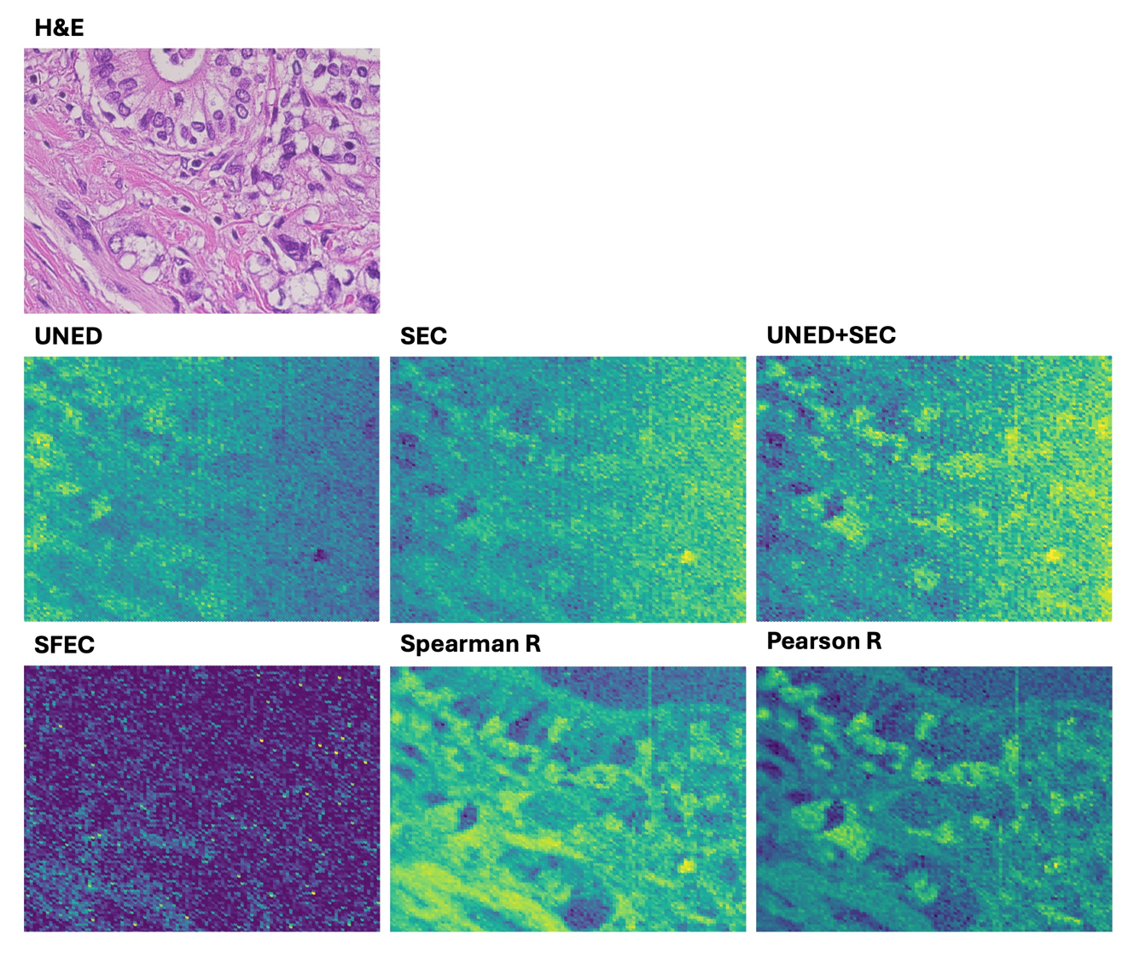
Supplementary Figure S11. A comparison study of best correlation-based approach technique. Various methods of spectral correlation were investigated, and judged on the best projection of PC tissues, based on the hematoxilin-&-eosin-stained slide (H&E). Specifically, unit normalized Euclidean distance (UNED), squared cosine similarity (SEC), UNED and SEC combined (UNED+SEC), squared first-difference cosine similarity (SFEC), Spearman correlation coefficient (Spearman R), and Pearson correlation coefficient (Pearson R) were assessed. Spearman R and Pearson R delivered similar results, although Pearson R was slightly more accurate in reproducing subcellular components (i.e. cancer cells nuclei).

References:
- Gorelik, V. S., Krylov, A. S. & Sverbil, V. P. Local Raman spectroscopy of DNA. Bulletin of the Lebedev Physics Institute 41, 310–315 (2014).
- Prescott, B., Steinmetz, W. & Thomas, G. J. Characterization of DNA structures by laser Raman spectroscopy. Biopolymers 23, 235–256 (1984).
- Movasaghi, Z., Rehman, S. & Rehman, I. U. Raman Spectroscopy of Biological Tissues. Appl Spectrosc Rev 42, 493–541 (2007).
- Peticolas, W. L., Patapoff, T. W., Thomas, G. A., Postlewait, J. & Powell, J. W. Laser Raman Microscopy of Chromosomes in Living Eukaryotic Cells: DNA Polymorphism In Vivo. Journal of Raman Spectroscopy 27, 571–578 (1996).
- Aliaga, A. E. et al. Surface enhanced Raman scattering study of l-lysine. Vib Spectrosc 50, 131–135 (2009).
- Aliaga, A. E. et al. SERS and theoretical studies of arginine. Spectrochim Acta A Mol Biomol Spectrosc 76, 458–463 (2010).
- Bhunia, S., Srivastava, S. K., Materny, A. & Ojha, A. K. A vibrational and conformational characterization of arginine at different pH values investigated using Raman spectroscopy combined with DFT calculations. Journal of Raman Spectroscopy 47, 1073–1085 (2016).
- Samuel, A. Z., Sugiyama, K., Ando, M. & Takeyama, H. Direct imaging of intracellular RNA, DNA, and liquid–liquid phase separated membraneless organelles with Raman microspectroscopy. Commun Biol 5, 1383 (2022).
- Li, L., Lim, S. F., Puretzky, A., Riehn, R. & Hallen, H. D. DNA Methylation Detection Using Resonance and Nanobowtie-Antenna-Enhanced Raman Spectroscopy. Biophys J 114, 2498–2506 (2018).
- Thomas, G. J. et al. Polarized Raman spectra of oriented fibers of A DNA and B DNA: anisotropic and isotropic local Raman tensors of base and backbone vibrations. Biophys J 68, 1073–1088 (1995).
- Lipiec, E. et al. Infrared nanospectroscopic mapping of a single metaphase chromosome. Nucleic Acids Res 47, e108–e108 (2019).

