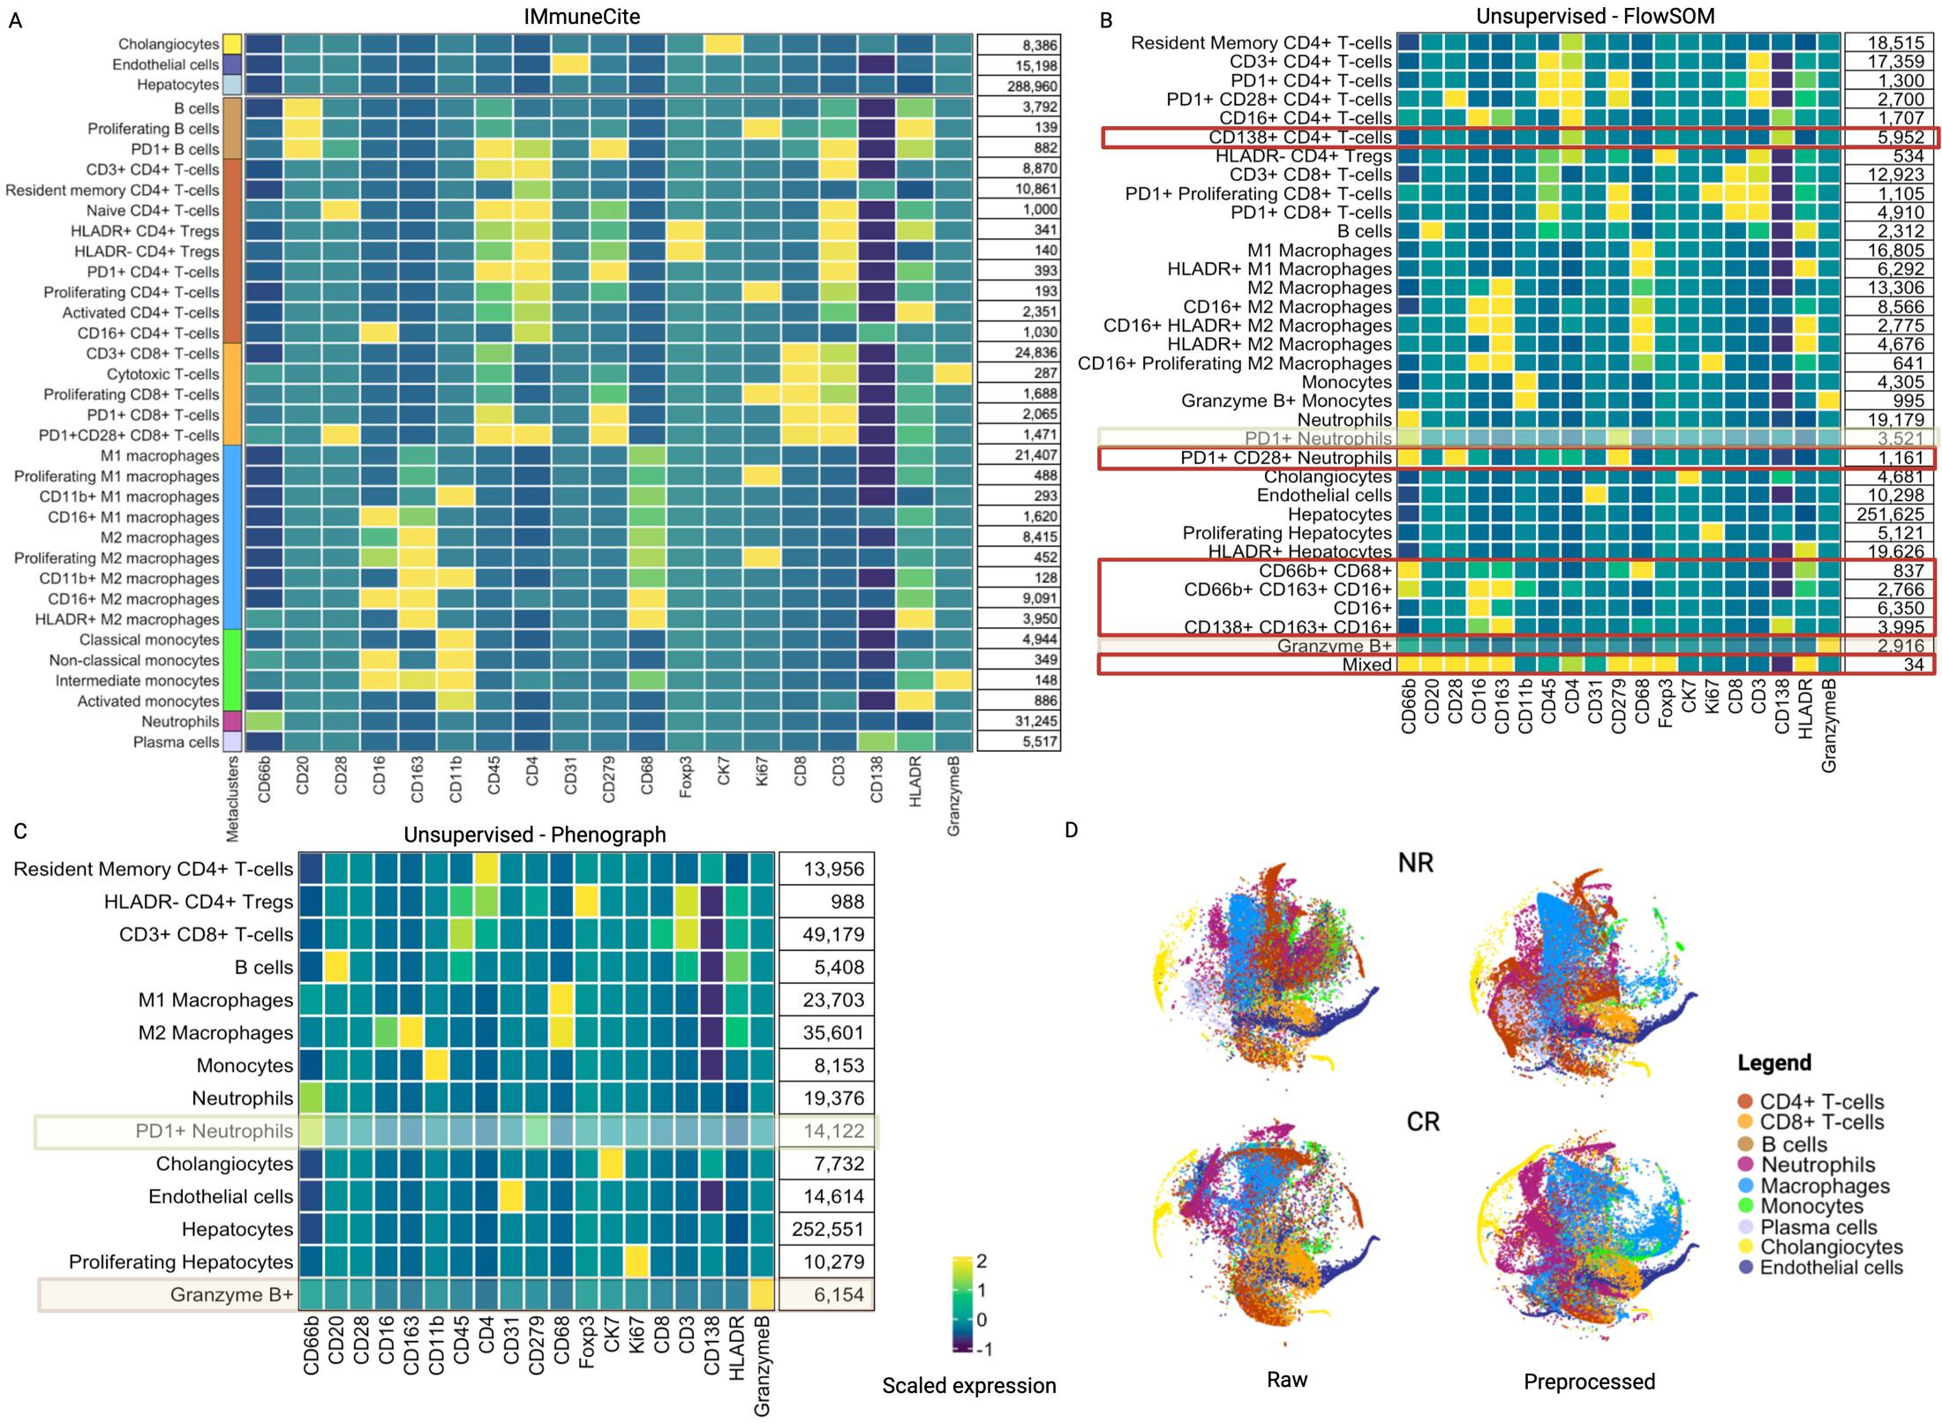
Supplementary Figure S1. The IMmuneCite clustering algorithm eliminates non-biologic marker clustering of different cell lineages. A. Heatmap showing clusters derived from the IMmuneCite clustering algorithm. The IMmuneCite clustering algorithm allows a granular identification of distinct cell phenotypes while eliminating the presence of clusters expressing markers from different cell lineages. B. Heatmap showing a FlowSOM-based unsupervised clustering including 19 markers used to identify different immune cell subpopulations and structural components. The resulting FlowSOM clusters show association of markers from different immune cell lineages which can confound and make phenotype assignment more difficult. Non-biological cell population are highlighted in red. C. Heatmap showing a Phenograph-based unsupervised clustering including 19 markers used to identify different immune cell subpopulations and structural components. A lower number of different clusters was identified via Phenograph compared to IMmuneCite (A) and FlowSOM (B), reducing the possibility of a detailed description of different cell subpopulations, while still presenting clusters with non-biological marker association (colored boxes). D. t-SNE plots showing differences in metacluster density and distribution in raw vs IMClean-processed for NR and CR samples.

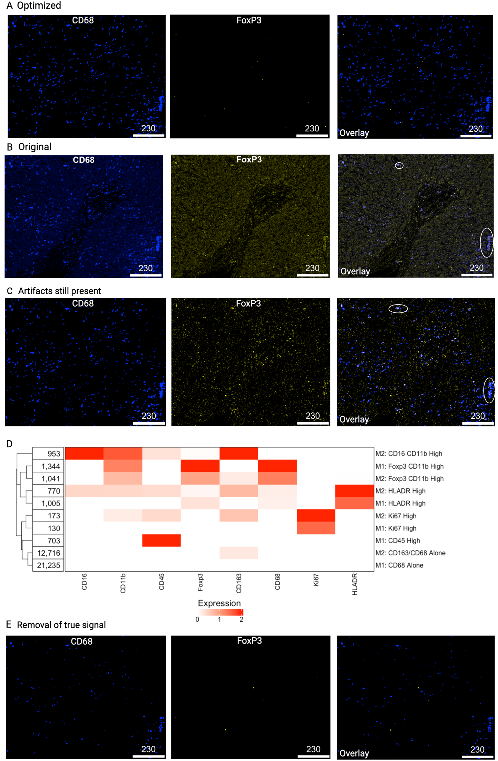

Supplementary Figure S2. Optimization of IMClean pre-processing allows removal of image artifacts and downstream identification of non-biological immune cell phenotypes. A. CD68 and FoxP3 raw signal after IMClean application and optimization, showing in Overlay enhanced true signal. B-C. Original CD68 and FoxP3 signals (B) and both signals prior to IMClean optimization (C) with spillover of CD68 in FoxP3 (white circle) and noise and aggregates still visible. D. Heatmap showing the two clusters of FoxP3+ macrophages as a result of image artifacts still present in the signal. E. Example of a too aggressive image pre-processing which eliminates some true signal, especially in CD68.

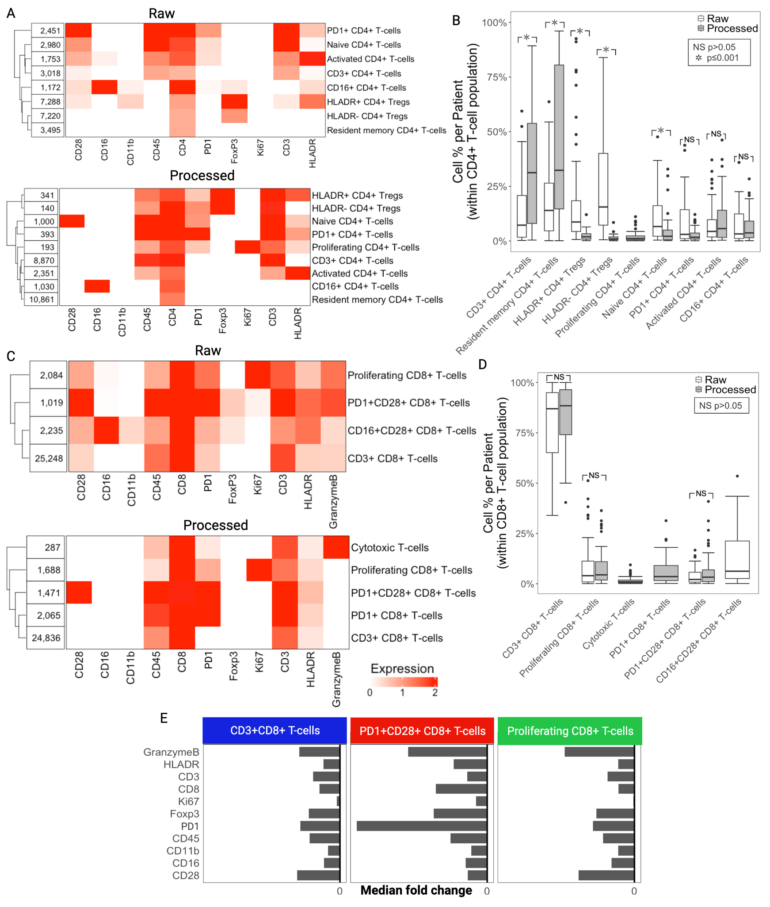

Supplementary Figure S3. Comparison of CD4+ and CD8+ T-cell subpopulations identified in the raw dataset vs the dataset processed following the IMmuneCite workflow. A. Heatmaps showing CD4⁺ T-cell subpopulations identified via unsupervised clustering within the CD4⁺ T-cell metacluster using the expression values from specific markers – CD28, CD16, CD11b, CD45, CD4, PD1, FoxP3, Ki67, CD3, and HLADR – within both the raw and IMClean-processed datasets. This approach identified eight subpopulations in the raw IMC data vs nine in the pre-processed IMC data; it was not possible to identify a proliferating CD4⁺ T-cell population in the raw data. B. Percentage of each CD4⁺ T-cell subcluster was compared between the two datasets; IMClean allowed for a greater identification of resident memory and CD3+ CD4+ T-cells. C. Heatmaps showing CD8⁺ T-cell subclusters identified via unsupervised clustering within the CD8⁺ T-cell compartment using selected markers – CD28, CD16, CD11b, CD45, CD3, CD8, GranzymeB, PD1, FoxP3, Ki67, and HLADR – in both the raw and IMClean-processed single-cell datasets. This approach identified 4 distinct subclusters in the raw data and 5 distinct subclusters in the pre-processed data. Three subclusters shared the same marker expression pattern, CD3⁺ CD8⁺ T-cell, Proliferating (Ki67⁺) CD8⁺ T-cells, and PD1⁺ CD28⁺ CD8⁺ T-cells. D. Boxplots showing the comparison of CD8⁺ subpopulations as a percentage of cells per patient (Kruskal-Wallis test). There were no differences in CD8⁺ T-cell subsets shared between the two datasets. E. Median fold change of marker expression in the CD8⁺ T-cell compartment between raw and IMClean-processed data.

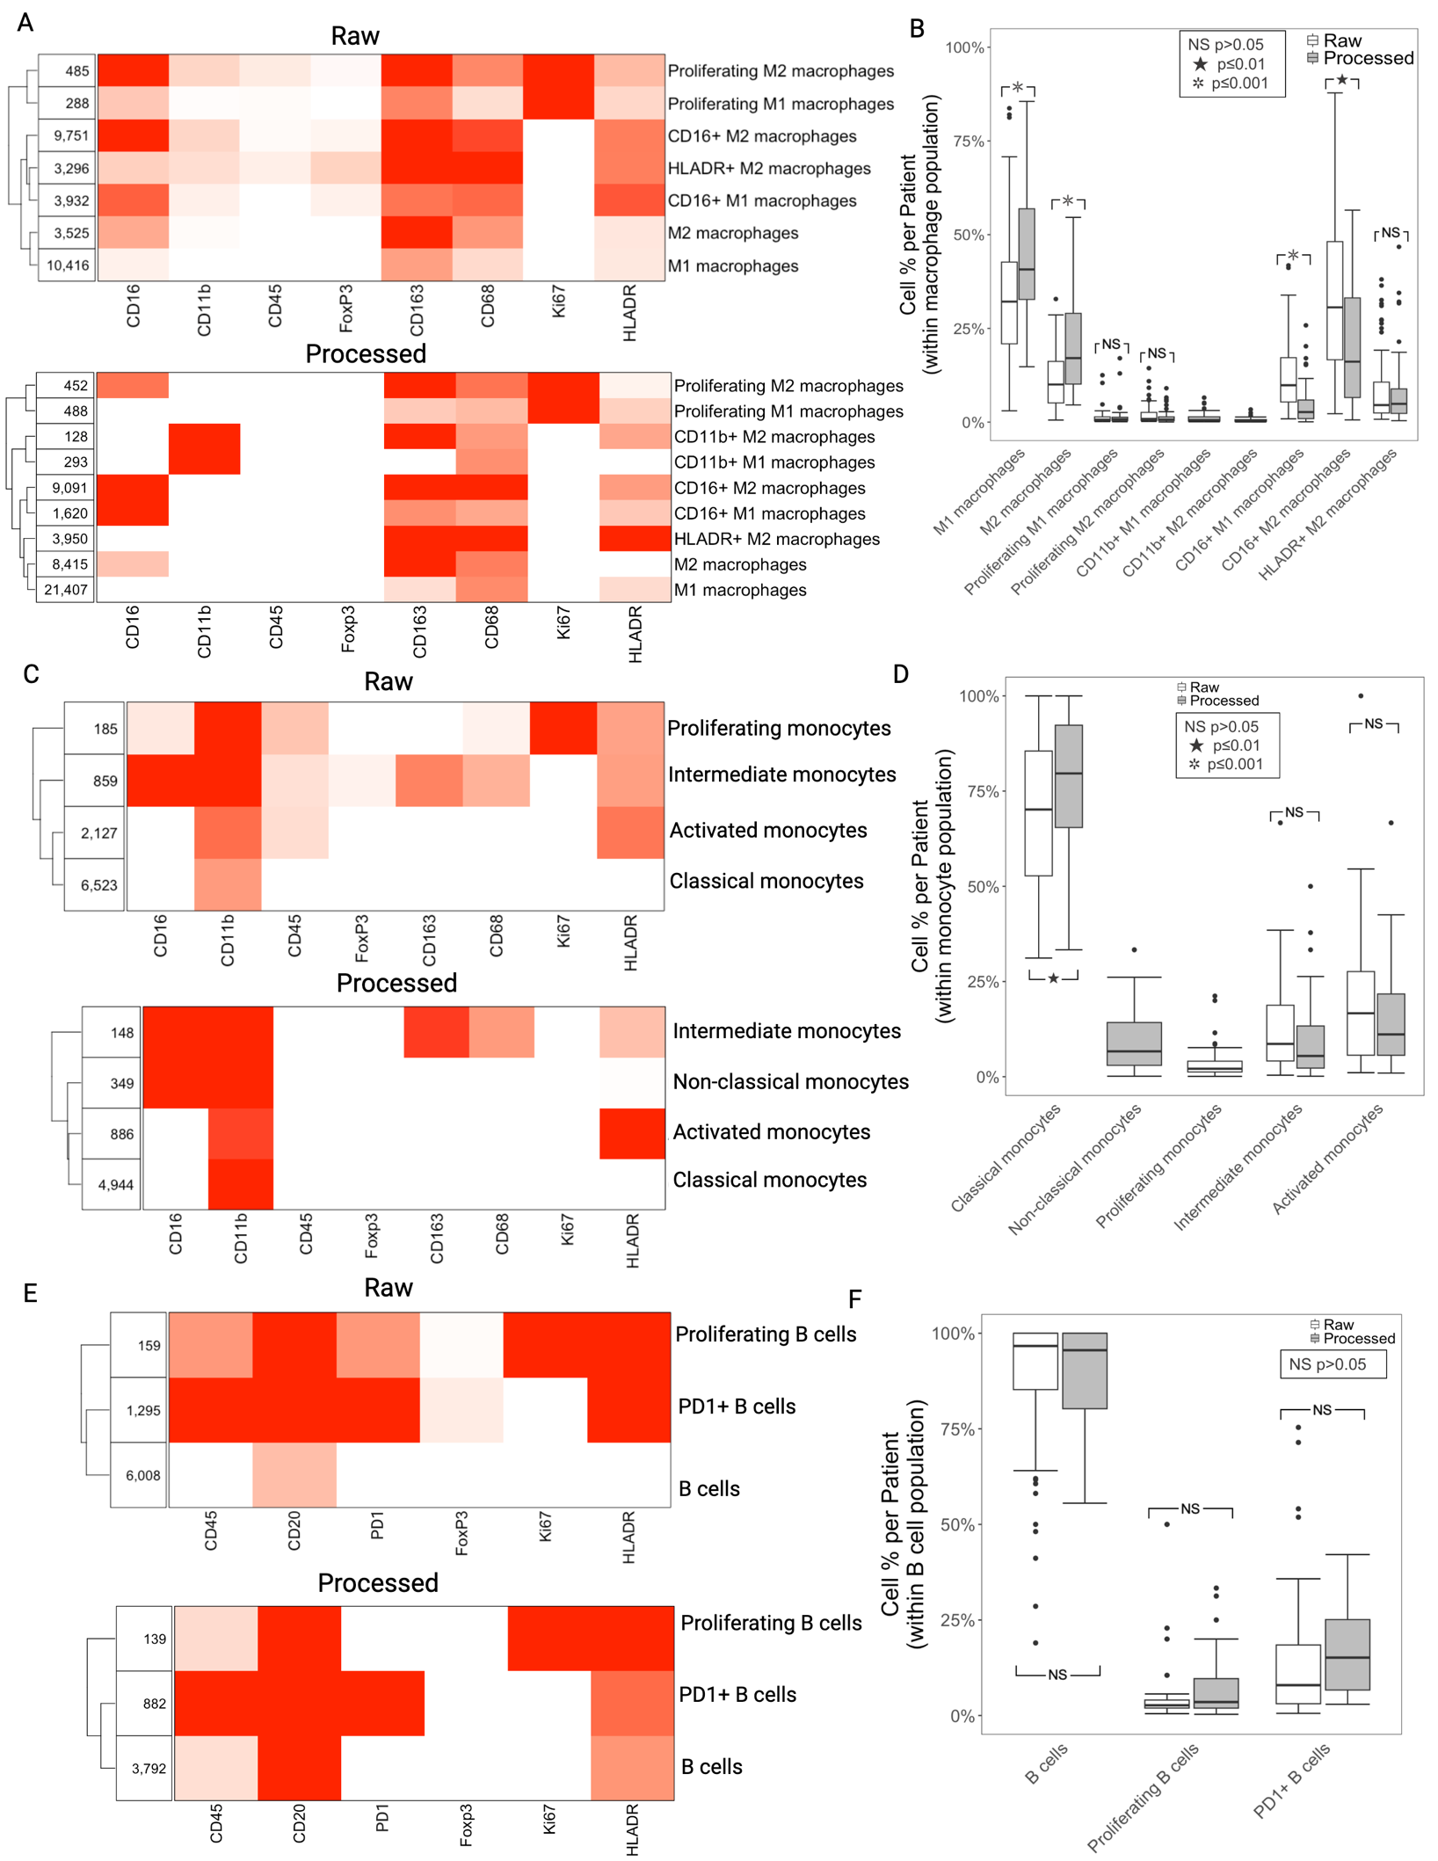
Supplementary Figure S4. Comparison of macrophage, monocyte, and B cell subpopulations identified in the raw dataset vs the dataset processed following the IMmuneCite workflow. A. Heatmaps showing macrophage subpopulations identified via unsupervised clustering using the expression values from select markers – HLADR, CD68, CD163, CD16, Ki67, CD45, CD11b, and FoxP3 – in raw vs pre-processed single-cell datasets. Seven and nine distinct subclusters were identified in the raw vs IMClean-processed datasets, respectively. B. Boxplots of macrophage subclusters of raw vs pre-processed data. A different distribution was observed between the two datasets for M1 and M2 macrophages as well as CD16⁺ M1 and M2 macrophages. C. Heatmaps showing monocyte subpopulations identified via unsupervised clustering using specified markers – CD16, CD11b, CD45, CD68, CD163, HLADR, FoxP3, and Ki67 – in raw vs pre-processed single-cell datasets. This approach identified 4 distinct subclusters in the raw data and 4 distinct subclusters in the pre-processed data, with similar expression profiles in 3 out 4 subclusters: Classical monocytes (CD11b⁺), Intermediate monocytes (CD11b⁺ CD68⁺ CD163⁺ CD16⁺ HLADR⁺), and Activated monocytes (HLADR⁺ CD11b⁺). D. Boxplots showing the comparison of monocyte subclusters as a percentage of cells per patient (Kruskal-Wallis test). A greater percentage of classical monocytes was identified in IMClean-processed data. E. Heatmaps showing B cell subpopulations identified via unsupervised clustering using the expression values from select markers – HLADR, CD20, Ki67, CD45, PD1, and FoxP3 – in raw vs pre-processed single-cell datasets. B-cell subclusters identified in both datasets presented the same expression patterns which led to the identification of a generic B-cell subpopulation (CD20⁺ CD45⁺HLADR⁺), PD1⁺ (CD20⁺ CD45⁺HLADR⁺) B-cells, and Proliferating (Ki67⁺CD20⁺ CD45⁺HLADR⁺) B-cells. F. Boxplots comparing distribution of B cell subclusters between the two datasets with no differences in cell proportion observed.

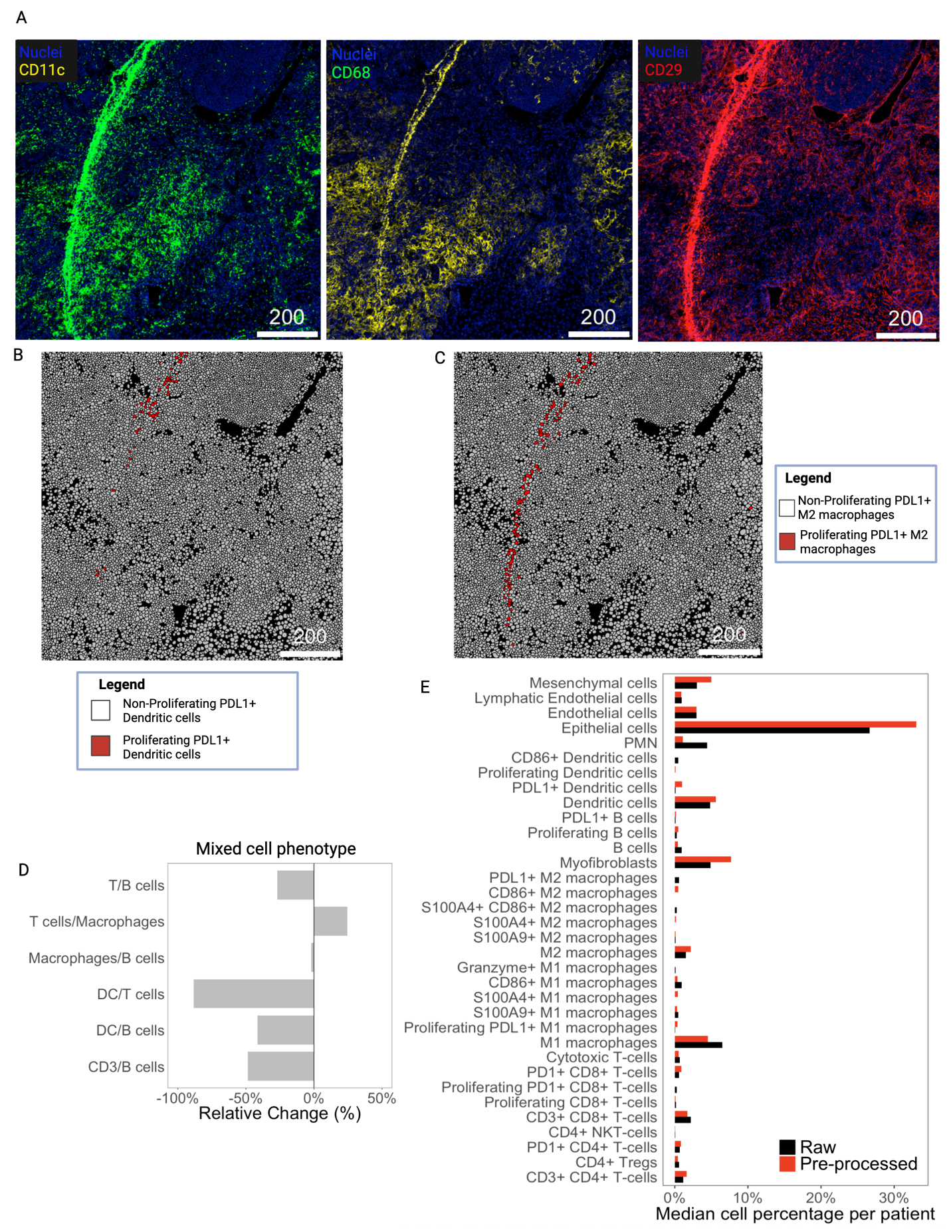

Supplementary Figure S5. The IMmuneCite workflow allows detection of image artifacts and exclusion of false data as proven in mouse HCC IMC data. A. Example of raw signal from CD11c, CD68, and CD29 highly co-expressed in a specific area of the tissue corresponding to a wrinkle artifact in the tissue staining. The high expression of all the markers was noted in the above tissue section as well as in some other samples. B-C. Cells detected in those areas were classified by the IMmuneCite clustering algorithm as either proliferating PDL1 dendritic cells (B) or proliferating PDL1 M2 macrophages (C); these expression profiles were not specific for their main cell lineages. Those cells were visualized on the tissue (as shown in B and C) and proven to all be located in the same area corresponding to the artifacts in A. Those cells were thus excluded from the analysis. D. IMClean reduces the frequency of cells showing mixed phenotypes – cells that express markers belonging to different cell lineages (e.g. CD20 and CD8, or CD20 and CD4/CD8) – thus decreasing the rate of non-biological immune phenotypes. E. Cell percentages for each immune subcluster were compared between raw and IMClean-processed mouse IMC data.
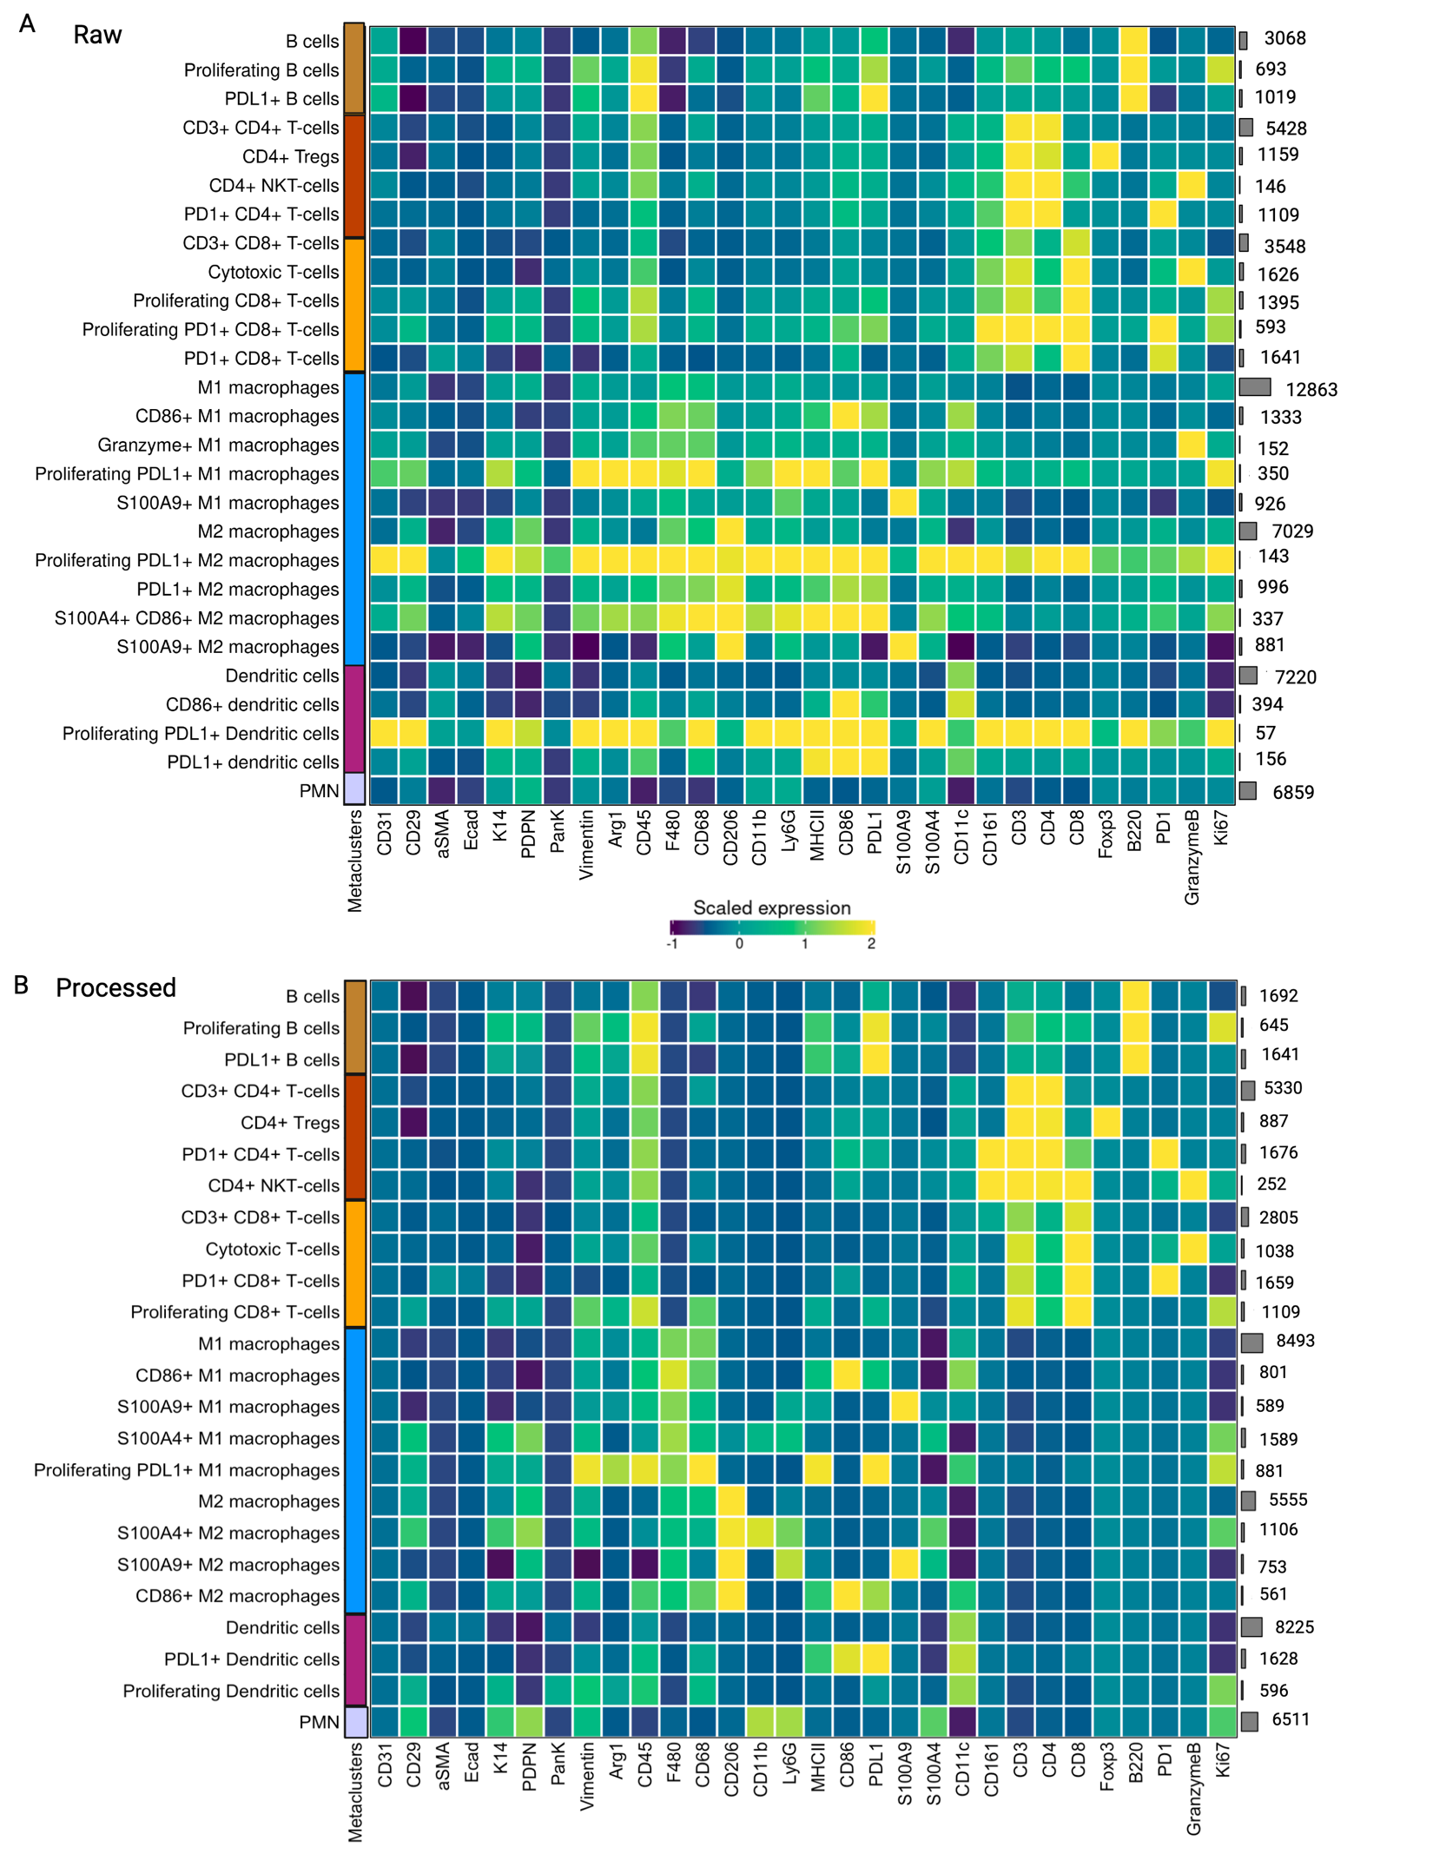
Supplementary Figure S6. Validation of the IMmuneCite workflow in HCC mouse models. A. Heatmap showing 25 immune clusters identified in raw IMC data obtained from mouse HCC mouse models. B. 24 immune clusters identified in the same mouse HCC IMC dataset after IMClean pre-processing.

Metal tag | Marker | Clone | Source | Catalog # | Dilution
139La | CD66b | G10F5 | BioLegend | 305102 | 75
142Nd | CD20 | L26 | Thermo Fisher Scientific | 14-0202-82 | 600
144Nd | CD28 | EPR22076 | Abcam | GR3252786-4 | 100
146Nd | CD16 | EPR16784 | Standard Biotools | 3146020D | 100
147Sm | CD163 | Edhu-1 | Standard Biotools | 3147021D | 500
149Sm | CD11b | EPR1344 | Standard Biotools | 3149028D | 400
152Sm | CD45 | CD45-2B11 | Standard Biotools | 3152018D | 100
153Eu | CD4 | EPR68551 | Abcam | ab181724 | 100
154Sm | CD31 | C31.3 | Novus | NBP2-33154 | 1000
156Gd | CD279  (PD-1) | NAT105 | BioLegend | 367402 | 50
159Tb | CD68 | KP1 | Standard Biotools | 3159035D | 200
160Gd | Foxp3 | 236A/E7 | Abcam | ab96048 | 75
164Dy | CK7 | RCK105 | Standard Biotools | 3164020A | 50
167Er | Ki-67 | B56 | BD Pharmingen | 624084 | 1000
168Er | CD8a | C8/144B | BioLegend | 372902 | 250
169Tm | Collagen Type I | Goat polyclonal | Standard Biotools | 3169023D | 250
170Er | CD3e | Polyclonal | Standard Biotools | 3170007B | 200
172Yb | CD138 | 4F3A8 | Proteintech | 67155-1-Ig | 6000
174Yb | HLA-DR | LN3 | Standard Biotools | 3174025D | 800
175Lu | Granzyme B | EPR20129-217 | Abcam | ab219803 | 500
191Ir | DNA1 | -- | Standard Biotools | 201192A | 800
193Ir | DNA2 | -- | Standard Biotools | 201192A | 800

Supplementary Table 1 | IMC Antibody Panel for Human Liver Tissue

Variable | Clusters | Ratio_Raw | Ratio_Processed | Ratio_Relative_Change | Change
CD11b | B cells | 1.7% | 1.2% | -0.31% | DOWN
CD11b | CD4+ T-cells | 10.3% | 4.7% | -0.54% | DOWN
CD11b | CD8+ T-cells | 10.2% | 10.0% | -0.01% | DOWN
CD11b | Cholangiocytes | 2.5% | 2.0% | -0.22% | DOWN
CD11b | Endothelial cells | 4.3% | 2.3% | -0.47% | DOWN
CD11b | Hepatocytes | 45.9% | 34.8% | -0.24% | DOWN
CD11b | Macrophages | 14.1% | 16.2% | 0.15% | UP
CD11b | Monocytes | 4.8% | 23.5% | 3.94% | UP
CD11b | Neutrophils | 5.3% | 5.1% | -0.03% | DOWN
CD11b | Plasma cells | 0.9% | 0.1% | -0.86% | DOWN
CD163 | B cells | 1.5% | 0.5% | -0.65% | DOWN
CD163 | CD4+ T-cells | 10.0% | 4.4% | -0.56% | DOWN
CD163 | CD8+ T-cells | 14.2% | 9.9% | -0.30% | DOWN
CD163 | Cholangiocytes | 0.7% | 0.2% | -0.69% | DOWN
CD163 | Endothelial cells | 3.5% | 1.6% | -0.53% | DOWN
CD163 | Hepatocytes | 38.6% | 32.3% | -0.16% | DOWN
CD163 | Macrophages | 24.2% | 48.0% | 0.98% | UP
CD163 | Monocytes | 2.8% | 0.9% | -0.66% | DOWN
CD163 | Neutrophils | 3.5% | 1.6% | -0.55% | DOWN
CD163 | Plasma cells | 1.0% | 0.5% | -0.51% | DOWN
CD20 | B cells | 3.0% | 36.4% | 11.31% | UP
CD20 | CD4+ T-cells | 8.2% | 8.0% | -0.03% | DOWN
CD20 | CD8+ T-cells | 8.9% | 13.2% | 0.48% | UP
CD20 | Cholangiocytes | 1.9% | 0.3% | -0.82% | DOWN
CD20 | Endothelial cells | 4.4% | 3.1% | -0.30% | DOWN
CD20 | Hepatocytes | 54.8% | 32.9% | -0.40% | DOWN
CD20 | Macrophages | 8.8% | 1.6% | -0.82% | DOWN
CD20 | Monocytes | 2.1% | 0.8% | -0.64% | DOWN
CD20 | Neutrophils | 7.2% | 3.6% | -0.51% | DOWN
CD20 | Plasma cells | 0.8% | 0.1% | -0.82% | DOWN
CD3 | B cells | 3.2% | 4.5% | 0.40% | UP
CD3 | CD4+ T-cells | 15.7% | 17.4% | 0.11% | UP
CD3 | CD8+ T-cells | 21.6% | 37.9% | 0.76% | UP
CD3 | Cholangiocytes | 1.5% | 0.9% | -0.42% | DOWN
CD3 | Endothelial cells | 5.3% | 4.3% | -0.18% | DOWN
CD3 | Hepatocytes | 34.6% | 18.2% | -0.47% | DOWN
CD3 | Macrophages | 9.2% | 8.4% | -0.09% | DOWN
CD3 | Monocytes | 3.1% | 2.4% | -0.24% | DOWN
CD3 | Neutrophils | 5.1% | 5.4% | 0.05% | UP
CD3 | Plasma cells | 0.7% | 0.6% | -0.14% | DOWN
CD4 | B cells | 2.2% | 2.1% | -0.02% | DOWN
CD4 | CD4+ T-cells | 13.4% | 28.4% | 1.12% | UP
CD4 | CD8+ T-cells | 10.8% | 13.6% | 0.26% | UP
CD4 | Cholangiocytes | 0.9% | 0.4% | -0.59% | DOWN
CD4 | Endothelial cells | 4.2% | 2.1% | -0.49% | DOWN
CD4 | Hepatocytes | 46.7% | 41.8% | -0.11% | DOWN
CD4 | Macrophages | 12.9% | 8.2% | -0.37% | DOWN
CD4 | Monocytes | 2.6% | 1.0% | -0.61% | DOWN
CD4 | Neutrophils | 5.4% | 2.1% | -0.62% | DOWN
CD4 | Plasma cells | 0.9% | 0.4% | -0.56% | DOWN
CD66b | B cells | 1.9% | 0.7% | -0.66% | DOWN
CD66b | CD4+ T-cells | 7.9% | 2.8% | -0.65% | DOWN
CD66b | CD8+ T-cells | 9.5% | 6.0% | -0.37% | DOWN
CD66b | Cholangiocytes | 1.8% | 0.9% | -0.51% | DOWN
CD66b | Endothelial cells | 4.3% | 2.1% | -0.50% | DOWN
CD66b | Hepatocytes | 52.0% | 54.2% | 0.04% | UP
CD66b | Macrophages | 10.2% | 6.4% | -0.37% | DOWN
CD66b | Monocytes | 2.4% | 1.5% | -0.39% | DOWN
CD66b | Neutrophils | 9.1% | 25.2% | 1.77% | UP
CD66b | Plasma cells | 0.9% | 0.3% | -0.63% | DOWN
CD68 | B cells | 1.5% | 0.2% | -0.84% | DOWN
CD68 | CD4+ T-cells | 9.3% | 2.4% | -0.74% | DOWN
CD68 | CD8+ T-cells | 10.8% | 7.3% | -0.32% | DOWN
CD68 | Cholangiocytes | 2.2% | 0.4% | -0.84% | DOWN
CD68 | Endothelial cells | 4.9% | 1.0% | -0.79% | DOWN
CD68 | Hepatocytes | 48.2% | 37.2% | -0.23% | DOWN
CD68 | Macrophages | 14.6% | 49.6% | 2.41% | UP
CD68 | Monocytes | 2.9% | 0.6% | -0.81% | DOWN
CD68 | Neutrophils | 4.7% | 1.0% | -0.79% | DOWN
CD68 | Plasma cells | 1.0% | 0.3% | -0.69% | DOWN
CD8 | B cells | 2.0% | 2.0% | -0.01% | DOWN
CD8 | CD4+ T-cells | 12.0% | 3.2% | -0.73% | DOWN
CD8 | CD8+ T-cells | 20.8% | 53.9% | 1.60% | UP
CD8 | Cholangiocytes | 1.6% | 1.3% | -0.20% | DOWN
CD8 | Endothelial cells | 3.9% | 2.9% | -0.26% | DOWN
CD8 | Hepatocytes | 42.0% | 26.9% | -0.36% | DOWN
CD8 | Macrophages | 9.4% | 6.3% | -0.34% | DOWN
CD8 | Monocytes | 2.3% | 1.1% | -0.55% | DOWN
CD8 | Neutrophils | 5.4% | 1.9% | -0.64% | DOWN
CD8 | Plasma cells | 0.6% | 0.4% | -0.20% | DOWN
CK7 | B cells | 1.6% | 0.1% | -0.91% | DOWN
CK7 | CD4+ T-cells | 8.3% | 0.8% | -0.91% | DOWN
CK7 | CD8+ T-cells | 10.0% | 3.1% | -0.69% | DOWN
CK7 | Cholangiocytes | 4.3% | 69.3% | 15.12% | UP
CK7 | Endothelial cells | 4.5% | 1.7% | -0.63% | DOWN
CK7 | Hepatocytes | 48.5% | 18.3% | -0.62% | DOWN
CK7 | Macrophages | 10.1% | 0.9% | -0.91% | DOWN
CK7 | Monocytes | 2.4% | 0.6% | -0.75% | DOWN
CK7 | Neutrophils | 9.6% | 4.7% | -0.51% | DOWN
CK7 | Plasma cells | 0.8% | 0.6% | -0.24% | DOWN

Supplementary Table 2 | Relative change in marker expression by metacluster.

