List of Tables

Table 1. Characterization of conventional and non-conventional fruits and vegetables included in this study.

Table 2. Equation of the linear regression and correlation coefficient of the standard curves for each bioactive amine and respective quantification limits.

Table 3. Content of bioactive amines in siriguela, marolo, custard apple, acerola, jabuticaba, starfruit, ora-pro-nobis, kale, purple chicory, and serralha.

Table 1.
Fruit and vegetable | Conventional or non-conventional | Part used | Family | Species | Picture
Seriguela (Purple mombin) | Non-conventional | Fruit, pulp and peel, without seeds | Anacardiaceae | Spondias purpurea L. | 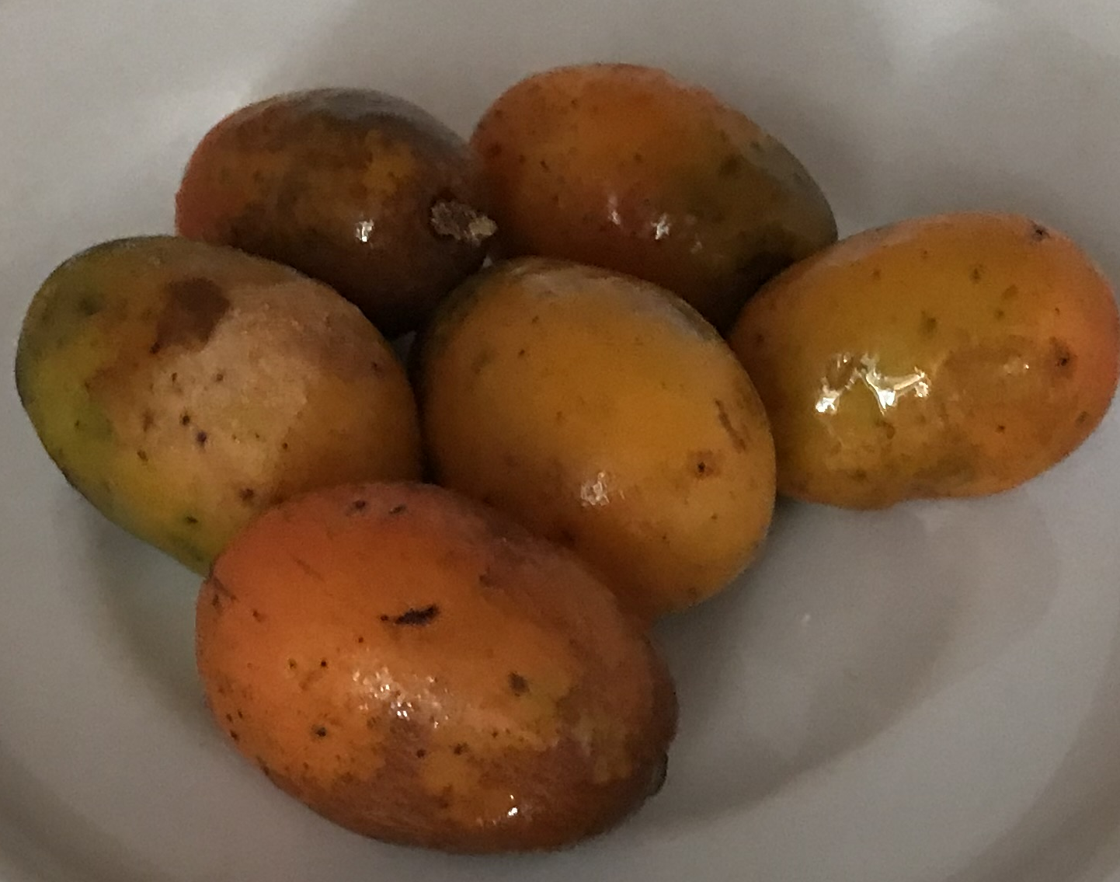
Marolo | Non-conventional | Fruit, pulp, without seeds | Annonaceae | Annona crassiflora Mart. | 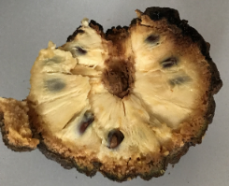
Custard apple (Sweet sop) | Non-conventional | Fruit, pulp, without seeds | Annonaceae | Annona squamosa | 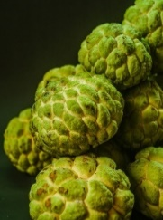
Acerola (Barbados cherry) | Conventional | Fruit, pulp and peel, without seeds | Malpighiaceae | Malpighia glabra L. | 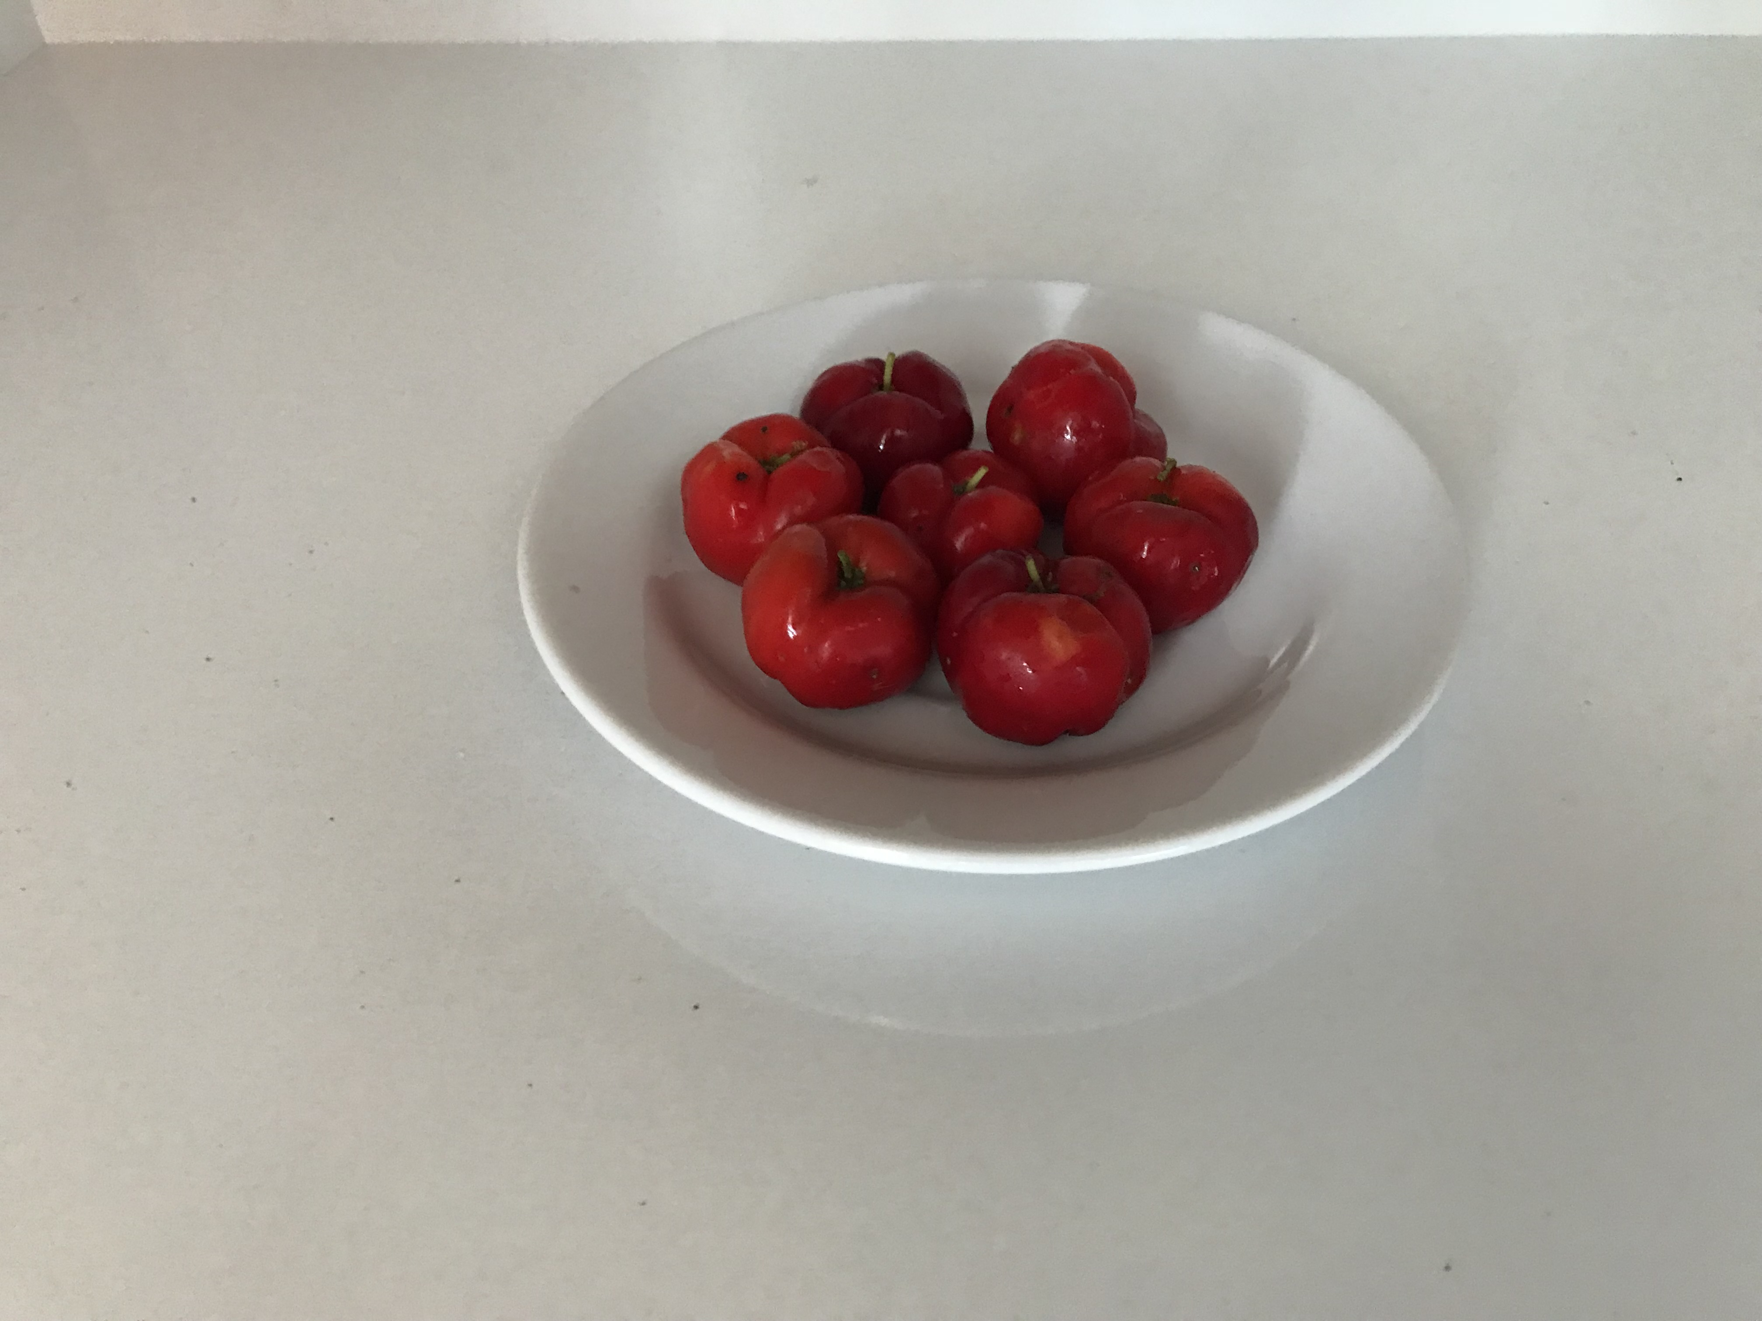
Jabuticaba | Non-conventional | Fruit, pulp, without seeds | Myrtacea | Plinia cauliflora | 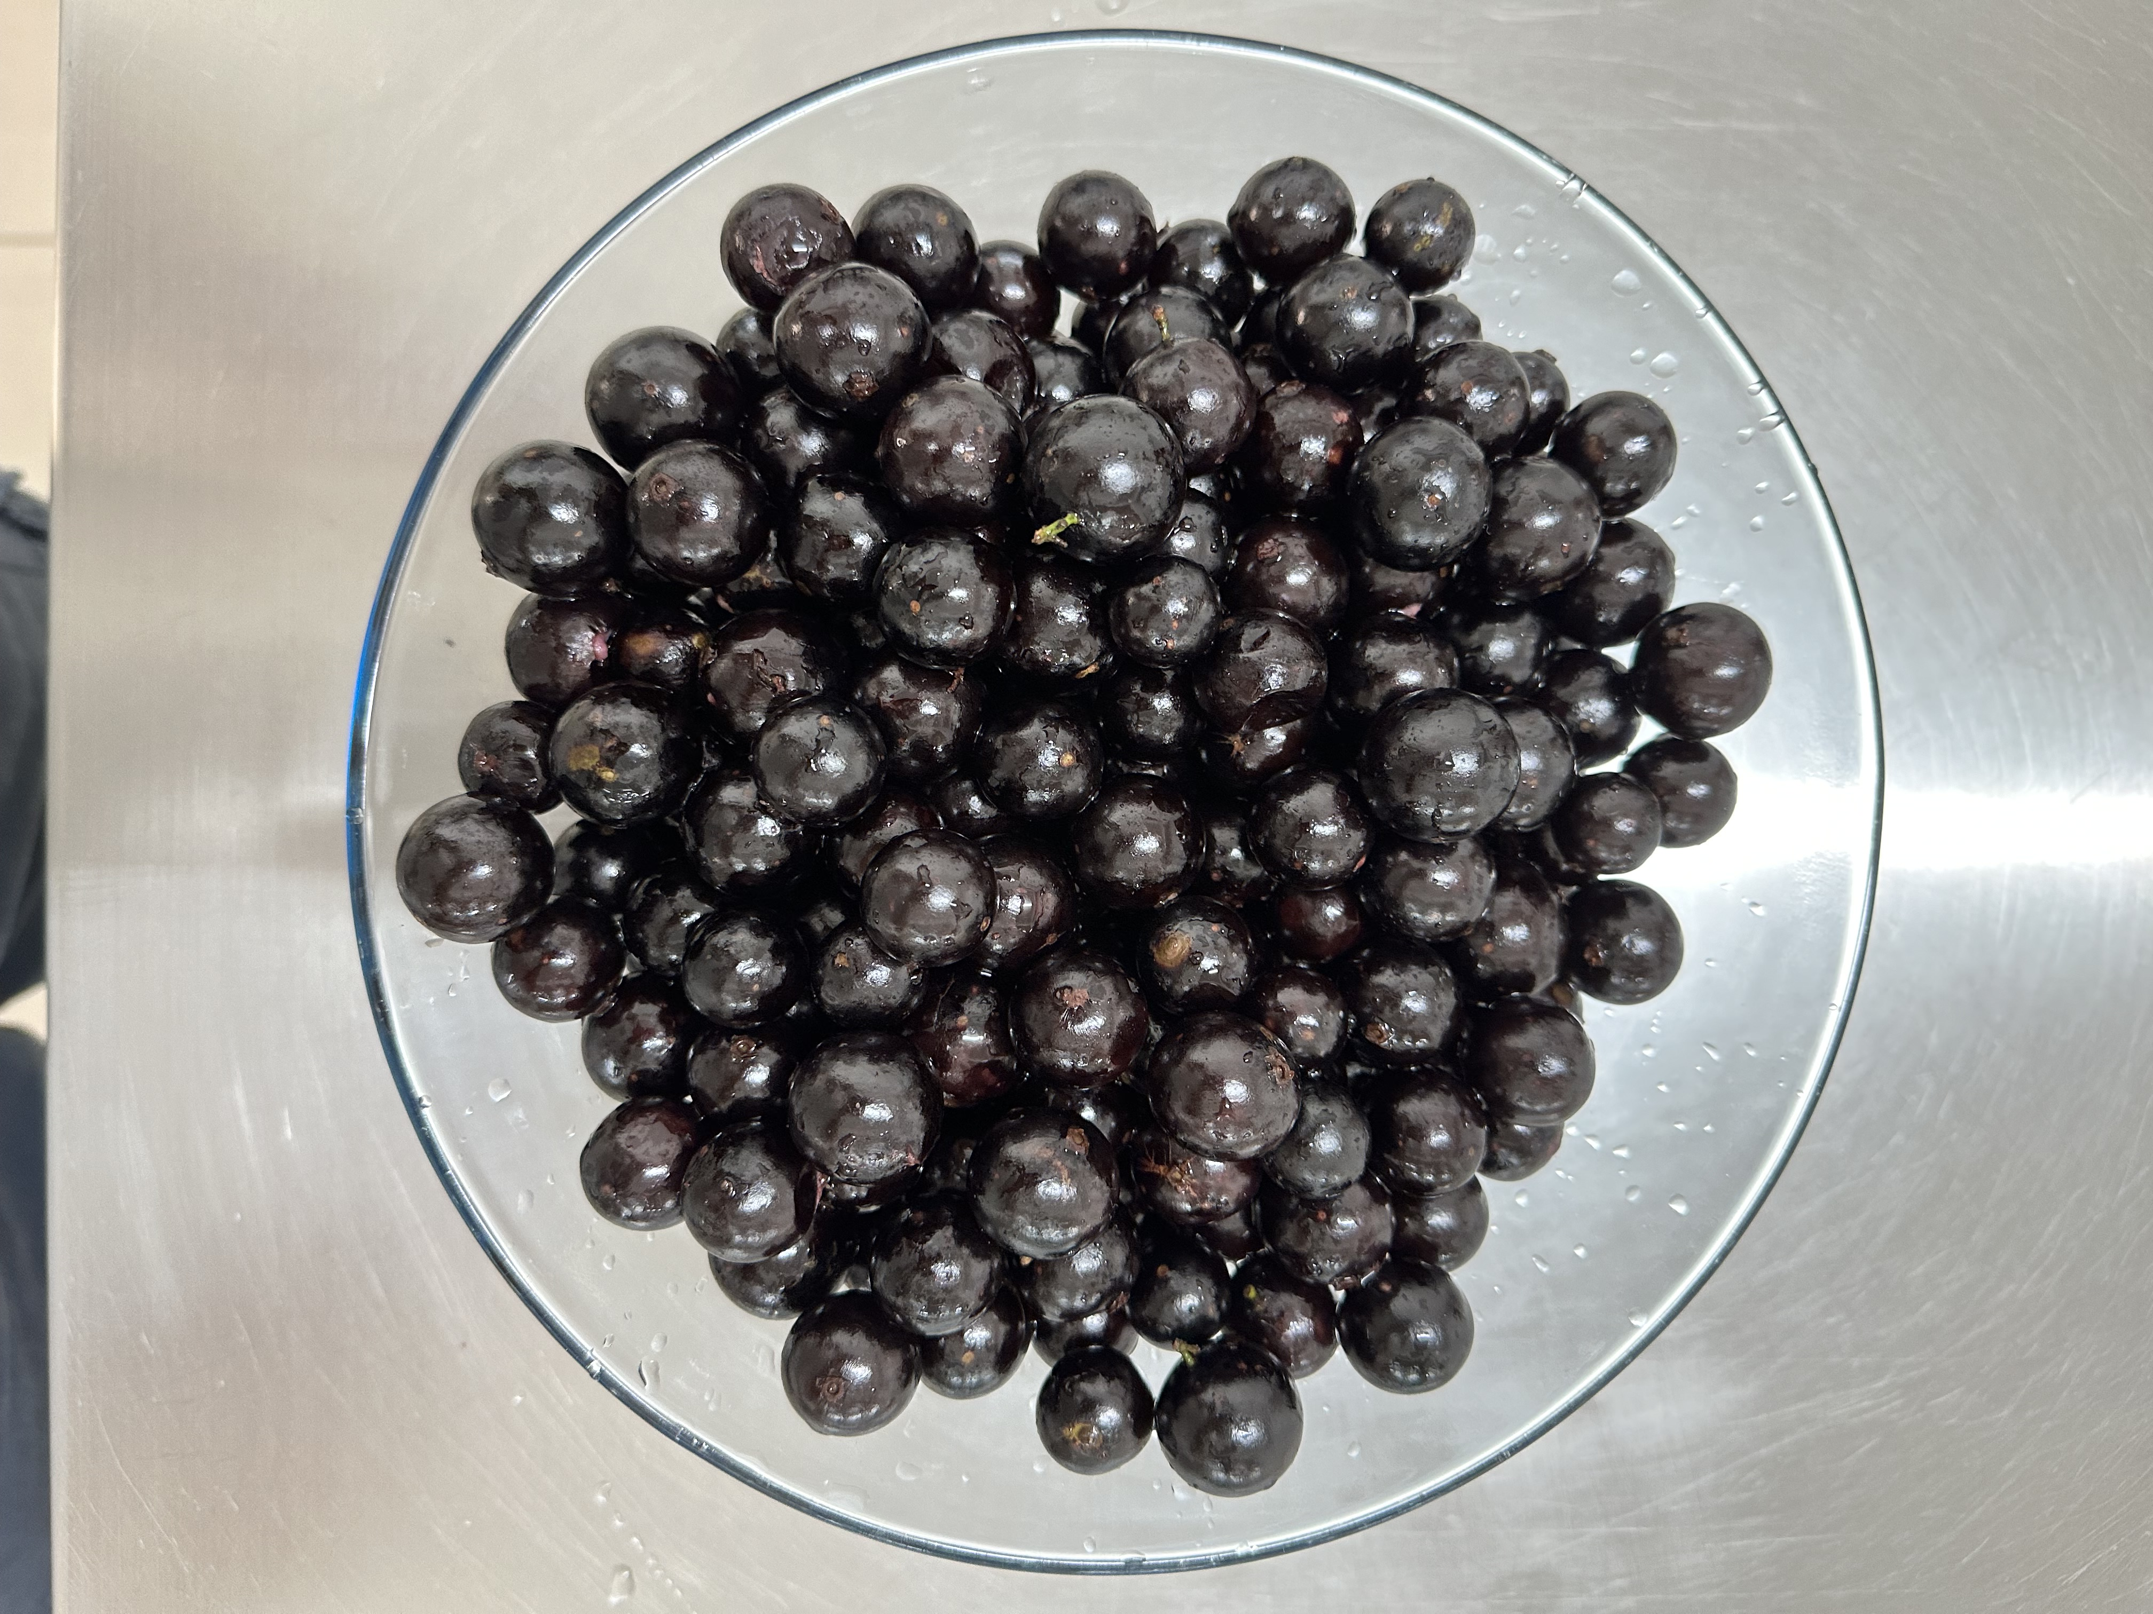
Starfruit (Carambola) | Conventional | Fruit, pulp, without seeds | Oxalidaceae | Averrhoa carambola L. | 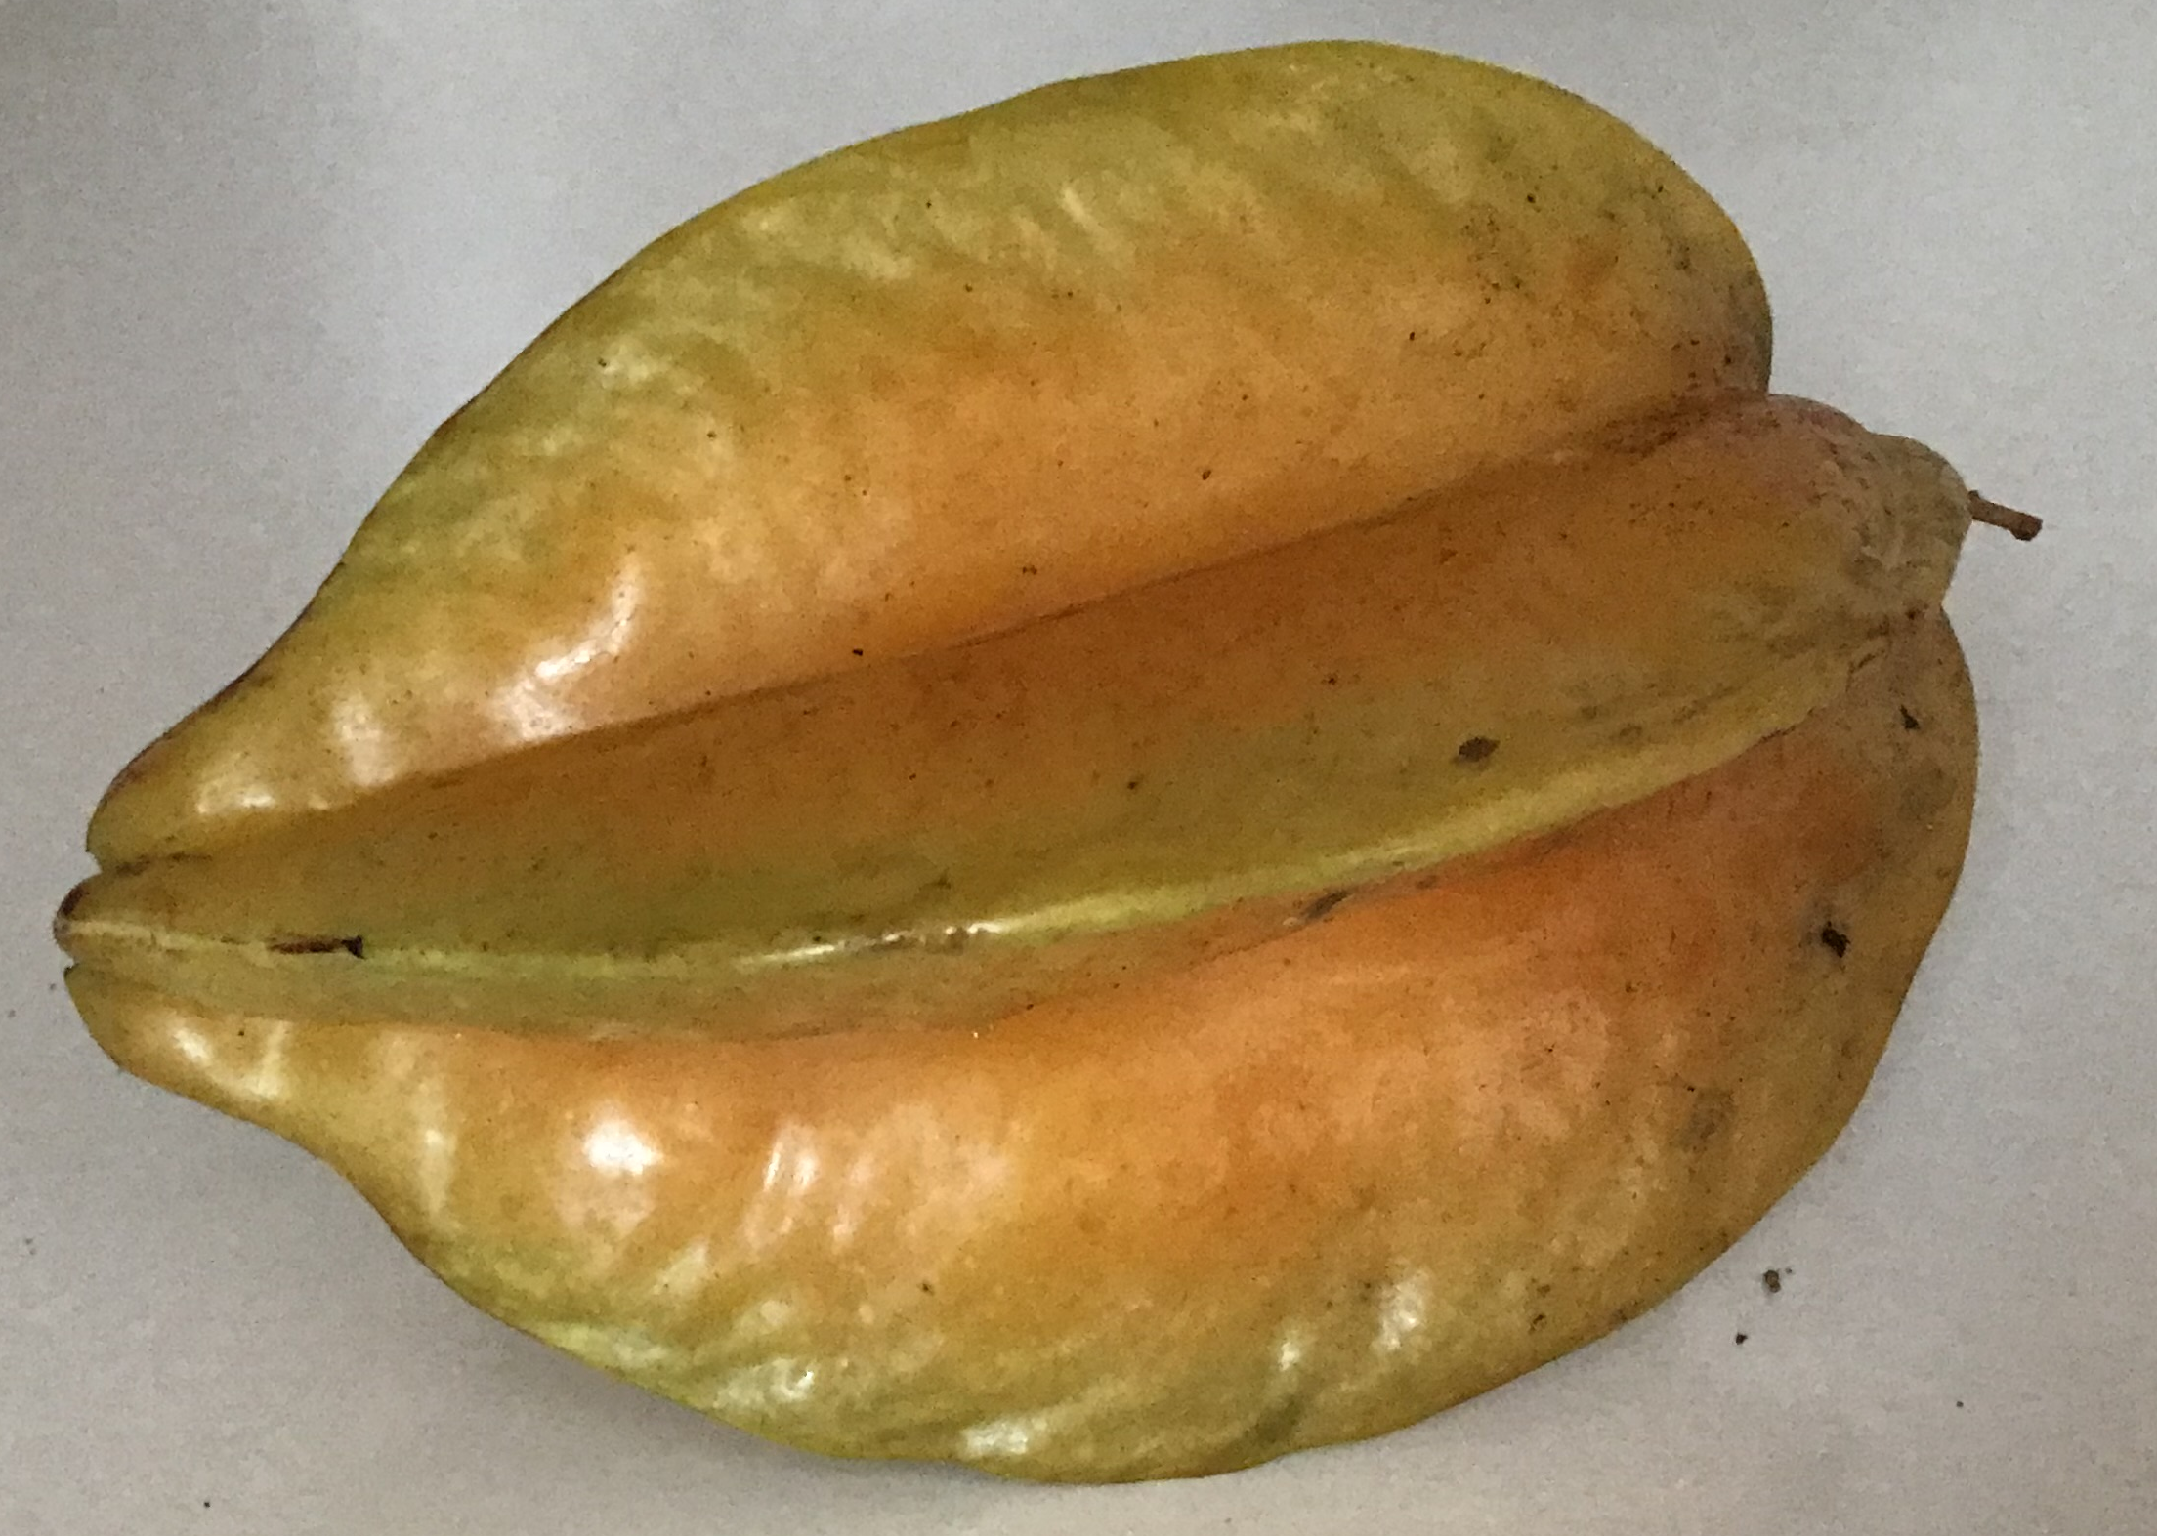
Kale | Conventional | Leaves | Brassicaceae | Brassica oleracea L. | 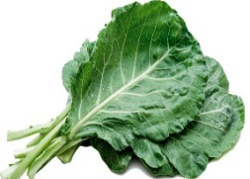
Ora-pro-nobis (Barbados shrub) | Non-conventional | Leaves | Cactaceae | Pereskia aculeata Mill. | 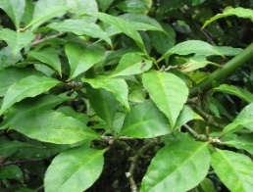
Almeirão roxo (Wild lettuce) | Non-conventional | Leaves | Asteraceae | Lactuca canadensis L. | 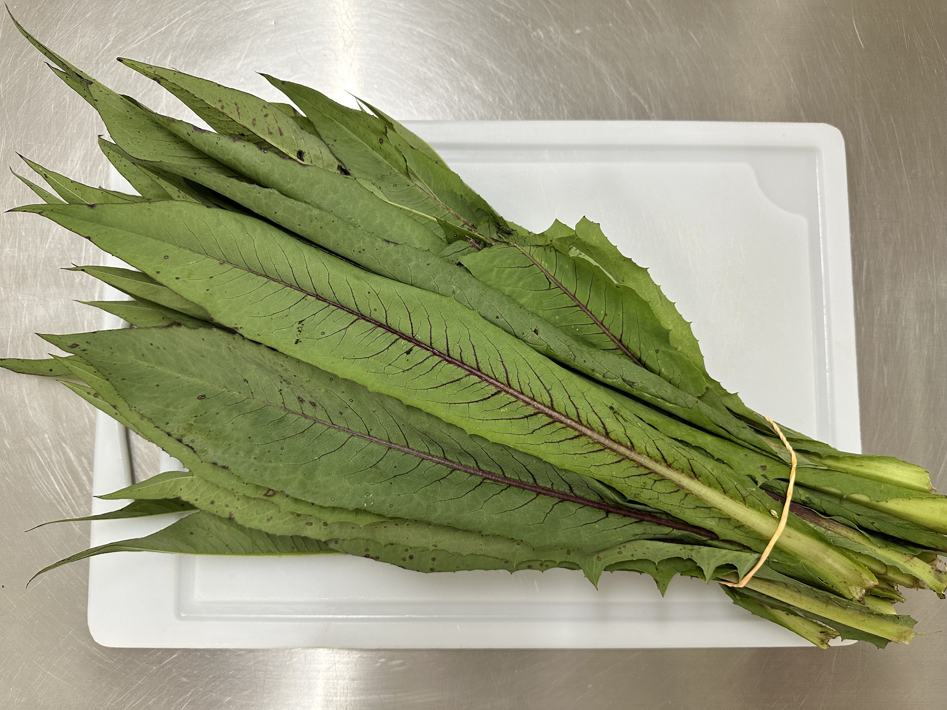
Serralha (common sow-thistle) | Non-conventional | Leaves | Asteraceae | Sonchus oleraceus L. | 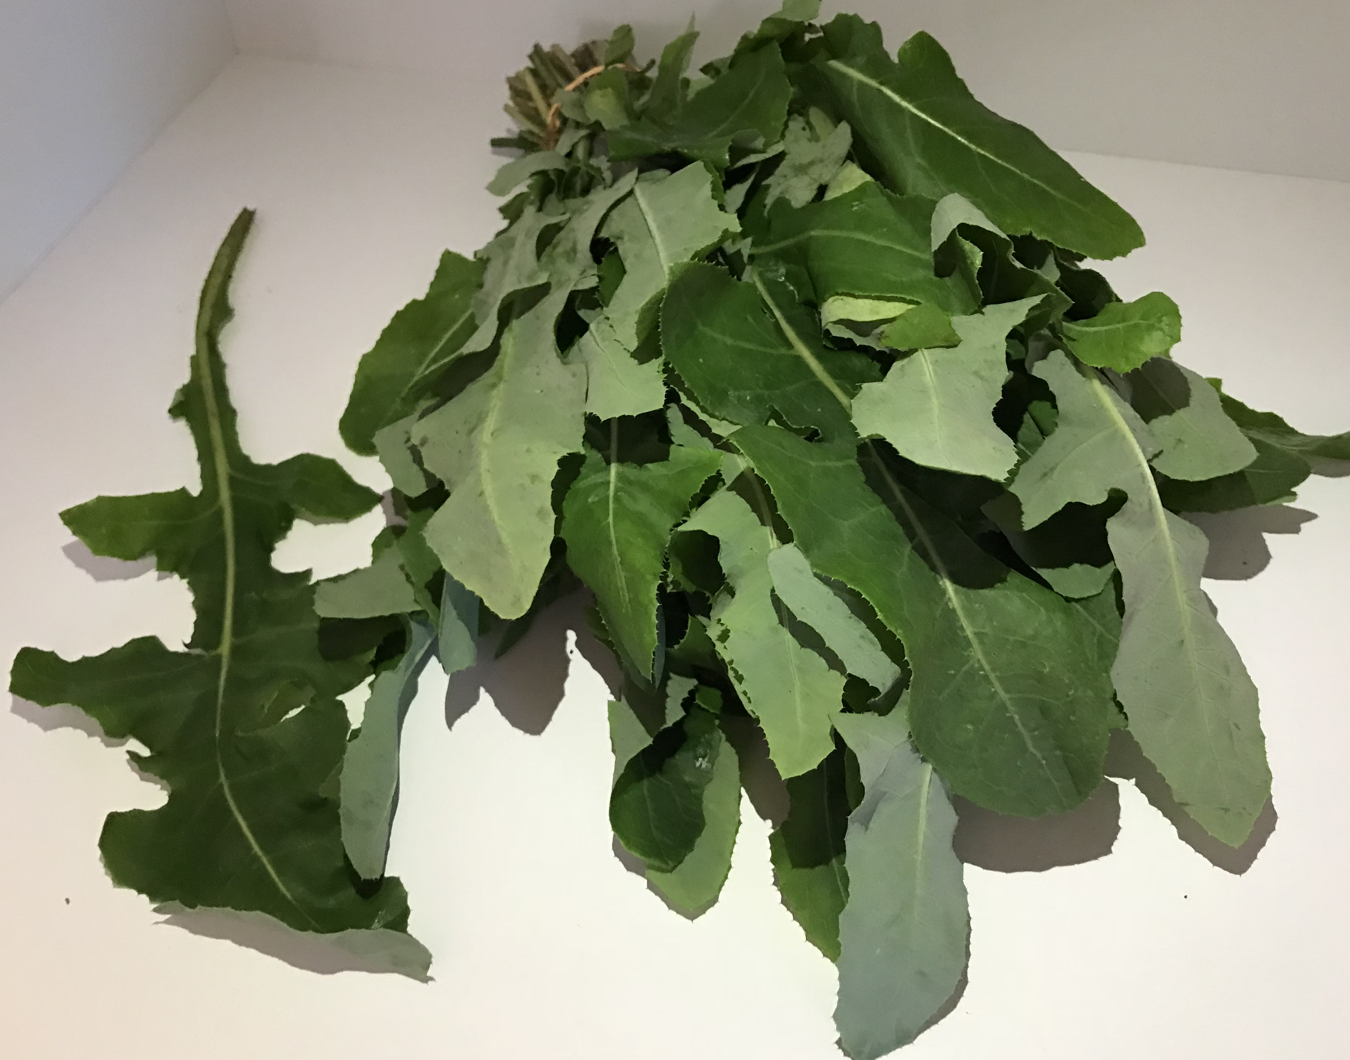

Table 2.

Bioactive amines | Standard curve |  | LOD (mg/kg) | Quantification limit (mg/kg)
Bioactive amines | Linear equation | r² | LOD (mg/kg) | Quantification limit (mg/kg)
Spermidine | Y¹ = 188750x + 24983 | 0.998 | 0.03 | 0.08
Agmatine | Y = 158549x + 18397 | 0.998 | 0.05 | 0.16
Putrescine | Y = 398444x – 38161 | 0.998 | 0.03 | 0.08
Cadaverine | Y = 399508x + 3071.6 | 0.998 | 0.03 | 0.08
Histamine | Y = 206823x + 18297 | 0.997 | 0.03 | 0.08
Tyramine | Y = 154797x – 29613 | 0.999 | 0.05 | 0.14
Serotonin | Y = 86096x + 18720 | 0.993 | 0.05 | 0.16
2-Phenylethylamine | Y = 223190x + 40708 | 0.996 | 0.03 | 0.08
Tryptamine | Y = 131653x + 38436 | 0.994 | 0.05 | 0.14
¹Y = area; x = concentration; r² = correlation coefficient. LOD: limit of detection

Table 3.
Product | Bioactive amines (mg/kg)¹
 | SPD* | AGM* | PUT* | CAD* | HIM** | TYM* | PHM** | SRT** | Total*
Fruit
Seriguela (Min-max)  Average (SD)  Median | 13.26-13.54  13.41 (0.14)  13.42a | ndª | 3.27-3.34  3.30 (0.04)  3.30bc | ndª | nd^{b} | 40.88-42.29  41.56 (0.71)  41.52a | 0.55-0.56  0.56a (0.01)  0.56 | nd^{b} | 58.25-59.45  58.83 (0.60)  58.79ab
Marolo (Min-max)  Average (SD)  Median | 8.79-11.13  9.92 (1.18)  9.85ab | ndª | 12.31-16.72  14.60 (2.21)  14.78ab | ndª | nd^{b} | 18.25-25.47  22.10 (3.63)  22.57a | 0.23-0.39  0.28b (0.09)  0.23 | nd^{b} | 43.88-50.33  46.90 (3.2)  46.49ab
Custard apple (Min-max)  Average (SD)  Median | 5-76-8.57  7.31 (1.43)  7.61ab | ndª | 14.74-17.32  15.78 (1.36)  15.29ab | ndª | nd^{b} | ndª | nd^{e} | nd^{b} | 20.50-25.89  23.10 (2.7)  22.90bc
Acerola (Min-max)  Average (SD)  Median | 5.13-5.48  5.31 (0.18)  5.32ab | 0.23-0.24  0.23 (0.01)  0.23a | 10.71-11.27  10.98 (0.28)  10.96bc | nd-0.57  0.28 (0.29)  0.26a | nd^{b} | ndª | 0.24-0.27  0.25bc (0.02)  0.24 | nd^{b} | 16.67-17.44  17.05 (0.39)  17.04bc
Jabuticaba (Min-max)  Average (SD)  Median | 7.05-10.98  8.87 (1.98)  8.58ab | ndª | 2.06-2.98  2.53 (0.46)  2.55bc | ndª | nd^{b} | ndª | nd^{d} | nd^{b} | 9.11-13.96  11.40 (2.44)  11.13bc
Starfruit (Min-max)  Average (SD)  Median | 2.49-2.81  2.64 (0.16)  2.63ab | 0.20-0.22  0.21 (0.01)  0.21a | 2.32-2.85  2.57 (0.27)  2.56bc | nd-0.32  0.15 (0.16)  0.14a | nd^{b} | ndª | 0.22-0.24  0.23bc (0.01)  0.23 | 0.94-1.07  1.01a (0.07)  1.00 | 6.17-7.51  6.82 (0.39)  6.77bc
Vegetable
Kale (Min-max)  Average (SD)  Median | 8.84-9.10  8.97 (0.13)  8.96ab | ndª | 0.65-0.67  0.66 (0.01)  0.66c | ndª | nd^{b} | ndª | nd^{d} | nd^{b} | 9.51-9.75  9.63 (0.12)  9.62bc
Ora-pro-nobis (Min-max)  Average (SD)  Median | 1.55-1.96  1.74 (0.24)  1.70ab | ndª | 3.87-4.43  4.10 (0.29)  4.00bc | 0.89-1.00  0.94 (0.06)  0.94a | 1.08-1.44  1.25a (0.18)  1.23 | 0.52-0.91  0.77 (0.21)  0.87a | nd^{d} | nd^{b} | 8.20-9.74  8.80 (0.82)  8.46bc
Almeirão roxo (Min-max)  Average (SD)  Median | 1.48-1.85  1.66 (0.19)  1.65ab | ndª | 1.66-1.77  1.71 (0.06)  1.71bc | 0.25-0.32  0.28 (0.04)  0.28a | nd^{b} | ndª | 0.15-0.16  0.16c (0.01)  0.16 | nd^{b} | 3.54-4.10  3.81 (0.28)  3.79c
Serralha (Min-max)  Average (SD)  Median | 1.17-1.44  1.31 (0.14)  1.32b | 0.20-0.22  0.21 (0.01)  0.22a | 1.28-1.37  1.32 (0.05)  1.33bc | 0.14-0.32  0.23 (0.09)  0.22a | nd^{b} | ndª | 0.16-0.17  0.17c (0.01)  0.17 | nd^{b} | 3.14-3.34  3.24 (0.10)  3.25c
¹ n = 3 lots, randomly gathered at an open-air market in Alfenas, MG, Brazil; SD-standard deviation; Min-minimum; Max-maximum; SPD-spermidine; AGM-agmatine; PUT-putrescine; CAD-cadaverine; HIM-histamine; TYM-tyramine; PHM-2-phenylethylamine; SRT-serotonin. nd-not detected (quantification limit in mg/kg: SPD, PUT, CAD, HIM, PHM < 0.08; TYM, TRM < 0.14 and, AGM, SRT < 0.16). Values followed by the same letter in the same column are not significantly different (*Kruskal-Wallis’ test followed by Dunn’s multiple comparison test; **ANOVA followed by Tukey’s Test, p ≤ 0.05).

