Supplemental data

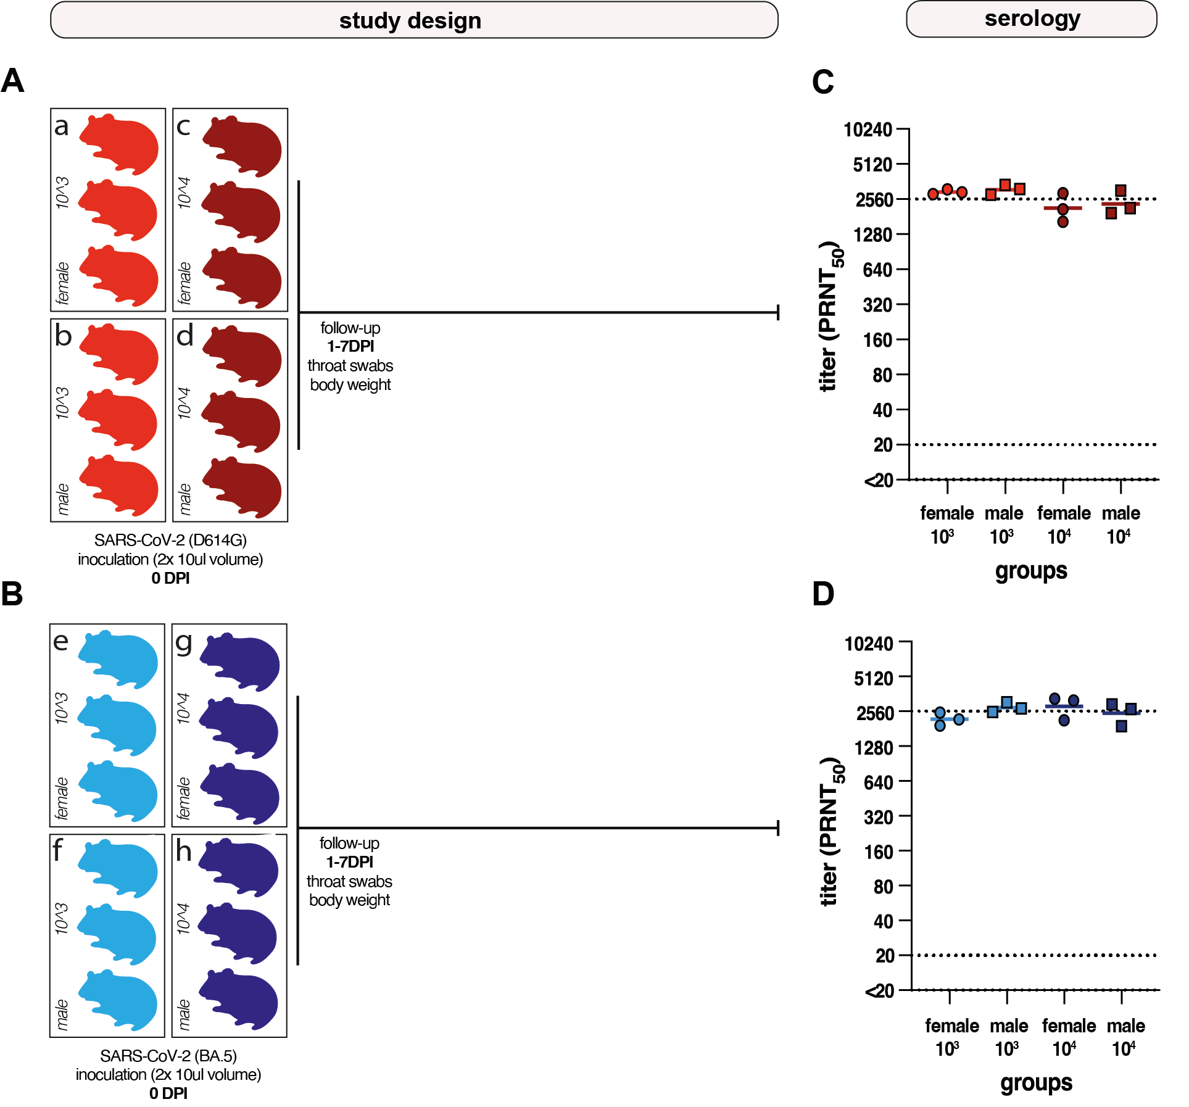

Supplementary Figure 1. Dose-finding study design and neutralizing antibody levels in serum. (A) Male or female hamsters were inoculated intranasally with 10³TCID₅₀ (light red) or 10⁴TCID₅₀ (dark red) ancestral SARS-CoV-2 (D614G) in 10 µl per nostril (n=3 per group). (B) Male or female hamsters were inoculated intranasally with 10³TCID₅₀ (light blue) or 10⁴TCID₅₀ (dark blue) SARS-CoV-2 Omicron BA.5 in 10 µl per nostril. (C, D) Neutralizing antibody levels measured 7 days post inoculation (DPI) as PRNT₅₀ against the respective variant used for inoculation. (C) Neutralizing antibody levels against D614G. Symbols represent individual animals; lines represent group median. (D) Neutralizing antibody levels against Omicron BA.5. Symbols represent individual animals; lines represent group median. The dotted lines represent the lower limit of detection (LLoD; 20 PRNT₅₀) and the upper limit of detection (2560 PRNT₅₀).
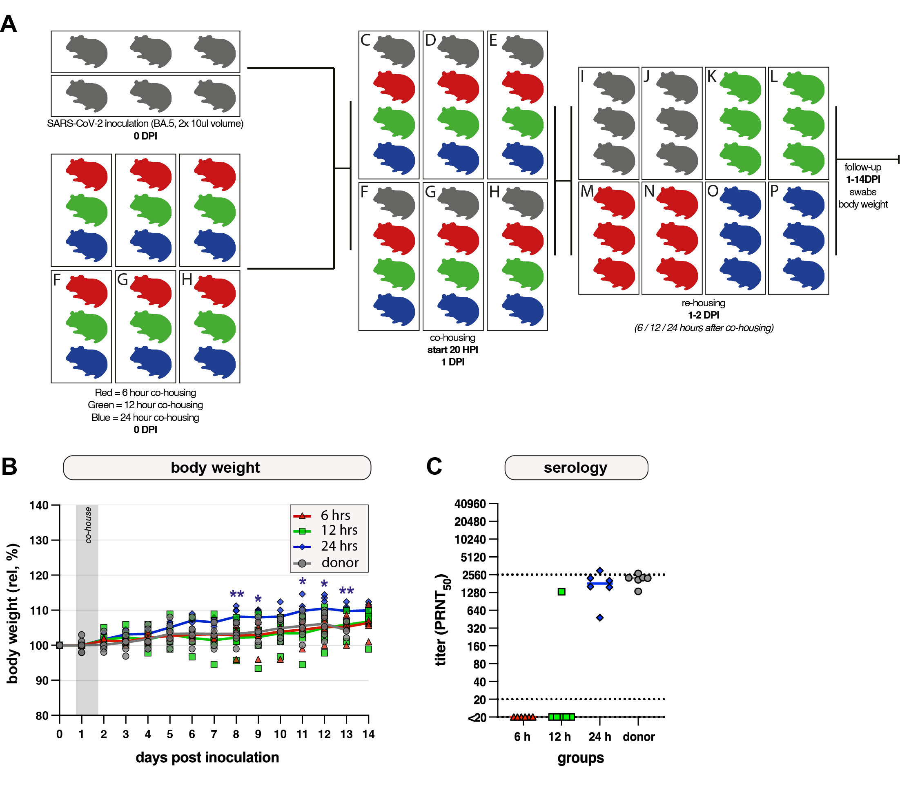
Supplementary Figure 2. Establishment of Omicron BA.5 transmission model. (A) Study design. Grey animals represent donor animals inoculated intranasally with 10³ TCID₅₀ Omicron BA.5 in 10 µl per nostril; colored symbols represent the acceptor animals, rehoused at 6 (red), 12 (green) or 24 (blue) h after start of co-housing (n=6 per group). (B) Body weights were recorded daily; relative body weights over time are shown, day 0 was set at 100%. Symbols represent individual hamsters; line represents group means. Differences between groups were estimated using two-way ANOVA, corrected with Dunnett. Asterisks indicate significant differences at specific timepoints, and are shown in group colors. *, p<0.05; **, p< 0.01; ***, p<0.001. (C) Neutralizing antibody levels measured at 14 days post inoculation (DPI) as PRNT₅₀ against Omicron BA.5. Symbols represent individual animals; lines represent group median. The dotted lines represent the lower limit of detection (20 PRNT₅₀) and the upper limit of detection (2560 PRNT₅₀).
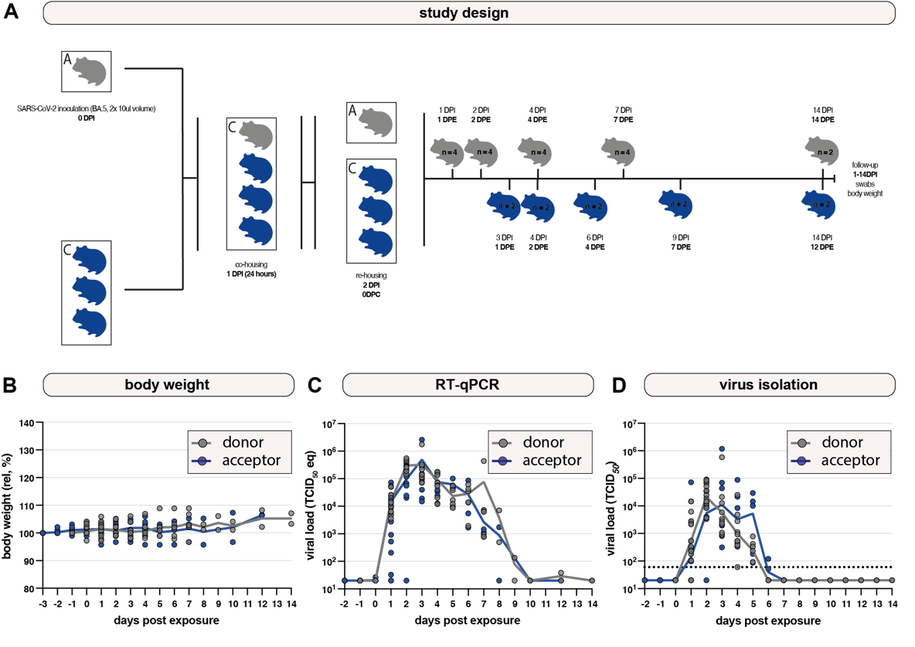
Supplementary Figure 3. Virological comparison between hamsters exposed via direct inoculation and direct-contact transmission. (A) Study design. Grey animals represent donor animals inoculated intranasally with 10³ TCID₅₀ Omicron BA.5 in 10 µl per nostril (n=4 per timepoint)l; blue symbols represent acceptor animals (n=2 per timepoint). Co-housing started 20 hours post inoculation (HPI) and acceptors were rehoused from the co-housing cage 24 hours after start of co-housing (44 HPI). Hamsters were sacrificed 1, 2, 4, 7 days post exposure (DPE; donor exposure = time of inoculation; acceptor exposure = end of co-housing), and at end of experiment. (B) Body weights were recorded daily. Relative body weights over time; first measurement before challenge was set at 100%. Symbols represent individual hamsters; line represents group median. (C) Viral genomes in throat swabs were measured by RT-qPCR and plotted as TCID₅₀ eq/ml over time. Symbols represent individual hamsters; line represents group median. (D). Infectious virus in throat swabs was measured by virus isolation and plotted as TCID₅₀/ml transport medium over time. The dotted lines represent the lower limit of detection (60). Symbols represent individual hamsters; line represents group median.

Supplementary Table 1. Histopathology and immunohistochemistry (IHC) scores of donor and acceptor hamsters. Hamsters were sacrificed 1, 2, 4, 7 days post exposure (DPE; donor exposure = time of inoculation; acceptor exposure = end of co-housing) and at end of experiment (EOE; 14 DPE for donor, 12 DPE for acceptor). Scores: 0, no inflammation / no cells positive; 1, mild inflammation / few numbers of cells positive; 2, moderate inflammation / moderate numbers of cells positive; 3, severe inflammation / abundant numbers of cells positive for viral antigen by IHC; *, Respiratory Epithelium (RE) mainly found IHC positive; **, Both Olfactory Epithelium (OE) and Respiratory Epithelium (RE) found IHC positive, but RE > OE.
 | Donor (n = 4) |  |  |  | Acceptor (n = 2)
 | Severity rhinitis (0-3) /  IHC nasal mucosa (0-3) | Severity tracheitis (0-3)  / IHC trachea (0-3) | Severity bronchitis (0-3) / IHC bronchi (0-3) | % inflamed lung area /  % IHC lung area | Severity rhinitis (0-3) /  IHC nasal mucosa (0-3) | Severity tracheitis (0-3)  / IHC trachea (0-3) | Severity bronchitis (0-3) / IHC bronchi (0-3) | % inflamed lung area /  % IHC lung area
1 DPE | 0 / 1.5* | 0 / 1 | 0 / 0.25 | 0 / 0 | 0 / 1* | 0 / 0.66 | 0 / 0.66 | 0 / 0
2 DPE | 1 / 2** | 0 / 0.75 | 0 / 0.75 | 0 / 0 | 0.66 / 1* | 0 / 1 | 0 / 1 | 0 / 0
4 DPE | 1 / 1.5** | 0.5 / 1.5 | 0 / 1 | 0 / 0 | 0.66 / 1* | 0 / 1 | 0 / 0.66 | 0 / 0
7 DPE | 1.5 / 1* | 0.25 / 1 | 0 / 1 | 1.25 / 0 | 1.5 / 1* | 1 / 1 | 0 / 1 | 0.5 / 0
EOE | 1 / 1* | 0 / 1 | 0 / 1 | 0 / 0 | 1 / 1* | 0 / 1 | 0 / 1 | 0 / 0

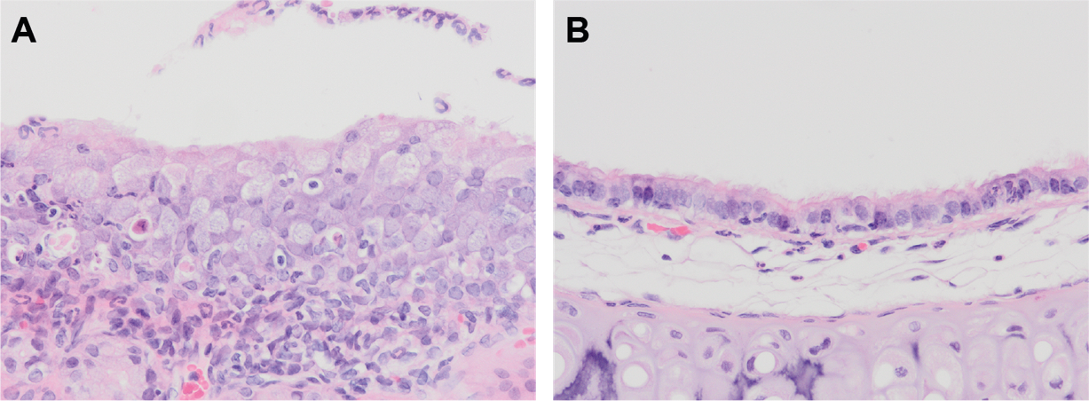
Supllementary Figure 4. Representative histopathological photographs of the upper respiratory tract. (A) Rhinitis evidenced by intra-epithelial infiltrates of neutrophils (black arrow), and exudate containing cellular debris of inflammatory cells and sloughed epithelial cells (grey arrow) in donor hamster 7 days post exposure (DPE). (B) Tracheitis with mucosal neutrophil infiltration (black arrow) in donor hamster 4 DPE. Original magnifications 200×.
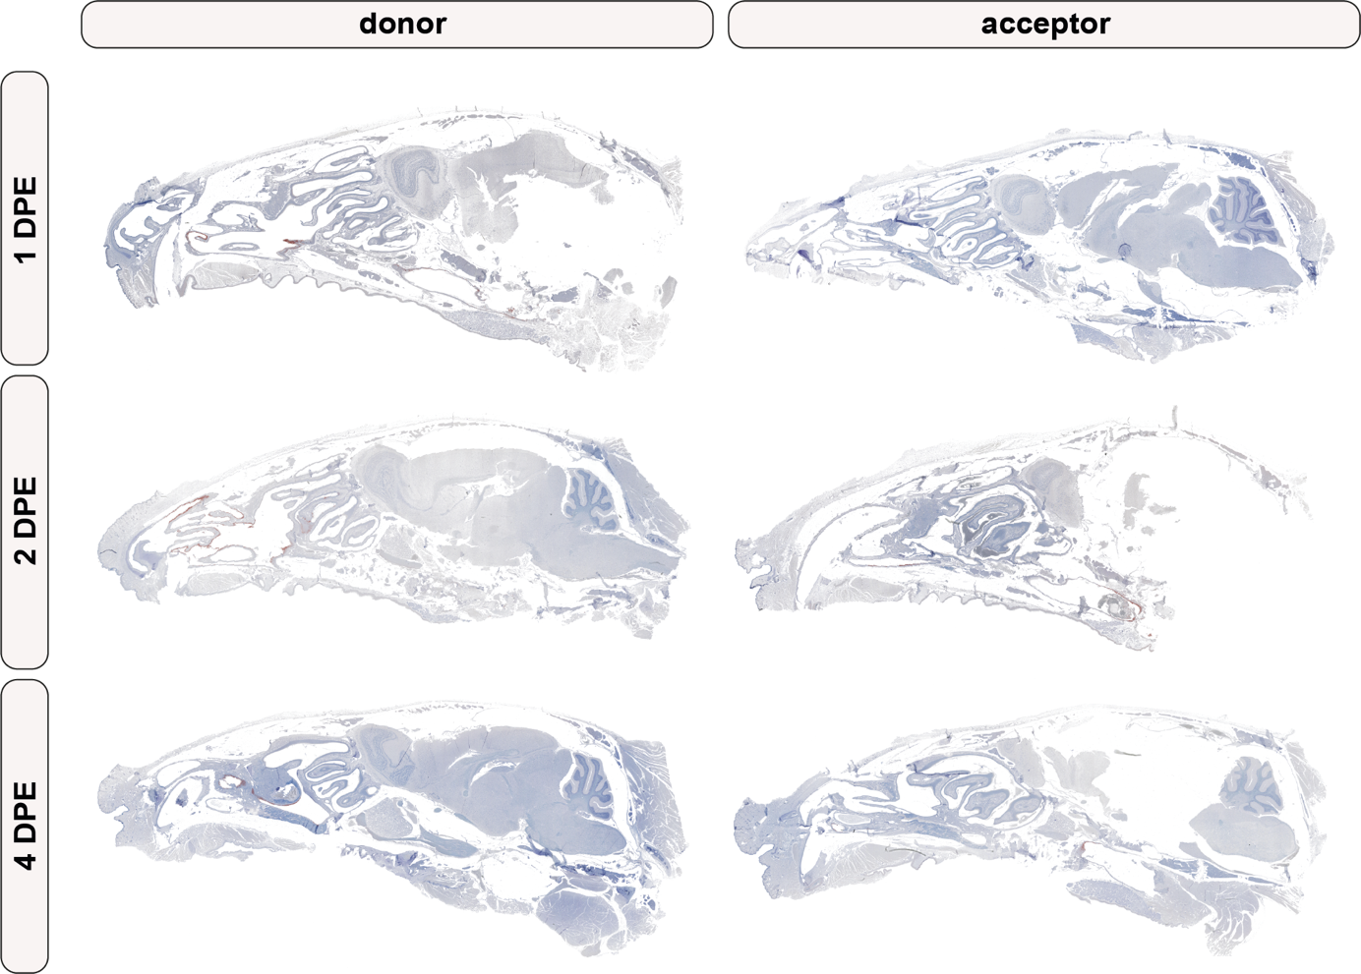

Supplementary Figure 5. SARS-CoV-2 immunohistochemistry of representative sagittal cut heads from donor and acceptor hamsters. From top to bottom, the consecutive days post exposure (DPE; donor exposure = time of inoculation; acceptor exposure = end of co-housing) are depicted. Positive viral antigen is visualized as reddish-brown staining of the epithelial cells’ cytoplasm and/or cilia by AEC-immunoperoxidase, on haematoxylin counterstain. Arrows indicate representative areas with high viral antigen loads.

