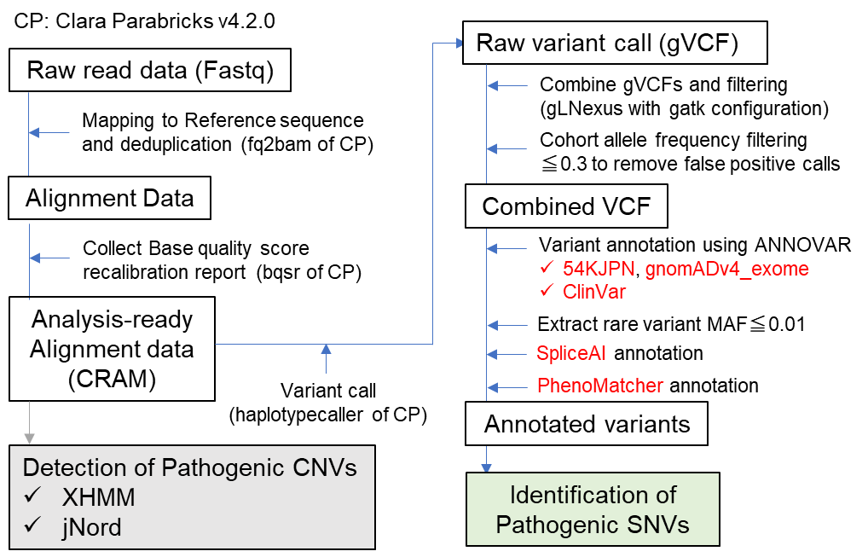
Supplementary Figure 1. Our workflow of exome data (re)analysis
CRAM, compressed reference-oriented alignment map; CNVs, copy number variants; SNVs, single nucleotide variants; VCF, Variant Call Format; MAF, minor allele frequency
XHMM, eXome-Hidden Markov Model¹.
jNord² is available at GitHub (https://github.com/bitsyamagu/jnord).

Supplementary Figure 2. SpliceAI prediction of aberrant splicing by three intronic variants 10-bp away from the exon-intron boundary
SpliceAI prediction of aberrant splicing in CEP290 (ID:20065, A), L1CAM (ID:21038, B), and L1CAM (ID:21118, C) variants. Yellow highlights indicate canonical splice sites. Blue highlights indicate newly predicted splice sites by SpliceAI. Red highlights and arrows indicate variants that are predicted to cause aberrant splicing. Delta scores of each splice sites are shown with red arrows. Aberrant splicing caused by the CEP290 variant (A) has been previously confirmed³. AG, Acceptor gain; AL, Acceptor loss; DG, Donor gain; DL, Donor loss.

Supplementary Figure 3. Confirmation of FOXG1 variant. (A) Read information from the VCF file before combining gVCF files. GT, Genotype; AD, Allelic depth (reference, alteration), DP Approximate read depth. (B) IGV view of the variant, showing low depth of coverage. (C) Sanger sequencing confirmed the de novo FOXG1 variant.

Reference
1 Fromer, M. et al. Discovery and statistical genotyping of copy-number variation from whole-exome sequencing depth. Am J Hum Genet 91, 597-607, doi:10.1016/j.ajhg.2012.08.005 (2012).
2 Uchiyama, Y. et al. Efficient detection of copy-number variations using exome data: Batch- and sex-based analyses. Human mutation 42, 50-65, doi:10.1002/humu.24129 (2021).
3 Tsurusaki, Y. et al. The diagnostic utility of exome sequencing in Joubert syndrome and related disorders. J Hum Genet 58, 113-115, doi:10.1038/jhg.2012.117 (2013).

