Supplementary Figure 1. Mutational landscape of all available samples from ADJUVANT-CTONG1104 by Targeted NGS.
Only genes that have ≥ 5% mutation frequency in both VP and gefitinib treatment groups were displayed.

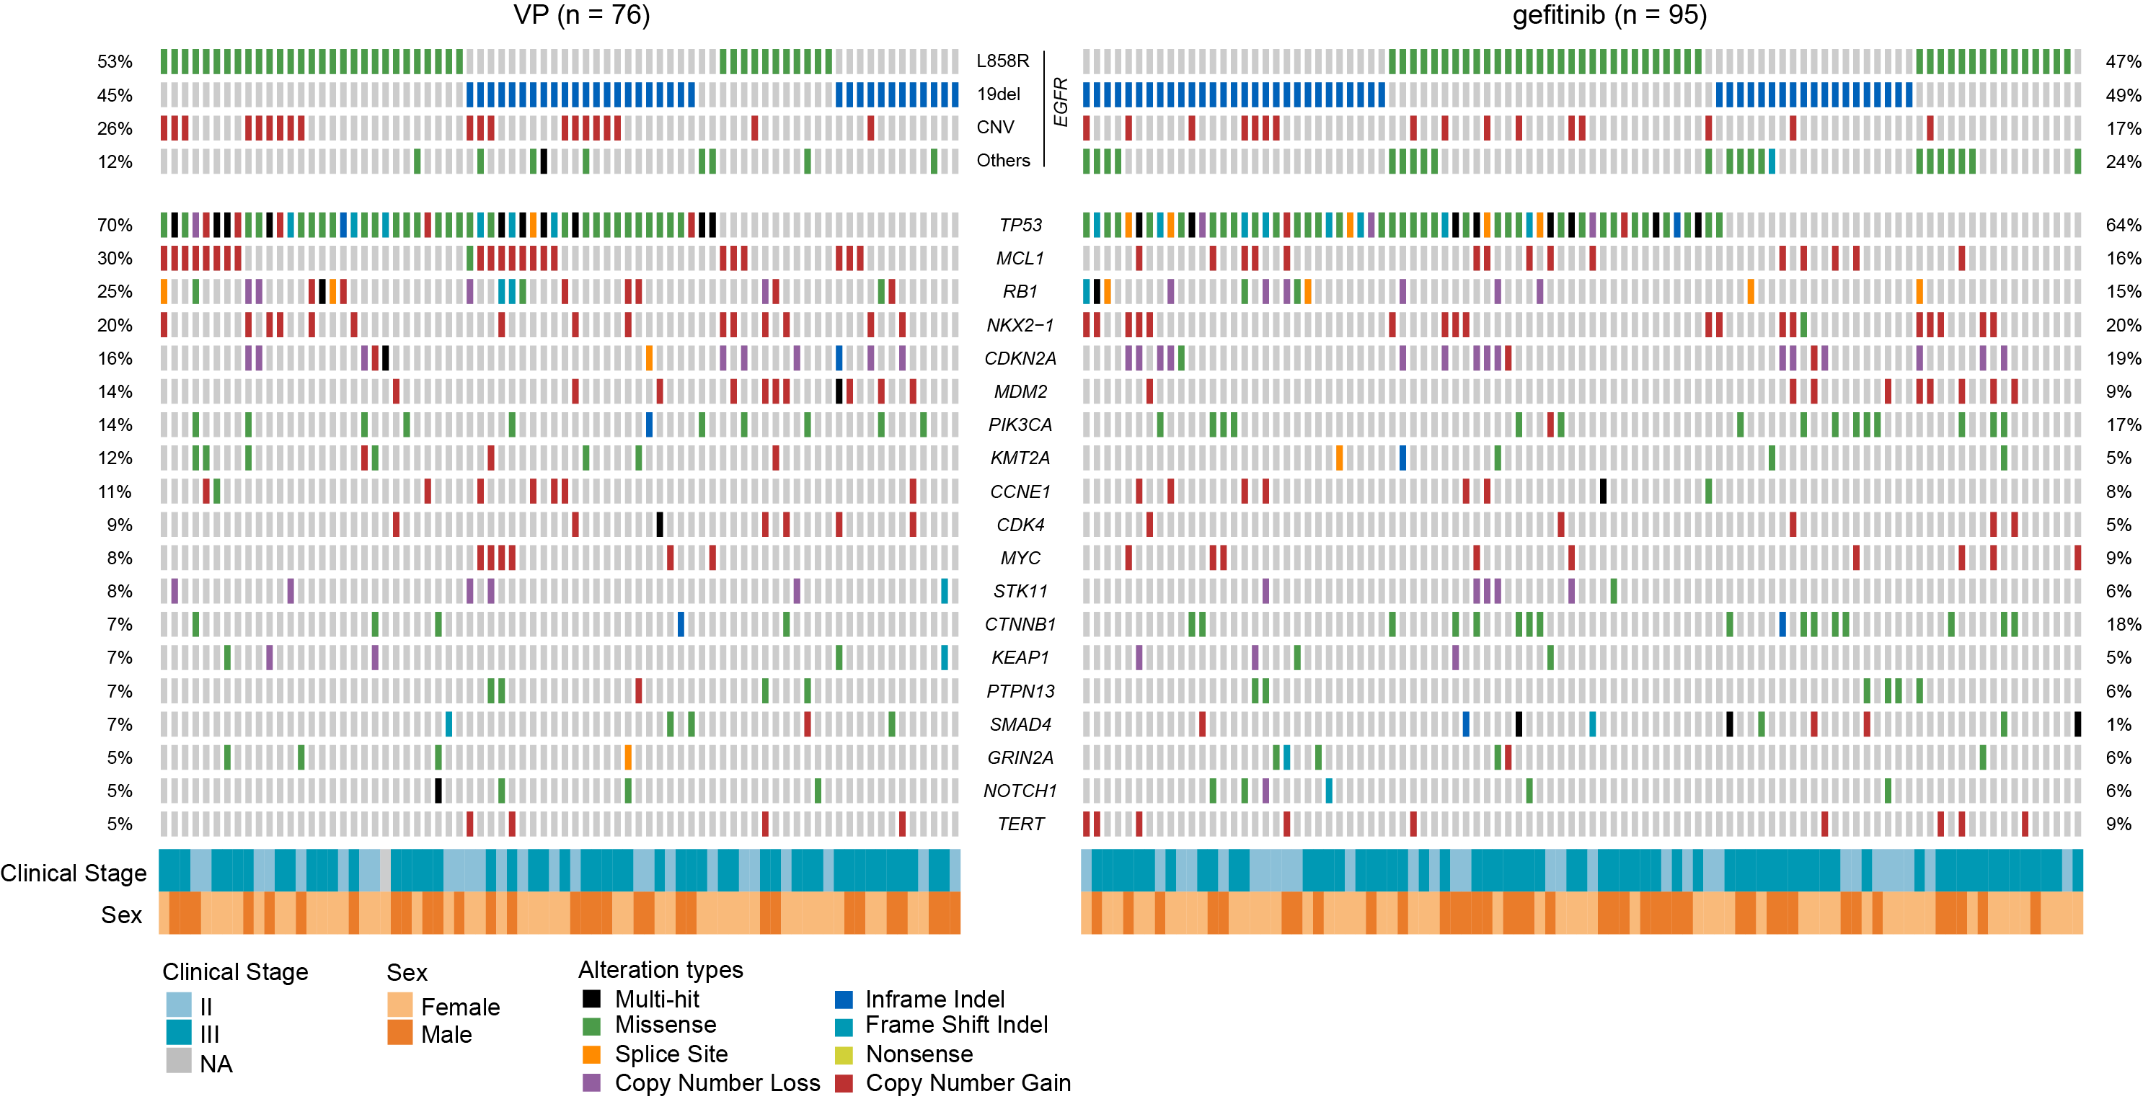

Supplementary Figure 2. Schematic diagram of predictive and prognostic biomarkers for adjuvant TKI and chemotherapy

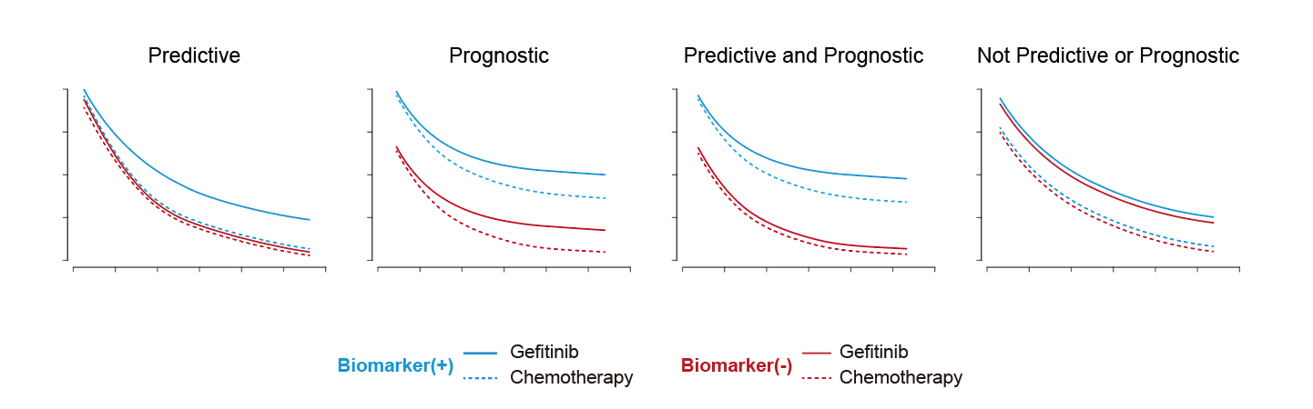

Supplementary Figure 3. KM survival plots showing prognostic markers in the exploratory cohort from the ADJUVANT/CTONG1104 study

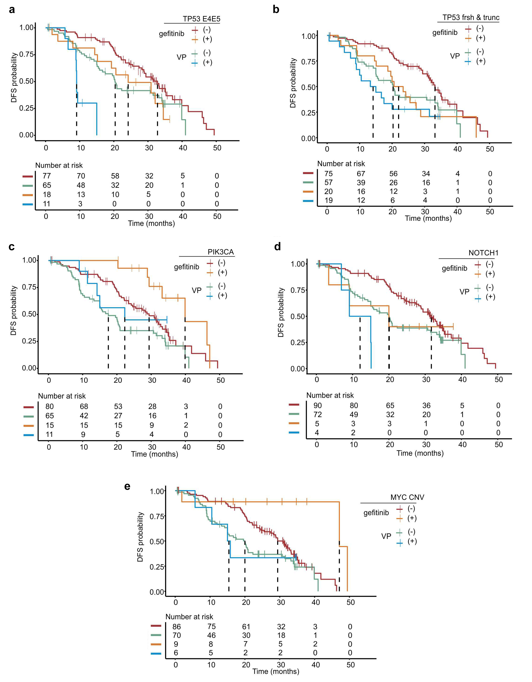

Supplementary Figure 4. Three subgroups identified from MINERVA.

a) Histogram shows the distribution of MINERVA score in entire cohort. b) Density plot reveals three subgroups of patients.

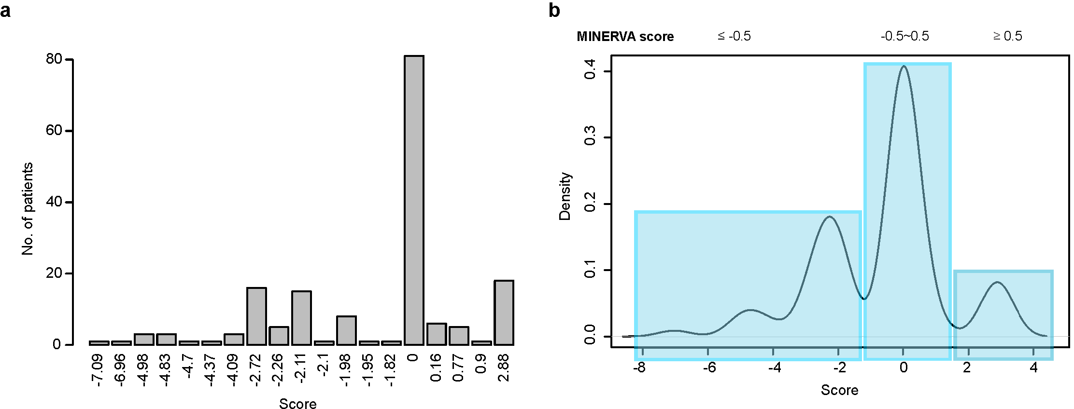

Supplementary Figure 5. Analysis of overall survival by prespecified subgroups in the exploratory cohort from ADJUVANT-CTONG1104.

Supplementary Figure 6. Two-year, three-year and five-year overall survival rates in MINERVA stratified patients.

Bar graphs illustrate two-, three- and five-year overall survival rate of the entire pre-stratified cohort and three MINERVA score groups. Error bars indicate 95% confidence interval.

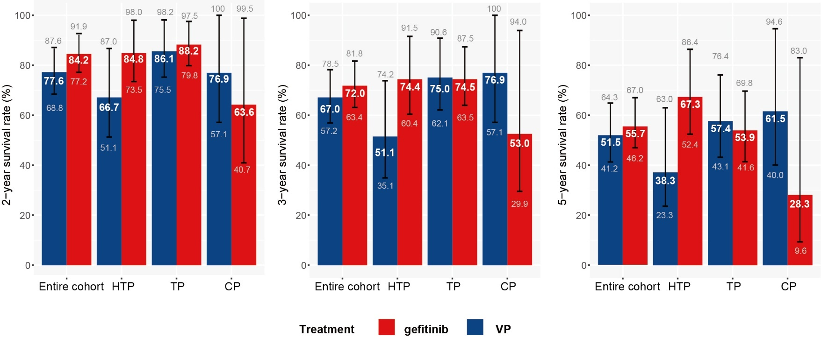

Supplementary Table 1. Summary of basic characteristics in the exploratory cohort from ADJUVANT-CTONG1104
 | Exploratory cohort
 | Gefitinib  (n=95) | Vinorelbine plus cisplatin  (n=76)
Age (years) | 58 (32-74) | 59 (26-73)
Sex
Female | 55 (58%) | 45 (59%)
Male | 40 (42%) | 31 (41%)
Never smoker | 70 (74%) | 58 (76%)
ECOG
0-1 | 93 (98%) | 76 (100%)
Not available | 2 (2%) | 0
Pathology stage
IIA | 27 (28%) | 24 (32%)
IIB | 4 (4%) | 2 (3%)
IIIA | 65 (68%) | 49 (64%)
Not available | 0 | 1 (1%)
Lymph node status
N1 | 31 (33%) | 26 (34%)
N2 | 64 (67%) | 49 (65%)
Not available | 0 | 1 (1%)
Pathology
Adenocarcinoma | 89 (93%) | 74 (97%)
Squamous carcinoma | 4 (5%) | 0
Adenosquamous carcinoma | 2 (2%) | 2 (3%)
Other | 0 | 0
EGFR sensitive mutation status by NGS
Exon 19 deletion | 50 (53%) | 36 (47%)
Exon 21 L858R | 45 (47%) | 40 (53%)

Data are median(range) or number of patients (%)
ECOG = Eastern Cooperative Oncology Group

Supplementary Table 2. Multivariate cox proportional hazard regression of predictive biomarkers and clinical status
 | Coefficient | HR  (95% CI) | Standard error of coefficient | z | p value
RB1
RB1 alterations | -0.404 | 0.67  (0.35-1.26) | 0.3243 | -1.247 | 0.21
Treatments (Gefitinib vs VP) | -0.959 | 0.38  (0.24-0.603) | 0.2317 | -4.141 | <0.001 | ***
Interaction between treatments and RB1 alterations | 1.376 | 3.96  (1.51-10.4) | 0.4909 | 2.803 | 0.005 | **
Age | -0.00047 | 1.00  (0.98-1.02) | 0.0117 | -0.040 | 0.97
Sex | 0.277 | 1.32  (0.75-2.32) | 0.2885 | 0.962 | 0.34
Smoking history | 0.302 | 1.35  (0.72-2.54) | 0.3222 | 0.938 | 0.35
Clinical stage | 0.088 | 1.09  (0.22-5.38) | 0.8142 | 0.108 | 0.91
N stage | 0.496 | 1.64  (0.34-7.97) | 0.8064 | 0.615 | 0.54
NKX2-1
NKX2-1 copy number gain | 1.158 | 3.18  (1.69-6.02) | 0.3246 | 3.568 | <0.001 | ***
Treatment (Gefitinib vs VP) | -0.430 | 0.65  (0.42-1.02) | 0.2280 | -1.888 | 0.059 | .
Interaction between treatment and NKX2-1 copy number gain | -1.410 | 0.24  (0.091-0.66) | 0.5057 | -2.789 | 0.005 | **
Age | -0.010 | 0.99  (0.97-1.01) | 0.0115 | -0.855 | 0.39
Sex | 0.272 | 1.31  (0.75-2.3) | 0.2855 | 0.952 | 0.34
Smoking history | 0.234 | 1.26  (0.68-2.36) | 0.3187 | 0.733 | 0.46
Clinical stage | -0.038 | 0.96  (0.21-4.39) | 0.7737 | -0.049 | 0.96
N stage | 0.617 | 1.85  (0.41-8.31) | 0.7659 | 0.805 | 0.42
CDK4
CDK4 copy number gain | 0.852 | 2.34  (0.91-6.02) | 0.4811 | 1.772 | 0.076 | .
Treatment (Gefitinib vs VP) | -0.591 | 0.55  (0.37-0.83) | 0.2081 | -2.839 | 0.005 | **
Interaction between treatment and CDK4 copy number gain | -1.933 | 0.15  (0.026-0.81) | 0.8792 | -2.199 | 0.028 | *
Age | -0.003 | 1.00  (0.98-1.02) | 0.0115 | -0.225 | 0.82
Sex | 0.300 | 1.35  (0.77-2.38) | 0.2897 | 1.037 | 0.30
Smoking history | 0.300 | 1.35  (0.72-2.53) | 0.3215 | 0.932 | 0.35
Clinical stage | -0.021 | 0.98  (0.22-4.4) | 0.7667 | -0.027 | 0.98
N stage | 0.599 | 1.82  (0.41-8.07) | 0.7596 | 0.789 | 0.43
TP53
TP53 exon4/5 missense mut | 1.634 | 5.12  (2.34-11.2) | 0.4002 | 4.082 | <0.001 | ***
Treatment (Gefitinib vs VP) | -0.673 | 0.51  (0.33-0.80) | 0.2262 | -2.976 | 0.003 | **
Interaction between treatment and TP53 exon4/5 missense mutations | -1.023 | 0.36  (0.13-1.01) | 0.5282 | -1.937 | 0.053 | .
Age | -0.003 | 1.00  (0.98-1.02) | 0.0116 | -0.219 | 0.83
Sex | 0.319 | 1.38  (0.78-2.43) | 0.2910 | 1.096 | 0.27
Smoking history | 0.362 | 1.44  (0.76-2.71) | 0.3234 | 1.120 | 0.26
Clinical stage | 0.075 | 1.08  (0.22-5.26) | 0.8086 | 0.092 | 0.93
N stage | 0.525 | 1.69  (0.35-8.09) | 0.7988 | 0.657 | 0.51
MYC
MYC copy number gain | -0.035 | 0.97  (0.34-2.73) | 0.5295 | -0.065 | 0.95
Treatments (Gefitinib vs VP) | -0.575 | 0.56  (0.38-0.85) | 0.2074 | -2.773 | 0.006 | **
Interaction between treatments and MYC copy number gain | -2.390 | 0.092  (0.0094-0.90) | 1.1629 | -2.055 | 0.04 | *
Age | -0.006 | 0.99  (0.97-1.02) | 0.0114 | -0.525 | 0.60
Sex | 0.179 | 1.20  (0.67-2.13) | 0.2943 | 0.607 | 0.54
Smoking history | 0.152 | 1.16  (0.61-2.22) | 0.3304 | 0.460 | 0.65
Clinical stage | -0.041 | 0.96  (0.22-4.20) | 0.7531 | -0.054 | 0.96
N stage | 0.666 | 1.95  (0.45-8.43) | 0.7479 | 0.891 | 0.37

Supplementary Table 3. Interaction between treatments and RB1 alteration
 | Recurrence events/  No. of Patients | Coefficient | HR  (95% CI) | Standard error of coefficient | z | p value
RB1 mutations | 15/23 | -0.34 | 0.71  (0.37-1.40) | 0.343 | -0.98 | 0.33
Treatments (Gefitinib vs VP) | 15/23 | -0.75 | 0.47  (0.31-0.72) | 0.217 | -3.47 | <0.001***
Interaction between treatments and RB1 mutations | 15/23 | 1.21 | 3.34  (0.96-11.60) | 0.634 | 1.90 | 0.06.
RB1 copy number loss | 8/10 | -0.39 | 0.68  (0.16-2.80) | 0.724 | -0.54 | 0.59
Treatments (Gefitinib vs VP) | 8/10 | -0.72 | 0.49  (0.33-0.73) | 0.207 | -3.45 | <0.001***
Interaction between treatments and RB1 copy number loss | 8/10 | 1.35 | 3.86  (0.74-20.20) | 0.844 | 1.60 | 0.11

VP: Adjuvant Chemotherapy Regimen: vinorelbine plus cisplatin.
Significant codes: ‘***’, p<0.001; ‘**’, p<0.01; ‘*’, p<0.05; ‘.’, p<0.1.

Supplementary Table 4. Multivariate cox proportional hazards regression of prognostic markers and clinical status
 | Coefficient | HR  (95% CI) | Standard error of coefficient | z | P value
TP53 exon 4-5 missense mut
TP53 exon 4-5 missense mut | 0.989 | 2.69  (1.60-4.52) | 0.2650 | 3.730 | <0.001 | ***
Treatment  (Gefitinib vs VP) | -0.850 | 0.43  (0.28-0.65) | 0.2096 | -4.040 | <0.001 | ***
Age | -0.001 | 0.999  (0.98-1.02) | 0.0117 | -0.107 | 0.91
Sex | 0.278 | 1.32  (0.75-2.33) | 0.2887 | 0.963 | 0.34
Smoking history | 0.333 | 1.39  (0.74-2.62) | 0.3224 | 1.032 | 0.30
Clinical stage | 0.172 | 1.19  (0.23-6.07) | 0.8321 | 0.207 | 0.84
Lymph node status | 0.463 | 1.59  (0.32-7.96) | 0.8221 | 0.563 | 0.57
TP53 frameshift & truncating mut
TP53 frameshift & truncating mut | 0.525 | 1.69  (1.08-2.65) | 0.2294 | 2.290 | 0.022 | *
Treatment  (Gefitinib vs VP) | -0.676 | 0.51  (0.34-0.76) | 0.2023 | -3.341 | <0.001 | ***
Age | -0.001 | 0.999  (0.98-1.02) | 0.0115 | -0.070 | 0.94
Sex | 0.280 | 1.32  (0.75-2.33) | 0.2894 | 0.967 | 0.33
Smoking history | 0.187 | 1.21  (0.63-2.31) | 0.3313 | 0.564 | 0.57
Clinical stage | 0.147 | 1.16  (0.27-5.01) | 0.7475 | 0.197 | 0.84
Lymph node status | 0.405 | 1.50  (0.35-6.42) | 0.7426 | 0.545 | 0.59
PIK3CA mut
PIK3CA mut | -0.777 | 0.46  (0.24-0.88) | 0.3312 | -2.347 | 0.019 | *
Treatment  (Gefitinib vs VP) | -0.687 | 0.50  (0.34-0.75) | 0.2026 | -3.392 | <0.001 | ***
Age | 0.001 | 1.00  (0.98-1.02) | 0.0114 | 0.085 | 0.93
Sex | 0.219 | 1.24  (0.70-2.21) | 0.2937 | 0.745 | 0.46
Smoking history | 0.218 | 1.24  (0.65-2.36) | 0.3280 | 0.663 | 0.51
Clinical stage | 0.581 | 1.79  (0.32-10.10) | 0.8849 | 0.656 | 0.51
Lymph node status | 0.005 | 1.01  (0.18-5.61) | 0.8771 | 0.006 | 1.00
MYC gain
MYC gain | -1.047 | 0.35  (0.14-0.89) | 0.473 | -2.214 | 0.027 | *
Treatment  (Gefitinib vs VP) | -0.670 | 0.51  (0.34-0.76) | 0.202 | -3.308 | <0.001 | ***
Age | -0.005 | 1.00  (0.97-1.02) | 0.011 | -0.399 | 0.690
Sex | 0.248 | 1.28  (0.73-2.26) | 0.290 | 0.855 | 0.393
Smoking history | 0.279 | 1.32  (0.70-2.49) | 0.323 | 0.864 | 0.388
Clinical stage | -0.013 | 0.99  (0.22-4.35) | 0.757 | -0.017 | 0.986
Lymph node status | 0.609 | 1.84  (0.42-8.01) | 0.751 | 0.812 | 0.417
NOTCH1 mut
NOTCH1 mut | 0.907 | 2.48  (1.12-5.47) | 0.404 | 2.244 | 0.025 | *
Treatment  (Gefitinib vs VP) | -0.714 | 0.49  (0.33-0.73) | 0.203 | -3.527 | <0.001 | ***
Age | -0.003 | 1.00  (0.98-1.02) | 0.011 | -0.218 | 0.83
Sex | 0.391 | 1.48  (0.85-2.58) | 0.284 | 1.375 | 0.17
Smoking history | 0.449 | 1.57  (0.84-2.92) | 0.317 | 1.415 | 0.16
Clinical stage | 0.054 | 1.06  (0.23-4.91) | 0.784 | 0.069 | 0.95
Lymph node status | 0.517 | 1.68  (0.37-7.7) | 0.777 | 0.665 | 0.51

