Supplementary

Fig. 1S Species identification certificate of P. sibirica Linnaeus

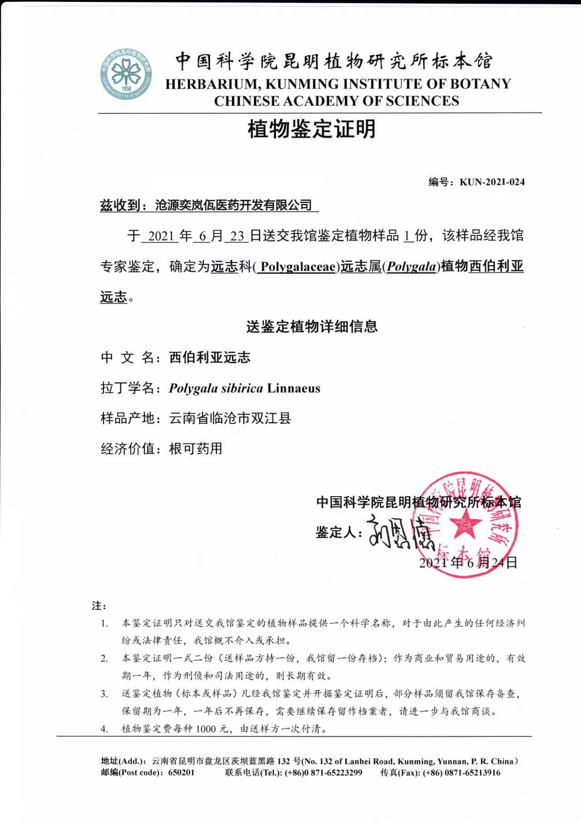

Fig. 2S Species identification certificate of P. crotalarioides
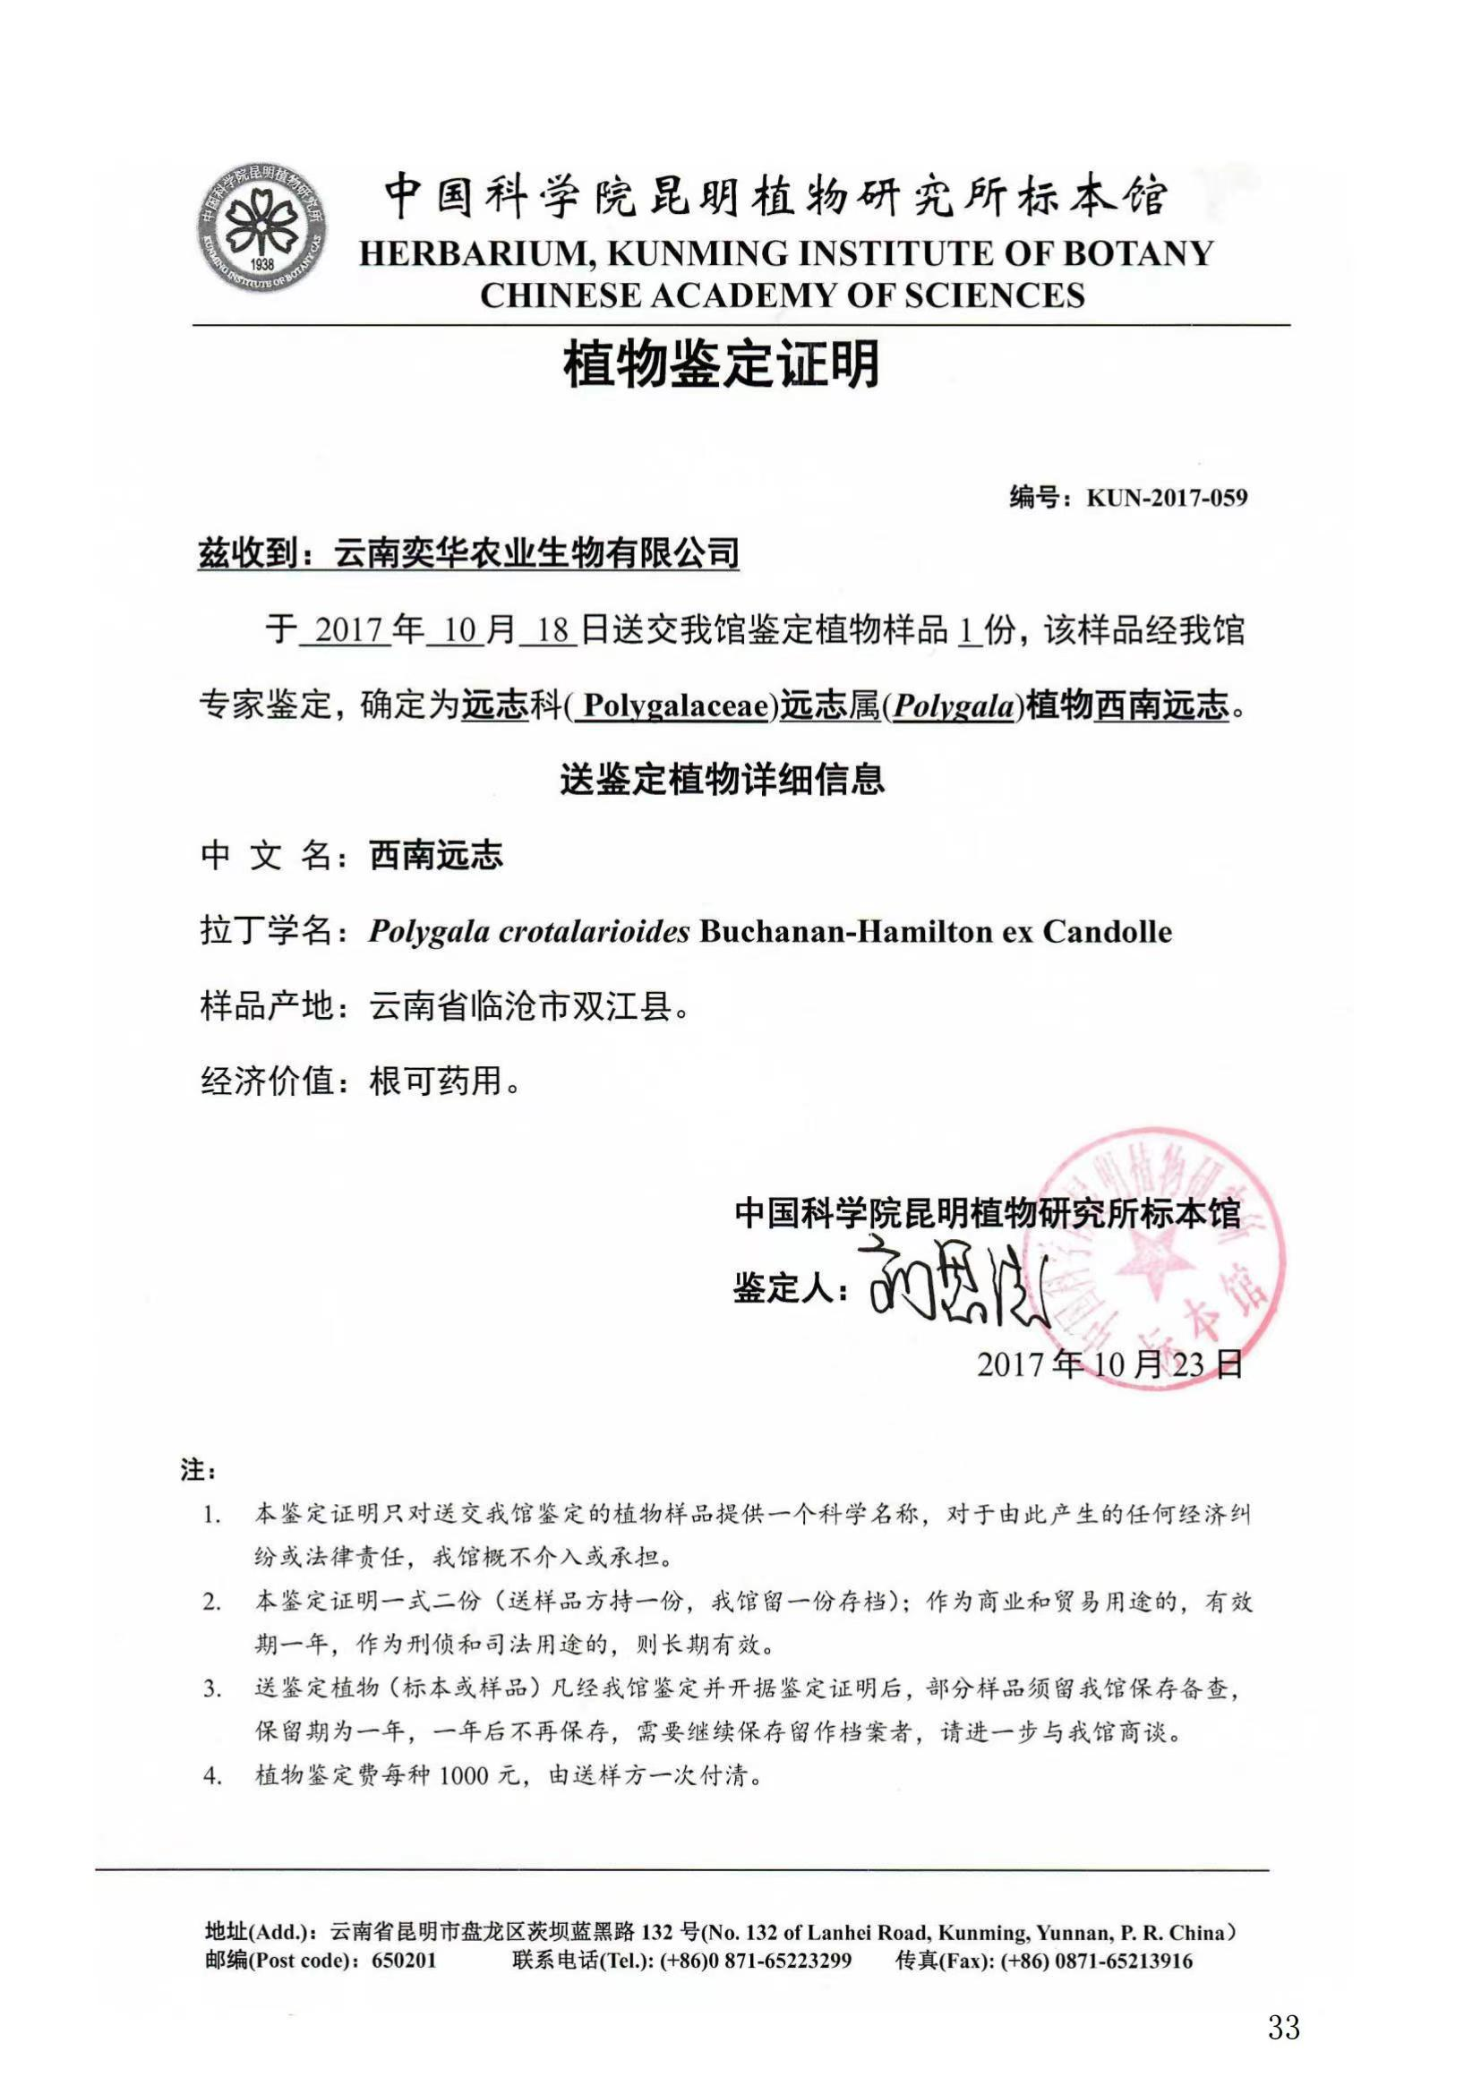

Fig. 3S Rarefaction curve of detected endophytic bacteria genes in leaf, root, and stem of Polygala sibirica Linnaeus and Polygala crotalarioides Buchanan-Hamilton ex Candolle. All curves reached a plateau, indicating that the amount of sequencing data gradually tended to be reasonable
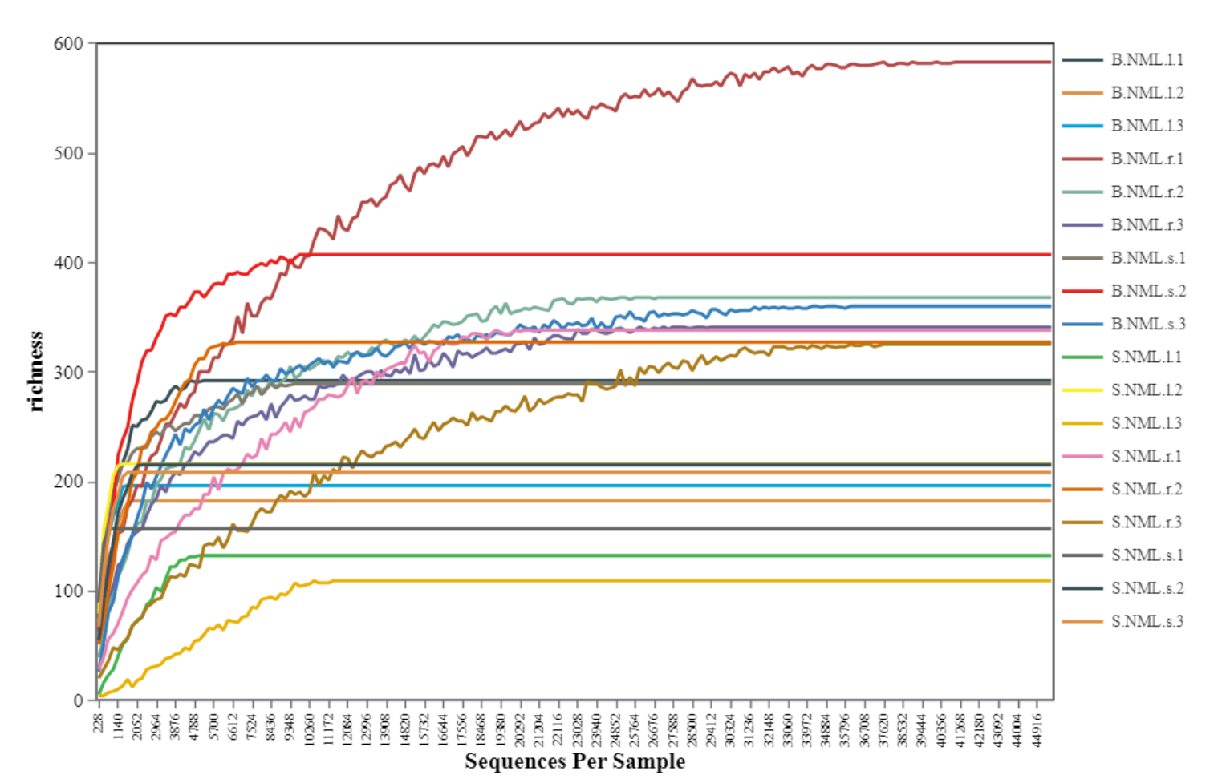

Fig. 4S Significant difference taxa of leaf (a, A3), root(b, A1), and stem(c, A2) samples of P. sibirica Linnaeus by Kruskal-Wallis analysis. [LDA score (log10) = 4]. Statistical signiﬁcance was deﬁned by p < 0.05.

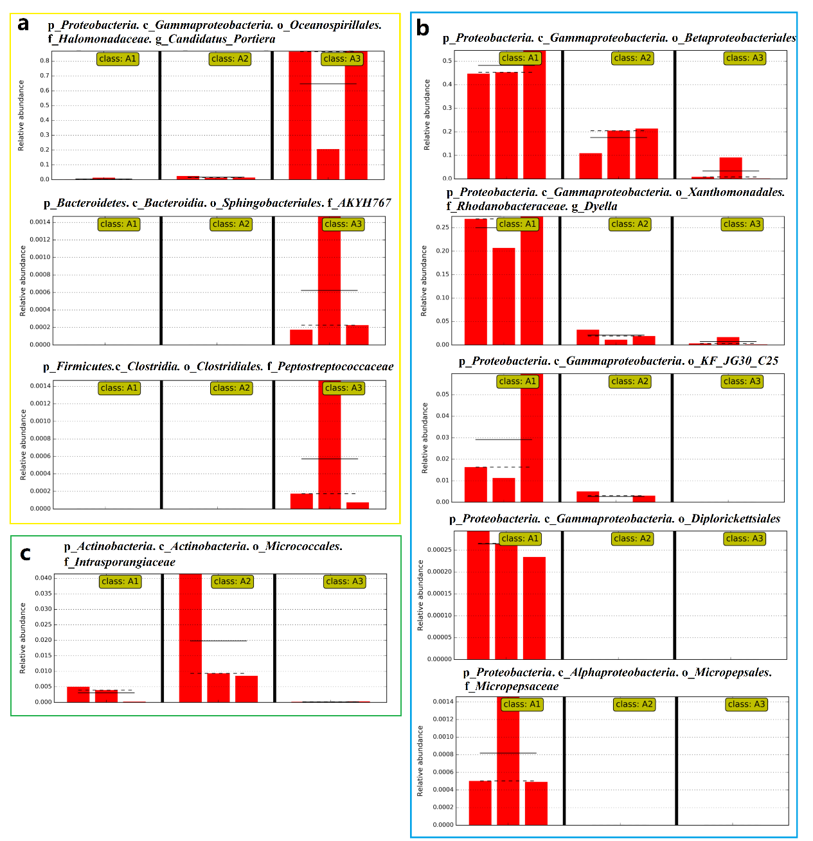

Fig. 5S Significant difference taxa of leaf (a, A3), root(b, A1), and stem(c, A2) samples of P. crotalarioides Buchanan-Hamilton ex Candolle by Kruskal-Wallis analysis. [LDA score (log10) = 4]. Statistical signiﬁcance was deﬁned by p < 0.05.

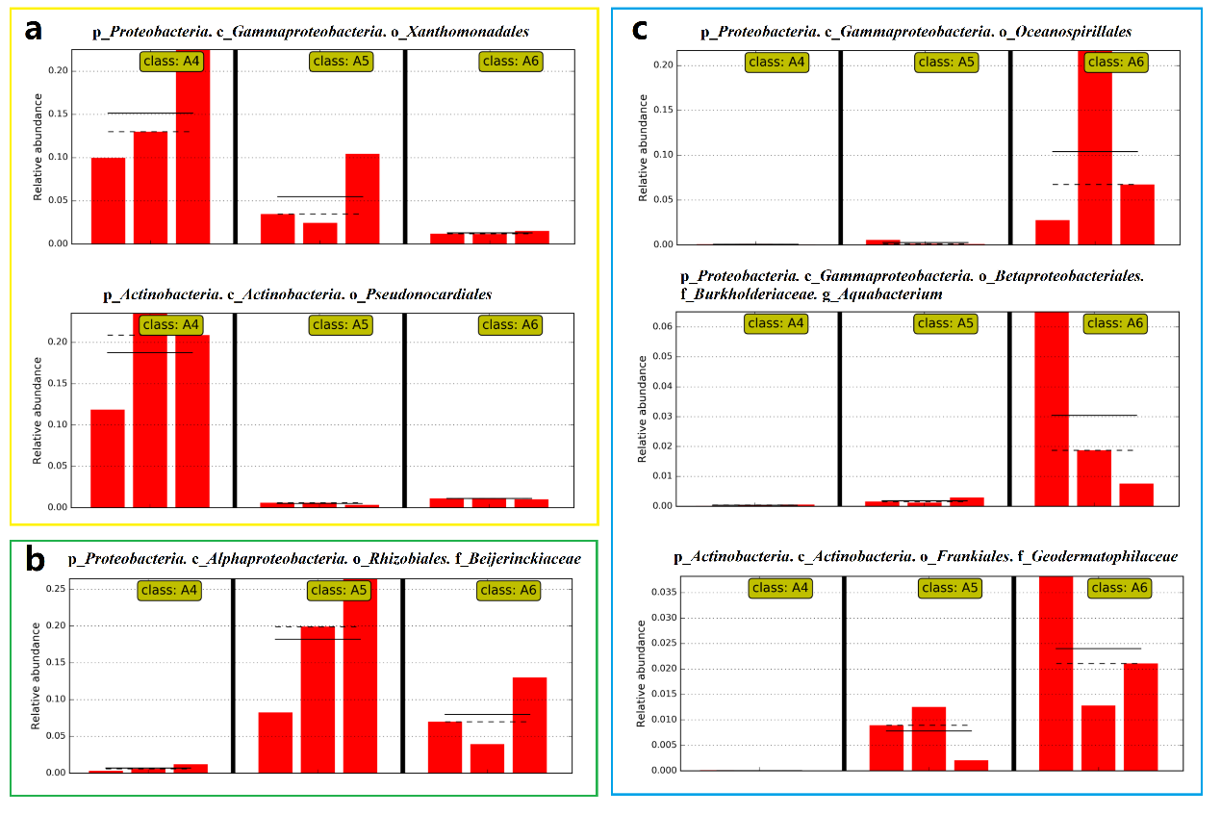

Fig. 6S KEGG pathway variance analysis using PICRUSt. (a) pathways of endophytic bacteria in roots (A1), stems (A2) and leaves (A3) of P. sibirica Linnaeus. (b) pathways of endophytic bacteria in roots (A1), stems (A2) and leaves (A3) of P. crotalarioides Buchanan-Hamilton ex Candolle. The pathways with relative abundance≥ 1% were selected for analysis of variance.
