Supplemental materials

Supplemental Figures

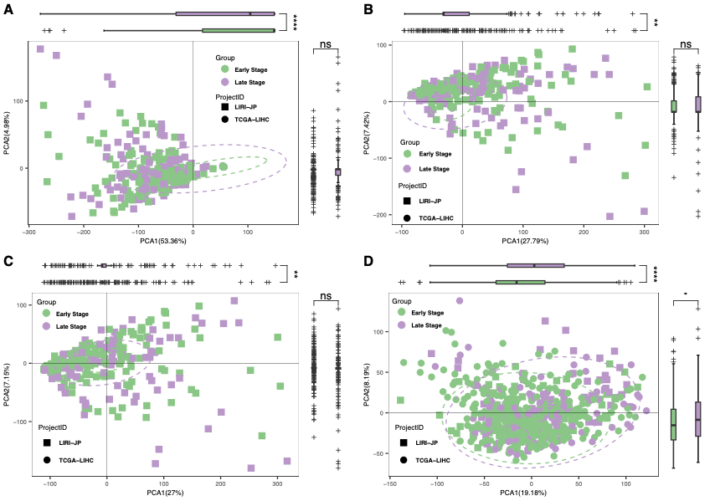
Supplemental Figure 1: PCA of multiple types of gene expression matrix for batch removal on merge data cohort (LIHC-US and LIRI-JP). A. PCA of raw gene expression matrix. B. PCA of adjusted gene expression matrix by ComBat function from sva (version 3.50.0) R package. C. PCA of adjusted gene expression matrix by removeBatchEffect function from limma (version 3.58.1) R package. D. PCA of adjusted gene expression matrix through VOOM and SNM function from limma (version 3.58.11) and SNM (version 1.50.0) R package. Dark green represents the HCC early-stage samples and light purple represents the HCC late-stage samples.

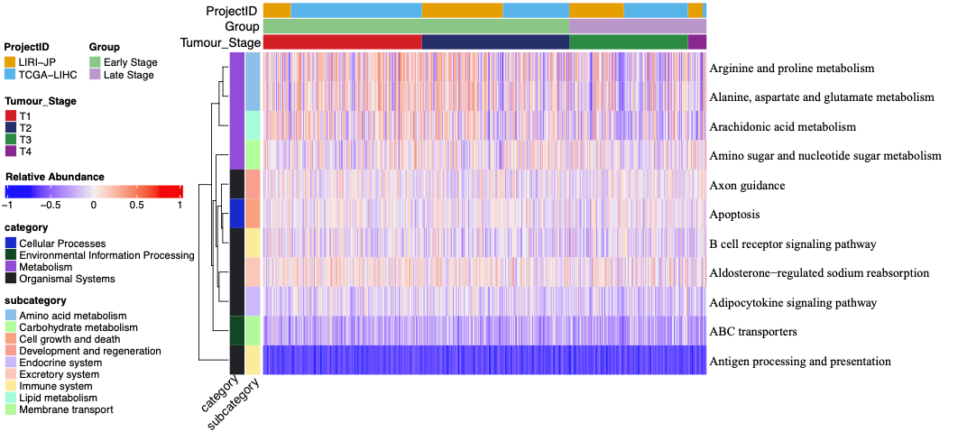
Supplemental Figure 2: GSVA enrichment analysis of gene expression matrix between the HCC early stage and late stage in merge data.

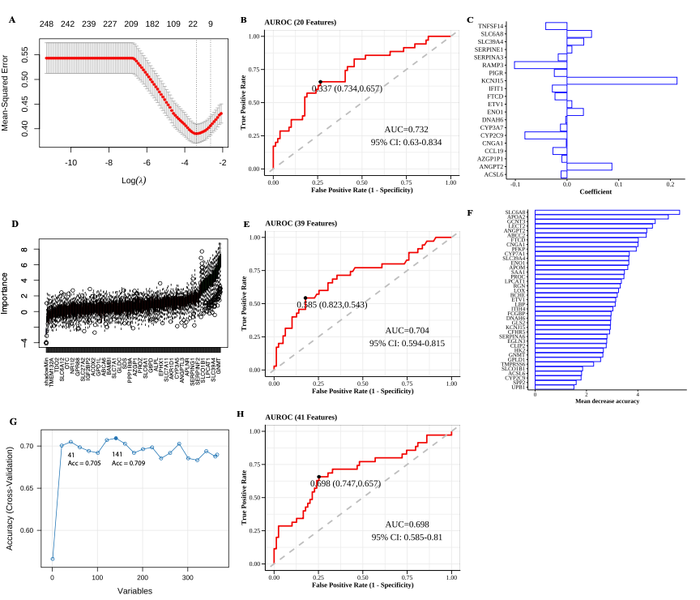
Supplemental Figure 3: Machine learning algorithms to screen potential diagnostic markers from DEGs between the HCC early stage and late stage in merge data. A. LASSO logistic regression found 20 biomarkers. B. The performance of LASSO logistic regression diagnostic model built by 20 biomarkers. C. The coefficient of 20 biomarkers in LASSO logistic regression. D. 39 biomarkers were identified by Boruta and random forest. E. The performance of random forest diagnostic model built by 39 biomarkers. F. The importance scores of 39 biomarkers in random forest. G. 41 biomarkers were identified by Recursive Feature Elimination feature selection. H. The performance of SVM diagnostic model built by 41 biomarkers.

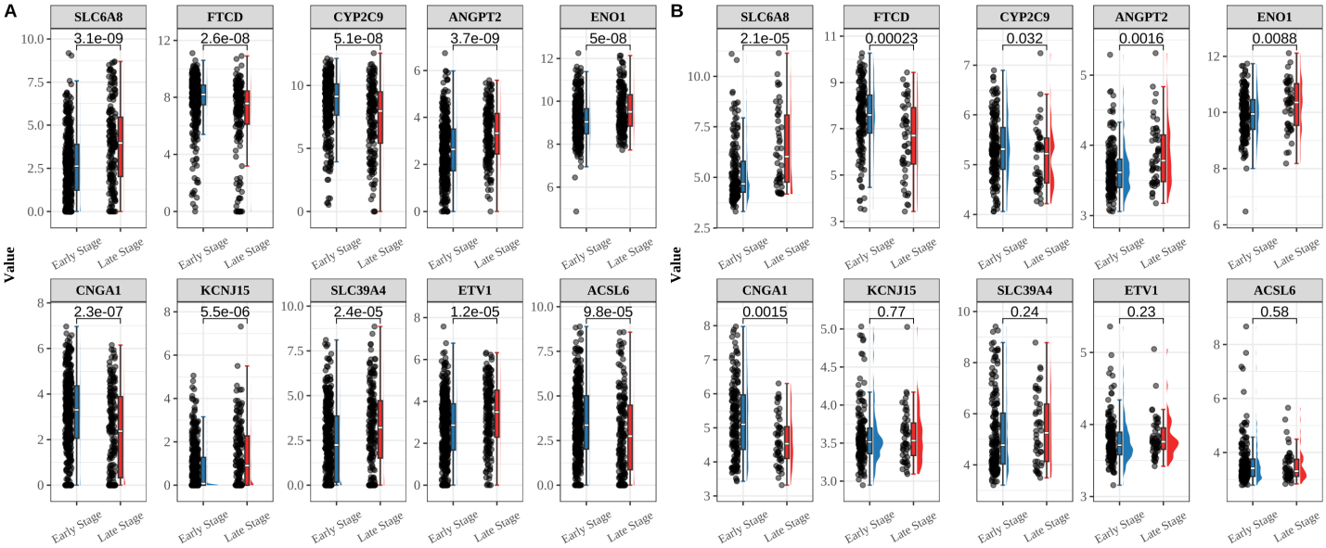

Supplemental Figure 4: 10 overlapping genes screened from machine learning algorithms were validated in the validation cohort. A. The expression level of overlapping genes SLC6A8, FTCD, CYP2C9, ANGPT2, ENO1, CNGA1, KCNJ15, SLC39A4, ETV1, and ACSL6 between the HCC early stage and the HCC late stage in the merge dataset, respectively. B. The expression level of overlapping genes SLC6A8, FTCD, CYP2C9, ANGPT2, ENO1, CNGA1, KCNJ15, SLC39A4, ETV1, and ACSL6 between the HCC early stage and the HCC late stage in the validation GSE14520 dataset, respectively.

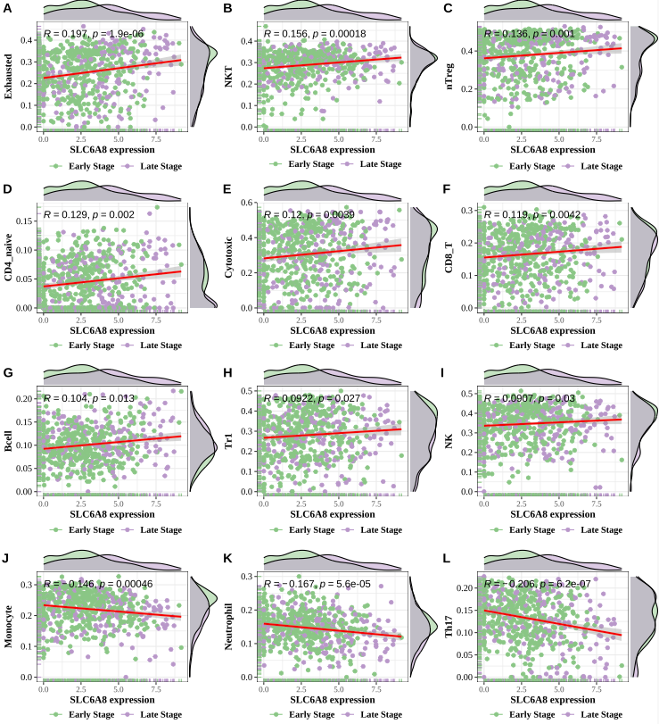
Supplemental Figure 5: Correlation between SLC6A8 and 12 immune cells. A-B. Scatter plots of correlation between SLC6A8 expression and different immune cell contents, Exhausted, NKT, nTreg, CD4 naïve, Cytotoxic, CD8 T, B cell, Tr1, NK, Monocyte, Neutrophil, and Th17.

Supplemental Tables
Supplemental Table 1: Clinicopathologic characteristics of patients.
Characteristic |  | LIRI-JP  (N = 231) | TCGA-LIHC  (N = 344) | GSE14520  (N = 218) | GSE149614  (N = 10)
Age (years)
Age (years) |  | 69 (62, 74) | 61 (51, 68) | 50 (44, 58) | 64 (55, 65)
 | N/A |  | 1
Gender
 | female | 61 (26%) | 110 (32%) | 30 (14%) | 1 (10%)
 | male | 170 (74%) | 234 (68%) | 188 (86%) | 9 (90%)
Group
 | Early Stage | 141 (61%) | 256 (74%) | 170 (78%) | 4 (40%)
 | Late Stage | 90 (39%) | 88 (26%) | 48 (22%) | 6 (60%)
Tumor Stage
 | T1 | 36 (16%) | 170 (49%) | 93 (43%) | 3 (30%)
 | T2 | 105 (45%) | 86 (25%) | 77 (35%) | 1 (10%)
 | T3 | 71 (31%) | 83 (24%) | 48 (22%) | 2 (20%)
 | T4 | 19 (8.2%) | 5 (1.5%) | 0 (0%) | 4 (40%)
Dataset Type
 | Discovery | 231 (100%) | 344 (100%) | 0 (0%) | 0 (0%)
 | Validation | 0 (0%) | 0 (0%) | 218 (100%) | 10 (100%)

Supplemental Table 2: Gene signature from feature selection by least absolute shrinkage and selection operator (LASSO) and logistic regression (LR).
Gene Name | LASSO Coefficient
SLC6A8 | 0.047436726
FTCD | -0.023280924
CYP2C9 | -0.081536246
ANGPT2 | 0.086855552
ENO1 | 0.031724872
RAMP3 | -0.101691327
CNGA1 | -0.001393845
AZGP1P1 | -0.009962116
KCNJ15 | 0.212922829
CYP3A7 | -0.01268626
SERPINA3 | -0.017085184
SLC39A4 | 0.032329432
DNAH6 | -0.002558978
ETV1 | 0.009360757
TNFSF14 | -0.041135365
IFIT1 | -0.02840627
PIGR | -0.024637568
ACSL6 | -0.011459132
CCL19 | -0.027386115
SERPINE1 | 0.009470971

Supplemental Table 3: Gene markers from feature selection by Boruta and random forest (RF).
Gene Name | LASSO Coefficient
SLC6A8 | 5.63
APOA2 | 5.19
GCNT3 | 4.68
LECT2 | 4.57
ANGPT2 | 4.35
ABCC2 | 4.33
FTCD | 4.02
CNGA1 | 4.01
PFKP | 3.94
CYP7A1 | 3.67
ENO1 | 3.65
SLC39A4 | 3.65
APOM | 3.61
SAA1 | 3.48
PROC | 3.46
LPCAT1 | 3.36
RGN | 3.32
LOX | 3.25
BCHE | 3.2
ETV1 | 3.14
LBP | 3.12
ITIH4 | 3.03
FCGBP | 2.96
DNAH6 | 2.95
GLS2 | 2.94
KCNJ15 | 2.93
CFHR5 | 2.9
SERPINA6 | 2.8
EGLN3 | 2.79
CLIP2 | 2.77
HK2 | 2.66
GNMT | 2.64
GPLD1 | 2.55
TMPRSS6 | 2.28
SLCO1B1 | 1.85
ACSL6 | 1.81
CYP2C9 | 1.79
SPP2 | 1.6
UPB1 | 1.51

Supplemental Table 4: Gene markers from feature selection by Recursive Feature Elimination (RFE) and support vector machine (SVM).
Gene Name | Accuracy | Kappa | AccuracySD | KappaSD
CYP7A1 | 0.683224933 | 0.116860206 | 0.035927159 | 0.097182934
CYP2C9 | 0.683224933 | 0.116860206 | 0.035927159 | 0.097182934
GCNT3 | 0.683224933 | 0.116860206 | 0.035927159 | 0.097182934
EGLN3 | 0.683224933 | 0.116860206 | 0.035927159 | 0.097182934
ITIH4 | 0.683224933 | 0.116860206 | 0.035927159 | 0.097182934
DUSP9 | 0.683224933 | 0.116860206 | 0.035927159 | 0.097182934
LBP | 0.683224933 | 0.116860206 | 0.035927159 | 0.097182934
ACSL6 | 0.683224933 | 0.116860206 | 0.035927159 | 0.097182934
CNGA1 | 0.683224933 | 0.116860206 | 0.035927159 | 0.097182934
FTCD | 0.683224933 | 0.116860206 | 0.035927159 | 0.097182934
APOM | 0.683224933 | 0.116860206 | 0.035927159 | 0.097182934
IFIT1 | 0.683224933 | 0.116860206 | 0.035927159 | 0.097182934
SLC6A8 | 0.683224933 | 0.116860206 | 0.035927159 | 0.097182934
ADM | 0.683224933 | 0.116860206 | 0.035927159 | 0.097182934
CUX2 | 0.683224933 | 0.116860206 | 0.035927159 | 0.097182934
SERPINA3 | 0.683224933 | 0.116860206 | 0.035927159 | 0.097182934
SLCO2A1 | 0.683224933 | 0.116860206 | 0.035927159 | 0.097182934
PROC | 0.683224933 | 0.116860206 | 0.035927159 | 0.097182934
NRCAM | 0.683224933 | 0.116860206 | 0.035927159 | 0.097182934
F5 | 0.683224933 | 0.116860206 | 0.035927159 | 0.097182934
SLC39A4 | 0.683224933 | 0.116860206 | 0.035927159 | 0.097182934
GLS2 | 0.683224933 | 0.116860206 | 0.035927159 | 0.097182934
SERPINA6 | 0.683224933 | 0.116860206 | 0.035927159 | 0.097182934
GNMT | 0.683224933 | 0.116860206 | 0.035927159 | 0.097182934
BCHE | 0.683224933 | 0.116860206 | 0.035927159 | 0.097182934
PFKP | 0.683224933 | 0.116860206 | 0.035927159 | 0.097182934
APOA2 | 0.683224933 | 0.116860206 | 0.035927159 | 0.097182934
GPLD1 | 0.683224933 | 0.116860206 | 0.035927159 | 0.097182934
LECT2 | 0.683224933 | 0.116860206 | 0.035927159 | 0.097182934
TNFSF14 | 0.683224933 | 0.116860206 | 0.035927159 | 0.097182934
FST | 0.683224933 | 0.116860206 | 0.035927159 | 0.097182934
ETV1 | 0.683224933 | 0.116860206 | 0.035927159 | 0.097182934
SLC6A9 | 0.683224933 | 0.116860206 | 0.035927159 | 0.097182934
KCNJ15 | 0.683224933 | 0.116860206 | 0.035927159 | 0.097182934
ENO1 | 0.683224933 | 0.116860206 | 0.035927159 | 0.097182934
ESM1 | 0.683224933 | 0.116860206 | 0.035927159 | 0.097182934
CYP3A7 | 0.683224933 | 0.116860206 | 0.035927159 | 0.097182934
MYOM1 | 0.566108996 | 0.01696109 | 0.06772342 | 0.138702244
ANGPT2 | 0.566108996 | 0.01696109 | 0.06772342 | 0.138702244
ABCC2 | 0.566108996 | 0.01696109 | 0.06772342 | 0.138702244
LOX | 0.566108996 | 0.01696109 | 0.06772342 | 0.138702244

