SUPPLEMENTAL FIGURES

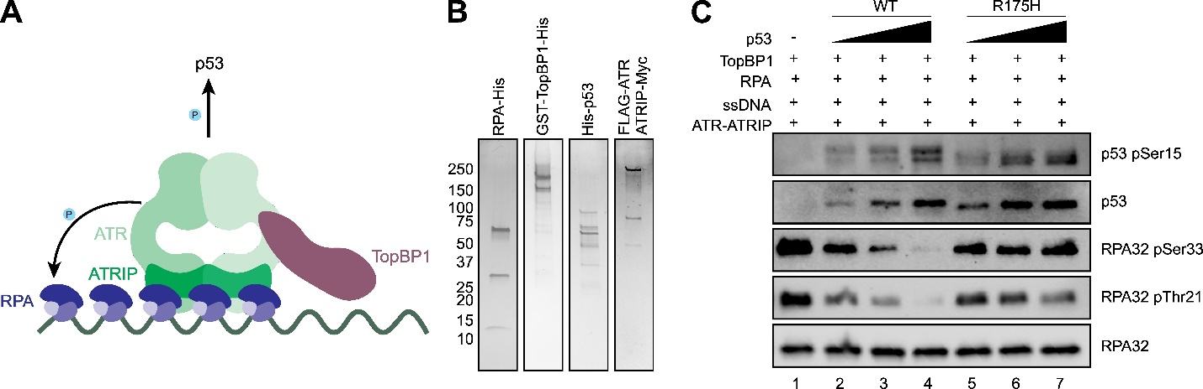
Figure S1. ATR kinase reconstitution. (A) Cartoon illustrating the proteins and DNA substrate used in this work to reconstitute ATR kinase activity. (B) Protein gels of the purified proteins used in this study. (C) Representative western blot of ATR-dependent phosphorylation events upon the titration of WT or R175H p53 into the reconstituted ATR reaction.

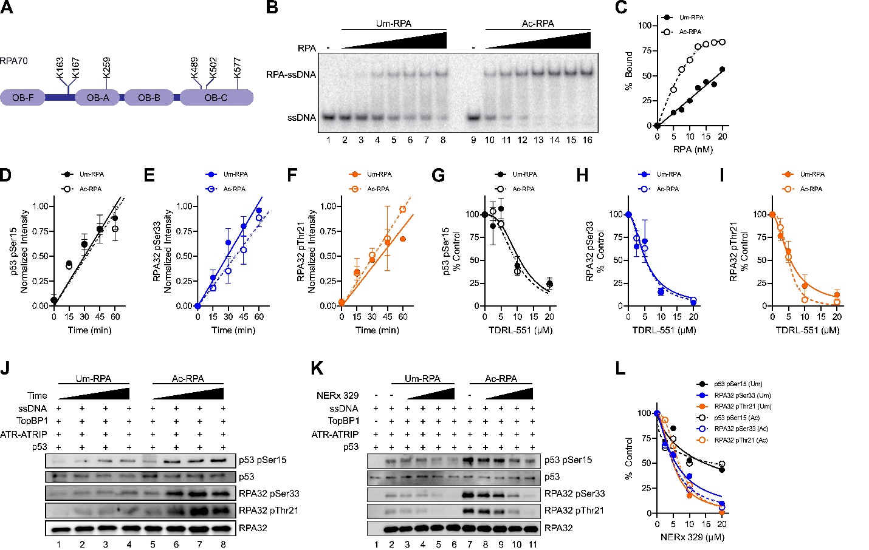
Figure S2. Activation of ATR by Ac-RPA and sensitivity to RPA-DBi. (A) Identified Lys acetylation sites upon in vitro acetylation by p300 (Ref 41 in main text). (B) Representative electrophoretic mobility shift assay of Um- or Ac-RPA binding to ³²P-labelled dT30 ssDNA. (C) Quantification from band intensities in panel B. (D) Quantification of p53 Ser15, (E) RPA32 Ser33, and (F) RPA32 Thr21 phosphorylation by ATR over time utilizing Um- or Ac-RPA from triplicate experiments (mean ± SEM) fit to a linear curve. (J) Representative western blot of ATR-dependent phosphorylation events with differential activation when utilizing Um- or Ac-RPA. (K) Representative western blot of ATR-dependent phosphorylation events with differential activation upon increasing amounts of RPA-DBi NERx 329 (2.5-20 µM) when utilizing Um- or Ac-RPA. (L) Quantification of band intensities from panel K (normalized to lanes 2 and 7 for Um- and Ac-RPA, respectively).
FULL-LENGTH GELS/BLOTS
