Supplementary Material

Spatial pattern in fractional contribution of the different sources
The fractional contribution of different endmembers shows no or weak spatial pattern - Moran’s I statistics never exceeding 0.24 for a given endmember in any of the models (Table S4). Except for Madhupur tract and Araihazar where precipitation was the dominant recharge source, a spatially consistent pattern in the contribution of the different sources was not observed (Figure S4). Even in the districts with high density of isotopic data such as Kolkata neighboring wells showed large and unsystematic variation in the contribution of standing water, precipitation and major rivers.

Limitations of using modern precipitation and river endmember values for deeper groundwater samples
During Pleistocene global water cycle oscillated between periods of intensified and weakened summer monsoon (1–4) thereby affecting precipitation isotope ratios. In the Bengal Basin, precipitation isotope ratios during late Pleistocene and early Holocene (20,000 -10,000 years before present (BP)) are suggested to have been 1 to 3‰ heavier (δ¹⁸O ) than the modern values (5–8). The isotope ratios of Ganges and Brahmaputra River waters were also lighter than the modern values during certain time periods such as around 30,000 years and 19,000 years BP (9, 10), when the northern hemisphere deglaciation resulted in the addition of isotopically depleted Himalayan meltwater to the rivers.
It is possible that the modern values used in our model could over- or underestimate the contributions from precipitation, standing water and river endmembers for Pleistocene groundwater samples. Since river and precipitation endmembers lie on the local meteoric water line (LMWL) their proportional contribution is negatively correlated. Qualitative evaluation of possible range of endmember values (Figure S5) suggests that it might be possible that the endmember values used in our model could have under and overestimated the contribution of precipitation and rivers for some of the deep groundwater samples. The contribution from evaporated standing water for samples falling off the LMWL would have been similar to the values calculated by our model. We acknowledge the limitation of our model endmembers and focus our discussion on groundwater samples between 0 -100 m deep which is recharged primarily during the last 1000 years.

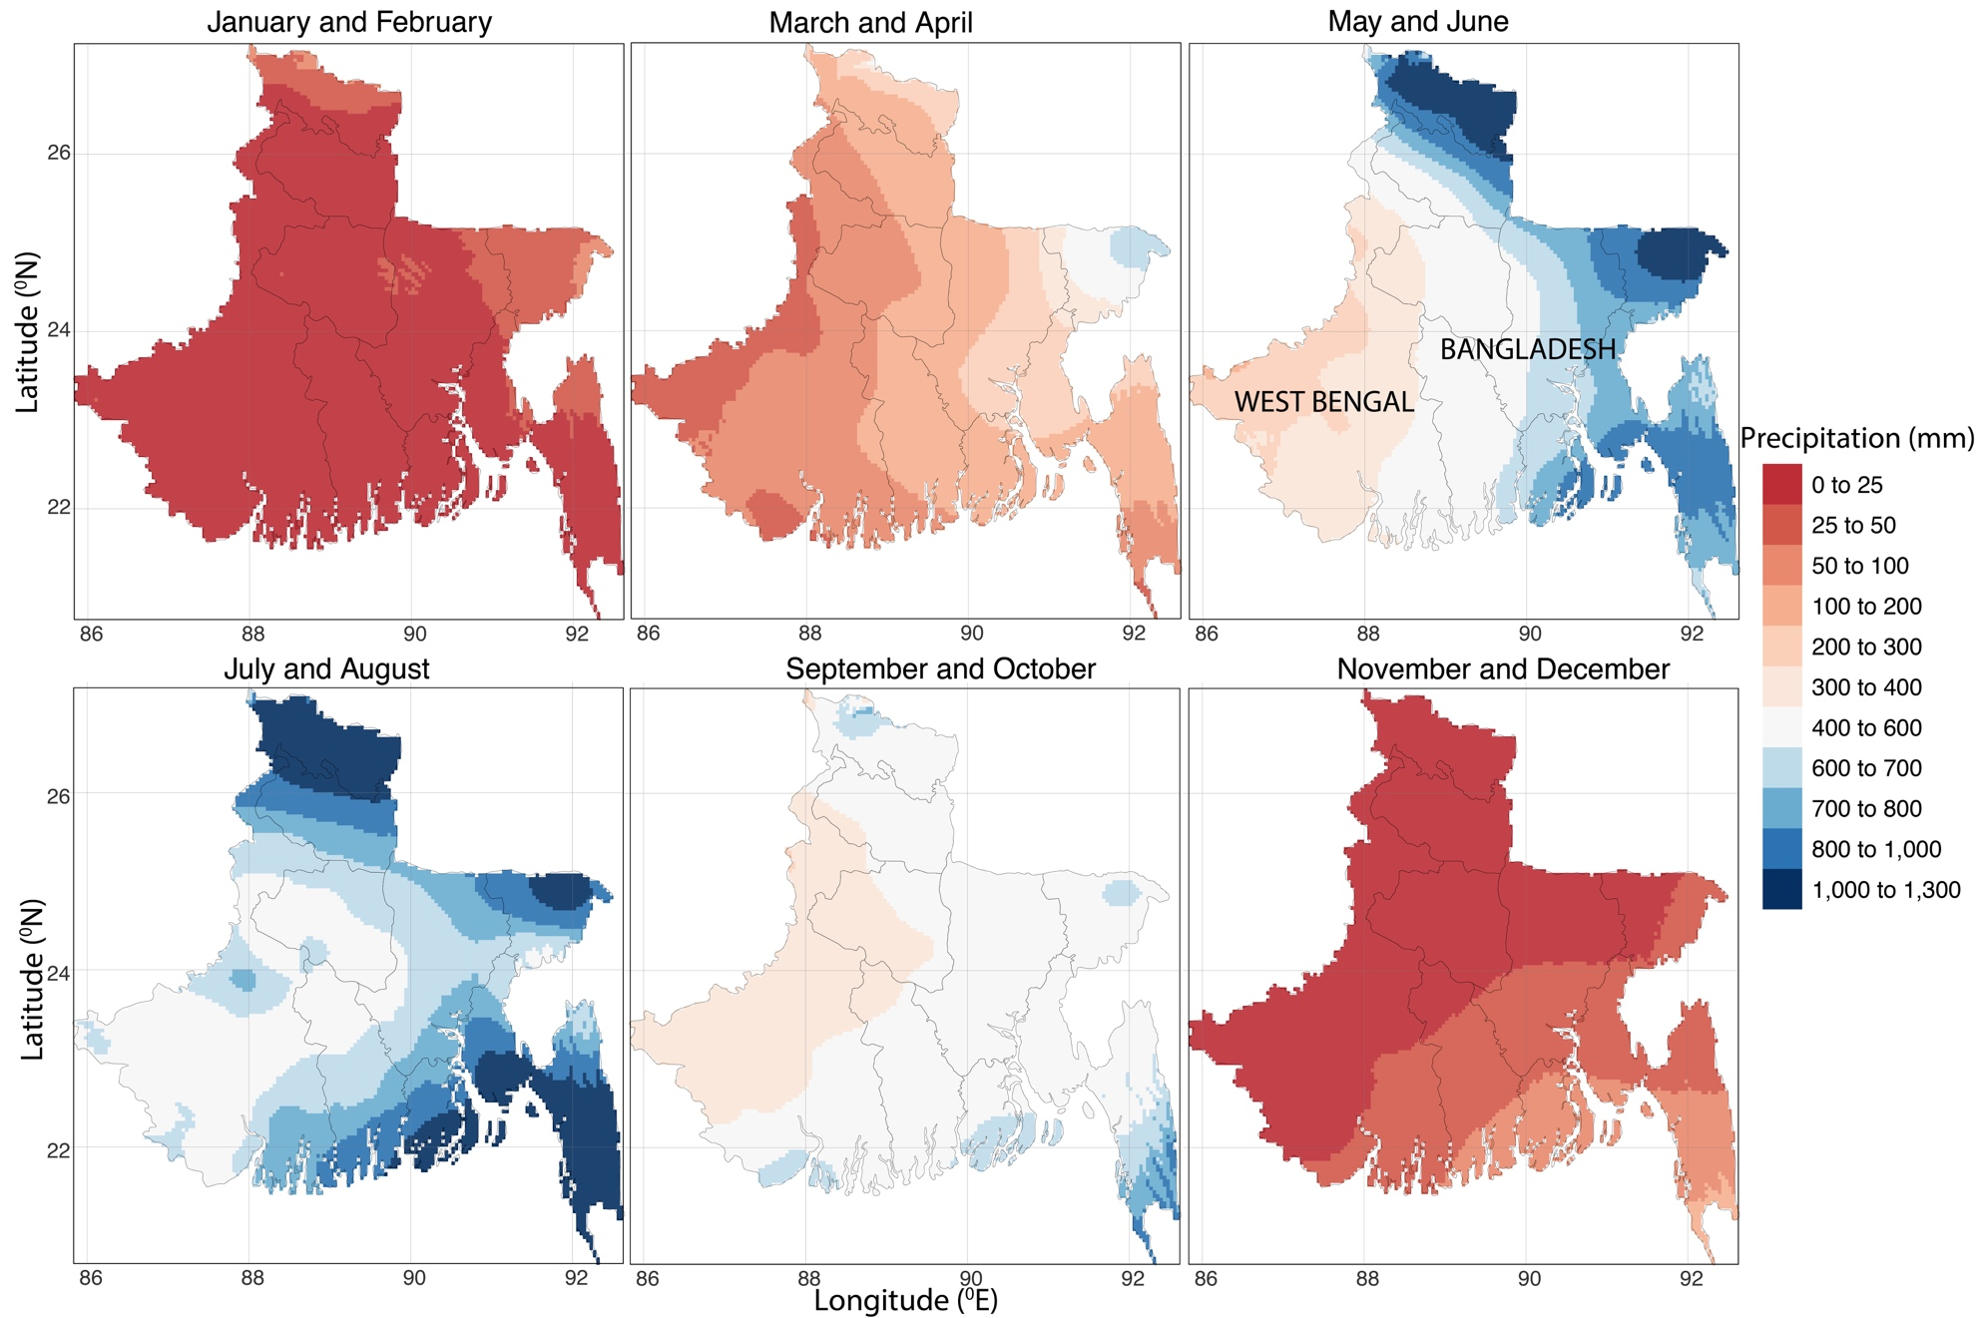

Figure S1: Bi-monthly precipitation amount for the Bengal Basin (data: https://www.worldclim.org/).
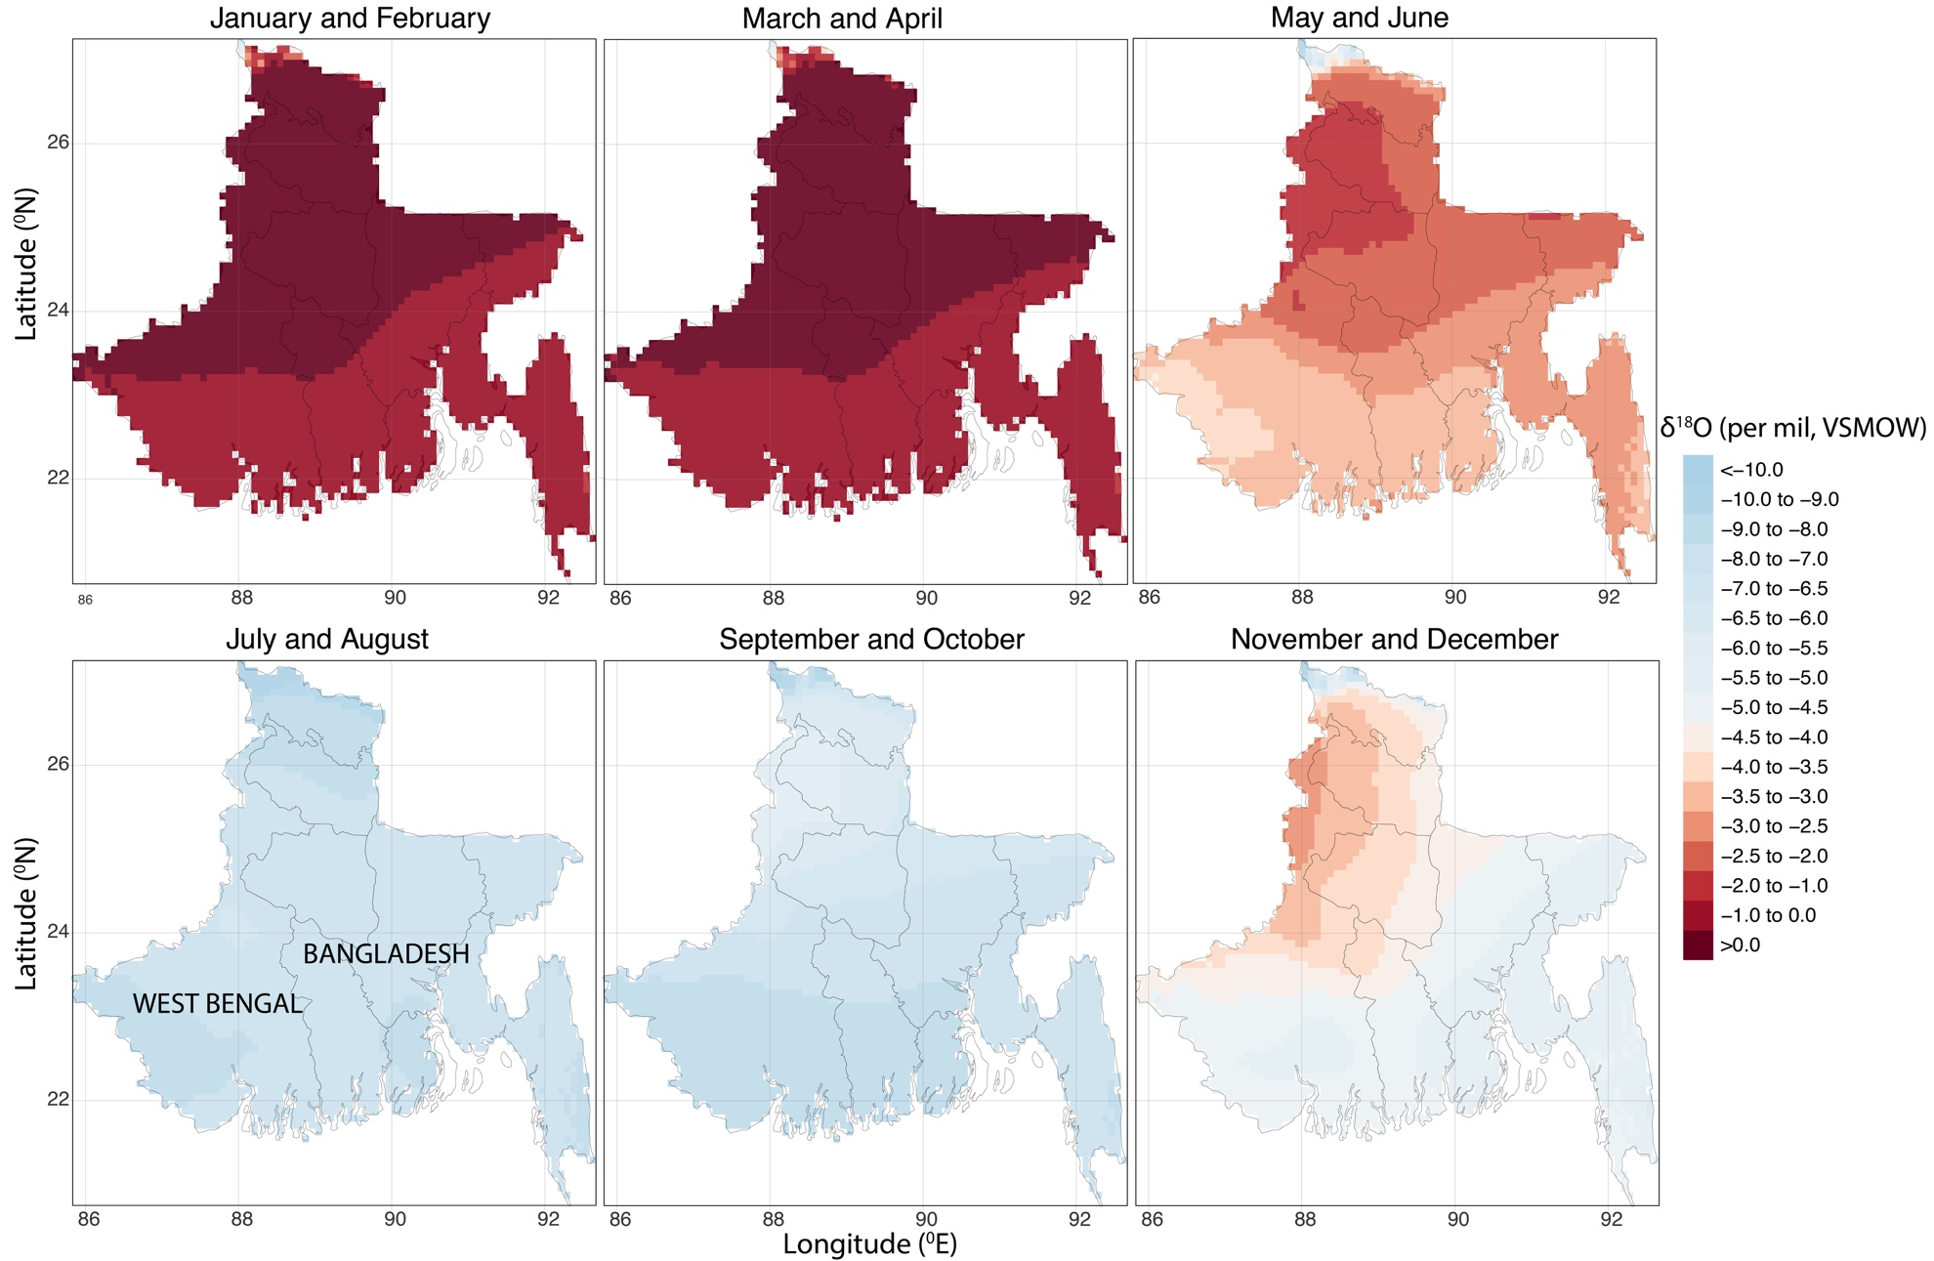

Figure S2: Bi-monthly modeled mean δ¹⁸O precipitation values for the Bengal Basin. Late Monsoon precipitation is isotopically lighter than dry season and early monsoon precipitation (data: https://wateriso.utah.edu/waterisotopes/index.html).
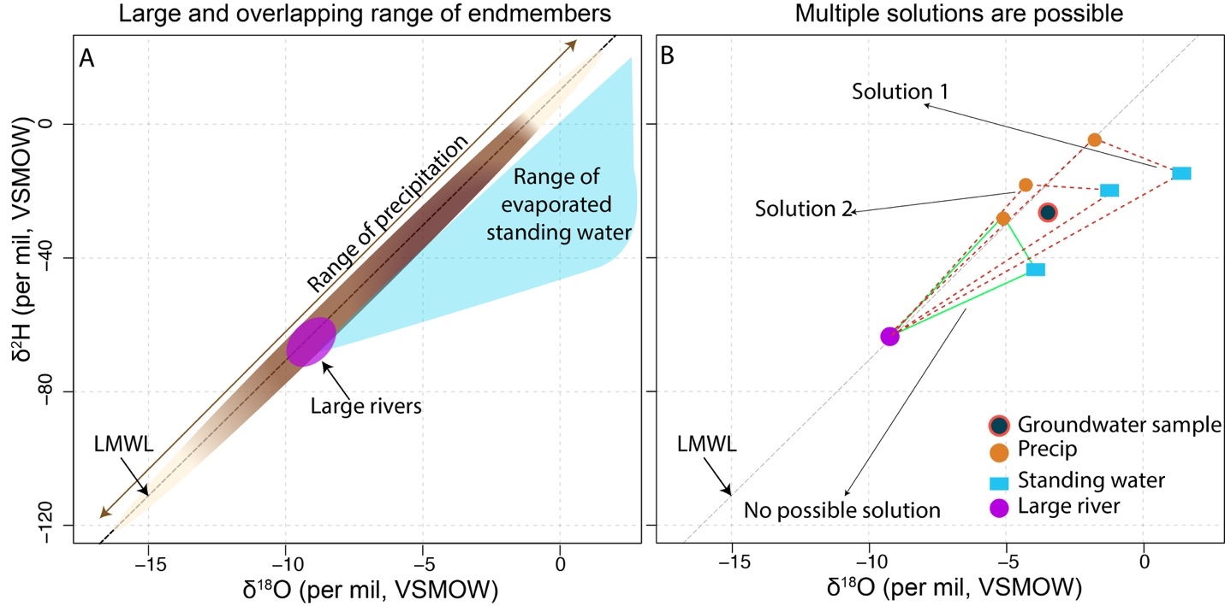Figure S3: (A) Range of precipitation, large rivers and standing water endmembers. (B) For mixing model consisting of precipitation river and standing water endmembers (model 2), two mixing scenarios are shown where a solution is possible – for these scenarios the endmember values are connected by red dashed lines. One mixing scenario is shown where a solution is not possible (connected by green lines).

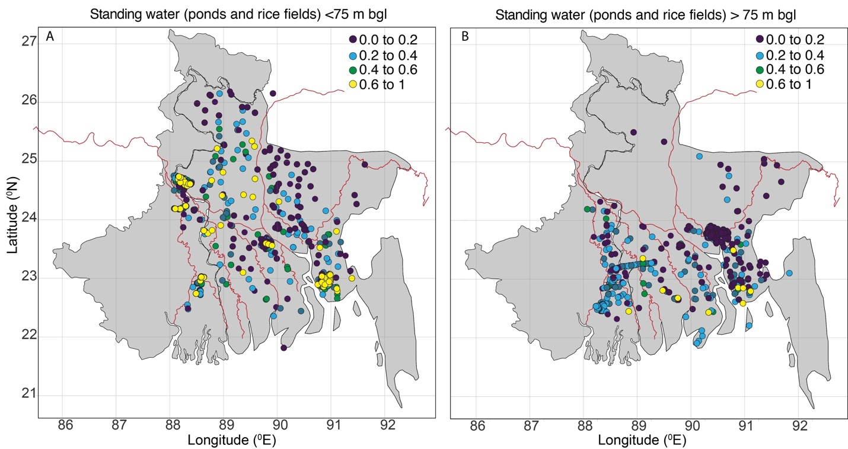
Figure S4: Spatial distribution of fractional contribution of standing water for shallow and deep wells. bgl: below ground level

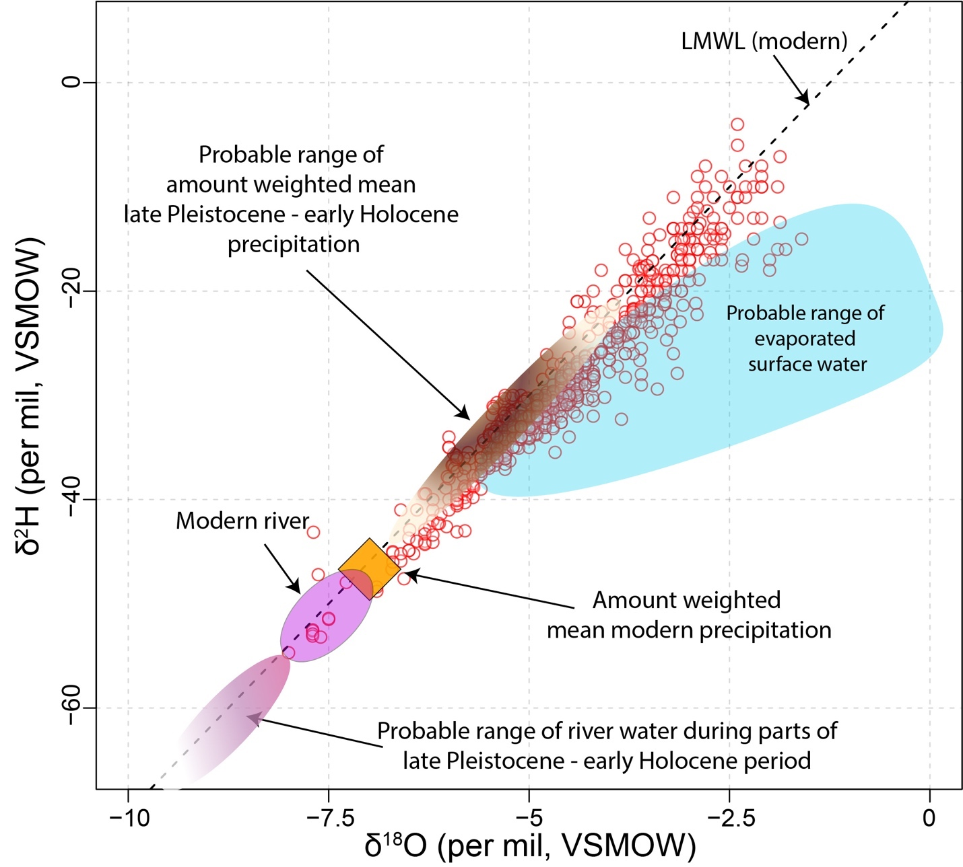
Figure S5: Schematic showing the probable isotope end-member sources values during modern and Late-Pleistocene-Early Holocene time. The red circles, purple square and the orange diamond are the isotope values of groundwater below 75 m depth, large rivers and the amount-weighted mean of modern precipitation. The brown and purple ellipse shows the possible range of mean precipitation and river isotope values during Late Pleistocene -Early Holocene period, see ref. (5). Light blue shaded region is the possible range of evaporated surface water based upon the surface water samples analyzed in this study.

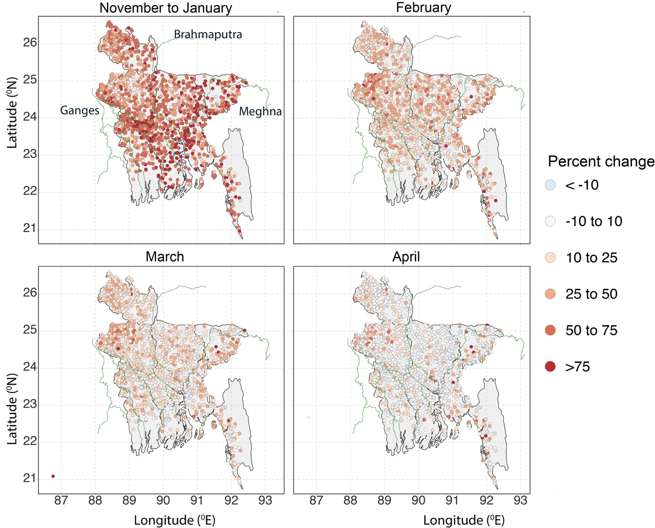
Figure S6: Change in the water table between October (high groundwater level) and April (low groundwater level) expressed as percent change occurring each month(s). Panels (A-D) shows percent discharge in November to January (A), February (B), March (C) and April (D). A percentage change of 75 means that 75% of the net groundwater discharge occurred in that month(s). Negative discharge percent for some wells in April means that lowest groundwater level occurred in March and groundwater level increased in April.

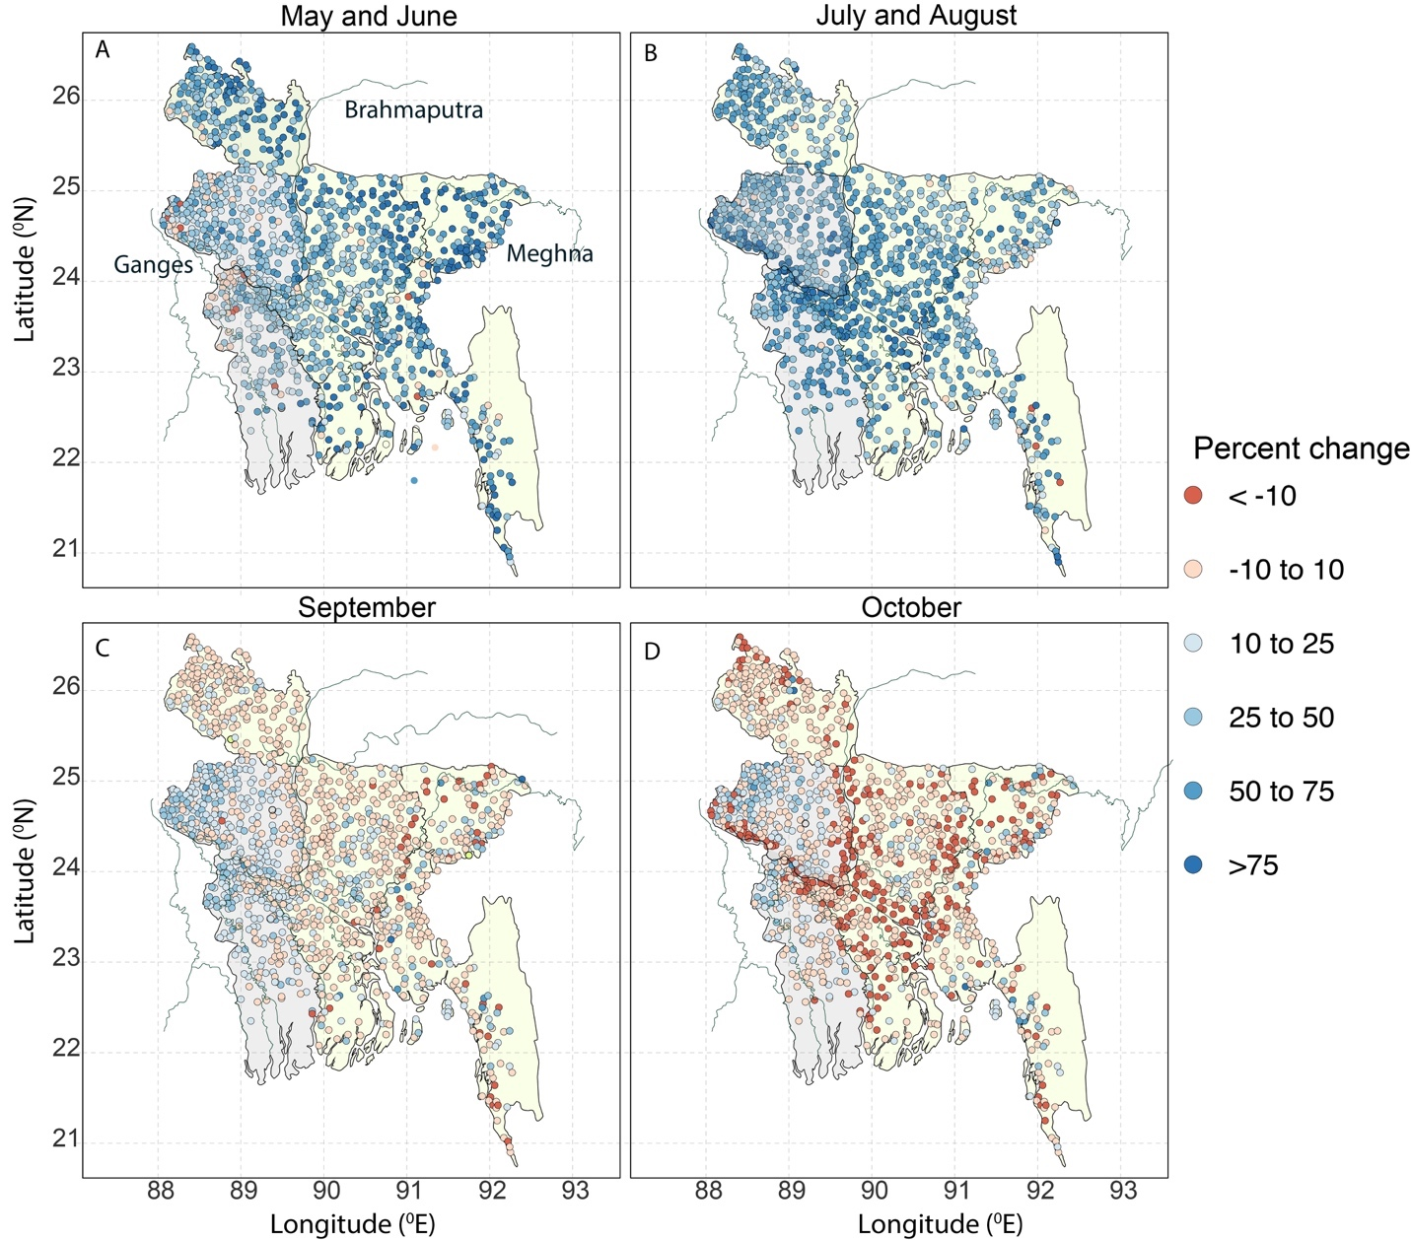
Figure S7: Change in the water table between April (lowest groundwater level) and October (highest groundwater level occurs either in late September or early October) expressed as percent change occurring each month. Panels (A-D) shows percent recharge in May and June (A), July and August (B), September (C) and October (D). Light green and light gray states highlight the states where majority of the recharge occurs in May and June and July and August respectively. A percentage change of 75 means that 75% of the groundwater level recovery occurred in that month. Negative recharge percent for some wells in October means that highest groundwater level occurred in September and from September to October the groundwater level decreased.

Table S1: Data source, year of publication of groundwater, surface water and precipitation stable isotope ratios across the Bengal Basin
Authors | Year of publication | Reference
Aggarwal et al | 2000 | (8)
BAEC | 2010 | (10)
DPHE | 2001 | (11)
Burgess et al | 2007 | (12)
Darling et al | 2002 | (13)
Datta et al | 2011 | (14)
Davies and Exley | 1992 | (11)
Desbarats et al | 2014, 2017 | (15, 16)
Dray et al | 1982 | (11)
Hoque et al | 2012 | (17)
Hoque et al | 2014 | (11)
Khan et al | 2019 | (18)
Kumar et al | 2010 | (19)
Kumar et al | 2019 | (20)
Lamb et al | 2005 | (21)
Lex van Geen | Unpublished | See Table S5
Majumder et al | 2011 | (22)
Majumder et al | 2013 | (23)
McArthur et al | 2016 | (24)
McArthur et al | 2018 | (25)
Mihajlov et al | 2016 | (7)
Mukherjee et al | 2018 | (26)
Mukherjee et al | 2008 | (27)
Munksgaard et al | 2019 | (28)
Neumann et al | 2009 | (29)
Sashidharan M S | 2013 | (30)
Sengupta et al | 2006 | (31)
Sengupta et al | 2008 | (32)
Stahl et al | 2014 | (33)
Stuben et al | 2003 | (34)
Stute et al | 2007 | (35)

Table S2: Data source, year of sample collection, detection limit and precision of tritium measurements across the Bengal Basin. N: number of measurements. NR: Not reported. TU: Tritium Units.
Authors | Year of publication | Year of collection | N | Detection limit | Precision | Reference
Dowling et al | 2002 | 1999-2000 | 41 | NR | ±0.1 TU or ±5% at 5 TU | (36)
Klump et al | 2006 | 2004 | 13 | NR | 0.005 TU | (37)
Stute et al | 2007 | 2000-2001 | 21 | 0.05 TU | ±0.1 to 1.0 TU | (35)
Sikdar and Sahu | 2009 | 2006 | 12 | NR | NR | (38)
BAEC | 2010 |  | 18 | NR | NR | (10)
McArthur et al | 2010 | 2003-2010 | 15 | NR | NR | (39)
Majumder et al | 2011 | 2006-2008 | 36 | NR | NR | (22)
Hossain et al | 2014 |  | 14 | NR | NR | (40)
Mihajalov et al | 2016 | 2003-2004, 2008 | 76 | 0.05-0.1 TU | ﻿0.02–0.16 TU | (7)
Khan et al | 2019 | 2015-2016 | 14 | 0.01 TU | 0.01 TU | (18)

Table S3: Data source, year of publication of C14 measurements across the Bengal Basin. N: number of measurements.
Authors | Year of publication | N | Reference
Aggarwal et al | 2000 | 18 | (8)
BGS-DPHE | 2011 | 8 | (41)
Zheng et al | 2005 | 8 | (42)
Majumder et al | 2011 | 16 | (22)
Hoque et al | 2012 | 18 | (17)
Stahl et al | 2020 | 6 | (43)
Hossain et al | 2014 | 6 | (40)
Mihajlov et al | 2016 | 48 | (7)
Lapworth et al | 2018 | 12 | (44)
BAEC | 2001 | 18 | (10)
Khan et al | 2019 | 55 | (18)

Table S4: Moran’s I statistics for fractional contribution from standing water, precipitation and river. All values are statistically significant (p<0.05).
 | Model 1 | Model 2 | Model 3
Standing water | 0.22 | 0.18 | 0.24
Large River | ------ | 0.14 | ------
Precipitation | 0.20 | 0.13 | 0.23

Table S5: Unpublished deep groundwater isotope ratios from Bangladesh

Longitude | Latitude | Depth (m) | d¹⁸O | D²H
90.63 | 23.76 | 184.62 | -5.57 | -35.01
90.62 | 23.75 | 200.00 | -4.70 | -29.29
90.69 | 23.75 | 264.62 | -4.78 | -28.50
90.68 | 23.78 | 153.85 | -5.34 | -33.84
90.70 | 23.72 | 153.85 | -5.41 | -33.99
90.62 | 23.79 | 246.15 | -5.19 | -32.03
90.62 | 23.79 | 184.62 | -4.21 | -24.46
90.66 | 23.77 | 246.15 | -4.66 | -27.87
90.63 | 23.77 | 246.15 | -4.06 | -23.21
90.62 | 23.79 | 184.62 | -4.38 | -25.29
90.63 | 23.78 | 215.38 | -4.95 | -30.56
90.59 | 23.77 | 246.15 | -3.95 | -29.18
90.64 | 23.79 | 250.77 | -6.04 | -39.46
90.67 | 23.73 | 215.38 | -6.22 | -40.81
90.69 | 23.78 | 184.62 | -4.94 | -30.22
90.62 | 23.80 | 215.38 | -4.93 | -30.23
90.61 | 23.81 | 270.77 | -5.06 | -31.09
90.69 | 23.78 | 203.08 | -4.87 | -29.49
90.64 | 23.78 | 230.77 | -4.20 | -24.03
90.66 | 23.79 | 276.92 | -5.79 | -37.54
90.62 | 23.79 | 178.46 | -4.37 | -25.72
90.71 | 23.67 | 215.38 | -4.00 | -22.35
90.62 | 23.75 | 246.15 | -4.92 | -30.16
90.60 | 23.82 | 246.15 | -2.99 | -15.03
90.63 | 23.79 | 250.77 | -4.92 | -30.72
90.62 | 23.79 | 200.00 | -4.71 | -28.71
90.64 | 23.80 | 184.62 | -5.71 | -36.71
90.62 | 23.79 | 233.85 | -5.20 | -32.07
90.65 | 23.77 | 230.77 | -4.75 | -28.72
90.62 | 23.80 | 215.38 | -5.14 | -31.12
90.66 | 23.78 | 200.00 | -5.50 | -33.91
90.59 | 23.77 | 215.38 | -5.60 | -34.86
90.64 | 23.84 | 215.38 | -6.07 | -36.42
90.65 | 23.79 | 169.23 | -5.51 | -33.74
90.67 | 23.79 | 215.38 | -5.67 | -35.29
90.66 | 23.78 | 246.15 | -5.50 | -33.89
90.72 | 23.72 | 307.38 | -5.39 | -32.68
90.62 | 23.75 | 190.77 | -4.77 | -28.45
90.65 | 23.79 | 190.77 | -5.67 | -35.70
90.68 | 23.78 | 230.77 | -5.30 | -32.53
90.62 | 23.75 | 203.08 | -4.94 | -29.25
90.68 | 23.75 | 246.15 | -4.99 | -29.96
90.63 | 23.76 | 184.62 | -5.56 | -34.41
90.66 | 23.79 | 246.15 | -5.82 | -36.53
90.65 | 23.80 | 172.31 | -5.94 | -36.84
90.66 | 23.79 | 221.54 | -5.81 | -36.46
90.66 | 23.77 | 215.38 | -4.44 | -25.56
90.72 | 23.72 | 246.15 | -5.62 | -34.68
90.63 | 23.76 | 200.00 | -4.56 | -26.16
90.64 | 23.76 | 184.62 | -4.12 | -22.52
90.70 | 23.80 | 169.23 | -5.83 | -36.75
90.61 | 23.76 | 184.62 | -4.65 | -27.15
90.72 | 23.69 | 224.62 | -4.48 | -25.79
90.66 | 23.79 | 175.38 | -5.69 | -35.42
90.62 | 23.75 | 200.00 | -4.93 | -29.58
90.66 | 23.79 | 230.77 | -5.49 | -33.68
90.71 | 23.72 | 246.15 | -5.58 | -34.25
90.66 | 23.79 | 215.38 | -5.86 | -35.73
90.71 | 23.71 | 184.62 | -5.01 | -29.80
90.64 | 23.76 | 200.00 | -3.62 | -17.77
90.66 | 23.79 | 200.00 | -5.76 | -34.95
90.72 | 23.72 | 246.15 | -5.46 | -32.84
90.67 | 23.77 | 246.15 | -4.74 | -27.75
90.70 | 23.72 | 184.62 | -5.60 | -34.87
90.67 | 23.78 | 209.23 | -5.36 | -32.79
90.66 | 23.79 | 184.62 | -5.82 | -36.38
90.66 | 23.79 | 246.15 | -5.69 | -35.37
90.71 | 23.70 | 307.38 | -4.84 | -28.32
90.72 | 23.71 | 307.38 | -5.24 | -31.68
90.64 | 23.76 | 215.38 | -4.35 | -24.42

References
1. D. Fleitmann, S. J. Burns, A. Mangini, M. Mudelsee, J. Kramers, I. Villa, U. Neff, A. A. Al-Subbary, A. Buettner, D. Hippler, A. Matter, Holocene ITCZ and Indian monsoon dynamics recorded in stalagmites from Oman and Yemen (Socotra). Quat. Sci. Rev. 26, 170–188 (2007).
2. F. Sirocko, M. Sarnthein, H. Erlenkeuser, H. Lange, M. Arnold, J. C. Duplessy, Century-scale events in monsoonal climate over the past 24,000 years. Nature. 364, 322–324 (1993).
3. P. U. Clark, A. S. Dyke, J. D. Shakun, A. E. Carlson, J. Clark, B. Wohlfarth, J. X. Mitrovica, S. W. Hostetler, A. M. McCabe, The Last Glacial Maximum. Science (80-. ). 325, 710–714 (2009).
4. A. Sarkar, R. Ramesh, B. L. K. Somayajulu, R. Agnihotri, A. J. T. Jull, O. S. Burr, High resolution Holocene monsoon record from the eastern Arabian Sea. Earth Planet. Sci. Lett. 177, 209–218 (2000).
5. S. Jasechko, Late-Pleistocene precipitation δ18O interpolated across the global landmass. Geochemistry, Geophys. Geosystems. 17, 3274–3288 (2016).
6. P. K. Kumar, S. T. Band, R. Ramesh, N. Awasthi, Monsoon variability and upper ocean stratification during the last ∼66 ka over the Andaman Sea: Inferences from the δ18O records of planktonic foraminifera. Quat. Int. 479, 12–18 (2018).
7. I. Mihajlov, M. Stute, P. Schlosser, B. J. Mailloux, Y. Zheng, I. Choudhury, K. M. Ahmed, A. van Geen, Recharge of low-arsenic aquifers tapped by community wells in Araihazar, Bangladesh, inferred from environmental isotopes. Water Resour. Res. 52, 3324–3349 (2016).
8. P. Aggarwal, A. Basu, J. P. Robert, K. Kulkarni, S. Tarafdar, M. Ali, N. Ahmed, A. Hussain, M. Rahman, S. Reazuddin Ahmed, “A Report on Isotope Hydrology of Groundwater in Bangladesh: Implications for Characterization and Mitigation of Arsenic in Groundwater Work Performed within an IAEA-TC Project (BGD/8/016)” (2000).
9. A. V. Sijinkumar, S. Clemens, B. N. Nath, W. Prell, R. Benshila, M. Lengaigne, δ18O and salinity variability from the Last Glacial Maximum to Recent in the Bay of Bengal and Andaman Sea. Quat. Sci. Rev. 135, 79–91 (2016).
10. P. Ravenscroft, J. M. McArthur, M. S. Rahman, Identifying multiple deep aquifers in the Bengal Basin: Implications for resource management. Hydrol. Process. 32, 3615–3632 (2018).
11. M. A. Hoque, J. M. McArthur, P. K. Sikdar, J. D. Ball, T. N. Molla, Tracing recharge to aquifers beneath an Asian megacity with Cl/Br and stable isotopes: The example of Dhaka, Bangladesh. Hydrogeol. J. 22, 1549–1560 (2014).
12. W. Burgess, K. M. Ahmed, A. Carruthers, H. Cheetham, J. Cobbing, M. Cuthbert, S. Mather, E. McCarthy, Trends in arsenic concentration at tubewells in Bangladesh: conceptual models, numerical models, and monitoring proxies. Trace Met. other Contam. Environ. 9 (2007), pp. 63–83.
13. W. G. Darling, W. G. Burgess, M. K. Hasan, “Isotopic evidence for induced river recharge to the Dupi Tila aquifer in the Dhaka urban area, Bangladesh” (International Atomic Energy Agency (IAEA), 2002), (available at http://inis.iaea.org/search/search.aspx?orig_q=RN:33037888).
14. S. Datta, A. W. Neal, T. J. Mohajerin, T. Ocheltree, B. E. Rosenheim, C. D. White, K. H. Johannesson, Geophys. Res. Lett., in press, doi:10.1029/2011GL049301.
15. A. J. Desbarats, T. Pal, P. K. Mukherjee, R. D. Beckie, Geochemical Evolution of Groundwater Flowing Through Arsenic Source Sediments in an Aquifer System of West Bengal, India. Water Resour. Res. 53, 8715–8735 (2017).
16. A. J. Desbarats, C. E. M. Koenig, T. Pal, P. K. Mukherjee, R. D. Beckie, Groundwater flow dynamics and arsenic source characterization in an aquifer system of West Bengal, india. Water Resour. Res. 50, 4974–5002 (2014).
17. M. A. Hoque, W. G. Burgess, 14C dating of deep groundwater in the Bengal Aquifer System, Bangladesh: Implications for aquifer anisotropy, recharge sources and sustainability. J. Hydrol. 444–445, 209–220 (2012).
18. M. R. Khan, H. A. Michael, B. Nath, B. L. Huhmann, C. F. Harvey, A. Mukherjee, I. Choudhury, M. Chakraborty, M. S. Ullah, K. M. Ahmed, S. L. Goodbred, P. Schlosser, B. C. Bostick, B. J. Mailloux, T. Ellis, A. van Geen, High-Arsenic Groundwater in the Southwestern Bengal Basin Caused by a Lithologically Controlled Deep Flow System. Geophys. Res. Lett. 46, 13062–13071 (2019).
19. B. Kumar, S. P. Rai, U. S. Kumar, S. K. Verma, P. Garg, S. V. V. Kumar, R. Jaiswal, B. K. Purendra, S. R. Kumar, N. G. Pande, Isotopic characteristics of Indian precipitation. Water Resour. Res. 46 (2010), doi:10.1029/2009WR008532.
20. A. Kumar, P. Sanyal, S. Agrawal, Spatial distribution of δ 18 O values of water in the Ganga river basin: Insight into the hydrological processes. J. Hydrol. 571, 225–234 (2019).
21. L. Lambs, K. Balakrishna, F. Brunet, J. L. Probst, Oxygen and hydrogen isotopic composition of major Indian rivers: a first global assessment. Hydrol. Process. 19, 3345–3355 (2005).
22. R. K. Majumder, M. A. Halim, B. B. Saha, R. Ikawa, T. Nakamura, M. Kagabu, J. Shimada, Groundwater flow system in Bengal Delta, Bangladesh revealed by environmental isotopes. Environ. Earth Sci. 64, 1343–1352 (2011).
23. R. K. Majumder, M. A. Halim, J. Shimada, B. B. Saha, A. Zahid, M. Q. Hasan, M. S. Islam, Hydrochemistry and isotopic studies to identify Ganges River and riverbank groundwater interaction, southern Bangladesh. Arab. J. Geosci. 6, 4585–4591 (2013).
24. J. M. McArthur, U. Ghosal, P. K. Sikdar, J. D. Ball, Arsenic in Groundwater: The Deep Late Pleistocene Aquifers of the Western Bengal Basin. Environ. Sci. Technol. 50, 3469–3476 (2016).
25. J. M. McArthur, P. K. Sikdar, M. J. Leng, U. Ghosal, I. Sen, Groundwater Quality beneath an Asian Megacity on a Delta: Kolkata’s (Calcutta’s) Disappearing Arsenic and Present Manganese. Environ. Sci. Technol. 52, 5161–5172 (2018).
26. A. Mukherjee, A. E. Fryar, E. M. Eastridge, R. S. Nally, M. Chakraborty, B. R. Scanlon, Controls on high and low groundwater arsenic on the opposite banks of the lower reaches of River Ganges, Bengal basin, India. Sci. Total Environ. 645, 1371–1387 (2018).
27. A. Mukherjee, A. E. Fryar, P. D. Howell, Regional hydrostratigraphy and groundwater flow modeling in the arsenic-affected areas of the western Bengal basin, West Bengal, India. Hydrogeol. J. 15, 1397–1418 (2007).
28. N. C. Munksgaard, N. Kurita, R. Sánchez-Murillo, N. Ahmed, L. Araguas, D. L. Balachew, M. I. Bird, S. Chakraborty, N. Kien Chinh, K. M. Cobb, S. A. Ellis, G. Esquivel-Hernández, S. Y. Ganyaglo, J. Gao, D. Gastmans, K. F. Kaseke, S. Kebede, M. R. Morales, M. Mueller, S. C. Poh, V. dos Santos, H. Shaoneng, L. Wang, H. Yacobaccio, C. Zwart, Data Descriptor: Daily observations of stable isotope ratios of rainfall in the tropics. Sci. Rep. 9 (2019), doi:10.1038/s41598-019-50973-9.
29. R. B. Neumann, K. N. Ashfaque, A. B. M. Badruzzaman, M. Ashraf Ali, J. K. Shoemaker, C. F. Harvey, Anthropogenic influences on groundwater arsenic concentrations in Bangladesh. Nat. Geosci. 3, 46–52 (2010).
30. S. M. Sasidharan, thesis, Kansas State University (2013).
31. S. Sengupta, A. Sarkar, Stable isotope evidence of dual (Arabian Sea and Bay of Bengal) vapour sources in monsoonal precipitation over north India. Earth Planet. Sci. Lett. 250, 511–521 (2006).
32. S. Sengupta, J. M. Mcarthur, A. Sarkar, M. J. Leng, P. Ravenscroft, R. J. Howarth, D. M. Banerjee, Do ponds cause arsenic-pollution of groundwater in the Bengal Basin? An answer from West Bengal. Environ. Sci. Technol. 42, 5156–5164 (2008).
33. M. O. Stahl, M. H. Tarek, D. C. J. Yeo, A. B. M. Badruzzaman, C. F. Harvey, Crab burrows as conduits for groundwater-surface water exchange in Bangladesh. Geophys. Res. Lett. 41, 8342–8347 (2014).
34. D. Stüben, Z. Berner, D. Chandrasekharam, J. Karmakar, in Applied Geochemistry (Elsevier Ltd, 2003), vol. 18, pp. 1417–1434.
35. M. Stute, Y. Zheng, P. Schlosser, A. Horneman, R. K. Dhar, S. Datta, M. A. Hoque, A. A. Seddique, M. Shamsudduha, K. M. Ahmed, A. van Geen, Hydrological control of As concentrations in Bangladesh groundwater. Water Resour. Res. 43 (2007), doi:10.1029/2005WR004499.
36. C. B. Dowling, R. J. Poreda, A. R. Basu, S. L. Peters, P. K. Aggarwal, Geochemical study of arsenic release mechanisms in the Bengal Basin groundwater. Water Resour. Res. 38, 12-1-12–18 (2002).
37. S. Klump, R. Kipfer, O. A. Cirpka, C. F. Harvey, M. S. Brennwald, K. N. Ashfaque, A. B. M. Badruzzaman, S. J. Hug, D. M. Imboden, Groundwater dynamics and arsenic mobilization in Bangladesh assessed using noble gases and tritium. Environ. Sci. Technol. 40, 243–250 (2006).
38. P. K. Sikdar, P. Sahu, Understanding wetland sub-surface hydrology using geologic and isotopic signatures. Hydrol. Earth Syst. Sci. 13, 1313–1323 (2009).
39. J. M. McArthur, D. M. Banerjee, S. Sengupta, P. Ravenscroft, S. Klump, A. Sarkar, B. Disch, R. Kipfer, Migration of As, and 3H/3He ages, in groundwater from West Bengal: Implications for monitoring. Water Res. 44, 4171–4185 (2010).
40. Z. Hossain, K. Bashar, R. K. Majumder, M. Islam, M. R. Sarker, Hydrogeological investigations of Chapai Nawabganj town of Nawabganj district, North-West Bangladesh using isotope and other techniques. J. Bangladesh Acad. Sci. 38, 131–142 (2014).
41. p 630. British Geological Survey/Department of Public Health Engineering (BGS/DPHE).In: Kinniburgh DG, Smedley PL (eds) British Geological Survey Technical Report WC/00/19, British Geological Survey, Keyworth, “Arsenic contamination of groundwater in Bangladesh” (2001), (available at https://nora.nerc.ac.uk/id/eprint/11986/).
42. Y. Zheng, A. van Geen, M. Stute, R. Dhar, Z. Mo, Z. Cheng, A. Horneman, I. Gavrieli, H. J. Simpson, R. Versteeg, M. Steckler, A. Grazioli-Venier, S. Goodbred, M. Shahnewaz, M. Shamsudduha, M. A. Hoque, K. M. Ahmed, Geochemical and hydrogeological contrasts between shallow and deeper aquifers in two villages of Araihazar, Bangladesh: Implications for deeper aquifers as drinking water sources. Geochim. Cosmochim. Acta. 69, 5203–5218 (2005).
43. M. O. Stahl, A. B. M. Badruzzaman, M. H. Tarek, C. F. Harvey, Geochemical transformations beneath man-made ponds: Implications for arsenic mobilization in South Asian aquifers. Geochim. Cosmochim. Acta. 288, 262–281 (2020).
44. D. J. Lapworth, A. Zahid, R. G. Taylor, W. G. Burgess, M. Shamsudduha, K. M. Ahmed, A. Mukherjee, D. C. Gooddy, D. Chatterjee, A. M. MacDonald, Security of Deep Groundwater in the Coastal Bengal Basin Revealed by Tracers. Geophys. Res. Lett. 45, 8241–8252 (2018).

