Table 2: Therapeutic Tattoo Classifications for CSs
 | Description | Image | Supporting Quote
Medical¹  Reconstructive | Tattooing over skin that is scarred, or damaged from a surgical procedure or medical condition where the design’s goal is to return the body to how it looked before the damage, such as nipple-areola reconstructive tattooing. | 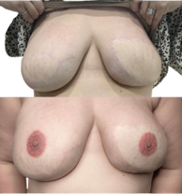 | “What makes it a breast to a lot of people and very culturally is that nipple and areola” (Mac)
Non-Medical Reconstructive | Tattooing over skin that is not scarred, or damaged from a surgical procedure or medical condition where the design’s goal is to return the body to how it looked before the effects of treatment, such as eyebrow tattooing following hair loss from chemotherapy. | No image provided by participants | “They call [The tattoo] battle brows so lots of times women are going into cancer treatment you know they're gonna lose most of their body hair and so she'll do she'll do eyebrows on ladies before they go in or after that way, they could still have the appearance of normalcy” (Mr. G)
Medical Decorative² | Tattooing over skin that is scarred, or damaged from a surgical procedure or medical condition where the design’s goal is to add a new symbol/image, such as a brain zipper. | 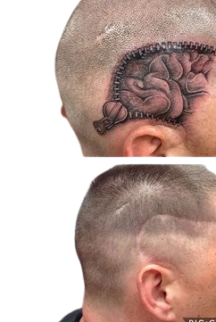 | “ He's just sort of got it as a like I mean it was literally a zipper with his brain showing over the scar so it was just sort of, he had a sense of humor about it, I mean, obviously there's deeper emotional you know threats to his you know existence but his tattoo he just if it's head was shaved he wanted to just sort of have a little giggle about it you know” (Mac)
Non-Medical Decorative | Tattooing over skin that is not scarred, or damaged from a surgical procedure or medical condition where the design’s goal is to add a new symbol/image such as a ribbon. | 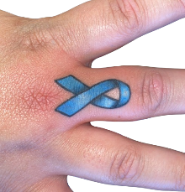 | “I think the ribbon is more like it, they've gotten through it and they're over it and it's part of them and they want to mark it somehow that happened” (Sarah)
¹ Medical is sometimes referred to as para-medical.
²Decorative is sometimes referred to as cosmetic.

