Appendices
Appendix A
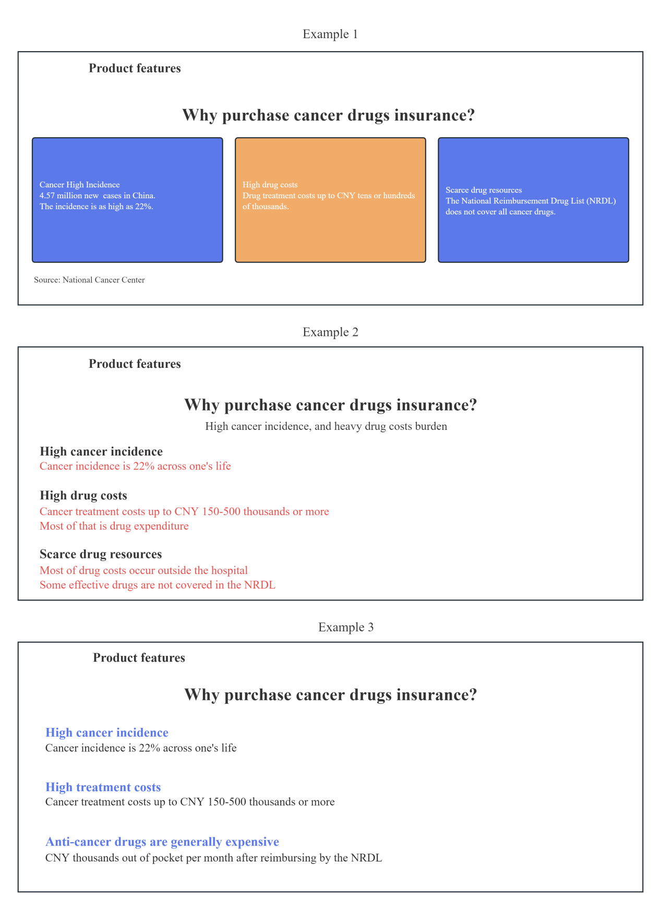

Appendix B
LRIF (r=1, control group): National Cancer Center (NCC) presented the data showing that there are new cancer cases with 18.6% incidence rate every year in China. The National Reimbursement Drug List (NRDL) only covers a limited number of cancer drugs, and cancer drugs annual spending up to CNY tens or hundreds of thousands, imposing heavy financial burdens on most ordinary families.
HRIF (r=2, treatment group): National Cancer Center (NCC) presented the latest data showing that there are 4.06 million new cancer cases with 18.6% incidence rate every year, and deaths are increasing by 2.41 million per year with the incidence continues to rise in China. To date, the steep price of commercially available cancer drugs is still prohibitive. The National Reimbursement Drug List (NRDL) only covers 157 specific cancer drugs as of 2023, each pack of cancer drug that not included in NRDL costs CNY 50,000 averagely, and cancer drugs annual spending up to CNY 600,000! However, the vast majority of cancer drugs fee needs to be paid by patients themselves due to not covered by NRDL, causing great physical and mental suffering due to the lack of cancer drugs treatment and imposing heavy financial burdens on most ordinary families. This tend to mean that one person gets cancer, one or several families collapse!

Appendix C
Annual benefit limit: CNY 2 million; Deductible: CNY 0; Waiting period: 30 days
Guarantee content: 122 domestic and 60 overseas cancer drugs on the market
Guarantee duration: valid during the insurance period; Compensation ratio: 100%
Free cancer drugs provided duration after diagnosis: j years (j=1, 2, or 3), renewal not guaranteed

Option 0: Not insured | Option 1: Just insured 1 year, premium CNY 179 | Option 2: Insured 3 years consecutively, premium CNY 521

Appendix D
Selected demographic characteristics of subjects for each study group (15% sample size)
Variable | Group 1.1 | Group 1.2 | Group 1.3 | Group 2.1 | Group 2.2 | Group 2.3 | Total | χ² | P
Variable | N (%) | N (%) | N (%) | N (%) | N (%) | N (%) | N (%) | χ² | P
Age |  |  |  |  |  |  |  | 9.971 | 0.822
18 to 29 years old | 73 (51.4) | 68 (49.6) | 68 (45.6) | 67 (51.1) | 76 (55.1) | 71 (53.0) | 423 (50.9)
30 to 39 years old | 50 (35.2) | 51 (37.2) | 59 (39.6) | 39 (29.8) | 41 (29.7) | 39 (29.1) | 279 (33.6)
40 to 49 years old | 14 (9.9) | 12 (8.8) | 15 (10.1) | 20 (15.3) | 15 (10.9) | 16 (11.9) | 92 (11.1)
50 to 60 years old | 5 (3.5) | 6 (4.4) | 7 (4.7) | 5 (3.8) | 6 (4.3) | 8 (6.0) | 37 (4.5)
Gender |  |  |  |  |  |  |  | 5.105 | 0.403
Male | 79 (55.6) | 82 (59.9) | 82 (55.0) | 67 (51.1) | 73 (52.9) | 84 (62.7) | 467 (56.2)
Female | 63 (44.4) | 55 (40.1) | 67 (45.0) | 64 (48.9) | 65 (47.1) | 50 (37.3) | 364 (43.8)
Marital |  |  |  |  |  |  |  | 5.447 | 0.364
Married | 63 (44.4) | 72 (52.6) | 85 (57.0) | 70 (53.4) | 67 (48.6) | 69 (51.5) | 426 (51.3)
Not married | 79 (55.6) | 65 (47.4) | 64 (43.0) | 61 (46.6) | 71 (51.4) | 65 (48.5) | 405 (48.7)
Residence |  |  |  |  |  |  |  | 7.714 | 0.173
Rural | 41 (28.9) | 52 (38.0) | 46 (30.9) | 38 (29.0) | 54 (39.1) | 52 (38.8) | 283 (34.1)
Urban | 101 (69.6) | 85 (65.7) | 103 (66.6) | 93 (68.6) | 84 (65.4) | 82 (64.8) | 548 (66.8)
Annual disposable income individually |  |  |  |  |  |  |  | 14.622 | 0.479
Up to 19999 CNY | 30 (21.1) | 28 (20.4) | 32 (21.5) | 30 (22.9) | 38 (27.5) | 22 (16.4) | 180 (21.7)
20000 to 29999 CNY | 12 (8.5) | 15 (10.9) | 8 (5.4) | 13 (9.9) | 15 (10.9) | 13 (9.7) | 76 (9.1)
30000 to 49999 CNY | 57 (40.1) | 59 (43.1) | 63 (42.3) | 61 (46.6) | 51 (37.0) | 66 (49.3) | 357 (43.0)
At least 50000 CNY | 43 (30.3) | 35 (25.5) | 46 (30.9) | 27 (20.6) | 34 (24.6) | 33 (24.6) | 218 (26.2)
Education |  |  |  |  |  |  |  | 16.671 | 0.674
Junior | 5 (3.5) | 2 (1.5) | 5 (3.4) | 3 (2.3) | 4 (2.9) | 5 (3.7) | 24 (2.9)
Senior | 18 (12.7) | 23 (16.8) | 19 (12.8) | 21 (16.0) | 16 (11.6) | 22 (16.4) | 119 (14.3)
Associate | 47 (33.1) | 32 (23.4) | 28 (18.8) | 33 (25.2) | 36 (26.1) | 37 (27.6) | 213 (25.6)
Undergraduate | 65 (45.8) | 69 (50.4) | 88 (59.1) | 69 (52.7) | 74 (53.6) | 61 (45.5) | 426 (51.3)
Postgraduate | 7 (4.9) | 11 (8.0) | 9 (6.0) | 5 (3.8) | 8 (5.8) | 9 (6.7) | 49 (5.9)
Health insurance type |  |  |  |  |  |  |  | 16.285 | 0.699
Free | 15 (10.6) | 14 (10.2) | 16 (10.7) | 17 (13.0) | 10 (7.2) | 18 (13.4) | 90 (10.8)
Urban employees | 57 (40.1) | 51 (37.2) | 66 (44.3) | 52 (39.7) | 50 (36.2) | 44 (32.8) | 320 (38.5)
Urban and rural residents | 57 (40.1) | 59 (43.1) | 59 (39.6) | 58 (44.3) | 68 (49.3) | 63 (47.0) | 364 (43.8)
Commercial | 9 (6.3) | 7 (5.1) | 6 (4.0) | 2 (1.5) | 6 (4.3) | 7 (5.2) | 37 (4.5)
Without | 4 (2.8) | 6 (4.4) | 2 (1.3) | 2 (1.5) | 4 (2.9) | 2 (1.5) | 20 (2.4)
Sample size | 142 | 137 | 149 | 131 | 138 | 134 | 831

Appendix E
Results of purchasing decisions for CDI schemes (15% sample size)
Framework | Group | Option 0 | Option 1 | Option 2 | χ² | P
 | Group | Number (%) | Number (%) | Number (%) | χ² | P
LRIF | 1.1 | 7 (4.9) | 49 (34.5) | 86 (60.6) | 3.866 | 0.145
 | 1.2 | 14 (10.2) | 40 (29.2) | 83 (60.6) | 4.895 | 0.087
 | 1.3 | 8 (5.4) | 27 (18.1) | 114 (76.5) | 9.621 | 0.008
HRIF | 2.1 | 7 (5.3) | 38 (29.0) | 86 (65.6) | 0.274 | 0.872
 | 2.2 | 7 (5.1) | 41 (29.7) | 90 (65.2) | 0.571 | 0.752
 | 2.3 | 9 (6.7) | 37 (27.6) | 88 (65.7) | 0.060 | 0.971
χ² |  | 4.858 | 10.586 | 11.008
P |  | 0.434 | 0.060 | 0.051
Abbreviations: LRIF=low risk information framework; HRIF=high risk information framework; Option 0=not insured; Option 1=just insured 1 year, 179 CNY premium; Option 2=insured 3 years consecutively, 179 CNY premium.

Appendix F
Results of time orientation towards CDI purchasing (15% sample size)
Dimensions | Items | LRIF (N=428) | HRIF (N=403) | Comparison
Dimensions | Items | M (SD) | M (SD) | t (829) | P
Present-oriented | I focus on my current NOT future cancer risk when I choose the CDI scheme | 3.70 (1.060) | 3.83 (0.998) | 1.822 | 0.092
Present-oriented | I care more about current premium NOT future cost reduce when I choose the CDI scheme | 3.81 (0.994) | 3.82 (0.939) | 0.149 | 0.119
Future-oriented | I value more on the future security when I choose the CDI scheme | 3.95 (0.948) | 3.97 (0.902) | 0.260 | 0.166
Future-oriented | I consider its long-term impact on my future life seriously when I choose the CDI scheme | 4.06 (0.872) | 4.08 (0.803) | 0.366 | 0.402
Abbreviations: LRIF=low risk information framework; HRIF=high risk information framework

Appendix G
Results of perceived risk related to developing cancer (15% sample size)
Dimensions | Items | LRIF (N=428) | HRIF (N=403) | Comparison
Dimensions | Items | M (SD) | M (SD) | t (5581) | P
Cancer | Carcinogenic factors are ubiquitous in daily living and working conditions | 4.12 (0.922) | 4.07 (0.929) | 0.735 | 0.710
Cancer | I'm worried about developing cancer in my life | 3.82 (1.050) | 3.86 (0.997) | 0.506 | 0.066
Financial | I'm worried about the price of cancer drugs is steep | 2.75 (1.400) | 2.76 (1.322) | 0.176 | 0.057
Financial | If I get cancer, the cancer drugs expenses are unaffordable for my family | 3.96 (1.062) | 4.05 (0.941) | 1.350 | 0.077
Financial | Cancer drugs insurance could avoid economic risk caused by cancer | 3.93 (0.946) | 3.97 (0.929) | 0.586 | 0.682
Abbreviations: LRIF=low risk information framework; HRIF=high risk information framework

