Supplementary Fig. S1.
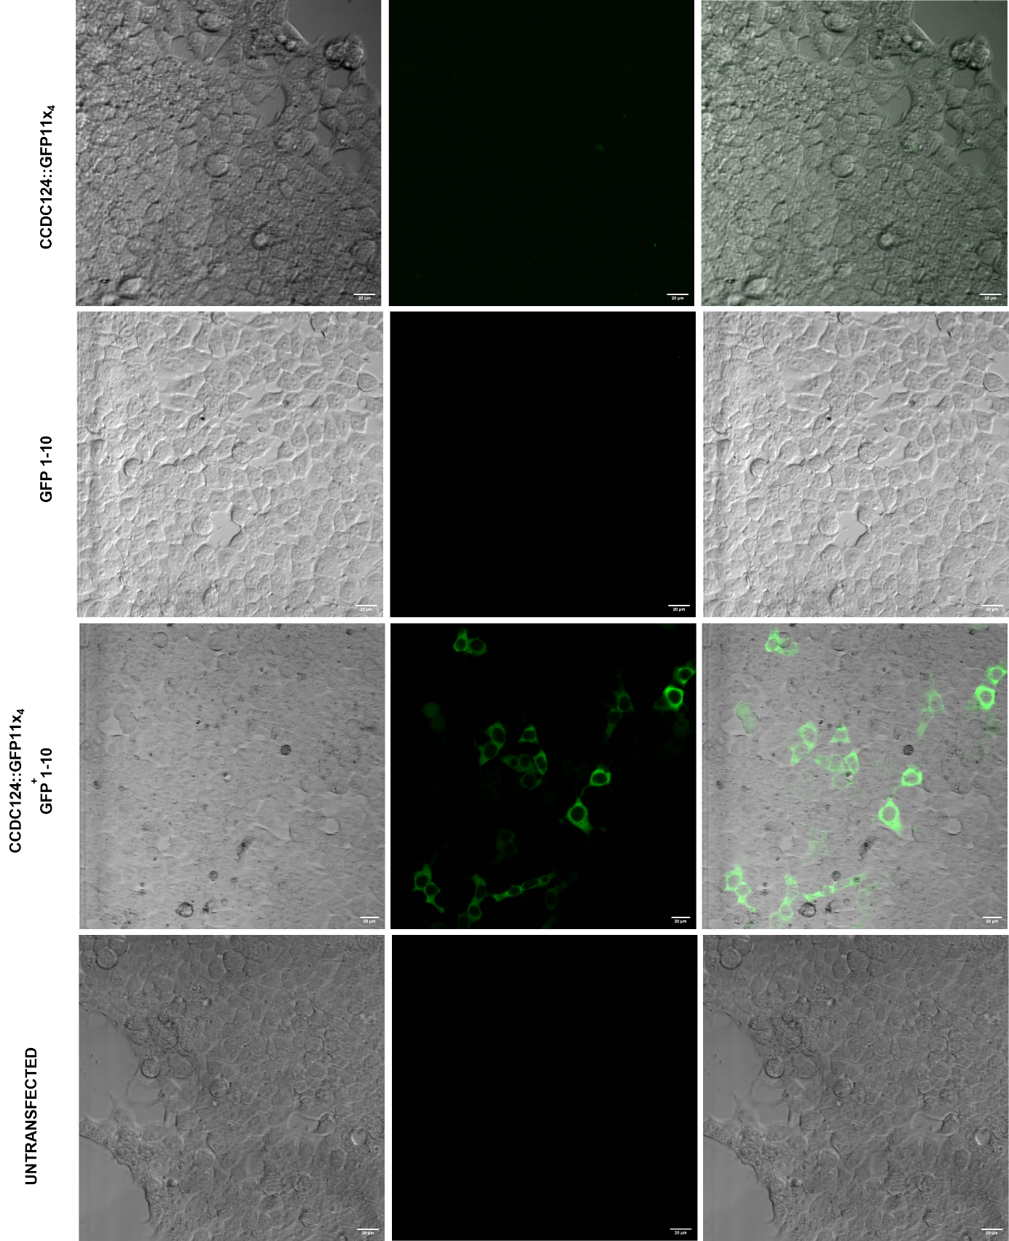
Supplementary Figure S1: Fluorescence emission due to complementation of GFP11-CCDC124 and GFP1-10 fragments. Representative images obtained after transient transfection of U2OS cells with single vectors containing uncomplemented fragments of GFP1-10, CCDC124::GFP11x_{4,} or cotransfected with both vectors (GFP1-10 and CCDC124::GFP11x₄), as compared to the untransfected negative control cells. Bars represent 20 µm.

