GAPDH
Figure 2E

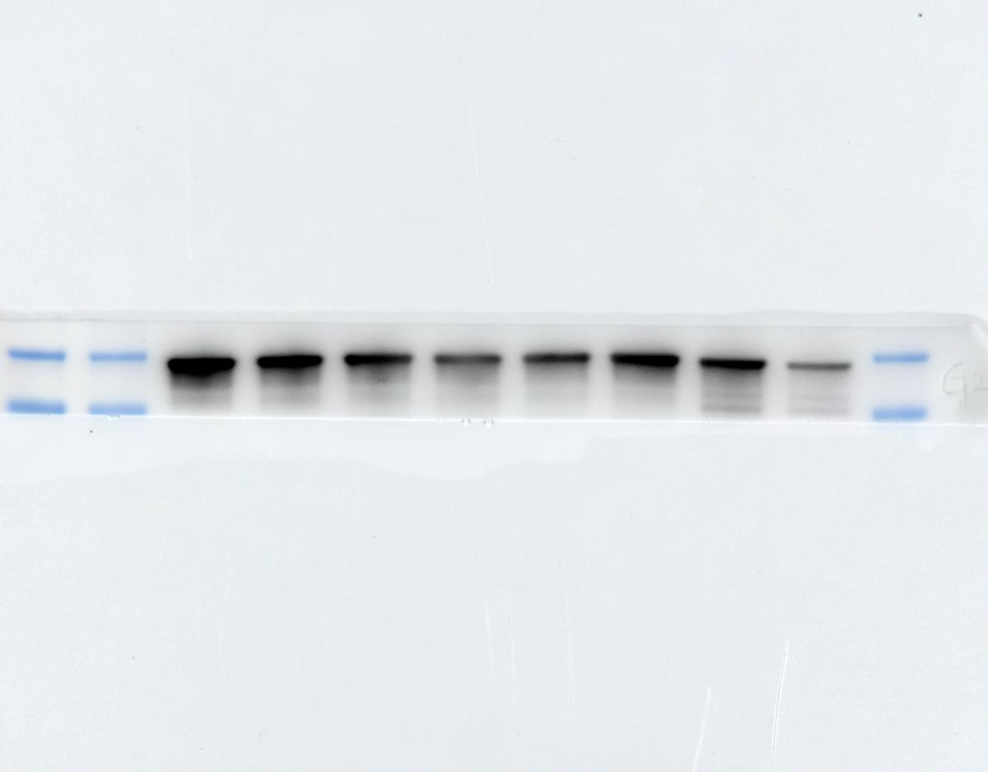
40kDa
30kDa
PlexinA1

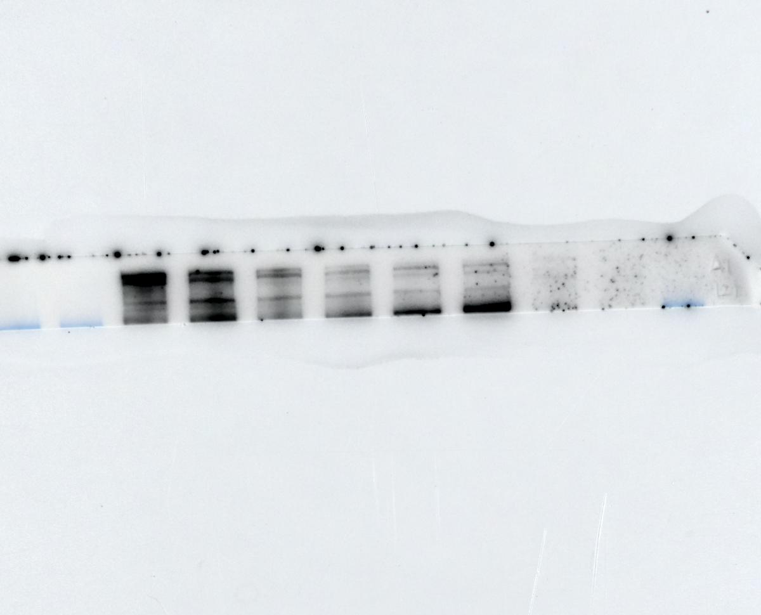
>180kDa
PlexinB3
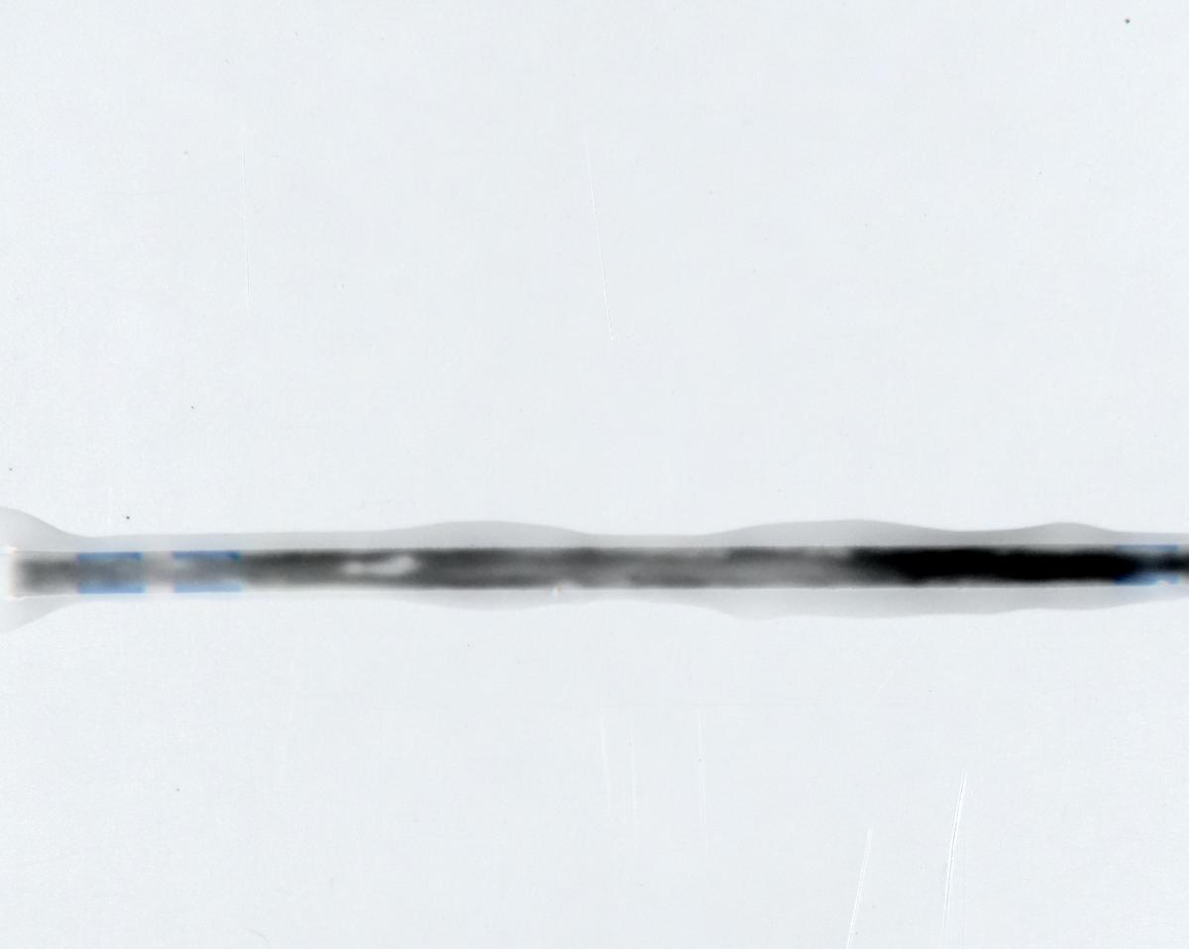
180kDa
130kDa

GAPDH
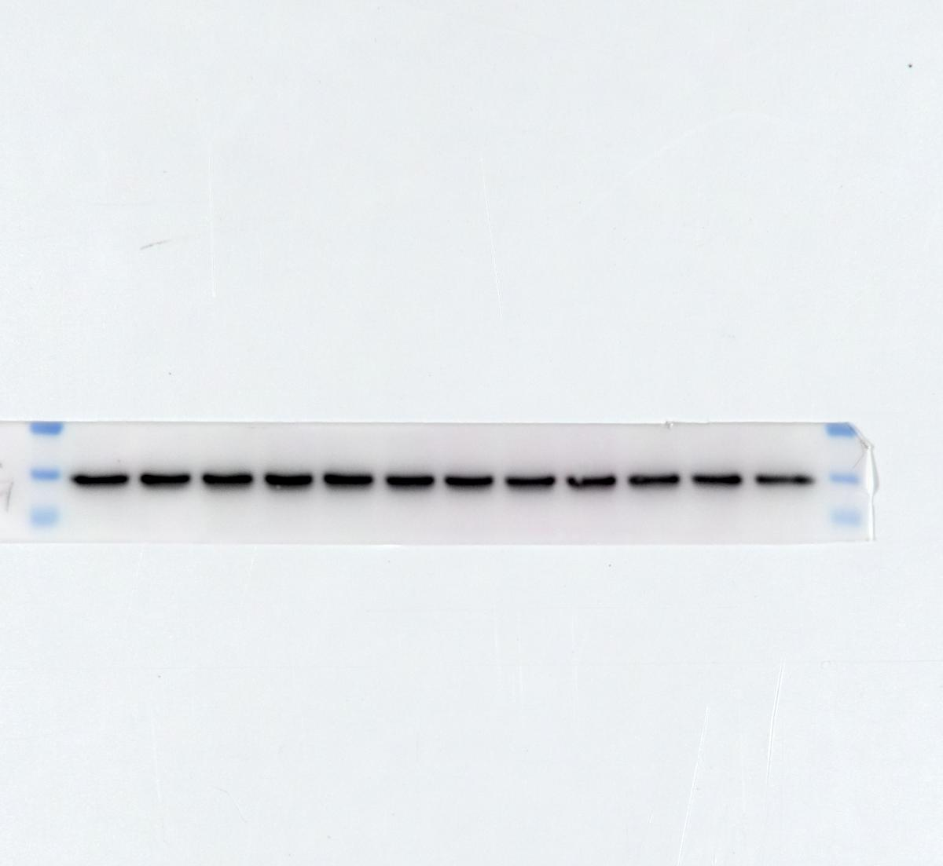
40kDa
30kDa
Figure 2F

PlexinA1

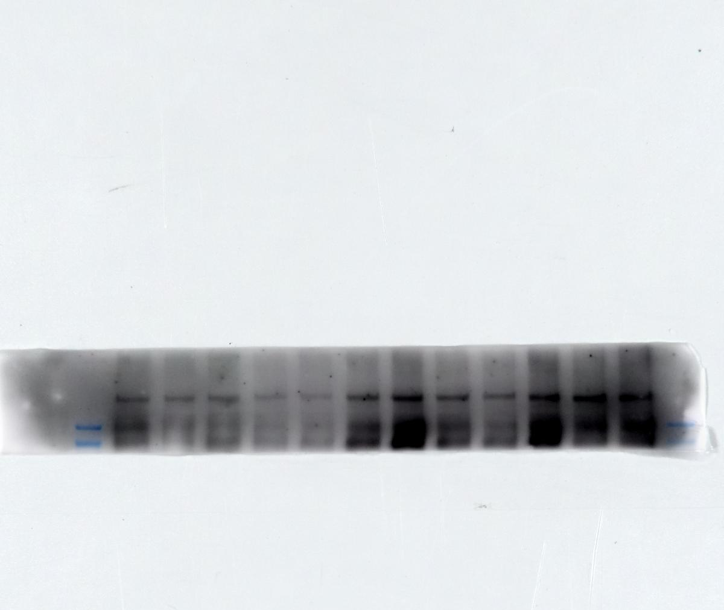
>180kDa
PlexinB3
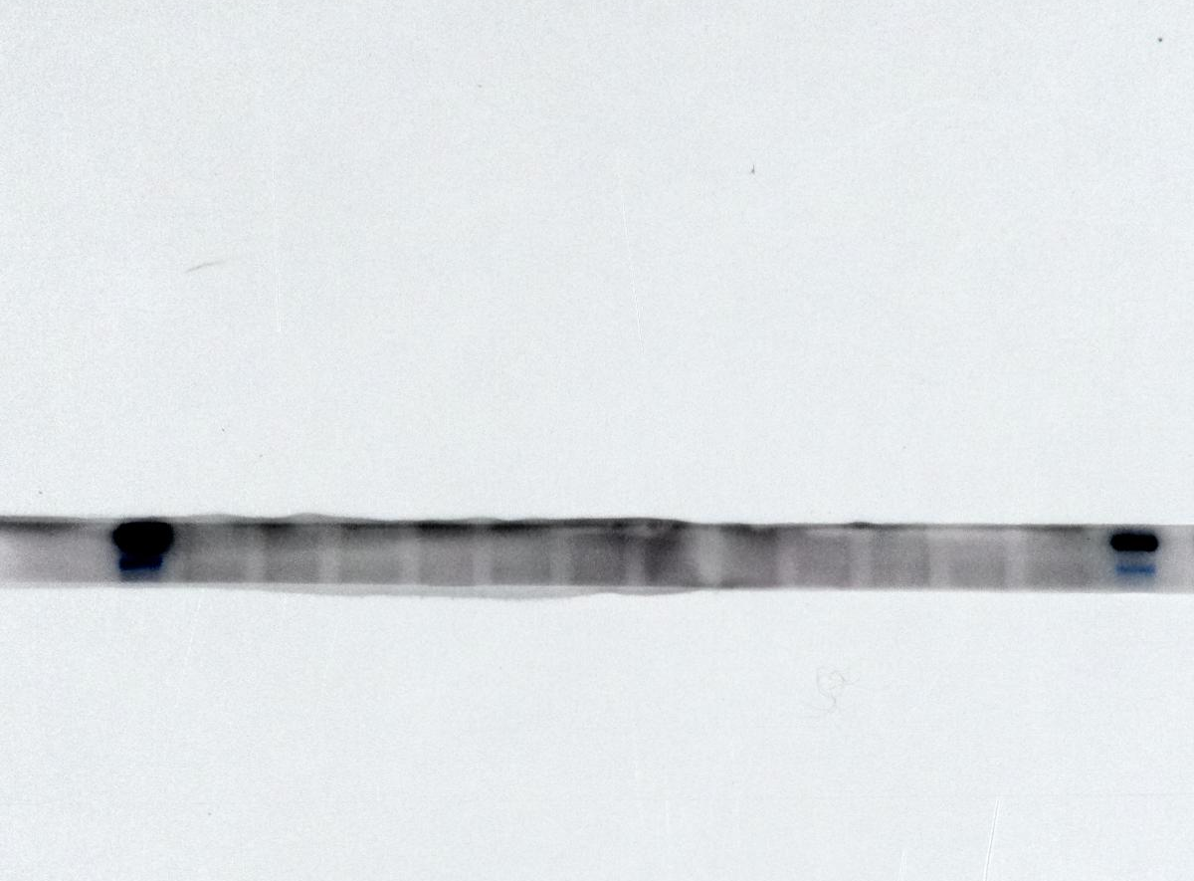
180kDa
130kDa
GAPDH
Figure 5B
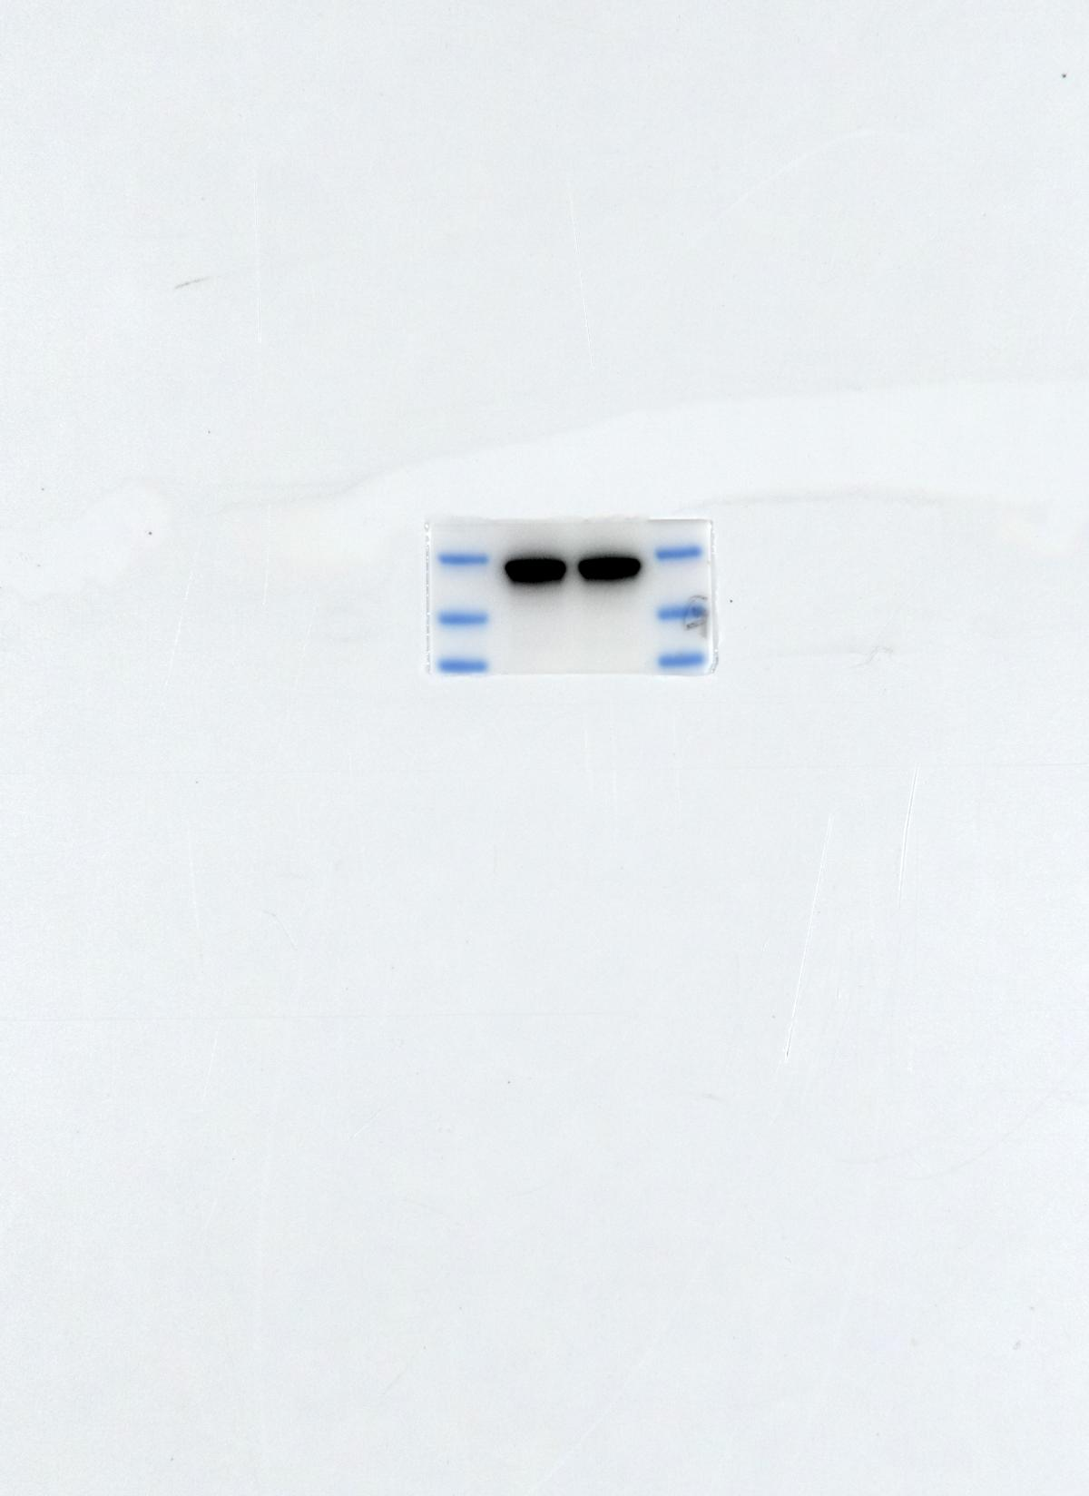
40kDa
30kDa
PlexinA1
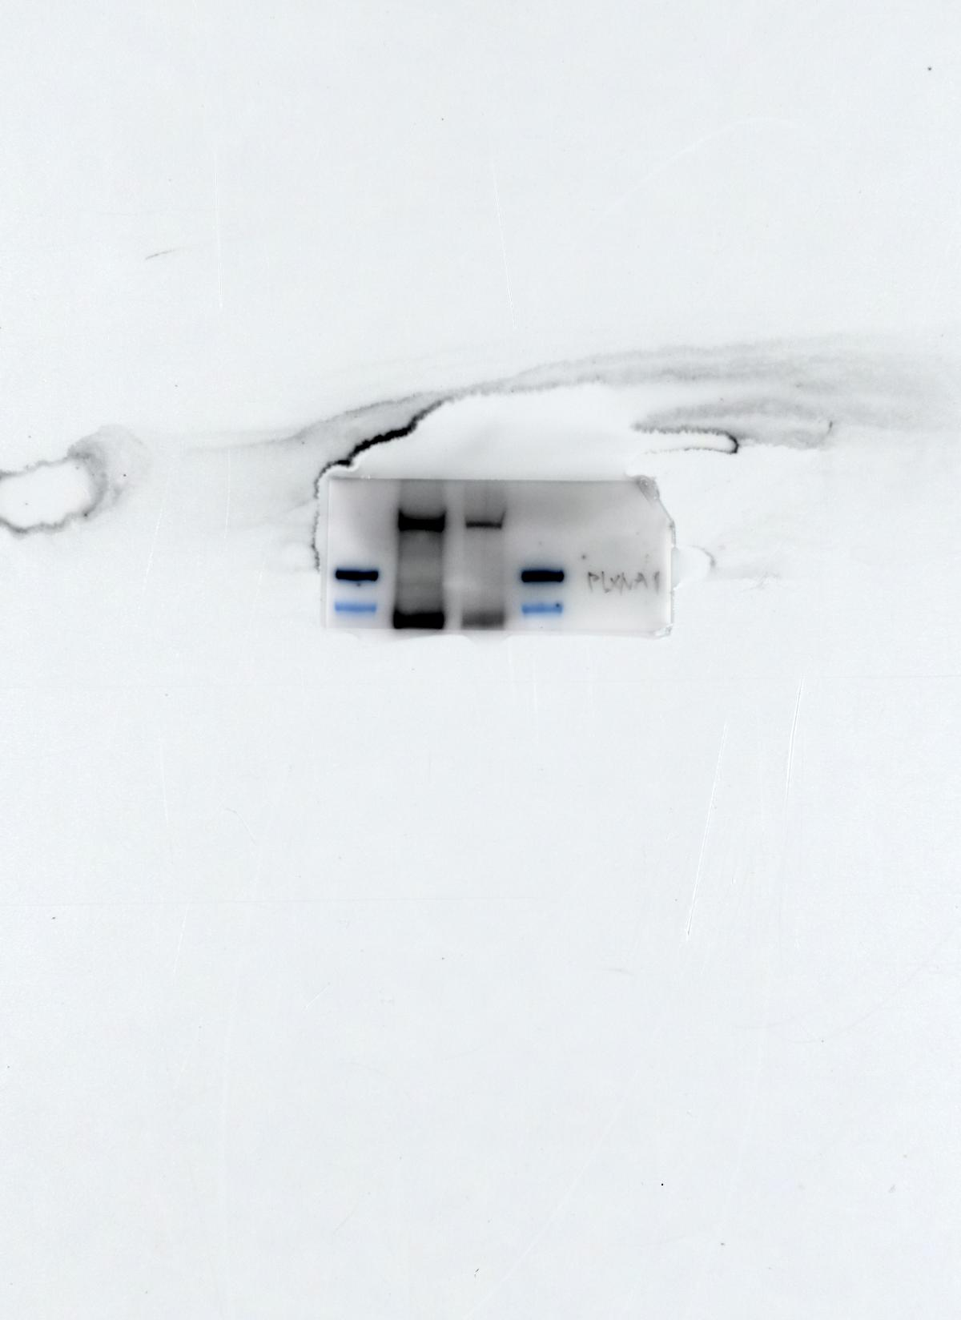
>180kDa
GAPDH
Figure 6A
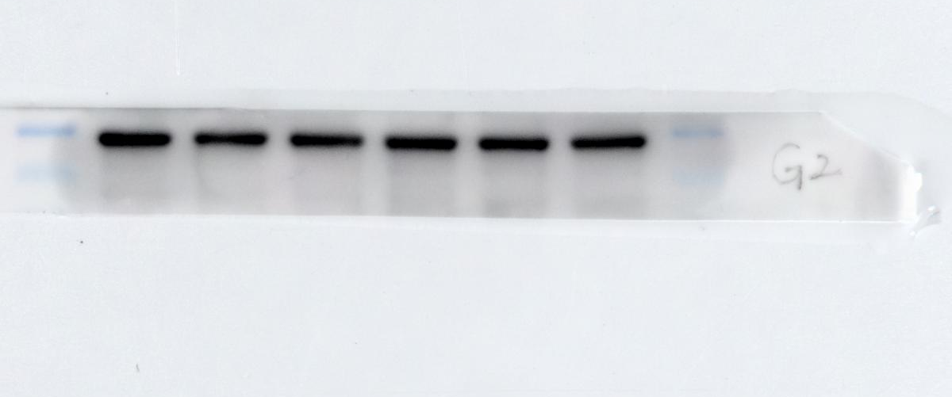
40kDa
30kDa
Th17 0h 0h 1h 1h 4h 4h
Sema5A - + - + - +
p-mTOR
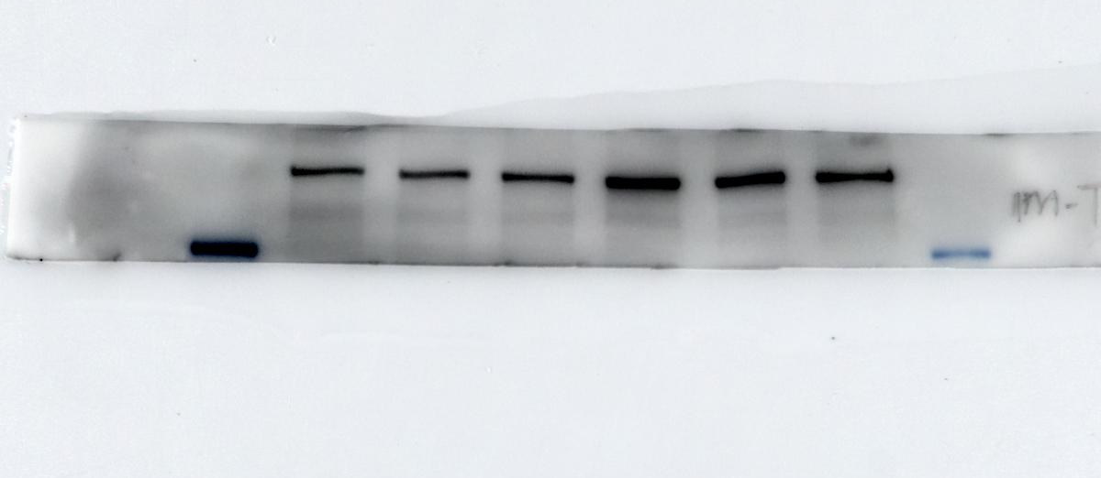
>180kDa
mTOR
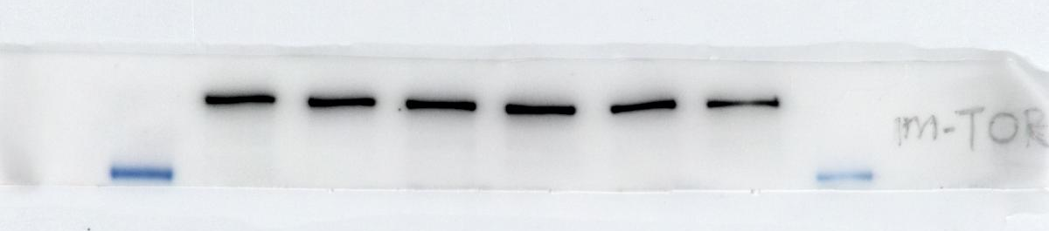
>180kDa
PI3K
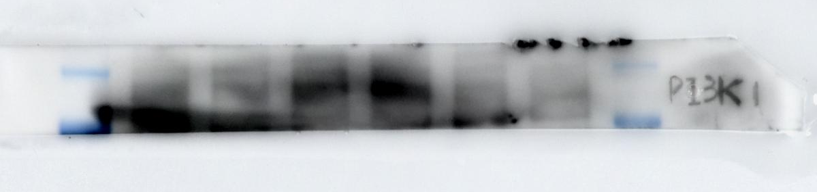
130kDa
100kDa
p-AKT
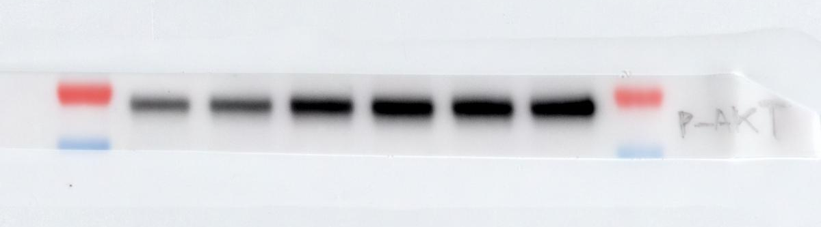
70kDa
55kDa
AKT
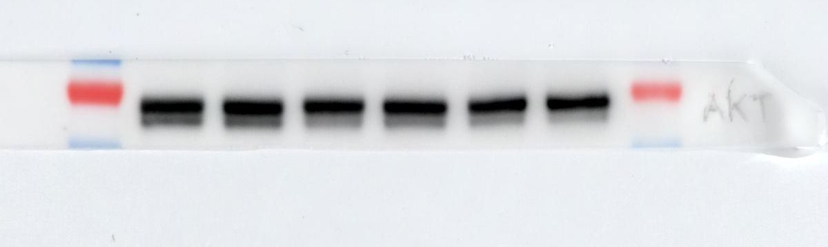
70kDa
55kDa

GAPDH
40kDa
30kDa
Figure 6B
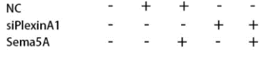
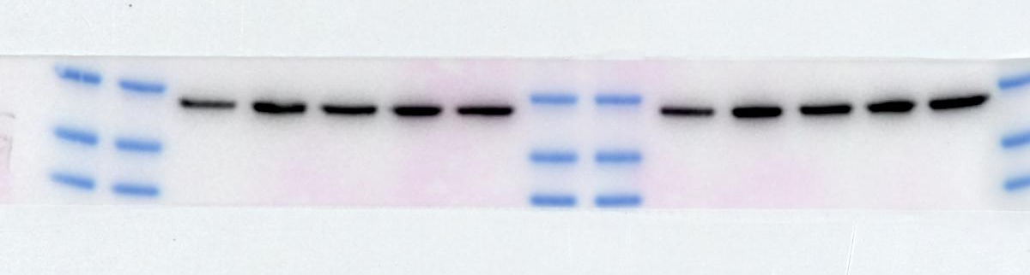

p-mTOR
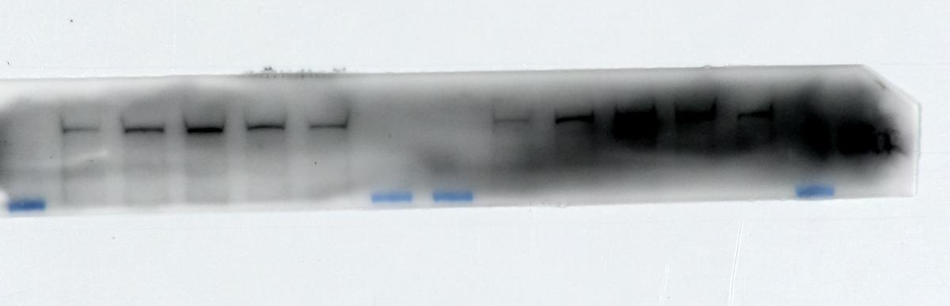
>180kDa
mTOR
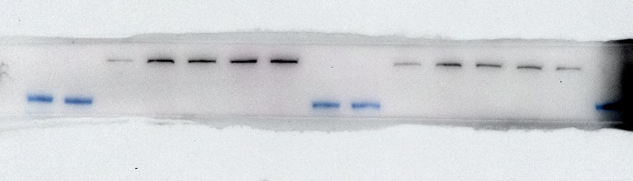
>180kDa
PI3K
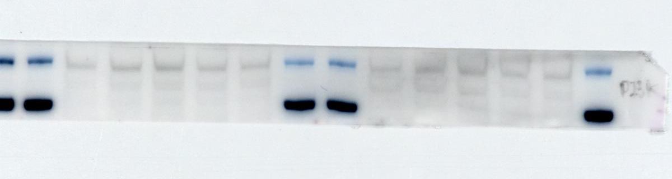
130kDa
100kDa
p-AKT
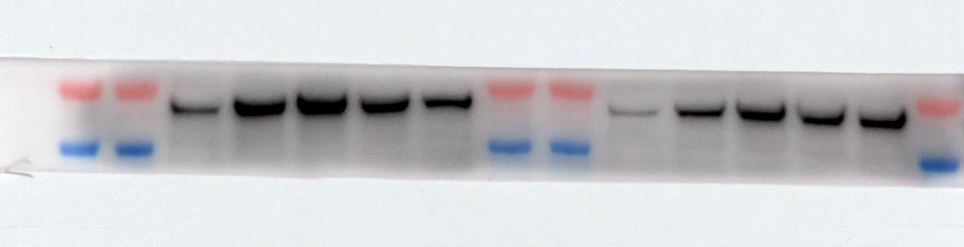
70kDa
55kDa
AKT
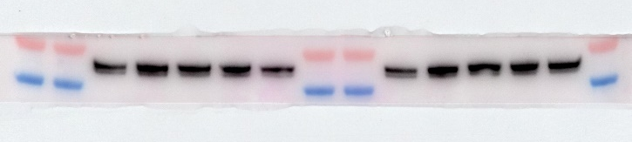
70kDa
55kDa

